

Mature students and the economy of knowledge.
Who are the actual benefactors of a graduating mature student?

Independent Study : ECEU7003

“If you think education is expensive, try ignorance”
(Orben, R, cited in Rodenhizer, S, 2017)

Introduction
This independent study seeks to investigate and evaluate the phenomena of adult education through an investigation of the financial facets associated with Higher Education (HE) in Wales. In order to explore these concepts in depth, this review of the literature shall be focused upon, what constitutes as an adult learner at the individual level, with an exploration of the statistics relating to adult enrolments in Higher Education (HE) in Wales. Moving onto an exploration of the key extrinsic motivating factors (financial) for pursuing HE and an exploration of the Political drivers in place within the UK and more specifically in Wales to guide changes within the socio-economical structure of the workforces and graduates, concluding with a consideration of HE establishments as architects of the knowledge-based economy.
The Rationale behind the research is simply a need to synthesise the existing literature from different aspects of the mature student experience to create a fuller deeper picture of the current financial issues facing not only Welsh mature students but also Welsh Universities. As an educator working within the sector and seeing first-hand the impact of financial insecurities on the enrolment and retainment’s rates of mature students alongside the devastating reduction of funding from local and national governments, this research hopes to generate new insights and build a unique picture of education for the mature HE student in Wales.
A mature student is typically aged over 21 and has had a period outside of full-time education (Ucas, 2020). They may hold little or no previous qualifications and usually are balancing studies with the demands of life. This lived experience while can benefit the student may also become a barrier, especially when considering the cost of Higher Education (HE) within the UK. The attendance of mature students is the key for a discussion on the purpose of a university education or higher educational course. The debate relating to the purpose of HE is longstanding with arguments for both the expansion of knowledge and the preparation for the working environment both with their own merits, however, the later leaves little room for the mature or adult learner who may have already established careers or who face less “career” time once they have graduated (Marks, 1999).
The Phenomena of adult education or non-traditional students holds Political, Cultural, Economic and Social implications (Gilardi & Guglielmetti, 2011). Adult education in recent years has become the focus of many differing fields such as social sciences, alongside the development of new fields such andragogy and pedagogy (Jarvis, 2012). In recent times it has been discussed in terms of being a vessel for social change and cultural hegemony of the working classes within the developed world, thus making the business of adult education a key driver in the economic success of a country Nuissl, & Sava, (2018). Therefore, the onus shifts from individual to pursue a higher education and over to the collective (Governments) to provide opportunities to study at higher educational establishments (Stauverman & Kumar, 2018).
Within the UK the cost of a Higher Educational (HE) course has increased in recent years and thus becomes a barrier for those in low economic areas, in the past free access to degrees was considered a gold standard of an economy that valued a skilled workforce and benefited socially from having a higher level of graduated employees that drove forward pioneering technologies and innovation (Anderson, 2016). The shift occurred in 1998 in the UK under a new Government that reintroduced fees, from a maintenance perspective to a personal loan which moved from state ownership to market proprietorship. The concept of student fees and changes to the stakeholders changed the landscape of adult education into a business model which still stands in today’s economic climate. The UK government's ambitious aim to expand access to HE whilst expecting students and their families to shoulder more of the cost has seen an increase in student debts running in excess of thirty thousand just for course fees. With the rapidly rising cost of HE courses and the confounding student debt (interest of student loans exceeding any other personal debt within the UK) there is an evolving dichotomy (Johnson, 2019). While the infrastructure provides demand and supply for students and universities it is not sustainable in the long term for cost effectiveness and economic sustainability. This is further confounded by the differences in each of the UK devolved regions which have a different approach to the fee system. Rees et al (2005, while the source is 15 years old, in recent years the choice while being offered to students has increased, financial burdens and strains on those wishing to pursue HE courses is actually reducing the option’s for students from lower socioeconomic backgrounds as will be discussed in the main body of the research) puts this eloquently “The 'market' between the countries of the UK which have different fee structures means that 'choice' is now increasingly confusing for students, and there is a view that the home country offers the best deal (whether or not this true), this restricts choice for poorer students” which has an overall impact on the enrolments and attainment of students who under the grant scheme had less barriers to face when considering HE as an option for social mobility and change.

Adult learners within Wales
In the education sector, it has become increasingly apparent that provision needs to be made for the non-traditional students who for socio-cultural reasons are returning to study outside of formal educational ages, which for a Welsh resident formal or compulsory education ends aged 16 (Gov, 2019). There is no clear consensus or clarification on the definition of an “adult learner” which makes it difficult to avoid being vague when considering who is an “adult learner within the UK, and at an institutional level the inconsistency with definitions can lead to a lack of consensus (Mckendry & Boyd (2012). For some there is the assumption that all University students are adults as they are aged over 18 (which in the UK under current law is the start of adulthood, ONS 2019), However, within the UK HE system anyone aged over 21 is usually seen as a mature student (Kasworm, 2003).
When considering the data on enrolments within Wales it is clear to see the majority of undergraduate enrolments fit within the 19-20 age category (34,740 for the 2018/19 academic year, Stats Wales, 2020), this may be due to the fact that the education system prepares and encourages the university pathway as a means to employment, and so students entering young adulthood are supported both physically and financially to pursue an undergraduate degree. There is also a difference in the Full-Time (FT) students within this age grouping and Part Time (PT) students (1465), (Stats Wales, 2020), this suggests that most under 20 students wish to pursue a fulltime degree instead of gaining full time employment. The Welsh Government set out in the “Adult learning in Wales” 2017 document that working with the UNESCO framework that education is a human right and not only should access be widened but also quality. This strategy addresses the demands for a future workforce with such areas as essential, digital and employability skills all given provision, however, it must be noted that this framework is aimed at all areas of the post 16 educational landscape and not solely for HE provisions, nevertheless it provides support for the numbers of enrolments from FE feeder systems and sixth form academies.
When considering the enrolments for the combined age categories (32,815) (Stats Wales, 2020) it is clear to see why most of the provision is aimed at the 18+ student. However, that is considering the data for the fulltime courses and part time provision for the 25-39 (9,340 v 10,160) almost matches the fulltime enrolments, this as we have seen is not the case for the 19-20 provision which had a significant difference, thus suggesting that in Wales the mature or adult learner is more likely to pursue a part time degree while still maintaining the demands of life, unlike the fulltime 19-20 students. It must be noted that these figures are only related to the Welsh nationals and do not include the enrolments for the age categories of applicants outside of Wales, or for Welsh students who have decided to study outside of Wales. While this data would give a richer picture, for the purpose of the independent study the focus has been narrowed accordingly. A report produced by Universities UK (2013) recorded that almost half a million UK residents were pursuing a PT undergraduate course in 2011-2012 making up 29% of the undergraduate population and furthermore that nine out ten were aged between 21 & 65, this further supports the data previously confirming that PT courses are the chosen method study for mature students. This data from the Department of Education (Fig 1.), (2019) clearly shows the sustained enrolment rates for mature students (over 21) in HE, but it must be noted this data relates to the UK as a whole and not solely the devolved principality of Wales.
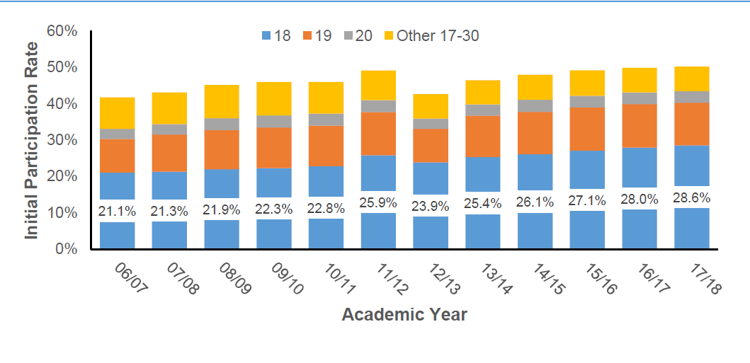
Fig 1.
So why is this of any relevance? Investigation regarding the PT student experiences is an important one, given the positive impact this has on the UK economy (UUK, 2013). Research conducted by The Higher Education Academy (HEA, 2015) in Wales emphasized considerable amounts of PT students experiencing a disability or long-term health condition (22%), being a parent of children under 18 (39%) or be a live-in carer (12%). The research of learner’s voices also found that PT students felt the financial burden of FT study to be too much and felt they had no other option than the PT route into HE, in agreement with ARC, (2013) often it is the students who are disadvantaged (usually working) who participate with HE through PT modes of study due to financial hardship.
The funding system within then UK HE provision see full time students being given an opportunity to seek out financial aid both for the course fees and for living costs while studying (Gov, 2019), while for part time students the provision is less. Does this system seem fair when it clearly favours full time students who we now know the majority to be aged 19-20 over the part time students who are aged 21+ and who contributing towards society in many ways but also trying to pursue HE. This is impacted further by the fact that most of those part time students are females (2018/19 enrolments for females on part time courses stood at 8410 in Wales compared to 5140 for their male counterparts, Stats Wales 2019). Female undergraduates outnumber males in all areas of the UK, this gender gap is larger in certain geographical areas such as Scotland, however this trend is being documented worldwide (Bilton, 2018), the graphic below gives a visual representation of the trend which is being seen across the UK in all HE courses (Dept of Education, 2019).
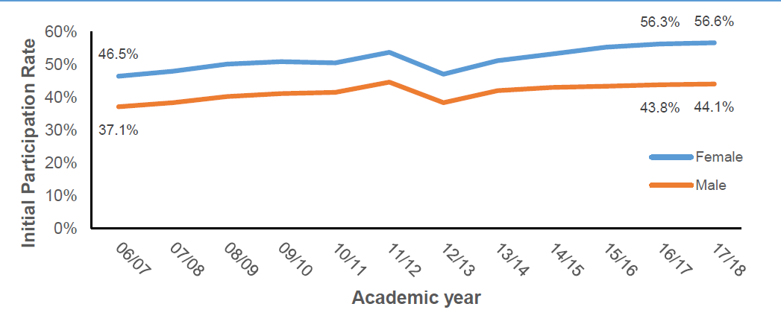
Fig 2.
There could be many explanations for this demographic change, such as professional careers which are dominated by females, such as nursing or teaching did not demand the qualifications in the past and are funded in Wales with a Bursary system which reduces the cost significantly, yet this would only explain the full-time enrolments which are associated with the bursary scheme. There have been considerable changes to the labour market in recent years and again this may be reflected in the enrolment rates of females, seeking employment in areas previous generations may be evaded (Francis, 2007).
While the funding system in Wales is the same for both genders, social norms would suggest the mature student age category of 21+ are in a life stage where most females are setting up family units and so may have the added pressure of insufficient financial or family support (Lin, 2016). Non-traditional students usually have multiple roles such as employee, partner, and parent (with all the accompanying extra duties this entails), females may have the added responsibility for childcare or financial insecurity, these barriers can widely impact the academic experiences while they try to balance both roles (Bauer & mott (1990). Research conducted by the London south bank university (2005) reported students in the 19-20 category (99%) had no dependents while 50% of the students aged 25+ had dependents and out of the 50%, three quarters where lone parents. Furthermore, Callender (2001) found gender differences in the paid work engaged with between the genders during term time, females were more likely to work during their education than their male counterparts. So, this leaves us with the questions of, if education is indeed a vessel for social change then surely the part time students of both genders and from low socio-economic backgrounds should be given the same opportunities for fiscal support as their full-time equivalents widening participation across the board. The answer will be given consideration in the following sections.
A report by the Gov UK (2019) showed that HE progression rates (2018/19) for students with lower socio-economic backgrounds (free school meals) was only 26.3% of the population which was the same for the previous year, this data was focused upon ages 19 and no data has been provided for mature students within this category (due to the fact they left compulsory education). While the progression rate for students who did not receive free school, meals was up by 18.8% from the previous year, thus suggesting that students from lower income families (most likely to take loans to cover university education) are not entering into HE. Mullen (2010, while this source is 11 years old the issues addressed are still most relevant to HE) in her briefing to Scottish parliament, report that many barriers are faced when considering participation in HE, and that the influences for participation are combined socio-economic characters. Family background and circumstances are obvious when considering income, parental education, occupations, and geographical areas of origin. These barriers impact both traditional and non-traditional students in terms of academic success, however for the purpose of this research an exploration of the non-traditional students (or second chance learners) will be the focus. The second chance learners face similar barriers to the traditional learner, although they face an under representation in HE participation rates. Widening access to HE is simply not enough to confront to socio-economical exclusion which is taking place within global universities, in the case of the UK and Wales the focus has become on how to support prospective students financially offering grants and scholarships to those who are in need, once again this is mostly focused upon full time students within the 18-20 age category.
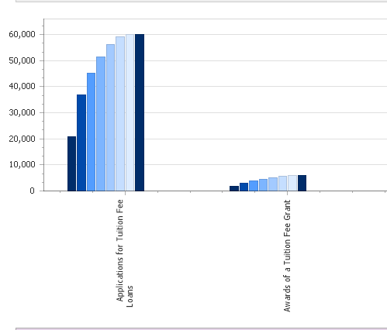
Fig 3.
(Stats Wales, 2020)
The data set collected by stats Wales above clearly shows the applications for academic year 2020/2021 for tuition fee loans, and it is clear to see the awards of tuition fee grants is below 5,000. This while ensures the students who have been awarded are given access, it is evidently not enough. Students applying after august 2018 can apply for living costs up to £4,500 for the lowest income backgrounds, but in truth a loan would be needed to subsidise this income. Students from lower socio-economic backgrounds are offered financial support but this is not enough and thus end up in debt trying to obtain a degree (Houle, 2013, while 8 years have passed since this body of research when considering the data from 2017 in Fig 4, there is still clearly and divide in the level of debt being occurred for all students and it will impact the students from Lower socioeconomic backgrounds greater).
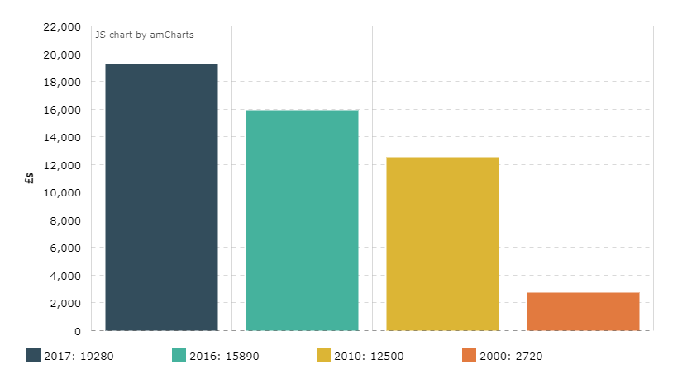
Fig 4.
(Wightwick, 2017)
The above graph clearly shows that student debt as increased exponentially in the last decade (the data is unclear as to if relating to FT or PT enrolments), the cost of living is increasing, and this is forcing students to incur more loans to enable the completion of a degree. It is estimated by Royal London insurance (2019), that graduates will have pensions that are 1/5th smaller than previous generations. This will have an impact on the economy as mortality and morbidity rates increase exponentially, the average life span of someone born in 2000 in estimated to be 80+ years (please see Fig 5.)
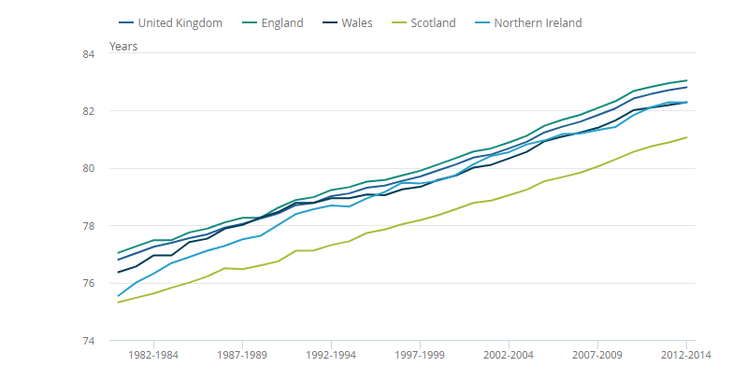
Fig 5.
ONS (2014).
That could mean increasing the pensionable age to ensure the financial viability of that generation. The impact of this will be discussed in Student Finance and Widening Participation section below. The stark reality is that new graduates are facing reductions in disposable incomes, which then impacts other areas of the economy, such as the housing market, and banking and finance (Johnson, 2020). While this research clearly shows that mature students are benefiting from access to HE, a consideration of the issues (financial) facing non-traditional students from under represented population groups needs to be addressed.

Student Finance and Widening Participation
In education it is important to consider the changing gaps in participation rates for each of the different student populations and how (if) this has been impacted by the changes made to the way in which HE courses are funded. In recent years, the development of the “knowledge economy” (please see next section for definition and full explanation) has seen governments in western economic markets give priority to the development, reform, and expansion to the HE system to widen access and participation (Adrett, 2006, this source was considering the changes that had just been implemented, however now the changes are well established and thus relevant to this body of research). In the UK following the 1990 Education (student loan) Act and the 1998 teaching and HE Act (with means tested contributions to tuition fees amendments), education reforms took place, in terms of students carrying the cost of the undergraduate degree switching the cost from the tax player to the student (London, south bank university, 2005).
The 2003 white paper “the future of HE” discussed the notion of HE as a product in a market where the students are the consumers (as cited in Callender & Jackson, 2008, this source is referring to a key piece of educational research that influenced the changes being made in education at a policy level). This means that for anyone wishing to pursue an undergraduate degree there will be an element of debt involved. This switch in the fundamental approach to HE and how it is paid for has led to each devolved country within the UK to adopt a different approach, for the purpose of the paper, to narrow the focus, student funding within Wales so be considered. With costs of an undergraduate degree reaching nine thousand per year, (27k for full course over three years and the equivalent for part time over 6 years), all Welsh undergraduates can borrow the fees and repay once the earn over £26,575 per annum (Cardiff Uni, 2020). This relates to FT courses and as we have seen the majority of the student base will be aged 19-20. In addition, a means tested grant of up to £8,100 is available for students who have a household income of £18,370 or less, according to Office of National Statistics (ONS, 2020) the average household income £18,745 in Wales (2017/18) takes most applications for student finance over the threshold (a copy of the data sheet in attached in Appendix 1), therefor the grant drops to £5,930, once again these figures are relating to the FT degrees. For PT students the loans peak at £6,935 (Gov, 2020), with a grant of up to £4.500 depending on household income and the intensity of study. So, it is important to consider the household incomes for the PT students and how the Welsh government are providing financial support for students from low socio-economic groups. HE has always attracted students who have financial security, and access to HE continues to be positively correlated with household income and affluence (BIS,2020).
One of the main issues faced within this study has been the lack of reliable data sets relating to patterns of participation for PT undergraduates over 25+ from low socioeconomic backgrounds which has been reported an issue for other researchers within the field (Taylor & Garand, 2004 while this is 17 years old the issue still stands, there is little or no data readily available to the researcher at the time of writing this independent study), this is alarming as the data will be informing the direct funding given to each HEI (Higher Educational Institute) for this specific student characteristic, these students may have not been given the opportunity to attend HE from the compulsory education route and need to be given every opportunity as a mature student. The lack of data surrounding this specific student group suggested that there is a need for more data to a) be captured at enrolment or b) created using current methods employed by the Welsh assembly and shared on an open forum. The data which is available is either missing items, not up to date or is difficult to analyse, nevertheless, some inferences can be made from the data which is available.

Considering the data from Higher Education Student Statistics (HESA, 2019) for 2017/18 students females 51,235 outnumbered males 44,310 with the highest age groups of 20 and under 48,260, followed by 21-24 28,635 and 25+ 18,740, the figures for part time students show a significant difference, females 20,460 outnumber males 13,465 (as in FT enrolments) which is support by data from Taylor & Garand, (2004, while this source is 16 years old, it can be see that the same pattern is currently occurring in Females within HE) that females make up 58% of Welsh domiciled students in HE, however it is of interest when looking at the age categories 20 and under, 2,960 21-24, 5090, and 25+, 25,880, thus showing there are more part time students ages 25+ and overall more females than males as undergrads as previously mentioned.
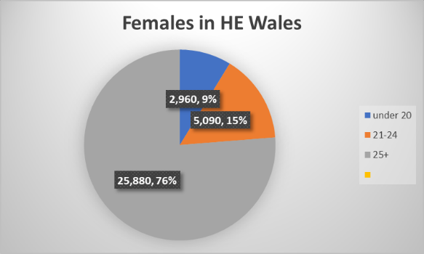
Fig 6
HESA,2019
The data clearly shows the increasing gap between Males and Females entering HE, but also the female enrolments are higher within a certain age category, thus impacting the widening gap, not just for genders but also within the genders when accounting for age. Governmental policy to attract more females into HE has clearly been successful and while this is a positive for HEI’S, there is clearly still a lack in equality for both genders. The gender gaps switch when considering the labour market of graduates, where there is still clearly a pay difference between the genders (Hewitt, 2020). However, looking at the above statistics in isolation does not give a clear picture of the issues faced within equality in HE enrolments when given consideration of other student characteristics the gap grows even further. An appraisal of the full-time figures’ further into student characteristics, only 30 of the FT enrolments came from a family background of full time unemployed or never worked, 855 were from lower supervisory or technical operations, and 6,715 had no parental Further Education (FE). 2,055 were from the 20% most deprived areas (welsh index of multiple deprivation marker), which is less than 1% of the total enrolments? Inequalities within the enrolments needs to be addressed as a priority, HE enrolments need to reflect the diverse communities it serves, thus governmental policy needs a framework that drives social mobility and equality (National strategy for access and student success in HE, 2014).

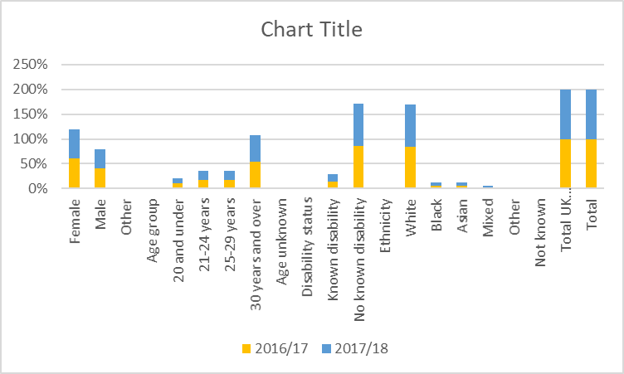
Fig 7
HESA, 2019

What can be done regarding the inequalities in student enrolment as seen in Fig 7? A meta-analysis conducted by Herbaut & Geven (2019) found that unmet financial needs showed to be a significant barrier to students and that financial aid (in the form of grants) was a statistically significant factor in graduation rates for disadvantaged students. It must be noted however, this study was conducted using USA and Canadian students, this does nevertheless show the impact of the financial burden for lower socioeconomic students in a HE system. Further research conducted by Braga et al (2013) found financial support (in grants) correlated with positively with educational mobility. The Financial strain of obtaining a degree for those from disadvantaged backgrounds is an issue which needs to be fully addressed, further reviews and changes to the funding system could also be on the horizon not only for Welsh Universities but all UK HEI’s.

The Augar review (2019) proposed taking the term of the loan from the current 25 years over to 40, this is 15 years longer than most mortgages, should the education system burden students with a 40-year debt? How will this impact the mature student who may not have 40 years of a career left? Currently in Wales, the repayment terms of student loans are devolved and so this recommendation may not affect the HE system in Wales, but that not maybe the case in the long term. The review also suggested a decrease in the threshold of earnings for the repayment which again would further the gap between the lower earning graduates and their higher earning peers, rather than the review being progressive in terms of widening HE access and participation this is in fact regressive and damaging to social mobility for graduates, is it likely that Wales would take up these recommendations? Universities Wales (2019) address the Diamond review, which is presently being implemented in Wales means that Welsh HE establishments offer progressive and inclusive support for students and the Augar review holds opposing recommendations. This may lead to confusion for students when selecting the Universities of choice, (which is in agreement with the original statement by Rees et al (2005, while 16 years old this is a key piece of educational governmental research, thus relevant to this body of research) this confusion and differences between the devolved countries will lead to inequality in HE education rather than the egalitarian vales that HE previously held.

There is a blurred line in the UK with what is and is not devolved with each of the UK countries and the HE system, and so this review could be damaging to Welsh students, especially when the Augar review has suggested a planned cut in fees to £7500, leaving Wales with the highest fees of £9000 (Rees, 2019). The reforms in the Welsh HE system from Sir Ian Diamonds’ review are even now in the process of being employed with recommendations in key areas 'The focus of undergraduate support should move towards improved maintenance support arrangements for all full-time and part-time undergraduate students, with the highest level of grant support covering the full cost of maintenance for those who are most in need, together with loans to cover tuition fees' (gov.wales,2018), this has had a positive impact on the enrolment numbers of FT mature students as undergraduates and post graduates in Wales, 2008/09 24,515 compared to 2017/18 26,025, however this was not the case for part time students who since the fee increase, has seen a steady decline in enrolments, 2008/09, 3,220 compared 2017/18, 2,505 (Stats Wales, 2020). Nevertheless, there has been a spike in the data for 2018/19 (3,645) which could be the direct consequence of the implementation of the grants (rather the loans) in Wales available to PT undergraduates, until the figures are released for the academic years 19/20 and 20/21 we will not know if there is a trend in the data set and the true impact the review has had in Wales, and this makes the Augar review even more consequential for Welsh students.

A shortfall in the fees could result in a deficit of the sector funding which was recommended by the diamond review and is currently in the embryotic stage of implementation. This leaves students from Wales with a stark choice if this recommendation is implemented, study in England and save £1500 a year so £4500 in total from a 25-year term debt (and the interest this entails) and receive less financial support in the short term or choose to stay within Wales and accept the larger fees. This will further decrease the choice for students in lower socioeconomic backgrounds who are already more vulnerable to debt and have a confounding impact when considering the other costs associated with studying such as housing and living costs. This would also disadvantage those who must stay local due to studying PT with a local University, due to work commitments and childcare needs. While education is seen as an investment since the reforms, not only for students but also industry, local economies, and HE establishments, it is also using a business model which has needed updating, restructuring and reform. The cost of HE is rising for students but the cost of providing education continue to rise and the funding sources are being eroded (Lapovsky, 2015). Financially, it can be seen that the HEI’s are benefiting from the enrolment of mature student at the cost of burdening students with debt so they are able to access the HE courses or undergraduate degrees, which will enable social mobility and changes to the labour market within the UK. It is important to also consider then the impact these financial changes will have on the overall economy of the UK.

HE and the knowledge-based economy
Higher Education in the UK has moved away from a ‘state-centric’ model over to the ‘Individual-centric’ model of financing (as discussed above), the implication of this change has far reaching impact not only for the prospect graduates but also the HEI’S. Higher Education is seen within the UK as a labour market resource and graduates can strengthen their place within the labour market which increases social status and reduces social inequalities for the next generation, thus HEI’s have a responsibility in attracting students from lower socioeconomic backgrounds to change the social landscape (Bjorn, 2017). It is important to give consideration to the value between HE graduates and the success of the economy with in the UK.
One of the fastest growing industries within the Western world is based on information ownership and knowledge. This sector is known as the economy of knowledge and initiated a shift in the labour market from production using industrialized manufacturing over to knowledge intensive activities linked to scientific, technological, and educational innovation. Globalisation was a driving force behind the new economic development within the 80’s & 90’s where the workforce was no longer based on muscle but on the mind (Toffler, 1990). Investment shifted to areas that generated knowledge such as research in all fields and the innovation of new infrastructure that support it (George, 2006). The UK Government identified the shift from industrial based production to knowledge intensive industries, as Vince Cable remarked in his 2014 speech, the UK’s mission is to establish the UK as a leader in the global knowledge economy. The European Union (EU) in 2002 established the aim of achieving a competitive rank in the worldwide market as a knowledge-based economy, thus setting an agenda for all western economies to make a shift in the infrastructure needed (Al-maadeed & Weerakkody, 2016). Gammage & Mininberg (2003) reference a country based in a knowledge economy means the wealth of a nation depends upon higher educated individuals, thus a higher education has never retained so much worth, however, has previous discussed the onus has now shifted from the Government to pay for the higher education (which is directly linked to the economic growth of the country) over to the individual who will enter a state of debt once graduated. This leaves the question of who is responsible for the economic development of a country? The citizens or the state? While this valid topic for further investigation and enquiry, however, due to the limited scope of this research this question must remain unanswered.
The economic development of any developed country depends upon many factors, however, one of the main areas is the Gross Dependant Product (GDP), comprised of the total value of goods, commodities, or services sold within a fiscal year (BBC, 2020). Research conducted by Valero and Reenan (2019) found a significant correlation (using data from 15,000 universities across 78 countries) between the growth of universities and growth of GDP per capita. How is the relevant to the mature students who wish to pursue an education in Wales? A 2018 report by Universities Wales showed over 5bn output from Welsh Universities and through services provided generated £544 million or equivalent of 4.1% of all exported Welsh goods. Not to mention the 49,216 jobs they created, thus demonstrating the prosperity of both the individual and the Welsh and UK economy. Similarly, a report from Universities UK (2014), showed that the UK H E sector generated £73 billion in output for 2011/12, which was 2.8% of the whole of the UK GDP. It is important to note here that the report also makes refences to the fact that less than half the overall income had come from public sources or funding. This reveals how the impact of the switch from grants to loans within the HE sector had made a difference to the overall gross profit of the HEI’S. Examination of the data from Higher Education Statistics agency for 2011-12 within the UK showed total GDP for Universities as £36.40 Billion (Universities UK, 2014, there is no current data available and so the researcher has decided to use the data available within the research but is aware of the age of the data set). This shows a significant correlation between students contributing to the overall Welsh and UK economy when pursuing a degree.
The development of the knowledge-based economy in areas such as information and communication technologies, new provision providers such private corporations, along with private HEI’s and institutions, and community colleges or the old poly-technical institutes drive a competitive marketplace for HE and this challenge the previously held privileged position of HE landscapes (Middlehurst, 2001; Gross Stein, 2007,). This is enabling further widening participation and giving access to those who may not have had the educational opportunity previously. With the success of the HEI’s in Wales and the increased GDP, further funding needs to be associated with students who are from lower socioeconomic backgrounds to ensure social change for the communities served by the HEI’s. Overall, the research covered suggested that the UK economy is a benefactor of the enrolments of mature students. It is important to also consider how the changes to the knowledge economy have been impacted by HEI’s in the UK.

The business model of HE
With all the reform of Higher Education and how it is now currently being funded, this has triggered challenges to the previously established models of governess to colleges and universities within the UK and more specifically in Wales. The cost of degrees has increased but the funding is further being eroded over time, this is impacting students and affecting participation rates (as previously discussed), prospective students are questioning the value (other than monetary) of a higher education due to the debt incurred for access and lack of prospects once graduated (Lapovsky, 2016). The switch from state funded to competitive business has seen some of the UK’s largest universities become some of the UK’s largest listed companies, and when compared to FTSE rankings HE is the largest industry within the UK (Corver, 2019). Especially when considering the three broad types, HEI’s, FE colleges and Alternative providers (AP’s) (Higher education sector report, 2018). Universities have faced the challenge of the loss of funding, with course fee increases and by becoming market leaders in recruitment of prospect students. Universities in Wales generate a competitive revenue (which is dependent on student enrolment and retainment) but being a successful business means changes to the operating structure and models previously used. Until the 21st C HEI’S remained largely insulated from the global marketisation with the main purpose being the creation of non-utilitarian expertise and scholars (Askehave, 2007; Kwong, 2000; Zhang, 2017). Universities not only educated the future workforce, generated, and disseminated knowledge and prepared alumni to be successful, but now they are profitable businesses with all the regulatory framework and executive position that corporations entail (Mckenna, 2018).
One of the main concerns to address here is the benefits of HE is not solely confined to a graduate and a loss of HE contributions to the wider society may have a long-term damaging impact to civilisation such as inequality, diversity, and Stem areas of research (Brown & Carasso, 2013). It is therefore essential that Universities adapt and establish new practices that enable the reconstruction of the socio-academic influences and offset the changes produced by the fiscal model (Shahnaz et al, 2019). Rutherford (2005) considered how Universities have changed into dominant consumer orientated corporations whose main objective to make money with productivity targets rather than serve the greater good of humanity through an enlightenment of knowledge. This has had a major impact upon some key functional areas within HE.
Universities are now being governed like conglomerates and some students view the gaining of a degree as no more than the purchasing of a commodity, the product being the graduation which comes at a high cost. Brown (2014) discusses the marketisation of Higher education through the introduction of the fee and loan model and suggests that a degree has become “a means to an end” the value of the degree switches to consuming education, rather than academic achievements. The extrinsic motivation of “owning a degree” while is no longer enough to secure to a lucrative position in society, it does still carry a level of societal approval and thus is sought after. While in intrinsic motivations of pursuing HE such as the desire to learn, explore and generate new knowledge are not directly profitable to the business model currently used within universities. There is a strong case to be made for HEI’s as service providers with students as consumers within the new model in HE, moving away from Universities as providing opportunities for social change and growth (Bunce, 2020). University branding is now commonplace, and while can be seen as oppositional to the purpose of knowledge (reducing education to a label), it is marketable, thus has commercial benefit, we only need to consider the success of Harvard, Oxford or Cambridge Universities to see the advantage of holding such a successful brand (Chapleo, 2005). Another aspect of H E as a business in the way in which it generates data upon its effectiveness and efficacy. The National Student Survey (NSS) gathers data sets relating to the student experience within each of the HEI’s in Wales (and UK), (Universities Wales, 2019). While the survey in theory encourages best practice and student satisfaction it aids in forming part of the competition agenda that each HEI’s hold for each other and is very limited in understanding the true nature of the student experience (due to being available for final year students only, so misses the students who have failed to complete). However, the survey promotes H E has a sellable product (the consumer ethos reinforces the notion of a degree has a commodity), performance measures of courses, staff and universities campuses drive competition for enrolments of prospective students for each of the HEI’S (Langan & Harris, 2019).
The cap for student enrolments is now longer an issue within the UK universities, thus enabling a larger number of students access to degrees than in previous years, so HEI’s can maximise income the admission rates have increased this however has caused many issues, especially for the students, such as larger class sizes, less access to teaching staff and fewer resources (Collini, 2018). There are some benefits such as stronger links to industry and feeder educational systems within each community, nonetheless, a large increase in numbers has put pressure on the students to be independent learners who may only see a tutor twice in an academic year (Sharpe, 2014), this can prove challenging for part time mature students (who as we know are enrolling in Welsh Universities in large numbers). The universities have always been selective in the process of admission, however since the profit margin depends upon enrolments, this process has been lowered and students are now being recruited with lower entry requirements or qualifications. This is causing an inequality within the student populations; prominent Universities recruit the higher standard students leaving lower-level universities with the shortfall in admission. One of the ways this challenge has been addressed is by providing foundation degrees (which is a four-year course rather than three adding an extra £9000 in fees). The data provided by the HESA 2003-4 showed an increase of 62% in enrolment numbers onto Foundation Degrees (FD) for the UK. This is of consequence to Welsh students as Wales has a smaller proportion of the prestigious Universities.
In Wales in 2005/06 saw 1,306 foundation degree student enrolments which made up 3.2% of all the undergraduates, 60% of this population were part time students and ¾ of this population were aged over 21, while 56% of the students were female. The most dominated area was South Wales HEI’s but was reported that all 10 HEI’s in Wales had enrolments upon FD (Report for Higher Education Funding Council for Wales (2007). While the FD would benefit students, who may not have reached the entry requirements for a full undergraduate degree they also hinder those who many already financially be at risk of debt and it adds that extra year onto the study framework. It does however raise the access and academic performance (for those who complete the full four years) for students from underserved populations (Curtis et al, 2017). The findings of the research suggest that HEI’s are benefactors of mature students returning to education, not only financially, but in terms of governance, quality assurance and adapting new methods of reaching students who may not have traditionally sought out a HE degree.

Discussions and Implications
In summary this body of research has found a difference in the enrolment patterns for FT and PT students in Wales both in the under 20’s population and over 25+. Part Time students only made up 4.2% of the overall admissions for under 20’s but this figure changes drastically for the over 21’s. Full time for rates for over 25-39 stands at 47.9% while Part Time rates stand at 52.1%, this shows clearly that whilst most of the Welsh national student population is under 20 and has chosen to study FT, mature students’ rates are high with FT enrolments but are higher for PT enrolments. Research from stats Wales 2018/19 showed PT males students 38% while females at 62%, so again the research shows a pattern emerging, which agreed with findings of full-time students by the department of education for academic year 17/18 females’ students made up 56% of the overall enrolments and Males only 44%. Further, research (London south bank University, 2005) suggested that students under 20 only had 1% with dependants, while those over 25 had 50% dependants and ¾ of the 50% were lone parents (It would be safe to assume this is made up from mostly females), which also agrees with the research from HEA (2015) finding that PT students had 39% dependants under 18. The research has also shown that student debt is increasing exponentially over the last few academic years (see fig 5.), thus, PT students 25+ are further at risk of being at a disadvantage when enrolling in a HE undergraduate course. However, it is important to not make generalised statements regarding the financial burden of HE on students from lower socioeconomic backgrounds, this body of research has been limited and lacks in the most current recent data sets for some of the enrolment figures or the original data sets before any analysis had been performed.
The burden of student debt for non-traditional students is (as discussed) a barrier and the research has found that financial insecurity is an issue faced by students from lower socioeconomic backgrounds. The research has observed links between the changes to the funding system from ‘state-centric’ to ‘Individual’ has increased the value of HEI’s and the overall GDP of the Welsh economy, but this comes at a cost which the students must bear. While the benefits of the new funding system for HEI’s are increased employment associated with the communities that are served by the HEI’s and the local economy, along with the development of new innovative technologies and knowledge dispersal, the cost has been passed onto the hopeful graduates (due to lack of government funding). The HEI’s are now in the process of changing the landscape of education from purveyors of social change through the acquisition of knowledge and the preparation of the labour market resources, (while there has always been an association between HE and the labour market success, the over saturation of graduates has changed the value placed upon the obtainment of a degree) to selling HE as a commodity, thus leaving those who wish to pursue HE with debt and lower chances of social mobility once graduated. In view of the research that has been considered in this report it must be noted that this study has been very limited, despite this, the findings do warrant further investigation as this debate is wide ranging and the impact for mature students has far reaching implications.
The study has begun the discussion in terms of who are the actual benefactors of a graduating mature student? It has discussed HEI’s as the benefactors, the UK economy as benefactors, and students as benefactors, most importantly it has considered society as being the main benefactor. It has discussed how student’s over 25+ are now returning to HE (especially females) and this is holds significant advancement to the social, cultural, and political implications associated with HE and the far-reaching benefits it holds for society. The main issue which has emerged from the research which needs to be addressed is that financial assistance may not be enough to attract non-traditional students from low socio-economic backgrounds and support is needed which focuses on the domains of social, psychological, economic, and cultural. The study has provided a unique picture of the educational system for the mature student in Wales and recommends that further deeper research linking the covered areas, using the most current data sets, and narrowing the focus solely on the student characteristics of mature student enrolments.

References

1. Adrett, N. (2006) Student Finance and Widening Participation in the British Isles: Common
Problems, Different Solutions. Institute for Education Policy Research.
2. Al-Maadeed, S. and Weerakkody V. (2016) The Determinants of Knowledge-based Economy Development at a National Level: A Conceptual Model driven from KBE Theoretical Paradox and Advanced Practices” The Electronic Journal of Knowledge Management ,14 (4) pp193-206, available at www.ejkm.com. (Accessed 30/12/2020).
3. Anderson, R. (2016) University fees in historical perspective. History and Policy. Available at http://www.historyandpolicy.org/policy-papers/papers/university-fees-in-historical-perspective (Accessed on 22/12/2020).
4. Askehave, I. (2007) The impact of marketization on higher education genres, The international student prospectus as a case in point. Discourse Studies, 9(6), 723–742. doi:10.1177/1461445607082576.
5. Augar, P. (2019) Independent panel report to the Review of Post-18 Education and Funding. Available at https://assets.publishing.service.gov.uk/government/uploads/system/uploads/attachment_data/file/805127/Review_of_post_18_education_and_funding.pdf (Accessed 14/12/2020).
6. Bilton, I. (2018) Women are outnumbering men at a record high in universities worldwide: Study International. Available at https://www.studyinternational.com/news/record-high-numbers-women-outnumbering-men-university-globally/ (Accessed on 11/12/2020).
7. BIS (Department for Business Innovation & Skills (2020). The future of universities in a knowledge economy. Available at https://www.ed.ac.uk/files/atoms/files/bis-higherambitions-summary-nov2009.pdf (Accessed on 17/12/2020).
8. Björn Högberg (2019) Educational policies and social inequality in well-being among young adults, British Journal of Sociology of Education, 40:5, 664-681, DOI: 10.1080/01425692.2019.1576119
9. Brage, M, Daniele , and Elena. (2013) “Educational Policies in a Long‐Run Perspective.” Economic Policy 28 (73): 45–100. doi:10.1111/1468-0327.12002
10. Brown, R. (2014) THE MARKETISATION OF HIGHER EDUCATION: ISSUES AND IRONIES. H E policy, (1), 1, pp 5-9. Available at www. Uwl.ac.uk. (Accessed 29/12/2020).
11. Brown, R. and Carasso, H. (2013) Everything for Sale? The Marketisation of UK Higher Education. London and New York: Routledge
12. Bunce, L. (2020) A degree of studying- students who treat education as a commodity. Available at https://blogs.lse.ac.uk/impactofsocialsciences/2020/01/15/a-degree-of-studying-students-who-treat-education-as-a-commodity-perform-worse-than-their-intrinsically-motivated-peers/ (Accessed 29/12/2020).
13. Cable, V. (2014) Innovation and the UK's knowledge economy. Transcript available at https://www.gov.uk/government/speeches/innovation-and-the-uks-knowledge-economy (Accessed on 23/12/2020).
14. Callender C. (2001) Term-time Working Among Full-time Undergraduate Students in the UK, London South Bank University.
15. Callender. C. and Jackson, J. (2008). Does the fear of debt constrain choice of university and subject of study? Studies in Higher Education, 33, (4), pp. 405- 429.
16. Cardiff University (2020). Funding available from Student Finance Wales (SFW) for starting a course in September 2020. Available at https://www.cardiff.ac.uk/study/undergraduate/funding/loans-and-grants/wales. (Accessed 14/12/2020).
17. Chapleo, C. (2005) Do Universities have “Successful” Brands. International Journal of Educational Advancement. 6 (1), pp. 54-64. Available at https://www.researchgate.net/publication/233712265_Do_Universities_Have_Successful_Brands (Accessed 29/12/2020).
18. Curtis, E, Wikaire, E, Jiang, Y, McMillan, l, Loto, R. (2017) Open to critique: predictive effects of academic outcomes from a bridging/foundation programme on first-year degree-level study, Assessment & Evaluation in Higher Education, 42:1, 151-167, DOI: 10.1080/02602938.2015.1087463
19. Francis, D, R. (2007) Why Do Women Outnumber Men in College? National Bureau of economic research, 1,. Available at https://www.nber.org/digest/jan07/why-do-women-outnumber-men-college (Accessed on 11/20/2020).
20. Gammage, D. and Mininberg, E. (2003) The Australian and American higher education:
Key issues of the first decade of the 21st century. Higher Education, 45, pp. 183–202.
21. George, E. (2006) ‘Positioning higher education for the knowledge based economy’, Higher Education, 52(4), pp. 589–610. doi: 10.1007/s10734-005-0955-0.
22. Gibb, A. (2010) Towards the entrepreneurial university. National Council for Graduate Entrepreneurship.
23. Gov. UK (2019). School leaving age. Available at https://www.gov.uk/know-when-you-can-leave-school (Accessed on 11/12/2020).
24. Gov. UK (2019). Student Finance. Available @ https://www.gov.uk/student-finance/new-fulltime-students (Accessed on 11/12/2020).
25. Gov. UK (2020). Widening participation in higher education. Available at https://explore-education-statistics.service.gov.uk/find-statistics/widening-participation-in-higher-education#releaseHeadlines-summary (Accessed 30/12/2020).
26. Gov.Wales (2018). Welsh Government response to the recommendations from the Review of Student Support and Higher Education Funding in Wales ('the Diamond Review'). Available @ https://gov.wales/sites/default/files/publications/2018-02/response-to-the-recommendations-from-the-review-of-student-support-and-higher-education-funding-in-wales.pdf (accessed on 14/12/2020).
27. Greenaway, D. and Haynes, M. (2003) ‘Funding higher education in the UK: the role of fees and loans’, The Economic Journal, 113, 485: F150–F166. Available at: http://dx.doi.org/10.1111/1468-0297.00102
28. Gross Stein, J. (2007) ‘What, why, and how? The university and public policy in a networked society’, In P. Axelrod, Knowledge matters: Essays in honor of Bernard J. Shapiro pp. 27–36. London: McGill-Queen’s Press.
29. HESA. (2019). Higher Education Student Statistics: UK, 2017/18 - Student numbers and characteristics. Available at https://www.hesa.ac.uk/news/17-01-2019/sb252-higher-education-student-statistics/numbers (accessed 17/12/2020).
30. Herbaut, E. and Geven, K. (2019) What Works to Reduce Inequalities in Higher Education? A Systematic Review of the (Quasi-)Experimental Literature on Outreach and Financial Aid. Available at https://hal.archives-ouvertes.fr/hal-02095249/document (Accessed 11/01/2021).
31. Houle, J. (2013) Disparities in Debt: Parents’ Socioeconomic Resources and Young Adult Student Loan Debt. Sociology of Education. 87 (1), pp. 53-69 DOI: 10.1177/0038040713512213.
32. Jarvis, P. (2012) The sociology of adult and continuing education. Routeledge: London.
33. Johnson, D. (2019). What Will It Take to Solve the Student Loan Crisis? Harvard Business Review. Available at https://hbr.org/2019/09/what-will-it-take-to-solve-the-student-loan-crisis (Accessed 11/12/2020).
34. Johnson, P. (2020). A bad time to graduate. Institute for Fiscal Studies. Available at https://www.ifs.org.uk/publications/14816 (Accessed 30/12/2020).
35. Kasworm, C. E. (2003) ‘Setting the Stage: Adults in Higher Education’, New Directions for Student Services, (102), p. 3. doi: 10.1002/ss.83.
36. Kwong, J. (2000) Introduction: Marketization and privatization in education. International Journal of Educational Development, 20(2), 87–92. doi:10.1016/S0738-0593(99)00060-7
37. Langan, A. and Harris, W. (2019) National student survey metrics: Where is the room for improvement? Higher Education, 78, pp. 175-1089. Available at https://link.springer.com/article/10.1007/s10734-019-00389-1 (Accessed on 29/12/2020).
38. Lapovsky, L. (2016) The Higher Education Business Model. CREF Institute. Available at www.tiaa-crefinstitute.org (Accessed 29/12/2020).
39. Lin, X. (2016) Barriers and Challenges of Female Adult Students Enrolled in Higher
Education: A Literature Review. Higher Education Studies; 6, (2) pp. 119-126. http://dx.doi.org/10.5539/hes.v6n2p119 (Accessed on 11/12/2020)
40. Lu, L. and Etzkowitz, H. (2008) Strategic challenges for creating knowledge-based innovation in China: transforming triple helix university-government-industry relations. Journal of Technology Management in China, 3, 5–11.
41. Mackendry, S. and Boyd, V. (2012) Defining the “Independent Learner” in UK Higher Education: Staff and Students’ Understanding of the Concept, International Journal of Teaching and Learning in Higher Education, 24 (2) pp. 209-220. doi: http://www.isetl.org/ijtlhe/ (Accessed on 13/12/2020).
42. Marks, A. (1999) ‘Really useful knowledge: the new vocationalism in higher education and its consequences for mature students’, British Journal of Educational Studies, 47(2), pp. 157–169. doi: 10.1111/1467-8527.00109. Available @ https://onlinelibrary.wiley.com/doi/epdf/10.1111/1467-8527.00109?saml_referrer (Accessed on 11/12/2020).
43. Marcucci, P. and Johnstone, D.B. (2007) ‘Tuition policies in a comparative perspective:
A theoretical and political rationales’, Journal of Higher Education Policy and Management, 1: 25–40.
44. Mckenna, S. (2018) Here are the Five signs that universities are turning into corporations. The Conversation (Academic Rigour). Available at https://theconversation.com/here-are-five-signs-that-universities-are-turning-into-corporations-93100 (Accessed 29/12/2020).
45. Middlehurst, R. (2001) ‘University challenges: Borderless higher education, today and
tomorrow’, Minerva, 39 (1), pp.3–26.
46. Mullen, F. (2010) Barriers to Widening Access to Higher Education. Available @ http://www.parliament.scot/Research%20briefings%20and%20fact%20sheets/SB_10-07.pdf (Accessed 30/12/2020).
47. National strategy for access and student success in HE. (2014). Department for Business, Innovation and Skills. Available at https://assets.publishing.service.gov.uk/government/uploads/system/uploads/attachment_data/file/299689/bis-14-516-national-strategy-for-access-and-student-success.pdf (Accessed on 11/01/2021).
48. Nuissl, E., & Sava, S. L. (2018) Reflexive competence of adult education professionals in political adult education. Form@re, 18(3), 237-249. doi:http://dx.doi.org/10.13128/formare-24192
49. ONS, (2019). Milestones: journeying into adulthood. Available at https://www.ons.gov.uk/peoplepopulationandcommunity/populationandmigration/populationestimates/articles/milestonesjourneyingintoadulthood/2019-02-18#:~:text=Age%2018%3A%20Legally%20an%20adult&text=From%20as%20young%20as%208,responsibility%20to%2012%20years%20old (Accessed 11/12/2020).
50. ONS, (2014). National life tables, UK: 2012 to 2014. Available at https://www.ons.gov.uk/peoplepopulationandcommunity/birthsdeathsandmarriages/lifeexpectancies/bulletins/nationallifetablesunitedkingdom/2015-09-23#life-expectancy-at-birth (Accessed 30/12/2020).
51. Report to the Higher Education Funding Council for Wales (2007). Study of the role of foundation degrees in Wales. Available at https://www.sqw.co.uk/files/9413/8712/1366/121.pdf (Accessed 29/12/2020).
52. Rees, K. (2019). What might the Augar review mean for Wales? WonkHE, Available at https://wonkhe.com/blogs/what-might-augar-mean-for-wales/ (Accessed on 14/12/2020).
53. Rees, T., Bell, D., Bruce, T., Davies, D., Humphreys, R., Jenson, G, McGinley, D., Reynolds, S., Richards, K., Singh, R., Smith, E., Williams, F., Woodall, M., and Wynne-Jones, E. (2005) Fair and Flexible Funding: A Welsh Model to Promote Quality and Access in Higher Education Final Report of An Independent Study into the Devolution of the Student Support System and Tuition Fee Regime in Wales (The Rees Review) Main Report, Cardiff: Welsh Assembly Government ISBN 0 7504 3657 3 pp pp 113 plus CD-ROM of appendices.
54. Stats Wales. (2020) National Statistics Student enrolments in Wales by age, level and mode of study. Available at https://statswales.gov.wales/Catalogue/Education-and-Skills/Post-16-Education-and-Training/Higher-Education/Students/Enrolments-at-Welsh-HEIs/enrolmentsatwelshheis-by-age-level-modeofstudy (Accessed on 11/12/2020).
55. Gilardi, S & Guglielmetti, C. (2011) University Life of Non-Traditional Students: Engagement Styles and Impact on Attrition, The Journal of Higher Education, 82:1, 33-53, DOI: 10.1080/00221546.2011.11779084
56. Stauverman, P. J, & Kuman, R., R. (2018) Adult Learning, Economic Growth and the
Distribution of Income, Economies, 6:11, 2-12, https://www.mdpi.com/2227-7099/6/1/11.
57. Taylor, C. & Gorard, S. (2004) Participation in Higher Education, Wales Report for the Independent Study into the Devolution of the Student Support System and Tuition Fee Regime.
58. Toffler, A. (1990) Powershift: Knowledge, wealth and violence at the edge of the 21st
century. New York: Bantam Books.
60. Universities Wales (2019) Statement from Universities Wales on the publication of the post-18 review of funding in England. Available at http://www.uniswales.ac.uk/augar-review/ (Accessed 14/12/2020).
61. Universities UK (2014) The impact of universities on the UK economy. Available at https://www.universitiesuk.ac.uk/policy-and-analysis/reports/Pages/impact-higher-education-institutions-uk-economy.aspx (Accessed 23/12/2020).
62. Universities UK. (2013) The power of part time : Review of part time mature higher education. Available at https://www.universitiesuk.ac.uk/policy-and-analysis/reports/Documents/2013/power-of-part-time.pdf (Accessed on 11/12/2020).
63. Urbano, D. and Guerrero, M. (2013) Entrepreneurial universities: socioeconomic impacts of academic entrepreneurship in a European context. Economic Development Quarterly, 27, 40–55.
64. Valeo, A. and Reenan, J. (2019) The economic impact of universities: Evidence from across the globe. Economics of Education Review. 68, PP 53-67. Available at https://www.sciencedirect.com/science/article/pii/S0272775718300414 (Accessed 29/12/2020).
65. Zhang, T. (2017) The marketization of higher education discourse: A genre analysis of university website homepages in China. Higher Education Studies, 7(3), 64. doi:10.5539/hes.v7n3p64

