Workplace Culture and its impact on Organisational Efficiency

BA (Hons) Management and Leadership-Skills for the Workplace

BMSK5005

Student Name: Riffet Parveen
Student Number: 1711891

Eric Osei

Submission Date:
8th November 2019

Executive summary
The following report is focused on Tesco as an organisation. The report will critically assess the culture and broader environment taking into consideration organisational ethical behaviour.

Contents

Introduction 4
1: External environmental analysis by using PESTLE analysis: 5
2. Analysis of internal context of the organisation using McKenzie’s 7s framework: 8
3: Ethical stance of organisation: 11
4: Comparison of organisation culture and its competitor: 12
5: recommendations to further enhance the organisations workplace culture in the future: 14
Conclusion: 15
References: 16

Table of Figures
Figure 1 4
Figure 2 4
Figure 3 6
Figure 4 8
Figure 5 10
Figure 6 13

Tesco’s workplace Culture and impact on organisational efficiency

Introduction
In this report, Tesco’s workplace culture and context will be discussed. The analyses will include an external environmental analysis through use of PESTLE and porters five forces. The internal context of the Tesco will be analysed using McKenzie’s 7s framework. Its ethical stance and the comparison of organisations culture to its competitor . Finally, recommendations will be drawn to further enhance the workplace culture in the future (Schein, 2004).
Tesco supermarket ownership style consists of several partners the structure is a corporate based structure. It consists of a board and 5 separate committees.
Figure 1
Tesco Corporate Governance Structure
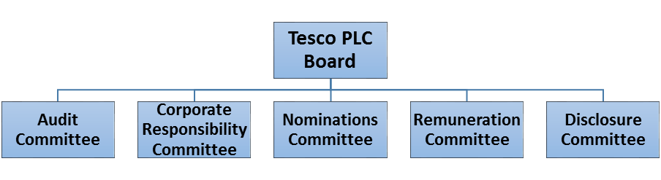
Within the organisation there are further sublevels that breakdown the way it operates.
Figure 2
Tesco organisational structure at store level
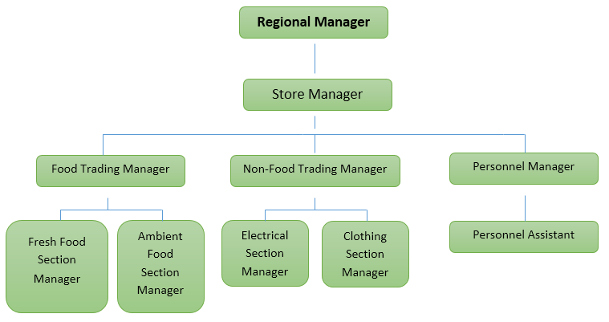

Any organisation that exists and functions to serve a purpose is affected by many factors that surround the outcome of its success or failure. Some of these factors can be macro environment: Political/ legal, Enviromntal, Culture, Echonomic, Nature, Demographics. Others factors can be from the micro environment: Immediatiries, suppliers, company, customers and competitors.
It is important to analyses these factors. PESTLE and McKensy’s 7S framework can provide detailed and valued information that can be used to overcome obstacles that potentially cause barriers towards the organisation serving its purpose.

1: External environmental analysis by using PESTLE analysis:
An external environment comprises of all the outside factors that affect the organisation operations (Global Powers of Retailing, 2010) to sustain its operations an organisation has to respond to these outside factors. They contain the following:
PESTLE analysis:
Through PESTLE analysis companies are able to know their competitiveness in the marketplace where they have to compete with many companies (Walden, 2011).
Political: As Tesco operates its business globally it faces many worldwide political issues. Social factors influence the company and the performance. The diverse Laws and legislation, taxes; country stability are the factors that influence the company performance and operations in different country or region (Walden, 2011).
Social: The market social environment, includes demographics, trends, cultural norms, analytics, and population etc. It includes social behaviour of Tesco Company as customer buying choices change; the companies, strategy needs to change with social trends for attracting more customers . Tesco has to identify areas where local population have high interest. For example, time of the year locals may be interested in festive foods (Walden, 2011).
Technological: It includes factors that influence the operations of the company related to technology and innovation. These technological tools are affecting the company performance to a greater extent. An example of this is the high rise in self-serve checkouts and online shopping. Tesco has changed overtime to cater for the change in technological advances (Walden, 2011).
Due to the computerisation, research & development and technological advancement in the marketplace puts the company in a fierce competition so, company should be aware of their technological advancement in order to compete with these factors. Tesco also offers its services online only due to the Technological innovation (Walden, 2011).
Legal: The certain laws and regulation affect the operation of the business. It includes laws, legislations and policies that influence the business environment of a certain country where that company operates its business for example safety and health standards, labour and consumer laws etc (Walden, 2011).
Environmental factors: Many companies are committed to avoid environmental issues and Tesco has initiated Corporate Social Responsibility campaign for resolving environment issues. Tesco launched its CSR campaign and by 2020 it is committed to decrease carbon footprint by 50 % (Towler, 2004).
Economical: Tesco financial performance such as the costs, profit, demand and price etc. So, company should be attentive about the changes in taxes rates, policies, and other factors that affect the accessibility of the finance (Walden, 2011). Tesco always be conscious to drop the prices and provide high quality goods and services to its customers. This is the reason they are successful in the market by offering their products at low a price and high quality and beat competitors (Mason, 2015).
Porter 5 forces:
Porters 5 forces are used for determining the organisational structure and its competition level. If there are a lot of organisations it means there is a strong competition between them therefore it is less profitable (Grundy, 2014).
Figure 3
Porters Five forces
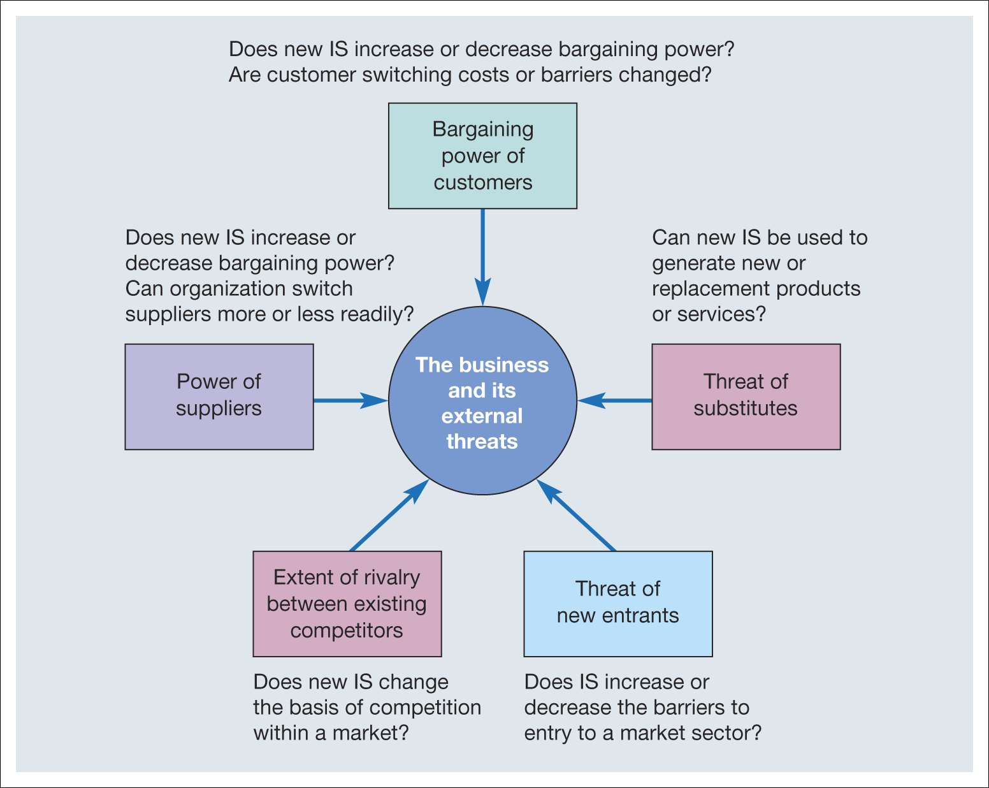

Paul BociJ, Andrew Greasley, Simon Hickie; Business Information Systems, 5th edn: Technology, Development and Management for the E-Business
Supplier power: Determining that how suppliers boost their prices easily. The supplier power directly influences the buying power of the organisations it has to pay more for materials (Grundy, 2014).
Tesco is very famous for its exceptional services to its customers store and also deliver cheaper supplies abroad and facilitate suppliers for negotiating prices that other stores cannot offer (Grundy, 2014).
Chief suppliers are afraid to do business with foreign suppliers as they have positive image of Tesco. Supplier’s power is strong when the following will occur:
- Supplier power is strong when there are small suppliers and numerous buyers.
- There are very little substitute of raw material available in the market.
- Suppliers having very inadequate resources available to them.
- Supplier are in great number and frighten to mix up (Grundy, 2014).
Barriers to enter: This force determines industry entry. If the industry is profitable but there are more barriers for entering high levels of competition from rival supermarkets. When more companies compete for the same market share their profit line shrinks so, in this situation it is vital for previous organisations for making high barriers for entering and to discourage new entrants. Tesco have many competitors like Sainsbury, Asda, and Cost cutter all of these superstores are earning high market shares however Tesco have made a high investment and have a strong place by implementing its forceful strategies and plans so, it is very tough to beat its position (Grundy, 2014).

Buyer’s power: When buyer’s power is strong it is easy to demand less price and high quality products from producers. Tesco have initiated many strategies to gain buyer power and introduce its club cards strategy etc that allows it to make more profits and also allow it to get an inclusive database for its customers. They are offering products that are standardised and undifferentiated of lesser cost having more power to pull more buyers towards it (Grundy, 2014).
Buyer’s power is strong when
- Little number of buyers exists in the industry.
- When trading at high level.
- The number of substitute are comparatively high.
- Buyers are price sensitive (Grundy, 2014).
Threat of substitutes: In this force buyers can easily discover substitute products with attractive prices in good quality. Consequently, this situation creates alarming situation for company’s survival. When customer sees an alternative product in another store with low price and good quality they switch over it so, Tesco have reduced their prices and also modify its range to avoid the threats of substitutes (Grundy, 2014).
Rivalry amongst existing competitors: This force assists in assessing the industry competitiveness and profitability. When industries are more competitive, it means there is a strong competition among them and organisation’s for a market share that lowers its profit. Tesco is very successful in the grocery business and have kept its strong image and position over its competitors like Asda, Sainsbury and cost cutter etc however Tesco is recognised by their supremacy as they are offering their exceptional services in this industry and not only providing employment but also produce quality products (Grundy, 2014).

2. Analysis of internal context of the organisation using McKenzie’s 7s framework:
McKinsey’s 7s framework is very effective approach for examine the various parts of the organisation. It also assists in improving the performance of the organisation to find out the ways for implementing a future strategy (Waterman, 1980).
Figure 4
McKinseys 7s framework
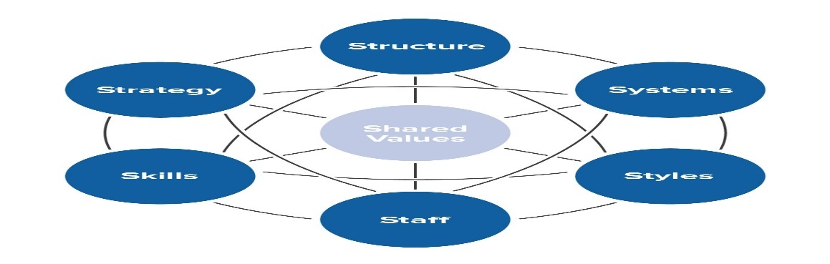
(Mindtools, 2019)
Strategy:
A strategy is a method used to gain competitive advantage over its rivals. This is the organisation's plan that it used for taking viable gain over its competitors. As Tesco business has adopted a cost leadership business strategy. Tesco has continued its strategy because of its wide use of the bargaining power in trading with its suppliers. Tesco has also used economies of scale so; it keeps this strategy (Waterman, 1980).
Structure: Structure can be described on how the organisation organises its departments to function. Tesco have maintained their hierarchical structure. They have a lot of management positions from sale person to CEO. They have a lot of branches as well working in different location (Waterman, 1980).
Systems: systems are considered the main areas for managerial focus as the determine how smoothly operations are run.
To run its every day operations, Tesco have implemented an extensive range of systems. Tesco have implemented an evaluation system for checking performance of employees through a performance evaluation system (Waterman, 1980).
Shared values: these are regarded as the guidelines and actions to set the standards. Tesco’s objective is to satisfy its customer by offering them quality goods and services. They have a strong belief in shared value for their company (Waterman, 1980).
Styles: style can be in the form of how the organisations interacts within, from the managers down to shop floor staff. Tesco have adopted a unique culture and style of doing business in which they not only take care of their employees and suppliers but also of their customers (Waterman, 1980).
Staff: in an organisation the workforce is hired through different forms, interviews, selection processes. Further the way in which they are trained and appraised for their performance also sets the internal context of organisations. can be crucial in getting the Tesco have hired a team of skilled workers and also giving those comforts, good salary package and also other reliefs (Waterman, 1980).
Skills: skills are the capabilities and strategies used to achieve the organisational goals. Tesco train and updated their staff by offering them good skills of doing work so, that they can able to work effectively and efficiently at workplace.

Explain impact on the performance of the organisation.
Tesco is a UK based global retail and supermarket. They have branches in many locations working not only locally but also internationally. They have a strong hierarchical organisational structure in which Tesco management have divided diverse positions for ensuring work with care and dedication (Organisational culture, 2019).
Company always care to advance its performance and providing care to its customers. They offer different merchandise at their store and to value their customers. They have also maintained the social and psychological culture of its organisation and also maintained good relationships with their staff, supplier’s and its customers. Their outstanding performance permits them to employing over 475,000 people at their company and also opened 6,500 stores at different locations (Nash, 2006).

Figure 5
Tesco’s Wheel
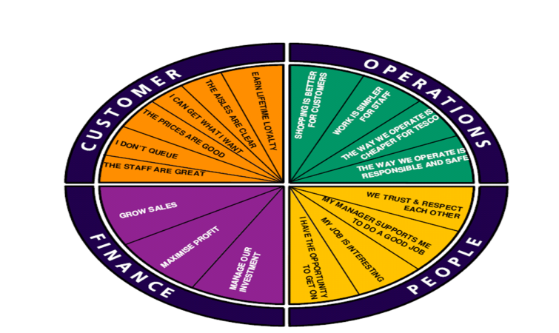
(Organisational culture, 2019)
Companies have to face many issues regarding its performance time by time so, to deliver its services accurately Tesco always takes care of its strategy and also started many programs to enhance its performance. Tesco has also started a framework of strategic performance management that is known as Corporate Steering Wheel. It is one of the strong tools that line up the company vision and mission. It also permits company to support its strategy and also checked that is properly checked and inspected on regular basis to maintain its position (Organisational culture, 2019).
It is necessary to take this type of framework so, that company’s performance can be checked on a regular basis, they can be updated and revised for reflecting the business environment. Tesco steering wheel assists the company according to the four perspectives regarding to its Finance, Operations, Customer, and People in which each perspective has a meaning and significance to fulfilling their strategic goals that not only highlight their concerns but deliver them on a timely basis (Organisational culture, 2019).
To keep performance up to the mark Tesco revived and modernised its framework repeatedly not only the individual goals but also for the full perspectives for the entire organisation. There are a lot of companies that have performance framework but they do not update and change them on a regular basis even when a change is required that may damage the company performance and fail to progress. Tesco have also launched the key performance indicator (KPI) that assists the company to observe its progress for its long term goals. This scale is also used for evaluating company success (Humby, 2006).

3: Ethical stance of organisation:

Companies are conscious to have a good ethical stance of their business. Companies should create a better environment for raising an ethical organisation. They must focus towards their employees and train them to better increase their manners, ethics and morals of their staff members. Tesco have always sought to have strong culture and ethical environment. Tesco always preferred a strong image of its food items and non-food items for its customer’s to offer quality in its everything for example in range, price, atmosphere and services. For example when Tesco started its business in china they have faced many ethical issues but its ethics stack up and sustain the company from those challenges (Vendemiati, 2004).

Tesco is a founder member of Ethical Trading Initiative (ETI). They use ETI code to choose the freedom of association, freely chosen employment, and the right to bargain collectively. They take care of all services linked to food sanitary, child labor and wages to their employees in timely manner. They offer the work regularly and they use no discrimination and their working hours are not too much. They have efficiently managed the Fair Trade assurance for their farmers. They are committed to keep data protection act 1998 and stoutly faithful for keeping up their information private and should not sell it to third party (Vendemiati, 2004).
Tesco values its business and introducing their busbies since many years. They value their culture and they have kept up the Tesco culture in a such a way that every person at the store is able to distinguish its importance. All the staff at Tesco work with teamwork and collaboration so, that they are able to enliven their external and internal environment and fulfill the needs of their customers. According to the need of the customers and always more and more customer are attract towards it due to their unique culture, compassion and ethical behavior (Vendemiati, 2004).

4: Comparison of organisation culture and its competitor:

Workplace culture is the characteristics or personality the organisation has built. The culture makes any organisation unique. Some factors that impact the culture within a organisation can be seen as organisational values, beliefs, traditions behaviours and attitudes.

Cultural web Analyses

Johnsons cultural web is a modal used to clarify different elements of organisational culture.

Stories – connected to organisation history. They can be based on opinions and past events The past events and people talked about inside and outside the company.

Rituals and Routines – this is the behaviour and norms set in the organisation.

Symbols – the image the organisation sets out. This can be the colour and themes that are used to attract an opinion.

Organizational Structure – the organisational layout and how it operates.

Control Systems – this is systems such as stock control. Data that may contain details of sales and services.

Power Structures – can be seen as the way in which the company is managed. Ie supervisors, managers, executives or departments (Mindtools, 2019).

Tesco have maintained their organisation culture and offering a unique set of services to their customers so; they have more ability to vie their competitors. Due to the globalisation more organisations are emerging globally offering their services due to which there is a vast competition among them, but Tesco’s diversification strategy, tactics and planning have more capability of offering a value added services, cost benefit and greater value of products and services to its customers compared to its competitors (Mason, 2015).
Tesco have a famous brand name that not only makes more wealth for its buyers but also make high market sale for its services for example grocery, clothing etc. because these items have competitive pricing that facilitate higher profit and fulfil demand of demand of its customers more easily than its competitors.
One of Tesco’s main competitors is Sainsbury’s they share some similarities in organisational culture, such as:
Figure 6

Cultural Web

Cultural Web | Sainsbury | Tesco
Stories | Founded in 1869.  Grocery retailer in Victorian era. | Established in 1919.  Started as a market stall.
Rituals and routines | Trusted retailer where people love to work and shop. | Devoted to fulfilling staff potential.
symbols | Orange, blue walls and grey shelves. | Tesco’s Steering wheel  (Illustrated above)
Organizational structure | Hierarchy, different levels of responsibility. | Divided in2 parts has a board of directors and executive comittee
Control Systems | Corporate governance | Follow good governance practice.
Power Structures | Have various layers chief executives, operating boards, managers etc. | Applies Talent and planning whilst employing.

5: recommendations to further enhance the organisations workplace culture in the future:
Tesco is a big UK grocery store that has kept its position among the top retail stores and always tries to achieve its goals by providing a high class services and amenities to its customers. Beside all these services Tesco lack in some areas and is unsuccessful to control and monitor those areas well. This situation is not only painful and destroys brand image but also there is threat of losing customers. Therefore they need to correct all flaws in order to maintain its position among the giant companies (Mason, 2015).
Recommendations:
- Tesco is a global company that is the reason they are always committed to launching their new store at diverse locations local and overseas. In 2012, they have opened their stores in Japan and America but soon they failed to create their image among their giant companies. They were unsuccessful and closed their stores and also were unable to attract customers. I recommend Tesco to do deep market research and update their strategy before going to the foreign markets like America and Japan as these countries have already chain of successful stores that required high research and development strategy to implement to attract customer, maintain their position, enhance market share and also to offer high quality goods and services to its customers for keeping their brand image (Mason, 2015).

- In the past Tesco is familiar for its outstanding services for its customers. They are offering their offers and promotion for their customers time by time. I recommend Tesco to offer extra services for their customers for example to enhance and provide good health services for old, young and children male and female. They should offer free eye, blood pressure and diabetes, check-ups. They should launch campaigns to attract more customers towards them and also to enhance their contribution for wellbeing of humanity (Schein, 2004).

- Tesco have always paid its high concerns to enhance its store culture for attracting its customer and also to compete with its competitors. But I recommend that Tesco should enhance its commitment to clear and clean the environment hazards. They should initiate CSR campaigns on a great level and also ban the plastic bags to decrease the toxin from the environment. They should start on the go green campaign for decreasing the pollution from surroundings (Schein, 2004).

Conclusion:
Tesco is a large superstore working globally. With the help of an external and internal environmental analysis company can judge its present working and also maintain its future working position. Every company when it comes in a market it have to face a lot of competitors at this situation only company strong strategy and marketing plans save its working position. So, time by time Tesco look over its policies, strategy so, that the working position remains strong and lively and more and more customer drag towards it. Company also take proper care of its innovation and technological needs for its company (Mason, 2015).

The External and internal environmental factors tells the internal and external picture of the company. It helps to turnout flaws and to keep them properly, organized and maintained. It is conclude that Tesco aim is to keep a strong culture in retailing business and offer its services outstandingly (Mason, 2015). They offer an extraordinary variety of all types for its customers according to their choices to attract them toward their store. They not only follow ethics, moral and principles but also follow trends, styles and economical choices for their customers so, that they can enjoy to shop from their stores (Mason, 2015).
Companies offer quality services high range of product and services with reasonable price range to gain customer loyalty. This is only possible when companies are committed and devoted to offer high value for their customers and they make clear that their primary focus is its customers (Schein, 2004).

References:
Mason, Robert; Evans, Barry (2015). The Lean Supply Chain: Managing the Challenge at Tesco. Kogan Page. p. 32. ISBN 9780749472085.
Schein,Edgar H,(2004). Organizational culture and leadership (3rd ed).San Francisco: Jossey-Bass pp.26-33.ISBN 0787968455. OCLC 54407721
Organizational culture Busnissdictioanry.com Retrieved 2019-08-11
"Global Powers of Retailing 2010" (PDF). Deloitte. Archived from the original (PDF) on 9 November 2012. Retrieved 18 August 2010.
Humby, Clive; Hunt, Terry; Phillips, Tim (2006). Scoring points: How Tesco continues to win customer loyalty. London & Philadelphia: Kogan Page. ISBN 978-0-7494-4752-6.

Mind Tools Content Team, 2019. mindtools. [Online]
Available at: https://www.mindtools.com/pages/article/newSTR_90.
[Accessed 7 November 2018].

Nash, Bethany (2006). Fair-Trade and the growth of ethical consumerism within the mainstream: an investigation into the Tesco consumer. Leeds: University of Leeds. OCLC 75272130.
Walden J. (2011), Comparison of the STEEPLE Strategy Methodology and the Department of Defense’s PMESII-PT Methodology, Supply Chain Leadership Institute, accessed 10 February 2019
Grundy, Tom. "Rethinking and Reinventing Porter's Five Forces Model" (PDF). WileyInterScience. Retrieved 15 October 2014.
Waterman, R. H., Peters, T. J., & Phillips, J. R. (1980). Structure is not organization. Business Horizons, 23(3), 14-26.
Vendemiati, Aldo, In the First Person, An Outline of General Ethics, Rome, Urbaniana University Press, 2004.
Towler,A.B. (2004) Department of Business & Professional Studies, Guildford College Available at:
https://www.researchgate.net/publication/249362976_A_comparative_study_of_contents_of_corporate_social_responsibility_reports_of_UK_companies

