Samuel Ford

Task 1. E-Commerce Website Builders and Software Solutions

1.1 WooCommerce
WooCommerce is a free, open-source plugin that turns an ordinary WordPress site into a fully functioning online store. It is used by businesses of all sizes to sell physical products, digital downloads and subscriptions, and it covers the core mechanics of running a shop: product listings, inventory, secure checkout, order processing and shipping [1]. Because the plugin sits on top of WordPress rather than a closed hosted system, store owners keep full ownership of their site and their data, and can adapt almost every part of the build to their own needs.
The main appeal of WooCommerce is the degree of control it hands to the user. Rather than being locked into a single vendor's ecosystem, owners can choose their own host, add whichever payment gateways suit them, and extend the store with themes and add-ons covering everything from marketing automation to subscription billing. This openness is repeatedly cited as WooCommerce's defining strength, particularly for businesses that expect to outgrow a template-based storefront [2]. Running on WordPress also gives stores a head start on search visibility, since the underlying CMS is already well optimised for SEO.
That same openness comes at a cost, however. WooCommerce needs its own hosting, and the owner is responsible for keeping it secure, backed up and updated. Reviews of the platform consistently note that as a store adds more third-party extensions, the site becomes harder to maintain and more prone to plugin conflicts and performance issues [2], and many of the most useful features, such as advanced shipping rules or abandoned-cart recovery, only come through paid extensions, so total cost and technical overhead both rise as a store grows.

1.2 Wix
Wix takes the opposite approach: it is a fully hosted, software-as-a-service website builder, so there is nothing to install and nothing to patch. It is built around a drag-and-drop editor and a large library of ready-made templates, which makes it approachable for someone with no coding background. On the commerce side it covers the essentials, product catalogues, integrated payments, order tracking, stock management and mobile-friendly storefronts, all managed from one dashboard [3], which suits smaller retailers who want to be trading quickly.
Because Wix looks after hosting, security patching and uptime on the user's behalf, store owners are freed from most of the technical upkeep that a self-hosted platform demands, and can spend that time on design, marketing and sales instead. Built-in SEO tools, analytics and marketing add-ons are included as standard, and the platform is regularly highlighted for how quickly a workable store can be launched compared with open-source alternatives [3].
The trade-off is flexibility. Because the code underneath a Wix site is not accessible to the user, customisation stops at whatever the editor and app market allow, and independent reviews note that this can become limiting once a business needs bespoke functionality or expects to scale significantly [4]. The more advanced commerce features, such as multi-currency selling or higher product limits, also sit behind pricier subscription tiers, so costs climb in step with a store's ambitions.

Task 2. Mind-Map of Contemporary Software Applications

Mind mapping and its benefits in business operations
Mind mapping is a visual note-taking method built around a single central idea, from which related themes branch outward and can be broken down further into sub-branches as the topic gets more detailed. Colour, imagery and short keywords are used along each branch to make the connections between ideas easy to follow at a glance. Because the layout mirrors the associative way the brain naturally organises information, mind maps are widely used as a study, planning and problem-solving aid [6], and a controlled study of the technique found it produced a measurable improvement in recall compared with conventional linear notes [5].
In a business setting, mind mapping is most often reached for during planning and idea generation. Unlike a written list, which tends to fix ideas in a rigid order, a mind map lets contributors add, move and connect thoughts freely as a session develops, which keeps a brainstorm open-ended and encourages the group to build on each other's suggestions rather than settling too quickly on one option [7].
Mind maps also bring order to otherwise unwieldy processes. Activities such as strategic planning, project scoping or workflow design involve many moving parts, and a mind map lets a manager break the overall goal into smaller branches while still keeping the connection back to the central objective visible, which makes it easier to prioritise tasks and allocate resources sensibly [6].
A further benefit is in communication. A diagram is generally quicker to absorb than a page of prose, which matters most where a meeting brings together people from different departments with different levels of background knowledge; mind maps are commonly used in exactly this kind of session to get everyone aligned on objectives and next steps [7].
Finally, mind mapping supports structured problem-solving. Laying out a problem alongside its likely causes and possible responses gives a manager a clearer view of the whole issue rather than just the part currently under discussion, and research into visual note-taking methods links this kind of structured layout to stronger comprehension and longer-lasting recall [5], which is particularly useful when a team is working through something complicated or planning several steps ahead. Taken together, these benefits make mind mapping a lightweight but genuinely useful tool across planning, communication and decision-making in modern business settings.
Mind map of contemporary software applications
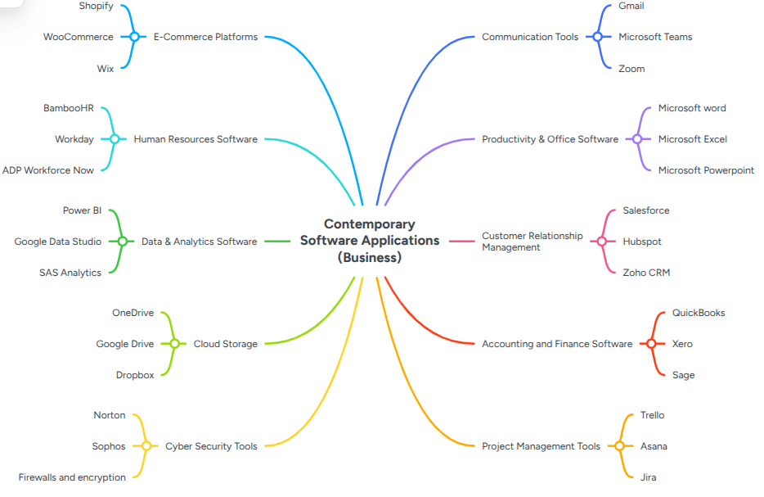

Task 3. Office Applications

Four office software solutions for business operations

MS Word
Microsoft Word is the office suite's core word-processing application and remains the standard tool for producing business documents, reports, contracts, proposals, policies and correspondence.
At its core, Word provides a full set of formatting tools, styles, headings, tables, headers and footers, page numbering, footnotes and referencing, that keep organisational documents consistent and professional in appearance. Built-in templates speed this up further by standardising the layout of routine business documents such as reports and formal letters.
Collaboration is one of Word's stronger features. Once a document is saved to a cloud location such as OneDrive or SharePoint, several people can co-author it in real time, and every change stays attached to its author through Track Changes and threaded comments, so nothing gets lost in the edit [8]. This matters for organisations whose staff are spread across sites or working remotely, since it removes much of the need to circulate drafts by email and reduces the version-control confusion that a long email chain tends to create [9]. Word also links up with the rest of the Office suite, embedding Excel tables and charts, running mail merges from Excel or Outlook data, and exporting to PDF for secure sharing.
Word's advantages in a business setting largely come from how familiar it already is. Because most employees have used it before, training costs are low, and its wide device and platform compatibility means documents can be shared externally with minimal formatting problems. Built-in spelling, grammar and style checking further reduce errors in business writing and help maintain a consistent professional tone.
It does have limits, though. Word is not designed to handle large volumes of structured data or complex analysis, tasks that sit more naturally with spreadsheet or database software. Long documents with several contributors can still run into version-control problems if there is no clear process for managing edits, and heavy use of advanced formatting can break when a file is opened on a different device or Word version. Newer AI-assisted writing tools can speed things up but are also capable of introducing inaccuracies, so their output still needs to be checked, especially on anything contractual or legally binding.
Overall, Word remains a dependable, widely adopted tool for professional document production and collaborative editing, though it works best as part of a broader office toolkit rather than on its own.

MS PowerPoint
Microsoft PowerPoint is the suite's presentation tool, used across business for briefings, pitches, training sessions and meeting materials. It builds structured, visual presentations by combining text, images, charts and other media across a sequence of slides, which makes it easier to convey complex ideas to an audience than a written report would [10].
One of its main strengths is the range of design and layout options on offer. Splitting content into individual slides, each covering one point, keeps a presentation easy to follow, and built-in themes and layouts help maintain a consistent, professionally branded look throughout. Text, images, tables and charts can all be formatted to present business information clearly.
PowerPoint also supports audio, video, animation and slide transitions, and used well these can hold an audience's attention and reinforce the key points of a talk; industry surveys on presentation habits suggest well over half of business presenters rely on this kind of multimedia support for in-person pitches [10], and separate research on presentation retention indicates that visual material is remembered considerably better than text-only slides [11].
Collaboration and delivery are further strengths. Presentations saved to OneDrive or SharePoint support real-time co-authoring, which cuts down on the back-and-forth of emailing files between contributors, an increasingly relevant benefit for teams that are not all in the same office. Presenter View lets a speaker see their notes and the next slide while the audience only sees the current one, and the software works equally well for in-person talks and remote or hybrid meetings.
For a business, PowerPoint's main benefit is making it easier to communicate strategy, data and complex ideas without losing an audience along the way. Because so many employees already know how to use it, training costs are minimal, and it integrates neatly with the rest of Office, for instance by embedding an Excel chart directly into a slide, keeping business materials consistent across formats.
Its limitations mostly come down to how it is used rather than what it can do. A slide deck that is overloaded with text or runs to too many slides will lose an audience regardless of how polished it looks, so a presentation's success still rests heavily on the presenter's design choices and delivery. PowerPoint is also poorly suited to detailed documentation or in-depth data analysis, and, like other cloud-based Office files, shared decks can run into version-control issues if they are not managed carefully.
In short, PowerPoint is an effective communication tool for business, but getting real value from it depends on thoughtful slide design as much as the software itself.

MS Excel
Microsoft Excel is the third application covered here, and it supports business operations by organising, calculating and presenting data. It is used routinely for budgeting, accounting, sales analysis, forecasting and inventory tracking.
As a spreadsheet application, Excel arranges data into rows and columns, which makes large volumes of information much easier to manage and interpret, and its flexibility means the same tool works for everyday tasks and for more advanced analysis across departments.
Its calculation engine is arguably its most important feature. Excel provides a wide range of mathematical, statistical, logical and financial functions that automate work a person would otherwise do by hand, and tools such as cell referencing, conditional formatting and data validation help keep that work accurate. PivotTables and PivotCharts go further still, letting large datasets be summarised, filtered and explored in ways that support real decision-making.
Excel is also strong on visualisation and integration. Charts, graphs and dashboards let managers track key metrics visually, and because Excel sits inside the wider Office suite, those charts can be dropped straight into a Word report or a PowerPoint deck. Cloud-based sharing also lets several people work on the same workbook while Excel keeps a version history of what changed.
The benefits for a business are considerable: automating repetitive calculations cuts down on manual effort and the errors that come with it, and the ability to analyse historical data and spot trends supports better forecasting and more informed decisions. Given how many business processes touch a spreadsheet at some point, Excel remains one of the most heavily used tools in any office.
Even so, Excel has well-documented weaknesses. A peer-reviewed study of operational spreadsheets found that formula errors are common and tend to compound as a workbook grows in size and complexity, rather than being rare or isolated mistakes [12]. The consequences are not just theoretical: a single mismatched formula or copy-paste error in a live spreadsheet has been linked to budget miscalculations and financial reporting errors running into the millions in real organisations [13]. Excel is also not built for very large or genuinely relational datasets, and, like other Office files, is vulnerable to version-control problems when shared without clear rules around who edits what.
In summary, Excel's analytical and visualisation capabilities make it a genuinely powerful business tool, but the risk of quiet, compounding errors means it needs proper review processes around it rather than being trusted blindly.

MS Access
Microsoft Access is the database component of the Office suite. As a database management system, it is built to handle larger volumes of related data than a spreadsheet comfortably can, which makes it a good fit for small and medium-sized businesses that need structured storage and retrieval.
What sets Access apart from a tool like Excel is that it is a genuinely relational database: multiple tables can be linked through primary and foreign keys, which cuts down on duplicated data and keeps information consistent across the whole system. Once set up, that data can be searched, sorted, filtered and queried far more precisely than a flat spreadsheet allows [14], and modern Access no longer requires deep technical expertise to get this kind of structure working.
Forms and reports are two of Access's more practical features. Forms give staff a straightforward, guided way to enter and update records without needing to understand the underlying tables, while reports let an organisation turn that stored data into invoices, summaries or management information at the click of a button [15]. Access also integrates with the rest of Office, so data can move between Access, Excel, Word and Outlook without much friction [16].
For businesses working with structured records, customers, inventory, orders, Access is markedly more efficient than trying to manage the same information in a spreadsheet, and that advantage grows once several people need to work with the data at once or the dataset gets larger. On top of the accuracy that its table structures enforce, Access also offers stronger built-in security than a typical spreadsheet, including user-level permissions, which makes it a reasonable choice for a small business or department that needs its own database without the cost of a full database server [14].
That said, Access is not intended for very large databases or for large numbers of simultaneous users, situations better handled by systems such as SQL Server. It is reasonably easy to pick up, but a more elaborate build still needs some understanding of database design, and a poorly structured database can create ongoing maintenance headaches. Because it is primarily a desktop application, Access is also less scalable than a fully web-based database platform.
Overall, Access is a strong option for structured business data at small to medium scale, though organisations do need to weigh its limits on size, concurrent users and scalability before committing to it long-term.

Task 4. Communication and Collaboration Applications

a. MS Outlook
Microsoft Outlook is the Office suite's email and personal-information manager, and it functions as the main hub for business communication, bringing email, calendar, contacts and task lists together in a single application rather than several separate tools [17].
Its email tools go well beyond sending and receiving messages. Users can format messages, attach files or even calendar details and contact cards, and set up rules that automatically sort, flag or file incoming mail based on its sender or subject, which keeps a busy inbox manageable without constant manual sorting [18]. The calendar side is just as central to business use: it lets staff schedule meetings, check colleagues' availability before booking a slot, set reminders and manage more than one calendar at once, which cuts down on the double-booking and back-and-forth that scheduling by email tends to create [17].
Outlook's business value comes largely from how tightly it sits inside the Microsoft 365 ecosystem. It links directly with SharePoint, so an email can be saved straight to a team site, and with Teams, so a meeting booked in Outlook shows up automatically with its chat and files attached. Security is also built in as standard, with data-loss prevention and encryption protecting sensitive business correspondence [17]. Because most staff already know the interface from personal use, adoption tends to be quick and training costs low.
The main drawback is one of volume rather than function: as a business grows, inboxes and shared calendars can become cluttered, and without good rule-setting or folder discipline, important messages are easy to miss. Outlook is also primarily built around asynchronous communication, so businesses needing fast, real-time discussion often pair it with a tool such as Teams rather than relying on email alone.

b. MS Teams
Microsoft Teams is the Office suite's communication and collaboration platform, combining chat, channels, video calls and document sharing in one place so that a team's conversations and files stay together instead of being scattered across email and separate apps [19].
Its core structure is built around channels and chat. Channels group ongoing project or department discussions so anyone can catch up on the history, while one-to-one and small-group chat handles quick decisions that do not need a full channel post. Meetings can be scheduled directly from Teams or Outlook, and once underway they support screen sharing, live captions and shared notes, keeping the discussion and its outcomes in the same place [19].
For a business, the main benefit is fewer fragmented conversations. Bringing calls, chat and document collaboration into a single platform reduces the volume of internal email and shortens the time it takes to get a decision made, which matters most for organisations with staff working across sites or time zones. Internal reviews of Teams adoption have reported that a clear majority of staff felt the platform improved how effectively their teams worked together after switching to it [20]. Its tight integration with Word, Excel and PowerPoint also means files can be co-authored directly inside a chat or channel rather than being emailed back and forth as attachments.
The trade-off is that a platform this central can generate its own noise: constant notifications across many channels and chats can fragment attention rather than focus it, and without agreed norms around when to use a channel post, a chat message or a meeting, Teams can end up adding to a business's communication load instead of simplifying it.

Practical demonstration of two office features

Mail Merge

IF Function
The following shows the budget for a business trip and illustrates how companies can use the IF function to help track business expenses.
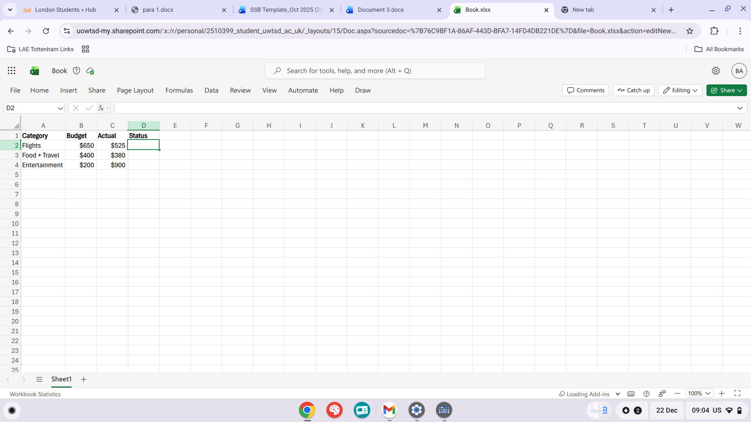
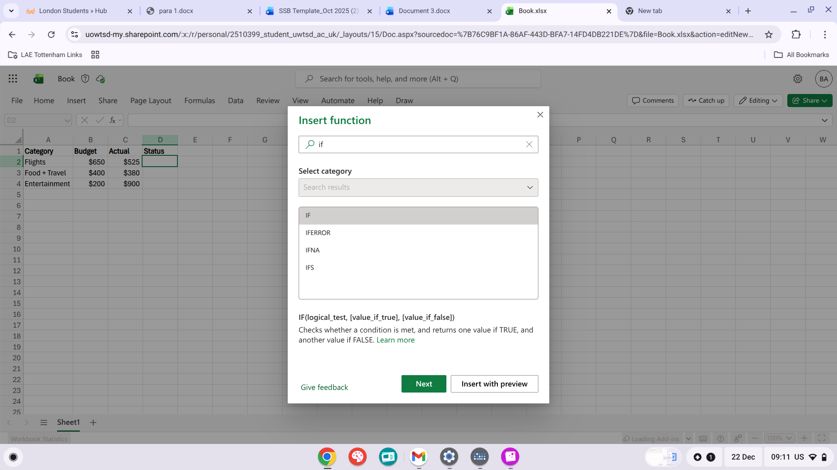
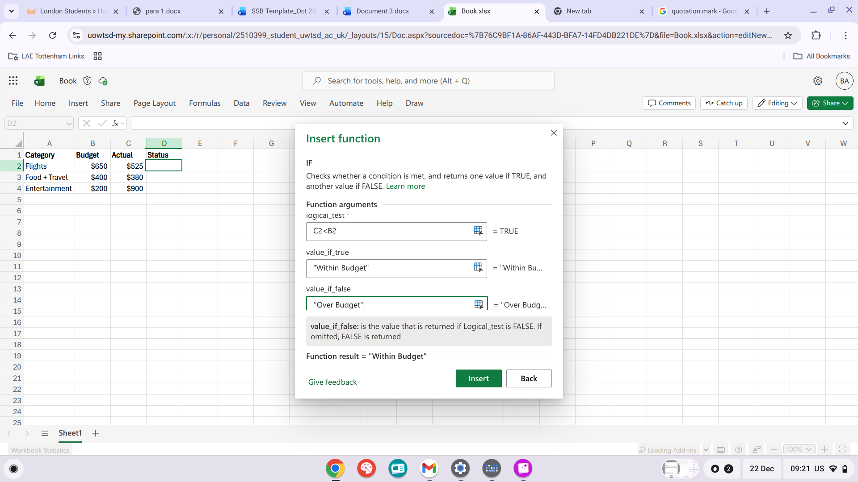
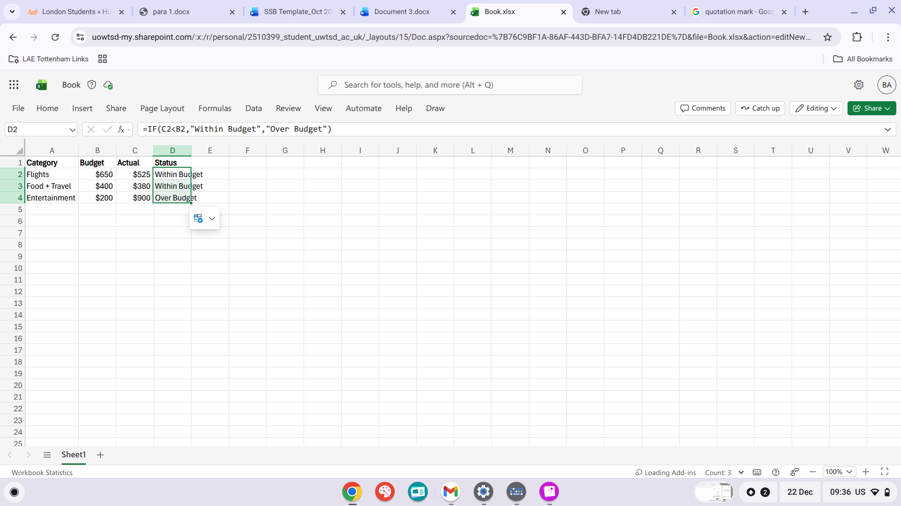

References
[1] WooCommerce, "WooCommerce," 2026. [Online]. Available: https://woocommerce.com/
[2] StackPlan, "WooCommerce is an open-source e-commerce plugin for WordPress," 2025. [Online]. Available: https://stackplan.com/woocommerce/
[3] FireBear Studio, "Wix ecommerce: is Wix good for ecommerce in 2026?," 2026. [Online]. Available: https://firebearstudio.com/blog/what-is-wix.html
[4] Enzuzo, "Pros and cons of using Wix — 13 factors to consider (2026)," 2026. [Online]. Available: https://www.enzuzo.com/blog/pros-and-cons-of-using-wix
[5] C. Farrand, F. Hussain, and E. Hennessy, "The efficacy of the 'mind map' study technique," Medical Education, vol. 36, no. 5, pp. 426-431, 2002.
[6] Atlassian, "How to do mind mapping: effective brainstorming tips," 2026. [Online]. Available: https://www.atlassian.com/work-management/project-management/mind-mapping
[7] Lucid Software, "The benefits of mind mapping, backed by scientific evidence," 2024. [Online]. Available: https://lucid.co/blog/benefits-mind-mapping
[8] Microsoft, "How teams can collaborate securely in Microsoft Word," Microsoft Word Blog, 2026. [Online]. Available: https://word.cloud.microsoft/create/en/blog/document-collaboration-in-word/
[9] Vevo Digital, "Microsoft Word collaboration features: complete guide," 2026. [Online]. Available: https://www.vevodigital.com/microsoft-word-collaboration-features-complete-guide/
[10] SketchBubble, "Fascinating PowerPoint statistics to amaze you," 2025. [Online]. Available: https://www.sketchbubble.com/blog/fascinating-powerpoint-statistics-to-amaze-you/
[11] Visme, "23 presentation statistics you should know in 2026," 2025. [Online]. Available: https://visme.co/blog/presentation-statistics/
[12] S. G. Powell, K. R. Baker, and B. Lawson, "Errors in operational spreadsheets," Journal of Organizational and End User Computing, vol. 21, no. 3, pp. 24-36, 2009.
[13] Webexpenses, "The business risks of using Excel spreadsheets," 2024. [Online]. Available: https://www.webexpenses.com/us/blog/tools-tips/financial-fails-business-risks-spreadsheets/
[14] The Knowledge Academy, "How to use Microsoft Access for your small business," 2025. [Online]. Available: https://www.theknowledgeacademy.com/blog/microsoft-access-for-small-business/
[15] Mallette, "What is Microsoft Access," 2026. [Online]. Available: https://www.mallette.ca/en/tips/what-is-microsoft-access
[16] Zenzero, "What is Microsoft Access used for?," 2025. [Online]. Available: https://zenzero.co.uk/news/what-is-microsoft-access-used-for
[17] Neo, "Outlook business email: pricing, features & account creation process," 2026. [Online]. Available: https://www.neo.space/blog/outlook-for-business-email
[18] Charles IT, "Outlook business email: see what it can really do for your business," 2026. [Online]. Available: https://www.charlesit.com/blog/outlook-business-email-see-what-it-can-really-do-for-your-business/
[19] Stanfield IT, "40 Microsoft Teams features for business 2026," 2026. [Online]. Available: https://www.stanfieldit.com/blog/microsoft-teams/
[20] Centric Consulting, "7 benefits of using Microsoft Teams for business," 2025. [Online]. Available: https://centricconsulting.com/blog/remote-work-how-microsoft-teams-can-keep-your-business-running/

