Menu engineering
Part 1: Restaurant Concept
Part 2: Menu design

Aniko Takacsne Feher
2245369
Food and Beverage Operation BMIH402

Lecture’s name: Antoinette Milne
Word count – part 1: 437
PART I.:
Restaurant Concept
The Harvest concept strives to provide a unique dining experience that honours the dynamic beauty off each passing seasons ^{[1]}. The original concept is supported by a thorough research of the preferences of the target market, ensuring a restaurant that resonates with the local and international guests of Hotel Trinity. Within London, in Walthamstow, our chosen downtown location serves as the setting for a culinary journey that harmonizes with the environment ^{[3][9]}.

Target Audience:
- Hotel Guests: We extend a warm welcome to travellers staying at Hotel Trinity, offering more than just a meal. The Harvest provides an opportunity for hotel guests to savour the essence of both urban and countryside living. It's a unique chance to experience the charm of the countryside in an elegant setting, introducing them to local flavours.
- Business Professionals: For busy executives seeking a tranquil escape within the city, our restaurant offers a serene ambiance ^{[6]}. It provides a space to unwind from the urban bustle and reconnect with nature while indulging in a delightful culinary experience.
- Locals: For residents of the chosen city, The Harvest becomes an oasis, an escape to a tranquil world amidst the urban landscape. It's an opportunity for them to celebrate the changing seasons, reconnect with their roots through farm-fresh dining, all without leaving the city.

Menu Choices:

- Embracing Seasons: We prioritize seasonality and source ingredients locally, ensuring fresh flavours while supporting the local economy.
- Farm-to-Table Excellence: At The Harvest, rustic charm meets fine dining, allowing guests to experience the seasons like never before.
- Inclusivity for Everyone: Our menu presents a diverse range of options to suit a variety of dietary preferences, ensuring that The Harvest welcomes guests from all culinary backgrounds.
- Traditional Meets Innovative: Our culinary team expertly blends traditional and modern techniques to create dishes that are both classic and innovative, delivering memorable dining experiences ^{[7][11]}.
- Harvest-Inspired Beverages: Complementing our dishes, our drink menu includes a curetted selection of locally crafted wines, beers, and signature cocktails that perfectly harmonize with our dishes. We also feature refreshing non-alcoholic beverages and house-made herbal infusions ^{[4].}

Located in the heart of the city, Hotel Trinity's vintage offers more than a meal; it's a celebration of the seasons and a tribute to sustainable and ethical food practices ^{[10]}. It provides an escape from the hustle and bustle of the city and invites guests to savour the flavours of the countryside while appreciating the elegance of a 4-star hotel environment. This unique dining experience creates a sense of harmony and connection with nature, offering a true escape in the heart of Walthamstow ^{[12].}

PART II: Menu Design 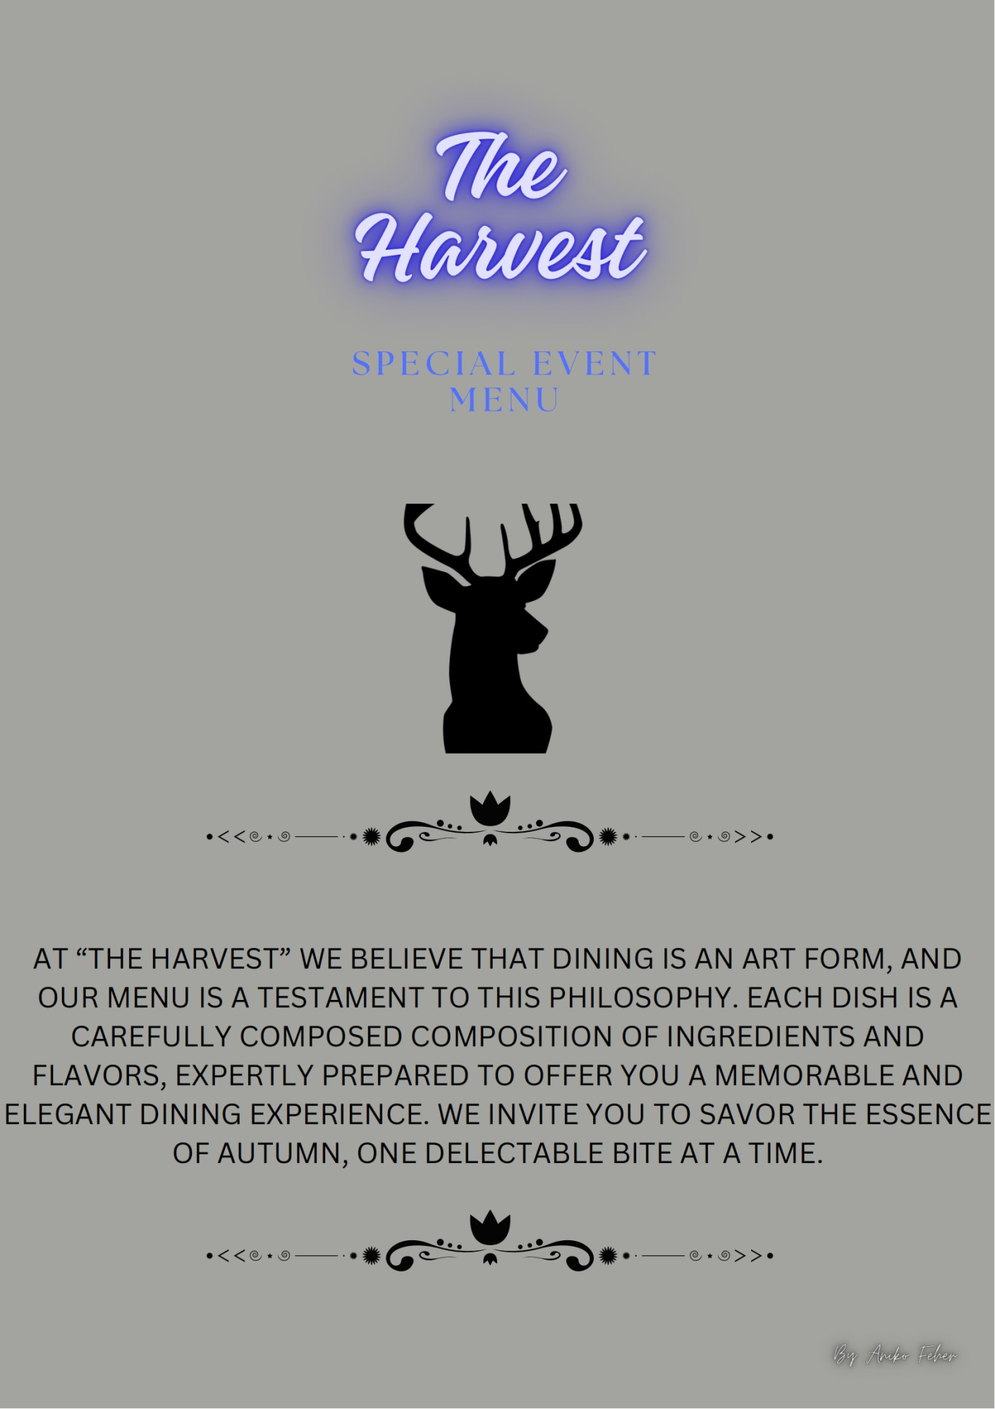

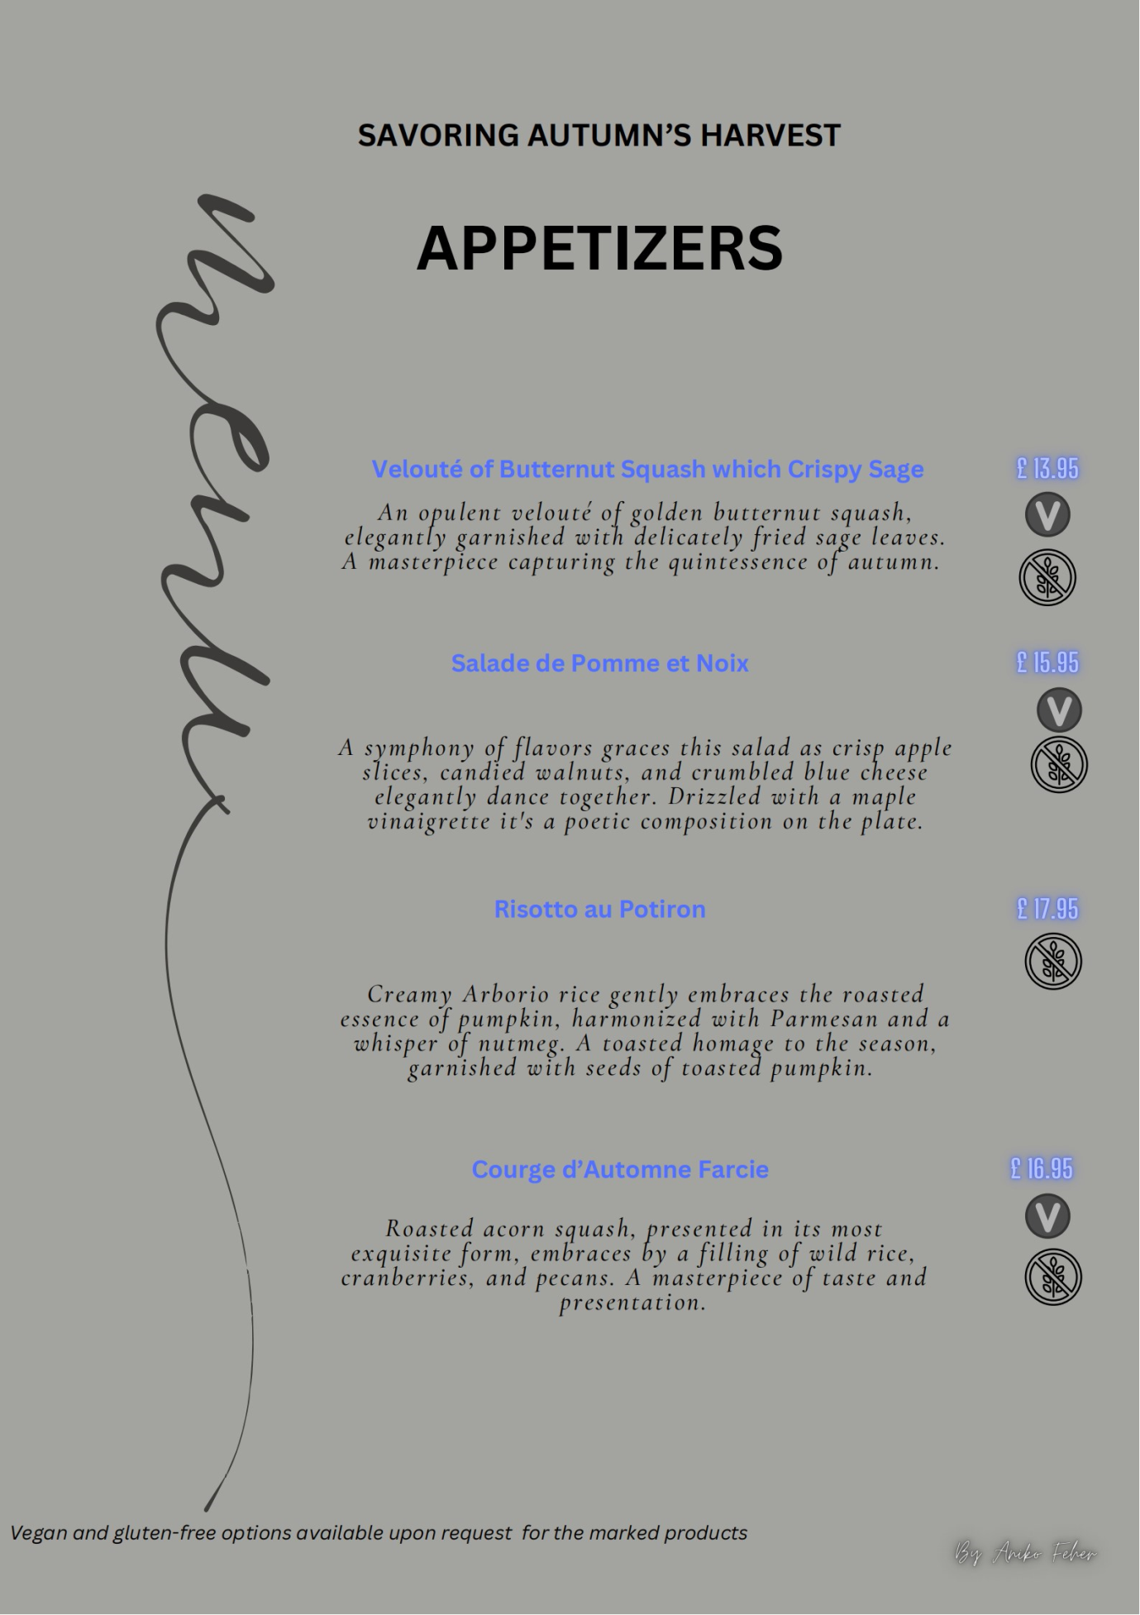

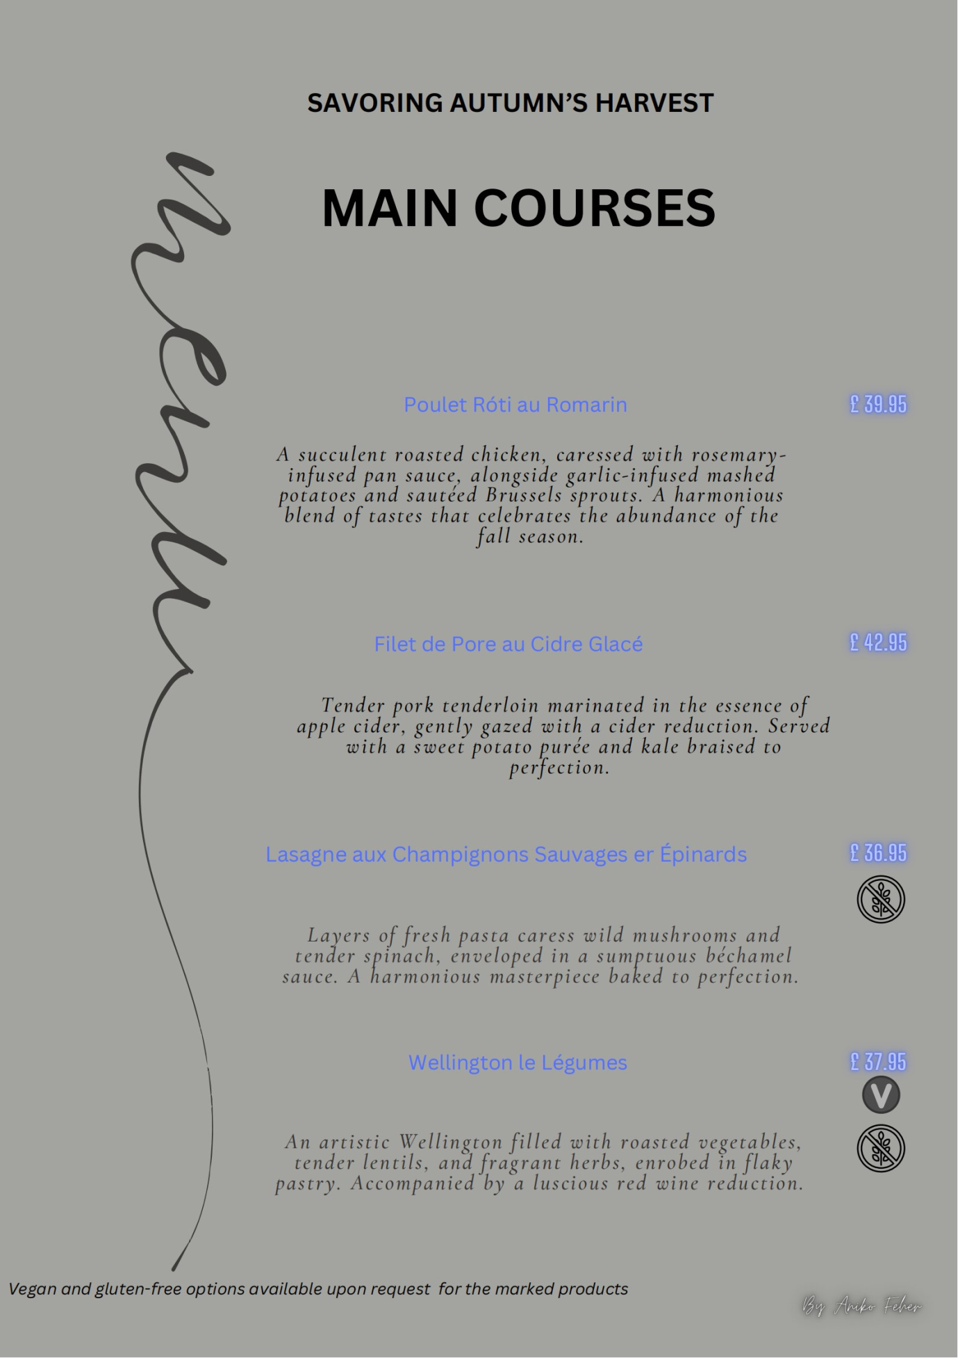

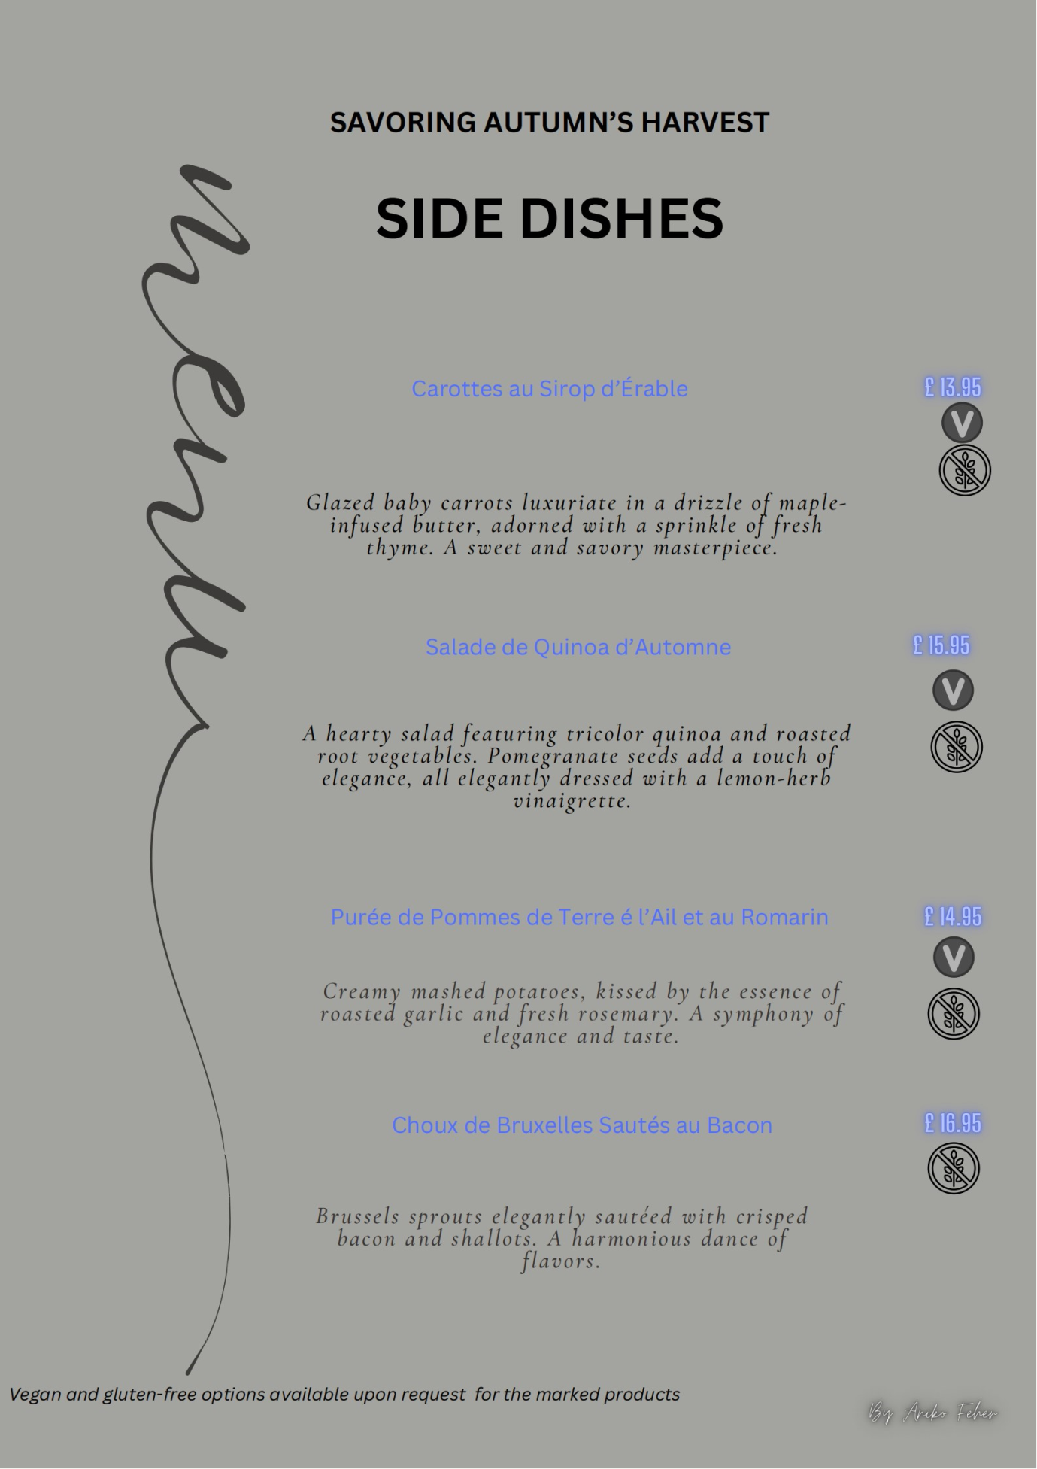

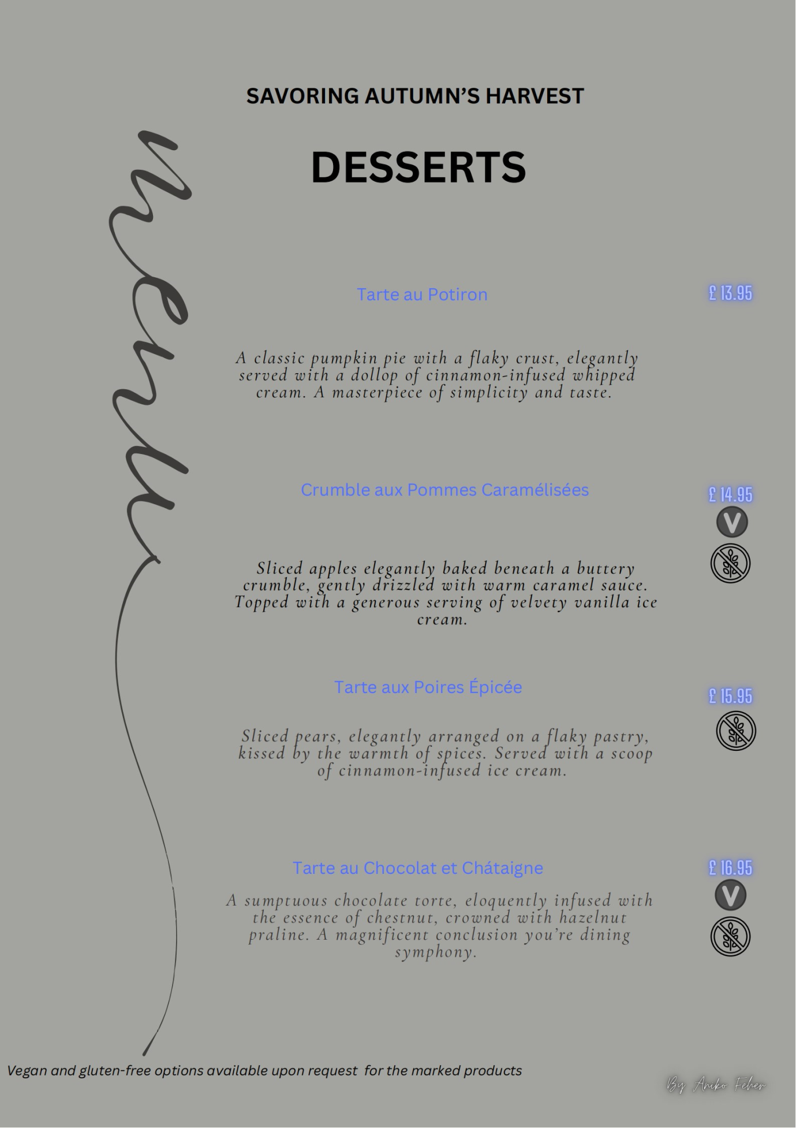

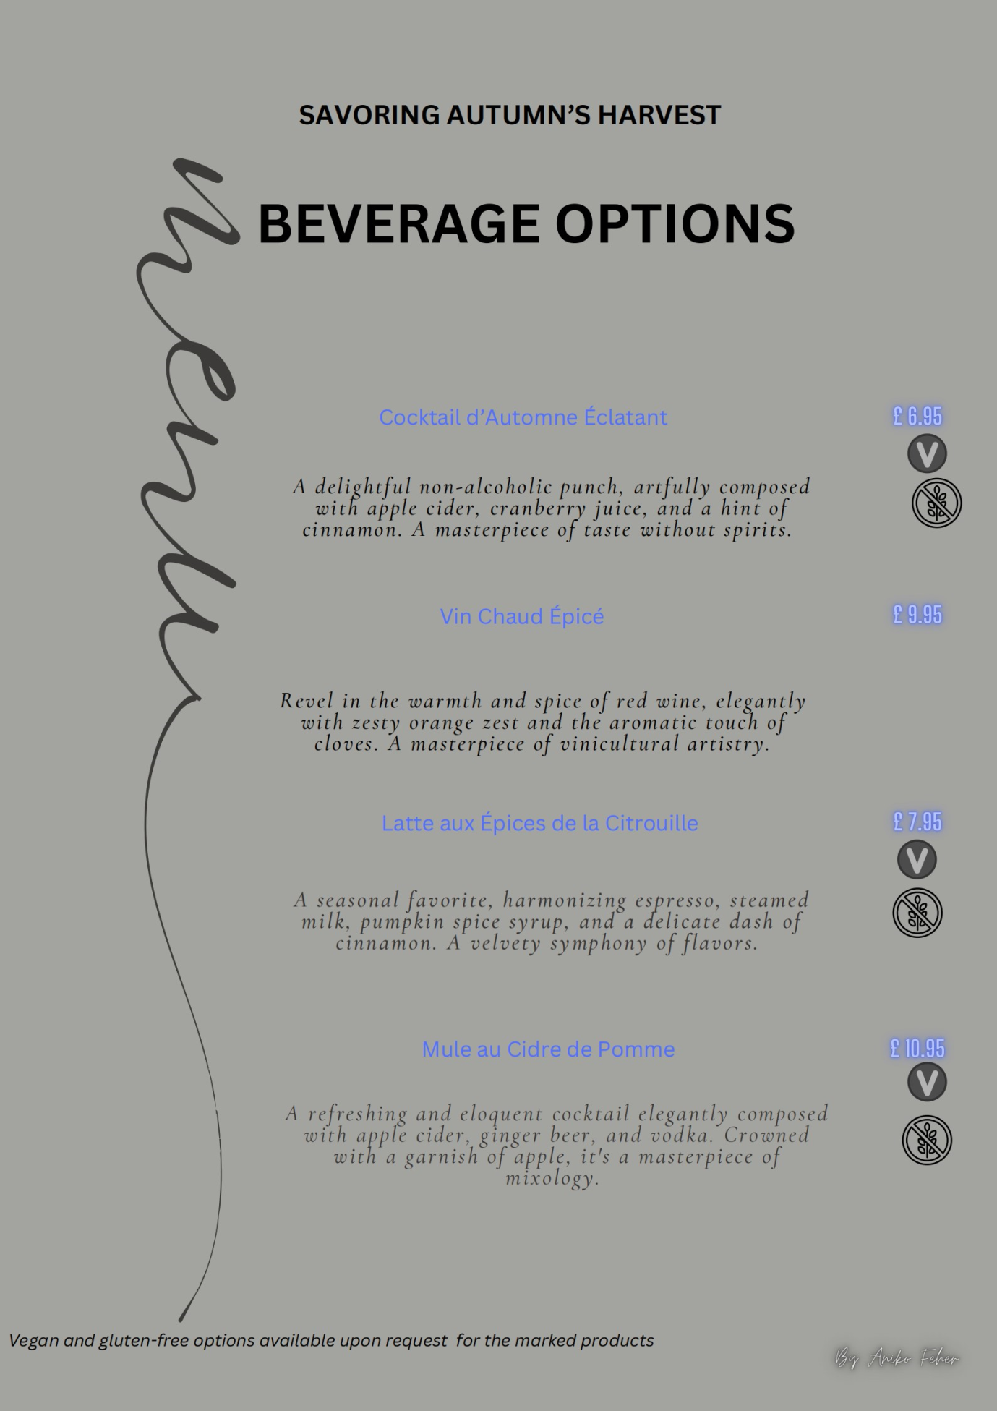(Canva 2023; Michael and Fusté‐Forné 2022)
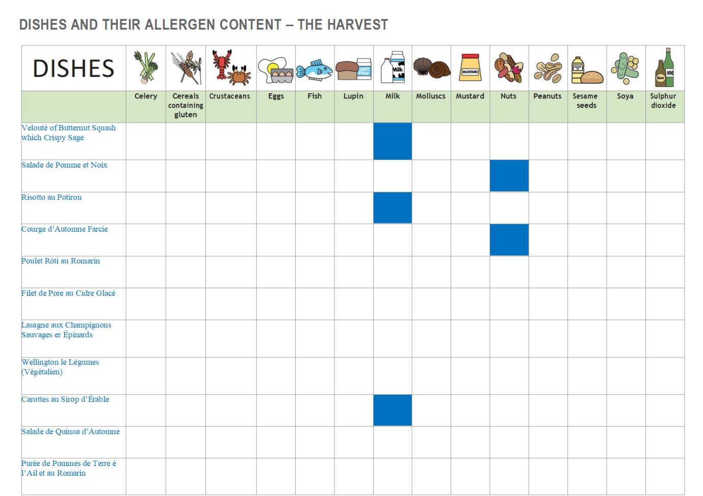 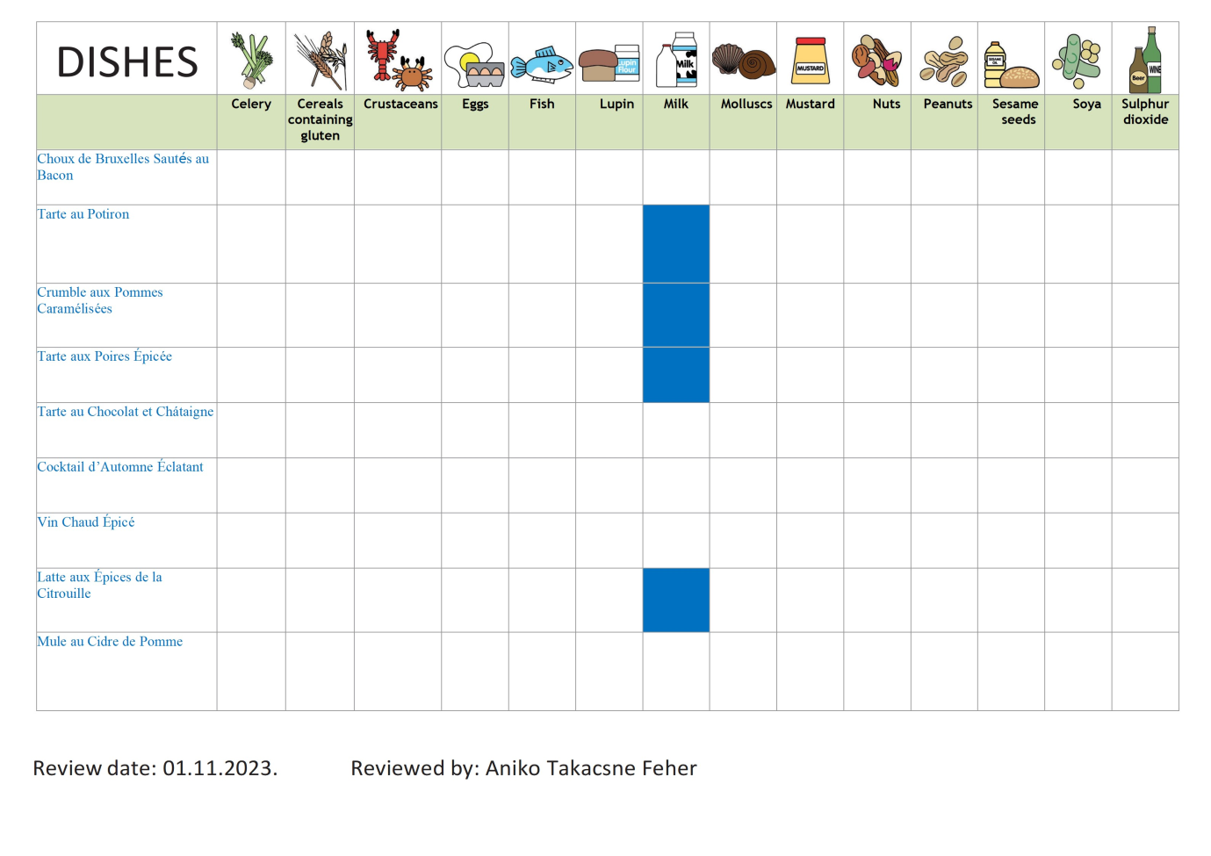(Food Docs 2023)

Citations:

- Aslam, S. Crafting a Healthy and Happy Dining Experience Through an Interactive Dining Table.
- Canva. (2023). Canva. Retrieved from https://www.canva.com.
- Cousins, J., Lillicrap, D., & Weekes, S. (2014). Food and beverage service. Hachette UK.
- Davis, B., Lockwood, A., Pantelidis, I., & Alcott, P. (2013). Food and beverage management. Routledge.
- Food Docs. (2023). Food allergy matrix templater for free. https://www.fooddocs.com/food-safety-templates/food-allergen-chart.
- Hayes, D. K., Ninemeier, J. D., & Miller, A. A. (2017). Hotel operations management. Pearson.
- Johs-Artisensi, J. L., & Hansen, K. E. (2022). Food and Dining. In Quality of Life and Well-Being for Residents in Long-Term Care Communities: Perspectives on Policies and Practices (pp. 135-154). Cham: Springer International Publishing.
- Kanani, R. B. (2017). A wealth of insight: the world's best luxury hoteliers on leadership, management, and the future of 5-star hospitality. Black Truffle Press.
- Kwan, M., & Tong, L. (2023). CREATING AND PROVIDING EXTRAORDINARY DINING EXPERIENCES: A CASE OF CROWNE PLAZA ZHUHAI CITY CENTER HOTEL, IHG. Gulf Journal of Advance Business Research, 1(1), 30-43.
- Michael, N., & Fusté‐Forné, F. (2022). Marketing of luxurious gastronomic experiences on social media: The visual storytelling of luxury hotels. International Journal of Tourism Research, 24(6), 827-838.
- Riley, M. (2005). Food and beverage management: A review of change. International Journal of Contemporary Hospitality Management, 17(1), 88-93.
- Shammas, C. (1983). Food expenditures and economic well-being in early modern England. The Journal of Economic History, 43(1), 89-100.

