Greenwashing and Hotel Industry
Student’s name: Gianina Aghinitei
Student’s ID: 2126415
Lecturer: Kathryn Roberts

Table of Contents
Introduction 2
Organisational background 2
Greenwashing and the chosen organisation 3
Self-evaluation and its significance in the organisation 4
What could they do instead of self-evaluating? 5
Is ‘Green’ technology being used and is it more sustainable? 6
Recommendation 7
Conclusion 8
References 9

Introduction
Sustainable business practice has been a major concern in the present business world. Rapid growth in the international business industry has been brought through several business activities. Though these activities have revolutionized the business world, inducing immense growth, it has impacted the global environment negatively (Liang et al., 2019). Eventually, such negative environmental impacts have severely impacted human livelihood in the present society. Thus, in response to this scenario, controlling the negative environmental impact of business activities has been a major concern for business organisations in the global business industry.
However, scholars have argued that multiple business organisations claim to practice green business operations to glorify their image in the international business industry but in reality, they do not commit the same. Such activities are known as Greenwashing. Additionally, there are some organisations in the hospitality industry which commit inappropriate strategies as sustainable business practices as it affects another sustainability factor. For instance, many hotel corporations do not clean their towels regularly to reduce water usage which further is considered an effective cost-saving measure. Such a "Save the towel" movement further affects the hygiene of the customers which cannot be considered a sustainable business practice (Pellegrino, 2023). In this situation, this report aims to illustrate the concept of greenwashing and its significance in the hospitality industry by demonstrating the instance of Hotel Marriott. It will escalate self-evaluation by SWOT model to identify potential advantages of this hotel company. Lastly, it will recommend some strategies that will help Marriott to combat these challenges.

Organisational background
Marriott International is one of the most renowned hotel organisations in the realm of the international hospitality industry. This hotel organisation was established in 1927. Over these past decades, this organisation has expanded its business significantly. At present, this hotel corporation is operating its business operation across 139 countries with more than 8,700 properties with over 30 brands. This organisation offers hospitality services to customers by operating hotels and restaurants. It has been noted that this organisation has multiple franchises, licensed hotels as well as residential accommodations in the UK under multiple renowned brand names. This hospitality organisation aims to provide its services with the best quality to its customers to enhance their experience (Marriott, 2024). It has been explored that this organisation impacts society significantly by contributing to a larger part of the global economy. It has been reported that this hospitality organisation generates approximately more than 15, 890 billion British pounds every year. Though the onset of covid-19 pandemic has affected its annual turnover drastically considering the figure of the revenue, generated by this company in 2022, it can be stated this organisation has combat successfully the previous financial loss significantly Statista, 2023).
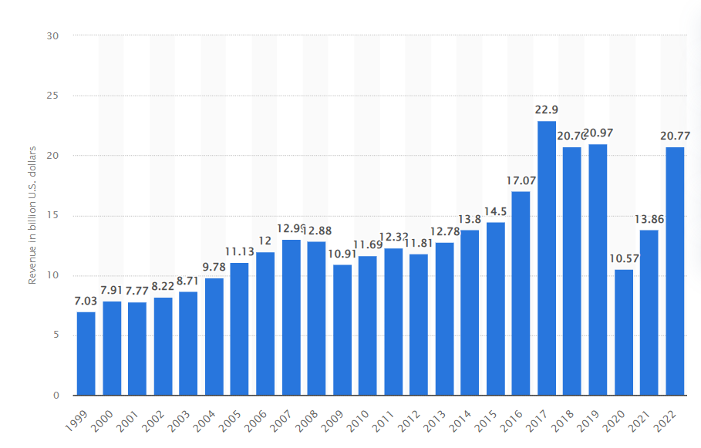
Figure 1: Annual revenue of Marriott
Source: (Statista, 2024)

Greenwashing and the chosen organisation
Greenwashing is considered as one of the most significant drastic activities of business organisations. According to de Freitas Netto et al. (2020) the term "greenwashing" describes the dishonest practice of businesses making inflated or false claims regarding the environmental benefits of their goods or operations. Using this strategy, businesses can continue to use environmentally damaging methods while profiting from the expanding demand for sustainable goods. Through the manipulation of environmentally conscious customers, businesses can conceal their actual environmental impact and avoid taking responsibility for their actions. In this regard, Lindwall (2023) has mentioned that this term was coined in 1986 by environmentalist Jay Westerveld while addressing most debate phenomena 'save the towel' movement of the hospitality industry. This movement suggests the hospitality industry reuse the towels in the hotel. In other words, the hotels in the global hospitality industry started reusing towels without cleaning them regularly to reduce costs and water usage. They believe that it will help to impact the environment positively and start practising sustainable business practices. However, many customers believe that such activities may affect their health and hygiene in the hotel. As a result, it is often considered a practice of greenwashing.
In this context, it has been reported that several hotel companies practice greenwashing. An article, published on MirrorReview (2024) reveals that Mariott International has also been accused of practicing Greenwashing. Leffy (2018) has reported that Mariott International devalues its Green Choice Program. To reduce water usage along with the cost of business operation it has introduced least sanitary jobs as well. Eventually, it has affected the customer's experience drastically. It has also been reported that despite being germophobic, customers do not experience regular cleaning of towels, bedsheets and others. Eventually, it affects the health and hygiene of the customers which further contradicts the concept of promoting sustainable business practice.

Self-evaluation and its significance in the organisation
The term self-evaluation indicates the assessment of the aspects of a business organisation. In this regard, SWOT can be used as a significant self-evaluation model that enables a business organisation to evaluate the potential strengths, weaknesses, opportunities as well as threats that may influence the business organization's performance effectively. The self-evaluation plays a significant role in the context of business organisations as it enables the organisations to design appropriate strategies by analysing their resources (Xie et al., 2024). It has been reported that the digital marketing team of Marriott is consistently working to remain connected with the customers. It provides consistent support to the customers which further helps this organisation to detect the customers' needs and demands so that they can improve their service accordingly (Jaekel, 2024). Such a ‘customer-first’ approach of this company is its major strength in improving its service as it allows it to understand the dynamic purchase behaviour of customers. On the other hand, CDP (2023) has reported that Mariott has reduced 30% carbon emissions by 2016 along with a 30% reduction of electricity by renewable energy while aiming to achieve net-zero carbon emission by 2025. Such activities can be considered as an opportunity for this company as it glorifies its brand in the global hospitality industry. On the other hand, devaluing its ‘Green Choice Program’, by cutting sanitary jobs may affect the hygiene of the customers in the territory of these hotel corporations (Leffy, 2018). Thus, this can be considered a major weakness for this company. Eventually, it may reduce the number of customers by impacting their experience negatively. As a result, the financial profit of Mariott will be harmed. Thus, it can be considered a potential threat to this company.

What could they do instead of self-evaluating?
Marriott UK can consider the implementation of the external assessment and feedback mechanisms in order to gain the more comprehensive understanding of the performance and the areas to improve. They can implement the customer survey and feedback on the quality of the services, satisfaction levels and guest experiences. The external perspectives can help to provide the valuable insights where they have to improve (Wickham and French, 2021). They can engage in exercising of benchmarking against the key competitors in the hospitality industry. The analysis of the perspectives of the competitor’s practices, industry benchmarks and customer reviews can help Marriot Hotel UK to identify the areas where they have to develop in order to increase green practices. Apart from that they can seek the consultations with the industry experts who are specializing in the hospitality sector. The external professional can help to provide unbiased evaluation of Marriott UK operations and can provide the strategic recommendations based on the practices of the industry. Employee feedback is also necessary for the development of the organisational performance and process (Haski-Leventhal, 2018). They provide the valuable insights into the workplace culture, areas that need attention and internal process.

Is ‘Green’ technology being used and is it more sustainable?
The green technology and the sustainability strategy is the most crucial in the hospitality industry and thus it is applicable for Marriott hotel UK also. In terms of energy efficiency, the Marriott hotel chain has been investing in their energy efficiency technologies. This can include the use of the LED lighting, energy management systems and smart thermostats to reduce the overall energy consumption (Chan et al. 2020). In terms of the renewable energy successes, Marriott hotel has been focusing on using renewable energy sources such as wind turbines and solar panels. This can help to reduce the environmental impact and contributes to the long-term costs savings. Water conservation technologies are also useful as green technology. It includes the use of the low flow faucets, smart integration systems and water efficient laundry equipment to minimise the water wastage. Waste management is the most crucial part of the green technology and present days majority of the hospitality organisations have been using the waste management practices. It has been identified that hotels are incorporating the recycling program, waste reduction and composting (Ben Youssef and Zeqiri, 2022). Hence, it is necessary for Marriott also to adopt effective waste management practices. Some hotel organisations have been adopting innovative technologies to convert the organic wastes into energy.
The sustainable initiative of Marriott hotel UK has been reflected through the use of the LED lights and they have achieved the LEED (Leadership Energy Environmental design) certificate. Apart from that they have focused on the minimising of the single use plastics. It involves the use of the reusable or biodegradable alternative for the amenities like packaging and toiletries (Legrand et al. 2022). Through community engagement they have been also trying to spread their sustainability initiatives. It has been performed through the supporting of the local environmental projects, contributing to the community wellbeing and sourcing products locally. The main benefits are cost savings, brand image and regulatory compliance (Cabral and Jabbour, 2020). The main challenges are initial investment, technological advancements, and customer education. The implementation of the technology enhances the performance as to connect the latest sustainable technology which requires adaptation and investment. Sustainable practices can also help increase the brand image through efficiency and services (Mzembe et al. 2020). Green technologies have been highly involved in recent days in the hospitality industry and Marriott hotels are also increasing the use of the green practices in order to get competitive advantages.

Recommendation
Implementation of the Green technologies can help the Marriott hotel UK to meet its goal and to achieve the organisational sustainability. The organisation must follow the below recommendations:
Energy efficient automation and lighting
The use of the LED light can lead to smart automation technologies. Therefore, the motion sensor can also be useful as the green technology (Abdou et al. 2020). It is also necessary to ensure the lights are only active when needed and in reducing the overall energy consumption.
Renewable energy integration:
It is necessary to explore the feasibility of incorporating the sources of renewable energy. Installation of the solar energy panels in the premises for the renewable energy from the local providers (Gürlek and Koseoglu, 2021). This not only reduces the carbon footprints of the hotels but also positions Marriott hotel UK as the leader in the sustainable practices.
Green building design and retrofitting:
It is necessary for Marriott hotel UK to evaluate the possibility of incorporating green building principles of design in the new constructions. Therefore, it is also necessary to utilise the eco-friendly materials, design with the natural lighting in mind and improve insulation of energy efficiency.
Engage in sustainability transport support:
In order to get the sustainability, Marriott hotel UK encourage in adopting sustainability transportation options for the staff and guests. They can offer the electric vehicle charging stations in hotel parking facilities. They can collaborate with the local transportation providers in promoting eco-friendly alternatives such as the electric vehicle rentals.

Conclusion
The integration of the green technologies in the Marriott Hotel can help to increase its sustainability. Through the analysis it has been identified that Marriott hotel UK is focused on the green technology adoption in all its practices. Hence, it is necessary to provide the continuous monitoring and improvement. Implementation of the real time monitoring system can help to enable Marriott to track the progress and to identify the areas of improvement. It also enables to adapt the evolving technologies and the best practices.

References
Abdou, A.H., Hassan, T.H. and El Dief, M.M., 2020. A description of green hotel practices and their role in achieving sustainable development. Sustainability, 12(22), p.9624.
Ben Youssef, A. and Zeqiri, A., 2022. Hospitality industry 4.0 and climate change. Circular Economy and Sustainability, 2(3), pp.1043-1063.
Cabral, C. and Jabbour, C.J.C., 2020. Understanding the human side of green hospitality management. International Journal of Hospitality Management, 88, p.102389.
CDP. 2024. Marriott International, Inc. - Climate Change 2023. Available at: https://serve360.marriott.com/wp-content/uploads/2023/09/CDP-Climate-2023-vHsm2.pdf (Accessed on 20 February 2024).
Chan, E.S., Okumus, F. and Chan, W., 2020. What hinders hotels’ adoption of environmental technologies: A quantitative study. International Journal of Hospitality Management, 84, p.102324.
de Freitas Netto, S.V., Sobral, M.F.F., Ribeiro, A.R.B. and Soares, G.R.D.L., 2020. Concepts and forms of greenwashing: A systematic review. Environmental Sciences Europe, 32(1), pp.1-12.
Gürlek, M. and Koseoglu, M.A., 2021. Green innovation research in the field of hospitality and tourism: The construct, antecedents, consequences, and future outlook. The Service Industries Journal, 41(11-12), pp.734-766.
Haski-Leventhal, D. 2018. Strategic corporate social responsibility : tools & theories for responsible management. London: SAGE
Jaekel, B. 2024. How Marriott delivers seamless, consumer-first experiences. Available at: https://www.retaildive.com/ex/mobilecommercedaily/marriott-creates-online-and-offline-seamlessness-in-a-people-first-strategy (Accessed on 20 February 2024).
Leffy, G. 2018. Housekeeping Protesting Guests Who ‘Make a Green Choice’ With Marriott. Available at: https://viewfromthewing.com/housekeeping-protesting-guests-who-make-a-green-choice-with-marriott/ (Accessed on 20 February 2024).
Legrand, W., Chen, J.S. and Laeis, G.C., 2022. Sustainability in the hospitality industry: Principles of sustainable operations. Taylor & Francis.
Liang, L., Wang, Z. and Li, J., 2019. The effect of urbanization on environmental pollution in rapidly developing urban agglomerations. Journal of cleaner production, 237, p.117649.
Lindwall, C. 2023. What Is Greenwashing? Available at: https://www.nrdc.org/stories/what-greenwashing (Accessed on 20 February 2024).
Marriott International. 2024. We Are Marriott International. Available at: https://www.marriott.com/marriott/aboutmarriott.mi (Accessed on 20 February 2024).
Mirror Review. 2024. Marriott Criminal Investigation: Whitewashing in the Hotel Industry. Available at: https://www.mirrorreview.com/marriott-criminal-investigation/ (Accessed on 20 February 2024).
Mzembe, A.N., Lindgreen, A., Idemudia, U. and Melissen, F., 2020. A club perspective of sustainability certification schemes in the tourism and hospitality industry. Journal of Sustainable Tourism, 28(9), pp.1332-1350.
Pellegrino, S. 2024. Explainer: Household brands accused of greenwashing. Available at: https://capitalmonitor.ai/sector/consumer/explainer-household-brands-accused-of-greenwashing/ (Accessed on 20 February 2024).
Statista. 2023. Revenue of Marriott International worldwide from 1999 to 2022. Available at: https://www.statista.com/statistics/266279/revenue-of-the-marriott-international-inc-hotel-chain/ (Accessed on 20 February 2024).
Wickham, Donnelly, T., and French, L. 2021. Strategic Sustainability Management in the Event Sector. Event Management, 25(3), 279–296
Xie, Y., Kawaguchi, K., Zhao, Y., Zhao, J.X., Kan, M.Y., He, J. and Xie, M., 2024. Self-evaluation guided beam search for reasoning. Advances in Neural Information Processing Systems, 36.

