Module Code:
BMIH4009 / BMIH4009D
Module Title:
Marketing Essentials
Marketing Plan
Title:
Launching Premier Inn’s Eco-Stay Experience: A Sustainable Marketing Plan for UK Hospitality
Lecturer: Natalie Brailsford
Student ID:2132762
Student Name: Elena Diana Balan

Table of Contents
Introduction 2
Marketing Objectives 3
Market Research 3
Target Market and Customer Profile 4
SWOT Analysis 4
Unique Value Proposition 5
Marketing Mix 5
Marketing Activities 6
Promotion Methods 6
Gantt Chart 7
Monitoring 8
Conclusion 9
References 10

Introduction
It belongs to the United Kingdom, and one of the biggest and most well-known hotel brands in the country is the one owned by Whitbread PLC: Premier Inn. It has established its brand name through providing quality and cheap hotel in both business and leisure travellers. The marketing plan presents a new program named the Eco-Stay Experience that provides the guests with the opportunity to spend their time in eco- friendly rooms created in such a way that they reduce their carbon footprint without losing the level of comfort and value the Premier Inn possesses. The plan shall encompass marketing objectives, market research, target audience, and a marketing mix plan that will be employed to introduce this new service to the hotels in the UK.
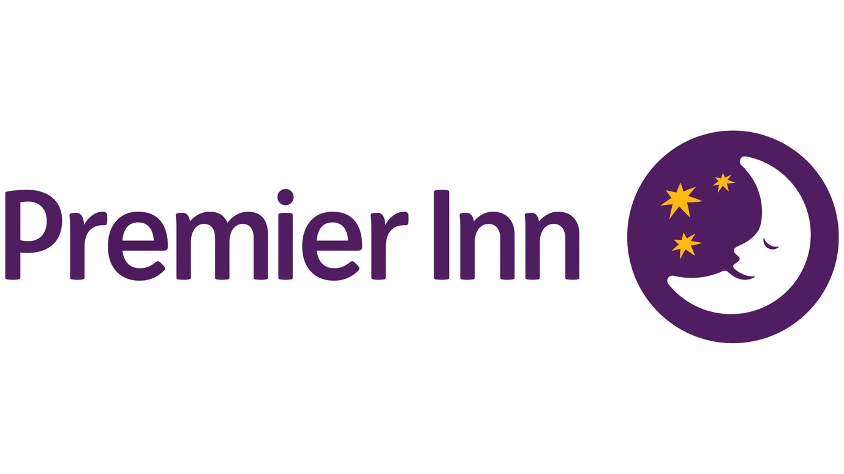
Figure 1: Premier Inn Logo (Blythe, 2019)

Marketing Objectives
This marketing plan aims at having a successful launch of the "Eco-Stay Experience" with specific and quantifiable goals. The initial task is to establish the eco-stay service in half a year of launching on fifty hotels of the Premier Inn chain. The second is to ensure a fifteen per cent rise in bookings by environmentally conscious travellers within the same time (Blythe, 2019). These objectives are achievable as Whitbread already has good sustainability programmes under its Force for Good framework at Premier Inn. The goals also apply to the trends within the UK market, where an increasing number of customers demand that hotels should be responsible in their operations. It is planned to be implemented nationwide by the end of the second year, during which the company will integrate customer satisfaction with environmental responsibility at Premier Inn (Kotler and Armstrong, 2018).

Market Research
UK hospitality market is huge and competitive and ever changing. The new challenges that have been experienced in the industry following the pandemic include the increased costs and altered priorities of customers. According to recent findings, a significant number of British travellers are willing to visit hotels with green and sustainable design aspects, including waste minimisation, energy-consuming lighting, and environmentally friendly handwash products and lotions (Benzo et al., 2017).

Figure 2: Market Research (Burgess and Burgess, 2020)
Premier Inn can distinguish itself using the competitors such as Travelodge and Holiday Inn Express who provide value accommodation but have not embedded much of the environmental branding, which creates an opportunity to differentiate the three competitors. The primary research, including customer surveys, and secondary research, including Mintel and VisitBritain reports, can contribute to the identification of the willingness of customers to spend on an environmentally-friendly stay (Burgess and Burgess, 2020).
According to the data of market segmentation, millennials, Generation Z, and other young business travellers are the most interested in sustainability. They will also make their bookings online and search hotels that portray their ethical and environmental beliefs. Such insight will assist Premier Inn to align its marketing mix with such expectations (Baack et al., 2018).

Target Market and Customer Profile
The targeted customer is primarily the environmentalists in the domestic travel market between the age of twenty-five and forty-five years and who are urban dwellers and middle income earners. They are typically professionals or young families and are sensitive to high prices, comfort, and ethical decisions (Baines, Fill and Rosengren, 2017). They are techno savvy, research oriented and use online platforms to help them plan their travel.
The secondary target market will be business travellers and companies that are interested in sustainable corporate travelling. A number of the companies in the UK are now establishing eco-policies which determine the places that their staff members will reside. The consumers at these segments are willing to pay some extra to stay at eco-friendly places which will be in line with their values. Investigating these segments, Premier Inn will be able to enhance the relationship with socially responsible guests and empower the image of a modern sustainable hotel chain (Kotler et al., 2018).

SWOT Analysis
Another strength that will help the Eco-Stay Experience at premier inn is the strong brand name and the number of hotels that it has in the UK. Whitbread operations are also efficient and the company has set sustainability goals (Baack et al., 2018). Yet, the disadvantage is that Premier Inn is mostly targeted at low-end clients, and eco-friendly upgrades can result in the increased expenditures in both business and consumer.
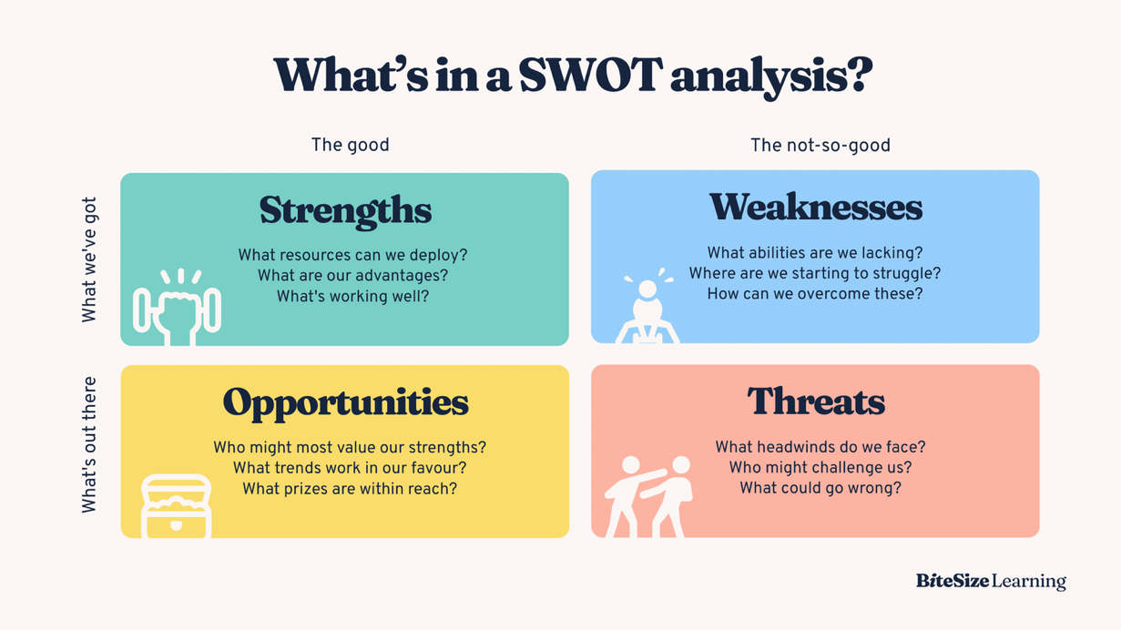
Figure 3: SWOT Analysis (Baack et al., 2018)
The prospects are eminent. In the UK people are more conscious of sustainability and the government is relating its incentives to business owners to cut down on the consumption of energy and emission. Premier Inn can be in the forefront on this eco-friendly stay, which will introduce a new trend in the mid-scale hotel sector. Some of these threats are imitation by competitors, inflation and uncertainty on whether greenwashing is real.

Unique Value Proposition
The Eco-Stay Experience provides the guests with the opportunity of staying green and budget-friendly, and sleep well, which means to be really responsible toward the environment. The new service will feature energy-efficient lighting, intelligent thermostats, digital room keys that will reduce plastic waste, and full recyclability of toiletries (Bowie et al., 2017). Visitors are also able to order plant-based breakfast and obtain the optional green stay, consisting of few linen and towel servicings to conserve water and energy.
This service will distinguish the Premier Inn among the competitors as it will be offered not only in terms of its long-time reputation as a good value but also with sustainability innovations that are typically considered with higher-class hotels. Other chains, Hilton and Accor have introduced similar ones, but mostly at high price. The strategy of the Premier Inn makes sustainability affordable to the average traveler, as well as enables the organisation to provide emotional and moral worth to the experience (Kotler et al., 2018).

Marketing Mix
The marketing mix used with respect to Eco-Stay Experience puts emphasis on five fundamental aspects which include product, price, place, promotion, and people.
The product also has rooms that are fully furnished using recycled materials, greens website toiletries, and energy saving systems. The booking page will have an eco badge to emphasise these features, which further builds the green image of Premier Inn (Bowie et al., 2017).
The pricing will be value pricing where eco-room will be priced at a little higher by five per cent. This will make the service affordable and promote sustainable decisions. Loyalty members and longer-term stays will also be promoted through discounts, which will encourage retention in customers (Blythe, 2019).
The place aspect is concerned with the opening of the service in the key cities like London, Manchester, and Birmingham where there is high demand of sustainable hotels. It will advertise the experience on the website, mobile application, and eco-travel booking platforms of the premier Inn (Baack et al., 2018).
The campaign will focus on a digital campaign named Sleep Green with premier inn and will include social media campaign, email newsletters, influencer collaboration and search engine optimisation (Clow and Baack, 2013).
The people component entails educating personnel on the sustainability values and being competent messengers of the eco-values of Premier Inn. The employees will be significant in helping customers to experience a positive and consistent experience (Egan, 2011).

Marketing Activities
The focus of the marketing efforts of the Premier Inn will be primarily digital platforms that will be used to target environmentally conscious travellers. Instagram, Tik Tok, and LinkedIn social media campaigns will be used to present eco-rooms, sustainability efforts, and customer reviews (Fill and Turnbull, 2019). The service will be promoted with the help of Google Ads and SEO with the use of the words such as ecofriendly hotels UK.
This will involve content marketing through the use of blogs and short videos on how the company is minimising waste and energy consumption. Cooperation with influencers and tourism boards of the region will enhance coverage and authority. The outcomes will be tracked according to the traffic at the websites, booking rates, and the data of engagements (Burgess and Burgess, 2020).

Promotion Methods
Advertisement will be done through online and offline. The awareness will be mobilised through online advertising and booking-tailored websites and site promotions will feature real experiences of guests posted on social media. Some of the offline advertising will involve lobby and transport hub posters, sponsoring green events (Clow and Baack, 2013). Premier Inn will collaborate with environmental charities so as to gain their trust and positive publicity. A reward system will be implemented which will give more points to the loyalty members upon booking of eco- rooms. The new service will also be announced in press releases that will be distributed to the UK travel magazines to reinforce the media coverage (Kotler et al., 2019).

Gantt Chart
Quarter / Month | Key Activities | Timeline (Months) | Duration
Q1 (Jan–Mar) | Conduct detailed market research (customer surveys, competitor review, environmental trends). Develop final concept and pilot design. Staff sustainability training begins. | Jan – Mar | 3 months
Q2 (Apr–Jun) | Launch pilot programme in selected city hotels (London, Manchester, Birmingham). Roll out initial digital marketing campaigns – “Sleep Green with Premier Inn.” PR announcements and press coverage begin. | Apr – Jun | 3 months
Q3 (Jul–Sep) | Gather customer feedback and booking data from pilot. Evaluate campaign performance. Adjust marketing content, pricing, and eco-features based on insights. Expand to 25 additional hotels. | Jul – Sep | 3 months
Q4 (Oct–Dec) | Full national rollout of Eco-Stay Experience across UK hotels. Continue digital promotion and influencer partnerships. Conduct annual performance review and KPI analysis. Plan next-year sustainability improvements. | Oct – Dec | 3 months

Monitoring
Some of the key performance indicators that will be used to measure success include eco-rooms bookings, occupancy rate, social media interactions, and customer satisfaction rate. Guest attitudes towards sustainability will be measured with the help of feedback surveys (Baines, Fill and Rosengren, 2017). Financial performance, such as increase in revenue and ROI will also be looked on. Online reviews and coverage in the media will be used to check the brand reputation. Quarterly review will guarantee that the use of performance data will modify the subsequent marketing approaches (Kotler et al., 2018).

Conclusion
To conclude, the Eco-Stay Experience is a significant development of both Premiere Inn and the UK hospitality industry in general. It is a sustainable and affordable product with current consumer demands. The marketing plan objectives, research, and strategies demonstrate that the Premier Inn can remain on the growth path and encourage the environmental objectives. With the right planning and management, the company would be able to move towards being a responsible leader within British hospitality and attract the new generation of travellers who are conscious and comfortable in their wants and needs.

References
Baack, D.W., Czarnecka, B. and Baack, D.E. (2018) International Marketing. 2nd edn. London: SAGE Publications Ltd.
Benzo, R., Mohsen, M.G. and Fourali, C. (2017) Market Research: Planning, Process, Practice. London: SAGE Publications.
Blythe, J. (2019) Essentials of Marketing. 7th edn. Harlow: Pearson Education.
Bowie, D., Buttle, F., Brookes, M. and Mariussen, A. (2017) Hospitality Marketing. 3rd edn. London: Routledge.
Burgess, C. and Burgess, M. (2020) The New Marketing: How to Win in the Digital Age. London: SAGE Publications.
Clow, K. and Baack, D. (2013) Integrated Advertising, Promotion and Marketing Communications. 6th edn. London: Pearson Education.
De Mooij, M. (2019) Global Marketing and Advertising: Understanding Cultural Paradoxes. 5th edn. London: SAGE Publications.
Egan, J. (2011) Relationship Marketing: Exploring Relationship Strategies in Marketing. 4th edn. Harlow: Pearson Education.
Fill, C. and Turnbull, S. (2019) Marketing Communications: Touchpoints, Sharing and Disruption. 8th edn. Harlow: Pearson Education.
Kotler, P., Armstrong, G. and Opresnik, M.O. (2018) Principles of Marketing. 17th Global edn. London: Pearson Education.
Kotler, P., Armstrong, G., Harris, L.C. and Piercy, N. (2019) Principles of Marketing. 8th edn. London: Pearson Education.

