Links between the Aegean and Egypt during the second millennium BCE

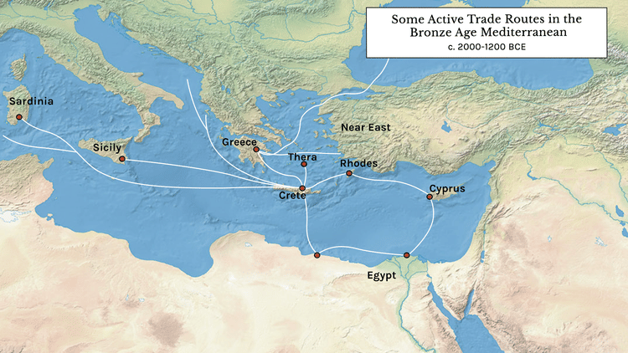
During the second millennium BCE, Egypt developed strong trade connections with the Aegean region, especially with the Minoans on Crete and the Mycenaeans on mainland Greece. These relationships became part of a wider web of exchange across the Mediterranean, where sea travel made regular contact between distant communities much easier.
Figure 1- Map showing trade networks between The Aegean and Egypt in the Bronze Age
Both sides gained a lot from this trade. Egypt relied on other regions for materials that were hard to find along the Nile, such as wood and certain metals. The Aegean world supplied many of these resources, along with well-made pottery and jewellery that were valued in Egypt. In return, Aegean societies received goods that Egypt produced in abundance, including papyrus, gold, and different kinds of precious stones. This steady flow of items helped both regions grow economically and stay connected to wider trade networks.
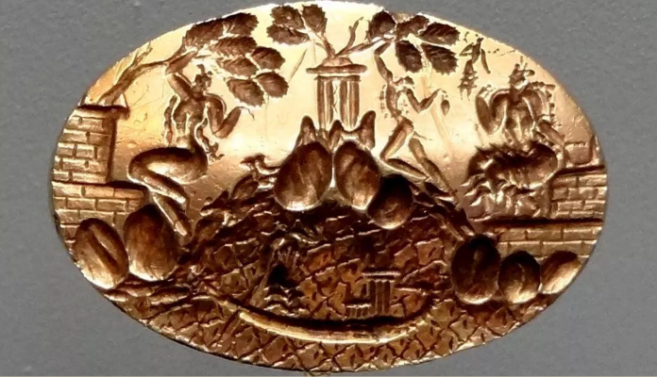
The movement of goods depended heavily on boats. The Nile River served as Egypt’s main transport route, helping move products from inland areas to ports along the Mediterranean coast. From there, ships carried these goods across the sea to Aegean ports. Using both river and sea routes made long-distance trade practical and efficient.
Figure 2 - Minoan Seal Ring, shows cultural exchange as has an image of an Egyptian royal boat
Trade also encouraged cultural exchange. Archaeologists have found Egyptian objects in Aegean sites, showing that ideas and artistic influences travelled alongside physical goods. These interactions helped shape the development of both societies and contributed to a more connected cultural environment in the eastern Mediterranean during this time.

Where and When

Where:
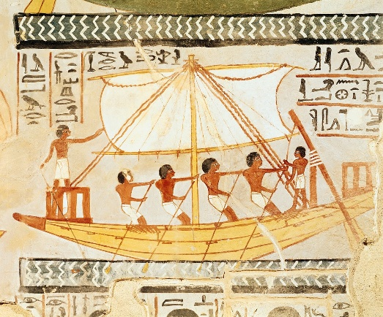
Egypt and the Aegean occupy neighbouring zones within the eastern Mediterranean, and their geographical settings played a direct role in shaping patterns of interaction during the second millennium BCE. Egypt is situated in northeastern Africa and is centred on the Nile Valley and Delta, where a narrow but fertile corridor of land contrasts sharply with the surrounding Eastern and Western Deserts. The Nile served not only as the foundation of agricultural productivity but also as Egypt’s main internal transport route, supporting the movement of goods, labour, and administration. Its access to the Mediterranean coast enabled participation in maritime networks that linked Egypt to Cyprus, the Levant, and the wider Near East.
Figure 3 - Boatmen on the Nile
The Aegean region consists of the Aegean Sea along with the Greek mainland, the Cycladic islands, and the western Anatolian coast. The terrain is highly fragmented, characterised by rugged mountains, limited agricultural plains, and a dense distribution of islands. These geographic features encouraged a reliance on maritime communication and transport, contributing to the development of advanced seafaring traditions among Aegean communities. Such conditions supported extensive long-distance exchange and facilitated Aegean integration into broader Mediterranean interaction spheres.
Although differing in topography, Egypt and the Aegean were separated only by a relatively short stretch of the eastern Mediterranean. Established sea routes made regular contact feasible. The combination of Aegean maritime capability and Egypt’s strategic position at the crossroads of Africa, Asia, and Europe enabled sustained interaction throughout the second millennium BCE.

When:
Both regions experienced major cultural and political developments during this period. In Egypt, the second millennium BCE spans the Middle Kingdom (2050–1710 BCE), the Second Intermediate Period, and the New Kingdom (1550–1070 BCE). The New Kingdom marked a phase of increased foreign contact, imperial expansion, and intensified trade activity. Rulers such as Hatshepsut, Thutmose III, and Amenhotep III established diplomatic and commercial links that connected Egypt to the Near East and the eastern Mediterranean. Archaeological evidence for Aegean imports, including Minoan and Mycenaean ceramics, appears across Egyptian sites during this time.
In the Aegean, the early second millennium BCE corresponds to the height of Minoan civilization on Crete. Palatial centres such as Knossos and Phaistos functioned as administrative and economic hubs, and their maritime networks reached across the Mediterranean. The eruption of the Thera volcano around 1600 BCE had far-reaching consequences and contributed to shifts in regional political structures. Following this event, the Mycenaean palatial states on mainland Greece rose to prominence. By the 14th–13th centuries BCE, the Mycenaeans operated highly organised palace economies and participated extensively in trade with Egypt and the Near East.
Archaeological finds demonstrate that exchange between Egypt and the Aegean persisted throughout much of the second millennium BCE. Minoan and Mycenaean pottery appears in significant quantities at sites such as Avaris in the Nile Delta and Thebes in Upper Egypt, while Egyptian items including scarabs, faience beads, and gold ornaments appear in Aegean tombs and settlement contexts. This evidence reflects long-term patterns of exchange rather than sporadic contact.
Trade likely took place through both direct and indirect routes. Some goods may have been transported by Aegean merchants sailing across the Mediterranean, while others may have passed through Levantine intermediaries. Regardless of the specific mechanisms, these exchanges contributed to economic development and facilitated the spread of artistic styles, administrative practices, and technological knowledge.
Toward the end of the second millennium BCE, exchange between the two regions declined. The collapse of Late Bronze Age systems, linked to the movement of the Sea Peoples, the destruction of Mycenaean palatial centres, and widespread regional instability, interrupted long-standing maritime networks. Although Egypt remained a major political entity, its international connections narrowed, signalling the end of the intensive, structured trade relations that had characterized earlier centuries.

Archaeological Evidence
Archaeological evidence forms the primary basis for understanding the extent, nature, and chronology of contact between Egypt and the Aegean during the second millennium BCE. Material finds from both regions show the movement of goods, raw materials, artistic practices, and symbolic objects across the eastern Mediterranean. These discoveries come from a wide range of archaeological contexts, including elite tombs, palatial centres, administrative structures, and coastal settlements, allowing modern scholarship to reconstruct patterns of exchange with considerable clarity.
One of the most prominent categories of evidence is imported Aegean ceramics found within Egypt. Minoan and later Mycenaean pottery occurs at several major sites, particularly at Avaris in the eastern Nile Delta, where large assemblages dating to the 18th Dynasty have been recovered. The fine quality, distinctive decoration, and chemical composition of these vessels indicate that they were imported rather than locally manufactured. Their frequent appearance in elite or cultic settings suggests that Aegean pottery held social or symbolic value within Egyptian contexts. This pattern aligns with broader interpretations of intercultural ritual influence, such as those discussed by Martino, who highlights how Aegean ritual iconography and practices could be selectively adopted or adapted within Egyptian ceremonial environments.
A complementary body of evidence comes from Egyptian artefacts discovered in Aegean contexts. Egyptian scarabs, faience beads, amulets, carved stone vessels, and gold ornaments appear across Crete and mainland Greece, often in burial assemblages. Scarabs are particularly common in Mycenaean shaft graves and chamber tombs, where they functioned as status markers or personal ornaments. Their distribution indicates that Egyptian materials were viewed as prestigious imports, integrated into local funerary customs. Matić’s analysis of New Kingdom objects in Theban tombs further suggests that such items could carry layers of meaning relating to foreign identity, memory, and social signalling, ideas that may have applied in the Aegean as well.
Raw materials also provide significant evidence for long-distance trade. Scientific analyses of metal artefacts indicate that certain gold objects found in Aegean sites likely originated from Egypt or Egyptian-controlled regions. Gold was a key export commodity for Egypt, and its presence in Aegean workshop contexts implies both the movement of raw materials and the integration of Egyptian resources into local craft traditions. Similarly, semi-precious stones such as carnelian and amethyst, which were abundant in Egypt and its surrounding territories, appear in Aegean jewellery assemblages. These materials demonstrate the exchange not only of finished prestige goods but also of the inputs required for regional craft production.
Artistic and architectural evidence further illustrates cultural interaction. At Avaris, Minoan-style wall paintings depicting bull-leaping and other Aegean motifs have been uncovered. These frescoes share close stylistic parallels with those from palatial centres such as Knossos, suggesting either the presence of Aegean artisans working in Egypt or strong familiarity with Aegean artistic traditions among Egyptian painters. Their placement within elite architectural complexes points to a deliberate adoption of foreign visual languages, possibly for diplomatic, ceremonial, or aesthetic purposes.
Finally, hybrid artefacts, objects that combine Egyptian and Aegean stylistic or technological features indicate deeper forms of interaction. These items may reflect joint production, skilled craft mobility, or local reinterpretation of imported designs. Such hybridity suggests that trade networks facilitated not only material exchange but also the transmission of technical knowledge and symbolic forms across cultural boundaries.
Taken together, the archaeological record demonstrates that Egypt and the Aegean were linked through sustained economic and cultural contact across the second millennium BCE. The distribution of imported ceramics, elite Egyptian objects, raw materials, hybrid artefacts, and shared artistic motifs contributes to a well-supported picture of long-term interaction. As noted in broader historical surveys, Egypt’s strategic position and participation in international trade networks played a central role in facilitating this exchange, which shaped both regional economies and artistic traditions throughout the eastern Mediterranean.

Historical and Textual Evidence for Egypt - Aegean Trade
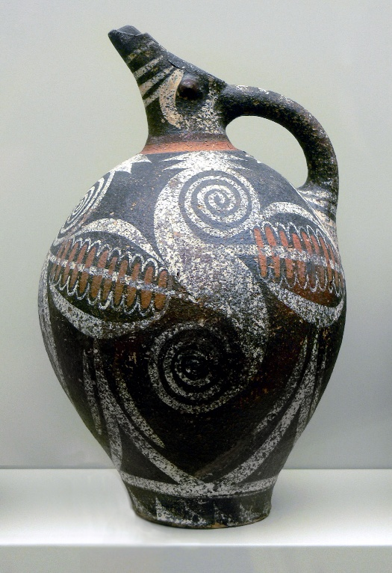
In addition to archaeological evidence, historical and textual sources provide important insight into the nature and scope of trade between Egypt and the Aegean during the second millennium BCE. Egyptian inscriptions, administrative records, and correspondence, alongside Aegean and Near Eastern texts, document the exchange of goods, diplomatic gifts, and tribute that formed part of long-distance trade networks across the eastern Mediterranean.
Figure 4- Minoan Kamares Wares
Egyptian sources, particularly from the New Kingdom period, refer to interactions with distant regions, including the Aegean. Royal annals and temple inscriptions note the receipt of luxury items and materials, some of which align with known Aegean products, such as decorated pottery and metalwork. Diplomatic correspondence preserved in the Amarna Letters (14th century BCE) indicates the circulation of gifts and commodities among Egypt, its vassals, and allied polities, suggesting established trade mechanisms that could have facilitated exchanges with Aegean societies indirectly or via intermediaries. Textual evidence thus complements archaeological finds, demonstrating that trade was embedded within broader systems of diplomacy and political relations.
Literary and symbolic texts also provide evidence for cross-cultural awareness and contact. Egyptian iconography and ritual texts occasionally reference foreign peoples, ships, and exotic goods, reflecting an awareness of Aegean material culture. Martino, for example, notes the influence of Minoan ritual motifs in Egyptian ceremonial contexts, which indicates not merely physical exchange but also the transfer of ideas and symbolic forms. Such references suggest that Egyptians recognized the prestige and value of Aegean objects, integrating them into elite and ritual settings.
Textual evidence from the broader eastern Mediterranean provides additional context. Late Bronze Age records from Canaan and other Levantine polities, such as those discussed by Dever and Gitin, reveal extensive trade networks linking Egypt with the Aegean, Anatolia, and the Levant. These sources demonstrate that Egypt was part of a complex, multi-directional exchange system, which included the movement of metals, luxury goods, and craft products, and that Aegean objects could reach Egypt through established regional channels. Stewart further highlights that textual references often corroborate archaeological finds, reinforcing the presence of imported Aegean ceramics and luxury items in Egyptian contexts.
Together, these historical and textual sources indicate that trade between Egypt and the Aegean was systematic, long-term, and embedded within political, diplomatic, and economic frameworks. Combined with archaeological evidence, they demonstrate that the exchange of goods, ideas, and symbolic practices played a central role in the interconnected world of the second millennium BCE Mediterranean.

Mark., Joshua J., ‘Trade in Ancient Egypt’, World History Encyclopedia, 15 June 2017 <https://www.worldhistory.org/article/1079/trade-in-ancient-egypt/> [accessed 5 December 2025]
Edu, World History, ‘Trade and International Connections in Ancient Egypt’, World History Edu, 18 March 2025 <https://worldhistoryedu.com/trade-and-international-connections-in-ancient-egypt/> [accessed 5 December 2025]
Mark., Joshua J., ‘Trade in Ancient Egypt’, World History Encyclopedia, 15 June 2017 <https://www.worldhistory.org/article/1079/trade-in-ancient-egypt/> [accessed 5 December 2025]
Stewart, B. (2022, March 25). Interconnectivity in the bronze age mediterranean. https://www.academia.edu/74576031/Interconnectivity_in_the_Bronze_Age_Mediterranean , p14
Mark., Joshua J., ‘Trade in Ancient Egypt’, World History Encyclopedia, 15 June 2017 <https://www.worldhistory.org/article/1079/trade-in-ancient-egypt/> [accessed 5 December 2025]
Stewart, B. (2022, March 25). Interconnectivity in the bronze age mediterranean. https://www.academia.edu/74576031/Interconnectivity_in_the_Bronze_Age_Mediterranean
Mark., Joshua J., ‘Trade in Ancient Egypt’, World History Encyclopedia, 15 June 2017 <https://www.worldhistory.org/article/1079/trade-in-ancient-egypt/> [accessed 5 December 2025]
Fantuzzi, Tiziano, ‘A Matter of Times’: Tell El Dab’a and the Interlinked Chronologies of Minoan Crete and Egypt in the Bronze Age, 3 June 2025 <https://unitesi.unive.it/handle/20.500.14247/2876> [accessed 26 November 2025]
Stewart, B. (2022, March 25). Interconnectivity in the bronze age mediterranean. https://www.academia.edu/74576031/Interconnectivity_in_the_Bronze_Age_Mediterranean
Mark., Joshua J., ‘Trade in Ancient Egypt’, World History Encyclopedia, 15 June 2017 <https://www.worldhistory.org/article/1079/trade-in-ancient-egypt/> [accessed 5 December 2025]
Stewart, B. (2022, March 25). Interconnectivity in the bronze age mediterranean. https://www.academia.edu/74576031/Interconnectivity_in_the_Bronze_Age_Mediterranean
Fantuzzi, Tiziano, ‘A Matter of Times’: Tell El Dab’a and the Interlinked Chronologies of Minoan Crete and Egypt in the Bronze Age, 3 June 2025 <https://unitesi.unive.it/handle/20.500.14247/2876> [accessed 26 November 2025]
Stewart, B. (2022, March 25). Interconnectivity in the bronze age mediterranean. https://www.academia.edu/74576031/Interconnectivity_in_the_Bronze_Age_Mediterranean
Martino, Paula L., ‘Egyptian Ideas, Minoan Rituals: Evidence of the Interconnections between Crete and Egypt in the Bronze Age on the Hagia Triada Sarcophagus’, Journal of Ancient Egyptian Interconnections, 4.1 (2012), pp. 31–50
Matić, Uroš, ‘Memories into Images: Aegean and Aegean-like Objects in New Kingdom Egyptian Theban Tombs’, Cambridge Archaeological Journal, 29.4 (2019), pp. 653–69, doi:10.1017/S095977431900026X
Edu, World History, ‘Trade and International Connections in Ancient Egypt’, World History Edu, 18 March 2025 <https://worldhistoryedu.com/trade-and-international-connections-in-ancient-egypt/> [accessed 5 December 2025]
Stewart, B. (2022, March 25). Interconnectivity in the bronze age mediterranean. https://www.academia.edu/74576031/Interconnectivity_in_the_Bronze_Age_Mediterranean
Martino, Paula L., ‘Egyptian Ideas, Minoan Rituals: Evidence of the Interconnections between Crete and Egypt in the Bronze Age on the Hagia Triada Sarcophagus’, Journal of Ancient Egyptian Interconnections, 4.1 (2012), pp. 31–50
Dever, William G., Seymour Gitin, and W. F. Albright Institute of Archaeological Research, Symbiosis, Symbolism, and the Power of the Past: Canaan, Ancient Israel, and Their Neighbors from the Late Bronze Age Through Roman Palaestina (Eisenbrauns, 2003)
Edu, World History, ‘Trade and International Connections in Ancient Egypt’, World History Edu, 18 March 2025 <https://worldhistoryedu.com/trade-and-international-connections-in-ancient-egypt/> [accessed 5 December 2025] Bibliography: BIETAK (Ed.), M. (2003) The Synchronisation of Civilisations in the Eastern Mediterranean in the Second Millennium B.C. II, ISBN 3-7001-3176-3. Verlag der Österreichischen Akademie der Wissenschaften. Available at: https://www.austriaca.at/epub-topics/Aegyptologie/Aegyptologie/3176-3 (Accessed: 26 November 2025). Dever, W.G., Gitin, S. and Research, W.F.A.I. of A. (2003) Symbiosis, Symbolism, and the Power of the Past: Canaan, Ancient Israel, and Their Neighbors from the Late Bronze Age Through Roman Palaestina. Eisenbrauns. Edu, W.H. (2025) ‘Trade and international connections in ancient Egypt’, World History Edu, 18 March. Available at: https://worldhistoryedu.com/trade-and-international-connections-in-ancient-egypt/ (Accessed: 5 December 2025). Fantuzzi, T. (2025) ‘“A Matter of Times”: Tell el Dab’a and the Interlinked Chronologies of Minoan Crete and Egypt in the Bronze Age’. Available at: https://unitesi.unive.it/handle/20.500.14247/2876 (Accessed: 26 November 2025). Mark., J.J. (2017) ‘Trade in Ancient Egypt’, World History Encyclopedia [Preprint]. Available at: https://www.worldhistory.org/article/1079/trade-in-ancient-egypt/ (Accessed: 5 December 2025). Martino, P.L. (2012) ‘Egyptian Ideas, Minoan Rituals: Evidence of the Interconnections between Crete and Egypt in the Bronze Age on the Hagia Triada Sarcophagus’, Journal of Ancient Egyptian Interconnections, 4(1), pp. 31–50. Matić, U. (2019) ‘Memories into Images: Aegean and Aegean-like Objects in New Kingdom Egyptian Theban Tombs’, Cambridge Archaeological Journal, 29(4), pp. 653–669. Available at: https://doi.org/10.1017/S095977431900026X. Merrillees, R.S. (1972) ‘Aegean Bronze Age Relations with Egypt’, American Journal of Archaeology, 76(3), pp. 281–294. Available at: https://doi.org/10.2307/503921. Papasavvas, G. and Kassianidou, V. (2012) ‘Eastern Mediterranean Metallurgy in the Second Millennium BC’, pp. 1–304. Stewart, B. (no date) ‘Interconnectivity in the Bronze Age Mediterranean’, p. 14. Figure 1 - Macquire, K. (2020). Some Active Trade Routes in the Bronze Age Mediterranean. [online] World History Encyclopedia. Available at: https://www.worldhistory.org/image/12695/some-active-trade-routes-in-the-bronze-age-mediter/. Figure 2 - Nuttersworld.com. (2025). Available at: https://nuttersworld.com/bronze-iron-age-shipbuilding-mediterranean/2000-1600BC/. Figure 3 - MeisterDrucke (2025). Boatmen on the Nile, from the Tomb of Sennefer, New Kingdom. [online] MeisterDrucke. Available at: https://www.meisterdrucke.us/fine-art-prints/Egyptian-18th-Dynasty/418788/Boatmen-on-the-Nile%2C-from-the-Tomb-of-Sennefer%2C-New-Kingdom.html [Accessed 7 Dec. 2025]. Figure 4 - smarthistory.org. (n.d.). Kamares Ware Jug – Smarthistory. [online] Available at: https://smarthistory.org/kamares-ware-jug/.

