

Name and Students ID:

Pawel Szpinek 2440926 group leader
Laszlo Balogh 2441884
Dan Alexandru Serban 2333276
Yasin Farooq 2337209
Daniel Burulea 2332668

Module Code: (LCBB5015_LON)
Module: Principles of Marketing
Subject: Component 2: Coursework: Group Report
Lecturer: Dr. Sinan He s.he@uwtsd.ac.uk

Table of Contents:
Executive Summary
1.0 Introduction and Company Mission
1.1 Company Background
1.2 Mission and Purpose of the Report
2.0 Situational Analysis
2.1 PESTEL Analysis
2.2 SWOT Analysis
2.3 Porter’s Five Forces
3.0 Marketing Strategy
3.1 Segmentation and Targeting
3.2 Positioning
3.3 Integrated Marketing Communications (IMC)
3.4 Ansoff Matrix
4.0 Marketing Mix Strategy – 7Ps
4.1 Product
4.2 Price
4.3 Place
4.4 Promotion
4.5 People
4.6 Process
4.7 Physical Evidence
5.0 Implementation and Control
5.1 Implementation Plan
5.2 Key Performance Indicators (KPIs)
5.3 Balanced Scorecard
6.0 Conclusion
7.0 Recommendations

Executive Summary
This report develops a strategic marketing plan aimed at increasing sales at Sainsbury's plc within the highly competitive UK grocery retail market. The sector is influenced by price competition, changing consumer expectations, digital transformation and increasing demand for sustainable business practices. Consequently, supermarkets must provide value for money while maintaining quality, convenience and profitability. The report evaluates Sainsbury's position using PESTEL, SWOT and Porter's Five Forces. It then applies Segmentation, Targeting and Positioning (STP), Integrated Marketing Communications (IMC), the Ansoff Matrix and the extended marketing mix (7Ps). The analysis identifies Sainsbury's strong brand, Nectar loyalty programme, omnichannel presence and own-brand portfolio as important competitive strengths. However, competition from discount supermarkets, price-sensitive customers and changing technological expectations remain significant challenges. The report recommends greater use of Nectar data for personalised promotions, continued development of sustainable and healthy products, improved digital shopping experiences and stronger omnichannel services. Implementation is supported by measurable Key Performance Indicators (KPIs) and the Balanced Scorecard. Overall, the proposed strategy aims to increase sales while strengthening customer loyalty and Sainsbury's long-term competitive position.

1.0 Introduction and Company Mission
1.1 Company Background
Sainsbury's plc was established in London in 1869 by John James Sainsbury and Mary Ann Sainsbury. It has developed from a small grocery business into one of the UK's leading retailers. Its operations include supermarkets, convenience stores, online grocery services, Argos and the Nectar loyalty programme (Sainsbury's, 2025). Sainsbury's operates in a highly competitive environment alongside Tesco, Asda, Aldi, Lidl, Morrisons and Marks & Spencer. The growth of discount supermarkets and online shopping has significantly changed consumer behaviour. Customers increasingly expect competitive prices, convenience, quality products, sustainability and personalised digital services (Kotler, Keller and Chernev, 2022). Sainsbury's strategic approach is based on delivering quality and value while developing its digital, convenience and sustainability capabilities. These priorities are particularly important because competitive advantage in grocery retailing can no longer depend only on store location or product availability.
1.2 Mission and Purpose of the Report
Sainsbury's mission is centred on helping customers live well for less by combining quality, value, customer service and responsible business practices. This reflects the marketing principle of creating customer value while addressing wider stakeholder expectations (Armstrong et al., 2021).The purpose of this report is to develop a marketing plan that can increase Sainsbury's sales in the UK. It evaluates the organisation's internal and external environment, identifies attractive customer segments, assesses its marketing mix and proposes practical recommendations. The key challenge is balancing affordability with differentiation. Inflation and cost-of-living pressures have increased price sensitivity, strengthening the appeal of Aldi and Lidl. At the same time, customers expect convenient digital services, personalised offers and environmentally responsible products. Therefore, Sainsbury's must compete on value rather than price alone.
2.0 Situational Analysis
Situational analysis enables an organisation to understand the internal and external factors affecting its marketing decisions. Kotler, Keller and Chernev (2022) argue that effective marketing strategy requires an understanding of customers, competitors and the wider business environment. PESTEL, SWOT and Porter's Five Forces are therefore applied to Sainsbury's.

2.1 PESTEL Analysis
PESTEL considers political, economic, social, technological, environmental and legal influences on an organisation (Johnson et al., 2020).

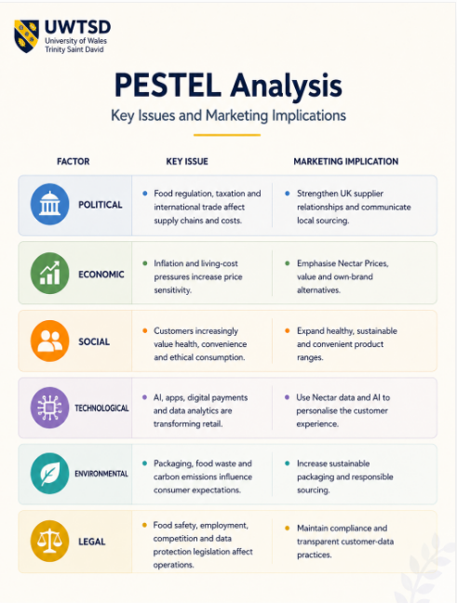
The economic environment presents a significant challenge because customers facing higher household costs are more likely to compare prices and consider discount supermarkets. Sainsbury's should therefore strengthen perceptions of value through Nectar Prices and competitively priced own-brand products rather than relying on extensive price reductions that could damage profitability. Technology creates a significant opportunity. Nectar provides customer purchasing information that can support more personalised marketing. Chaffey and Ellis-Chadwick (2022) suggest that digital technologies and customer data can improve targeting and engagement. Sainsbury's can therefore use analytics to offer relevant promotions rather than relying on generic discounts. Environmental expectations also create opportunities for differentiation. Sustainable packaging, responsible sourcing and reduced food waste can contribute to brand reputation. However, sustainability initiatives must remain affordable because customers may be unwilling to pay substantial premiums during periods of economic pressure.

2.2 SWOT Analysis
SWOT identifies internal strengths and weaknesses alongside external opportunities and threats (Armstrong et al., 2021).
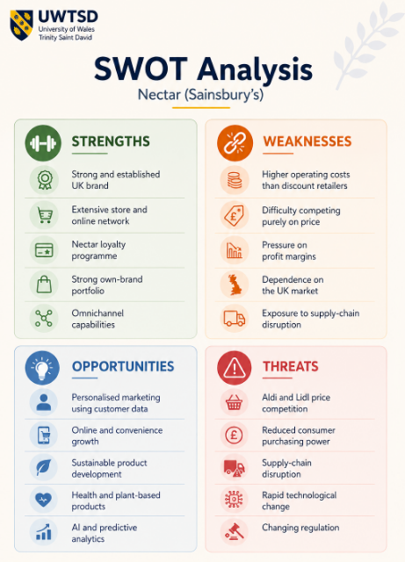
Sainsbury's brand reputation and Nectar programme provide an important basis for differentiation. Nectar is particularly valuable because it supports both customer loyalty and data-driven marketing. However, Sainsbury's higher operating-cost structure means competing directly with Aldi and Lidl solely through low prices may be unsustainable. The strongest opportunities therefore involve combining technology with existing capabilities. Personalised promotions can encourage repeat purchasing without requiring discounts across the entire product range. Similarly, sustainable and healthier products can differentiate Sainsbury's from competitors. The strategic priority should consequently be to strengthen customer value while protecting the brand's quality position.

2.3 Porter's Five Forces
Porter's Five Forces assesses competitive intensity and the factors influencing industry profitability (Porter, 2008).
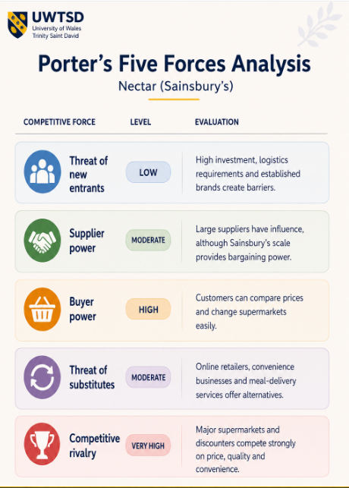
Competitive rivalry and buyer power are the most important forces. Customers face low switching costs and can compare prices online, making loyalty difficult to maintain. Discount supermarkets further increase pressure on established retailers. Nevertheless, price is not the only basis of competition. Sainsbury's can reduce the risk of switching by combining Nectar rewards, personalised promotions, high-quality own-brand products and convenient online and physical shopping. Overall, the situational analysis suggests that differentiation through customer experience, digital innovation and value offers a more sustainable strategy than direct price competition.

3.0 Marketing Strategy
Marketing strategy determines how an organisation selects customers and creates superior value for them. Sainsbury's should adopt a customer-focused approach based on STP, integrated communications and carefully selected growth strategies.

3.1 Segmentation and Targeting
Market segmentation divides customers into groups with similar characteristics, needs or behaviours (Armstrong et al., 2021). Sainsbury's can segment customers demographically, geographically, psycho-graphically and behaviourally. Demographic groups include families, students, professionals and older customers. Geographic segmentation reflects differences between urban, suburban and rural markets. Psychographic segmentation is increasingly relevant to health-conscious and environmentally aware consumers. Behavioural segmentation includes frequent online shoppers, Nectar members and value-conscious customers. Behavioural segmentation provides particularly strong potential because Nectar data can identify shopping frequency and product preferences. This can enable Sainsbury's to provide more relevant promotions and recommendations. Psychographic segmentation is also important because demand for healthy, plant-based and sustainable products continues to influence grocery purchasing. Sainsbury's should maintain a differentiated targeting strategy focusing particularly on four groups: families, working professionals, health-conscious consumers and value-conscious shoppers. Families provide frequent purchases and high lifetime value, while professionals value digital convenience and delivery. Health-conscious customers create opportunities for product innovation, while value-conscious consumers can be retained through own-brand ranges and Nectar Prices.

The disadvantage of differentiated targeting is increased marketing complexity. Therefore, Sainsbury's should use customer analytics to improve targeting efficiency rather than developing expensive mass campaigns for every customer group.

3.2 Positioning
Positioning concerns the place a brand occupies in customers' minds compared with competitors (Ries and Trout, 2001). Sainsbury's occupies a middle-market position combining quality, affordability, convenience and trusted British heritage. This differentiates it from Aldi and Lidl, which focus strongly on price, while remaining more accessible than premium-focused competitors. However, increased price sensitivity means quality alone may not be sufficient. Sainsbury's positioning should therefore communicate quality, personalised value and sustainable convenience. This approach reinforces the idea that value does not necessarily mean the lowest price. Instead, customers receive quality products, relevant discounts, convenience and responsible choices within one retail relationship.

3.3 Integrated Marketing Communications
Integrated Marketing Communications coordinates promotional activities so customers receive a consistent message across channels (Belch and Belch, 2021). Sainsbury's uses television, social media, email, digital advertising, in-store promotion, public relations and Nectar communications. Digital channels should receive increased emphasis because they allow more precise targeting. Nectar data can support personalised emails, app notifications and digital offers based on purchasing behaviour. Social platforms can also support engagement with younger consumers through short-form content and appropriate influencer partnerships. However, excessive promotional communication may cause customers to disengage. Sainsbury's should prioritise relevance rather than frequency. AI-supported recommendations could help determine which products and promotions are most appropriate for individual customers, while consistent sustainability and value messaging should reinforce the overall brand position.

3.4 Ansoff Matrix
The Ansoff Matrix identifies four growth strategies: market penetration, product development, market development and diversification (Ansoff, 1957). For Sainsbury's, market penetration should be the primary strategy because it provides opportunities to increase purchases from existing customers through personalised Nectar offers, loyalty incentives and digital engagement. It carries lower risk than entering unfamiliar markets. Product development is also appropriate. Expanding healthier, plant-based, sustainable and premium own-brand products would respond to changing customer preferences while strengthening differentiation. Market development can be achieved through wider online delivery coverage and convenience formats. Diversification, including new AI-enabled services, may provide longer-term opportunities but involves greater uncertainty and investment. Consequently, market penetration and product development should receive priority because they build on Sainsbury's existing brand, customer relationships and retail capabilities.

4.0 Marketing Mix Strategy – 7Ps
Booms and Bitner (1981) extended the traditional marketing mix to include People, Process and Physical Evidence. The 7Ps provide a practical framework for converting Sainsbury's marketing strategy into customer value.

4.1 Product
Sainsbury's portfolio includes groceries, clothing, homeware and Argos products alongside own-brand ranges such as Taste the Difference, Stamford Street and Plant Pioneers. This allows the organisation to serve customers with different budgets and preferences. Product development should focus on healthy, plant-based, locally sourced and sustainable products. Increasing recyclable or reduced-plastic packaging would further strengthen differentiation. Sainsbury's could also use the Nectar app to provide personalised meal recommendations based on purchasing behaviour.

4.2 Price
Pricing strongly influences both customer demand and profitability (Armstrong et al., 2021). Sainsbury's uses competitive, promotional, psychological and loyalty-based pricing, including Nectar Prices. Attempting to match discounters across all products could weaken profitability. Personalised Nectar discounts provide a more targeted alternative because discounts can be directed towards products relevant to individual customers. Dynamic reductions on short-dated food could additionally provide customer value while supporting food-waste reduction.

4.3 Place
Sainsbury's uses supermarkets, convenience stores, online grocery shopping, Click & Collect, home delivery and Argos collection points. This omnichannel structure provides significant convenience. Further improvements should focus on the digital customer journey, delivery efficiency and Click & Collect. Same-day services can be expanded where commercially viable, while AI-supported route planning could improve delivery efficiency. The objective should be to make movement between online and physical channels as simple as possible.

4.4 Promotion
Sainsbury's promotional activities include television, social media, digital advertising, email, Nectar promotions, public relations and in-store communication. Future promotion should place greater emphasis on personalised digital communication, short-form social content, loyalty rewards and sustainability messaging. Traditional advertising remains useful for brand awareness, but digital marketing offers stronger opportunities for individual targeting and measurable customer engagement (Chaffey and Ellis-Chadwick, 2022).

4.5 People
Employees remain central to the customer experience despite increasing automation. Staff knowledge, behaviour and service quality influence customer satisfaction and repeat purchasing. Sainsbury's should invest in digital skills, customer service and sustainability training. Technology should support employees rather than simply replace personal interaction. Performance recognition and employee wellbeing are also important because motivated employees are more likely to provide positive customer experiences.

4.6 Process
Process includes ordering, payment, delivery, returns, complaints and other activities involved in serving customers. Customers increasingly expect these processes to be fast and convenient. Sainsbury's should continue improving online checkout, digital receipts, smart shopping lists and customer support. AI-supported inventory and demand forecasting could also improve product availability. These improvements may simultaneously enhance customer satisfaction and operational efficiency.

4.7 Physical Evidence
Physical evidence includes store design, cleanliness, displays, packaging, branding, websites and mobile applications (Booms and Bitner, 1981). Although physical stores remain important, digital interfaces increasingly influence perceptions of service quality. Sainsbury's should therefore maintain attractive stores while improving website and app navigation, accessibility and personalisation. Sustainable packaging should also be visible and clearly communicated to customers. Overall, the 7Ps should operate as an integrated strategy rather than independent activities. Personalised pricing is more effective when supported by appropriate products, convenient digital processes and consistent communications.

5.0 Implementation and Control
Effective strategy requires clear implementation and performance monitoring. Kotler, Keller and Chernev (2022) emphasise that marketing implementation converts strategic plans into actions. Sainsbury's should therefore establish responsibilities, timescales and measurable outcomes.
5.1 Implementation Plan
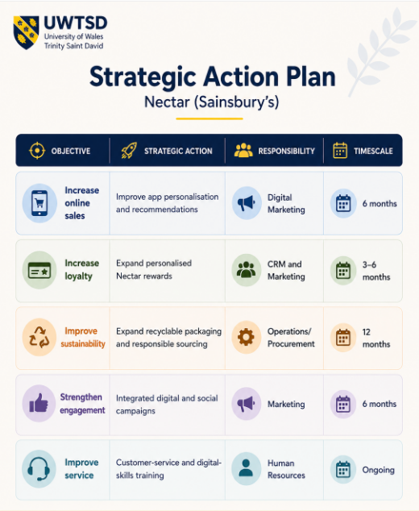
Digital personalisation should receive early priority because Sainsbury's already possesses Nectar and online infrastructure. Sustainability initiatives may require longer implementation because changes to packaging and sourcing involve suppliers and operational processes.

5.2 Key Performance Indicators
KPIs provide measurable evidence of whether marketing activities are achieving their objectives (Armstrong et al., 2021). Proposed indicators include a 10% increase in overall sales within 12 months, a 15% increase in online revenue, a 12% improvement in repeat purchasing, increased monthly active app users and improved customer satisfaction. These targets should be reviewed regularly rather than treated as fixed measures. Financial indicators demonstrate immediate commercial performance, while customer retention, digital engagement, employee satisfaction and sustainability indicators provide information about longer-term competitive strength.
5.3 Balanced Scorecard
Kaplan and Norton (1996) propose the Balanced Scorecard as a method of evaluating performance beyond financial results.

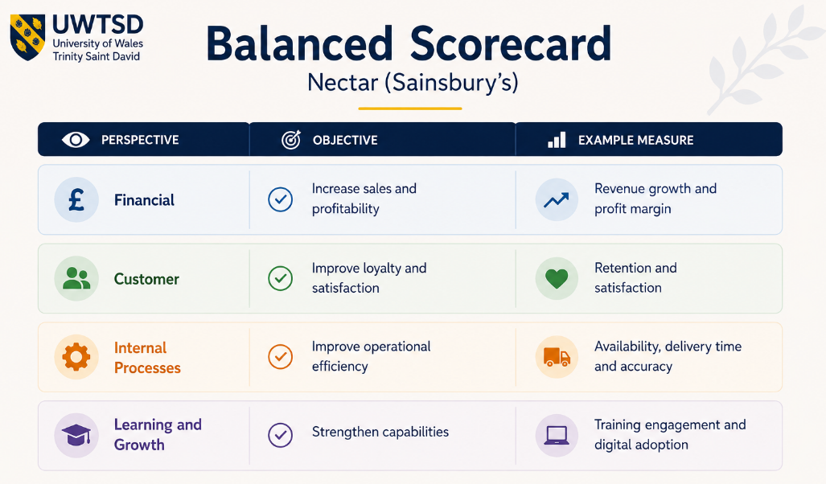
For Sainsbury's, this approach is appropriate because sales growth depends on several interconnected factors. Customer satisfaction can encourage loyalty, efficient processes can reduce costs and employee development can improve service quality. The Balanced Scorecard therefore provides a more complete assessment than financial measures alone.

6.0 Conclusion
This report has developed a strategic marketing plan for increasing Sainsbury's sales within the competitive UK grocery market. The situational analysis identified strong rivalry, high buyer power, price sensitivity, technological change and sustainability expectations as major influences on the organisation. Sainsbury's nevertheless possesses significant competitive strengths, particularly its established brand, store and online network, own-brand products and Nectar loyalty programme. These capabilities provide opportunities to differentiate the company through personalised value rather than relying entirely on price competition. The STP analysis demonstrates that behavioural and psychographic segmentation can strengthen customer targeting, particularly when supported by Nectar data. The Ansoff Matrix indicates that market penetration and product development represent the most appropriate growth strategies because they use existing capabilities while responding to changing customer expectations. The 7Ps analysis further demonstrates that digital personalisation should be supported by appropriate products, targeted pricing, omnichannel convenience, integrated promotion, trained employees and efficient processes. Implementation should then be monitored through clearly defined KPIs and a Balanced Scorecard. Overall, Sainsbury's should combine quality, personalised value, digital convenience and sustainability as the foundation of its marketing strategy. This approach provides a realistic opportunity to strengthen customer loyalty, increase purchasing frequency and support sustainable sales growth.

7.0 Recommendations
Based on the analysis, five recommendations are proposed. First, Sainsbury's should strengthen digital personalisation. Nectar purchasing data and AI-supported analytics should be used to provide relevant discounts, product recommendations and shopping experiences. This can increase purchasing frequency while avoiding unnecessary mass discounting. Second, sustainable and healthy product development should continue. Greater availability of plant-based, locally sourced and environmentally responsible products can respond to changing consumer expectations and support differentiation. Third, Sainsbury's should strengthen its omnichannel experience. Improvements to the mobile app, Click & Collect, delivery and online ordering can provide greater convenience and support growth among digitally engaged customers. Fourth, employee development should remain a strategic priority. Training in digital systems, customer service and sustainability can help ensure that technological change improves rather than reduces service quality. Finally, performance should be monitored continuously. Sales, online revenue, retention, customer satisfaction, employee engagement and sustainability indicators should be reviewed through KPIs and the Balanced Scorecard. This will allow management to identify underperformance and adapt marketing activities when required.

Reference List:

Ansoff, H.I. (1957) ‘Strategies for diversification’, Harvard Business Review, 35(5), pp. 113–124.
Armstrong, G., Kotler, P., Harker, M. and Brennan, R. (2021) Marketing: An Introduction. 5th European edn. Harlow: Pearson.
Belch, G.E. and Belch, M.A. (2021) Advertising and Promotion: An Integrated Marketing Communications Perspective. 12th edn. New York: McGraw-Hill.
Booms, B.H. and Bitner, M.J. (1981) ‘Marketing strategies and organisation structures for service firms’, in Donnelly, J.H. and George, W.R. (eds.) Marketing of Services. Chicago: American Marketing Association, pp. 47–51.
Chaffey, D. and Ellis-Chadwick, F. (2022) Digital Marketing. 8th edn. Harlow: Pearson.
Johnson, G., Scholes, K., Whittington, R. and Angwin, D. (2020) Exploring Strategy. 12th edn. Harlow: Pearson.
Kaplan, R.S. and Norton, D.P. (1996) The Balanced Scorecard: Translating Strategy into Action. Boston: Harvard Business School Press.
Kotler, P., Keller, K.L. and Chernev, A. (2022) Marketing Management. 16th Global edn. Harlow: Pearson.
Porter, M.E. (2008) ‘The five competitive forces that shape strategy’, Harvard Business Review, 86(1), pp. 78–93.
Ries, A. and Trout, J. (2001) Positioning: The Battle for Your Mind. New York: McGraw-Hill.
Sainsbury's (2025) Annual Report and Financial Statements 2025. London: J Sainsbury plc.

