Jhondel Piper

Student -2029600

Module Code -BMSW4002

Tutor – Azora Hurd

Effective Team Working and Communication



Introduction

Team work is vital in any organisation and it is especially critical to the survival of Trinity Social Care Home. Team work is required in the care home to achieve their common goal which is to provide care for service users. Lack of team work causes chaos and causes the team to be dysfunctional. Having an effective team at Trinity Social Care Home will build good team spirit and help to solve their current problems in the organisation and hence meet the company’s objective. (Amour (2005).

The primary objective of the team at Trinity Social Care Home should be to share knowledge with each other so that each member will be able to use this knowledge to accomplish their individual objective. Additionally, this makes the shared responsibilities easier to meet.
How management at Trinity Social Care Home can develop an effective team.

The primary reason of being an effective team in any organisation or in particular Trinity Social Care Home is that it builds a cohesive environment that can bring about innovative measures so that the organisations goals may be attained and as a result yield better efficiency and output.

There is always room for improvement in any organisation even when it appears that the team is highly efficient with robust performance. The team at Trinity Social Care lacks several measures that will be highlighted in the foregoing. As a result, there are several qualities that the manager must implement to make its team both efficient and effective.
- Understand the Key Elements that builds and eventually makes an Effective Team
There are five key elements that not only must be understood but be implemented into the fibre of the organisation. These will act as a catalyst to improve team building ( Canada Health Centre, 2003)
- Have define goals and objectives for the team
All staff at Trinity Social Care Home must have clear knowledge of the organisation’s objectives, that is their purpose and aim. If the employees are unaware or lack knowledge of the organisations goal and objectives, both the business and its employees will fail and the organisation will be forced to subcontract its business
- Clear well -defined roles
All employees must understand and have clear knowledge of their roles on the team and the position they hold within the organisation. They must know the company’s organisation chart and its hierarchy.
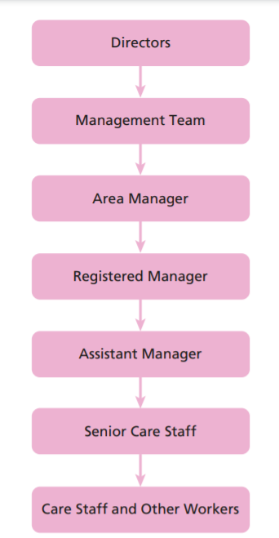
Figure 1 Examples of Health and Social Care organisational Chart, Source
Canadian Institute for Health Information. (2001)

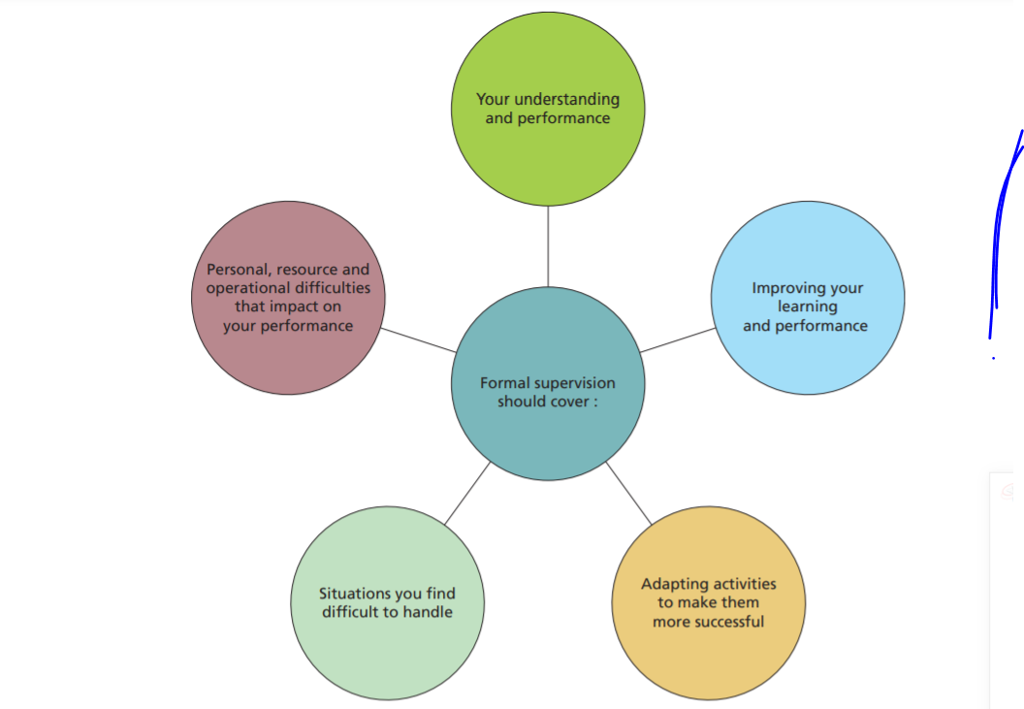
Figure Formal Supervision, Source
Canadian Institute for Health Information. (2001)
- Collaboration
There must be collaboration among the team as its about group efforts and not self-attainment
- Excellent communication
Good communication among the team members where they can speak freely must be encourage so as to encourage the flow of ideas and thoughts. The communication must be positive and without malice and negativity
- Self-Development
Although working as a team is great and has numerous benefits, self-development must be encourage to grow each individual
Creating a Cohesive and Effective Team

Being cohesive can impact the group positively and can make the working environment stress free when working with others. With different projects, different challenges are always present so it’s important we make sure we are unified and consistently work well as a team. A team often needs somebody to guide the group and push others, this is known as the team leader.

Ideas on how to build an effective cohesive team

- Define goals and values
- Offer training and development
- Encourage team building
- Communicate more
- Build trust
- Celebrate success together reach more goals

- Having Solid Leadership
The Manager of Trinity Social Car Home must be a strong leader. A leader that is driven to succeed will be able to inspire the team to be successful. The manager of Trinity Social Care Home must lead by example, not just to use their authoritative position to intimidate but to build trust and respect through transparency, They must be approachable so that members of the team feel confident and safe to discuss relevant matter with them.
Factors that Help to Build Good Leadership at Trinity Social Care Home
- A good manager must be able to virtualize and see the larger image
- A manager must have their ability to delegate duties in a fair manner
- A Manager must be able to communicate effectively to its team members . A good manager who communicates well with its member of staff and have other good qualities will be willingly followed by others,

- Establish a Connection

The Team Leader or Manager at Trinity Social Care Home must constantly assess how the team members collaborate with each other. It is their duty to both direct and lead its employees to build good relationship with one another , thus helping to increase their out put and efficiency of the organisation. One way to do this is to study and practise team building activities with its other members to help build trust and dependability on all.
- Team Leader/Manager must Establish Connection with Everyone

The team leader or Manager at Trinity Social Care Home must have one to one with each member the staff to get to know them better. Conversing with them gives the Manager a better idea of their skills and preferences, This information will help determine the particular role that is suitable for the employee.
When team leaders know these facts, they are able to match each worker with the right task and build trust and engagement on a personal level. (Alberta. Premier's Advisory Council on Health. (2001).
- Talk to the team members
One way to improve team building at Trinity Social Car Home is that the team leader or Manager must listen to all its members and encourage them to talk and share their ideas with the group.
The team leader must observe the connection between its member developing trust among them. The leader should discuss the role with each member and encourage its members to develop rapport among each other and with the team leader. The members can also give their impute on the task and suggestions on how to improve,
- Adopting Beneficial Hobbies
Adopting hobbies can help with entertain the team and also help build emotional support among its team members and help build positive relationships which in turn make the team more efficient, yielding profitability of the organisation in the long run. This could range from playing games to volunteering to assist another organisation.
- Team Building Exercises
Similarly, to Adopting Hobbies, implementing team building exercises will boost relationship among the staff, These range from outdoor adventures such as tennis match, hiking to games to social events such as picnics.
- Provide constructive Feedback
A good team leader gives constructive feedback to its members. It must measure the success of its members whether financially such as bonuses or non-financially that is awards in the form of certificates. The feedback must be within reasonable time so as to help even member improve the efficiency and effectiveness of the team.
The impact effective team working can have in a health and social care setting.

Being an Effective team can significantly impact the health and social care, This is because clinical care is now a necessity and is become vital to the survival of our community,

The health care sector must work together as a team to work together and battle these health complications. Additionally, with an aging population medical staff have no choice but to work together and are taking a serious and dedicated approach to work together to combat these chronic illnesses such as diabetes and heart disease just to name a few.
Another positive impact is effective team building in social care is that working together as a cohesive network improves the security and care of the patient. No one team member is responsible for a patient as an entire team is responsible for that individual
Health teams help break down hierarchy and centralized power of health organizations, giving more leverage to health workers. Therefore, health and social care workers working together as a team helps to build stability and assist with problem solving techniques in the care home. Researchers have confirmed that working in a team in a health and social care environment is a key component to treating its service users and give them access to better health care.

Lastly, families have reported to be now more satisfied with the health and social care setting due to the fact that communication is a major key characteristic in the health and social care setting. Recent survey has found that social and health care workers have become more satisfied with their work environment for those teams who have been practicing to build a successful team (Premier's Health Quality Council. 2002, January)

Barriers to Effective Teamwork

There are several barriers that can hamper effective teamwork, These are outlined below

Conflict
Conflict can occur when members have different perceptions. There are several persons in a team and each may have their own opinions This can lead to conflict and is a major barrier to effective team building. If the team continue to experience unresolved conflicts, this can have a negative effect in the team. This can lead to dislikes among team members, disengagement of team members and an overall break down of the team. When this occurs in a health and social care setting it is the clients that affected as they will no longer receive adequate and appropriate care that they require
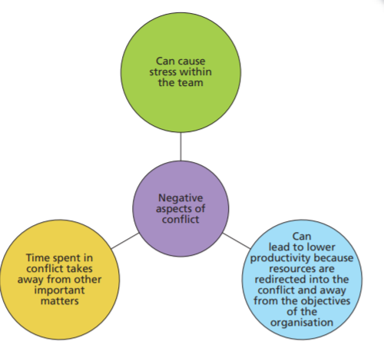

Figure 1 Negative aspect of Conflict ,Source
Canadian Institute for Health Information. (2001)

Role and Leadership Ambiguity

Each member of staff needs to understand their role and working within the boundary of their role. As there are several roles in the health and care sector it is important that your boundaries be explained. Performing duties outside your boundaries can have a significant impact and the health and wellbeing of the clients, other staff members and even yourself.

Conclusion

It is integral in any organisation to have to have an efficient team. In order for the Trinity Social Care to survive they must build an effective team; however, this takes time and does not happen instantly. It takes much evaluation that requires attention of management to complete this process and in turn help the organisation to succeed. Although there is diversity among the team which is good, without effective team work Trinity Social Care Home will become even more disorganised and the service users will be affected

REFERENCES

D’Amour, D., Oandasan, I. (2005). Interprofessionality as the field of interprofessional practice and interprofessional
education: An emerging concept. Journal of Interprofessional Care,19(Supplement 1), 8-20

Lomas, J., Culyer, T., McCutcheon, C., McAuley, L., & Law, S. (2005). Conceptualizing and combing evidence for health
system guidance: Final report.Ottawa, ON: Canadian Health Services Research Foundation

Canada. Health Canada. (2003). First Ministers’ accord on health care renewal.Ottawa, ON: Health Canada.

Canada. Health Canada. (2004). First Ministers’ meeting on the future of health care: A 10-year plan to strengthen health
care.Ottawa, ON: Health Canada.

Commission of the Future of Health Care in Canada. (2002, November). Building on values: The future of healthcare in

Canada. Parliament. Senate. Standing Committee on Social Affairs, Science and Technology. The health of Canadians:
The federal role: Final report on the state of the health care system of Canada.[Chair: M. J. Kirby] . Ottawa, ON: Standing
Committee on Social Affairs, Science and Technology

Alberta. Premier's Advisory Council on Health. (2001). A framework for reform: Report of the Premier’sAdvisory Council on
Health.[Chair: D. Mazankowski] . Edmonton, AB: Premier's Advisory Council.

Saskatchewan. Commission on Medicare. (2001). Caring for medicare: Sustaining a quality system.[Chair: K. J. Fyke].
Regina, SK: Commission on Medicare.

Québec Commission d'étude sur les services de santé et les services sociaux. (2000, December). Emerging solutions:
Report and recommendations of La Commission d’étude sur les services de santé et les services sociaux.[Chair: M. Clair].
Trois-Rivières, PQ: Commission d’étude sur les services de santé et les services sociaux.

New Brunswick. Premier's Health Quality Council. (2002, January). Health renewal: A discussion paper.Fredericton, NB:
Premier's Health Quality Council.

British Columbia. Legislative Assembly. Select Standing Committee on Health. (2001). Patients first: Renewal and reform
of British Columbia’shealth care system.Victoria, BC: Select Standing Committee on Health

Canadian Institute for Health Information. (2001). Canada’shealth care providers.Ottawa, ON: Canadian Institute for
Health Information

British Columbia. Office of the Auditor General. (2004). In sickness and in health: Healthy workplaces for British

