Pontypridd, Bridge of the earthen house. It sits between Merthyr Tydfil and Cardiff. Probably a house made of bricks which was not the normal building material in early Wales. Even today most of the older buildings are made of stone. It is a town in the district of Rhondda Cynon Taff. The river Rhondda joins the river Taff in the town of Pontypridd. This is one of the twenty-two unitary authorities in Wales. Looking at older maps you can see that it was part of a much larger district known as Glamorgan.
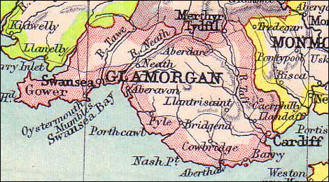
C. J. O. Evans suggests that the name Glamorgan is from the name “Gwlad Morgan” meaning, land of Morgan. He says the information is from the book of Llan Dav he also says this information is not reliable! We have many documents from the 11th century onwards, after the Norman invasion, that testify to the district being known as Glamorgan. It is interesting that much of the land around Glamorgan is Carboniferous that is, from the mountain region coming down from the Brecon Beacons until it changes as it gets to the flatter costal parts. Carboniferous translates to coal. Plenty of it and of a good quality. Therefore, people were willing to fund the mines and pits, and this is how the towns grew into cities in Glamorgan during the industrial revolution. The great influx of foreign workers meant that much of the population no longer spoke Welsh and the new homes and districts were, to some extent, becoming more anglicized and losing the Welsh identity.
The town of Pontypridd or “Ponty,” as it is colloquially termed, is also known as the head of the valleys. When you see Ponty on the map you can see the well-known names of the Rhondda valleys like Treherbert, a farmstead until the industrial revolution going from a population in 1841 of 218 people and by 1861 with the train line and coal mining the population had risen to 1,203. Treorchy has a similar history and has a world-famous male voice choir. This information can be found on any search engine and is only pertinent to our investigation of Pontypridd as they are neighbours and have a similar genesis. The coal mines brought in jobs with no shortage of people to take them. In the pre-industrial revolution, the area around Pontypridd was a rural, farming Welsh speaking population. After the railways and mines it became more cosmopolitan.
Initially looking at the place names we will be using the ordnance survey street atlas. This gives a better all-round view of the two-dimensional area. We will also look at the up-to-date map of the AA route planner.

P150
1A TON-TEG or Tonteg or the earliest recorded spelling Tonn Tege1541 The name could mean beautiful hill but is more likely to be related to the older Welsh, Tonnau, for grassland or Leyland as is used for nearby Tonypandy and Tonyrefail.
1B GWAELOD-Y-GARTH ROAD. A modern translation says the bottom enclosure. There was a hamlet in the Merthyr Tydfil recorded in 1426. The road mentioned leads to the Pen-tyrch iron works established in the 1740s.
Upper Boat. The upper boat, 1766. A ferry across the river Taff. A foot bridge was built in 1875 to replace the ferry and a road bridg by 1901.
1C HEOL-Y-BWNSI. The A740 was built in South Wales in 1971. The road between Ponty and Nantgarw was built over the old canal. There is an embankment that reaches up to the Heol-y-bwnsi lane that runs parallel. There doesn’t seem to be a translation for bwnsi. The lane is no more than a trackway that is half in the Ponty district and half in the Caerphilly district. There was a mill house on the lane that is now a home for a pylon. The modern interpretation for bwnsi in bun. Probably more a coincidence.
HEOL-Y-GAMLAS. Road by the canal. Gamlas, f. Camlesydd. canal.
HEOL CROCHENDY. Lane with the old house that makes crockery. The Hendy, means old house
NANT FFYNON WEN. Nant means stream. Ffynnon, mouth of? spring or well, ‘holy well’ rev’ J James informs that when a word has ‘Wen’ in it like; Yr Eglwys wen, or Llys Wen, and the different spelling as in, Ty Gwyn. Goes back much further that church and the holy site is probably the ancient stone circles of the ancient places,
Under the Cardiganshire Llangybi Edward Lhuyd wrote: "On Ascension Eve they (the people) resort to Ffynnon Wen; after they have washed themselves, they go to Llech Gybi, that is an arrow's flight from the well. There they put the sick under the Llech, where, if the sick sleeps, it is an infallible sign of recovery; if not, of death."
From 'The Lives of the British Saints, v2' by S. Baring Gould and John Fisher (1908).
http://books.google.co.uk/books?id=uE3pXSdZd5gC&pg=PA213

2A HAWTHORN. The general area was known as Taff Vale in 1868 and it was White hawthorn cottage in 1875 Taff Vale is probably modern beginning Glyn Taff. And it means the narrow valley. P212
AFON TAF. River Taf
DYNEA ROAD. Is near Rhydfelin. The closest meaning seems to be man. Though being a modern place, it could be from a modern name.
2C FFYNNON ISAFF. Is a farm that means ‘lower hill.’ It is on the Ffynnonbwla road. there is no translation for this name. it seems to be lost in antiquity. the dictionary has a similar word to bwla that seems to mean ‘gap’. This road leads downhill and on to the ‘heol-y-bwnsi lane.
LLWYN ONN FARM. Shrubby ash tree land. Called ‘Tere Llowyn On.’ in 1701. And ‘Tire Llowyn On’ in 1756. The name Onn could not be found in the Welsh dictionary or online. Is it a term no longer used or so obvious in Welsh that no explanation needed?
3A RHYDYFELIN. Felen – Melen. Yellow-brown ford. Suggested from the colour of the mud churned up by the horses’ hooves. Tir ynys y Ryd velen 1522. Rhyd-y-velen 1885. Rhydfelin is a late error meaning ford of the mill.
COED CRAIG-LWYD. The Grey wooded cliff. A description of the place of old.
3B FFORESTNEWYDD. The new forest. As opposed to the ancient forest that must have been in the area for millennia.
CWRT-Y-CELYN. The Holy court. A church or monastery. Some sort of holy order nearby.
4A CRAIG FACH. Small cliff.
BRYN TAIL. Translated as hill of manure. Could have been a dumping ground.
HENDRE-POSSER. Old house. Hendre is a term for the home you go home to in winter. The farmer and his family would go to higher, pleasant pasture for the summer and go home to Hendre, the old winter home. A Welsh translation for posser could not be found. In Victorian times a posser was an instrument used for washing clothes with. Could this be an Anglo-Welsh fusion word or is the original meaning lost to us?
TIR CAE MAWR. A third of the land.
P149
2E RHYD-Y-LLECH. The grey slate ford.
MAENDY. The house roofed with slate. In early times the stone homes would have been thatched so the slat roof would have been a thing to note.
2F CRAIG Y FFOREST FARM. Craig, rock or stone. Fforest, forest. Rocky forest farm. Not a good farm for arable crops.
HEOL-Y-CAWL. Soup lane. A track with Welsh broth on. It also translates to cabbage. So cabbage lane. It is very close to the farm Craig y Fforest. Part of the same complex?
COED TIR-ISAF. Trees on the low land.
3D MAES-Y-GRUG. (BUNGALOW) area of the heather. Grug translated to erica which is Gaelic for heather. An old Brythonic word?
LLANTRISANT ROAD the road that leads to the church of three Saints. Llantrissen, 1247.
3E COEDBERTHLWYD. Trees land Grey. As a translation it doesn’t make much sense but in one translation it says, a light reflection. Walking under the dappled leaves? Could not find a reasonable translation for this place.
NANT Y FFOREST. Stream by the forest.
FFOREST UDHAF FARM. High forest farm. The farm by the forest on the hill.
COED FFOREST UDHAF. Upper woodland forest.
TREFOREST. Forest land. There are plenty of placenames in this area that mention forest or coed, meaning trees. The area of Treforest was also known as craig y forest, 1833 and Fforest Isaf, lower forest. The Pontypridd tinplate works were in Treforest in 1794-1946 and the lower forest iron works that closed circa 1910. It is now home to a large trading estate.
3F NANT Y FFOREST. Stream by the forest
LLANTWIT ROAD. The road that leads to the church of St Illtud. Church village is next to and blended into Tonteg, that we mentioned earlier. Edward Lhuyd mentions the fair spring on Dihewid farm a mile from the village.
4D MAESCOED. Maes-y-coed, field at the wood. In past times known as Gelliwion wood. Because of its proximity to Gelliwion.
GELLIWION ROAD. Gwions grove, kellywyon 1541.
P125
1D PENHEOL ELY. Top of the road to the settlement. Eley c1126.
CEFN EGLWSILIAN. Back, ridge. Church of Ilan. There is no other mention of St Ilan. A man local to this area, William Thomas, 1762-1795 wrote the place name down as,Eglwyshilan. With Isaf meaning lower. The church on the lower ridge?
2D TWYN-Y-GWYNT. Windy hill. Also translates as windy dunes. Interesting because this is now the Pontypridd golf course.
COED BODWENARTH. Coed, Trees, Bod, to be. And if we follow the Reverend J James instruction, then Wen is an ancient holy meeting place. And Arth is a bear. We can speculate the meaning of this area, but it is no longer woodland but a housing estate.
CILFYNYDD. Mountain with a nook. The name was recorded as kylvuwch in 1729.
P124
1A PWLLGWAUN. Pool at the moor. Phool gwayn in 1623
RHONDDA ROAD. The road that leads to the Rhondda. The Rhondda stream or river runs into the river Taff in Pontypridd. The name has had many mutations over the years. Rotheni in the late 12th century. The Rhondda as we know it today is the villages that grew along the river during the industrial revolution.
CRAIGWEN. Stone cercle on the rocks?
PANTYGRAIG-WEN. Hollow in the rocks? This is now a housing estate. We can only speculate that the translation is the history.
1B TRALLWN. Dirty bogy pool. Next to the river Taff and prone to floods
1C PINTREBACH. Could this have been Pentre Bach? Small settlement.
COED-PEN-MAIN. Woods by the head rock or stone. On old maps it shows stone quarries in this area. There is an ancient rocking stone nearby, that local legend says, Saint Patrick is said to have leant against.
PENHEOL. ELY ROAD top of the lane. That leads to the settlement.
2A CRAIGWEN PARK. Is now part of craig wen housing estate.
DI-GOAD. There is nothing but a craggy looking field on the AA road map. In the Glamorgan Street atlas it shows as a wooded cope. On a google translate it says unsodden. has the meaning been lost in time?
GELLI-LWCH. Grove, Dust? There is nothing on the AA map, but it is Very close to the Graig-yr-Hesg Quarry
2B COED CRAIG-YR-HESG. Trees, cliff, the. Could Hesg be a name? this is a woodland nature reserve next to the quarry.
2C PONT SION NORTON. Siȏn Nortons Bridge. Nobody knows who Siȏn Norton was, but the bridge was built over the Glamorgan canal. C1862 This is not an old Celtic name but interesting that the canal was removed to make way for the A483 duel carriageway. But the name is now part of the road.

BODWENARTH. Arth as in the bear that we have already covered earlier. A few places with the same name would imply some importance. It would be interesting to ask the locals to find out what is meant by the name.
BERWEDD-DY FARM. If you separate the word then we have, Ber, Wedd, Dy, Richard Morgan says the spelling of Ber should be Byr, so, Byr wedd dy translates to “short view of your” ‘Farm’
3A DARREN-DDU ROAD. Black rocky hill. Could refer to the coal.
THE CEFN. The Ridgway.
3B GLYN COCH. Glyncoch in 1738. Red vally.
CEFN LANE. Older spelling Gavely Keven hamlet 1670 Morgan suggests that it could mean heritable land.
YNYSBWL ROAD. Ynys y bool 1739. Bowl shaped vally is the establisd translation though it could be bowling ally. Narrow tract
COED Y CWM. Wooded valley. It is now a housing estat built in the 1970s but was by the coed y cwm farm. 1900
3C CILFYNYDD. Mountain with a nook. Spelling of Kylvuwch in 1729
PANT-DU ROAD the black hollow road.

Looking at the town of Ponty it is not difficult to see how the farms grew to villages and some of the village’s merged into the town. Over 200 years of the industrial revolution bringing the industry and major changes. The coal mines employed much of the people for most of that time. The pits are now a museum, and the people must find a new form of employment. It is noteworthy that the Welsh language is growing in this same area now that the pits are gone.

bibliography
CBHC, ‘Pontypridd’, Historic Place Names RCAHMW, 2021 <https://historicplacenames.rcahmw.gov.uk/placenames?tab=&q=pontypridd> [accessed 10 December 2021]
Evans, C J O, Glamorgan. Its History and Topography (Cardiff: William Lewis LTD, 1938)
Foster Evens, Dr Dylan, ‘Welsh Language History - Place Names’, Wales, 2018 <https://www.wales.com/about/language/place-names-wales> [accessed 13 October 2021]
James, A G, and S Taylor, ‘Index of Celtic and Other Elements – Scottish Place-Name Society’, 2021 <https://spns.org.uk/resources/index-celtic-elements> [accessed 19 October 2021]
Mackay, George, A Scottish Place Names, 2009th edn (New Lanark: Waverley Books, 2009)
Mapcarta, ‘Glamorganshire Canal’, Mapcarta, 2022 <https://mapcarta.com/17642886> [accessed 3 January 2022]
morgan, RWelsh accademicichad, Place-Names of Glamorgan (cardiff: Welsh academic press, 2018)
Nilson, Dr Ken, ‘Gaelic in Scotland’, St. Francis Xavier University CELTIC STUDIES, 2021 <https://www.mystfx.ca/celtic-studies/gaelic-scotland> [accessed 25 October 2021]

https://en.wikipedia.org/wiki/List_of_places_in_the_Scottish_Borders#T
https://getoutside.ordnancesurvey.co.uk/guides/the-scots-origins-of-place-names-in-britain/
https://www.discoveringbritain.org/activities/wales/walks/welsh-valleys.html
https://information-britain.co.uk/naturaldetail.php?id=54
http://acen.co.uk/en/welsh-place-names-2/

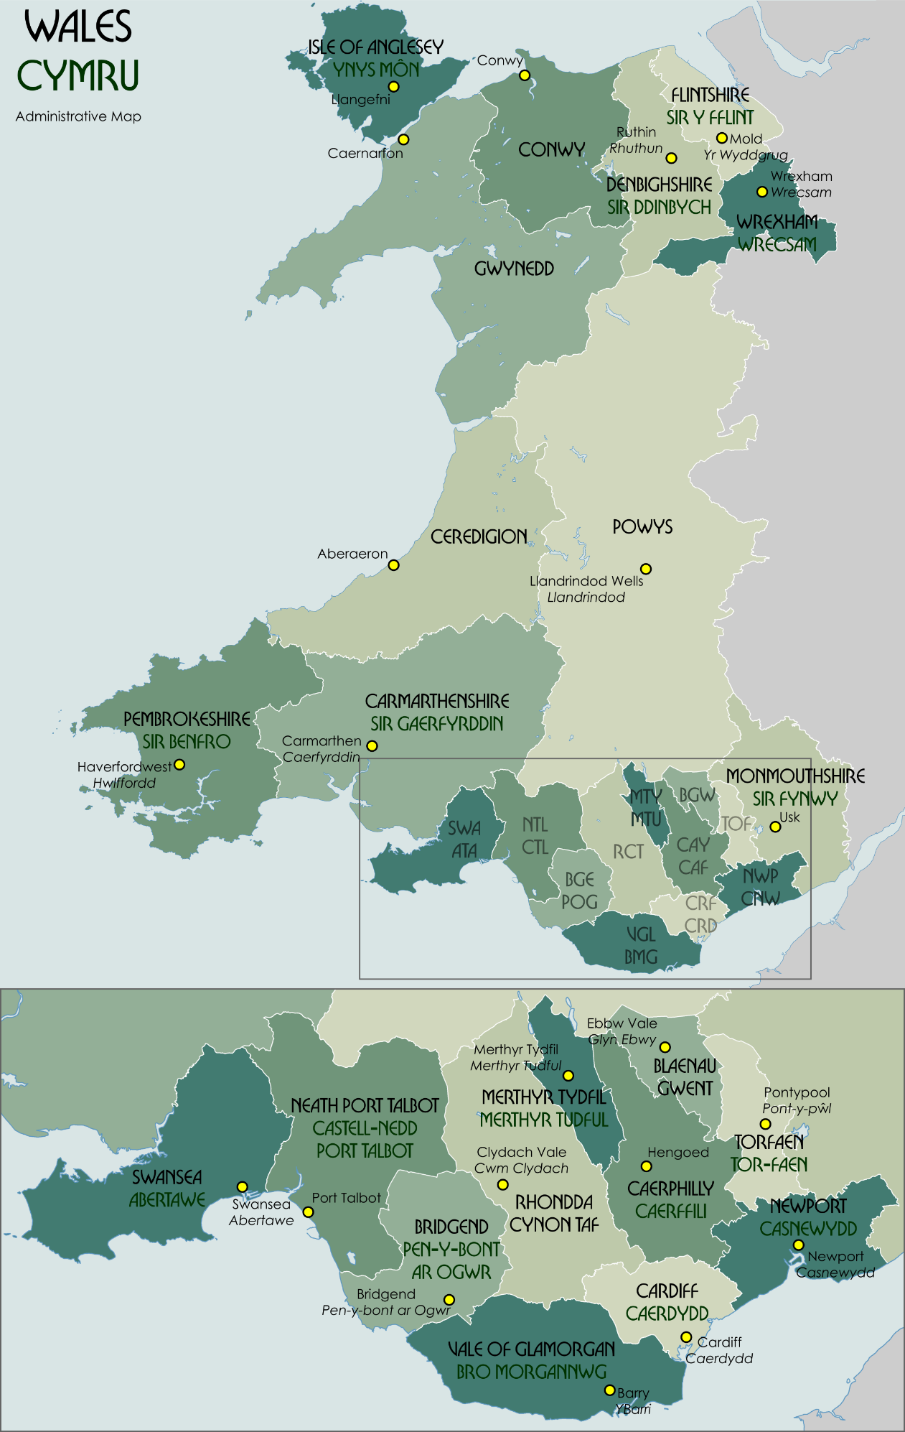
https://upload.wikimedia.org/wikipedia/commons/5/5a/Wales_Administrative_Map_2009.png

RWelsh accademicichad morgan, Place-Names of Glamorgan (cardiff: Welsh academic press, 2018).
‘Route Planner | Directions, Traffic and Maps | AA’ <https://www.theaa.com/route-planner/route> [accessed 13 January 2022].
‘Local Government Bodies | Law Wales’ <https://law.gov.wales/local-government-bodies> [accessed 9 January 2022].
C J O Evans, Glamorgan. Its History and Topography (Cardiff: William Lewis LTD, 1938).
Liber Landavensis and John Rhys, The Text of the Book of Llan Dav (Oxford, 1893) <http://archive.org/details/cu31924028051559> [accessed 11 January 2022].
‘Carboniferous Period and Prehistoric Facts’, Science, 2017 <https://www.nationalgeographic.com/science/article/carboniferous> [accessed 11 January 2022].
Rhondda Cynon Taf and others, ‘Treherbert’, The Reader Wiki, Reader View of Wikipedia <https://thereaderwiki.com/en/Treherbert> [accessed 11 January 2022].
Survey Ordnance, Street Atlas Glamorgan (Ordnance survey and Philips, 1995).
‘Route Planner | Directions, Traffic and Maps | AA’.
morgan.
morgan.
morgan.
James James, Welsh Names of Places (C T Jefferies and Sons).
morgan.
morgan.
James.
morgan.
morgan.
morgan.
James.
‘Route Planner | Directions, Traffic and Maps | AA’.
Ordnance.
morgan.
morgan.
morgan.

