  - BUSINESS INQUIRY AND RESEARCH

BMSP5007

DISSERTATION RESEARCH PROPOSAL

SUBJECT: SHOULD AGILE WORKING BE IMPLEMENTED INDEFINITELY IN A PROFESSIONAL CAPACITY?

ASSIGNMENT THREE

BY JESSICA ELLIS/ 1807462


MODULE LECTURER: DR ALEX BELL

Contents
Executive Summary …………………………………………..….…………………. Pages 1 & 2
Agile Working in Practise …………………………………………………………. Page 2
Methodological Approach ………………………………………………………… Pages 2, 3 & 4
Planned Data Analysis and Presentation …………………………….….….… Page 5
Hurdles of Agile Working …………………………………………….…………... Pages 5 & 6
References ………………………………………………………………………….. Page 6
Case Studies ……………………………………………………………………….. Page 7



Executive Summary

Incorporating dimensions of time, place, source and role title, agile working, often falling under the umbrella term ‘smart working,’ encompasses working with optimum flexibility and small constrictions, laconically described as being “an activity, not a place” (RICS, 2016) orientated. Now more than ever, companies have adapted to agile working, meaning it could be the ‘norm’ going forward. For many sectors, agile working has been the norm for decades, however following lockdown restrictions, many more have had to adapt to the concept. To understand the parameters of agile working, this proposed research study would hopefully address the feasibility of having it introduced and sustained, focusing on the positives and negatives for individuals, companies, the environment and external factors such as the financial costs and overall strengths and weaknesses. The rationale for this chosen topic is that it is highly relevant at present. By highlighting agile working pre lockdown and analyzing how companies have adjusted, it poses the question, ‘should it be sustained?’ There are many areas of focus this can stem out to. In example, unemployment due to mental health conditions, consisting of agoraphobia and social anxiety can be combatted if an individual is working form home, and perhaps introductory to a more conventional working environment, whether in an office or onsite; PTSD is heavily triggered by certain senses such as sound, smell and vision, so working from a safe location, their home for example, can further aid their recovery into employment. The 2020 lockdown has had an astronomical effect on the economy, causing many to speculate the government’s prioritizing ‘wealth over health’ however it could also be suggested that it has resulted in many opportunities for the nation. If lockdown hadn’t have occurred, agile working would not have skyrocketed as it has, therefore, there is sufficient grounds to ask if it should be implemented into companies’ conduct. While it is too soon to gain any real insight into how the virus will impact productivity, there is likely to be a fundamental shift in the way we view workspace and human interactions. (Vine, 2020)

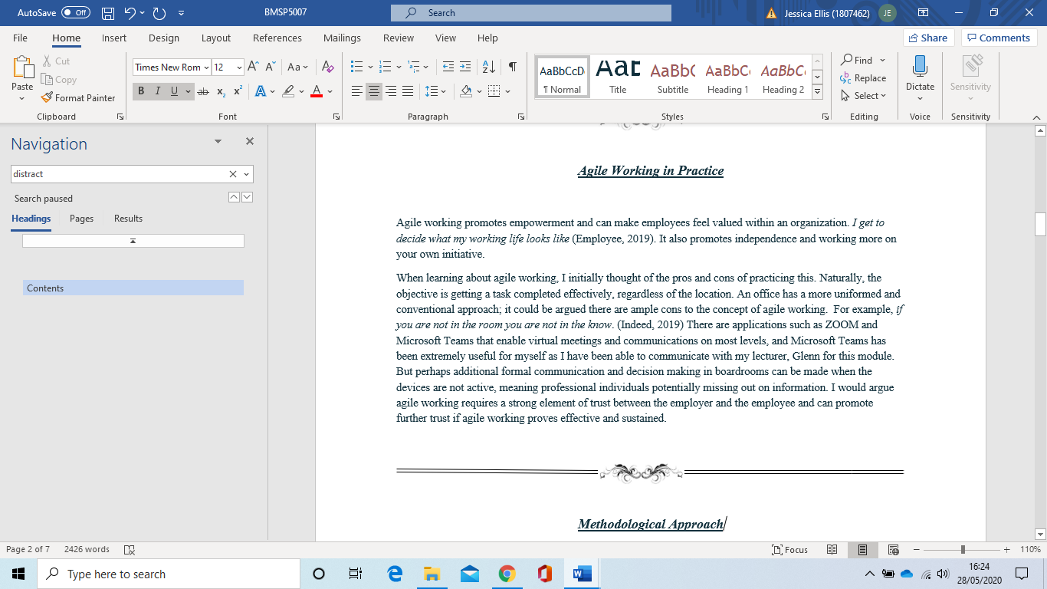
Agile Working in Practice
Furthermore, an employer can be deemed socially responsible for accommodating staff members’ circumstances.

Methodological Approach
This research study would hopefully focus on how the lockdown has opened doors to different concepts – if a company has successfully operated whilst in lockdown, perhaps it could do so post lockdown. Elements of the impact of the environment should be considered. Furthermore, many peoples’ perception of contagious germs may also manifest in them being more cautious about going to work again, therefore, agile working can help with this. As we are all different, the study would require a vast amount of data from all walks of life to deduce whether agile working can and should be implemented in the future. By exercising the Grantt tool, I can create a timetable in which shall hopefully ascertain how mindsets can change over time from what they initially thought and felt, as well as how my research study can be conducted. The timeline can help showcase how individuals’ attitudes may develop, in example they have become accustomed to working from home and so could be reluctant to resume normal working conditions. In addition, companies may not wish to foot the costs of safer working environments, and if the employees’ performance has been consistent whilst agile working, the employer may decide the costs of safer working environment procedures aren’t financially worth it for a mass of employees, subject to the employee/s, the employer may wish to keep agile working in place. Only time can tell.
In terms of the procedure, ideally, by liaising with job center employees and Work Capability Assessors, they could ask one simple question in appointments as part of their assessments: ‘if you could work from home, would you be willing to apply for more roles and feel confident that, given the training, you could apply yourself in your own home environment?’ Potentially, this could iron out anxiety triggers such as the prospects of leaving the house, communicating face to face, insecurities about their appearance or disability; and avert travel and the expenses. Yes, it can be argued that in the long term, this could simply be enabling the mental health conditions and not help to cure them, but it should be highlighted that there could be less employment figures. By assisting customers via phone calls and emails, it could boost the individual’s confidence in the shorter term, and this shall hopefully be a milestone in motivating them to improve their mental health hurdles. Nevertheless, for the upcoming dissertation, this probably wouldn’t be possible due to the magnitude; it would need to be enrolled across a region or the UK. For this dissertation, unfortunately and realistically it would only be looking at a smaller pool of data, in example one or multiple private companies.
In this study, a synthesis of data would be generated from a more quantitative approach. The rational for this is it is more time efficient to execute with bulkier results, accessible by anyone and easier to be sent to masses; provides anonymity and can be analyzed in great depth. Qualitative data research is more empirical and is engaging, especially using a thematic approach, however by using a the more quantitative method, the finding can be illustrated, trends can be identified, and a hypothesis can be made based on these results. As the qualitative data method requires more interaction to gage body language and the ability to ask to further/ follow up questions, due to lockdown restrictions, it’s not doable. Google Surveys shall be utilized in this plan and shall be sent to respondents digitally. This is free of charge, and so in terms of overheads there shall be none as it stands.
At three separate intervals, the same three questions would be asked. The present, in three months from today’s date and in six months from today’s date. This is to see how attitudes change over time. Many safety measures are yet to be implemented and businesses haven’t all reopened as yet, so ‘the fear of the unknown’ is still rife, therefore, health and safety concerns may be magnified at the prospect of returning to work presently, but who knows how it will change once measures are put in place? That is why it is important to ask the questions at different times due to developments.
In respect of ethically sourced data, as mentioned before, anyone with internet access can complete the survey, but most importantly, the data shall be richer in authenticity and honesty as it is done so anonymously. Prior to any respondent completing the survey, they shall be made fully aware that their privacy is paramount, and their answers are kept highly confidential, therefore hopefully this cements the element of trust.
Nevertheless, this research study isn’t without its disadvantages. Many large outfits such as supermarkets and well-known retail companies offer incentives for participation in their surveys. These include vouchers, discounts, cash and prize giveaways and holidays (etc). On the balance of probability, there is no prize and this is simply a fabricated ploy. Companies even include the transparent function of ‘please enter your email address so we can let you know if you have won;’ unfortunately, realistically they are just gaining your information to sell onto companies. The disadvantage here is that there isn’t an incentive to complete the survey, other than the prospect of their responses having an influence on future plans. In example, respondents are more likely to complete the survey if they are faced with the potential to have to return to work and prefer to remain agile working (and vice versa). Respondents need to feel valued and that their voices are heard, so incentive wise, perhaps inline with the confirmation of all information being kept confidential, the incentive should state that every participant can make a difference. This is true, they can make a difference, however like every charity advert or campaign, you never hear ’will’ you always hear ‘can.’ Broadcasting wise, the survey shall be sent to multiple site users on social media platforms, small business owners to send to their employees and perhaps public sector decision makers to forward onto their delegates.
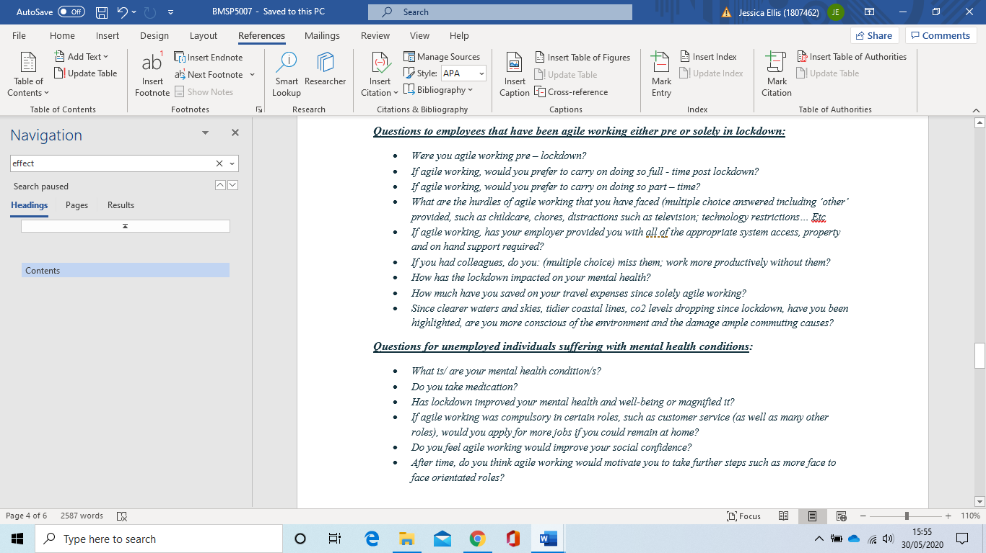
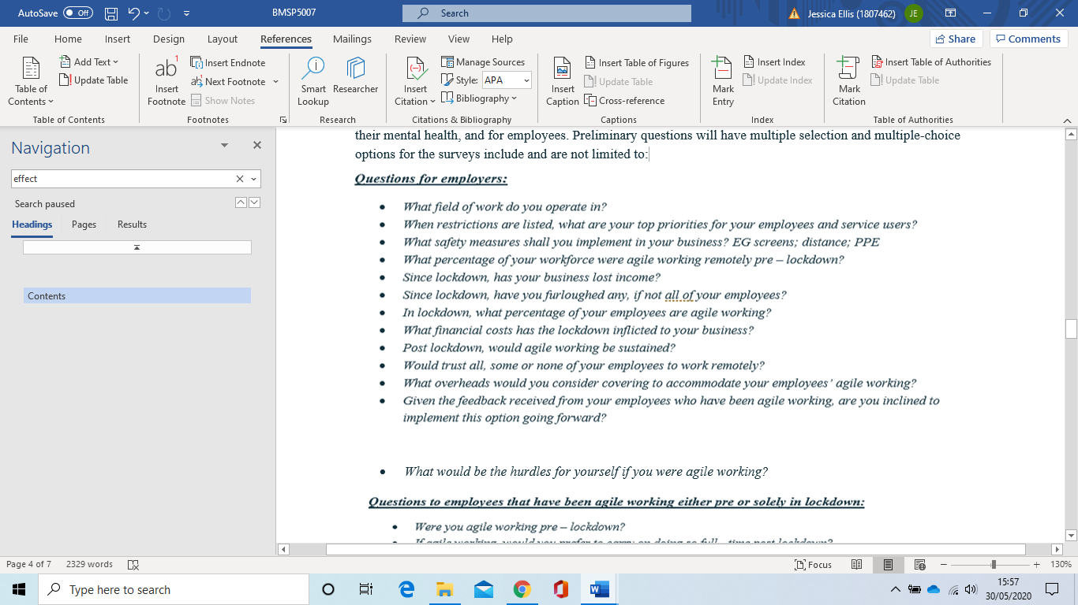
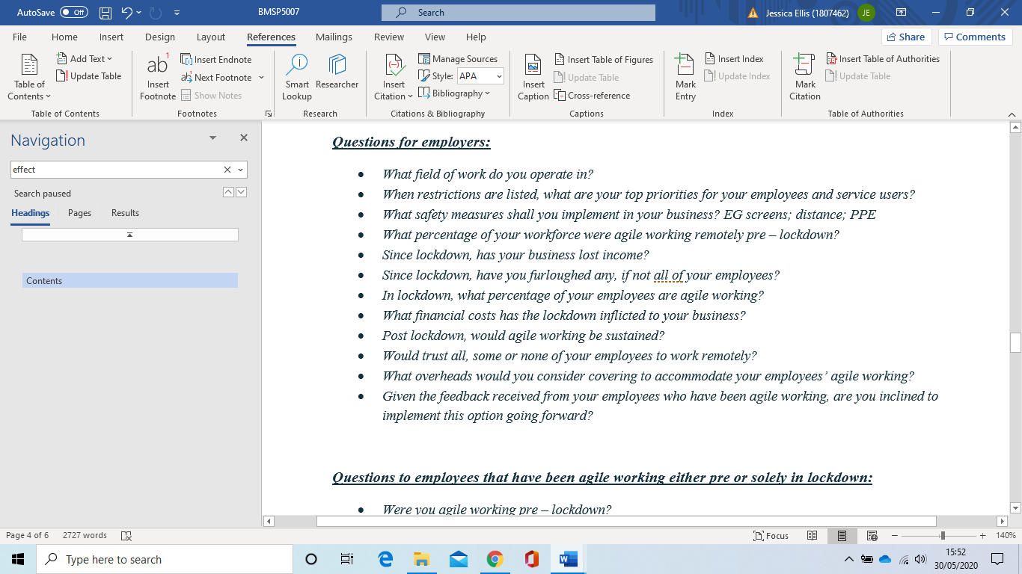
In order to acquire different perspectives, both employees and employers would be given a set of survey questions. There should be three parallel sets of questions for employers, unemployed individuals suffering in their mental health, and for employees. Preliminary questions will have multiple selection and multiple-choice options for the surveys include and are not limited to:

Planned Data Analysis and Presentation:

After each of the three times the same sets of questions are answered by a minimum of fifty people per survey, the three surveys can be deduced. There may be contrasting viewpoints from now during lockdown to post lockdown and once more in six months’ time. All data would be collated and input into SPSS due to it being installed on the device that shall be used, the acknowledge of how to use it already there and the zero fee incurred to use it. Although Google Surveys systematically generates a variety of charts, graphs and diagrams, SPSS enables statistical analysis, and more elaborate questions of trends can be recognized. In terms of time management, of course it shall be over a nine-month span. Once the surveys have been released, there will be a window of one week each time for respondents to complete the survey. On the eighth day, the results can be analyzed. For resources, all that shall be required is the laptop, access to the internet, the SPSS program installed; and the data variables.

Hurdles of Agile Working
Technological advancement has almost made the conventional office redundant. (Bell, 2020) Many schools, colleges and universities have adapted to agile learning, using tools such as Microsoft Teams. It could be argued that this program, whereby the ‘host of the event is leading the interactions and audience participation’ (Microsoft, 2020) has been instrumental and they have enabled companies to communicate effectively too. “We’re basically living on Teams” shows how perhaps obsolete conventional working environments can be. However, “if you’re not in the room, you’re not in the know” (Indeed, 2018) - Devices may switch off so individuals may miss information or ideas shared. If you’re physically in the room, you are less likely to miss anything. Nevertheless, agile working can promote empowerment and can make employees feel valued within an organization. I get to decide what my working life looks like (PA to Customer Team Manager, 2018). It also promotes independence and working more on your own initiative.
Although phone calls can be diverted to an at home phone, service users are more likely to not be transferred to the appropriate department or person that can help with their queries. Therefore, it costs callers more time and inconvenience by having to dial a different number due to there being no internal switchboard for a company if working remotely.
Although agile working promotes working on your own initiative, many people feel they excel better in teams. It could be argued that these types of people may feel overwhelmed with working alone and infers they could feel more isolated with additional responsibilities. Although some would thrive in these environments, many would not, and could feel unsupported by their employer. On the other hand, you don’t have to see colleagues you don’t like, and so performance can be more efficient and proactive.

In addition, agile working requires strong time management. If you are at home, there are ample distractions, such as children/ dependents and other family members demanding and/ or disturbing your concentration. Furthermore, if you are at home you could find yourself sidetracked by chores and to – do lists around the home in which interrupt your work performance. If you are in customer service, there could background sounds in which make it difficult to communicate effectively and be heard by the customer.
“WE SHAPE OUR PLACES AND THEN OUR PLACES SHAPE US” – Winston Churchill
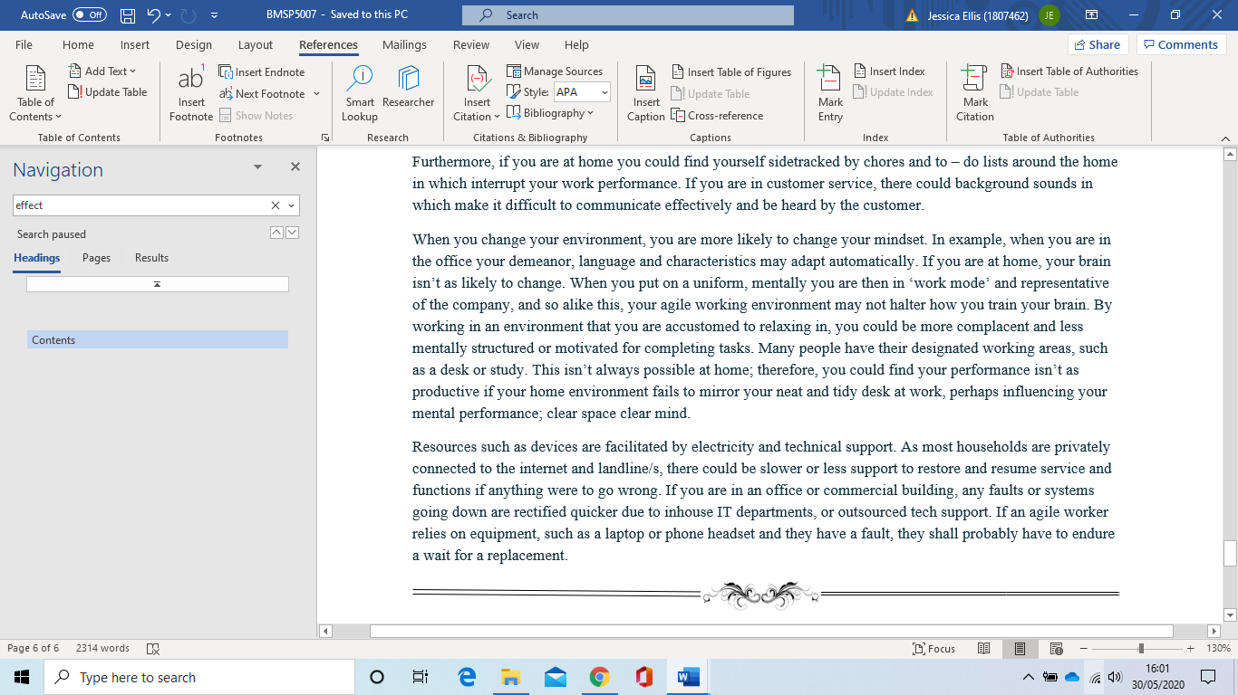
Without a strong communication channel, agile workers may become department focused, as opposed to organization orientated, which eventually impacts on the whole microenvironment.
Resources such as devices are facilitated by electricity and technical support. As most households are privately connected to the internet and landline/s, there could be slower or less support to restore and resume service and functions if anything were to go wrong. If you are in an office or commercial building, any faults or systems going down are rectified quicker due to inhouse IT departments, or outsourced tech support. If an agile worker relies on equipment, such as a laptop or phone headset and they have a fault, they shall probably have to endure a wait for a replacement.
References

Bell, D. A. (2020, May). N/A - Email Correspondence. (C. B. Management, Interviewer)
Indeed. (2018). Indeed Advertising. Retrieved from Indeed.
Microsoft. (2020, 05 03). What Are Microsoft Teams Live. Retrieved from Microsoft Teams: https://docs.microsoft.com/en-us/microsoftteams/teams-live-events/what-are-teams-live-events
PA to Customer Team Manager, N. P. (2018). Agile Working at NPower. UK: N Power.
RICS. (2016). Agility and Flexibility. Agile Working.
Vine, K. (2020). The future of Work. London: OnOffice Architecture and Design.



