  - Digital Skills and Research Methods

Impact of Virtual Learning Environment (VLE) – Moodle on students’

learning experience.

Tutor: Isaiah Oino
Student Name: Maria Magdalena Barbu
Student ID: 2011081

Contents
Introduction 2
Research Aim 3
Research Objective 3
Rationale behind research 3
Literature Review 4
Research Methodologies 5
Quantitative and Qualitative Research 5
Sample and Sample Size 5
Data collection tools 5
Analysis and Discussion 6
Design Questionnaire 6
Findings 8
Limitations of this Research 12
Recommendation 13
Conclusion 14
References 15

Introduction
VLE, which stands for Virtual Learning Environment, defines the online-based platform which enables students and staffs to enhance their learning experience with the use of digital solutions (Foss, 2012). VLE is different from the physical classroom, as it is aimed at replacing the physical classroom environment for distance learners with the help of modern technology which provides an in-class experience online. Quizzes, live classroom, digital communication as well as pols are examples of VLE. This is a research report, that focuses on Virtual Learning Environment’s impact on the students. The main focus of this research report will be conveying integral details about the research on the impact of VLE: Moodle on the students targeted towards the marketers. This research report will start with stating the aims and objectives of the research. This research will then shed light on the reasons behind this research. It will then review the works of literature on VLE.

Research Aim
This research aims to explore the Impact of the Virtual Learning Environment (VLE) – Moodle on students’ learning experience.

Research Objective
Objectives of this research are-
- Improving student’s digital skillset.
- Increasing awareness of the importance of analysis.
- Evaluation of the usage of contemporary techniques.
- Identification and evaluation of information sources.
- Illustration of data handling ability.

Rationale behind research
VLE has its fair share of advantages, and in a situation like this, where physical learning is next to impossible, the importance of VLE can’t be ignored. VLE, in normal time, can provide significant time and resource efficiency in organisation administration by automating certain things with the VLE and MIS integration. Resource management both for the organisation administration and learning is another huge advantage VLE provides, as it allows sharing of various media types from various sources and managing them with certain techniques effectively and efficiently possible. Student assessment and monitoring has also seen radical changes with the emergence of VLE. As VLE has these much advantages, and it is vastly used in remote learning in this pandemic, their impacts on the students need to be analysed. To implement new techniques and options in the VLE, the perception of the student also is important (Cvetkovic, 2016). For all these reasons, researching the impact of VLE on the student is important.

Literature Review
In this portion of this report, the researcher will review the existing work of literature on this particular topic, as it will present the existing knowledge such as substantive findings, theoretical and methodological contributions in the field of VLE.
(Pagani et al., 2016): Digital skills are the ability to use digital services, communication technology, and network to access and manage information, and it is becoming more and more important for students to learn to use digital devices and services to improve their educational outcome. Pagani, Argentin, Stanca and Gui in their research did just that. In this 2016 research, named ‘The impact of digital skills on educational outcomes: evidence from performance tests’, they have analysed and evaluated the impact of digital skills on the educational outcome, or the learning experience of the students. They have found that digital skills such as how to use the internet effectively positively influenced the academic achievement of the students. Students with low academic performance were impacted more often and more deeply by the digital skill, as the students with low family background were. Technical and vocational students were also on the list of significantly impacted students. This research illustrates how important digital skills are for the students and will increase awareness of the importance of learning.
(Waheed et al., 2020): Big data defines the process of analysing and extracting information from a large and complex data set to make a sense out of it or to make decisions, forecast trends and various other use cases. Data mining, data storage and data visualisation with big data are contemporary techniques that are being implemented in various fields. Hajra Waheed, Naif Radi Aljohani, Salem Alelyani, Saeed-Ul Hassan, Julie Hardman, and Raheel Nawaz have explored the use cases of these contemporary technologies in the educational fields. In a 2020 research named ‘Predicting the academic performance of students from VLE big data using deep learning models, they have explored the usage of big data for predicting academic performance. They have found from using big data that, VLE-generated big data helps to make data-driven long-term decisions. Students who at risk or are exposed to poor academic performance can be identified and taken special care of thanks to the prediction using clickstream data. This report also states that the usage of AI can outperform the existing prediction systems. This literature evaluates the usage of contemporary techniques and identifies information sources.
These two literature sources give context and credibility to the research.

Research Methodologies

Quantitative and Qualitative Research
Qualitative research defines the collection and analysis of non-numerical data for understanding concepts, opinions, or experiences, while quantitative research is the collection and analysis of numerical data for analysing finding, making predictions, or generalising results on wider populations (Sagor, 2011). This research is about generalising the impact of VLE on the sample group on the whole student base of this university.

Sample and Sample Size
There are various sampling techniques, such as Quota sampling, Clustered sampling, Snowball sampling, Systematic sampling, and simple random sampling (Alvi, 2016). For this research’s simplicity and time constrains, simple random sampling will be used, as it is cost-effective and easy to understand.

Data collection tools
There are various data collection techniques, such as interview, observation, survey and so on, and there are various tools to implement those techniques, such as Typeform, SurveyMonkey, Google Forms, QuestionPro, Qualtrics, SurveySparrow, SurveyGizmo (Now Alchemer), and Zoho Survey. This research will go with the survey as it is more direct than interpreting observation or interview and thus fits well in this time-constrained research project (Townsend, 2018). For the survey, it will use Google Forms, as it is easy to create and respondents are already familiar with it.

Analysis and Discussion

Design Questionnaire
In this portion of this research, the questionnaire for this research will be designed for the students.
- How do you feel about the VLE?
  - Good
  - Average
  - Bad
- Do you have a digital device to use VLE?
  - Yes
  - Yes, but has poor performance.
  - No
- What kind of device do you use for VLE?
  - Smartphone
  - Laptop
  - Tablet
  - Desktop
- How many hours do you spend behind virtual learning?
  - 0-2 hours
  - 2-3 hours
  - 3-6 hours
  - 6+ hours
- How much effective is virtual learning for you?
  - Effective
  - Moderately effective
  - Ineffective
- How helpful UWTSD was in providing the necessary learning resources for you?
  - Not helpful
  - Moderately Helpful
  - Helpful
- How stressful is VLE in the pandemic?
  - Very stressful
  - Moderately stressful
  - Not stressful
- Do you enjoy remote learning?
  - Yes
  - No

Findings
In this portion of this research report, the principal outcomes of this project will be illustrated, comprising of the project suggestion, and indication and revelation, which generally means the totality of outcomes, not any recommendations or conclusions, which will be discussed in their respective portions.
Question 1: The first question was about how the students feel about the virtual learning experience. 78% of the students feel good about virtual learning, while 12% of them feel bad. The other 10% feel average about it, not good or bad.
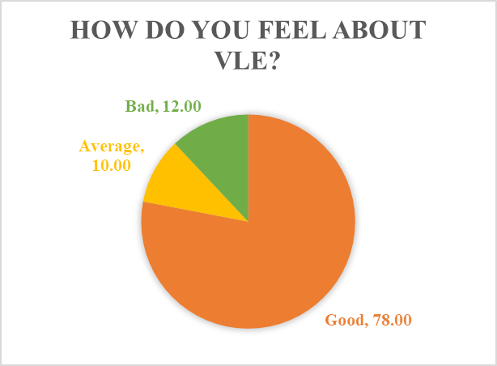
Question 2: The second question was to find out if the students had the necessary tools to carry out their virtual learning. 48% of the students have a digital device. But unfortunately, 19% of the student doesn’t have one, while 33% of others have a device, they are next to unusable for their poor performance.
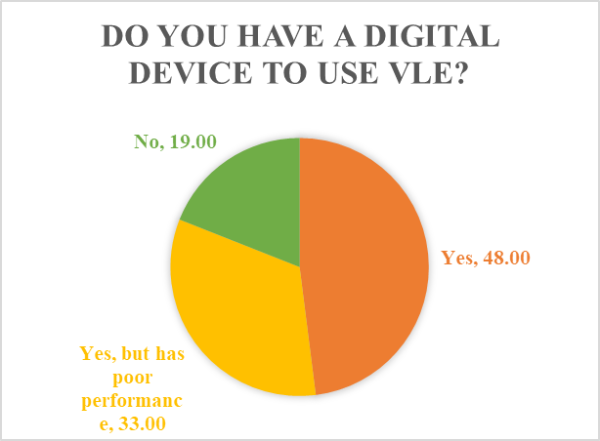
Question 3: The third question was to find out what type of device the student use for virtual learning. Most of the students use laptop followed by smartphone. Very few of them uses a tablet and desktop.
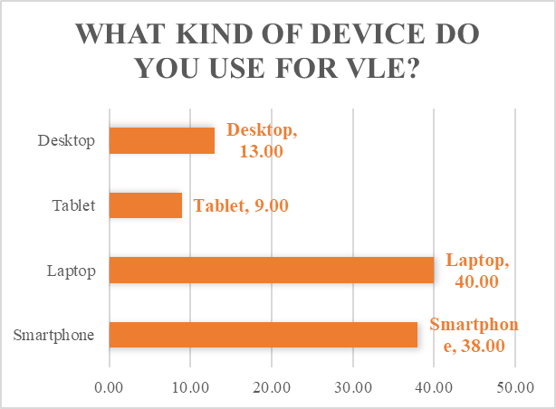
Question 4: The fourth question was about how much time the student spends behind Virtual learning. Most of the students spend 2-3 hours behind virtual learning, which is around 50%. 13% of them spend more than 6 hours and 18% of them spend 0-2 hours behind virtual learning.
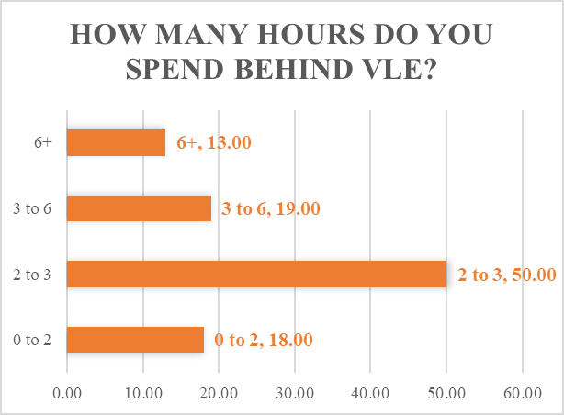
Question 5: The fifth question was to analyse the effectiveness of VLE. 38% of the students think it as very effective and 53% of them think it is moderately effective. The rest 9% of them think VLE is ineffective.
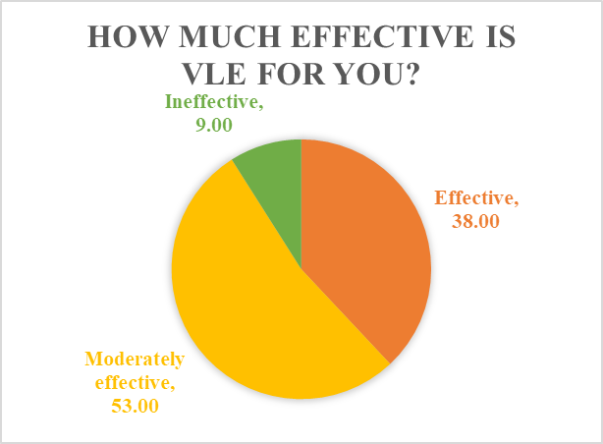
Question 6: The sixth question was to evaluate how helpful UWTSD is towards their student. 59% of them thinks that their university is very helpful for them and 13 of them thinks they are somewhat helpful. But 28% of the student think university as not helpful.
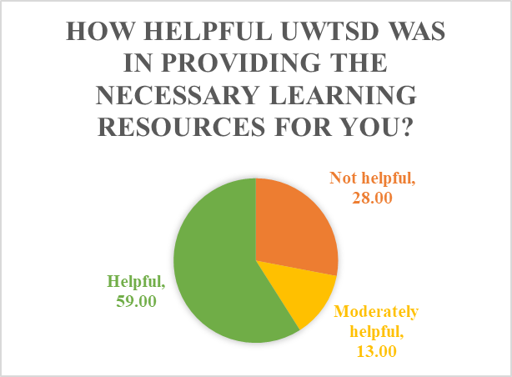
Question 7: The seventh question was to understand the stress virtual learning puts on the student. In the answer 48 thinks it is very helpful, 33% thinks it is somewhat stressful, while 19% find it not stressful.
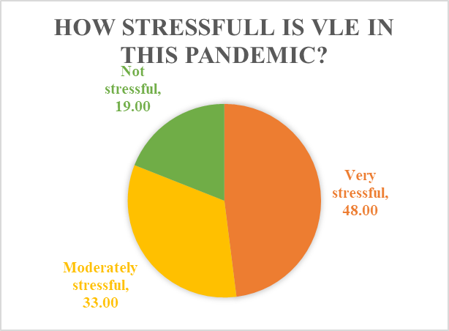
Question 8: The eight and last question was to find out if the student was enjoying virtual learning. 67% of the students enjoy remote learning, while 33% of the students don’t enjoy it.
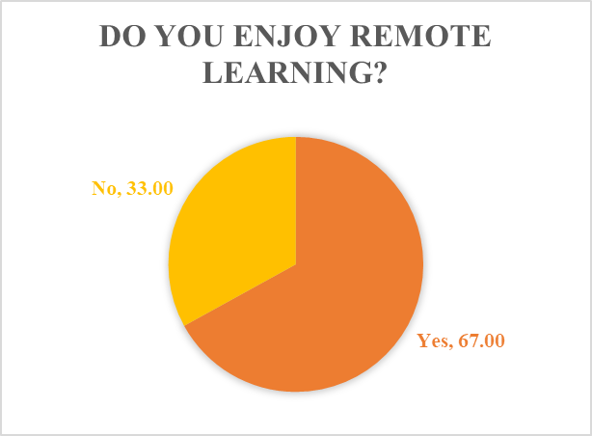

Limitations of this Research
Limitations define the influences which are out of the control of a researcher. And these kinds of shortcomings, influences and conditions put a restriction on the research methodology and findings. In this portion, all the limitations of this particular research will be listed and discussed.
- Sample and Selection issues: As simple random sampling is very simple and requires less time and resources, this research has used it. But this technique can result in a biased decision and can influence the conclusion (Cochran, 2016).
- Insufficient sample size: The sample size of this research, which is 100 is not enough for this organisation, as UTWSD have around 3000 students, and according to the 10% sampling size rule, the sample size needed to be 300 (KILIC, 2012).
- Lack of literature works: Before proceeding to conduct this research, the researcher needs to review all the other works on this topic and needs to go through the works found on resource finding sites, such as Wolfram Alpha, ERIC science.gov, Refseek, Google Books, Microsoft Academic, Google Scholar, or Educational Resource Information Centre. In all those sources, there were a selected few works on VLE, which though opens a vast field of possibilities, also provides less and little context to the researcher.
- Limited access to data: COVID-19, like many other things, has impacted research as well. Reaching the respondents directly was impossible due to the ongoing social distancing policy. While it was possible to use online survey services, like SurveyMonkey to do the same thing, the response rate was significantly lower and the result was not as accurate as it could be.
- Time constraints: The research had only two months’ time limit. Putting such time constrains hampers the research process and data quality.

Recommendation
Based on the reflection of this research, and the limitations that were found and discussed in the earlier section, here are some recommendations to improve the research in the future and to avoid the same mistakes again. Recommendations for future research are listed down below.
- If the same kind of research, with two different respondent types, are conducted, the research will make use of clustered sampling method, where the respondent will be divided into two different clusters, and in this way, students and teacher both will have the same chance to be selected by chance.
- The sample size of the existing research was too little in size and didn’t represent the overall student population of DTWSD. For instance, the student of DTWSD is 3,000 and the sample size needs to be 300.
- As there is less literature available on VLE on the general research finding websites, the professionals and specialists in the VLE filed need to be reached out for help and to give context and credibility to the research.
- Survey questions need to be designed with much more care and time so that the respondents don’t get bored and uninterested in the research and spend enough time behind it.
These are the recommendations for the researchers in the future, that wants to carry out some kinds of researches in the future.

Conclusion
This research report has focused on communicating the information about the impact of VLE: Moodle on the students, and it also shares the integral details of this research, such as the research methodology, limitations and recommendations, as well as the findings from this research. This research will help the education professionals, policymakers and management to make educational policy, build educational plans, develop future forecast, understand trends in the education industry and so on. This research was successful at achieving its objectives that were stated in the planning and engaged different sources and work literature with the primary research data while thoughtfully offering a very unique perspective on the impact of VLE on the students.

References
Alvi, M., 2016. A manual for selecting sampling techniques in research.
Pagani, L., Argentin, G., Gui, M. and Stanca, L., 2016. The impact of digital skills on educational outcomes: Evidence from performance tests. Educational Studies, 42(2), pp.137-162.
Waheed, H., Hassan, S.U., Aljohani, N.R., Hardman, J., Alelyani, S. and Nawaz, R., 2020. Predicting the academic performance of students from VLE big data using deep learning models. Computers in Human Behaviour, 104, p.106189.
Cochran, W., 2016. Sampling techniques. 3rd ed. New York: J. Wiley.
Cvetkovic, D., 2016. Virtual Learning. 1st ed. IntechOpen.
Foss, J., 2012. Lessons from learning in virtual environments. British Journal of Educational Technology, 40(3), pp.556-560.
KILIC, S., 2012. Sample size, power concepts and sample size calculation. Journal of Mood Disorders, 2(3), p.140.
Sagor, R., 2011. The action research guidebook. 4th ed. Thousand Oaks, CA: Corwin Press.
Townsend, H., 2018. The survey as a method of research. The Southern Speech Journal, 14(2), pp.115-118.

