Certificate of Higher Education in Skills for the Workplace

PROBLEM SOLVING AND DECISION MAKING

Problem

Dillon Rose 1818006
Student
University of Wales
Trinity Saint David
May 2020

Lecturer: Husam Helmi
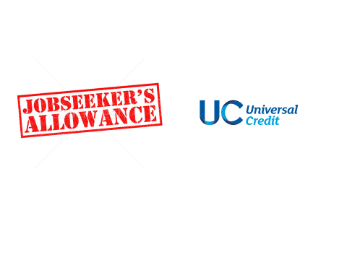
Slide 1/2
The problem I will speak about is allocation of work in my Office/Organisation. I work as a civil servant for the Department of Work & Pensions; it is a customer service environment. I work in a Jobcentre and this is important for us to get things right first time. The Government recently rolled out a new benefit called Universal Credit; this meant retraining all staff to administer this new benefit and have a smooth transition from the old benefit. There were customers claiming the old style benefit (Jobseekers Allowance) who needed to be transferred over to the new benefit. Initially the process was to allocate claimants to advisers using a team to take the new claim and distribute to advisers according to diary space. The advisers would then interview the customers and sent any documents to the processing department, the advisers would then add the customer to a caseload. They would then be the only person the customer would meet with on a regular basis. The process worked well in the early stages, managers used a taxi rank process (first come first served) to allocate customers to the new claims team and they would then pass to the advisers. The team still working on the old benefit would pass claims to the new claims team on a weekly basis to transfer to the new benefit system. Managers met with their teams on a weekly basis for feedback on how the system was progressing, the feedback was that some advisers had unequal sized caseloads than others across the five teams. The impact of this was a reduction in morale amongst staff, advisers felt more pressure than others, some customers were waiting longer to be seen as they were from outside the UK and their immigration status had to be looked at before processing. The managers monitored this for one month, meeting on a weekly basis to learn how this was happening. Their findings were that were advisers were unwell or on annual leave their caseload for that day was distributed between the remaining advisers. It was also impacted by the advisers working part-time.



Slide 3/4
The Managers looked at each adviser’s caseload, a caseload is the number of customers each adviser has to work with. In this case there was a distinct difference in the size of the caseloads between advisers. They also looked at weekly reports from the new claims team on how cases were allocated, which showed on certain days of the week the allocation was uneven due to the amount of part time advisers on some of the teams. The new claims team report also showed there were more claimants on the old style benefit than originally thought, some customers were reluctant to change to the new benefit and caused a high rate missed appointments so theses were rebooked with available advisers. There were also new customers registering for benefit who automatically were put on the new benefit, these customers were slotted in between the transferring customers. Staff schedule showed that due to the number of part time advisers some teams had more than other which affected diary space on these teams. The time taken to make each claim varied due to some customers having to produce more documents than others for example foreign nationals, this also had an impact on allocations.

The managers and their deputies had a meeting to brainstorm ideas for a solution,
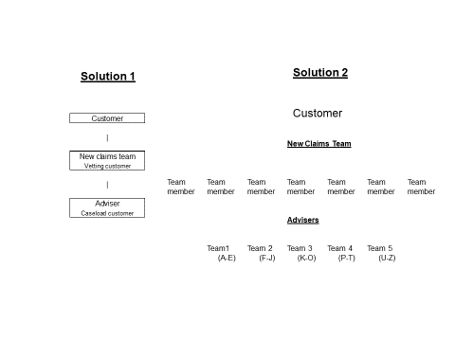
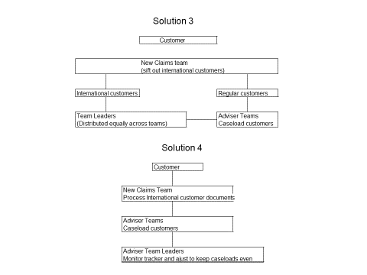

Slide 5/6
Solution 1
The first idea was for customers to have booked appointments with the advisers initially to take the claim and caseload. As there are only a limited number of appointment slots due to diary space it was suggested to try and address the caseload size issue.

Solution 2
The second idea was for the five adviser teams to be allocated parts of the alphabet

Team 1 (A-E)
Team 2 (F-J)
Team 3 (K-O)
Team 4 (P-T)
Team 5 (U-Z)

The new claims team would allocate customers alphabetically to the corresponding team, the manager would then allocate to advisers according to caseload size.

Solution 3
This looked at the customers taking longer to process, the new claims team would sift through the customers needing visas/immigration control and allocated the evenly to the team leaders who would allocate evenly across their teams. The straight forward claims would be distributed as per the currant process.

Solution 4
For this solution the new claims team would preview each claim to check for immigration control customers and contact them to make sure they had the correct documentation to attend the appointment. They would then see the customer collect any relevant documentation to process before allocation to an adviser. The managers had a tracker (document showing allocation of cases to advisers), this would be closely monitored to ensure fair distribution of cases across the teams.

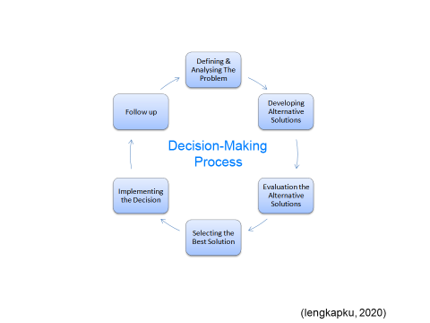

Slide 7
According to (lengkapku, 2020) the decision making process takes six stages. Defining and analyzing the problem, developing alterative solutions, Evaluate the alternative solutions, Selecting the best solution, Implementing the decision and Follow up. In this case the problem was the workload allocation and processing time. The managers brainstormed to develop four solutions, they looked at each solution using S.M.A.R.T objectives. Solution 1 although addressed the caseload size issue it overlooked the issue of processing time. Solution 2 was a logical approach but did not clearly address the caseload size issue or the processing time. Solution 3 dealt with the issue of processing time but the currant process would still allow for unfair workload allocation. Solution 4 addressed both issues and unlike the previous solutions it incorporated a monitoring tool for managers to keep track of progress.

Solution 4 was chosen to be implemented, the management teams plan to implement this solution was to meet with the new claims team and the adviser team but before this they drew up a process map showing the different stages of the new process. This would show clearly the advantages of the new process.
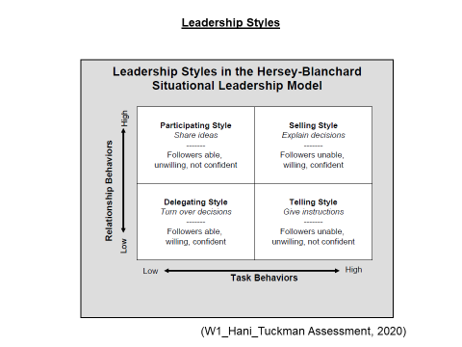

A leadership style is defined as a leader’s behaviors and characteristics when supporting, guiding and directing teams of people (W1_Hani_Tuckman Assessment, 2020) There are four main leadership styles:

Telling
This involves giving clear instruction and direction on how something should be done, when and how it should be done. There has to be trust between manager and worker. There is a clear definition who is the leader and whom are the workers, this style of leadership has its advantages depending on the situation. But this can also create a us and them culture between leaders and workers.

Selling
This leadership style involves getting the buy in from workers, explaining decisions as opposed to giving instructions. It focusses on followers who are willing and confident in what need to be done but are unable to make the decisions on how to go about it.

Participating
A participating leadership style does not require buy in from workers but it does requires sharing of ideas between leaders and workers. The workers do not have to be willing or confident but must be able in order to have an input. This style of leadership involves brainstorming to develop solutions.

Delegating
Delegating leadership style involves the least amount of guidance to the team, instead the team have to come up with the solution to any problems and also choose and implement the solution. The team members must be willing, confident and able to complete tasks set. The disadvantage of this leadership style is members of the team who are too confident would clash, the team would have a lack of direction which could lead to demotivation and less work done.

The leadership style appropriate for this solution was a selling style as this approach supported the two teams throughout the process and also allowed the two teams to draw on their experience and knowledge of the problem in order to add value to the solution and allow them to feel part of the process.

The delegating style would not be appropriate as this solution needed guidance and structure to solve the problem

Participating style does not have the buy in from the teams so would not be suitable for solving this problem

Telling might help to solve the problem but would not allow for feedback which is important in getting the solution correct. Staff would also tend to pull in different directions

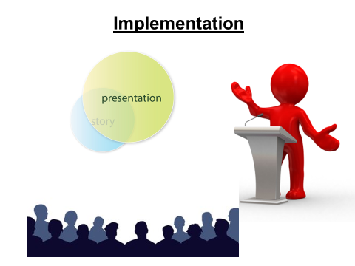
Implementation Plan

The management team used a selling leadership style where they held a group presentation with the adviser team and the new claims team. They presented their solution and how they came up with it, discussing the other solutions presented and their process of elimination. They gained feedback from the two teams were some concerns had been voiced around accuracy and document fraud. The leaders drew up a Rota for each of them to check accuracy on a daily basis and installed an ultra violet document scanner.
A communication meeting was held with the other departments and stakeholders to communicate the change in process and how it will affect the department as a whole. A process map was handed out to all departments for then to understand the new process and who is responsible for each section of the new process. Stakeholders would be sent a report each week on how the new process was rolling out, processing times and process/document accuracy. Leaders would meet with stakeholders once per month to discuss the teams progress.

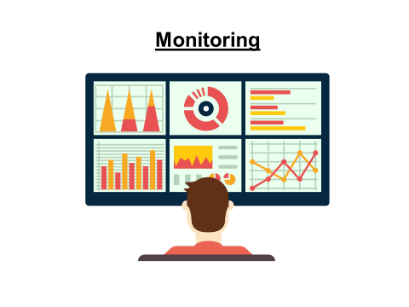
Monitoring

The team leaders put in place a six week monitoring plan where they would meet to discuss progress and any changes needed. The team leaders had trackers for each member of their team, this would be used to keep track of the distribution of cases. A tracker is a spreadsheet showing different pieces of information at a glance. This tracker showed the amount of cases each adviser had in their caseload also the age groups and the number of cases in the different age bracket. The age groups were important as the stakeholders and supporting agencies used this information to provide the correct assistance for specific age groups. A report was produced each week averaging the process time and the number of International customers making a claim. This information would be used to help streamline the process for international customers. At the end of the monitoring period the leadership team were able to meet with other departments and come up with solutions to further improve the new process.

lengkapku, L., 2020. HOW TO MAKING STEP DECISION. [online] Megahariani2903.blogspot.com. Available at: <http://megahariani2903.blogspot.com/2012/06/how-to-make-decision-in-six-steps.html> [Accessed 4 May 2020].

Verywell Mind. 2020. What Are Prominent Leadership Styles And Frameworks You Should Know?. [online] Available at: <https://www.verywellmind.com/leadership-styles-2795312?utm_source=emailshare&utm_medium=social&utm_campaign=shareurlbuttons> [Accessed 5 May 2020].

PMI-Oman 2014. 2020. W1_Hani_Tuckman Assessment. [online] Available at: <https://pmioman14.wordpress.com/2014/06/06/w1_hani_tuckman-assessment/> [Accessed 5 May 2020].

