
Faculty of Applied Design and Engineering/Cyfadran Dylunio Cymhwysol a Pheirianneg
School of Applied Computing/Ysgol Cyfrifiadureg Gymhwysol

Creating a Gantt Chart in Microsoft Excel
Graham Rees-Evans

Firstly we need some data to work with.

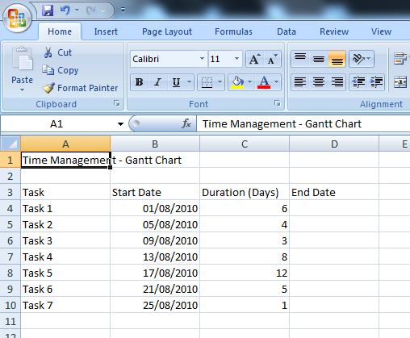

Set out an Excel Worksheet similar to this

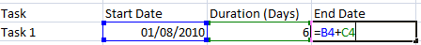
In the ‘End Date’ column, use a formula to add the ‘Duration’ to the ‘Start Date’, then copy the formula to all tasks/rows.

In the ‘Insert’ tab, select ‘Bar’ from the ‘Charts’ section, then select ‘Stacked Bar’
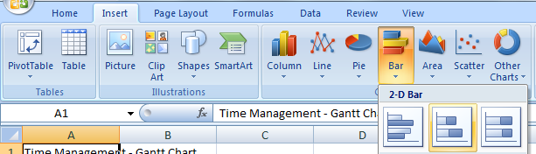

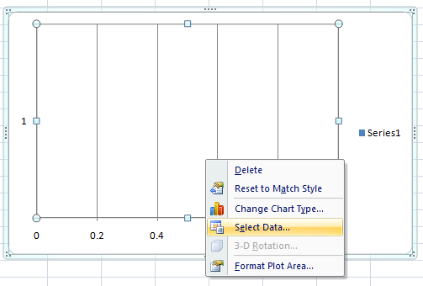

Excel will then add the graph to your Workbook but it will be wrong.
Right click on the Chart and click ‘Select Data’

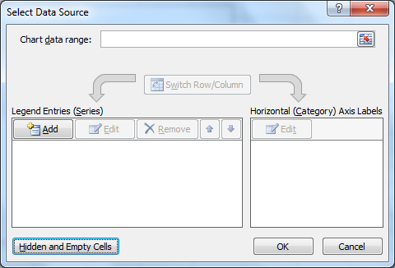
If there are any entries and any box, remove them to start from scratch.

Legend Entries (Series)

We are going to add 2 entries to this box
Click ‘Add’.  The First series you are going to add is the list of Start Dates.  Use the 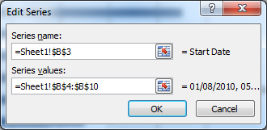 Link button to link to your worksheet.  Click the Series Name link button then click the cell with ‘Start Date’ in it.  Then delete ‘={1}’ from the Series Values box and use the Link button to select your list of ‘Start Dates’  Click OK to add the Series | Before:  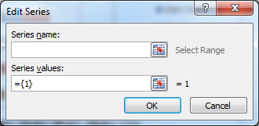  After:
Click ‘Add’.  The Second series you are going to add is the list of Durations.  Use the Link button to set the Series Name as ‘Duration’.  Then delete ‘={1}’ from the Series Values box and use the Link button to select your list of ‘Durations’  Click OK to add the Series | Before:  After:  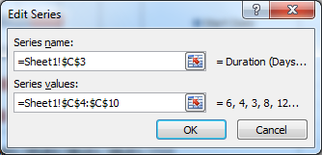
Horizontal (Category) Axis Labels’
Under ‘Horizontal (Category) Axis Labels’ click ‘Edit’  This will add the Labels  Use the Link button to select your list of ‘Tasks’.  Click OK to add the Labels | 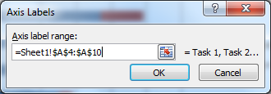
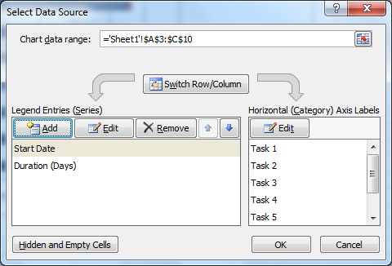 | Click OK to close the ‘Select Data’ dialogue

Now we have something that looks like a Gantt Chart

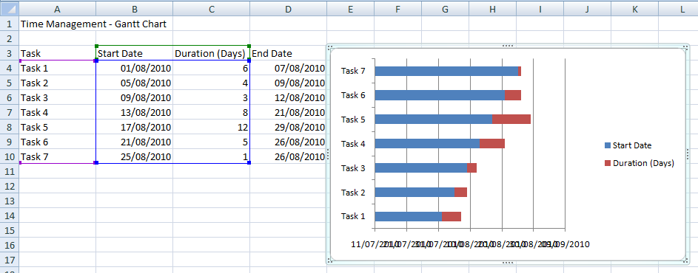

Task Order

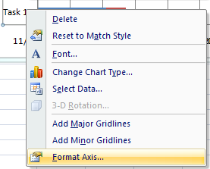
We need to re-order our tasks as they are currently backwards.
To do this, right click on the Task List within the chart area and select ‘Format Axis’.
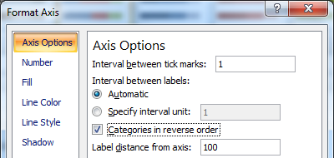
From here, put a tick in the ‘Categories in reverse order’ box and click ‘Close’

Hiding Bars
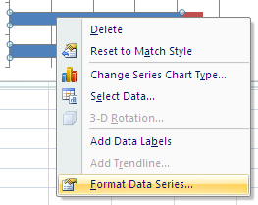
To make the chart look like a proper Gantt Chart we need to hide the blue bars.

To do this, right click on one of the blue bars and click ‘Format Data Series’
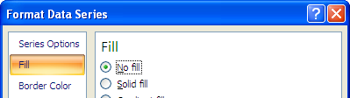
On the ‘Fill’ page, click ‘No Fill’

Fitting the Graph

The next thing we have to do is set the graph to start at our earliest date and end at our latest date.

Excel stores dates as numerical values, and it’s these values that the graph will use to display the correct range.
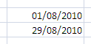
In 2 blank cells type in the earliest date (should be the start date of the first task) and the latest date (should be the end date of the last task).

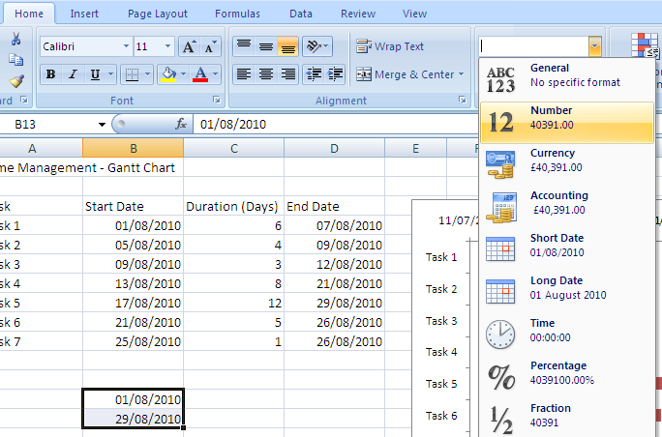

Format the cells to Number format.

To do this select the 2 cells, and on the home tab, select ‘Number’ from the ‘Number Format’ drop down box.
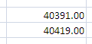

You now have 2 numbers that represent the dates you need.

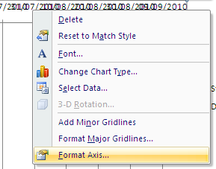
On the chart, right click the list of dates running along the top of the chart and click ‘Format Axis’

You need to set the Minimum value to the smaller number (i.e. 40391) and the Maximum to the larger number (i.e. 40419).

You can also set the Major Unit to 7 (as there are 7 days in a week) and the Minor Unit to 1 (for 1 day)
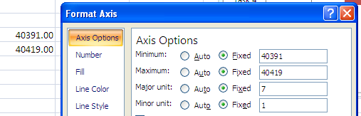

Remove the Legend

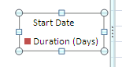
Last step is to remove the legend as you don’t need it.

Simply select it and press ‘Delete’.

