MA Music Business Level 7
Module Code BMTY7003
Discipline Tutor: Richard Small
Student John Uwejeyah
Student number 1808801

Introduction
For this assignment, I will be creating a marketing report for an artist by the name of Becky Smith. Becky is signed to a major record label in the UK and I am acting as her A&R person within the record label. My role is to convince senior executives why they should put the marketing budget behind Becky and her music. I will be writing about the music industry, with some key data and facts and producing a full marketing plan for a single and album release and the UK and international tour.

The Artist
“Becky Smith is a 25-year-old female, R&B/Soul artist from East London. Becky has been writing and singing from the age of 10 years old. Growing up in the church choir has helped Becky create a rich, deep and soulful sound that can be described as powerful, heartfelt and emotional. A sound that will have you reaching for the nearest box of tissues that you can find. Becky has a Strong sense of community and hosts a monthly event where an artist can perform and network with likeminded individuals, this is all for free. Due to the success of her monthly event called ‘Say it with your chest' we now feel it is time to release a project and a tour”. (Uwejeyah, 2019)
The Mission
“Is to transition away from Becky gospel roots into the mainstream pop music market. Becky sound is now more of an R&B Soul vibe. We have seen some of the biggest artists from the UK have major success with the style of music i.e. Ed Sheeran, Adele and Sam Smith. Becky is still a new artist compare to the other artist mentioned and she is only on her second music project, so our goals should be realistic. Our goals for Becky is to release her new single "From the heart" and create a video for the single, then Release her album "All of me to all of you" followed by the UK and international tours. We have a target set for what we want our streaming numbers to be and they will be discussed later on in the report”. (Uwejeyah, 2019)
Why is it a good time for Becky to release music (P.E.S.T)
Political
With the UK economy being influx, and the lack of trust for the current government and the population of the UK worrying about job opportunities, the Government is in desperate need of some positive PR. According to UK Music Measuring Music Report 2018, "the UK music industry grew by 2% in 2017 to contribute a record £4.5 billion to the economy – up by £100 million on 2016”. (Ukmusic.org, 2019) The figure that I feel is most important from a political standpoint from this report is that the UK music industry in 2017 employed over 145,815 people to full-time jobs, this was up from the year above and is set to rise again in 2018. If the government can demonstrate growth within employment, this could be used as a powerful political tool.
Economy
As mention above 4.5 billion was generated for the British Economy in 2017. In the case of Becky Smith the important figures are, “Musicians, composers, songwriters and lyricists - £2bn (+1%), Recorded music - £700m (+9%), Music publishing - £505m (+7%), Exports (whole sector) - £2.6bn (+7%), Recorded music - £468m (+11%), Music publishing (exports) - £719m (+11%),Music representatives (exports) £348m (+9%)”. (Ukmusic.org, 2019) Globally we are seeing growth with multiple music sectors. “There has been a 41.1% increase in streaming revenue, 54% growth in digital share of global revenue, 8.1% increase in global revenue growth”. (Ifpi.org, 2019)
Social
Becky music is what you would call music with a mean, music that can relate to the everyday common person. In her music, she discusses topics such as heartbreak, sexually liberation, female empowerment, racism within the UK just to name a few. These are all social issue that man people deal with daily. We have found from a music business standpoint that there is money to be made in creating music with themes. Beyoncé, Adele, Lady Gaga, Kendrick Lamar, Solange to name a few have had some of the biggest hits of the last decade and how won count music awards between them. It is important to remember that music is just a soundtrack to the time you're living in. Becky with her music is totally in tune with the social climate that we are living in now.
Technological
From Vinyl, cassettes, CD’s, MP3’s, downloads to streaming we have seen a significant change in the way the consumer listen and purchase music. Gone are the days of having specialist music devices like a Walkman, CD player and IPod’s now with a touch of your mobile device you can listen to any music from around the world. The rise of streaming services such as Spotify and Apple Music with their sizable music catalogue’s means that as a consumer of music my choice of music is bigger and the cost of music is now cheaper than ever.
If you take the PEST into consideration it is the perfect time for an artist like Becky Smith to release music. She will be contributing to the economy of the country, providing job opportunities for others through her music-making process and touring, her music is relatable to the struggles of many and she now has the distribution channels to spread her music to a larger audience which leads to great revenues not just for the artist but for labels as well.
Music Industry and Trends (Data Is Key)
As a label, it is important to have an understanding of what genre of music is popular at the moment and what type of acts are doing well i.e. solo acts, bands, singers, rappers etc. Data is key and an understanding of market segmentation is vital. Market segmentation basic mean dividing up the wider markets into groups with similar needs and wants. If the information is processed correctly then this should give you an advantage over your competition. (Pride, 2018) The uses of marketing mix tools are important with the breaking down of customers segments you can now start to anticipate consumer needs and divert your resources to the appropriate area needed based on the data you have collected. A popular tool that is used is the 7p’s Product, Price, Place, Promotion, People, Physical Evidence and Process.
According to Nielsen's 2017 report “hip-hop/R&B genre ended as the largest genre of the year in terms of "total consumption," which includes album sales and album-equivalent streaming figures”. (Lynch, 2019) “Seven of the top ten most-consumed albums of the year came from the hip-hop/R&B genre, with Kendrick Lamar's "DAMN." taking the second spot behind Ed Sheeran's "Divide." (Lynch, 2019)
If we look back IFPI report says "Revenues increased in most markets and in eight of the global top 10 markets. Driven by fans’ engagement with streaming – especially paid subscription audio streaming – digital revenues now account for more than half (54%) of the global recorded music market. Total streaming revenues increased by 41.1% and, for the first time, became the single largest revenue source. By the end of 2017, there were 176 million users of paid subscription accounts globally, with 64 million having been added during the year.” (Ifpi.org, 2019) This is important data because we know that not everyone streams music but it is growing each year.
In the graphic below this shows some key demographic data of which age range is streaming music and what gender they are,
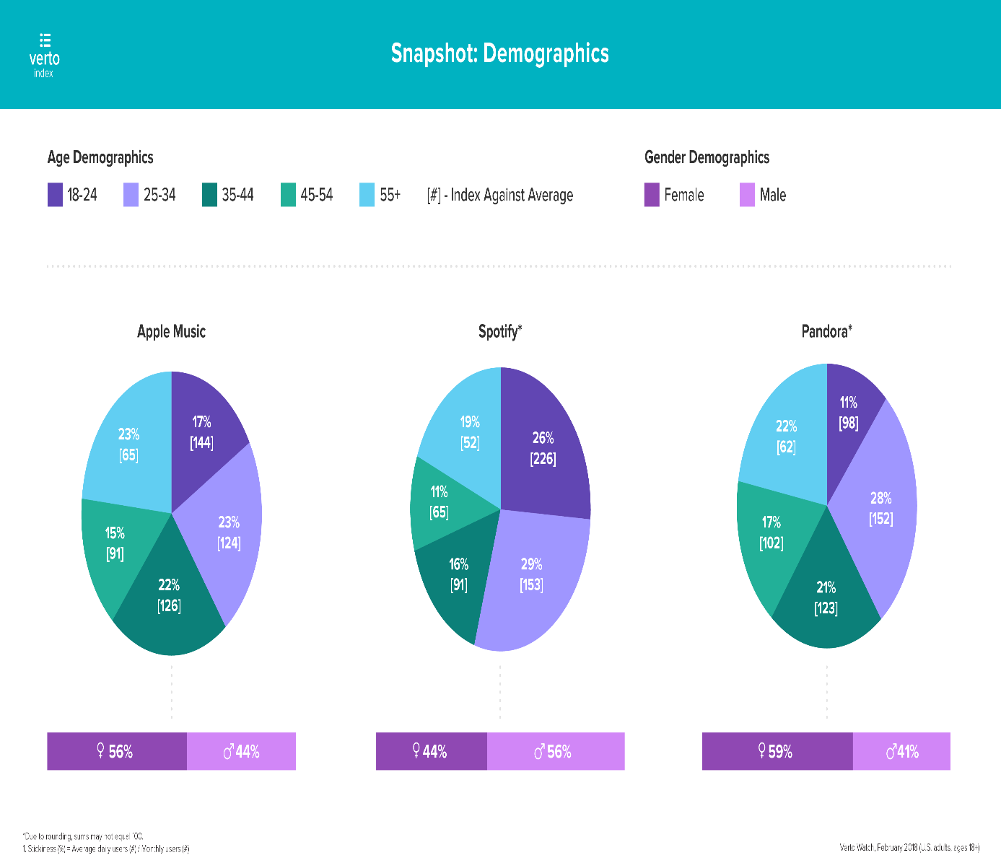

Figure 1 Spotify Demographics (Business of Apps, 2019)
Looking at the data we can see multiple consumer trends, under the '30s, like to use streaming service to listen to their music, R&B music is on the rise around the world, especially in the top 10 music markets and women are the biggest listener of R&B music. These are just a few trends that can be taken from the data provided.
With taking all of the above data into consideration, it would suggest that it is indeed a great time to release Becky music. Previous data from past touring and music streamed from other albums, we know Becky target audience is females between the age of 18-34 that live in various locations around the UK that also listen to predominately to R&B/Hip-Hop music. Becky also has good streaming numbers in the US and in Western Europe.

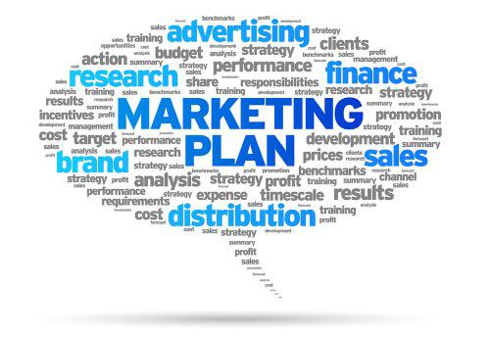

Now that we have analysed all the key data it is time structure Becky Smith marketing plan/strategy.
For any artist releasing music, it is extremely important for their fans to get the opportunity to get to know them, the best avenue for this is Social Media.
For Becky, we will create an Instagram, Twitter, YouTube and website so that Becky Smith fans can keep up to date with her plans, whereabouts and event dates. "80 20 rule: While sites like Facebook and Twitter are great for marketing your art business, social media is meant to be exactly that—social. People who follow you want to be wowed, not sold to. Therefore, when considering what to post in 2019, we are stick to the 80/20 rule: 80 per cent entertaining, 20 per cent promotional. And, that's the great part about content marketing! The fun and engaging content you post can actually help sell your art by creating goodwill towards your business. And, it opens the door to about a million ways to keep your fans engage". (Artwork Archive, 2019)
Social Media Push
Social media platforms give us as the label and Becky as the artist the chance to display our strong Relationship Marketing skills. We give the fans a chance to "Opt-In" so to speak, into the world of Becky Smith via her social media platforms. Becky will be engaging with fans on a personal level by replying to emails, replying back to fans who have left a message on the comment section of her socials and doing daily video chat session via Instagram video and snapchat where she will pick random fans to talk to on her live streams. This exchange benefits both parties because Becky social media followers will increase which could lead to more music streamed and bought, and for the fan, they get Becky personal time. Using Relationship Marketing technics like this will differently help increase fan retention.
New Single Promotional Tour
At the beginning of May Becky will start her promotional tour going from bar to bar, student events to student events performing her new song “from the heart”. This is to help gain traction for the new single and increase her notoriety within her local community which should help grow her fan base, ahead of her single release. This is a common technic used by large and small artist an example of the was the last time Pharrell Williams was in London before the release of his album he did multiple small venue spot dates leading up to his be UK arena tour.
New single on to Streaming Platforms
Most of Becky fans listen to music via streaming platforms. So this is the best distribution channels for us to use. The second phase is to get Becky on the popular playlists. “Spotify, Apple Music, and other streaming services have fundamentally changed how people listen to music. In the process, they've changed how artists and songs break” (Pierce et al., 2019) according to Mark Mulligans “Spotify playlists, and Spotify charts, and Spotify plays, have become the number one tool that labels and artists and managers are using in order to break artists and measure success,”. (Pierce et al., 2019) “Listeners now spend about half their time on Spotify listening to playlists, either of their own creation or curated by Spotify's editors and other tastemakers. As a result, every artist wants a spot on the high-traffic playlists like Today's Top Hits or Rap Caviar” (Pierce et al., 2019)
PRESS, TV AND RADIO AND ONLINE PROMOTION
The next stage for the release of Becky single is to send the track along with a press release to a variety of blogs and local papers, including the London Press which Becky received coverage for her last single. - Also sending the track, lyrics, instrumental and ‘vocals only’ track to local DJ’s. Targeting female DJ’s like Yinka Bokinni from Capital Xtra who Becky already has relationships with. This will help to create an even bigger buzz.
As part of the online Promotion, we will send the track, lyrics and instrumental to a variety of upcoming artists. The aim is to have them perform cover versions that can be uploaded to Becky Instagram and YouTube pages (each video will be a maximum of 1 minute long). Each week one version of the song can be uploaded, building up album release in June. We are looking at these artists as key partners in our single and album release campaign. Not only will they be uploading their version of Becky song on to Becky social media and website but they will be uploading their versions on to their social media, which will introduce a new set of fans to Becky music.
Music Video
The next step is to add visuals to the product so the consumer feels more invested in the project. A music video is an excellent way of promoting music, and with the music market being oversaturated having a music video gives an artist a little bit of an edge. Having a music video also helps with boosting artist visibility and exposure. You are far more like to get people paying attention to your song online if you have a video to accompany the music than not. In "July 6 2018, the chart has now included online views of music videos as the rules are adapted to reflect the going importance of YouTube and other video sites as a means of discovering to new music”. (Reporters, 2019) “The new chart will incorporate both free-to-view and streaming by customers who pay a monthly subscription”. (Reporters, 2019) “To reflect the “different in weight” between free video streaming on and subscription views, 100 video views via a subscription service will equate to one single sale, while it will take 600 free videos to record sale”. (Reporters, 2019) This proves, even more, the importance of creating a music video because now this can lead to a better chart position.
Video promotion
The promotional campaign for single and video release will be online via Becky YouTube page, Instagram and Facebook account. At the same time, physical posters will be distributed everywhere, from universities, local café's, bars, bus stops etc.

Album Release
With the release of the Becky Smith single, the single promotional tour and the release of her music video, this is the perfect time to drop her album “All of me to all of you”. Just before the album is released there will be an album listening party. This is a chance for music executives, social media influencers, TV and Radio personalities and DJ's have the chance to listen to the album. If the album is well received we will then get them to posts their positive reviews online or in their newspapers. This normally gives an album an extra push in albums sales. The decision was made not to put the album out for pre-order because Becky is simply not big enough yet and we do not want to put Becky under any extra pressure of album sales at the stage in her career.
Touring
There are many reasons why touring is good for artists. It's a great way for acts to perform to their fans and hopeful pick up some new ones along the way. Touring is also a vital way for an artist to make money as well as the labels. "According to The Verge, when someone streams one of your songs on Spotify, your profits are between $0.006 and $0.0084. So if you’re a relatively new artist and 1) don’t have a lot of songs to stream and 2) don’t have a lot of fans to listen to those songs, then you’re not going to be making a living from that alone. Some artists, such as Drake who made $23.7 million last year from streaming, can still make a lot of money. And still, he made more from his last tour–the Summer Sixteen tour with Future grossed $85 million”. (Medium, 2019) In Becky case, she is a new artist and although she will not be pulling in the numbers that Drake does, we do believe that we can make a profit.
UK Tour
We have created an interesting concept for Becky UK tour. It is called the 7nights tour. Where she will be performing over seven nights in seven different regions within the UK.
• North West (Manchester)
• North East (Newcastle)
• Midlands (Birmingham)
• Wales (Cardiff)
• Southeast (Cornwall)
• Southwest (Southampton)
• London
The tour dates are based on the data gathered from where people listening to her music the most and booking agents information. All venues are no more than 200 capacity in size.
International Tour
We decided that we will join the European summer festival circuit. The money is steady and paid on time, which helps reduce artist outgoing and increase artist revenue. Applesap (Holland) Afropunk (France) To the Beat (Sweden) All is love Fest (Denmark) We carefully choose these festivals because just like in the UK we have seen high streaming numbers come from these countries.

Why is budgeting important
Whether you’re an independent artist or you are signed like Becky is to a major label it is essential for you to know what a budget is and how to budget according to your needs “Budgeting is the process of determining how and where finances will be directed in order to achieve a particular goal”. (Musicthinktank.com, 2019) As a major label, we have 100's of acts which all have to be financed in order for them to release their projects. That is why it is important to know what is being spent where and on what. Because at the end of the day we are a business and our main objective is to make a profit.
Budgeting costs
Cost | Outgoings | Incoming | profits
Pre Single tour | £250 | £150
Single And Album Costs | £1,000 | £0
Single Release Promotion | £500 | £0
Single Release Tour | £1,000 | £0
Album Release Promotion | £250 | £0
Social Media Advertising | £500 | £0
Travel, Hotel and Food | £3,000 | £0
UK tour | £5,000 | £14,000
International Tour | £700 | £12,000
Press promotion | £500 | £700
Total | £12,700 | £26,850 | £14,150

These figures do not include figures from estimated profits from streams and albums sold. Although as a label we would happen to make in the region of £20,000.
Touring incomes is where we will generate our profits. Our UK tour has already sold out, the ticket is £10 per ticket and the capacity is 200 per venue and we are putting on seven shows (£14,000) International rates have been confirmed with the promotors already.
Summary: Can Becky Make Money
The simple answer is yes because Becky is signed to us on a 360 deal. A 360 deal is “contracts that allow a record label to receive a percentage of the earnings from all of a band's activities instead of just from record sales or money-making activities that the record label had a hand in”. (The Balance Careers, 2019) “Under 360 deals, which are also called "multiple rights deals," record labels may get a percentage of revenue that may have been previously off limits to them, such as Digital sales, Tours, concerts, and live performance revenue, Merchandise sales, Endorsement deals, Appearances in movies and television shows, Songwriting, lyric display and publishing revenue, Ringtone sales”. (The Balance Careers, 2019)
We can already see from her budget break down that Becky will be making money on touring of which we will receive our cut. Also, we stand to make money on the streaming of the album and the single.
Also, another amazing selling point for Becky is that she is a low costing artist. She performs most of the time by herself unless she is touring in these cases she will be with her DJ. She also writes and produces all of her own music as well as no instruments no dancers just Becky and her laptop.
It is important for us as a label that Becky is an artist in the infancy of her career, it's not just about generating profits at the start because they will be minimal. With Becky, it is more about generating awareness to Becky the person, the brand and the music.
According to the IFPI “While each recording deal is different, there are common areas of investment that usually feature, particularly in an agreement involving emerging artists. These are the payment of an advance, the funding of a recording, music video production, tour support and promotional costs. It can cost between US$500,000 and US$2,000,000 to break an artist in a major recorded music market”. (Ifpi.org, 2019) These numbers are similar in the UK. The Advantage that Becky has is that Becky came into the record deal with us with two albums already completed, which helps save us money in the long run.
In conclusion, it is a perfect time for Becky to be releasing her music. She has built up a loyal fan base from her monthly open mic night, she has also through the same night managed to network with DJ's and presenters that are willing to help give her project the boost that it needs. Becky is a low costing artist for us as well. We have also created a strong marketing plan that we believe will take Becky to the next level.
Timeline
- Update all of Becky social media letting her fans know about upcoming music that she will be releasing from April 16th 2019 onwards.
- The Single promotional tour will start from May 1st. Becky will be up and down the UK performing in pubs and student unions. The will end in London on May 14th 2019.
- During the promotional tour, we will be uploading Becky singles on to all of the streaming platforms on May 3rd 2019.
- From May 14th 2109 we will start to give the single to bloggers DJ’s and social influencers during this time we will be also giving the song to the upcoming artist so they can make their own cover version.
- The video for the new single will be released on May 22nd 2019.
- Video promotion will last from May 22nd till June 1st 2019.
- The album release date is June 2nd 2019.
- UK Tour will be in July from 7th till the 14th 2019
- The International Tour starts in Holland on 3rd of Augusts then 7th in France 21th in Sweden and the 24th in Denmark
All the data collected from the single and album release and tours will help us with the release of future projects. Armed with fresh data we will have an even better understanding of how to breakdown or customers segments. It also gives us the opportunity to work on our relationship marketing with Becky fans. All of the data above should help us make the next Becky project bigger.

Bibliography
The business of Apps. (2019). [online] Available at: http://www.businessofapps.com/data/spotify-statistics/ [Accessed 5 Apr. 2019].
Ifpi.org. (2019). [online] Available at: https://www.ifpi.org/downloads/GMR2018.pdf [Accessed 5 Apr. 2019].
For the first time in history, a., Lynch, J., For the first time in history, a. and Lynch, J. (2019). For the first time in history, hip-hop has surpassed rock to become the most popular music genre, according to Nielsen. [online] Business Insider Deutschland. Available at: https://www.businessinsider.de/hip-hop-passes-rock-most-popular-music-genre-nielsen-2018-1?r=US&IR=T [Accessed 5 Apr. 2019].
Pride, W., Ferrell, O.C., Lukas, B.A., Schembri, S., Niininen, O. and Cassidy, R., Marketing Principles, 3rd Asia-Pacific ed, Cengage, 2018, p. 200
Ukmusic.org. (2019). Measuring Music 2018 - UK Music. [online] Available at: https://www.ukmusic.org/research/measuring-music-2018/ [Accessed 5 Apr. 2019].
Uwejeyah, J (2019) Becky Smith [online] Available at: https://drive.google.com/file/d/0Bzw54ww1EU4LMW1ERS12TUV5TmtvOFZWNFRwbG1OMHdBRC1F/view?usp=sharing [Accessed 5 Apr. 2019]
Artwork Archive. (2019). A Fresh Social Media Strategy for Artists in 2017. [online] Available at: https://www.artworkarchive.com/blog/a-fresh-social-media-strategyfor-artists-in-2017 [Accessed 3 Apr. 2019].
Pierce, D., Pierce, D., Farrell, P., Camp, J., Baker-Whitcomb, A., Barrett, B., Barrett, B. and Ray, J. (2019). The Secret Hit-Making Power of the Spotify Playlist. [online] WIRED. Available at: https://www.wired.com/2017/05/secret-hit-making-power-spotify-playlist/ [Accessed 5 Apr. 2019].
Reporters, T. (2019). Music video views to be counted in the official chart for the first time as YouTube takes on MTV's mantel. [online] The Telegraph. Available at: https://www.telegraph.co.uk/news/2018/06/24/music-video-views-counted-official-chart-first-time-youtube/ [Accessed 5 Apr. 2019].
Musicthinktank.com. (2019). Why Budgeting Is So Important For Independent Artists - MTT - Music Think Tank. [online] Available at: http://www.musicthinktank.com/blog/why-budgeting-is-so-important-for-independent-artists.html [Accessed 6 Apr. 2019].
The Balance Careers. (2019). About 360 Deals in the Music and the Associated Controversy. [online] Available at: https://www.thebalancecareers.com/how-360-deals-in-the-music-industry-work-2460343 [Accessed 6 Apr. 2019].
Ifpi.org. (2019). How Record Labels Invest — IFPI — Representing the recording industry worldwide. [online] Available at: https://www.ifpi.org/how-record-labels-invest.php [Accessed 6 Apr. 2019].

