

The Marketing of Body Image:
An Exploration into the Social Responsibility of Marketers Within the Fashion & Beauty Industry

By Abbie Dark

(P146582)
Supervised by Will Fleming

May 2018

Submitted in part fulfilment of the requirements of the degree of BA (Hons) in Marketing Management

DECLARATION
This work has not previously been accepted in substance for any degree and is not being concurrently submitted in candidature for any degree

Signed……………………………………………

Date………………………………………………

STATEMENT 1

This dissertation is being submitted in partial fulfilment of the requirements for the degree of BA.
Signed…………………………………………….

Date………………………………………………

STATEMENT 2

This dissertation is the result of my own independent work/investigation, except where otherwise stated.Other sources are acknowledged by footnotes giving explicit references. A bibliography is appended.

Signed……………………………………………

Date………………………………………………

STATEMENT 3

I hereby give consent for my dissertation, if accepted, to be available for photocopying and for interlibrary loan, and for the title and summary to be made available to outside organisations.

Signed………………………………………………

Date…………………………………………………

STATEMENT 4

I hereby give consent for my dissertation, if accepted, to be available on the university’s IT system to those who have consent to use the system.

Signed………………………………………………

Date…………………………………………………

Acknowledgements

I would like to thank everyone who has supported me throughout the completion of this dissertation project. This includes my partner, family and friends, especially those friends at University who were also completing their dissertation projects. I would also like to thank the dissertation co-ordinator Caroline Jawad, who guided everyone fantastically throughout the year, as well as offering a shoulder to panic on and personal support when it was needed. Finally, I would like to thank my dissertation supervisor Will Fleming who has given me brilliant support and guidance about the project from beginning to end.

Abstract

This dissertation was designed in order to identify issues around mass media images and body image perception. The study’s aim was to uncover whether marketers are impacting on the public’s view and perceptions of body image due to their campaigns within the fashion and beauty industry.
To help meet the research aim, the following objectives were formed:
- To review and examine the secondary research and undertake thorough analysis of the literature and the relationship between images in the media and body perception
- To explore the views of consumers with regards to body image, digital alterations and media influence
- Evaluate the roles of marketers and their impact on how people perceive body image
Secondary research was used to inform an extensive and detailed literature review. The sources of literature included journal articles, academic textbooks, newspapers and reports. Two methods of primary research were conducted to support the findings of the literature review. These were an online questionnaire that received 122 total responses as well as one focus group with 5 participants.

The main findings from this research concluded that both respondents of the online survey and participants of the focus group believed that images used in the media gave feelings to individuals that they needed them to conform to a societal norm to look a certain way to look like the models in the images. However, this is not to say that the British public are easily duped by the manipulations of these marketing professionals, in fact, it has been reassuring to uncover that this research showed that the public are becoming more cynical to the images they see and do not necessarily believe in marketing images.

Table of Contents
Abstract 4
Table of Figures 7
CHAPTER ONE 8
1.0. Introduction to the Study 9
1.1. Rationale 9
1.2. Research Aims and Objectives 10
CHAPTER TWO 11
2.0. Introduction to Literature Review 12
2.2. Power of Marketing 12
2.3. Marketing Defined 12
2.4. Marketing Management 13
2.4.1. Promotional Mix 13
2.5. Promotion and Body Image 13
2.6. Body Image Perception 14
2.7. Self-Actualisation Theory 15
2.8. Marketer Ethics 15
2.9. Mass Media Influence 16
2.9.1. Social Media Influence 16
2.9.2. Wellness Industry Influence 17
2.10. Digital Alterations 18
2.11. Gender Stereotypes 19
2.12. Impact on Females 20
2.13. Impact on Males 21
CHAPTER THREE 23
3.0. Introduction to Methodology 24
3.1. Research Onion 24
3.2. Research Design 25
3.2.1. Research Philosophy 25
3.2.2. Research Approach 25
3.2.3. Research Strategy 26
3.2.4. Time Horizon 27
3.2.5. Research Sample 27
3.2.7. Data Analysis 28
3.5. Ethics 29
3.6. Limitations of the Research 29
CHAPTER FOUR 30
4.0. Introduction to Data Analysis 31
4.1. Analysis of Focus Group 31
4.1.1. Theme One: Societal Norms 31
4.1.2. Theme Two: Cynicism of the Public 32
4.2. Analysis of Online Survey 35
4.2.1. Gender Demographic- Question 1 35
4.2.2. Fashion Publications- Questions 2 & 3 36
4.2.3. Social Media- Questions 4 & 5 38
4.2.4. Social Media Follows- Questions 6, 7 & 8 40
4.2.5. Personal Photographs and Filters- Questions 9 & 10 42
4.2.6. Respondent Influence- Questions 11 & 12 43
4.2.7. Digital Alterations- Questions 13 & 14 44
4.2.8. Respondent Pressure- Question 15 46
CHAPTER FIVE 47
5.0. Conclusion 48
CHAPTER SIX 51
6.0. Recommendations 52
6.1. Implication for Marketers 52
6.2. Future Research 53
BIBLIOGRAPHY 54
Bibliography 55
APPENDICES 59
Appendix 1: Ethics Statement for Online Survey 60
Appendix 2: Copy of Online Survey 61
Appendix 3: Copy of Ethics Form for Study 65
Appendix 4: Consent form for Focus Group 72
Appendix 5: Focus Group Images 74
A. Protein World- Beach Body Ready Campaign 2015 74
B. Dove- Real Beauty Campaign- 2004 74
C. Non- Digitally Altered Images 75
D. Digitally Altered Images 76
Appendix 6: Focus Group Transcript 77

Table of Figures

Figure 2.1: Protein World’s ‘Beach Body Ready’ Campaign 2015……………….….19
Figure 2.2: Cover Image of Men’s Health Magazine October 2005…………….…...22
Figure 3.1: The Research Onion…………………………………………………….…..24
Figure 4.1: Gender………………………………….………………………………….….35
Figure 4.2: Fashion publications read…………….………………………………….….36
Figure 4.3: Fashion publications accessed………………………………………….….36
Figure 4.4: Social media use……………………………………………………………..38
Figure 4.5: Social media platforms………………..……………………………………..38
Figure 4.6: Fashion brands followed……………………………………………………..40
Figure 4.7: Fitness brands followed……………………………………………………..40
Figure 4.8: Beauty and Fragrance brands followed.…………………………………..40
Figure 4.9: Selfies on social media……………….……………………………………..42
Figure 4.10: Filters on personal pictures………………………………………….…….42
Figure 4.11: Peer image influence………………………..……………………………...43
Figure 4.12: Advertising campaign influence…………….……………………………..43
Figure 4.13: Digitally altered images…………………………………………………….44
Figure 4.14: Knowledge of digital alterations………..………………………………….44
Figure 4.15: Pressure of media images………………….……………………………..46

CHAPTER ONE
INTRODUCTION

- Introduction to the Study
The focus of the study is on mass media advertising images, mainly within the beauty and fashion industry, and the impact these images have on society. The public are constantly inundated with idealised images of both men and women in the media and this can have a serious impact on how individuals feel about themselves.

  - Rationale
As part of Level 6 study, there is a requirement to write a dissertation which conducts valuable research into a specific area of choice. Through the knowledge gained during levels 4 and 5, the prominent subject of responsible marketing has come to light, especially the areas surrounding the responsibility of marketers and their activities. The fashion industry is particularly affected by the ways in which marketers portray body image, which in turn can have an effect on the mental wellbeing of the public. From reading into the area of interest, it has become evident that there is an absence of research around the relationship between body image and the responsibility of professional marketers.

Advertisers are always looking for new ways to get the public’s attention, and nowadays, the ideal image of beauty is more tyrannical than ever (Kilbourne, 2012). Advertising, particularly for fashion and beauty brands, has a powerful effect on how individuals view themselves, and how society thinks they should look. Marketers now have to be aware that the consumer is becoming more powerful and there is a growing gap between consumer expectations of products and services and the ability of businesses to meet them (Wixcey et al, 2014). Consumers are now less interested in buying products that make them feel insecure and are now more likely to buy products that make them happy, with happiness from the experience of the purchase becoming an ingrained part of their identity (Cassano, 2016). There has been an increased interest in body image perception recently, especially with regards to the manipulations by marketers and their images projected onto the general public.

  - Research Aims and Objectives
The ultimate aim of the dissertation is to outline the ways in which marketers can gain a positive social standing with regards to body image from the fashion and beauty industry.
The following objectives will be achieved through carrying out extensive research:
- To review and examine the secondary research and undertake thorough analysis of the literature and the relationship between images in the media and body perception
- To explore the views of consumers with regards to body image, digital alterations and media influence
- Evaluate the roles of marketers and their impact on how people perceive body image
To achieve the objectives, this dissertation will conduct primary and secondary research through reviewing a range of different sources and carrying out an online survey and focus group to provide a general theoretical framework in order to gain an overall understanding of body image perception in the media.

CHAPTER TWO
LITERATURE REVIEW
- Introduction to Literature Review
The goal of this chapter is for the researcher to provide an in-depth review of literature that relates to the aims of this dissertation project. This includes the review of sources of relevant information to enable a critical analysis of the social responsibility of marketers within the fashion industry. This chapter of the dissertation study will aim to answer objective one. The research in this section will increase the researcher’s knowledge surrounding the topic whilst underpinning and informing the data collection exercise. Relevant literature to be explored includes research papers, academic journals, theories, models and case studies. Previous research on how marketers portray body image might give an insight on the current research topic of the social responsibility of marketers within the fashion industry. The following literature review will identify current issues relating to marketing, marketing ethics and the impact on society of irresponsible marketing.

  - Power of Marketing
As modern competitive pressures increase, marketing is now regarded as an integral part and essential attitude within business management. The marketing department must work interdependently with all of the other departments within an organisation. In simple terms, marketing is engaging customers and managing profitable customer relationships, but a successful marketing department will act as so much more than the old term to ‘tell and sell’ (Kotler et al, 2017). Products will become easy to sell if the marketer engages consumers effectively, understands their needs, develops products that provide customer value whilst pricing, promoting and distributing them well (Kotler et al, 2017). According to Peter Drucker (as cited in Kotler et al, 2017, p.5), ‘the aim of marketing is to make selling unnecessary’.

  - Marketing Defined
A traditional definition of marketing by the American Marketing Association is “the activity, set of institutions, and processes for creating, communicating, delivering, and exchanging offerings that have value for customers, clients, partners, and society at large” (American Marketing Association, 2013, p.1). The Chartered Institute of Marketing (CIM) support this definition whereby they state “marketing is the management process responsible for identifying, anticipating and satisfying customer requirements profitably” (CIM, 2015, p.2) By evaluating previous experiences, together with current practices, organistions can utilise their marketing department to fully understand and satisfy customer needs and wants (CIM, 2009). Marketing, as a social and managerial process, allows organisations and individuals to obtain what they want through creating and exchanging value with others (Kotler et al, 2017).

  - Marketing Management
Marketing is often wrongly defined within the narrow margins of advertising and selling. However, marketing is a key management discipline that ensures producers of goods and services interpret customer wants, needs and desires with the end goal of matching, or exceeding them (CIM, 2009). In order to achieve this, successful marketing depends upon addressing key issues surrounding product, price, place, promotion, people, process and physical evidence (CIM, 2015). These considerations are known as the 7P’s or Marketing Mix. The 7P’s consist of product, price, promotion, place, people, physical evidence and process (Kotler et al, 2017).

    - Promotional Mix
The key element of the marketing mix that applies to the research is promotion. Promotion is the way a firm communicates what it does and what it can offer customers (CIM, 2015). The promotional mix is sometimes referred to as the marketing communications mix and is a specific blend of promotion tools that the company uses to persuasively communicate customer value and build customer relationships (Kotler and Armstrong, 2014). The main promotional activity this research will focus on is advertising which, for marketers, will have a goal of gaining attention of the product whilst sending a consistent message to the customer (CIM, 2015). For example, marketers could use advertising activities to promote a healthy body image through targeting individual attitudes, knowledge, beliefs and behaviours consistent with messages received by individuals throughout their lives which will thoroughly underpin the need for positive body images in society (Robert-McComb et al, 2007).

  - Promotion and Body Image
Some advertising techniques involve constructing a problem that can only be solved by using the products portrayed in that set of advertisements (Kaur et al, 2013). Cook (2001) describes that advertisements inform, persuade, remind, influence and can sometimes change opinions, emotions and attitudes. Cook (2001) also states that the purpose of advertisements is give warnings or information to people and therefore, advertisements can help create awareness of products and brands, construct identities and change attitudes of the individuals receiving the message. Advertising campaigns are commonly accused of ‘body shaming’, and whilst brands have a right to market their products, provided the campaigns are not harmful or offensive, it is clear that negative body image is a destructive force in modern culture (Sanders, 2016). The relationship between body image and marketing is renowned for portraying images of ‘stick-thin’ models with eating disorders and lack of self esteem among teenage girls and young women (Gatrell, 2015). However, the increasing use of digital platforms means influential images have become more prevalent in modern society and the ways in which the fashion industry are able to handle body image anxiety may be altered. The standards of beauty set in advertisements means that the public are subjected to often unrealistic stereotypes in images that are often artificially created (Kilbourne, Beauty...and the Beast of Advertising, 1990). Media images that depict thin, digitally altered models through techniques such as airbrushing models and excessive retouching has been linked to body dissatisfaction issues which can include “unhealthy dieting regimes and problematic eating behaviours (starving, bingeing and purging), clinical eating disorders (anorexia, bulimia), cosmetic surgery and extreme exercising” (Kirkup, 2009, p.1).

  - Body Image Perception
The way in which individuals negatively perceive body image can lead to body image dissatisfaction. The issue can undermine self-confidence, contribute to depression and lead to the onset of a range of physical, emotional and societal problems (All Party Parlimentary Group on Body Image, 2012). McGuinness and Taylor (2016, p.4) define body image dissatisfaction as “the negative perceptions and feelings a person has about their body and is influenced by factors such as body shape and appearance, attitudes towards weight gain and cultural norms in relation to an ideal body”. There is no single cause of body dissatisfaction or disordered eating, but research shows that the media does contribute to problems surrounding these issues (National Eating Disorders Association, 2016). It is paramount to remember that images in the media may not actually cause problems such as eating disorders, but there is definitely a strong, reoccurring association between them (Simmons, 2016).

During periods whereby the ‘ideal woman’ was the thinnest in US history (1920’s to 1980’s), the highest number of incidents associated with disordered eating were reported and researchers at the University of Wisconsin-Madison found that the mass media played a role in promoting the “slim standard of bodily attractiveness fashionable among women” (Howard, 2018, p.1) According to a report conducted by Smink et al, (2012) during the 1990’s, anorexia nervosa was associated with the highest rate of mortality among all mental disorders. Whilst images of skinny models continued to be seen in the media during the 1990’s, the prevalence of obesity sharply increased, providing a stark contrast in the way body image was presented; extreme thinness seemed to be celebrated in fashion imagery whilst larger bodies were highlighted as unhealthy (Howard, 2018). A study conducted by Micali et al, (2013) found that the incidence rate of eating disorders for people aged 10 to 49 in the UK rose from 32.3% in 2000 to 37.2% in 2009 and according to the same study, the peak age of onset for an eating disorder diagnosis in women was between 15 and 19. Mass media images of idealized models are projected on to the public from a young age, therefore underpinning a widespread need for young people to conform to an ideal and, sometimes, impossible standard (Kilbourne, 1990).

  - Self-Actualisation Theory
Carl Rogers, a humanistic psychologist, believed that every person could achieve their goals, wishes and desires in life and when, or if, they did so, self actualisation would take place (McLeod, Carl Rogers, 2014). This theory is derived from an idea developed by Abraham Maslow whereby self actualisation represents growth of an individual toward fulfilment of the highest needs; those for meaning in life in particular.
In order to self-actualise, individuals would have to fulfil their full potential and achieve the highest level of ‘human-beingness’ that is possible (McLeod, 2014, p.1). Individuals will flourish and reach their potential if the environment is correct, however, the potential of a human is unique to the individual and meant to develop in different ways according to characteristics of personalities (McLeod, 2014). Self-actualisation occurs when a person’s ideal self coincides with their actual behaviour. When an individual’s ideal self is not congruent with the actual self, human beings can become self destructive when a poor self-concept or external constraints override the valuing process (McLeod, 2014). Individuals effected by body image dissatisfaction may not achieve self actualisation which can have a detrimental effect on their mental well-being. Marketers should be aware that using socially idealised images of men and women in advertising campaigns can mean the receivers of the image may internalise negative images of their own bodies (Gatrell, 2015). However, it has been said that relationships with friends, family and work colleagues, rather than marketing material, is more likely to have a negative impact on health and wellbeing as those who are already unhappy with their body image will not be further affected by the idealised images (Gatrell, 2015). Therefore, a question must be raised about the responsibility of marketers when issuing campaigns that use images that could have a negative impact on society.

  - Marketer Ethics
Marketers have to abide by principles set out by external governing bodies to ensure honesty, fairness and responsibility are promoted in all marketing activities. According to MSG, (2018, p.1) ethics must embody ‘a set of moral principles which govern a person’s behaviour or how the activity is conducted’. American Marketing Association outline ethical norms for marketers to abide by. One of the key points of these norms is: “Embrace ethical values. This means building relationships and enhancing consumer confidence in the integrity of marketing by affirming these core values: honesty, responsibility, fairness, respect, transparency and citizenship” (AMA, 2017, p.1). There is a view that marketers could benefit from introducing proactive communication guidelines to protect themselves in the future with regards to ethical issues (Lang, 2018). Undertaking a more responsive stance on ethics would show a responsible, customer-centric intent that would be sustainable long into the future (Lang, 2018). Recently, there has been a shift towards fashion brands using models that deviate from the usual standard model physique and stereotypes (Merrick, 2014). Marketers have begun to realise that consumers want to buy from brands that embody transparency, simplicity and honesty, as consumers would now prefer the notion of buying brand experiences rather than products (Merrick, 2014; Cooper, 2016). There is a widespread notion that any revolution in the depiction of women’s bodies will not come from marketers who promote products that will make the public think they are incomplete without the inclusion of that particular product in their lives (Merrick, 2014). When marketing aspirational products and brands, marketers promote feelings of worthiness and desire. In order to determine ethical standards when promoting products, marketers will struggle to avoid sounding cynical and alienating the target consumers (Merrick, 2014).

  - Mass Media Influence
It is a well known fact that mass media images influence individuals and most of the time, the general public will not realise that images are influencing their behaviours associated with body image (Warren, 2014). A study conducted by The Media Awareness Network estimated that the typical North American individual will see 3000 adverts per day (Eggleton, 2010). With such a high level of advertising constantly being made available to the average individual, it is likely that advertising will shape society and mirror pre-existing social trends (Eggleton, 2010). Images have become tools used to elicit specific and planned emotional reactions in the individuals who see them. Images used in this way are effective when they are vivid and emotionally saturated (Francis-Davis, 1992). An image can provoke emotions that may enlighten various stories and myths that are personal to individuals. The creators of these images hope that in the time it takes the receiver to consume the image, emotions will be evoked which will be a powerful tool for marketers (Francis-Davis, 1992). In order to not succumb to this, individuals must become more critical consumers of the mass media and think about the messages that are learnt from an early age including what is supposed to make us feel valuable or not (Warren, 2014).

    - Social Media Influence
With the popularity of social media sites continuing to rise, the way people present themselves on social media can also contribute to problems related to body image and body confidence. According to research by the Renfrew Center Foundation, around 70 percent of women and 50 percent of men, aged 18 to 35 edited their images before posting them to social media sites (Ratcliffe, 2017). A study conducted by Florida State University, published by the International Journal of Eating Disorders found that a group of women who were asked to browse Facebook for 20 minutes experienced greater body dissatisfaction than those who spent 20 minutes researching rainforest cats online (Dove, 2016). Through social media activity such as collecting ‘likes’ or ‘follows’, users try to gain a sense of achievement and popularity which can feed directly into users’ sense of self-worth (Paxton, 2016). This is supported by the self-actualisation theory as the ideal self would not match the actual self.

Using techniques such as global campaigns and popular hashtags promoting positive body image, social media can be used to spread body positivity with a sense of community that makes tackling body image anxiety issues feel less isolating (Howard C. , 2016). In February 2016, Project HEAL launched the ‘#WhatMakesMeBeautiful’ campaign which encouraged women to celebrate personality traits, talents and other factors outside appearance that make them beautiful (Howard, 2016). The campaign was launched alongside Project HEAL’s recovery campaign designed to support and educate people on recovering from an eating disorder (Rice, 2016).

Research conducted by McLean et al (2016) found that teenage girls who take a critical approach to viewing idealized appearance images in traditional media are protected against a negative effect on body image. This approach to understanding media is called media literacy and includes questioning the truthfulness of a media image, questioning whether an image has been manipulated to obtain an effect and assessing what are the motives behind the way an image has been presented (Paxton, 2016).

    - Wellness Industry Influence
Although images of thin women continue to be mainstream, during the 1980’s to 1990’s, there became more of an emphasis on strong, athletic and toned body types (Howard, 2018). This ‘new’ ideal has recently arisen again and the rise of the ‘wellness’ industry online has been helped by a growing popularity of fitness celebrities on social media. Fitness bloggers have used social media sites such as Instagram to build massive followings which means they are able to ‘sell’ messages of body positivity and self-love, typically via heartfelt captions or inspirational quotes (Praderio, 2017). Dr. Marika Tiggemann, a psychology professor at Australia’s Flinders University, found that even briefly looking at Instagram has an immediate negative effect on self esteem. Tiggeman suggests that images of fit bodies in the media can influence body image and made women engage in unhealthy practices regarding food, eating and body attitudes (Praderio, 2017). The team behind popular fitness blogger Kayla Itsines state; “Although some may believe that social media can have a negative impact, we believe it has the power to positively change millions of lives…it has been communicated that a ‘bikini body’ is not a certain body weight, size or look, but rather a state where women are confident, healthy and feel good about themselves” (Praderio, 2017, p.1). However, this fitness obsessed culture is becoming harmful and this view is supported by a study of French gym-goers, whereby 42 percent could be at risk of an exercise addiction with men and women equally affected (Fry, 2016).

  - Digital Alterations
Advertisers commonly alter photographs to enhance the appearance of models’ bodies (Arnold, 2011). The media uses digital alterations, or airbrushing, to provide unrealistic standards and expectations of what a beautiful person should look like (Hoel, 2015). Individuals can be negatively affected by these unrealistic standards as people will constantly compare themselves to the images, sometimes unconsciously (Hoel, 2015). In 2011, the American Medical Association took a strong stand against image manipulation in advertising whereby they stated “alterations made through processes like Photoshop can contribute to unrealistic body image expectations, eating disorders and other emotional problems” (Diller, 2011, p.1). The Advertising Standards Authority (ASA) is the UK’s independent advertising regulator and they respond to concerns and complaints from consumers or businesses and take action to ban adverts which may be misleading, harmful, offensive or irresponsible (ASA, 2018). In 2011, advertising campaigns by L’Oreal were banned by the ASA following complaints from Liberal Democrat MP Jo Swinson that the adverts ‘were not representative of the results the products could achieve’ (Sweney, 2011).

Swinson, the co-founder of the Campaign for Body Confidence, states “pictures of flawless skin and super-slim bodies are all around, but they don’t reflect reality… with one in four people feeling depressed about their body, it’s time to consider how these idealized images are distorting our idea of beauty” (The Canadian Press, 2011). In 2015, Protein World’s Beach Body Ready campaign led to the ASA receiving 378 complaints suggesting that the advert was socially irresponsible and implied that women should not feel comfortable in beach wear unless they conformed to a certain size and shape (Sanders, 2016). However, the ASA ruled that the advert did not breach the advertising rules on harm, offence and social responsibility (Graham, 2015)
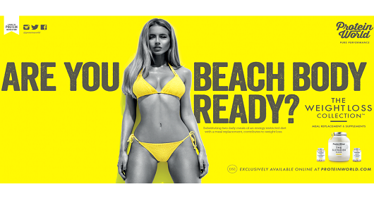
Figure 2.1: Protein World’s ‘Beach Body Ready’ Campaign 2015 (Source: Graham, 2015)

Although images that have been digitally altered have become an expected societal norm, many believe that brands and marketers can do more to combat the negative effects associated with the unrealistic standards that have been set. In 2017, French advertisers were banned for retouching and editing model’s bodies without indicating that the image has been digitally altered (Petter, 2017). To support this, French authorites brought in a new law that prohibits the alteration of body shape and does not apply to retouched hair or skin (Petter, 2017). In the UK, beauty brand CVS recently announced that it would not digitally alter any of its beauty images and would label these images with a ‘CVS Beauty Mark’ to show consumers that they had not been Photoshopped (Hanbury, 2018).

  - Gender Stereotypes
As is the case with girls, boys are also subjected to stereotypical cultural ideas from a young age such as masculine action figures and cartoon heroes (Psychology of Eating, 2018). A study conducted by Eisend (2009) indicated that the advertising industry has started to change its attitudes towards gender stereotypes but marketing materials have continued to target specific products to certain customers based on traditional gender roles. In 2017, U.N. Women joined forces with industry leaders such as Unilever, Facebook, Google, Mars and Microsoft to launch the ‘Unstereotype Alliance’ whereby the global campaign will aim to end stereotypical and sexist portrayals of gender in advertising (Beaudoux, 2017). The Advertising Standards Agency in the U.K. announced in July 2017 that advertisements that promoted gender stereotypes would be banned, as they stated “tougher advertising standards can play an important role in tackling inequalities and improving outcomes for individuals, the economy and society as a whole” (Beaudoux, 2017, p.1).

  - Impact on Females
Nowadays, the way in which women are portrayed in advertising has altered a great deal, compared to early television and magazine campaigns whereby women were widely characterised as homemakers who were responsible for raising children, cooking and cleaning (Marusic, 2016). The position of women in society has improved greatly, for example, in 2011, women made up more than half the workforce in the U.S., the images of women in advertising have not changed appreciably and women are still being used as a marketing instrument in a way that degrades women’s value (Gaag, 2014; Bayraktar, 2011). Women’s magazines, probably more than any other form of mass media, have been criticized as being advocates and promoters of an unrealistic and dangerous ideal (Wolf, 1990 as cited in Thompson and Heinberg, 1999). Kramer (2017) discusses the difference in impact between viewing idealized images of women in television and in magazines. Television has been shown to increase body dissatisfaction but less frequently associated with the need for thinness and disordered eating behaviour that occurs in women and girls who read fashion magazines. Kramer (2017) believes that this is due to women watching television for entertainment, but turn to magazines specifically for diet, fashion and fitness advice. However, Greenberg et al (2003) found that watching small amounts of television with actresses fitting the thin ideal can have negative effects, such as distorted self-perception, lower self-esteem and increases in depression, on women. Only around 14% of females and 24% of males depicted in television are overweight or obese, which is a disproportionately small amount when compared to the general population (Greenberg et al, 2003; Myers and Biocca, 1992).

According to the Dove Global Beauty and Confidence Report, women in the UK have one of the lowest self-esteem scores in the world (Whitelocks, 2016) but a study by the American Psychological Association found that from 1981 to 2011, women’s dissatisfaction with their bodies was decreasing (Sifferlin, 2016). Popular advertisements for companies such as Dove, that promote women of all different body sizes and races, show more body diversity and allow the public to become more critical of the extreme images they see. However, Dove is not always successful with its advertising campaigns and recently, the company produced a new shower gel in six differently shaped bottles designed to (in Dove’s words) “evoke the shapes, sizes, curves and edges that combine to make every woman their very own limited edition” (Craik, 2017). This campaign did not impress women as they felt patronised by a brand that had previously given them the feel-good factor and inspired them to love themselves (Maxwell, 2017).

  - Impact on Males
The use of ‘hyper-masculinity’ (the over-the-top portrayal of masculine stereotypes) has been seen to be detrimental to both men and society at large (Vokey et al, 2013) A Canadian study conducted by Vokey et al, 2013 found that publications with the highest rates of hyper-masculine advertisements were aimed at younger men of lower socioeconomic status and this is “an area of real concern, as they are still learning appropriate gender behaviours and their beliefs and attitudes can be subtly shaped by images that the mass media repeatedly represent” (Krans, 2013, p.1).
Research conducted by McCreary and Sadava (2001) found that adolescent boys are more likely than girls to perceive themselves as underweight. A study conducted by the University of West of England found that more than four in five men (80.7%) talk negatively about their body image by referring to perceived flaws and imperfections, compared with 75% of women (Campbell, 2012). An important piece of research conducted in this area is by Credos (2016) who found that 53% of secondary school boys said advertising puts pressure on them to look good. Weight dissatisfaction has a different meaning to men than it does to women. A study conducted by Psychology Today in 1997 found that 89 percent of women who were unhappy with their bodies wanted to lose weight, whilst 22 percent of men who were unhappy with their bodies wanted to gain weight (Garner, 1997).

Images in the media often exaggerate a model’s muscle development which can encourage unhealthy muscle-enhancing behaviours such as taking steroids or other supplements (Kirkup, 2009). Historically, steroid use was limited to those who wanted to improve their sporting performance but recently there has been a shift as appearance is now forming the main reason behind those using anabolic steroids and other image and performance enhancing drugs (IPEDs) (Morris, 2018). The results of a report from the national IPED information project (Begley et al, 2017) found that there were around 900,000 users in the UK with 56 percent of these users admitting that the use of these drugs was related to aesthetic purposes. It is thought that changes over the last 30-40 years in how men’s bodies are depicted in the media has a major effect on the way men perceive their bodies in a modern society (Heid, 2017). Magazines such as GQ, Men’s Health and Fortune portray the ideal man as muscular, wealthy and prestigious and often these ideally attractive men are featured with equally attractive women which sends the message that men that achieve this ‘ideal’ look will obtain ideal partners if they are willing to conform to society’s expectations (Hobza et al, 2007).
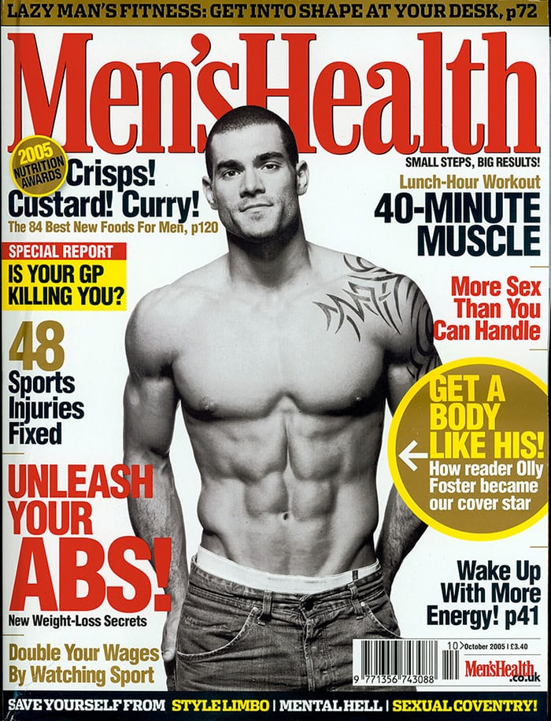
Figure 2.2: Cover Image of Men’s Health Magazine October 2005 (Source: The Guardian, 2013)

It is clear to see that body image dissatisfaction is a problem amongst both women and men. Companies are becoming more aware of an issue with the disparity between advertising campaigns, the idealised models they use, and the general public. It is suggested that marketers should take more responsibility when it comes to promoting images that coud be associated with body dissatisfaction but there is an argument that ultimately the responsibilty must come down to the individual and how they process the image. Consumers are becoming more aware of the images they see in the media, and nowadays are more likely to want products that promote a positive self image and feelings of worthiness and desire.

CHAPTER THREE
METHODOLOGY

- Introduction to Methodology
This chapter of the research project will aim to provide a detailed discussion relating to the various research methods that have been used to conduct primary and secondary research. The variety of methods were chosen with the goal of successfully achieving the aims and objectives of the research:

- To review and examine the secondary research and undertake thorough analysis of the literature and the relationship between images in the media and body perception
- To explore the views of consumers with regards to body image, digital alterations and media influence
- Evaluate the roles of the media in public view and perception of body image
The selected research and data collection methods will be outlined in this chapter, including justification for the selected methods in order to achieve the research objectives. Research is defined by Collis and Hussey, (2014, p.3) as “a systematic and methodical process of inquiry and investigation with a view to increasing knowledge.” Wilson (2010, p.3) furthers this definition whereby they state research is “a step-by-step process that involves the collecting, recording, analysing and interpreting of information”.

3.1. Research Onion
This project has been undertaken using the research ‘onion’ methodology in order to depict the issues underlying the choice of data collection method, (Collis and Hussey, 2014; Saunders et al, 2009).
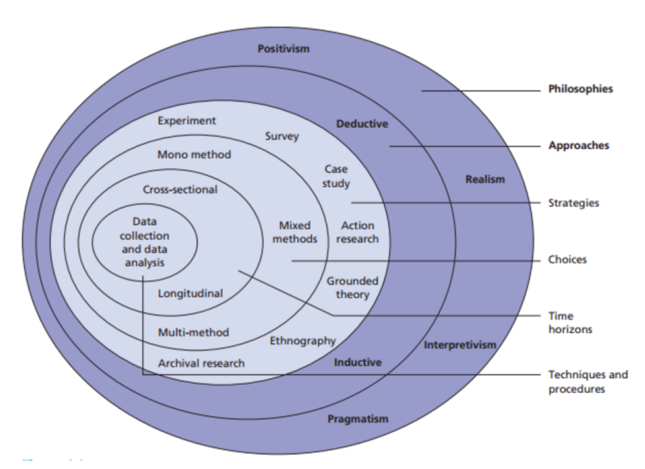
Figure 3.1: The Research Onion (Saunders et al, 2009, p.138)

3.2. Research Design
Research design is “a detailed framework or plan that helps to guide you through the research process, allowing a greater likelihood of achieving your research objectives” (Wilson, 2010, p.102).

3.2.1. Research Philosophy
According to Collis and Hussey (2014) a paradigm guides how research should be conducted based on philosophies and their assumptions about the world and the nature of knowledge. The exterior layer of the research onion forms the research philosophy. Saunders et al, (2009, p.108) explains that research philosophy relates to the development of knowledge in a particular field and will “underpin your research strategy and the methods you choose as art of that strategy”.

This study will undertake a philosophy of interpretivism. Interpretivism has been chosen as human emotions are involved and it is not an exact science with a clear, factual answer (Saunders et al, 2009). Collis and Hussey (2014, p.45) further this whereby it is stated; “interpretivism tends to focus on exploring the complexity of ‘social phenomena’ to gain a view that has an interpretive understanding.”

To form a philosophy of interpretivism, the researcher will conduct a focus group and carry out online surveys to understand individual perceptions of the responsibilities of marketers when promoting images in the mass media. Although surveys traditionally adopt a positivist approach, the researcher will be interpreting the data from a social aspect to glean an understanding of public perceptions. The interpretivism approach tends to use small sample, product quantitative data that is subjective and provide results with low reliability but high validity (Collis and Hussey, 2014).

3.2.2. Research Approach
The next layer of the research onion concerns itself with the research approach. The research approach can either be deductive, which is to develop a theory and hypothesis and design the research strategy to test said hypothesis, or inductive, whereby data is collected to develop the theory as a result of analysing data (Saunders et al, 2009).

The nature of this research will mainly call upon the use of inductive research as the researcher will seek to make observations about the research and then look to contribute to existing or new theory (Wilson, 2010). This approach is most suitable to the research method as it allows the collection of qualitative data to be analysed with findings being taken from the results. This type of approach allows the researcher to gain an understanding of the meanings humans attach to events (Wilson, 2010).

3.2.3. Research Strategy
The research strategy that was applied to this study were both quantitative and qualitative. The use of a survey allows for quantitative data to be gathered whilst the focus group method of data collection allows for the collection of qualitative data. A survey is defined by Collis and Hussey (2014, p.76) as a “methodology designed to collect primary or secondary research from a sample with a view of analysing them statistically and generalising the results to a population”. Collis and Hussey (2014, p.155) define focus groups as ‘a method for collecting data whereby selected participants discuss their reactions and feelings about a product, service, situation or concept, under the guidance of a group leader’. These strategies were chosen as the best options for the research as surveys were the most cost and time effective method of gathering a large amount of data and focus groups can further clarify the results from the online survey whilst adding a more human dimension to the data.

3.2.3.1. Quantitative Research
Quantitative research is described by Wilson (2010, p.14) as an approach that “might draw a large and representative sample from the population of interest, measure the behaviour and characteristics of that sample, and attempt to construct generalisations regarding the population as a whole”. For the purpose of this project, in order to obtain appropriate data to support the research study, an online survey was designed. The use of online surveys is advantageous to the researcher as this method will allow information to be collected that relates to respondent’s perceptions of body image in the mass media. The responses gathered through the use of surveys are factual and allows the researcher to generate themes relating to the study.

For the purpose of this study, the survey consisted of 15 questions ranging from questions relating to gender and social media usage to views on whether companies should state when they have digitally altered marketing images. The questions themselves were written in a way that was clear, to allow respondents to understand each question which means answers provided were honest based on individual perception of the topic. A pilot study was distributed to friends and family members. They were asked to complete the survey and highlight any issues associated with the survey. This allowed the researcher to alter any flaws that were identified within the survey before it was published online. The questions were carefully designed to avoid bias towards a particular answer and it was ensured that the survey questions followed a logical order. General outcomes of the online survey allowed the researcher to develop key themes that were used to generate questions for the focus group. There was a total of 120 responses.

3.2.3.2 Qualitative Research
According to Collis and Hussey (2014) qualitative research is data collected in a nominal form with the purpose of identifying key variables and themes. A focus group was conducted for qualitative data collection within this research. Focus groups are a form of group interview that capitalises on communication between participants in order to generate data that encourage group discussions to explore participant’s knowledge and experiences (Kitzinger, 1995). The use of focus groups was advantageous for this study as group processes can help people to explore and clarify their views in ways that would be less easily accessible in a one-to-one interview (Kitzinger, 1995).

The focus group conducted as part of this research consisted of 5 participants. All of the participants were women, aged between 25 to 50. The researcher initially planned for at least 6 participants to attend but time constraints meant that the focus group conducted only consisted of 5 participants. A brief pilot study was conducted with a group of 6 students to give the researcher an impression of the type of questions and approaches that would be suitable for the research. All of the questions asked by the researcher were open-ended and the researcher was conscious that participants could take the conversation into unnecessary areas therefore, the researcher ensured to prompt the discussion in the right direction without forming a bias towards a particular theme. The researcher had initially planned to conduct two focus groups but after analysing the data collected after the first focus group, there appeared to be rich, saturated data which sufficed to the need of the overall research objectives.

3.2.4. Time Horizon
A cross-sectional approach has been selected for this study which is defined by Saunders et al, (2009, p.155) as ‘the study of a particular phenomenon at a particular time”. A cross-sectional time horizon was necessary for the nature of the study as there are associated time constraints and this method allows the researcher to create a ‘snapshot’ of the area of interest at a given moment in time (Creswell, 2009).

3.2.5. Research Sample
Sampling techniques are explained by Saunders et al (2009, p.210) as a “range of methods that enable you to reduce the amount of data that is needed to collect by considering only data from a sub-group rather that all possible cases”.

For the purpose of this research, there were two samples chosen for the two primary data collection techniques that were used. The sample method that was be applied to surveys was random sampling as the surveys were online and they were not targeted at a particular sample group. This means everyone in the entire target population had an equal chance of completing the survey which allows a representative interpretation of the target population and eliminates sampling bias (McLeod, Sampling Methods, 2014). The intended sample size for this study was 100 responses and the actual response rate was 120.

The sample method that is applied to the focus group will be a convenience, or opportunity sample, whereby the participants are the most convenient and easy to reach (Coolican, 2014). Various members of staff from University of Wales Trinity St. David were selected to take part in the focus group. This was the easiest way to choose participants for the focus group. This method of sampling may not provide a representative sample and could be biased and if the researcher was to carry out the research again, a method of stratified sampling would be used to allow for a better representation of the target population and then generalize from the results obtained (McLeod, 2014).

3.2.7. Data Analysis
After all the data has been collected, it needs to be correlated, analysed and interpreted. The researcher will use tools provided by online survey platform Survey Monkey to analyse data collected through the online surveys. This information will then be put into spreadsheets and graphs to make it easy to read and understand. Information gleaned from the online surveys will then be correlated with information collected in the focus group to carry out thematical analysis.

3.3. Reliability and Validity
Reliability and validity are ways of demonstrating and communicating the rigour of research processes and the trustworthiness of research findings (Roberts, 2006). If data is going to be useful, bias and distortion should be avoided. According to Collis and Hussey (2014, p.65) validity is defined as ‘the extent to which the research findings accurately reflect the phenomena under study’. The key themes used to develop questions for both the online survey and focus group were derived from the academic literature review. Research techniques and methods were discussed with a dissertation supervisor in order to reduce the risk of observer and participant error.

Reliability refers to the extent to which assessments are consistent and there should be an absence of differences in the results if the research was repeated (Collis and Hussey, 2014). The reliability of this study could be tested by conducting the focus group for a second time or collecting more responses from the online survey to see whether the results of the two focus groups and additional survey results correlated but this was not possible during this study due to time and resource constraints. The reliability of the study was then reviewed with the results from the pilot studies to ensure the correlation of information.

3.5. Ethics
The research was only conducted with participants aged over 18. The research involved primary data collection from individuals and therefore an application for ethics approval was made to the appropriate department at University of Wales Trinity St. David. Research activity did not start before this approval was obtained. Participation in the research was entirely voluntary and participants were informed that they were under no obligation to take part in the research and they had the right to withdraw from participation in the research at any time. There was be a guarantee of anonymity from the research and any information they provide was treated in the strictest confidence.
Data from the research is to be kept secure and precautions taken to prevent any information being publicly available. Data files will only be held on password protected computers. The nature of the topic is for a marketing perceptual basis only and is highly unlikely to cause any psychological implications.

3.6. Limitations of the Research
A major limitation of this research was time. Due to the nature of the dissertation project, the researcher had around 2 weeks to collect the responses of the online survey. Despite this, the researcher exceeded the expectation of 100 responses and actually collected 120 responses. With regards to the focus group, the researcher found difficulty to get participants together on a voluntary basis. The researcher initially wanted 6-12 respondents for the focus group but due to time and availability issues, there were only 5 participants.

CHAPTER FOUR
DATA ANALYSIS
- Introduction to Data Analysis
This chapter of the dissertation study details the results of the survey and focus group conducted by the research, based on the methods discussed in Chapter 3. This chapter will seek to find relevant relationships and trends through interpreting the data with an inductive approach.

  - Analysis of Focus Group
The focus group session took place in March 2018. The group compromised of 5 females, aged between 25 to 50. The purpose of the researcher carrying out a focus group was to seek further opinions and gain a deeper understanding of the information gained from the survey.

The group were given a brief introduction by the conductor into the topic. All of the participants were given a set of images to look at and then asked to discuss the impact these images had on them. The conductor was then able to question the group and seek their opinions whilst allowing natural discussion to flow and take its course. Thematic analysis identified 2 main themes across the open-ended questions and resulting discussions by the participants.

    - Theme One: Societal Norms
A major reoccurring theme within the focus group was that there is a need from society for people to look a certain way. They all agreed that the model in the first image (see Appendix 5.A.) looked great, but the wording that accompanied the image was offensive and misleading. The participants also agreed that the average women do not look like the one used in the Protein World advertisement and they thought the image was most likely Photoshopped;

“She does look great but it’s the implication that you can’t be beach body ready unless you’re taking this weight loss supplement…Which part of her look makes her beach body ready? And the rest of us not? Is it the yellow bikini?”

One participant stressed the importance of the portrayal of idealised body image in the media, aimed at teenagers and young women. Kilbourne (1990) describes that idealised body images on models are constantly projected onto young people which makes them want to conform to an impossible body ideal. They all agreed that body image dissatisfaction is more common nowadays amongst young women, and they all believed it was not a big issue when they were all younger. This is supported from information in chapter 2, whereby Micali et al (2013) found that the rate of eating disorders for people aged 10 to 49 in the UK rose from 32.3% in 2000 to 37.2% in 2009 and according to the same study, the peak age of onset for an eating disorder diagnosis in women was between 15 and 19. However, one participant disagreed with an example given of her own 14-year-old daughter;

“She is not self conscious at all. She has no perception of body image…but she has put on a lot of weight since starting comprehensive school which I’m trying to sort out and its difficult for me then to draw the line between not wanting her to put on more weight.”

Issues such as this are supported by campaigns by companies such as Dove, whereby they use ‘real’ bodies to promote body equality. The participants all agreed that they thought the ‘Dove Be Real Campaign’ image (see Appendix 5.B.) was more realistic and promoted women in their natural states. One participant thought that Dove were not trying to sell a product using the image, whereas the Protein World image was promoting a weight loss supplement and individuals could aspire to look like the model in the image if they used a product;

“Although with this one (Protein World), they are showing you what you could look like if you use that product so I don’t suppose it would have the same impact if they went ‘you’d look like one of these (referring to Dove models) if you used our product’”

Following a question raised by the conductor, participants discussed the need to look a certain way to conform with society’s norms. They all agreed with the statement to an extent, but were sceptical as they all agreed they would want to put their best images out into the public domain and therefore, they thought companies would want to do the same. This result correlated with the answers from Question 15 of the online survey, whereby the majority of respondents thought they were ‘sometimes’ pressured by images in the media to conform to societal norms;

“The thing is we now Photoshop ourselves with filters. Even I have worked the filters out. I’ve learnt to improve my own image so I’m certainly going to expect people in the public eye to do that”.

    - Theme Two: Cynicism of the Public
Advertisers commonly use digital platforms to alter photographs and enhance the appearance of the models. Airbrushing, or digital alterations, provide unrealistic standards and expectations of what a beautiful person should look like. A reoccurring theme throughout the focus group was a realisation from all of the participants that all of the images they were shown had probably been digitally altered in one way or another.

“Have you noticed they’re all very attractive? All of the women in the Dove campaign, despite their different body images, they’re all very attractive women. So its not like they’ve gone and picked a random selection of women off the street, they’ve picked attractive women of all shapes and sizes. And probably a lot of them are plus size models.”

The participants were shown a set of 4 images that had not been digitally altered in any way (see Appendix 5.C.) with the following set of images, showing the same women in advertising images that had been digitally altered (see Appendix 5.D). They all agreed that the images were extreme versions of the first set and definitely not realistic;

“If you saw that campaign of Katy Perry and then saw her with perfect skin after seeing this image of her with acne, would that make you want to buy that product? If it was definitive that the results were down to that product then yes, but not otherwise. If its just done on a computer, then its just misleading”.

In chapter 2, digital alterations and unrealistic advertising campaigns were discussed, whereby MP Jo Swinson states adverts ‘were not representative of the results the products could achieve’ (Sweney, 2011). Therefore, the results of the focus group show that the public are questioning results that can be achieved from particular products and marketers could now benefit from being more open and honest with their customers;

“If someone genuinely looks like this (Protein World) then fab, put them out there and good on her, she’s probably young and healthy, beautiful and everything, but if its been tweaked then I think that should be stated just as a matter of ethical selling”.

When the participants were questioned about brands stating on their advertising when images had been digitally altered, all except one participant strongly agreed. The participant that did not agree thought that individuals must realise that images are altered to look good and that they knew unrealistic standards could not ever be met.

“It’s the bigger picture. This is the world that we live in where the rich get richer and the poor get poorer. This is a cynical marketing ploy and I don’t believe people are that stupid… But that is purely my opinion”.

The participants brought up the prevalence of filters on personal images on social media and young people are especially prone to using filters.

“I’ve learnt to improve my own image so I’m certainly going to expect people in the public eye to do that…I think younger people are much more up on filters and changes than I am… so maybe there needs to be disclaimers?”

According to research discussed in chapter 2, 70% of women and 50% of men edited their images before posting them to social media sites (Ratcliffe, 2017). This is supported by the results of Question 10 of the online survey, whereby 43% of the respondents said they used filters on their personal pictures. The participants of the focus group all agreed that they wanted to show themselves in the best possible way in their own personal pictures and they all expected advertisers to do the same. However, the participants thought that marketers should be wary with their tactics due to the impact on the public, especially on young girls;

“Young girls could go out and think, ‘it says one tablet but I want to look like the girl on the picture so I should take a few more’… some girls would think this is an attainable body image just from taking those tablets and then only take one and think there’s something wrong with me because it says take one and I’ll then look like her, then if its not working, they may take more”

On the whole, the results from the focus group supported the results of the online survey and the information gathered within the literature review.

  - Analysis of Online Survey
The online survey had a final response rate of 122. The respondents were from a random sample group, and were mixed male and female. The researcher has used tools provided by online survey platform Survey Monkey to analyse data collected through the online surveys which includes automatic generated charts and graphs to allow for easy interpretation of data.

    - Gender Demographic- Question 1
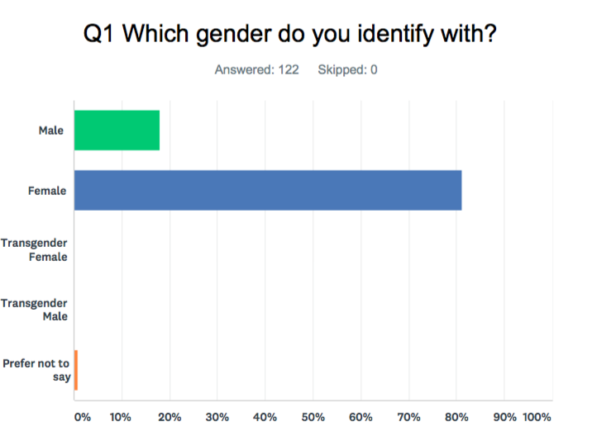
Figure 4.1: Gender

Figure 4.1 shows that the majority, 81%, of the respondents that completed the study were female. This may be due to the survey being distributed on the researcher’s personal social media pages, therefore being shared with more females than males. This demographic balance is acceptable for the study as there is a preconception of females being more affected by the way body image is portrayed in the media. As discussed in chapter 2, this is supported by Wolf (1990), whereby they found women’s magazines, possibly more than any other form of mass media, are stereotypically promoters of unrealistic body ideals. A study conducted by Eisend (2009) found that the advertising industry has started to alter its attitudes towards gender stereotypes but marketing materials do continue to target specific products towards certain customers based on stereotypical gender roles. Although there is a large female response, there is still a correlation between the effect the topic has on males and this can be seen with the 18% of male respondents.
    - Fashion Publications- Questions 2 & 3

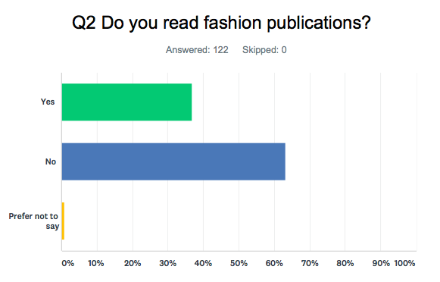
Figure 4.2: Fashion publications read
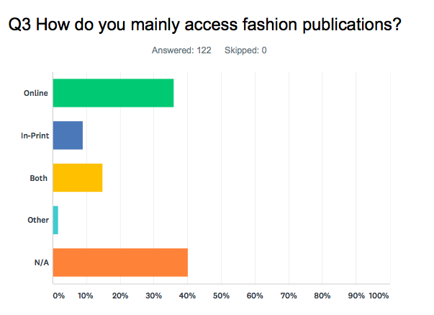
Figure 4.3: Fashion publication accessed

Questions 2 and 3 both ask respondents if and how they access fashion publications. The results of question 2 showed that 37% of the respondents did read fashion publications. Images of idealised models are projected on to the public from a young age, mostly in publications that promote fashion and beauty products. As discussed in chapter 2, the purpose of advertisements, such as those found in fashion publications, is to inform the public and create awareness of products or brands. The results of question 2 shows that advertisements that may promote an unhealthy body image, may not necessarily be found by the public in fashion publications and more in the general media. The results of question 3 show that the majority of respondents who read fashion publications, accessed them via an online format rather than in-print. The internet has made advertisements more accessible to the average individual and Eggleton (2010) found that this is highly likely to have a profound affect on society. A study conducted by The Media Awareness Network estimated that the typical American will see 3000 adverts per day (Eggleton, 2010) and reports have indicated that around 95% of Google’s revenue comes from online advertising (Saleh, 2017). The impact that the internet has had on the relationship between body image and advertising means that individuals are more likely to receive commercial messages on a day to day basis that have statements about beauty and body image (Croft, 2017).

    - Social Media- Questions 4 & 5

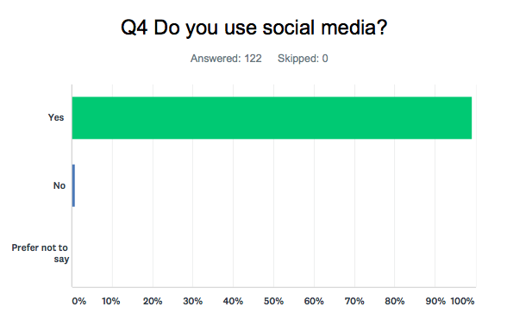
Figure 4.4: Social media use

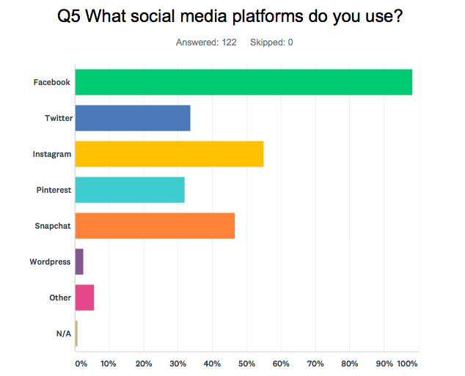
Figure 4.5: Social media platforms

Questions 4 and 5 relate to social media usage. The results of question 4 show that the majority (99%) of respondents used social media whilst only 1% did not. Question 5 showed that the majority of respondents used Facebook (98%) followed by Instagram (55%), Snapchat (47%) and Twitter (33%). The popularity of social media sites is constantly growing and this can have both negative and positive effects on body image dissatisfaction. Research conducted by Florida State University discussed in chapter 2 found that a group of women who were asked to browse Facebook for 20 minutes experienced greater body dissatisfaction than those who spent 20 minutes researching rainforest cats online (Dove, 2016). Social media can also be used to promote body positivity, also discussed in Chapter 2. Hashtags for body positive campaigns such as ‘#WhatMakesMeBeautiful’ encourages women to celebrate themselves for attributes outside areas surrounding body image.

    - Social Media Follows- Questions 6, 7 & 8

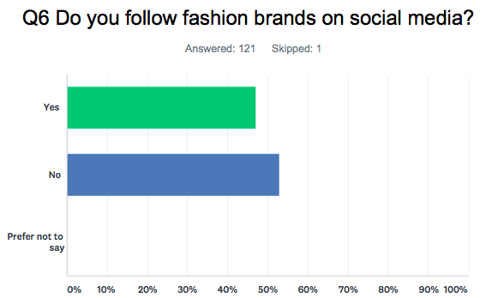
Figure 4.6: Fashion brands followed
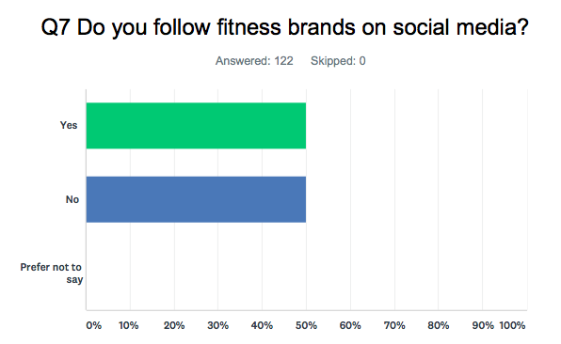
Figure 4.7: Fitness brands followed
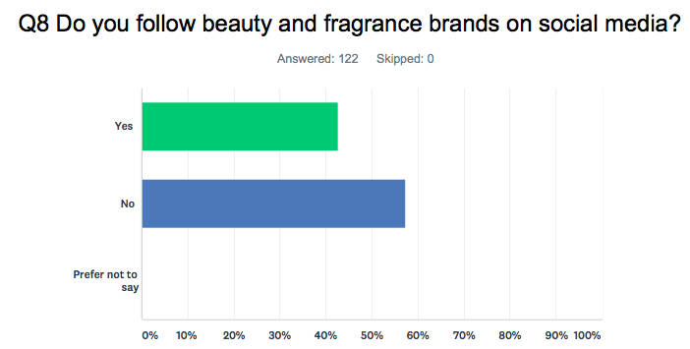
Figure 4.8: Beauty and fragrance brands followed
Questions 6, 7 and 8 are all related, and ask respondents what types of brands they follow on social media. Question 6 show the researcher that just under half (47%) of respondents follow fashion brands on social media. Question 7 show that half (50%) of the respondents followed fitness brands on social media. Question 8 shows that 42% of respondents followed beauty and fragrance brands on social media. Beauty and fashion brands are well perceived as being stereotypical for promoting an unhealthy ideal, which can lead to the failure of self-actualisation as discussed in chapter 2. In recent years, fitness, or wellness, brands have had more influence in social media circles. There is a growing population of fitness celebrities and bloggers that have built massive followings through the promotion of workout sessions. This is discussed in chapter 2, whereby Fry (2016) found that this new fitness obsessed culture is actually becoming harmful. Their study found that 42% of French gym-goers could be at risk of an exercise addiction.

    - Personal Photographs and Filters- Questions 9 & 10
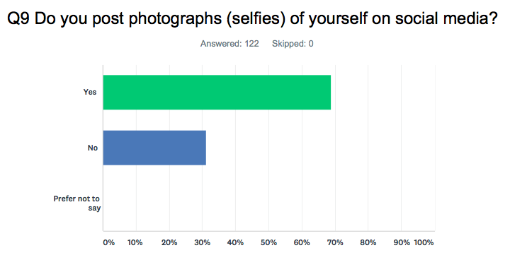
Figure 4.9: Selfies on social media
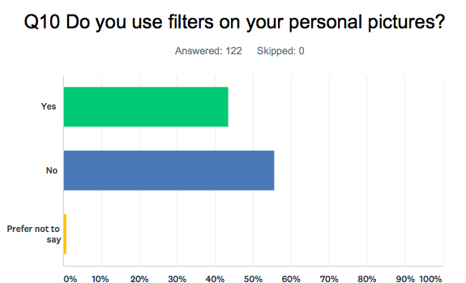
Figure 4.10: Filters on personal pictures

Questions 9 and 10 relate to personal photographs (selfies) and filters used on them. Question 9 showed that the majority of respondents (69%) posted selfies on social media, whilst question 10 showed that more respondents (56%) did not use filters on personal pictures than those who did. This is a juxtaposed argument to a study discussed in chapter 2, whereby the Renfrew Center Foundation found that 70% of women and 50% of men edited their images before posting them to social media sites (Ratcliffe, 2017).

    - Respondent Influence- Questions 11 & 12

Q11: Do you feel influenced by peer images on social media?


Figure 4.11: Peer image influence

Q12: Do you feel influenced by advertising campaigns?

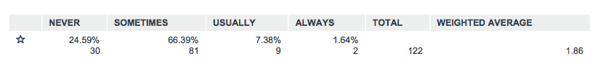
Figure 4.12: Advertising campaign influence

Questions 11 and 12 relate to the influence respondents feel by peer images on social media and advertising campaigns. For both questions, the highest rated answer was ‘sometimes’. For question 11, 34% of respondents answered ‘never’ with 51% of respondents answering ‘sometimes’. For question 12, 66% of respondents answered ‘sometimes’ and 25% answered ‘never’. These results are supported information from chapter 2 by Tiggeman (2017), Paxton (2016) and Warren (2014) whereby they all describe that individuals will be influenced by images they see, both in the mass media and on social media, either consciously or unconsciously. If the images are emotionally saturated and effect individuals without them actually realising, then this becomes a powerful tool for marketers.

    - Digital Alterations- Questions 13 & 14
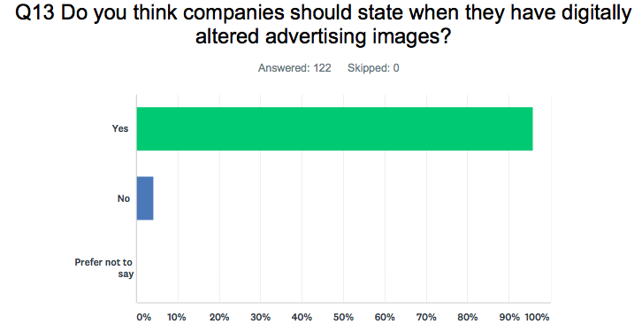
Figure 4.13: Digitally altered images

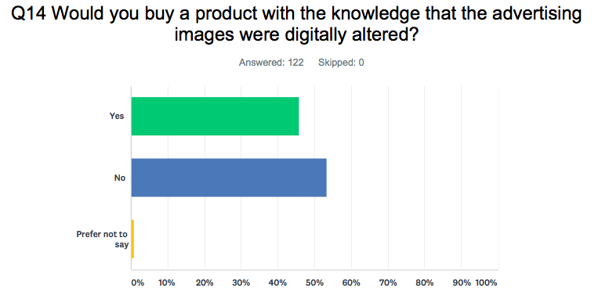
Figure 4.14: Knowledge of digital alteration

Question 13 and 14 both relate to digital alteration of images in the media. The results of question 13 show that a large majority (96%) thought that companies should state when they have digitally altered advertising images. In the UK, companies are not legally required to state when they have digitally altered an image. However, as discussed in chapter 2, beauty brand CVS have brought in a ‘CVS Beauty Mark’ which will be displayed on any of their beauty images that have not been digitally altered. Following the introduction of a new law, French advertisers are prohibited from altering body shape. ‘Photoshopping’ advertising images has become a sort of expected societal norm, many believe that brands and marketers should be doing more to stop the unrealistic body image expectations set by these altered images. Advertising campaigns from L’Oreal and Protein World have been criticised for being socially irresponsible and ‘were not representative of the results the products alone could achieve’ (Sweney, 2011). It seems the public are becoming more critical of the images they see in the media and research conducted by McLean et al (2016) discussed in chapter 2, found that teenage girls who take a critical approach to viewing idealized appearance images in traditional media are protected against a negative effect on body image. This is supported by the results from question 14, whereby the majority of respondents would not buy a product with the knowledge that the advertising image had been digitally altered.

    - Respondent Pressure- Question 15

Q15: Do you feel pressured by images in the media to look a certain way?
Figure 4.15: Pressure of media images

The results of question 15 show that respondents ‘sometimes’ feel pressured by images in the media to look a certain way. As discussed in chapter 2, there is no scientifically proven cause of body dissatisfaction or disordered eating, but research has shown that the media does contribute to problems surrounding these issues and there is a strong, reoccurring association between them (Simmons, 2016). Media images of the idealised body are projected on to the public from a young age, which underpins a need for young people to conform to the ideal which is regularly impossible.

CHAPTER FIVE
CONCLUSION

- Conclusion
This study was conducted in order to explore the role that marketers play when promoting images in the media that may ultimately have a detrimental effect on the public. It also includes recommendations for potential further areas of research. The specific objectives set to the research were:

- To review and examine the secondary research and undertake thorough analysis of the literature and the relationship between images in the media and body perception
- To explore the views of consumers with regards to body image, digital alterations and media influence
- Evaluate the roles of marketers and their impact on how people perceive body image
Based on these objectives, this final chapter of the study will summarise findings of the conducted research, providing conclusions based on these.

Having examined previous research and current news articles relating to the portrayal of body image in the media, the researcher has conducted an extensive literature review, thereby achieving the first of the research objectives which was ‘to review and examine the secondary research and undertake thorough analysis of the literature and the relationship between images in the media and body perception’. Within the literature review, a relevant theory was identified- Self-Actualisation Theory- which further underpins the importance of the study. The self-actualisation theory is concerned with the growth of an individual towards fulfilment of the highest needs; those for meaning in life in-particular. Marketers should be aware that when using socially idealized images in the media, individuals can create a poor self concept which can be extremely harmful. Considering the information identified in chapter 2 of this study, it has become evident that body image dissatisfaction is a problem in society, amongst both men and women. Companies have had to alter their tactics when marketing images that could negatively affect the general public as individuals are becoming more aware and cynical of the images that they see. It became apparent that there is no one single cause of body dissatisfaction or disordered eating but research does show that the media contributes to problems surrounding negative issues regarding body image. Images in the media may not actually cause issues, such as eating disorders, but there is certainly a strong, reoccurring association between them (Simmons, 2016).

To achieve objective two, primary research was used to identify and explore the views of consumers with regards to body image, digital alterations and media influence. The results of the focus group in chapter 4 brought about two main themes:
- Individuals views on body image portrayed in the media generates a need for people to conform to a societal norm
- Individuals are becoming more cynical of the images portrayed in the media.
These themes related to the results of the online survey and the literature review.

Results of the online survey showed that respondents felt pressured by images in the media and by peer images on social media. As discussed in chapter 2, 70% of women and 50% of men, edited their images before posting them to social media, whilst an important study by Florida State University, also discussed in chapter 2, found that a group of women who were asked to browse Facebook for 20 minutes experienced greater body dissatisfaction than those who spent 20 minutes researching rainforest cats online (Dove, 2016). These points show that images posted to social media has a great effect on individual’s sense of self-worth and can lead to issues associated with body dissatisfaction and disordered eating. Images in the media are often saturated with gender stereotypes that can further feelings of body dissatisfaction and a lack of self worth. This can also have an impact on feelings of individuals having to conform to societal norms, whereby it is felt that people have to look a certain way in order to be ‘normal’. The ideal self in the media, both applied to males and females, is projected onto the public from a young age which underpins a need for individuals to look a certain way and conform to a sometimes impossible standard.

A major reoccurring theme throughout the whole study was the use, and misuse, of digital alterations. Digital alterations, or Photoshop, is commonly used to enhance the appearance of model’s bodies (Arnold, 2011). Through altering images in this way, unrealistic standards can be set as individuals will constantly compare themselves to the images, sometimes, unconsciously. An overwhelming majority (96%) of the respondents of the online survey thought that companies should state when they have digitally altered advertising images which correlates with the findings from the focus group whereby all bar one of the participants of the thought that images that have been digitally altered should be labelled accordingly but there is no legal requirement in the UK for marketers to do so. French authorities have brought in a new law that prohibits the alteration of body shape, and British brand CVS have announced that it would not digitally alter any marketing image and would label them with a ‘CVS Beauty Mark’ to show this. The study shows that consumers would approve of labelling altered images and marketers could benefit from doing so. According to feelings from the focus group, the public are now becoming more aware that images in the media may not be what they seem and the public are now questioning the truthfulness of the media image. Individuals are realizing that images can be manipulated to obtain an effect and there is a feeling that marketers should be more open and transparent when it comes to promoting beauty and fashion products.

Throughout the study, roles of marketers and the impact they have on the perception of body image have been evaluated which meets objective three. One of the main challenges that face the research area are gender stereotypes which, even in a modern age, still present as a problem. Body image is typically perceived and associated with females, but research shows that males are equally affected and the issue embodies itself in a different way. Gaag (2014) and Bayraktar (2011) found that images of women in advertising have not changed in line with changing female roles in society and women are still being used as a marketing instrument in a way that degrades their value. Marketers use ‘hyper-masculinity’ in the media which has been seen to be detrimental to the social worth of men (Vokey et al, 2013). Based on traditional gender roles, marketers have historically targeted specific products to certain customers but the Advertising Standards Agency (ASA) in the UK announced in July 2017 that advertisements that promoted gender stereotypes would be banned. This is part of a wider problem, as women and men both fight for equality in all roles.

CHAPTER SIX
RECOMMENDATIONS

Recommendations

  - Implication for Marketers
The research suggests that consumers are becoming more aware of the images they see and the products they purchase. Consumers would rather purchase products that promote feelings of worthiness and desire. Marketers could benefit from changing their tactics and promoting images of ‘real’ males and females, that have not been digitally altered- the research showed that consumers were bored of looking at perfect models and would rather see a more natural image. Images should include more diversity, and could include models who are slim to fuller figured, toned, muscular and every body type in-between. This stays the same for both males and females. Advertisers should promote a healthy body image, without promoting extreme exercise regimes as seen with the mistakes of the wellness industry whereby there is a problem with exercise addiction.

Brands are recommended to lessen their digital alteration activity, if not cease it completely. However, it is highly doubtful that will become normal practice without government or legal intervention, as has been the case in France. Consumers are more powerful in a modern society, with the addition of social media, whereby it is clear that individuals have a voice that needs to be heard by the marketers. There is certainly a responsibility for marketers to uphold positive body standards that can be promoted to all ages. If body positivity is underpinned to young girls and boys, surely a more body positive society would be created for the long term. Marketers should state when images have been digitally altered. Marketers have become complacent with using images that are altered to make products look good but as the public become more aware in a transparent society, marketers must not use stereotypical images that have become outdated and lazy. It is acknowledged that this issue cannot be changed overnight, however it is recommended;

- Codes of conducts of professional marketing organisations are brought up-to-date regarding body image
- CIM become champions of this cause by providing education and training to existing professionals and by covering the topic directly within their qualification structure
- Issues of contemporary ethical issues surrounding body image are addresses on higher education undergraduate and postgraduate marketing programmes

  - Future Research
Due to restricted resources, the research had limited scope with regards to respondent and participant numbers. However, this is not to discredit the valuable data and information gathered through the research process.

It is recommended that the study be repeated on a larger scale, including a focus group incorporating males to make the research more balanced. Body image in the media is well documented with regard to the effect on women, however, the impact is less seen with males. Information gleaned in the literature review shows that the issue does impact males, but the effect differs to that of females.

Also, it is recommended that any further study include issues surrounding an age demographic. The issue can effect males and females of all ages, but the current study did not focus on this. This would provide more valuable data that could be analysed in depth and would give a broader range of views on the topic.
The study identified areas that could be further researched such as the effect of standards set by the ASA; “tougher advertising standards can play an important role in tackling inequalities and improving outcomes for individuals, the economy and society as a whole” (Beaudoux, 2017, p.1). This further study could then explore the effect the subject of body image perception has on wider society and the ways the issue may effect individuals in their working and social lives.

Information gathered within the literature review of chapter 2 brought about an interesting question:
‘Is the responsibility down to marketers to promote healthy body images or should the responsibility fall upon the public to perceive the image in a responsible way?’

This question could pose an interesting start for further research around the topic of body image perception.

BIBLIOGRAPHY

Bibliography
- All Party Parlimentary Group on Body Image. (2012). Reflections on body image. YMCA. London: YMCA.
- AMA. (2017). About AMA. Retrieved 2018, from American Marketing Association: https://www.ama.org/AboutAMA/Pages/Statement-of-Ethics.aspx
- American Marketing Association . (2013, July). About AMA. Retrieved November 06, 2017, from American Marketing Association Website: https://www.ama.org/AboutAMA/Pages/Definition-of-Marketing.aspx
- Arnold, C. (2011, June 29). What's Photoshop got to do with it? Retrieved March 8, 2018, from Psychology Today: https://www.psychologytoday.com/blog/body-evidence/201106/whats-photoshop-got-do-it
- ASA. (2018). About the ASA. Retrieved 2018, from ASA Website: https://www.asa.org.uk/about-asa-and-cap/about-regulation/about-the-asa-and-cap.html
- Bayraktar, A. (2011). It it ethical to use women as a marketing instrument? Global Conference on Business and Finance Proceedings , 6, 250-260.
- Beaudoux, V. G. (2017, October 18). How media sexism demeans women and fuels abuse by men like Weinstein. Retrieved March 13, 2018, from The Conversation: https://theconversation.com/how-media-sexism-demeans-women-and-fuels-abuse-by-men-like-weinstein-85789
- Begley, E., McVeigh, J., & Hope, V. (2017). Image and Performance Enhancing Drugs. Liverpool: Public Health Wales.
- Campbell, D. (2012, January 6). Body image concerns more men than women, research finds. Retrieved November 15, 2017, from The Guardian: https://www.theguardian.com/lifeandstyle/2012/jan/06/body-image-concerns-men-more-than-women
- Cassano, J. (2016, March 30). The Science of Why You Should Spend Your Money on Experiences Not Things. Retrieved April 26, 2018, from Fast Company: https://www.fastcompany.com/3043858/the-science-of-why-you-should-spend-your-money-on-experiences-not-thing
- CIM. (2009). Marketing and the 7P's. Retrieved 2018, from CIM: http://www.thensmc.com/sites/default/files/CIM%207Ps%20Resource.PDF
- CIM. (2015). Marketing and the 7Ps. Retrieved 2018, from CIM Website: https://www.cim.co.uk/media/4772/7ps.pdf
- Collis, J., & Hussey, R. (2014). Business Research: A practical guide for undergraduate and postgraduate students. Hampshire: Palgrave Macmillan.
- Cook, G. (2001). The Discourse of Advertising. New York: Routledge.
- Coolican, H. (2014). Research Methods and Statistics in Psychology (6th Edition ed.). East Sussex: Psychology Press.
- Cooper, L. (2016, May 27). Consumers Are Buying Brand Experiences Rather Than Products. Retrieved March 8, 2018, from Huffpost: https://www.huffingtonpost.com.au/2016/05/26/consumers-are-buying-brand-experiences-rather-than-products_a_21384105/
- Craik, L. (2017, May 15). How beauty giant Dove went from empowering to patronising. Retrieved November 15, 2017, from The Guardian: https://www.theguardian.com/fashion/2017/may/15/beauty-giant-dove-body-shaped-bottles-repair-damage
- Credos. (2016). Picture of Health? Media Smart. London: Credos.
- Creswell, J. W. (2009). Research Design: Qualitative, Quantitative and Mixed Methods Approaches. Los Angeles: Sage Publications.
- Croft, H. (2017). Eating Disorders: Body Image and Advertising. Retrieved 2018, from Healthy Place: https://www.healthyplace.com/eating-disorders/articles/eating-disorders-body-image-and-advertising/
- Diller, V. (2011, August 7). Is Photoshop Destroying America's Body Image? Retrieved March 8, 2018, from Huffington Post: https://www.huffingtonpost.com/vivian-diller-phd/photoshop-body-image_b_891095.html
- Dove. (2016, November 1). Positive body confidence- how social media can affect body image. Retrieved February 13, 2018, from Dove: https://www.dove.com/uk/dove-self-esteem-project/help-for-parents/talking-about-appearance/positive-body-confidence-how-social-media-can-affect-body-image.html
- Eggleton, M. (2010, June 26). Does Advertising shape society, or merely mirror societal trends? Retrieved February 8, 2018, from Pixel Work Digital Communications: http://pixelwork.com.au/articles/advertising/does-advertising-shape-society-or-merely-mirror-societal-trends/
- Eisend, M. (2009). A meta-analysis of gender roles in advertising. Journal of the Academy of Marketing Science , 38 (4), 418-440.
- Francis-Davis, J. (1992). Power of Images: Creating the Myths of Our Time. Retrieved 2018, from Center for Media Literacy: http://www.medialit.org/reading-room/power-images-creating-myths-our-time
- Fry, L. (2016, July 3). I was addicted to exercise: Here's how to spot the signs. Retrieved February 14, 2018, from The Telegraph: http://www.telegraph.co.uk/health-fitness/body/i-was-addicted-to-exercise-heres-how-to-spot-the-signs/
- Gaag, N. v. (2014, September 29). Women are better off today, but still far from being equal with men. Retrieved January 10, 2018, from The Guardian: https://www.theguardian.com/global-development/2014/sep/29/women-better-off-far-from-equal-men
- Garner, D. (1997, February 1). Body Image in America: Survey Results. Retrieved February 15, 2018, from Psychology Today: https://www.psychologytoday.com/articles/199702/body-image-in-america-survey-results
- Gatrell, C. (2015, April 2). Re-thinking the marketing approach to body image could benefit the bottom line. Retrieved November 15, 2017, from Campaign Live: https://www.campaignlive.co.uk/article/re-thinking-marketing-approach-body-image-benefit-bottom-line/1340429
- Graham, L. (2015, July 1). Protein World’s Beach Body Ready ad ‘not offensive’: Watchdog. Retrieved March 8, 2018, from CNBC: https://www.cnbc.com/2015/07/01/protein-worlds-beach-body-ready-ad-not-offensive-watchdog.html
- Greenberg, B., Eastin, M., Hofschire, L., Lachlan, K., & Brownell, K. (2003). Portrayals of overweight and obese individuals on commercial television. American Journal of Public Health , 1342-1348.
- Hanbury, M. (2018, January 16). CVS is adopting a bold strategy that's paying off for lingerie brands. Retrieved March 8, 2018, from Business Insider UK: http://uk.businessinsider.com/cvs-will-stop-digitally-altering-photos-in-ads-2018-1
- Heid, M. (2017, January 5). Why Men Have More Body Image Issues Than Ever. Retrieved February 15, 2018, from TIME: http://time.com/4622653/men-body-image-muscle-steroids/
- Hobza, C. L., Walker, K. E., Yakushko, O., & Peugh, J. L. (2007). What About Men? Social Comparison and the Effects of Media Images on Body and Self Esteen. Psychology of Men & Masculinity , 8 (3), 161-172.
- Hoel, R. (2015, September 7). Photoshop and Airbrushing Are Distorting Body Image. Retrieved March 8, 2018, from Odyssey: https://www.theodysseyonline.com/photoshop-airbrushing-distorting-body-image
- Howard, C. (2016, October 6). Positive Uses of Social Media in Body Image Advocacy. Retrieved February 13, 2018, from Eating Disorder Hope: https://www.eatingdisorderhope.com/blog/positive-uses-social-media-body-image-advocacy
- Howard, J. (2018, March 8). The history of the 'ideal' woman and where that has left us . Retrieved March 8, 2018, from CNN Health: https://edition.cnn.com/2018/03/07/health/body-image-history-of-beauty-explainer-intl/index.html
- Kaur, K., Arumugam, N., & Yunus, N. M. (2013). Beauty Product Advertisements: A Critical Discourse Analysis. Asian Social Science , 9 (3), 61-71.
- Kilbourne, J. (1990). Beauty...and the Beast of Advertising. Media & Values . CML.
- Kilbourne, J. (2012, February 13). Women's Bodies in Advertising. Retrieved from Our Bodies Our Selves: https://www.ourbodiesourselves.org/health-info/womens-bodies-in-advertising/
- Kirkup, J. (2009, November 9). Airbrushed images harming girls and boys, experts say. Retrieved February 13, 2018, from The Telegraph: http://www.telegraph.co.uk/news/politics/liberaldemocrats/6516537/Airbrushed-images-harming-girls-and-boys-experts-say.html
- Kitzinger, J. (1995). Introducing Focus Groups. BMJ , 311, 299-302.
- Kotler , P., Armstrong, G., Harris, L. C., & Piercy, N. (2017). Principles of Marketing (7th Edition ed.). Harlow: Pearson Education Ltd.
- Kotler, P., & Armstrong, G. (2014). Principles of Marketing (15th Edition ed.). Essex: Pearson Education Limited.
- Kramer, M. (2017, July 18). The Effects of Women's Magazines on Body Image. Retrieved April 22, 2018, from Livestrong: https://www.livestrong.com/article/548072-the-effects-of-womens-magazines-on-body-image/
- Krans, B. (2013, March 3). Hypermasculinity in Advertising: Selling Manly Men to Regular Men. Retrieved March 13, 2018, from Health Line: https://www.healthline.com/health-news/mental-masculine-ads-distort-mens-perceptions-030313#1
- Lang, H. (2018, February 13). Harry Lang: Marketers can redeem their sins if they start active responsibly. Retrieved March 8, 2018, from Marketing Week: https://www.marketingweek.com/2018/02/13/harry-lang-responsible-marketing/
- Marusic, K. (2016, March 10). People Still Believe Women Belong in the Kitchen and Men Belong at the Office. Retrieved February 15, 2018, from Women's Health: https://www.womenshealthmag.com/life/gender-stereotypes-study
- Maxwell, S. (2017, May 10). Why Dove's new Real Beauty bottle designs are a brand value lost in translation. Retrieved November 15, 2017, from The Drum: http://www.thedrum.com/opinion/2017/05/10/why-dove-s-new-real-beauty-bottle-designs-are-brand-value-lost-translation
- McCreary, D., & Sadava, S. (2001). Gender differences in relationships among perceived attractiveness, life satisfaction, and health in adults as a function of body mass index and perceived weight. Psychology of Men & Masculinity , 2, 108-116.
- McLean, S. A., Paxton, S. J., & Wertheim, E. H. (2016). Does Media Literacy Mitigate Risk for Reduced Body Satisfaction Following Exposure to Thin-Ideal Media? Journal of Youth and Adolescence , 45 (8), 1678-1695.
- McLeod, S. (2014). Carl Rogers. Retrieved 2018, from Simple Psychology: https://www.simplypsychology.org/carl-rogers.html
- McLeod, S. (2014). Sampling Methods. Retrieved 2018, from Simply Psychology : https://www.printfriendly.com/p/g/L4pdXA
- Merrick, A. (2014, April 1). Marketing "Real" Bodies. Retrieved March 8, 2018, from The New Yorker: https://www.newyorker.com/business/currency/marketing-real-bodies
- Micali, N., Hagberg, K. W., Petersen, I., & Treasure, J. L. (2013). The incidence of eating disorders in the UK in 2000–2009: findings from the General Practice Research Database. London: BMJ Open.
- Morris, S. (2018, January 21). Up to a million Britons use steroids for looks not sport. Retrieved February 15, 2018, from The Guardian: https://www.theguardian.com/society/2018/jan/21/up-to-a-million-britons-use-steroids-for-looks-not-sport
- MSG. (2018). Ethics in Advertising. Retrieved 2018, from Management Study Guide: http://www.managementstudyguide.com/advertising-ethics.htm
- Myers, P., & Biocca, F. (1992). The elastic body image: The effect of television advertising and programming on body image distortions in young women. Journal of Communication , 42, 108-133.
- National Eating Disorders Association. (2016). Media, Body Image and Eating Disorders. Retrieved 2018, from NEDA: Feeding Hope: https://www.nationaleatingdisorders.org/media-body-image-and-eating-disorders
- Paxton, S. J. (2016, September 27). Social media can damage body image – here’s how to counteract it. Retrieved February 13, 2018, from SBS: https://www.sbs.com.au/topics/life/health/article/2016/09/27/social-media-can-damage-body-image-heres-how-counteract-it
- Petter, O. (2017, September 30). France is banning companies from Photoshopping images of models in adverts. Retrieved March 8, 2018, from Independant: https://www.independent.co.uk/life-style/fashion/photoshop-models-france-ban-2017-october-a7975351.html
- Praderio, C. (2017, June 28). THE DARK SIDE OF INSTAGRAM: When fitness culture goes wrong. Retrieved January 28, 2018, from Insider: http://www.thisisinsider.com/the-dark-side-of-instagram-fitness-culture-2017-6
- Psychology of Eating. (2018). Men, Body Image and the Media. Retrieved 2018, from Institute for the Psychology of Eating: http://psychologyofeating.com/men-body-image-media/
- Ratcliffe, R. (2017, March 5). Friends' pictures of social media have biggest impact on body image. Retrieved February 13, 2018, from The Guardian: https://www.theguardian.com/society/2017/mar/05/friends-pictures-on-social-media-biggest-impact-body-image
- Rice, A. (2016, February 22). Social Media Campaign Celebrates Positive Body Image For Eating Disorder Awareness Week. Retrieved February 13, 2018, from Elle UK: http://www.elleuk.com/beauty/elle-fit/articles/a29458/social-media-campaign-celebrates-positive-body-image-for-eating-disorder-awareness-week/
- Robert-McComb, J. J., Norman, R. L., & Zumwalt, M. (2007). The Active Female: Health Issues Throughout the Lifespan (2nd Edition ed.). New York: Springer.
- Roberts, P. (2006). Reliability and validity in research. Nursing Standard , 20 (44), 41.
- Saleh, K. (2017). Effectiveness Of Online Advertising– Statistics And Trends. Retrieved 2018, from Invesp: https://www.invespcro.com/blog/effectiveness-online-advertising/
- Sanders, G. (2016, August 31). Brand Responsibility: Body Image. Retrieved November 15, 2017, from Figaro Digital: http://figarodigital.co.uk/article/brand-responsibility-body-image/
- Saunders, M., Lewis, P., & Thornhill, A. (2009). Research Methods for Business Students (5th ed.). Essex: Pearson Education.
- Sifferlin, A. (2016, August 5). Women Feel Better About Their Bodies Than They Used To. Retrieved April 24, 2018, from Time: http://time.com/4437468/women-body-image-obesity/
- Simmons, R. (2016, August 19). How Social Media Is a Toxic Media. Retrieved February 6, 2018, from TIME: http://time.com/4459153/social-media-body-image/
- Smink, F. R., Hoeken, D., & Hoek, H. W. (2012). Epidemiology of Eating Disorders: Incidence, Prevalence and Mortality Rates . Netherlands: Current Psychiatry Reports.
- Sweney, M. (2011, July 27). L'Oréal's Julia Roberts and Christy Turlington ad campaigns banned. Retrieved Februaru 13, 2018, from The Guardian: https://www.theguardian.com/media/2011/jul/27/loreal-julia-roberts-ad-banned
- The Canadian Press. (2011, July 27). Global News. Retrieved February 13, 2018, from U.K. watchdog bans 2 makeup ads with Julia Roberts, Christy Turlington: https://globalnews.ca/news/139794/u-k-watchdog-bans-2-makeup-ads-with-julia-roberts-christy-turlington/
- The Guardian. (2013, October 2). Men's Health covers - in pictures. Retrieved April 25, 2018, from The Guardian: https://www.theguardian.com/media/gallery/2013/oct/02/mens-health-covers
- The Guardian. (2013, October 2). Men's Health covers- in pictures. Retrieved March 13, 2018, from The Guardian Online: https://www.theguardian.com/media/gallery/2013/oct/02/mens-health-covers
- Thompson, J. K., & Heinberg, L. J. (1999). The Media's Influence of Body Image Disturbance and Eating Disorders: We've Reviled Them, Now Can We Rehabilitate Them? Journal of Social Issues , 55 (2), 339-353.
- Vokey, M., Tefft, B., & Tysiaczny, C. (2013). An Analysis of Hyper-Masculinity in Magazine Advertisements. Sex Roles , 68 (9-10), 562-576.
- Warren, C. S. (2014, June 4). The Mass Media, Body Image, and Self-Deception. Retrieved March 8, 2018, from Psychology Today: https://www.psychologytoday.com/blog/naked-truth/201406/the-mass-media-body-image-and-self-deception
- Whitelocks, S. (2016, June 23). British women 'have the LOWEST self-esteem in the world' - with 80% unhappy with the way they look . Retrieved April 25, 2018, from Daily Mail: http://www.dailymail.co.uk/femail/article-3654749/British-women-s-body-image-lowest-world.html
- Wilson, J. (2010). Essentials of Business Research. London: SAGE Publications.
- Wixcey, N., Turner, N., Perkins, B., & Fenech, C. (2014). The growing power of consumers . London: Deloitte Consumer Review.

APPENDICES

Appendix 1: Ethics Statement for Online Survey
Before you start to answer the main online survey questions, please read the following statements. By continuing with the online survey you are confirming that you are happy to take part and understand the terms on which you are providing information.
By continuing, with this survey you are agreeing to all of the statements below.
1. I agree that I have:
[ ] Read the information provided on the first page
[ ] Received satisfactory information regarding the research.
2. I understand that:
[ ] I am free to withdraw from the study at any time if I wish and if I choose to do this, there will be no further contact from the researcher.
[ ] Any personal information I provide will be treated as strictly confidential.
[ ] I can refuse to answer any question.
[ ] Confidentiality and anonymity will be maintained and it will not be possible to identify me from any publications.
This online survey covers the ways and mediums in which images are used in marketing campaigns
For the purpose of this of research, image advertising attempts to create a favourable mental picture of a product or firm in the mind of consumers. This image aims to associate the advertised product and/or firm with certain lifestyles or values.
This survey contains 15 questions will only take approximately 5 minutes of your time.

Appendix 2: Copy of Online Survey
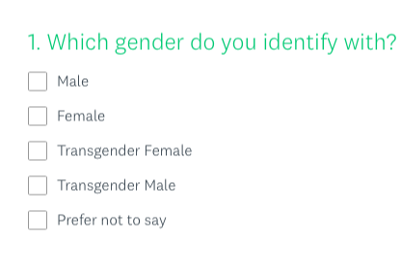
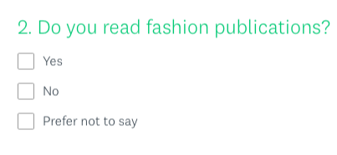

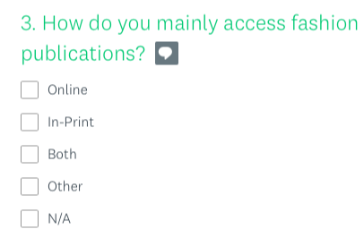
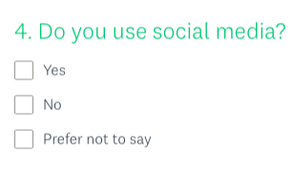

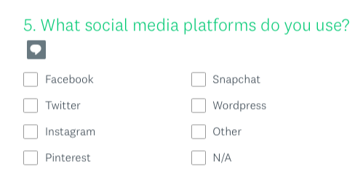
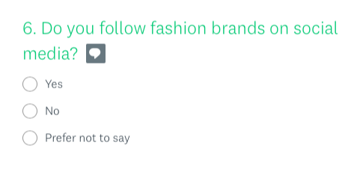
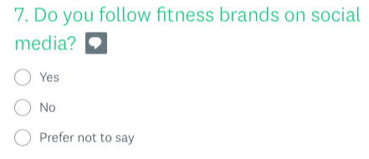

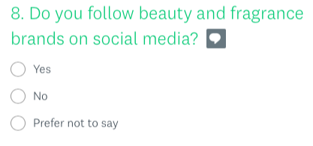

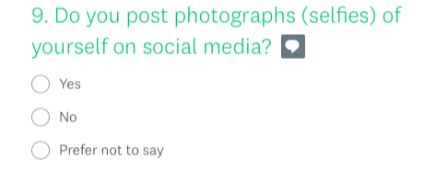

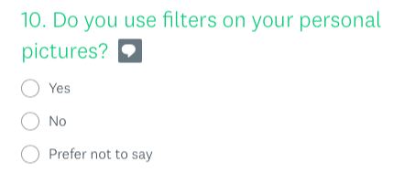

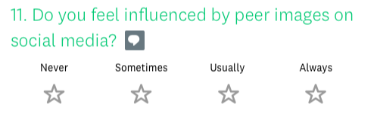
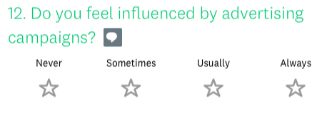

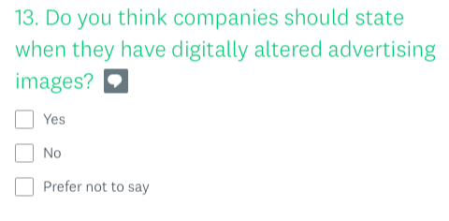

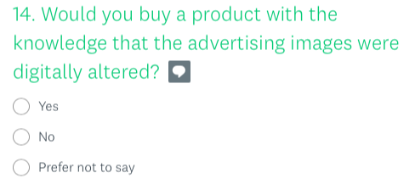

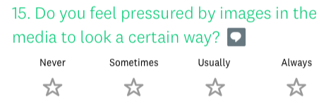

Appendix 3: Copy of Ethics Form for Study
 |  |  | E3 FORM
APPLICATION FOR ETHICAL APPROVAL – BA level

CAIS AM GYMERADWYAETH MOESEGOL – Lefel BA

Mae'r ffurflen hon i'w chwblhau gan bob BA myfyrwyr. Rhaid i bob ffurflen gael ei ystyried gan diwtor y modiwl.  Dylai un copi o'r ffurflen yn cael ei roi ar y ffeiliau Gyfadran ac un copi cadw ar y ffeil myfyrwyr. |  | This form is to be completed by all BA students conducting research, projects or productions. This form should be completed by the student. All forms must be considered by the Module tutor. A copy of the form must be kept centrally and on the student file.
ADRAN 1 – MANYLION MYFYRIWR |  | SECTION 1 - STUDENT DETAILS
Enw Llawn  Full Name | Abbie Dark
Ysgol/Cyfadran/  School/Faculty | School of Business |  |  | Rhif Myfyriwr Student Number | P146582
Cydlynydd prosiect / Tiwtor  Module Tutor/ Programme Co-ordinator | Caroline Jawad/ Will Fleming |  |  | Enw'r Gradd  Name of Degree | Marketing Management
Teitl dangosol yr Traethawd Hir: |  |  |  | Indicative Title of Dissertation:
The Marketing of Body Image: An Exploration into the Social Responsibility of Marketers Within the Fashion & Beauty Industry

ADRAN 2 – MANYLION CYFRANOGWYR / CYNULLEIDFA |  |  | SECTION 2 - PARTICIPANT / AUDIENCE DETAILS
Pwy yw’r cyfranogwyr arfaethedig? |  | Who are the intended participants? |  |  | Ydw / Yes | Na / No
Myfyrwyr / staff Y Drindod Dewi Sant |  | Students / staff of Trinity Saint David |  |  |  | No
Oedolion (dros oed 16 ac yn gymwys i gydsynio) |  | Adults (over the age of 16 and competent to give consent) |  |  | Yes
Plant a phobl ifanc dan oed |  | Children / legal minors |  |  |  | No
Cleifion neu gleientiaid gweithwyr proffesiynol |  | Patients or clients of professionals |  |  |  | No
Rhywun sy’n cael ei gadw yn y ddalfa neu y mae’r llys wedi cymryd cyfrifoldeb amdano |  | Anyone in custodial care or for whom the court has assumed responsibility |  |  |  | No
Aelod o unrhyw sefydliad lle mae’n bosibl bod angen i unigolyn arall hefyd gydsynio. |  | A member of any organisation where another individual may also need to give consent. |  |  |  | No
Eraill: Nodwch: / Others: please identify:

Nifer, Oed a Ffynhonnell y Cyfranogwyr  Rhowch fanylion yr demograffeg y cyfranogwyr / gynulleidfa. |  |  |  | Participant / Audience Number and Age  Provide details of the demographics of the participants / audience.
Nifer o Gyfranogwyr / yn y Gynulleidfa | Participant/ Audience number |  |  | 5 participants/ 100+ respondents
Grŵp oedran y Cyfranogwyr/y Gynulleidfa | Participant/ Audience age group |  |  | 18+

ADRAN 3 – GWEITHGAREDD YMCHWIL |  |  | SECTION 3 – RESEARCH ACTIVITY
1. | Ydy’r prosiect yn cynnwys: | Does the project include: |  | Ydy / Yes | Nac ydy/No
Defnyddio holiadur neu offeryn ymchwil tebyg |  | Use of questionnaire or similar research instrument |  | Yes
Defnyddio prawf ysgrifenedig neu gyfrifiadurol |  | Use of written or computerised test |  |  | No
Cyfweliad (cysylltwch gwestiynau posibl) |  | Interview (attach provisional questions) |  | Yes
Dyddiaduron |  | Diaries |  |  | No
Arsylwi ar gyfranogwyr a hwythau'n ymwybodol o hynny |  | Participant observation with their knowledge |  |  | No
Arsylwi ar gyfranogwyr a hwythau ddim yn ymwybodol o hynny |  | Participant observation without their knowledge |  |  | No
Recordio fideo neu sain |  | Video or audio-taping |  | Yes
Mynediad i wybodaeth bersonol neu gyfrinachol heb gydsyniad penodol y cyfranogwyr |  | Access to personal or confidential information without the participants specific consent |  |  | No
Defnyddio unrhyw gwestiynau, ysgogiadau prawf, cyflwyniad y gallai rhai cyfranogwyr eu profi fel rhywbeth sy'n achosi niwed / tramgwydd corfforol, meddyliol neu emosiynol |  | Administration of any questions, test stimuli, presentation that may be experienced as physically, mentally or emotionally harmful / offensive |  |  | No
Cyflawni unrhyw weithredoedd allai achosi embaras neu effeithio ar hunan-barch |  | Performance of any acts which may cause embarrassment or affect self-esteem |  |  | No
Ymchwilio i gyfranogwyr sy’n ymwneud â gweithgareddau anghyfreithlon |  | Investigation of participants involved in illegal activities |  |  | No
Gweithdrefnau lle defnyddir twyll |  | Procedures that involve deception |  |  | No
Gweini unrhyw sylwedd, cyfrwng neu blasebo |  | Administration of any substance, agent or placebo |  |  | No
Dull arall o gasglu data neu fformat cyflwyno (esboniwch) |  | Other method of data collection or presentation format (please explain) |  |  | No

2. | Restru eich dull o gasglu data | List your method of data collection:
Online surveys, focus group/interviews

3. | Risg Posibl:  (corfforol, seicolegol, cyfreithiol, cymdeithasol neu economaidd) | Potential Risk:  (physical, psychological, legal, social or economic)
A oes unrhyw risg bosibl i: |  | Is there any potential risk to: | Ydw / Yes | Na / No
A | Cyfranogwyr? | Participants? | Yes
B | Ymchwilydd? | Researcher? | Yes
C | BrifYsgol/Cyfadran? | University? | Yes

4. | Rheoli Risg:  Os oes, beth yw'r risg a sut y bydd yn cael ei reoli? | Management of Risk:  If yes, what is the risk and how will it be managed?
Regarding participants every effort will be applied to ensure to safety of the participants. Anonymity and confidently will be rigorously applied. Data collected will be secured safety and securely on password protected computer devices. Risk to the researcher will be managed by working closely and guidance of my supervisor. Also risk to the researcher will be managed through adopting previous experiences received during the undergraduate. Finally, risk to the university will be managed by an awareness by the importance of the good standing and name and reputation of the Swansea business school UWTSD.

5. | Os ydych yn delio â phlant a / neu oedolion agored i niwed, rhaid i chi gyflwyno eich tystysgrif DBS i'ch tiwtor goruchwylio i'w cymeradwyo cyn i unrhyw gysylltiad â cyfranogwyr hyn. | If you are dealing with children and/ or vulnerable adults you must present your DBS certificate to your supervising tutor for approval before any contact with these participants.
 |  |  |  | Ydw / Yes | Na / No
A | Ydych chi wedi gwneud cais am dystysgrif DBS? |  | Have you applied for a DBS certificate? |  | N/A
B | A yw eich tiwtor weld a'i gadarnhau eich tystysgrif DBS? |  | Has your tutor seen and approved your DBS certificate? |  | N/A

6. | A fyddwch yn cael cydsyniad gwybodus ysgrifenedig gan eich cyfranogwyr? |  | Will you obtain written informed consent from your participants?
 |  |  |  |  |  | Ydw / Yes | Na / No
A | Os na fyddwch, pam hynny? |  |  | If no, why not? |  |  | No
B | Os byddwch, sut byddwch yn sicrhau cydsyniad gwybodus? |  |  | If yes, how will you secure informed consent?
Rhowch eglurhad / Please explain:
Interviews are conducted on a voluntary basis and if the participants attend, consent is assumed

Cynhwyswch gopi o’r ffurflen gydsynio os ydych yn defnyddio un. |  |  |  | Please include a copy of the consent form if you are using one.

ADRAN 4 |  | SECTION 4
CEFNOGWYD /APPROVED |  | NIS CEFNOGWYD/  NOT SUPPORTED
Datganiad  Mae'r wybodaeth a gynhwysir yma yn gywir, hyd eithaf fy ngwybodaeth a’m cred. Rwyf wedi ceisio dynodi unrhyw risgiau a phroblemau sy’n gysylltiedig â’r prosiect / ymchwil neu gynhyrchiad ac rwyf yn cydnabod f’ymrwymiadau innau a hawliau’r cyfranogwyr. |  |  | Declaration  The information contained herein is, to the best of my knowledge and belief, accurate. I have attempted to identify any risks and issues related to the project/research or production and acknowledge my obligations and the rights of the participants.
Llofnodau  Dylai'r ffurflen hon gael ei chwblhau a'i llofnodi gan y myfyriwr a'r Cydlynydd y prosiect /Twitor |  |  | Signatures  This form should be completed and signed by the student and the Module tutor/Programme Co-ordinator.
Myfyriwr / Student  A DARK |  |  |  |  | Dyddiad: / Date:  20/11/2017
Cydlynydd y prosiect /Twitor  Project co-ordinator / Tutor  W FLEMING |  |  |  |  | Dyddiad: / Date:  20/11/2017


Cyfranogwr Rhif Adnabod:
Participant Identification Number:
CWESTIYNAU CYFWELIAD SAMPL | SAMPLE INTERVIEW QUESTIONS
TEITL Y PROSIECT: / PROJECT TITLE: The Marketing of Body Image: A critical analysis of the social responsibility of marketers within the fashion industry

1 | Would you say that the media has an impact on how men see themselves?
2 | Would you say that the media has an impact on how women see themselves?
3 | Do you think the pressure of looking a certain way in today’s society has an affect on you?
4 | Do you compare yourself to models in the media?
5 | What media do you think has the biggest influence on you?  TV programmes/ films; Magazines/newspapers; Social media; Online articles/blogs; None of the above; Other…
6 | Have you ever changed something about yourself because of something you saw or read in the media?
7 | How important is your appearance?  Very important; Moderately important; Slightly important; Not important
8 | Do you think images of overly thin models should be allowed?
9

10

ENW A CHYFEIRIAD YR YMCHWILYDD | NAME & ADDRESS OF RESEARCHER

Cyfranogwr Rhif Adnabod:
Participant Identification Number:
FFURFLEN GANIATÂD CYFRANOGIAD | PARTICIPATION CONSENT FORM
TEITL Y PROSIECT: / PROJECT TITLE: The Marketing of Body Image: A critical analysis of the social responsibility of marketers within the fashion industry

Name of Researcher: Abbie Dark
Please initial box

1. I confirm that I have read and understand the information sheet dated 20/11.17 for the above study. I have had the opportunity to consider the information, ask questions and have had these answered satisfactorily.

2. I understand that my participation is voluntary and that I am free to withdraw at any time, without giving any reason.

3. I understand that any information given by me may be used in future reports, articles or presentations by the research team.

4. I understand that my name will not appear in any reports, articles or presentations.

5. I agree to take part in the above study.

____________________ _________________________________________
Name of Participant Date Signature

A DARK
_________________________ ________________________________________
Researcher Date Signature

You may decline to participate in this study. You may end your participation in this study at any time. If you decide to remain anonymous, maintaining your anonymity will be a priority and every practical precaution will be taken to disguise your identity. If you prefer anonymity, there will not be any identifying information on audiotapes or transcripts of this or any interview. No-one will hear any audiotapes or see any transcripts without your prior consent. All materials generated from this or any interview will remain confidential.

When completed, please return in the envelope provided (if applicable). One copy will be given to the participant and the original to be kept in the file of the research team at: UWTSD

ENW A CHYFEIRIAD YR YMCHWILYDD | NAME & ADDRESS OF RESEARCHER  Abbie Dark  66 Pencaerfenni Lane, Crofty, Swansea

Appendix 4: Consent form for Focus Group

Cyfranogwr Rhif Adnabod:
Participant Identification Number:
FFURFLEN GANIATÂD CYFRANOGIAD | SAMPLE PARTICIPANT INFORMATION SHEET
TEITL Y PROSIECT: / PROJECT TITLE: The Marketing of Body Image: An Exploration into the Social Responsibility of Marketers Within the Fashion & Beauty Industry

About the Focus Group

The focus of this study is on mass media advertising images in the beauty and fashion industry and the impact these images have on society in which your participation is required.

This focus group should take about 20 minutes of your time. Any comments you may wish to make will provide the researcher with a greater understanding of any issues involved.

The information will be sound recorded and will be kept completely confidential and all information you provide will be recorded on a completely anonymous basis. You are not asked to provide your name at any point during the focus group. If you find the research interesting and would like to receive a copy of the results, please contact the researcher.

If you have any problems completing the focus group or would like to speak to the researcher, then please contact;

Abbie Dark
Swansea Business School
Mount Pleasant
Swansea
SA1 6ED
01792-481000

Before you start to answer the main questions, please tick the following boxes to confirm that you are happy to take part in the survey and understand the terms on which you are providing information.

I agree that I have:

[ ] Read the information provided on the first page

[ ] Received satisfactory information regarding the research

[ ] I am free to withdraw from the study at any time if I wish and if I choose to do this, there will be no further contact from the researchers

[ ] Any personal information I provide will be treated as strictly confidential

[ ] I can refuse to answer any question

[ ] Confidentiality and anonymity will be maintained and it will not be possible to identify me from any publications

Appendix 5: Focus Group Images
- Protein World- Beach Body Ready Campaign 2015
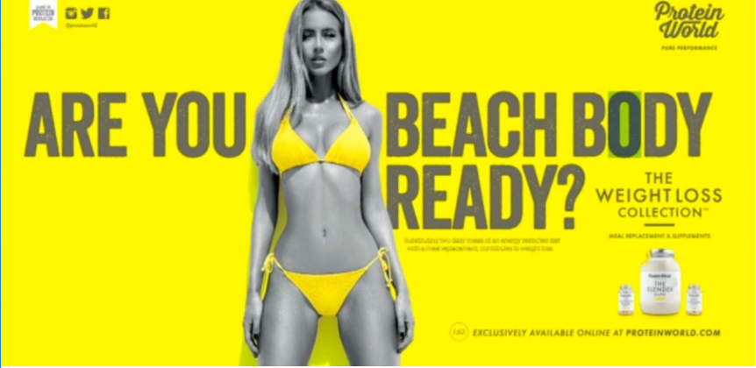

- Dove- Real Beauty Campaign- 2004
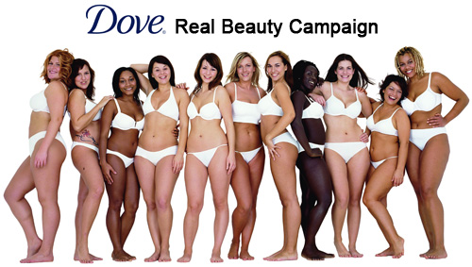

- Non- Digitally Altered Images
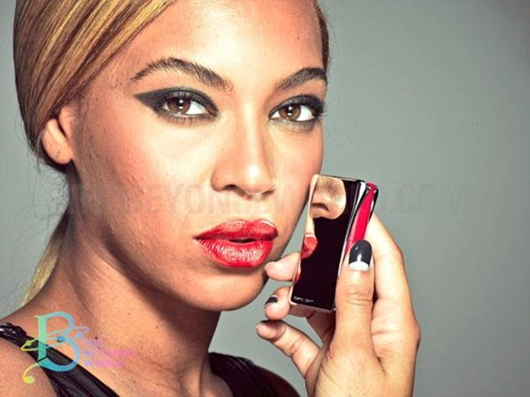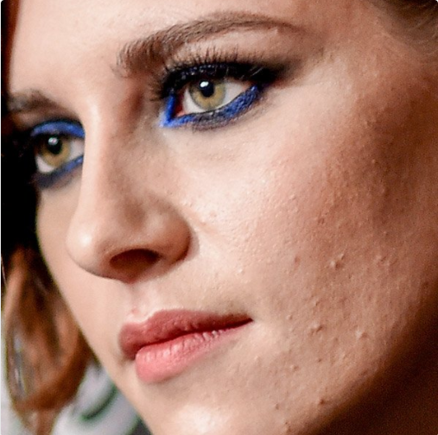
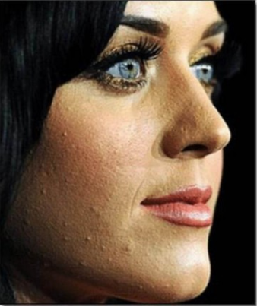

- Digitally Altered Images
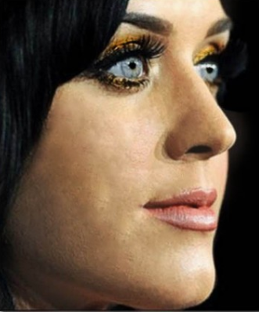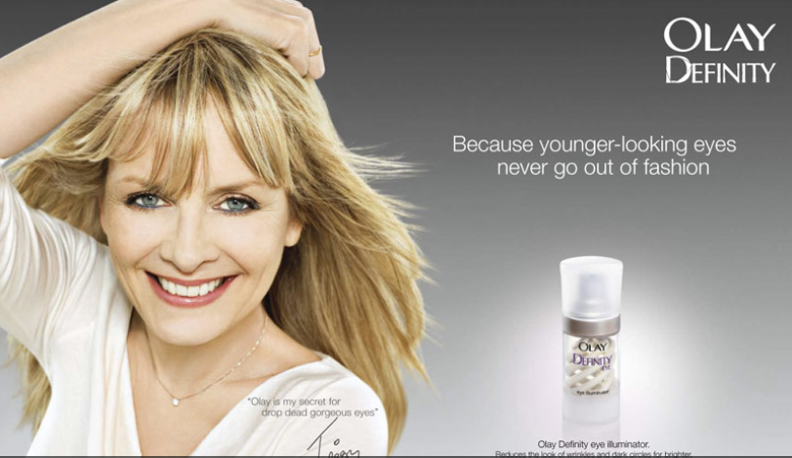

Appendix 6: Focus Group Transcript

Focus Group 1 Transcript: 7th March 2018

For the purpose of this transcription, the participants will be referred to as A, B, C, D and E. Any individuals mentioned by the participants outside the group will be referred to as X. The researcher will be referred to as R.
Images that were used were advertising images from Protein World ‘Beach Body Ready’ campaign. This will be referred to as PW. An image from Dove’s ‘Be Real’ campaign was used; this will be referred to as DOVE. These images will be included in the research appendices.

R: The focus of the study is on mass media advertising images in the beauty and fashion industry and the impact these images have on society
We are constantly inundated with images of good looking women and men in the media and this can impact the way we feel about ourselves.
Aspirational brands sometimes use marketing techniques that can alter the way we think about our bodies
With that in mind what do you think of the image you have in front of you?

A: I remember there was something similar to this in comprehensive school to get ready for prom and that was seen to be particularly offensive. I personally just think she looks great.

B: She looks fantastic

C: She does look great but it’s the implication that you can’t be beach body ready unless your taking this weight loss supplement

D: Which part of her look makes her beach body ready?

C: And the rest of us not (beach body ready)?

D: Is it the yellow bikini? I may have a yellow bikini therefore I am beach body ready. Which part of that message is the one I would qualify as being beach body ready

C: Why is she more ready than anyone else?

D: They’re obviously implying that you need to be skinny to look great

A: (Aimed at researcher) If you had a load of 16-year-old girls in they wouldn’t be saying half the things that we think but then again that’s a perception and that may not be right. I wouldn’t mind looking like her

B: I wouldn’t mind looking like her but I never looked like her. The average women doesn’t look like that

E: The chances are the image is Photo-shopped because you pick up magazines every week and they’re the same

C: I did look like that once, but 20 years later and now I don’t. Girls are much more aware of their body image now than when I was in school. I didn’t care really

E: I don’t know about that because I went on my first diet when I was 10/11. Now X, my daughter, is going to be 14 the end of this month, and she is not self conscious at all. She has no perception of body image

C: That’s good in a way though

E: Its good in a way but bad in another way because she has put on a lot of weight since starting comprehensive school which I’m trying to sort out and its difficult for me then to draw the line between not wanting her to put on more weight…

C: You want her to be healthy but you don’t want her to be skinny. Its hard

R: So in relation to the conversation we’ve just had, can you flip to the next image. This is the Dove Be Real beauty campaign. How do you feel about this image?

C: Its more realistic I think. More women look like this (DOVE) than look like this (PW). That (PW) is unattainable for most people and if you did attain it you’d have to start working out for hours in the gym, restrict your eating… But these ladies (DOVE) seem much happier than this lady (PW) who looks a bit miserable

D: It’s a little bit about… there’s a black lady, a short one, a tall one, short hair, long hair… its equality in a way

B: Its women in all of their guises rather than just the …

C: Skinny beach model

B: Although with this one (PW) they are showing you what you could look like if you use that product so I don’t suppose it would have the same impact if they went ‘you’d look like one of these (referring to DOVE models) if you used our product’

A: I think I’m more like E’s daughter, I’m not really interested at all. If I want to leave the house clean, yeah, with my clobber ironed, maybe I’ve just accepted what I am and who I am. I’m very cynical about marketing because of the area that I research; not interested at all. Going back to this girl (PW) because I have two boys, 19 and 22, all the girls that are their mates they all look like that. I don’t know whether society is requiring girls to look this good, they all look good! I don’t know whether they (sons) just don’t let the other girls come but a lot of the time

C: Are there any heavier girls?

A: Son 1’s girlfriend was 6 ft. 1 and size 6. And son 2 is a big rugby player and he sees a lot from the women’s rugby team so I suppose they don’t all look like that but what I’m trying to get at, when I was growing up, gyms were for deviant people, they were all on … a lot of people go to the gym now

B: Its more of a social centre now isn’t it

A: I’ve gone away from the focus now, but its been said that you can’t mention people’s hair as it can be very offensive. But I am obsessed with people’s hair because I feel I have terrible hair and I’m more wondering on the extensions. I’d like to know is that her hair. I think my priorities are perhaps different

C: Perhaps you’re not focussing on what they want you to focus on

A: Yes

C: Who are they aiming this at though? (PW)

B: I don’t know if people are focusing on the right thing

A: I’m just thinking that maybe because I’m older

C: Who is their target for this? Are they talking about ladies with older children…

B: Young girls.

C: Yes

B: When I was 36 I didn’t actually have the ‘upper compartment’ that she has, I almost had a boys figure. The yellow bikini would have looked awful

A: If we look at the yellow bikini top, its very possible that they (breasts) are her own and its equally as possible that they are surgically enhanced. These are things that I didn’t grow up with. Obviously I did grow up with them, but it was more Hollywood people

B: This is probably fake marketing, shes probably been photoshopped

E: She looks over 6 feet tall to me

C: I bet those aren’t her real cheekbones either.

B: It’s probably all contouring, filters

A: I reckon she actually looks like that

C: She looks great

A: There are people who do look like that and I have to get a grip

B: There are some people who get out of bed in the morning and just look like this

A: They (PW) have maybe chosen a model, and they (DOVE) have chosen people who are less representative of models. This is a very sophisticated set

B: Have you noticed they’re all very attractive? All of the women in the Dove campaign, despite their different body images they’re all very attractive women. So its not like they’ve gone and picked a random selection of women off the street, they’ve picked attractive women of all shapes and sizes. And probably a lot of them are plus size models

R: Moving on, to a different topic, if you would like to flip to the next set of photos, what do you think of these images?

C: Twiggy looks really annoyed

C: They’re not Photo-shopped I would guess as you can see acne on Kristen Stewart

B: And the ‘jawels’ on Twiggy. I think she looks stunning anyway

B: The reflection of Beyoncé’s nose in the lipstick doesn’t seem to match her face

C: They don’t look Photo-shopped anyway

A: There was a Japanese student that looked at washing powder, ‘whiter than white’, her argument was that we know that washing powder marketing doesn’t really work- and to me this is exactly the same

A: I think we’ve agreed we don’t know what whiter than white is

R: If you flip to the next set of images, what do you think about these?

C: Ah I see these are the photo shopped versions

B: You’d be rushing to the shops to buy Olay if that was what it could do to you

C: There’s hardly any imperfections on the imperfect photo really so that’s quite extreme

E: Twiggy in the second photo I’m not sure I’d even recognise her

C: She looks about 22 doesn’t she… if they are marketing this to mature ladies then they’ve done a bang on job

C: Katy Perry did the infomercial for that acne treatment product, Proactiv

R: IF you saw that campaign of Katy Perry and then saw her with perfect skin after seeing this image of her with acne, would that make you want to buy that product?

D: If it was definitive that the results were down to that product then yes but not otherwise. If its just done on a computer, then its just misleading.

A: I wouldn’t believe those claims anyway

B: It was like that Impulse advert, I used to spray that stuff on and not one person chased me down the road with a bunch of flowers

D: I don’t think you can trust celebrities like this

A: Its shocking that I follow NYX makeup on Instagram, I’m really into all of that but I think I’ve given up, am I clean, am I presentable, then I’m ready

R: With regards to seeing media images like this all of the time (photo shopped images, changed to alter the way the models actually look) Do you think you need to look a certain way to conform with society’s norms?

B: I would prefer to see proper results with real people. Even the Dove image I’m quite cynical about that because I believe they’re all models, can’t see the wobbles you would with normal ladies and I bet they’ve been photo shopped

D: They all have pretty flat stomachs don’t they

B: yes these women do not have rolls like most women. I think sometimes you take things with a pinch of salt

C: We know these things are photo shopped, even young teenagers they know too

A: the thing is we now photo shop ourselves with filters. Even I have worked the filters out. I’ve learnt to improve my own image so I’m certainly going to expect people in the public eye to do that

B: Yes even my profile picture was a picture after 87 attempts and one student said to me that I looked really young and attractive

C: yes you wouldn’t want to put a random, bad picture on there though would you?

A: We were in a meeting last week where management requested that we all have profile pictures but some staff refused because they didn’t want pictures of themselves up there

E: I’m just not interested at all in filters, selfies etc. I know my daughter, I have seen pictures she has posted of herself with filters like the ones Cheryl Cole posts with butterflies around her head and I really don’t like it I think its stupid. I think she’s beautiful and she doesn’t need it
R: Last question, do you think brands should state on their advertising when images have been digitally altered?

C: Definitely

B: Yes

D: Yes

E: Yes

A: No. Not at all. Why don’t people get a grip? Get real? Nobody really believes this do they

E: You know when you say about photo shopping with teenagers, I don’t think they do

C: Its always a shock when you see the real thing though. Even though you know they’re photo shopped, very occasionally you’ll see something in the pictures/ media, ‘the difference between this and this’ and you’ll think, holy hell! Even though I knew that was photo shopped there’s a huge difference

B: Its going back to styling, a friend of mine loved Demi Moore and he saw her in London one day and he said it was the biggest let down of his life, what she actually looked like in real life

A: I think that younger people are much more up on filters and changes that I am, so whether there needs to be disclaimer…? Does an ice cold can of Coke really look like that? They’re trying to sell something and that’s the reality of the world

B: I’d always want to look my best in my profile photo and it’s the same for advertisers, they’d want to put their best selves forward too

D: I think they should state it because if they use an image as a message, which these are, I think they should be clear about that. Just as important as the impact of the words

B: I think if they are selling a beauty product they have to be more honest

C: It’s a form of trickery

D: If someone genuinely looks like this (PW) then fab, put them out there and good one her, shes probably young and healthy, beautiful and everything but if its been tweaked then I think that should be stated just as a matter of ethical selling

B:Yes bevasue young girls could go out and think, ‘it says one tablet but I want to look like the girl on the picture so I should take a few more’

A: are we not concerned with mental health issues or a level of education that they wouldn’t think that?
D: we are privileged in here to have been subject to education and be able to think logically about this image and the situation

B: some girls would think this is an attainable body image just from taking those tablets and then only take one and think theres something wrong with me because it says take one and I’ll then look like her, then if its not working, they may take more

A: in the past they have used mashed potato instead of ice-cream in commercials because it photographs better. Filters and spots don’t really worry me, there are more important issues in the world

C: its about the honesty I suppose, like the mascara company’s adverts being banned because they used all fake eyelashes in the adverts

B: It is about mental health because if somebody thinks theyre going to get that body just from using that product and then they don’t that could have mental health implications

C: we know taking these tablets on their own is not going to make a blind bit of notice unless you modify your eating and exercise. But a 14-year-old girl may not get that

D: Do you think A that adding that information into an advert would have a negative impact on the marketing industry/brands?

A: It’s the bigger picture. This is the world that we live in where the rich get richer and the poor get poorer. This is a cynical marketing ploy and I don’t believe people are that stupid other than those with mental health or low educational achievement. But that is purely my opinion. I am out of the loop here, not everybody else.

