A report focussing on:

The Tendering Process

Prepared for: Dr Deborah Hughes

Created by: D. Hole

Date completed: 05th December 2022

Word Count: 2,442 words.

Table of Contents
Page Number
1.0 Executive Summary 3
2.0 Terms of reference 3
3.0 Review 3
4.0 Conclusion 13
5.0 References 14

1.0 Executive Summary

This report aims to provide the client, UWTSD, with a comprehensive overview of the
tendering process for the innovation matrix project and to advise the best route forward in regard to tendering process. This report will seek to provide an understanding of the items listed in Article II below.

2.0 Terms of reference

The principal focus is of this report is:

- To understand the various forms of tendering available and which suits a D&B project.
- To understand what documents are needed within a tender pack.
- To understand the additional documents required for a Design and Build procurement route.
- To understand the input that a Quantity Surveyor will have in the tendering process required to be undertaken by the client’s team.

3.0 Review

The client has advised that design and build is the procurement route they have decided upon and therefore, this has formed the basis of this report. This report seeks to review the various types of tendering and conclude which tendering process best suits the clients needs for a Design and Build route of construction below.

The following are types of tendering used within the construction industry:

- Open Tendering
- Selective Tendering
- Negotiated Tendering
- Framework Tendering

Open tendering

Open tendering is the process whereby a tender is advertised to the open market and it allows all companies interested to submit a tender. A notice can be served on a variety of websites and allows for any contractor’s interested to submit a tender, providing it is in line with the tender requirements. The client may use a pre-qualification questionnaire (PQQ) to ensure that the tenderer has the capability and knowledge required for the project and this would normally be sent out beforehand. The contractor will fill out a PQQ detailing past projects, experience in the sector that the clients project is within, other company information, sustainability information and much more; this really depends on what the client asks within the questionnaire.

The problem with open tendering is the amount of time that it can take to get into contract with the contractor to deliver the works and therefore, this route is mainly used for projects that have more time before they need to commence.
An example timeframe is included below for an open tender scenario: 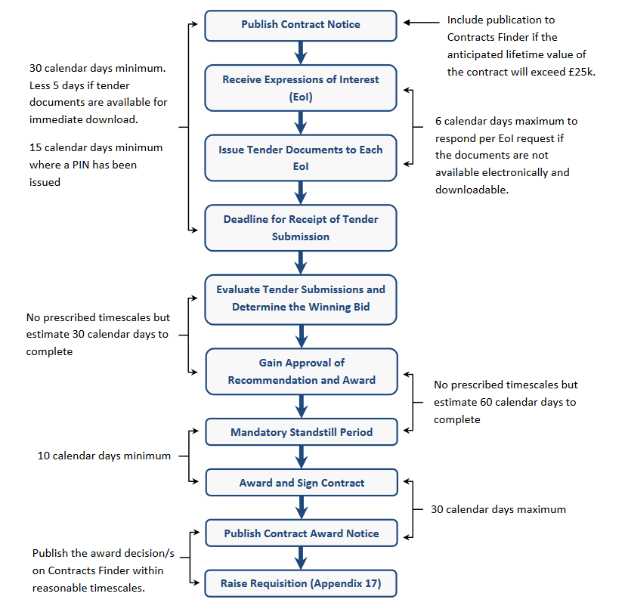
Figure 1 – Open tendering timeline. (Stonard, 2022)

It should also be noted that open tendering can be via one stage or two stage tendering.

Selective Tendering

Selective tendering, sometimes referred to as restricted tendering due to its nature, utilises a list of contractors that the client has hand picked to send the tender out to. Usually, this list is formed from the client sending an initial letter / email asking if they would be interested in pricing the work and for the contractor’s that do wish to, they are added to the client’s shortlist; a tender pack will be sent out to those on the list. The amount of tenderers will depend on the client’s requirements. This form of tendering is used when a client either has a few reliable contractor’s that they like to use and feel they can rely upon or simply where there are not enough contractor’s / suppliers to have open tendering.

An example of the process of selective tendering is shown below:

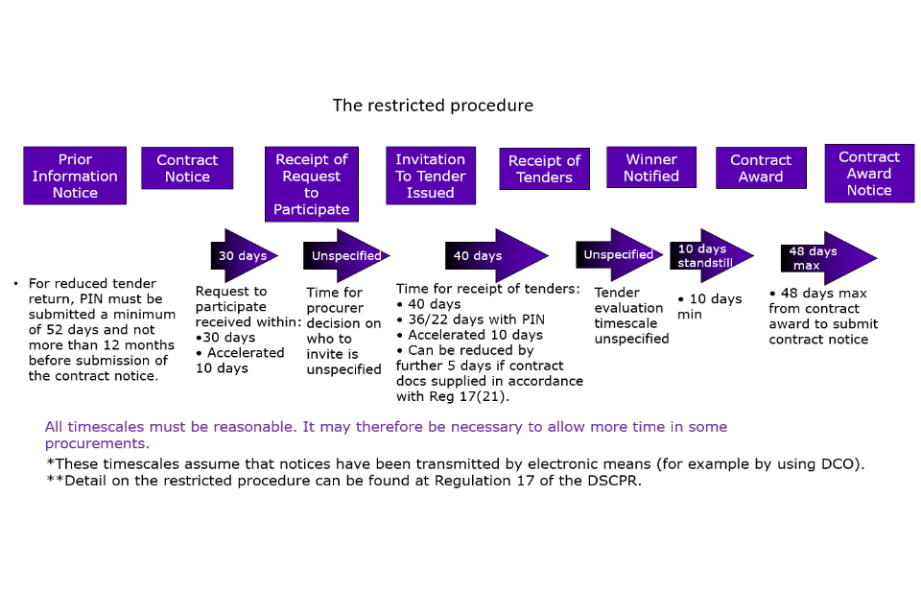
Selective Tendering – Figure 2 (Ministry of Defence, 2022)

Negotiated Tendering

Negotiated tendering is when the client approaches one contractor / supplier to tender for the work, this may be in cases where there is only one supplier that provides the material/work that the client is sourcing. This route of tendering is often performed by having multiple meetings to negotiate a price and further, the contract details.

This method can also be used when a client has a longstanding contractor that they opt to use. The disadvantage of this method is the lack of competitiveness and benchmarking against other tenders returned.

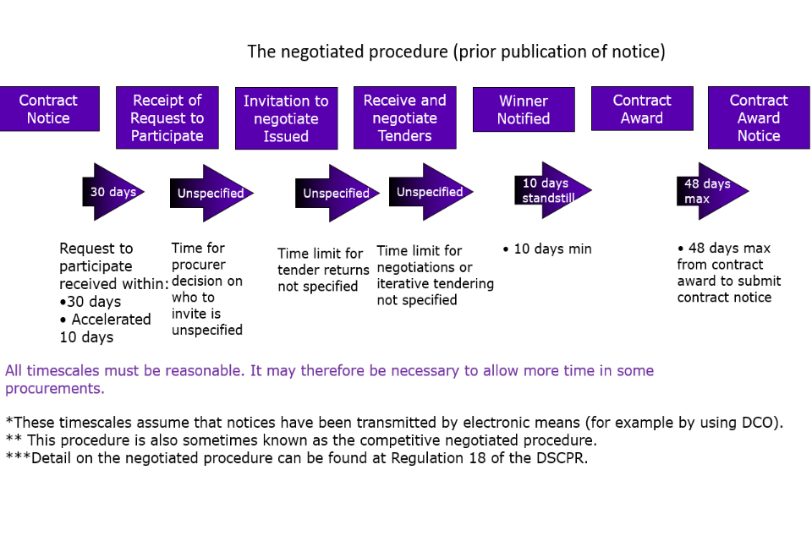Negotiated Tendering – Figure 3 (Ministry of Defence, 2022)

Framework Tendering

Framework tendering is when a client takes a list of contractors that they use consistently and put them onto a ‘framework agreement’ which has standard terms and conditions that are used for upcoming work. A framework is put together normally beforehand and is usually used for things such as maintenance works which require a quick set up and are generally continuous streams of projects. A framework can have as little as 5 to as many as 50+ contractor’s / suppliers on it and although a framework usually means continued work for a contractor, it also means greater competition on occasions where the frameworks have a large number of contractor’s / suppliers.

Tendering summary

In summary, for a Design and Build procurement procedure, the client can use multiple of the tendering processes above. Open tendering can be used for a client that has a completely blank canvas and the design will have no unknowns, meaning that it is perfect for a design and build tendering route. Selective tendering provides a smaller pool of contractors to manage their tenders and is significantly quicker than open tendering. Framework tendering is perfect to have a very quick set up but is usually used for small and less complex projects. Negotiated tendering would also be acceptable to use but does lack competitiveness and therefore, could not be as cost effective.

Taking the above into account, this report recommends that open tendering or selective tendering would be the suggested tendering process for the client, UWTSD, to use on their innovation matrix project. This provides enough competitiveness and allows for contractors with the expertise to tender for the project and thus in turn increases the chances of a successful delivery of the project.

What documents are needed to form a tender for D&B project?

The client has expressed an interest in exploring a design and build project, therefore, the following items are advised to be included within the tender pack:

- A letter of invitation to tender – a letter inviting the contractor to tender for the project, any considerations should be listed within this letter of invitation such as submission deadlines, how the client would like the tender submitted (online, by post, delivered in person etc). Further, a small description of the works, form of contract, guide budget, key dates etc should be included within the document for the tenderer to have a high-level overview in order for them to decide if they would like to tender.
- Works Information / Scope of Work / Specification – the works information is one of the most important documents within a tender pack as this forms the basis of what works the contractor is pricing and also can prevent any disputes on what work should have been priced for
- Site Information – this should include any working hours, any special considerations (e.g., if the site is located in a built-up area) and any other information that the client / client team considers important for the contractor to be aware of when carrying out their works.
- Pricing document & contract sum analysis – a pricing document should be included to ensure that you get comparative formatting from the tenderers to allow you to compare the tender returns against one another.
- Contract details – the contract details should include what form of contract is to be used (e.g., NEC3, JCT, FIDIC etc), contract conditions and any amendments to the contract if using a standard form that need to be considered within the pricing of the work.
- Form of tender – this is prepared by the client or the client team to ensure that the contractor has understood and accepts the conditions of the tender documents.
- Confidentiality agreements – depending on what works are included, the client may want the contractor to sign a confidentiality agreement to ensure that competitors / outside parties do not get leaked information about the tenders or works contained within the tender pack.
- Questionnaires – a questionnaire should be included to identify what the contractor intends to do for social impact etc. For example, is the contractor proposing that they will take 1% of all workforces as apprentices, employ local people, invest in the local community development of construction roles etc. Depending on the clients wants and commitments, this may bear a weighting on the tender evaluation if the client has a commitment to the local community in their planning permission.
- Details of how the tender is weighted – does the client value social impact / sustainability impact over cost etc.

The above items are standard in most tender packs and form the basis of the contractual information should the tenderer submit a successful bid; therefore, it is important to include all information required and ensure that it is accurate.

The client, UWTSD, should ensure that enough information is included within the tender pack that is sent out to the potential tenderers.

What other documents would be required for a traditional procurement approach?

If the client were to decide upon a traditional procurement route, the following items would be advisory to include within the tender pack as additions to those required in the design and build route:

- Drawings – a drawing pack should be included detailing all the contractors’ requirements for pricing and to provide the contractor with the details of what they need to build. It is important to have a full drawing pack to provide to the contractor to ensure that expensive variations are not raised down the line when both parties realise that an element of work has not been priced for.
- More detailed risk register - detailing the client risks / contractor risks, which are shared, which are 100% the client’s risk or contractor’s risk.
- Bill of Quantities – a bill of quantities would normally be produced to ensure that all the contractors are pricing the same works. The clients Quantity Surveyor will do a take-off from the drawing pack and create a BOQ based upon NRM to issue out to the tenderers; the tenderers will fill in their rates only for each section and the client bares the risk of the quantities being correct.

The above are additional requirements under a traditional procurement route due to the client completing the design under traditional. Under a design and build procurement route, the above items are not needed as the contractor will do the designs and produce an estimate based upon these outline designs submitted with his tender.

When using a traditional procurement route, it’s important to ensure the drawings and as much information is provided to the contractor to prevent any variations during the construction stage which would become costly as there is very little choice and negotiation with the contractor around pricing. If there are rates within the BOQ, these will usually be used but where rates are non-existent, it can become expensive.

What is the role of the Quantity Surveyor in assisting in the preparation of this tender?

A Quantity Surveyors role when putting together the tender pack are the following:

- Preparation of an order of cost estimate – advising the client on construction costs and this allows the client to have a realistic budget and expectation of the ballpark figures they will receive back from the contractors.
- Discussing a route of tendering and advising the client – the QS will review the clients needs and the details of the project and advise on a recommended procurement route, along with a recommended tender process dependent on the requirement.
- Deciding a form and type of contract – fixed price, target cost, cost reimbursable are all considerations that will need to be discussed prior to sending out the tender to ensure that the contractor has all information needed to enable him to price his risk appropriately. For example, it is much higher risk for a contractor to price a fixed price contract than a target cost as he takes 100% of the cost impact of anything that is missed, whereas, on a target cost this is shared between the client and contractor. A form of contract would also need to be decided upfront, NEC3, JCT & FIDIC are all examples of what should be discussed in the advisory meeting and at the end of the meeting the Quantity Surveyor should have enough information to allow them to give the client a recommendation of what form and type to use.
- Preparation of tender documents – following on from the above this would include preparing all of the conditions of contract, all contractual documents, collating all of the tender documents from the various team members (designers etc for drawings if needed), typing up the invitation to tender letter, producing a Bill of Quantities where required and dependent on which contract you use, there may be other documents that the Quantity Surveyor will help prepare. Essentially, the Quantity Surveyor assists in preparing any cost and contractual input into the tender pack.

Once the tenders have been returned, the Quantity Surveyor has a further role to carry out on behalf of the client to assess and compare the tender returns. The Quantity Surveyor will usually carry out the following tasks:

- Analyse and assess the tender returns – initial analysis of cost and programme to provide a very high-level cost comparison to the client.
- Detailed analysis of the tender returns – the Quantity Surveyor will review the tender returns and decide if any of the tender returns are not compliant with the tender conditions, those that are no will be discounted from the comparison as it would be unfair to the other tenderers for an uncompliant tender to be considered. The Quantity Surveyor will carry out a detailed tender return pricing comparison and normally produce an assessment sheet where they will compare and mark what each contractor has priced in all areas of the tender, this enables the Quantity Surveyor to see what areas the contractors’ tenders are high in, in comparison to the other tenders returned. This helps for the negotiation period below.
- Budget vs tender return comparison – this will be carried out once the tenders have been fully analysed and compared. Should the tender prices be significantly higher that anticipated, the Quantity Surveyor will review the reasoning for this increase to advise the client.
- Issuance of the tender returns to all relevant parties – e.g., if sustainability assessments need to be reviewed by a more experienced role.
- Negotiations – the Quantity Surveyor will have a tenderer that they recommend and then they will start the negotiation process to fine tune all of the contractual documents and on occasions where the tender price is significantly higher, this negotiation process can be used to de-scope / value engineer the scope to ensure that the client’s budget can be met.
- Recommendation report – the Quantity Surveyor will produce a recommendation report to submit to the client for approval.
- Contract formation – once all discussions are concluded and the client is happy to go ahead, the Quantity Surveyor will form all contracts and contractual documents for all parties to review and sign.

Conclusion

To conclude, this report recommends that the client goes down the open / selective tendering route as this will provide them with competitiveness and a wider variety of talent to successfully deliver the innovation project.

Further, it recommends that the client takes care when producing the tender pack and to follow the guidance above in regard to the contents of the tender pack for their design and build procurement route maintaining the involvement of a quantity surveyor to ensure that the tender pack is collated correctly and that all contractual documents are gathered.

References

Buildings, D., 2013. Tender processes for construction contracts. [Online]
Available at: https://www.designingbuildings.co.uk/wiki/Tender_processes_for_construction_contracts
[Accessed 29 11 2022].

Camarthenshire County Council, 2022. Supplier guide to tendering. [Online]
Available at: https://www.carmarthenshire.gov.wales/home/business/tenders-contracts/supplier-guide-to-tendering/what-is-included-in-a-tender-documentpack/.
[Accessed 01 12 2022].

Designing Buildings, 2022. Tender documentation for construction projects. [Online]
Available at: https://www.designingbuildings.co.uk/wiki/Tender_documentation_for_construction_projects
[Accessed 29 11 2022].

Hudson outsourcing, 2022. Procurement procedures explained. [Online]
Available at: https://www.tenderconsultants.co.uk/negotiated-tendering/#:~:text=Negotiated%20tendering%20involves%20the%20buyer,the%20terms%20of%20the%20contract.
[Accessed 29 11 2022].

Hudson Outsourcing, 2022. What is selective tendering?. [Online]
Available at: https://www.tenderconsultants.co.uk/selective-tendering/#:~:text=Selective%20tendering%20is%20sometimes%20referred,being%20suitable%20for%20a%20contract.
[Accessed 29 11 2022].

Ministry of Defence, 2022. DSPCR Chapter 8 : Procurement procedures. [Online]
Available at: https://www.gov.uk/government/publications/the-european-union-defence-and-security-public-contracts-regulations-dspcr-2011/dspcr-chapter-8-procurement-procedures
[Accessed 01 12 2022].

Stonard, D., 2022. depicting procurement process options. [Online]
Available at: https://www.restore.co.uk/Digital/Insights/Blogs/5-flow-charts-depicting-procurement-process-options
[Accessed 29 11 2022].

Thompson, L., 2022. What tender option is best for Design and Build projects?. [Online]
Available at: https://www.hollandgreen.co.uk/news/what-tender-option-is-best-for-a-design-build-project/
[Accessed 15 11 2022].

