

BMHP5014
Changemakers: Creativity and Value Creation
Component 1: Online Portfolio of Set Exercises

Student name – Ahmad Saman
Student ID – 2330541

Table of Contents
Task 1 – Conceptual Map 3
Task 2 – Self-reflection of group activity (Kolb’s Reflective model) 4
Task 3 – Case study of a UK innovation 5
Tasks 4 – Research Task 6
Task 5 – Podcasts 7
Task 6 – NHS Leadership Framework analysis 10
Task 7 – Self–Reflection Journal Entry 12
References 13

Task 1 – Conceptual Map

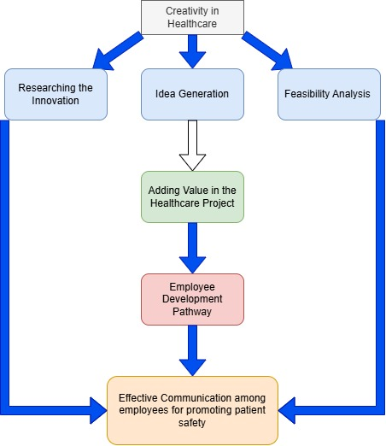

Figure 1 Concept Map
Source: (Author, 2025)
The concept map demonstrates the connection between creativity, value creation, and health and social care improvement. These three concepts are closely linked and support each other in improving the quality and overall well-being of people. Creativity is considered to be the initial point. It helps professionals think in a new and much better way to provide care. In the health and social care field, creativity allows staff to solve problems, design new treatment plans, and communicate with patients in more effective ways. For example, creative thinking can lead to new programs that support mental health or improve patient satisfaction.
Value creation includes the use of these creative ideas, turning them into real actions that benefit patients, families, and the healthcare organisation. This involves improving patient experiences, saving time, costs and increasing access to care. When creativity leads to new services or better systems, it creates value for both care providers and service users. Health and social care improvement is the final goal. It results from applying creative ideas and creating value through teamwork, innovation, and evidence-based practice. Together, these elements lead to safer, more efficient, and more person-centred care. In short, creativity inspires innovation, value creation ensures that ideas bring real benefits, and both lead to continuous improvement in health and social care. These three concepts together make the system more responsive, caring, and effective for everyone involved.

Task 2 – Using Gibbs’ Reflection Cycle (1988)
I reflected on a collaborative project where my team and I developed a design for a futuristic medical clinic inspired by the structure of the DNA helix. Our aim was to create a state-of-the-art facility that integrates advanced genetic research with tailored treatment plans for individuals with inherited disorders.
Description
The project required us to engage both divergent and convergent thinking. At first, we held open brainstorming sessions to explore a wide range of potential ideas about the clinic’s design, operations, and possible technologies. Later, we refined and organised these concepts into a realistic and ethically sound plan that could be applied in a real-world healthcare context.
Feelings
Initially, I felt unsure and somewhat anxious about sharing my thoughts, as the topic was complex and unfamiliar. As teamwork developed and communication within the group became more effective, I gained confidence and began to enjoy contributing creative ideas. By the end of the project, I felt proud of our progress and the way we balanced imagination with practical, evidence-based decision-making.
Evaluation:
This activity enhanced my ability to combine creative thinking with logical problem-solving. I valued how divergent thinking allowed us to explore innovative ideas, while convergent thinking helped us refine them into a coherent proposal. Although occasional communication barriers slowed our progress, this experience reinforced the importance of clear dialogue and active listening when working collaboratively.
Analysis:
The project highlighted how innovation and practicality can coexist in professional environments. Divergent thinking encouraged us to think beyond conventional healthcare models, while convergent thinking ensured our ideas were achievable and ethically appropriate. I recognised that integrating both approaches is vital when addressing complex, interdisciplinary challenges such as those found in healthcare design and innovation.
Conclusion:
Reflecting on this experience helped me recognise personal growth in creativity, teamwork, and reflective practice. It strengthened my confidence in applying structured thinking to future projects and deepened my appreciation of how collaboration can transform abstract ideas into feasible, meaningful outcomes. Overall, this reflection reminded me that creativity and logic are equally important in professional problem-solving.

Task 3 – Case study of a UK innovation
Innovation in the NHS and UK social care is playing a critical role in increasing the speed of change in order to improve patient experience for better outcomes and health results (NHS England, 2025). The NHS in England is working with the Department of Health and Social Care to develop innovation and collaborating with the Office of Life Sciences to develop the sector. The innovative project within the NHS and UK social care includes the use of artificial intelligence and data analytics. The use of AI (Artificial Intelligence within the healthcare sector) within the healthcare sector helps in analysing the data and helps in detecting changes in the routine. The use of artificial intelligence has the potential to improve the efficiency and quality of health and social care (Sheikh et.al, 2021). The use of AI apps helps in admitting the elderly, and the app provides alerts to the healthcare professionals at high risk. There is a use of various stroke analysis apps to identify and prevent strokes. There are many apps which are used in identifying the stokes and lays measures to prevent them. With the help of different Artificial intelligence tools, the data and information collected from the patient are kept safe, and there is are use of various personalised AI tools which help in providing better results as per the needs and requirements of the individuals.
There is another innovation project, which is named virtual and augmented reality (VR/AR). This project is widely used in social improvements and the healthcare sector. This innovative project helps in promoting better interactions within the three-dimensional environment (Venkatesan et.al, 2021). There is use of VR headsets in therapies conducted in the NHS and the UK social sector; the role of these headsets is to reduce the patient’s anxiety and pain. The use of headsets helps in promoting a calm environment, along with offering quick recovery for the patients. In the NHS and UK social sector, the introduction of VR headsets is leading to a risk-free environment and promotes a learning and engaging experience for healthcare professionals. The introduction of VR helps in promoting education, along with the visual representation and better healthcare for the patients.
This VR/AR is combined with 3D modelling technology, which helps in allowing doctors to practice surgical simulations and helps in improving communication during operations. The use of Augmented Reality in the healthcare sector helps in enhancing medical training programs and allows students to interact with 3D models of anatomy, which helps provide more valuable insights into the training.

Tasks 4 – Research Task
1) Mezzina et al., Frontiers in Psychiatry (2022) — “Social vulnerability and mental health inequalities in the syndemic”
Mezzina and colleagues argue that mental-health problems among vulnerable groups are not just individual illnesses but are produced and amplified by structural social factors such as poverty, unstable housing, precarious work, discrimination by caste, class, race, gender, and human-rights violations (Mezzina et al., 2022). These conditions increase both the prevalence of distress and the barriers to care: people living in insecure or marginalised situations are more likely to experience mental ill-health and simultaneously less able to access services because of economic constraints, lack of local services, and mistrust of institutions. The paper highlights COVID-19 as a “syndemic” example where social disadvantage and the disease interact to deepen mental-health inequalities. The authors emphasise that stigma and discrimination lead to worse exclusion, causing delayed help-seeking and poorer outcomes unless social determinants are addressed alongside clinical care.
2) Dumke et al., Social Science & Medicine / Scoping reviews (2024) — “Barriers to accessing mental health care for refugees and asylum seekers in high-income countries” (scoping review of reviews)
Dumke’s scoping review synthesises multiple reviews and finds recurring, interrelated reasons that refugees and asylum seekers fail to access mental-health care: legal and administrative barriers, language and communication gaps, cultural mismatch between available services and people’s beliefs or needs, and practical access problems related to transport, costs and workforce shortages. Crucially, stigma works is considered to be at multiple levels: community stigma that discourages disclosure, and provider system stigma that leads to exclusionary practices or poor-quality care (Dumke et al., 2024). The review also highlights low cultural competence among clinicians and a lack of trauma-informed, community-based services as drivers of non-use. The authors recommend policy changes (clear entitlement, funding for interpreters and culturally adapted models) and systemic shifts to reduce structural and provider-side barriers.
Both papers hold the same reasons for poor access, which include structural, social, service-level and Stigma is important, but it is accompanied by poverty, legal status, language, and poorly adapted services and the solutions must combine anti-stigma work with policy changes, culturally appropriate care, interpreter and outreach services, and tackling the social determinants that create vulnerability.

Task 5 – Podcasts
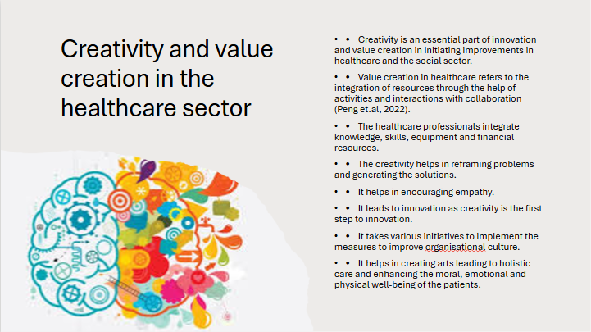

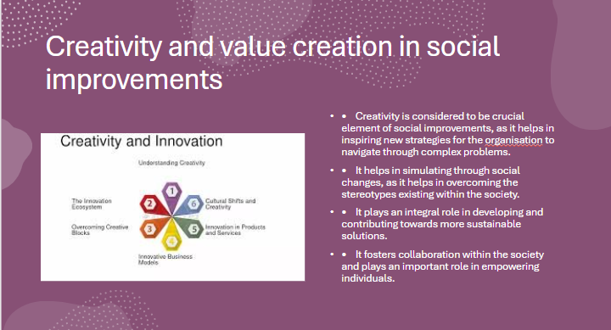
LINK -
Slide 1 – Creativity and value creation in the healthcare sector
- Creativity is an essential part of innovation and value creation in initiating improvements in healthcare and the social sector.
- Value creation in healthcare refers to the integration of resources through the help of activities and interactions with collaboration (Peng et.al, 2022).
- The healthcare professionals integrate knowledge, skills, equipment and financial resources.
- The creativity helps in reframing problems and generating solutions.
- It helps in encouraging empathy.
- It leads to innovation as creativity is the first step to innovation.
- It takes various initiatives to implement the measures to improve organisational culture.
- It helps in creating arts leading to holistic care and enhancing the moral, emotional and physical well-being of the patients.
Slide 2 – Creativity and value creation in social improvements
- Creativity is considered to be a crucial element of social improvements, as it helps in inspiring new strategies for the organisation to navigate through complex problems.
- It helps in simulating through social changes, as it helps in overcoming the stereotypes existing within the society.
- It plays an integral role in developing and contributing towards more sustainable solutions.
- It fosters collaboration within the society and plays an important role in empowering individuals.

Task 6 – NHS Leadership Framework analysis

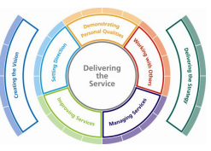
Figure 2 Leadership Framework
Source: (NHS Leadership Framework, n.d)
The NHS leadership framework helps in integrating the Medical Leadership Competency Framework (MLFC) and Clinical Leadership Competency Framework (CLCF). This acts as the foundation, which is designed for managers with essential knowledge and skills. The leaders present within the NHS help in delivering better health and care for patients and help in setting a better culture and adding value to the organisation. The NHS holds the five values and concepts as given below:
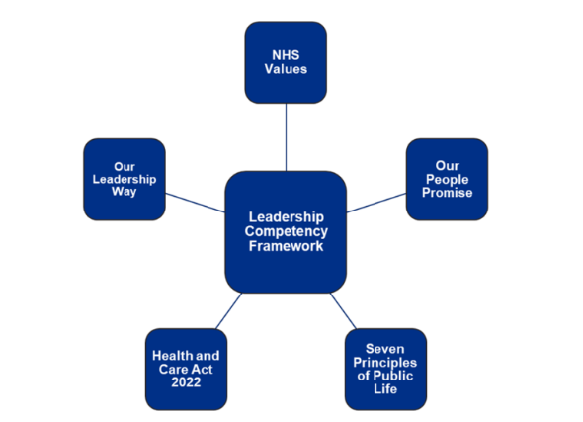
Figure 3 Leadership Competency Framework Source:
(NHS England, 2024)
The above demonstrates the five values and concepts, which are NHS values, our leadership way, our people promise, the Health and Care Act 2022, and the seven Principles of public life (NHS England, 2024). The NHS is considered to have an ever-changing identity, and the NHS calls for a dynamic leader who doesn’t follow any approach to overcome the challenges. The NHS leader follows the ideas of traditional leadership and acts more responsively in navigating through the challenges (Underwood, 2024). The main purpose of this leadership is to create the vision and deliver the strategy, focusing on the role of individuals. There are various applications of the leadership framework and supporting tools, which are to raise awareness of the need for effective leadership within the organisation, to underpin the talent strategy, develop the individual leadership skills, team development, enhance the existing appraisal systems and recruitment and retention process.
There are various key components of leadership, which include self-awareness, communication, decision-making and strategic thinking (Indeed, 2025). Critical thinking in healthcare empowers leaders to anticipate the challenges and choose the most appropriate course of action. The adoption of critical thinking in healthcare will help in optimising resource allocation, which includes conducting a comprehensive analysis of patients and staff productivity. This will help in identifying inefficiencies and implementing the strategies to target them. Critical thinking will help in implementing quality improvement initiatives and leading the multidisciplinary team (Forbes, 2024). It helps in navigating through ethical dilemmas, which require careful ethical decision-making. This helps in respecting the patient's autonomy, along with holding the ethical principles.

Task 7 – Self–Reflection Journal Entry
Creativity and value creation are very important in health and social care today. I have learned that creativity refers to finding new and better ways to help people. It is about thinking differently to solve problems and give good care. Value creation refers to doing things that make a real and positive difference for patients, families and the community. The portfolio helps in offering valuable insights related to care and offering help to patients. With the fast-paced world, healthcare and social sectors are evolving with the introduction of innovation, creativity and technology. The innovation and creativity help in laying a strong focus on the well-being of the patients. With the help of these innovations and professionals get better offers in choosing better options and processes. This can be explained with the help of examples, which involve the medical professionals using digital tools to attend online meetings, which helps in getting access to the other living in remote areas. With the help of this portfolio, I have built the ability to think more creatively and innovatively in future. I learned the skill of team collaboration and got the idea of working together and sharing leads to build an open and collaborative mind. This work made me build the skill of using creative skills and ideas to achieve goals. This helped me become more effective and efficient.

References
Dumke, L., Wilker, S., Hecker, T. and Neuner, F., 2024. Barriers to accessing mental health care for refugees and asylum seekers in high-income countries: A scoping review of reviews mapping demand and supply-side factors onto a conceptual framework. Clinical psychology review, 113, p.102491. https://www.sciencedirect.com/science/article/pii/S0272735824001120
Forbes. 2024. The Indispensable Role Of Critical Thinking In Healthcare Leadership. Forbes. Available at: https://www.forbes.com/councils/forbesbusinesscouncil/2024/04/01/the-indispensable-role-of-critical-thinking-in-healthcare-leadership/ [Accessed on – 5th October 2025]
Indeed. 2025. 12 Components of Effective Executive Leadership Teams. Indeed. https://www.indeed.com/career-advice/career-development/effective-executive-leadership-components
NHS England. 2024. NHS leadership competency framework for board members. NHS England. https://www.england.nhs.uk/long-read/nhs-leadership-competency-framework-for-board-members/
NHS England. 2025. Innovation. NHS England. Available at: https://www.england.nhs.uk/ourwork/innovation/ [Accessed on – 5th October 2025]
Peng, Y., Wu, T., Chen, Z. and Deng, Z., 2022. Value cocreation in health care: systematic review. Journal of Medical Internet Research, 24(3), p.e33061. https://www.jmir.org/2022/3/e33061/
Sheikh, A., Anderson, M., Albala, S., Casadei, B., Franklin, B.D., Richards, M., Taylor, D., Tibble, H. and Mossialos, E., 2021. Health information technology and digital innovation for national learning health and care systems. The Lancet Digital Health, 3(6), pp e383-e396. https://scholar.google.com/scholar?output=instlink&q=info:x4LWQ7J1qz4J:scholar.google.com/&hl=en&as_sdt=0,5&as_ylo=2021&scillfp=1827523024913438729&oi=lle
Underwood, S., 2024. Redefining leadership within the complex adaptive system. Future Healthcare Journal, 11(1), p.100015. https://www.sciencedirect.com/science/article/pii/S2514664524000146
Venkatesan, M., Mohan, H., Ryan, J.R., Schürch, C.M., Nolan, G.P., Frakes, D.H. and Coskun, A.F., 2021. Virtual and augmented reality for biomedical applications. Cell Reports Medicine, 2(7). https://scholar.google.com/scholar?output=instlink&q=info:b8z5WZV_c8wJ:scholar.google.com/&hl=en&as_sdt=0,5&as_ylo=2021&scillfp=9083008872019378211&oi=lle
Mezzina, R., Gopikumar, V., Jenkins, J., Saraceno, B. and Sashidharan, S.P., 2022. Social vulnerability and mental health inequalities in the “Syndemic”: Call for action. Frontiers in psychiatry, 13, p.894370. https://www.frontiersin.org/journals/psychiatry/articles/10.3389/fpsyt.2022.894370/pdf

