
Analysising and solving problems
CertHE Computing Skills for Workplace
Module Code: ACCA4019
Student Name: Mariam Jamil
Student ID: 2541507
Lecturer: Md Abdullah Usman


November 19, 2026
UNIVERISTY OF wALES TRINITY SAINT DAVID

Table of Contents
Introduction 2
1. Problem Deconstruction 3
1.1 Problem Overview 3
1.2 Key Requirements 3
1.3 MoSCoW Prioritisation 3
1.4 Key Variables 4
1.5 Functional Requirements - What the System Needs to Do 5
1.6 Non-Functional Requirements - How the System Should Operate 5
1.7 Constraints 6
2. Proposed Solution 7
2.1 Flow Chart 8
2.2 Pseudocode 9
3. Reflect and Justify 11
3.1 Problem Solving & Techniques Used 11
3.2 Justification of the Approach 12
3.3 Assumptions 12
3.4 Limitations 13
3.5 Overall Reflection 13
References 14

Introduction
Appointment scheduling plays a vital role in healthcare because delays can affect patient experience and how hospital resources are used. MediCare Plus is facing challenges in allocating appointment smoothly, reducing patient waiting times and ensuring that patients are not kept waiting more than 30 minutes beyond their scheduled appointment time.
The aim of this report is to analyse the appointment-scheduling problem and develop a structured solution using computational-thinking and problem-solving techniques. The report begins by outlining the main requirements, constraints and variables involved in the scheduling process. It then represents a proposed solution a flowchart and pseudocode explaining how appointments can be allocated, waiting times monitored and staff alerted when delays approach the 30-minute limit. The report also reflects on the techniques used, justifies the chosen approach and considers its assumptions, limitations and possible future improvements, including the potential use of artificial intelligence to guide scheduling decisions.

Problem Deconstruction

Problem Overview
The MediCare Plus Hospital is seeking a way to manage patient appointments. The challenge involves allocating patients to suitable slots, reducing waiting times and using doctors’ working hours wisely. The goal is ensuring patients are not kept waiting more than 30 minutes. This requires considering doctor availability, appointment demand, time-slot distribution and consultation duration to create a clearer scheduling process.

Key Requirements
The MediCare Plus scheduling system must achieve several aims. Patients need to be placed into appointment slots that match doctor’s schedules and waiting times should be reduced by arranging bookings according to available time slots and doctor availability. Niu et al. explain that long waits and limited access are common challenges, influenced by punctuality, demand and clinic conditions [1]. The system must also track the time between scheduled and actual consultations to ensure patients don’t wait more than 30 minutes, letting staff respond when delays occur and maintain appointment flow.

MoSCoW Prioritisation
The MoSCoW method classifies system expectations into Must Have, Should Have, Could Have and Won’t Have categories [2]. For MediCare Plus, Must Have elements include assigning patients to available slots, checking doctor availability and monitoring the 30-minute waiting limit. Should Have elements involve reducing waiting times and arrange appointments. Could Have features include automated delay alerts, while Won’t Have features cover area outside the project scope, such as billing integration.
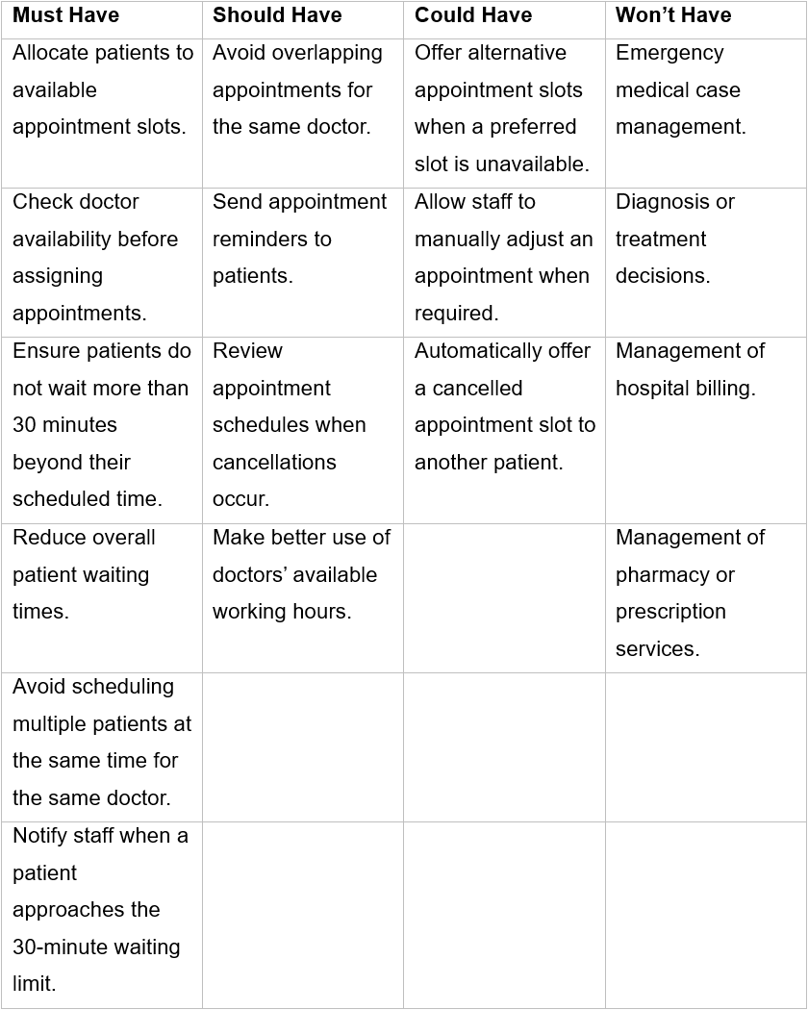
Figure 1: MoSCoW prioritisation of the MediCare Plus appointment scheduling system requirements.

Key Variables
Several variables shape the MediCare Plus scheduling system. Patient ID and Doctor ID distinguish individuals and clinicians while doctor availability accurately determines when consultations can take place. Agrawal et al examined appointment planning and noted the need to align patient demand with available clinicians [3]. Appointment slots also matter, as Eggleton et al. showed through their TNAA measure, which revealed limited slot access in some practices [4]. Morales et al. demonstrated how modelling can reduce delays and improve resource use within healthcare settings [5]. Consultation lengths also vary, as Lyzwinski et al. found across patient groups and health conditions [6].
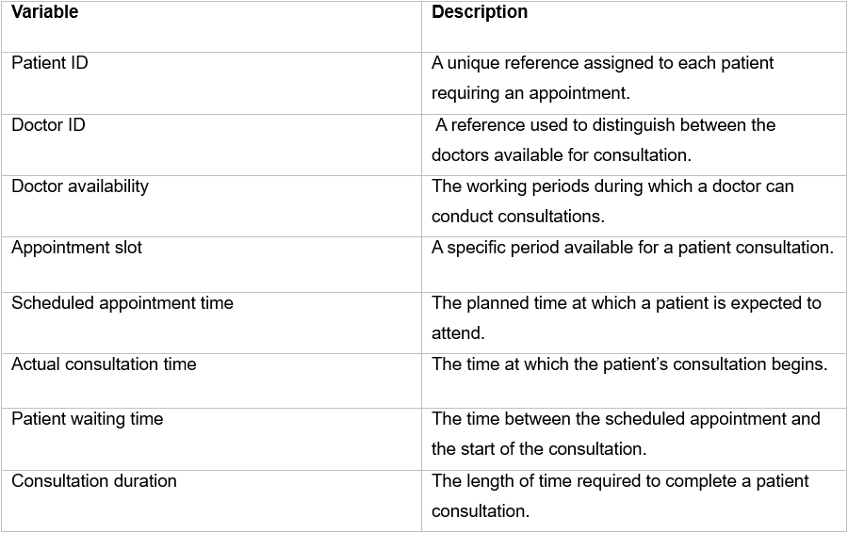
Figure 2: Key variables and descriptions for the MediCare Plus appointment scheduling system.

Functional Requirements - What the System Needs to Do
Functional feature requirements are what the system must carry out. Research on outpatient scheduling shows that structured appointment allocation improves access. Moura and Pinho’s optimisation model demonstrated smoother distribution of specialist appointments and decreased waiting times in stimulated data [7]. Waits can harm patient experience and delay diagnosis. For MediCare Plus, this means allocating patients to available slots, checking doctor availability and monitoring waiting times.

Non-Functional Requirements - How the System Should Operate
The MediCare Plus scheduling system must run smoothly to avoid errors and delays. Accurate appointment information is a must and patient data must be protected. The system also needs precision when staff update bookings. Machine-learning research shows how unpredictable behaviour, bias and transparency issues can affect decision-making. These concerns emphasise qualities such as fairness, privacy, reliability and integrity. Habibullah et al. outline accuracy, reliability, integrity and security as an important attribute in ML-based systems [8], which also guide MediCare Plus.

Constraints
The constraints of MediCare Plus affect appointment allocation. Doctor availability, working hours and appointment capacity limit scheduling options. Laan et al. found that outpatient scheduling is affected by patient demand, clinic resources and physician availability [9]. The system must prevent booking conflicts by avoiding unavailable doctors and occupied time slots, monitoring delays to keep waiting times within the 30-minute limit beyond their scheduled appointment time.

Proposed Solution
The solution allocates patients to suitable appointment slots, manage available resources and limits waits to 30 minutes beyond their scheduled appointment time. The process begins by receiving a patient request and checking doctor availability and appointment capacity. Zhuang et al. highlighted the importance of coordinating limited resources with changing demand in appointment-based systems, supporting this structured approach to scheduling [10]. Artificial intelligence (AI) could also support with resource planning by predicting healthcare demand and guiding scheduling decisions. Alnsour et al. developed an AI model to predict hospital length of stay, with their XGBoost model achieving an area under the curve (AUC) of 0.85 when classifying length-of-stay categories. XGBoost is a machine-learning method that combines decision trees to improve predictive performance. The authors concluded that these predictions could support hospital resource planning overall and scheduling decisions [11]. Similarly, MediCare Plus could use AI to anticipate resource needs and improve appointment planning, although any model would need to be tested using appropriate hospital data.
Research into online appointment scheduling (OAS) can offer patients greater flexibility while helping healthcare providers manage available appointments. The study found that online scheduling was associated with a decrease in missed appointments, with SMS reminders further contributing to this reduction in university hospital settings [12]. For MediCare Plus, automated appointment reminders could encourage patients to attend their consultations, letting appointment slots be used appropriately.
Managing patient flow is another important part of reducing delays in healthcare settings. Ramakrishnan et al. discussed approaches such as identifying bottlenecks, examining real-time data and developing staff coordination to support smoother patient flow [13]. MediCare Plus could monitor consultation progress throughout the clinic day. If a patient approaches the 30-minute waiting-time limit, an alert could notify staff so they can investigate the cause and take relevant action.
Artificial intelligence could further this process by predicting potential waiting-time delays. Gloyn et al. reviewed 15 studies on AI-based waiting-time prediction in emergency departments and found that machine-learning models outperformed traditional methods, particularly when queue-related information was included [14]. MediCare Plus could consider a similar approach to find patients at risk of long waits and alert staff earlier. However, any model would need to be tested using the hospital’s own outpatient data, as the review focused on emergency departments.
Finally, the system could use recorded waiting-time data to evaluate appointment management. Ludin et al. found that survey participants considered short waiting times the most important feature of digital healthcare services. Their research also found convenience and operation performance as potential benefits of digital healthcare [15]. Li et al. investigated machine-learning methods for predicting outpatient waiting times. Their findings showed that forest and gradient boosting decision tree models performed better than linear regression across the four outpatient department categories studied [16]. MediCare Plus could compare scheduled appointment times with actual consultation start times and use this recorded data to find recurring delays. In the future, these data could also support the development of AI models to improve scheduling decisions and help the hospital assess whether its approach is improving over time. However, the accuracy of any predictions would need to be evaluated using MediCare Plus’s own data.

Flow Chart
The flow chart shows the appointment scheduling process at MediCare Plus. It begins when a patient submits an appointment request. The system checks doctor availability and appointment slots. If a suitable slot is unavailable, the system searches for an alternative appointment. When an alternative slot is found, the appointment is booked. If no suitable option is available, the patient is informed. Once the appointment is arranged, a confirmation and reminder are sent to the patient.
During the clinic day, the system monitors patient waiting times. AI can estimate possible delays by analysing historical waiting-time information and current appointment progress. The patient’s waiting time is checked regularly. When it reaches 25 minutes, staff are notified of a possible delay. If the waiting time reaches 30 minutes, the delay is recorded for review. Monitoring continues until the consultation begins. The final waiting time is recorded and reviewed to improve future scheduling processes.
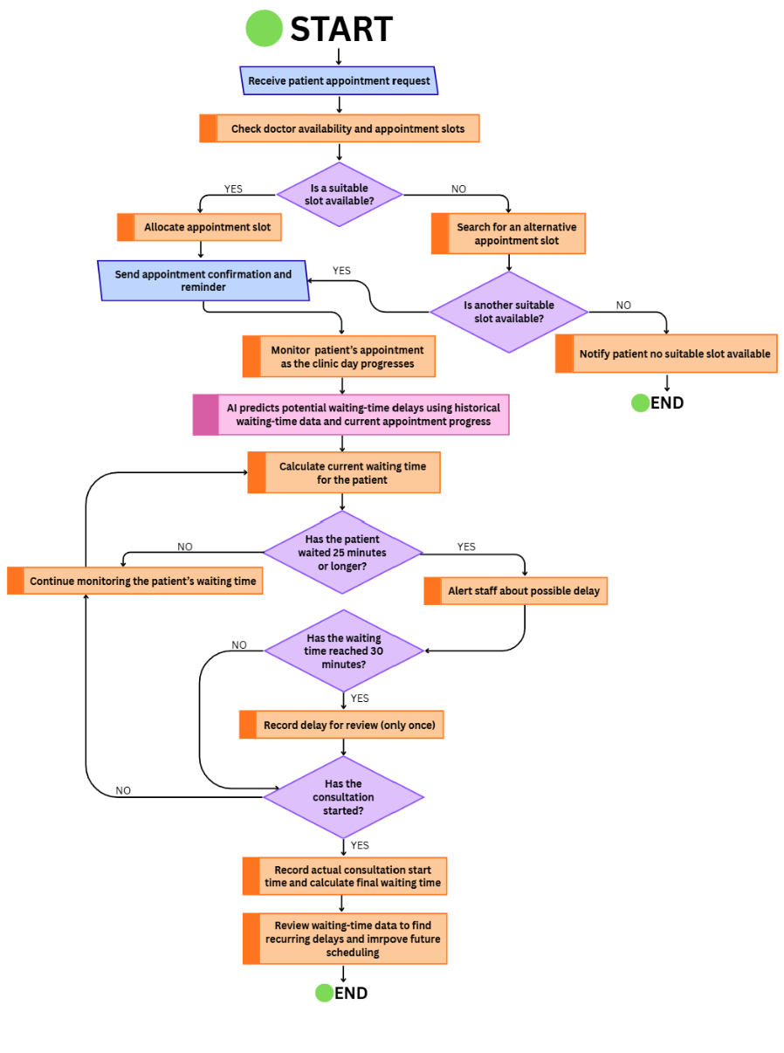
Figure 3: Flowchart of the workflow used to manage patient appointment scheduling including slot allocation, monitoring and delay handling.

Pseudocode
The pseudocode demonstrates how MediCare Plus could manage patient appointments and monitor waiting times. The process begins by checking patient details and doctor availability before allocating a suitable appointment slot. Once an appointment is allocated, the system sends a confirmation and reminder to the patient. If the preferred appointment is available, the system searches for an alternative slot. When no suitable alternative can be found, the patient is informed.
After the booking stage, the system monitors waiting times throughout the clinic day. AI could be used to predict possible delays by analysing historical data and current clinic activity, although the pseudocode only outputs an AI-related message and does not perform predictions. The system alerts staff when a patient has waited 25 minutes and records delays that reach 30 minutes. Monitoring continues until the consultation begins, after which the final waiting time is recorded and reviewed to improve future scheduling decisions.
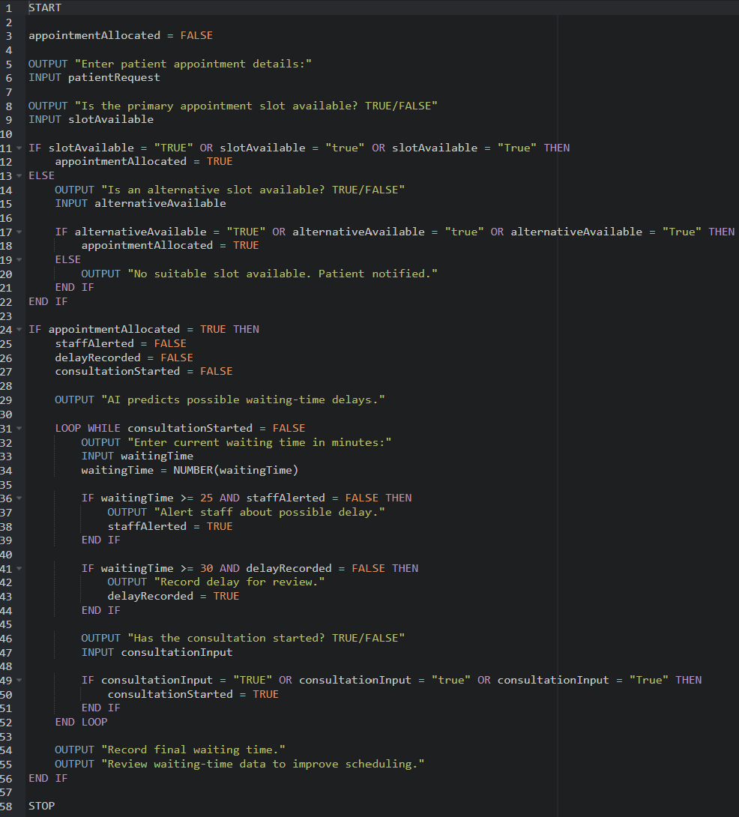
Figure 4: Block-program representation of the proposed delivery optimisation solution.

Reflect and Justify

Problem Solving & Techniques Used

Decomposition / Subdividing
Decomposition is a computational-thinking technique that breaks a problem into smaller, manageable parts. Ezeamuzie et al. determined how computational-thinking skills support structured problem-solving in everyday situations [17]. For MediCare Plus, the problem can be divided into doctor availability, patient demand, appointment slots and waiting-time limits. Examining these areas individually simplifies the problem and helps develop a clear scheduling process before combining them into one system.

Abstract Thinking
Abstraction is a computational-thinking skill that focuses on relevant information while ignoring unnecessary details. Benedetti et al. analysed 241 student submissions and found that abstraction, algorithmic thinking and decomposition were frequently used, although no consistently [18]. For MediCare Plus, abstraction means focusing on doctor availability, patient demand, appointment slots and the 30-minute waiting limit. This reduces complexity and ultimately helps develop a suitable scheduling solution.

Algorithmic Thinking
Algorithmic thinking involves creating logical steps to solve problems in a clear and organised sequence. Tariq et al. reviewed over 12,000 records and found 23 relevant studies on computational thinking in STEM education [19]. At MediCare Plus, this involves checking doctor availability, allocating appointment slots, sending confirmation and monitoring waiting times. Staff alerts help find delays, although success depends on accurate data and timely responses.

Logical Thinking & Decision Making
Logical thinking involves analysing problems and evaluating outcomes. Montuori et al. reviewed 19 experimental studies and found that computational-thinking activities enhanced problem-solving and planning skills, although effects varied across age groups [20]. At MediCare, decisions involve checking doctor availability, selecting alternative slots and alerting staff when waiting times approach 30 minutes. This process encourages scheduling, although results depend on accurate information and staff responding promptly.

Justification of the Approach
The chosen approach suits MediCare Plus because it combines computational-thinking techniques with a scheduling process. Decomposition and abstraction break down the problem, while algorithmic and logical thinking arrange the steps.
Abdalkareem et al. found that healthcare scheduling methods can reduce waiting times improve resources use [21]. Liu et al. developed an AI-based model for resource planning and patient scheduling during disasters [22]. Kumar et al. stressed the importance of connections between hospital services [23].
Checking availability, alerting staff at 25 minutes and recording consultation start times helps manage delays. Any future AI feature must be tested with MediCare Plus data.

Assumptions
The solution assumes that doctor availability, appointment slots and consultation times are accurate. Patients should arrive close to schedule and staff must respond to 25-munute alerts. Consultation start times must be recorded reliably, and alternative slots must be available. Future AI predictions would also require sufficient historical data for testing.

Limitations
The proposed solution cannot guarantee that all patients will be seen within 30 minutes because consultations, resource bottle necks and appointment overruns in hospitals [24]. The system also depends on accurate data and staff responding to alerts. De Hond et al. identified AI risks including bias, poor data quality and limited transparency [25]. Future improvements could include real-time hospital data and validated AI predictions, although potential delays may still occur.

Overall Reflection
Developing the MediCare Plus solution shows how computational-thinking can address healthcare scheduling problems. Decomposition separates the problem into smaller areas, while abstraction focuses on details including doctor availability, appointment slots and waiting-time limits. Algorithmic thinking and logical decision-making organise these requirements into clear steps, represented through the flowchart and pseudocode.
However, real hospital settings involve unpredictable consultation lengths, changes in patient demand and staff availability, which may affect scheduling. AI could be developed to predict waiting -time delays, but its predictions would depend on reliable historical data, careful validation and monitoring before use in practice.
Overall, the proposed solution applies problem-solving techniques to MediCare Plus’s main needs. Further development could include testing different appointment scenarios, connecting the system to live hospital data and examining how it responds when appointment overrun. These steps would help assess whether the scheduling process meets the hospital’s needs. The findings could also guide future changes to appointment allocation and staff alerts, while recognising that unexpected clinical demands may still cause delays. Regular evaluation would help determine whether these changes remain suitable as patient demand and hospital resources change.

References
[1] T. Niu et al., “A review of Optimization Studies for system appointment scheduling,” Axioms, vol. 13, no. 1, p. 16, Dec. 2023, doi: 10.3390/axioms13010016. [Accessed: Oct. 10, 2026].
[2] E. Miranda, “Moscow Rules: A Quantitative Exposé,” in Agile Processes in Software Engineering and Extreme Programming: XP 2022, Lecture Notes in Business Information Processing, vol. 445, pp. 19–34, Springer, 2022, doi: 10.1007/978-3-031-08169-9_2. [Accessed: Sep. 26, 2026].
[3] D.Agrawal, G. Pang, and S. Kumara, “Preference based scheduling in a healthcare provider network,” European Journal of Operational Research, vol. 307, no. 3, pp.1318-1335, 2023, doi: 10.1016/j.ejor.2022.09.027. [Accessed: Sep. 29, 2026].
[4] K. Eggleton, L. Penney, and J. Moore, “Measuring doctor appointment availability in Northland general practice,” Journal of primary health care, vol. 9, no. 1, pp. 56–61, Mar. 2017, doi: 10.1071/HC16036. [Accessed: Sep. 29, 2026].
[5] J. Morales, F. Silva-Aravena, and P. Saez, “Reducing waiting times to improve patient satisfaction: a hybrid strategy for decision support management,” Mathematics, vol. 12, no. 23, p. 3743, Nov. 2024, doi: 10.3390/math12233743. [Accessed: Oct. 10, 2026].
[6] L. Lyzwinski, Y. Evéquoz, and P.-Y. Rodondi, “Managing consultation duration in primary care: A systematic review with health equity insights,” Journal of Family Medicine and Primary Care, vol. 14, no. 8, pp. 3132–3158, Aug. 2025, doi: 10.4103/jfmpc.jfmpc_1594_24. [Accessed: Sep. 29, 2026].
[7] A. Moura and M. Pinho, “A scheduling optimization approach to reduce outpatient waiting times for specialists,” Healthcare, vol. 13, no. 7, p. 749, Mar. 2025, doi: 10.3390/healthcare13070749. [Accessed: Oct. 15, 2026].
[8] K. M. Habibullah, G. Gay, and J. Horkoff, “Non-functional requirements for machine learning: understanding current use and challenges among practitioners,” Requirements Engineering, vol. 28, no. 2, pp. 283–316, Jan. 2023, doi: 10.1007/s00766-022-00395-3. [Accessed: Sep. 30, 2026].
[9] C. Laan, M. Van De Vrugt, J. Olsman, and R. J. Boucherie, “Static and dynamic appointment scheduling to improve patient access time,” Health Systems, vol. 7, no. 2, pp. 148–159, Nov. 2017, doi: 10.1080/20476965.2017.1403675. [Accessed: Oct. 1, 2026].
[10] W. Zhuang, B. Song, M. Z. F. Li, and Q. Wang, “Dynamic resource allocation and scheduling for appointment-based systems with walk-ins,” IISE Transactions, vol. 57, no. 8, pp. 976–993, Oct. 2024, doi: 10.1080/24725854.2024.2397803. [Accessed: Oct. 04, 2026].
[11] Y. Alnsour, M. Johnson, A. Albizri, and A. H. Harfouche, “Predicting Patient Length of Stay Using Artificial Intelligence to Assist Healthcare Professionals in Resource Planning and Scheduling Decisions,” Journal of global information management, vol. 31, no. 1, pp. 1–14, Jan. 2023, doi: 10.4018/JGIM.323059. [Accessed: Oct. 19, 2026].
[12] P. K. Betancor et al., “Efficient patient care in the digital age: impact of online appointment scheduling in a medical practice and a university hospital on the ‘no-show’-rate,” Frontiers in Digital Health, vol. 7, p. 1567397, May 2025, doi: 10.3389/fdgth.2025.1567397. [Accessed: Oct. 15, 2026].
[13] R. Ramakrishnan et al., “Optimizing patient flow in hospitals: Strategies for reducing wait times and improving efficiency,” in 2025 3rd World Conference on Communication & Computing (WCONF), Raipur, India, Jul. 25-27, doi: 10.1109/WCONF64849.2025.11233409. [Accessed: Oct. 15, 2026].
[14] T. Gloyn et al., “Using artificial intelligence to predict patient wait times in the emergency department: A scoping review,” Artificial intelligence in medicine, vol. 171, Art. no. 103316, Jan. 2026, doi: 10.1016/j.artmed.2025.103316. [Accessed: Oct. 19, 2026].
[15] D. Ludin, S. Duman, V. Kirchner, and M. Mikulec, “Digital Innovation in Healthcare: Impacts on Patient Behaviour, Appointment Scheduling and Times in Waiting Rooms – An Explorative Empirical Study in Germany,” Marketing and Management of Innovations, vol. 16, no. 2, pp. 75-87, 2025, doi: 10.21272/mmi.2025.2-06. [Accessed: Oct. 15, 2026].
[16] X. Li et al., “Prediction of outpatient waiting time: using machine learning in a tertiary children’s hospital,” Translational pediatrics, vol. 12, no. 11, pp. 2030–2043, Nov. 2023, doi: 10.21037/tp-23-58. [Accessed: Oct. 19, 2026].
[17] N. O. Ezeamuzie, J. S. C. Leung, R. C. C. Garcia, and F. S. T. Ting, “Discovering computational thinking in everyday problem solving: A multiple case study of route planning,” Journal of Computer Assisted Learning, vol. 38, no. 6, pp. 1779–1796, Aug. 2022, doi: 10.1111/jcal.12720. [Accessed: Oct. 17, 2026].
[18] E. Benedetti, I. Alpizar-Chacon, and J. Jeuring, “The Use of Computational Thinking Skills, Difficulties, and Strategies of Introductory Programming Students Solving Bebras Tasks,” June 2026, doi: 10.48550/arxiv.2606.02175. [Accessed: Oct. 05, 2026].
[19] R. Tariq, B. M. A. Babines, J. Ramirez, I. Alvarez-Icaza, and F. Naseer, “Computational thinking in STEM education: current state-of-the-art and future research directions,” Frontiers in Computer Science, vol. 6, Jan. 2025, doi: 10.3389/fcomp.2024.1480404. [Accessed: Oct. 17, 2026].
[20] C. Montuori, F. Gambarota, G. Altoé, and B. Arfé, “The cognitive effects of computational thinking: A systematic review and meta-analytic study,” Computers & Education, vol. 210, p. 104961, Nov. 2023, doi: 10.1016/j.compedu.2023.104961. [Accessed: Oct. 17, 2026].
[21] Z. A. Abdalkareem, A. Amir, M. A. Al-Betar, P. Ekhan, and A. I. Hammouri, “Healthcare scheduling in optimization context: a review,” Health and Technology, vol. 11, no. 3, pp. 445–469, Apr. 2021, doi: 10.1007/s12553-021-00547-5. [Accessed: Oct. 17, 2026].
[22] Y. Liu, J. Zhang, and F. T. S. Chan, “AI-enhanced robust method for integrated healthcare resource pre-positioning and patient scheduling,” International journal of production research, vol. 63, no. 2, pp. 729–757, Jan. 2025, doi: 10.1080/00207543.2024.2309312. [Accessed: Oct. 20, 2026].
[23] A. Kumar et al., “Strategizing towards the future hospital: a systems thinking approach,” Health Research Policy and Systems, vol. 23, no. 1, p. 71, May 2025, doi: 10.1186/s12961-025-01333-9. [Accessed: Oct. 17, 2026].
[24] A. Kuiper, J. De Mast, and M. Mandjes, “The problem of appointment scheduling in outpatient clinics: A multiple case study of clinical practice,” Omega, vol. 98, p. 102122, Sep. 2019, doi: 10.1016/j.omega.2019.102122. [Accessed: Oct. 17, 2026].
[25] A. A. H. de Hond et al., “Guidelines and quality criteria for artificial intelligence-based prediction models in healthcare: a scoping review,” NPJ digital medicine, vol. 5, no. 1, Art. no. 2, Jan. 2022, doi: 10.1038/s41746-021-00549-7. [Accessed: Oct. 20, 2026].

