Alex Archer
152940
Abstract
The project for ‘Recycle Better’ has developed both our technical and production skills. Throughout this report you will understand the early stages of development of our product, whilst understanding our business decisions with all things ideation and development.
Product business innovation plan
ENTERPRISE & INNOVATION

Table of Contents
Ideation 1
The Proposed Idea 1
Illustration 3
Alpha Stage 3
Beta Stage 5
Design 6
Requirements 6
Differentiation 7
Prototype Development 8
Technical Skills Development 10
Appendices 11
Reflection 11
Networking 12
Team-working 14
References 15

Ideation

The Proposed Idea
Development of our final idea throughout this module has taken time and many drafts before agreeing on a suitable product. The product being discussed must have included technologies which relate to application development. Therefore, we agreed on developing an informative web application. The premise of our new idea ties in with the new kerbside collection service by Pembrokeshire County Council, which started on November 4th, 2019 [1]. With this new service releasing to Pembrokeshire, a lack of clarification was developed from both Pembrokeshire County Council and the public regarding this new service. The new system had its flaws, meaning that homeowners were placing the incorrect waste into their bins because of this newly developed framework, resulting in written warnings and fines. An article from the BBC stated that shows that people have not taken to this new system with the respect Pembrokeshire County Council was expecting. One resident, Marjorie Sullivan, 70, stated that the new system means that she must climb 23 steps from her home with each recycling bag. This creates an unhappy relationship between the public and Pembrokeshire County Council. Furthermore, opposition councillor says that he would have preferred to see a pilot scheme “like some authorities have done to flush out the issues”. [2] So, with these issues being addressed, we can identify the need for improvement In this new system. With both parties, the public and the council aware of these issues, we can focus on the market we believe to make a difference. As previously mentioned, our idea is a web application which ties into the new kerbside collection system. To do this, we have developed a website which greatly improves the display of information attempting to be portrayed by Pembrokeshire County Council. The application works like a search engine such as Google or Bing. To explore the search feature, the user would type in a piece of packaging material, for example “plastic bottle”, the user would then be re-directed to another page, known as the product page. There, the user is provided with various pieces of information about the packaging, such as where to dispose of it, whether it can be recycled and what to do if you have more information, in which case they would be redirected to the Pembrokeshire County Council website. [3]

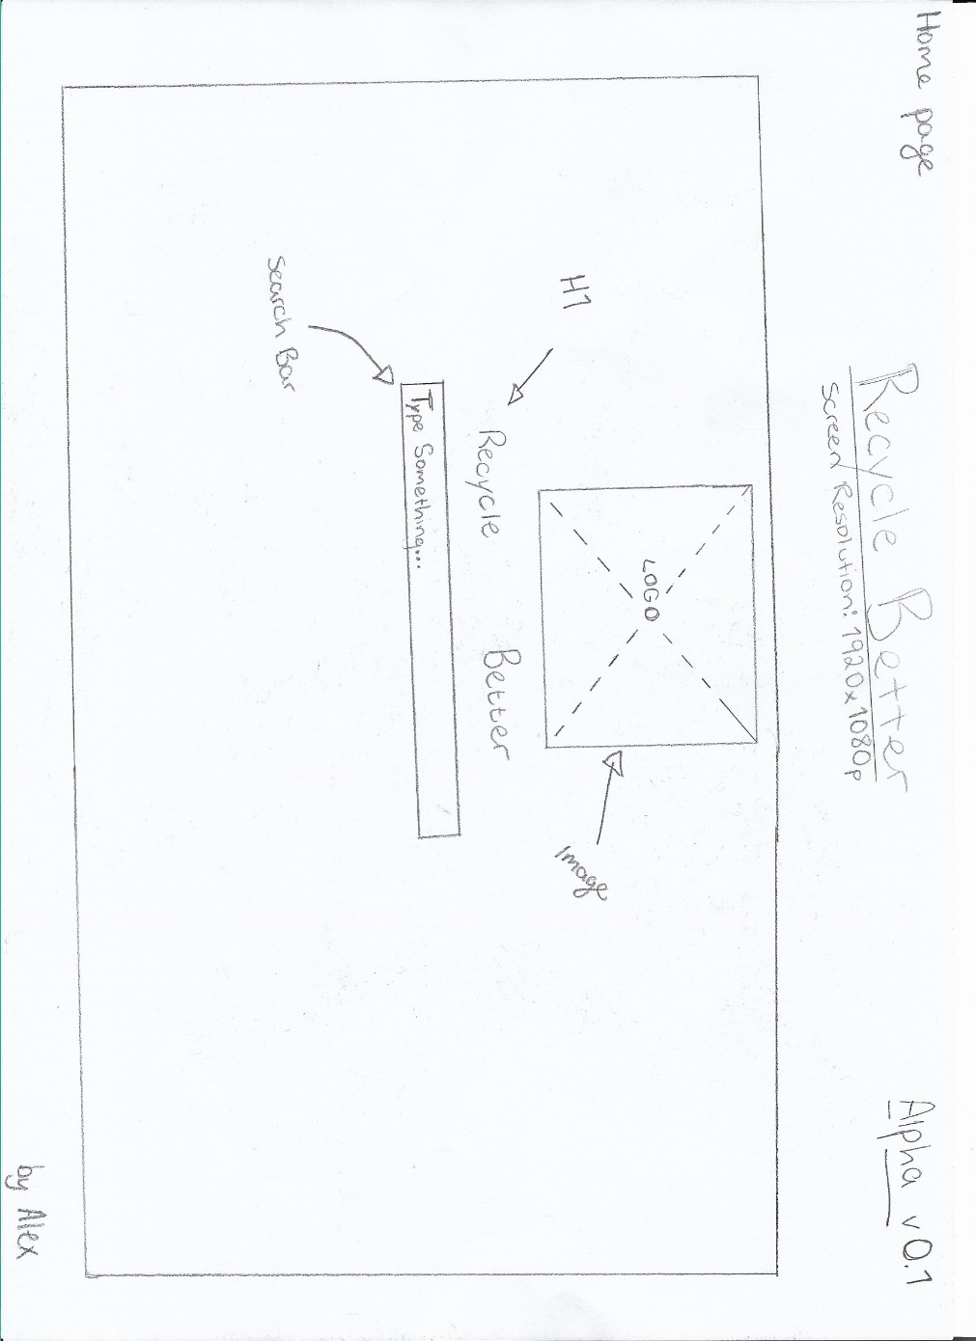
Illustration
1. Figure 4: Home Page Alpha 0.1

Alpha Stage
During the early development of our product, we designed wireframes for our initial draw-up of the application. Here is an early wireframe of our “Recycle Better” application below:
As you can see from the image above, the wireframe was designed with a resolution of 1920x1080p resolution in consideration. The application’s alpha version was created with a Minimum Viable Product (MVP) in mind. This is where the product has reached enough progress to start a feedback stage with partners and interested parties. The screen where the application would be rendered is in the rectangle below the “Recycle Better” title. Included in the application is a space for the logo which was created by Morgan using Photoshop. (see figure 0.2) Also included in the wireframe is a search function, which is the main feature to our product idea. Although the application looks undeveloped, we wanted to ensure a sleek and contemporary look for our new idea.
“What happens when you try to sell a house with an overgrown garden, cracks in the driveway, and a broken front door? No offers, right? That’s exactly why you need the best homepage design for your website.” [4]
To ensure a quality product, our group agreed on keeping the design as simple as possible during the early stages of development, so we can focus our time and resources on the functionality of our application. Although, websites like Crazy Egg (who write about website design) promote website simplicity and efficiency. Their homepage design web article states that there are clear characteristics when it comes to designing an effective homepage: Clear, dynamic, contrasting colours, loads fast, etc. Therefore, taking into consideration these characteristics, a simple design with minimal features will help us to portray the main function of the application easier.
Also, below is an image for the alpha stage product page - which is the result of a search from the homepage search engine feature:
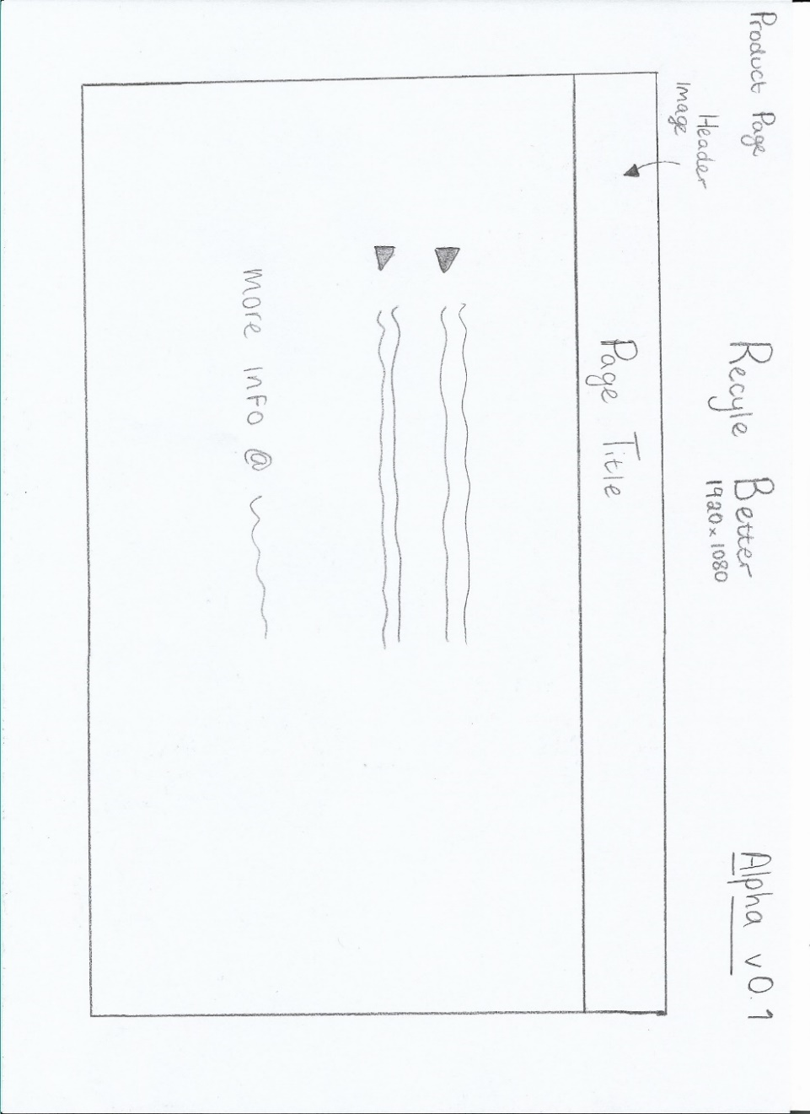
2. Figure 2: Product Page Alpha 0.1

Beta Stage
As you can see from the design below, the beta stage wireframes have an improvement on the design and functionality of the application. We wanted to re-design the homepage to make our company and brand stand out. Therefore, we included an extra section of the homepage which included a log-in and sign-up section and a section to clearly state our news, goals, and vision in an about section.
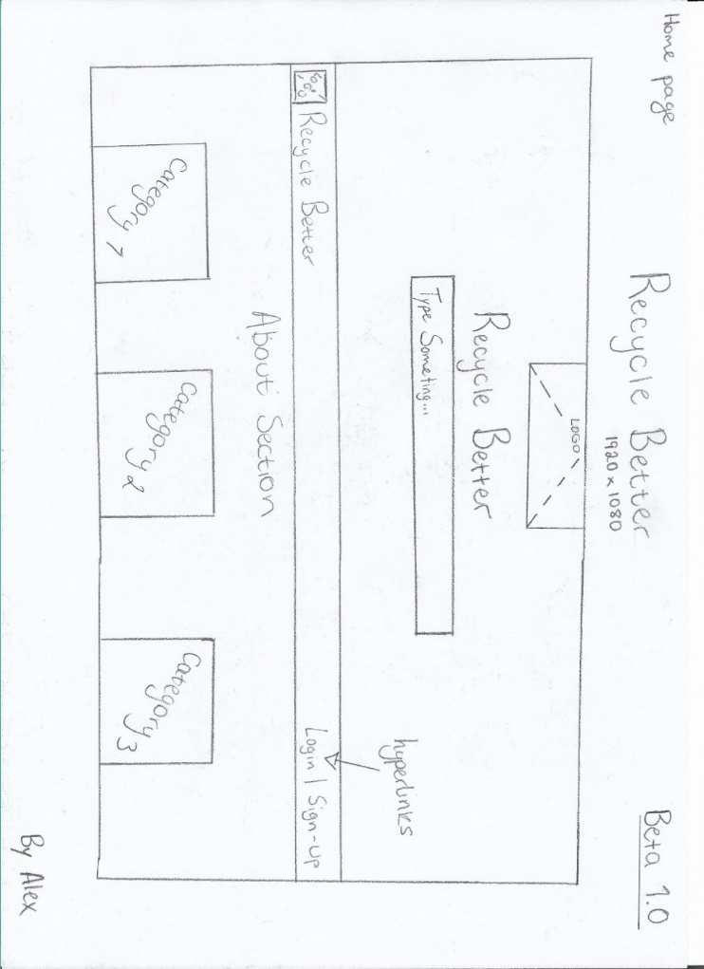
3. Figure 3: Home Page Beta 1.0
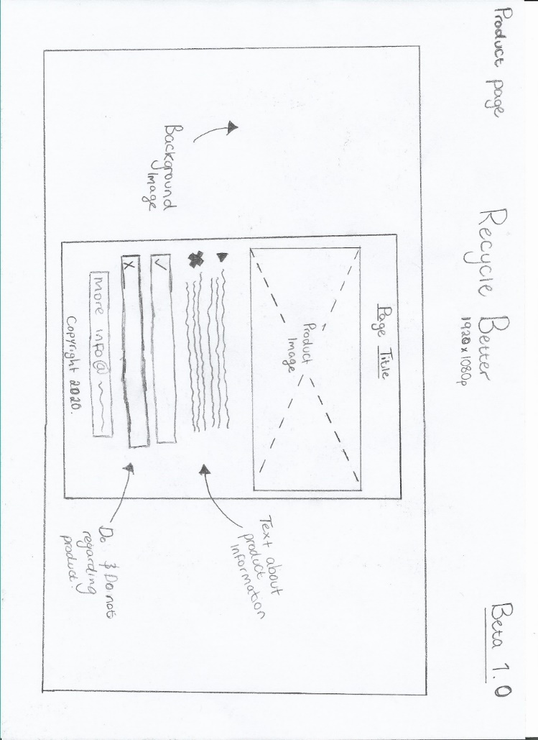
4. Figure 4: Product Page Beta 1.0

Design

Requirements

Objective/Goal
The objective of our product is to reinvent the display of information currently provided by the Pembrokeshire County Council. We will achieve this by developing an interactive web application which gives the user more accessibility through a graphical user interface (GUI). Our goal is to improve recycling in Pembrokeshire and to achieve Pembrokeshire County Council recycling targets earlier than planned.

Features
The product will use a contemporary graphical user interface to provide interactivity to users. To ensure this, we will use text editor ‘Microsoft Visual Studio Code’ as well as technologies such as HTML to structure the display of features on screen [5], CSS to style the code how we want it to look [6], and JavaScript to provide functionality and animation to the web page. [7]

System & Environment
To produce a quality product, we will need to ensure that all browsers are supported (Google Chrome, Microsoft Edge, Mozilla Firefox, etc.), as well as various operating systems that are still supported by Apple, Linux, and Microsoft (Windows 10, 8, 7, etc.). [8] On the other hand, there will be a need for online server space, too.

Assumptions, Constraints & Dependencies
There are various factors which we assume will have an affect on the outcome of this project. For example, as previously mentioned, the need for online server space is a system requirement so that the application can be publicly accessed. However, due to a lack of financial budget, we would prefer to use servers located in a development house so that we can identify any issues that may occur. Furthermore, I believe that, given that Pembrokeshire County Council are our authority, that they have their own servers located in their headquarters, which in turn, eliminates costs.

Differentiation
Our project ‘Recycle Better’ is part of a market which is growing in concern. However, this market does have its niche, it is mainly based in real-life business and does not have too much competition when it comes to online presence. There are a few competitors which are worth mentioning:
WeRecycle by OPRL – WeRecycle is an app which has been developed by a non-profit company who pushed towards an on-pack recycling label scheme. The premise of the application is to display information to users using a scan feature which scans labels on packaging. The app is funded by large name companies such as ASDA, McDonald’s, and Nestle. However, the app has not received an update since January 2019, making it out-of-date and no longer in development. [9]
Recycle for Greater Manchester (R4GM) – The Recycle for Greater Manchester application has many similarities to our product while also carrying 1000+ downloads. However, the development of the application has clearly been stopped as the GUI is outdated, and the most recent update was September 2018. The app was only used in the Manchester area, meaning that it doesn’t compete with our app, based in Pembrokeshire. [10]
Recycle! Belgium – This app based in Belgium to this day is a success. It is a joint initiative pf Bebat and Fost Plus. The application is regularly updated and has 100,000+ downloads. The app also prides itself around its easy to use GUI, which is important in the age of technology. [11]

Gap in the Market
From the previous research, we can identify that there is a need for recycling apps in rural areas, such as Pembrokeshire. However, apps which are neglected of updates often get swept under the carpet. Therefore, the app must have a constant stream of funding to ensure our application does not meet the same fate as its competitors.

Prototype Development
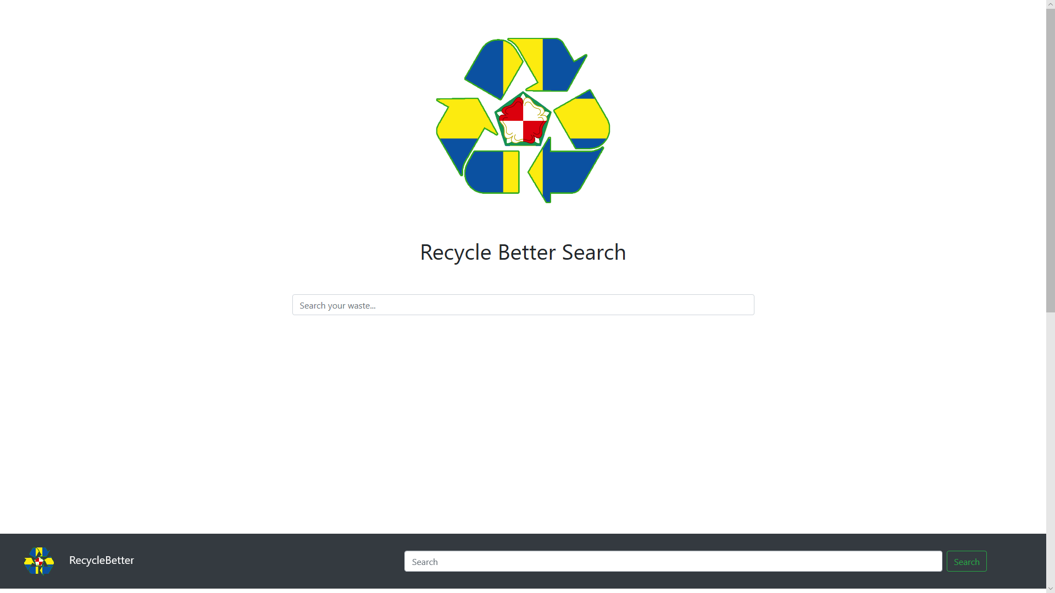
As you can see from the home page above, the design is like the beta wireframes that I produced for the group earlier in the ideation phase. The key feature to the prototype is the search engine which is in the centre of the screen. The homepage was initially coded by Aaron. However, I did provide assistance and coded the logo in to the centre. The search engine allows the user to proceed to the product page:
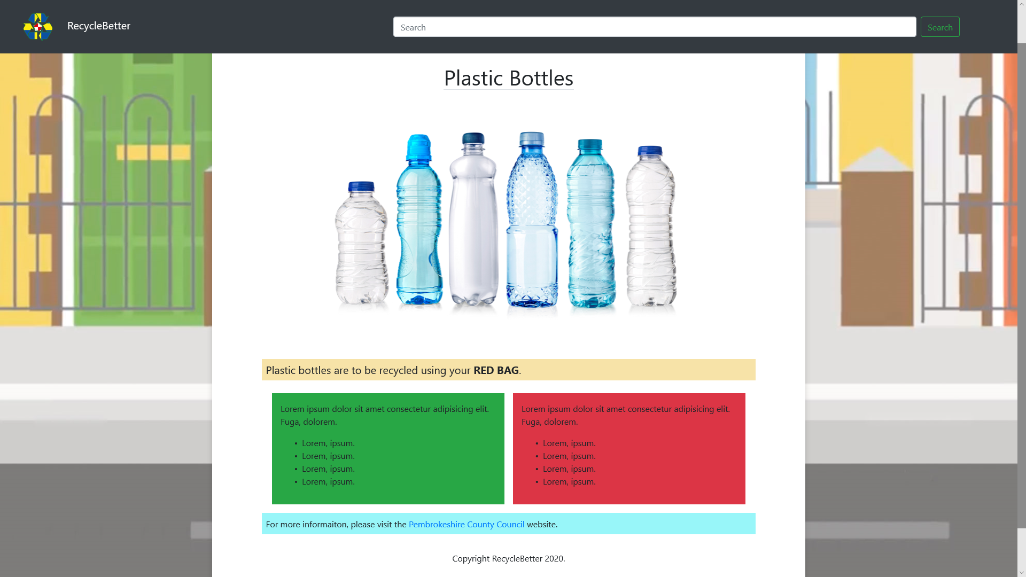
The product page is populated with information about a searched product packaging. For example, “Plastic bottle” was searched, resulting in the page for plastic bottles. Here, the user is provided with information about where to dispose of their waste and where to find more information. This page of the prototype was designed and programmed by me.
There is not much to say about the development of the prototype, as it was a simple structure of code that we already knew. We kept the program as optimised as possible, using a framework called ‘Bootstrap’, which uses a grid system to code elements onto a web application. These elements also have a responsive design, so they scale to fit mobile screens also. Here are screenshots of the application working on a smaller resolution:

iPad
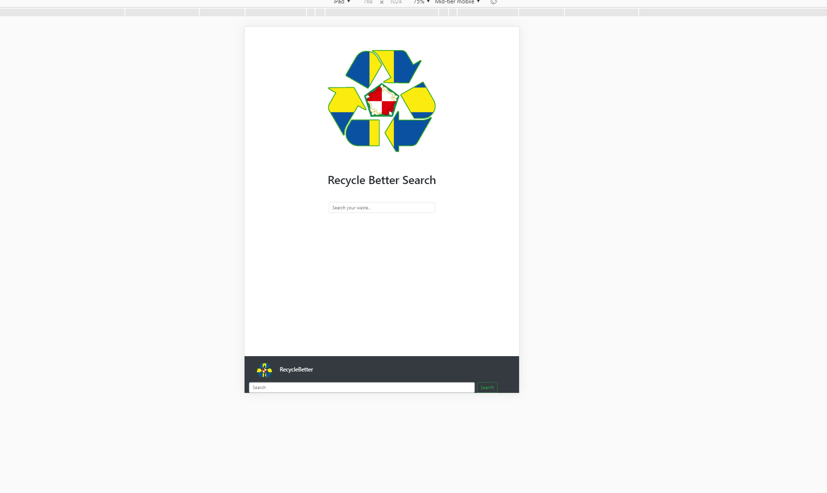

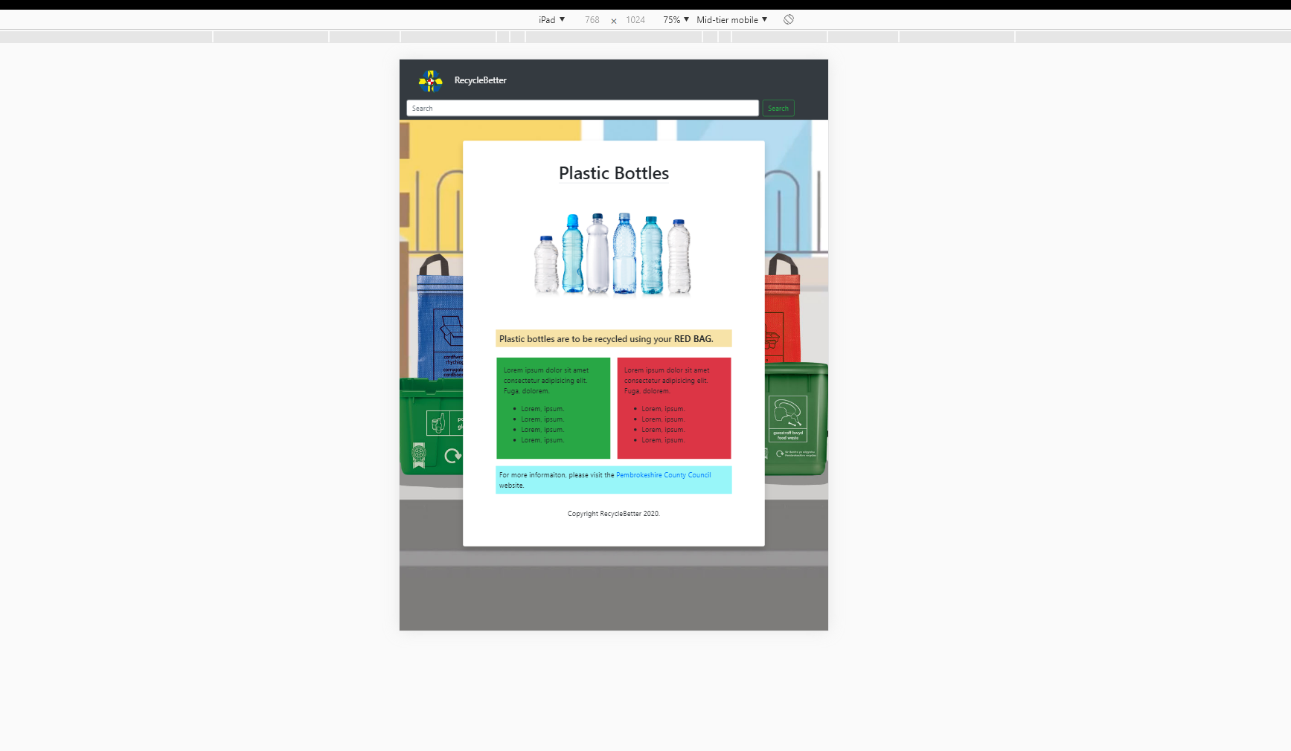

The search function is created using JavaScript. It was designed as follows:
function filterFunction() {
if (document.getElementById("Search1").value.length > 0){
document.getElementById("myDropdown").style.display = "block";
}
else if (document.getElementById("Search1").value.length ==0){
document.getElementById("myDropdown").style.display = "none";
}
var input, filter, ul, li, a, i;
input = document.getElementById("Search1");
filter = input.value.toUpperCase();
div = document.getElementById("myDropdown");
a = div.getElementsByTagName("a");
for (i = 0; i < a.length; i++) {
txtValue = a[i].textContent || a[i].innerText;
if (txtValue.toUpperCase().indexOf(filter) > -1) {
a[i].style.display = "";
} else {
a[i].style.display = "none";
}
}
}
The search engine is created by using drop down features which has its own storage of item names that display once typed into the bar. From there, a page is created for each product and linked to the name of the product on the search engine, so that once it has been clicked, it will direct the user to the product page.

Technical Skills Development
Throughout this project, I have developed various personal skills, which have been used to develop this project. For example, I had little understanding about developing websites using HTML, CSS, and JavaScript. However, I was given the role of lead developer on the prototype, alongside Aaron. The technical skills I used have improved drastically, considering I used them for multiple hours per week. Also, I developed online communication skills by talking to the project group members online, this did not affect the development of the project too much, as it was mainly done in class. However, it was useful to be able to communicate to them online.

Appendices

Reflection
Throughout the Enterprise & Innovation module, I have constantly been developing technical and employability skills, while working within a group. With our project ‘Recycle Better’, we designed and implemented a web application which can be used to improve recycling services in Pembrokeshire. The use of computer systems to develop this application has allowed me to further improve my technical skills. For example, I had little knowledge of web application development. The module has driven me to research development methods and design structures to make a quality product for the end-user. To extend on this point, I had little knowledge about specific programming languages such as Hypertext Mark-up Language (HTML) to format code to display elements on a screen in a specific order. The use of HTML is massive in the web development industry and it almost is not possible to create a full-scale website without implementing the programming language somewhere in a project. Also, other language such as Cascading Style Sheet (CSS) was used to style the HTML code to how I wanted it to appear on the screen. For example, HTML is only used to display elements on the screen, while CSS can be used to change colours, fonts and sizes of text and elements. Now that this module has ended, I have identified a passion for web development, and it is something I want to pursue in the future. Therefore, these skills that I have developed have become a major advantage for when I wish to pursue a career in the field. The Enterprise & Innovation module has also improved my technical writing abilities, as it has required me to document my work from start to finish. I also improved my project management skills, as I was put in a lead developer role, during the development of the prototype. Therefore, I had authority over the decision of which software and technologies our group would use. You could also argue that it improved my software proficiency skills.
The Enterprise & Innovation module has opened my career goals and given me an insight of what it would be like to innovate your own product to sell on the market. So here are some career goals that I am working towards in 2, 5- and 10-years’ time:
2 years – In 2 years I would hope to be a Senior Aircraftsman in the Royal Air Force as a Cyberspace Communications Specialist. Working in the military, you must serve additional duties. Therefore, I would hope that my technical skills are of a standard in which I can teach to other members of the military hoping to learn my trade. For example, the longer you serve, the more learning credits you accrue. Therefore, I would hope to learn a course in web development using those credits, for a discounted price. To achieve these goals, I need to train extremely hard mentally and physically, as it is often perceived as a game during military training. Fitness is already a part of my life, as I have been applying to join the military since December 2019.
5 years – In 5 years I would be working as a higher rank in the Royal Air Force, earning more money, while having explored many parts of the world at this point. The military is a great path to go down if you want to live a nomadic lifestyle. I would hope to have my own residence during this time also.
10 years – In a 10-year timeframe I would hope to have be on my way to innovating my own product and creating a brand for when I want to retire from the military. I would be financially stable and have different streams of income, through market shares and currency trading. I understand that many years of self-study would be needed to achieve this, as I would be learning a new industry. However, completing this degree has given me the discipline to study in my own time.

Networking
Networking is a major part in creating opportunities to enable your career. It gives you the opportunity to meet important people who can provide you with connections with people within your industry. I have pushed for the opportunity by signing up to newsletters and update my LinkedIn profile to maximise these chances of growing my network.

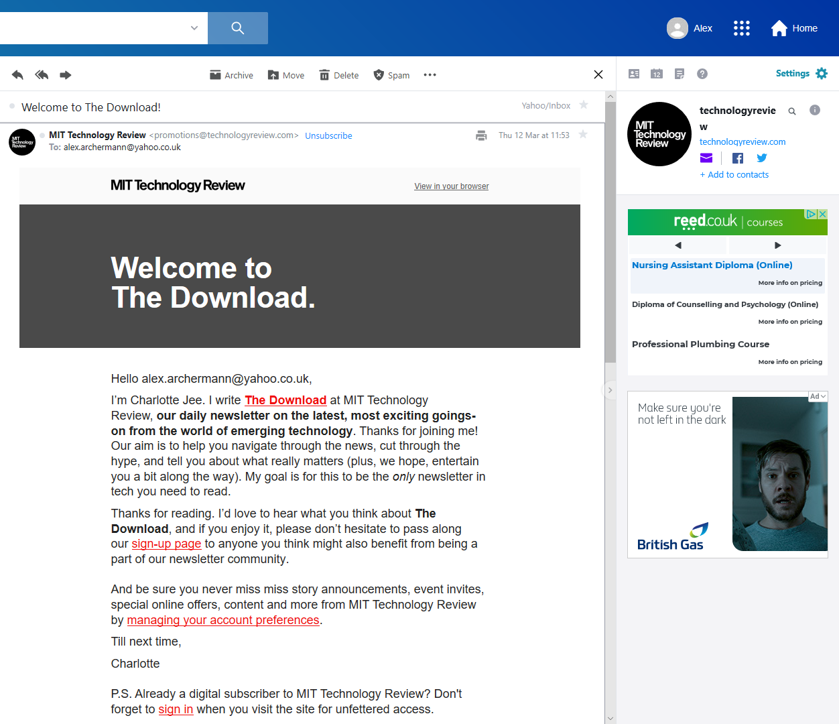
I signed up to The Download newsletter.
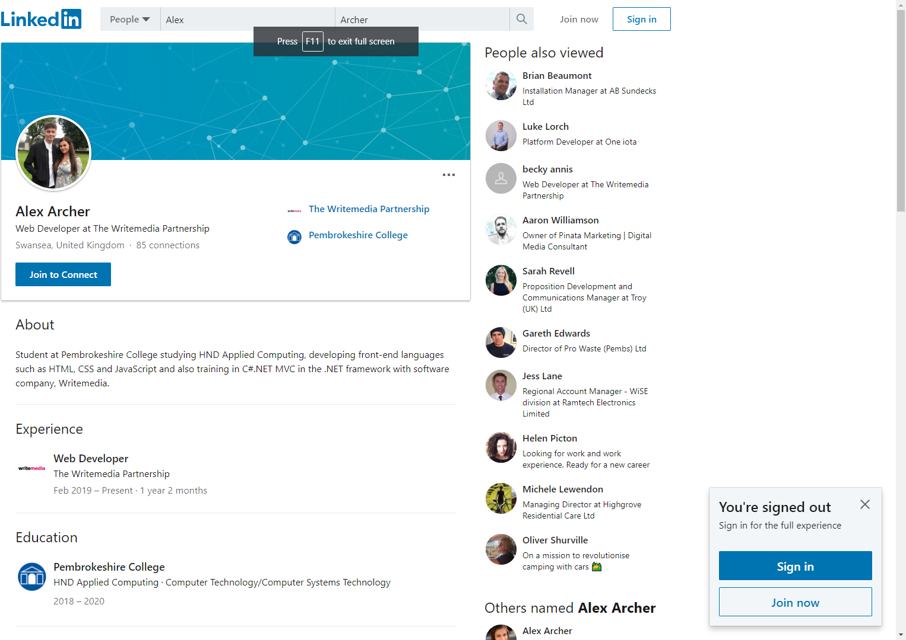
I have also had a LinkedIn account for some time, however, I recently updated my profile to include my current occupation.

Team-working
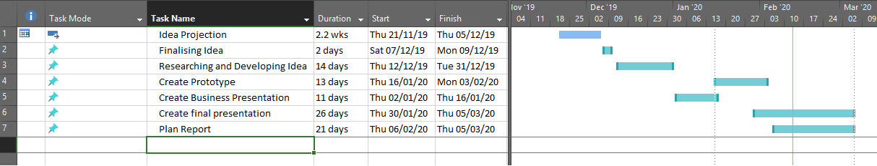
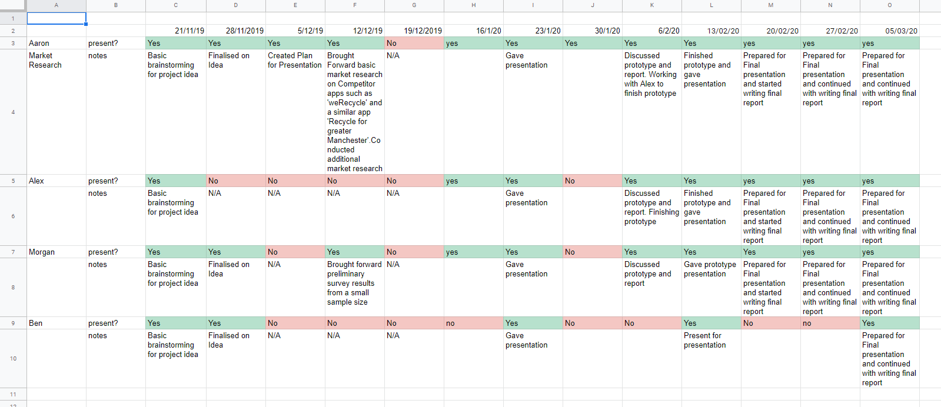

References

[1] | Pembrokeshire County Council, “Kerbside Collection,” 9 Nov 2019. [Online]. Available: https://www.pembrokeshire.gov.uk/kerbside-collection. [Accessed 12 Mar 2020].
[2] | BBC, “Recycling: New Pembrokeshire waste scheme 'too complicated',” BBC, 1 Nov 2019. [Online]. Available: https://www.bbc.co.uk/news/uk-wales-50255600. [Accessed 7 Mar 2020].
[3] | Pembrokeshire County Council, “Waste & Recycling,” 28 Jan 2020. [Online]. Available: https://www.pembrokeshire.gov.uk/waste-and-recycling. [Accessed 12 Mar 2020].
[4] | Crazy Egg, “The 28 Best Homepage Design Examples and Ideas for Your Website,” 19 Feb 2019. [Online]. Available: https://www.crazyegg.com/blog/homepage-design/. [Accessed 10 Mar 2020].
[5] | W3Schools, “HTML Tutorial,” [Online]. Available: https://www.w3schools.com/html/. [Accessed 12 Mar 2020].
[6] | W3Schools, “CSS Tutorial,” [Online]. Available: https://www.w3schools.com/css/. [Accessed 12 Mar 2020].
[7] | Javascript, “READY TO TRY: JavaScript?,” [Online]. Available: https://www.javascript.com/. [Accessed 12 Mar 2020].
[8] | Microsoft, “New features. Updated security. Windows 10 keeps getting better all the time.,” [Online]. Available: https://www.microsoft.com/en-gb/windows/get-windows-10. [Accessed 12 Mar 2020].
[9] | R. Cole, “OPRL CELEBRATES ITS FIRST 10 YEARS,” 12 Feb 2019. [Online]. Available: https://resource.co/article/oprl-celebrates-its-first-10-years-13086. [Accessed 12 Mar 2020].
[10] | Recycle for Greater Manchester R4GM, “Download our free app,” [Online]. Available: https://recycleforgreatermanchester.com/app/. [Accessed 12 Mar 2020].
[11] | Bebat Vzw, “App Store Preview,” Apple, [Online]. Available: https://apps.apple.com/be/app/recycle/id730904895. [Accessed 12 Mar 2020].

