

Computational Modelling of Ballistic Impact

  - ACDB 4007 Physics OME
  - Level 4 Ordnance, Munitions and Explosive Engineering
  - School of Applied Computing

Ellen James

Table of Contents
Table of Figures and Tables 2
1. Introduction 3
2. Methodology 4
3. Results 6
3.1 Cartridge Brass Projectile and AISI – 1045 Medium Carbon Steel Plate 6
3.1.1 Initial Impact 6
3.1.2 Initial Failure 6
3.1.3 Penetration 7
3.1.4 Breakthrough 8
3.1.5 Backplate 9
3.2 Cartridge Brass Projectile and Ti-6AI-4 V Titanium Alloy Plate 9
3.2.1 Initial Impact 9
3.2.2 Penetration 10
3.2.3 Backplate breakthrough 11
3.3 Cartridge Brass and Medium Steel Node Stress Probe 12
3.3.1 93578 Node Due to Fail 12
3.3.2 86648 Node Due to Fail 13
3.3.4 91814 Node Due to Fail 15
3.4 Cartridge Brass and Titanium Node Fail Probe 16
3.4.1 91813 Node Due to Fail 16
3.4.2 90049 Node Due to Fail 17
3.4.3 47634 Node Due to Fail 18
3.5 Time VS Velocity Graph 19
3.5.1 Cartridge Brass and Medium Steel Graph 19
3.5.2 Brass and Titanium Graph 19
3.6 Results Explained 20
4. Discussion 20
5. Conclusion 21
6. References 23

Table of Figures and Tables

Figure 1: Initial impact stress distribution for brass and steel. 7
Figure 2: Initial plate failure stress distribution for brass and steel. 7
Figure 3: Penetration of plate stress distribution for brass and steel. 8
Figure 4 Penetration of plate stress distribution for brass and steel image 2. 8
Figure 5: Breakthrough of plate stress distribution for brass and steel. 9
Figure 6: Full breakthrough of plate stress distribution for brass and steel. 9
Figure 7: Backplate stress distribution for brass and steel. 10
Figure 9: Initial impact of brass and titanium stress distribution. 10
Figure 10: Penetration of brass and titanium stress distribution. 11
Figure 11: Penetration of brass and titanium stress distribution image 2. 11
Figure 12 Penetration of brass and titanium stress distribution image 3. 12
Figure 13: Backplate stress distribution for brass and titanium. 12
Figure 14 Max principal stress probe for node 93578. 13
Figure 15: Shear stress probe for node 93578. 13
Figure 16: Shear stress probe for node 86648. 14
Figure 17: Max principal stress probe for node 86648. 14
Figure 18: Shear stress probe for node 93620. 15
Figure 19: Max principal stress probe for node 93620. 15
Figure 20: Max principal stress probe for node 91814. 16
Figure 21: Shear stress probe for node 91814. 16
Figure 22: Shear stress probe for node 90049. 17
Figure 23: Max principal stress probe for node 91813. 17
Figure 24: Shear stress probe for node 90049. 18
Figure 25: Max principal stress probe for node 90049. 18
Figure 26: Shear stress probe for node 47634 19
Figure 27: Max principal stress probe for node 47634. 19
Figure 28: Velocity vs time graph for cartridge brass projectile and medium steel plate. 20
Figure 29: Velocity vs time graph for cartridge brass projectile and Titanium alloy plate. 20

Table 1: Properties of materials used in this model. 6

Introduction
Ballistic impact modelling is a crucial aspect of defence, aerospace and material engineering. Ballistic impact modelling involves a high-velocity collision between a projectile and a target, which results in being able to formulate potential failures, see complex stress distributions and deformations. Understanding these failures allows enhancements in armour plating, for example, and helps to ensure the safety of military personnel and civilians in the defence sector.
Finite analysis (FEA) tools such as Abaqus allow engineers to simulate these high-velocity impacts to a great degree of accuracy. It allows researchers to study stress wave propagation, energy absorption and failure models.
This report focuses on the computational modelling of high-speed projectiles striking a plate. Two different scenarios are simulated; the projectile is kept the same material throughout and at the same velocity. Whilst the armour plate is made from two different materials.
Using Abaqus, the aim of this study is to investigate how material properties affect stress distributions, particularly direct and shear stresses, and to see the projectile's velocity behaviour over time. This study aims to identify the parameters that contribute to a plate's failure and, therefore, provide insights into the material selection of armour plates and any potential material design improvements.
FEA by Abaqus has been extensively used for ballistic impact modelling and understanding material behaviour in high-velocity conditions. The widely used model in these simulations is the Johnson-Cook model, which uses parameters such as strain rate, thermal softening and strain hardening to predict behaviour and failure of materials [1]. Juan Camilo Osorio-Pinzon used strain hardening, heat softening and strain rates to establish the Johnson-Cook material model constants [1]. From this, the constants were compared to other literature and agreed upon. These constants are vital in determining material deformation and characterising the interaction of a material between strain and stress [1].
Similar studies are Nordendale et al (2013), which used Abaqus to analyse brittle failure in ceramic plates when impacted by steel projectiles and compared the results to actual experimental data [2]. Titanium alloys such as Ti-6A1-4V are often used in armour applications since it is lightweight and have an excellent strength-to-weight ratio[3]. Due to titanium alloys being expensive, studies have been conducted to determine if the low-cost alternative if ATI-425, a titanium-iron alloy, would perform similarly [3]. Like this study, the effects of ballistic impact on titanium and steel were analysed by Shasthri and Kausalyah (2020) using the Johnson-Cook model in a CAE package[4]. The results of this study found that when the titanium plate was used in front of the steel plate that the impact resistance was significantly improved even at higher velocities[4].
While there is extensive research on many materials, with steel being the most common projectile material, there are not many studies on the performance of a cartridge brass projectile like in this study. This is perplexing given that cartridge brass is a popular choice of material for bullets since the late 1800s due to its corrosion resistance, high ductility and formability[5]. Yaqoob et al (2022) do, however, conduct FAE using a cartridge projectile but concentrate on the failure of the projectile and not the plate. The brass projectile was found to crack upon firing, and the optimisation of annealing the material properly was recommended as a corrective measure [5]. This study aims to address the gap in the literature on this subject and provide insight into how material selection affects failure.

Methodology
This section outlines the setup and parameters performed in Abaqus to model a high-speed projectile impacting a plate. Two scenarios were modelled to investigate the influence of target material properties on stress response and failure behaviour.
Both models consisted of a cylindrical projectile of 0.1m in length and a 0.304m² plate. The projectile was positioned in the middle of the plate. The student created the mesh of the projectile and plate. The projectile was meshed fine tetragonal, whilst the plate was hexagonally meshed with a denser mesh at impact and coarser towards the edges of the plate. This was done to capture stress gradients more accurately.
The boundary conditions were set as ENCASTRE on the plate to prevent rotation and movement.
A velocity of 800m/s was applied to the projectile.
Three materials were used in the simulations:
- Projectile: Cartridge Brass 30/70
- Plate 1: AISI-1045 Medium Steel
- Plate 2: Ti-6Al-4V Titanium alloy
Material properties for all three were obtained from the literature and can be observed in the table below. A simple model was used for the projectile, consisting of Density, Young’s modulus and Poisson’s ratio. Whilst the Johnson-Cook plastic and damage model was selected for the plates due to its ability to accommodate for strain rate and temperature behaviour, which is common in impact events. The model for the plate used an equation of state (EOS), the Johnson-Cook damage model, temperature behaviour, and fracture energy, which was set at zero to equate for the damage evolution law.
Each simulation had a max simulation time of 0.001s, which is sufficient to capture the impact.
The output from these simulations will be direct and shear stress distributions, and projectile velocity vs time graphs to analyse deceleration behaviour.

Table 1 Properties of materials used in this model.
Property | Cartridge Brass [6] | AISI – 1045 Medium Carbon Steel [1], [7] | Ti-6AI-4 V Titanium Alloy [1], [8]
Density Kg/m³ | 8800 | 7870 | 4429
Youngs Modulus GPa | 121.8 | 200 | 114
Poisson’s Ratio | 0.35 | 0.29 | 0.33
A Mpa |  | 50.103 | 987.9
B MPa |  | 176.091 | 761.5
n |  | 0.5176 | 0.41433
m |  | 0.5655 | 1.516
Melting temp K |  | 1793 | 1905.5
Transition Temp K |  | 293 | 293
C |  | 0.1056 | 0.01516
Epsilon dot zero |  | 1 | 1
d1 |  | 0.04 | -0.09
d2 |  | 1.519 | 0.25
d3 |  | -6.905 | -0.5
d4 |  | -0.023 | 0.014
d5 |  | 1.302 | 3.87
Fracture Energy |  | 0 | 0

Results

Cartridge Brass Projectile and AISI–1045 Medium Carbon Steel Plate

Initial Impact

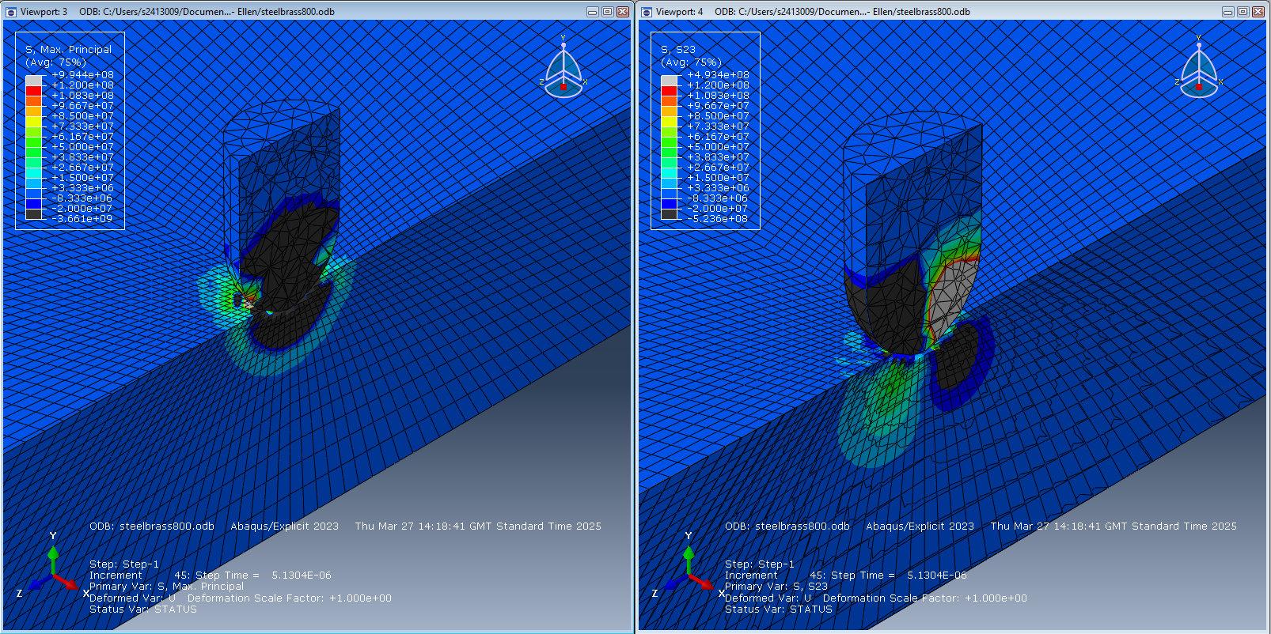
Figure 1 Initial impact stress distribution for brass and steel.

Initial Failure

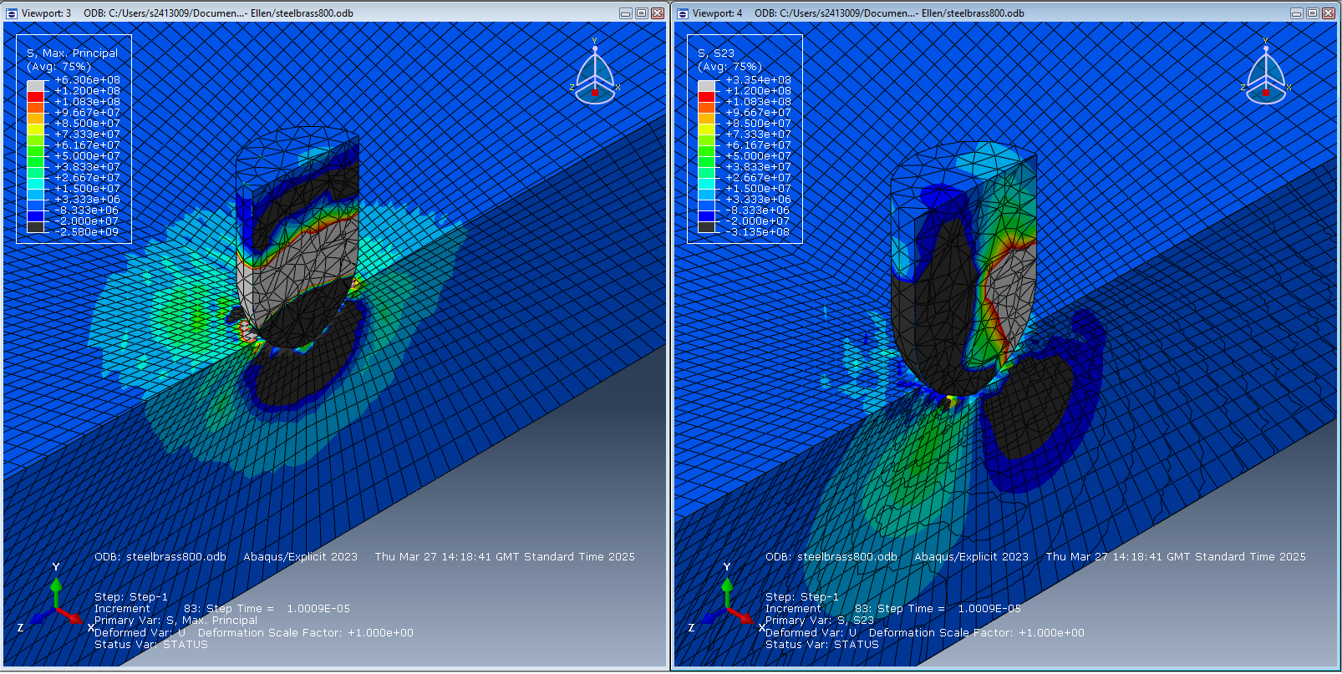
Figure 2 Initial plate failure stress distribution for brass and steel.

Penetration

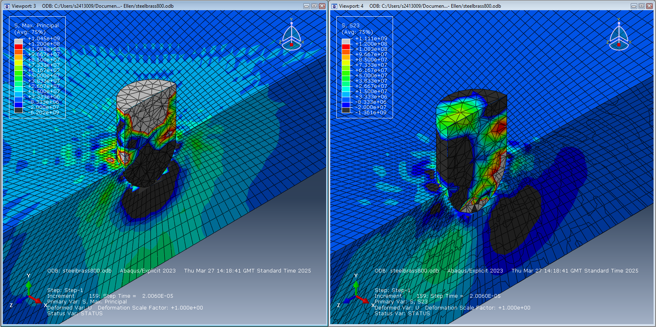
Figure 3 Penetration of plate stress distribution for brass and steel.

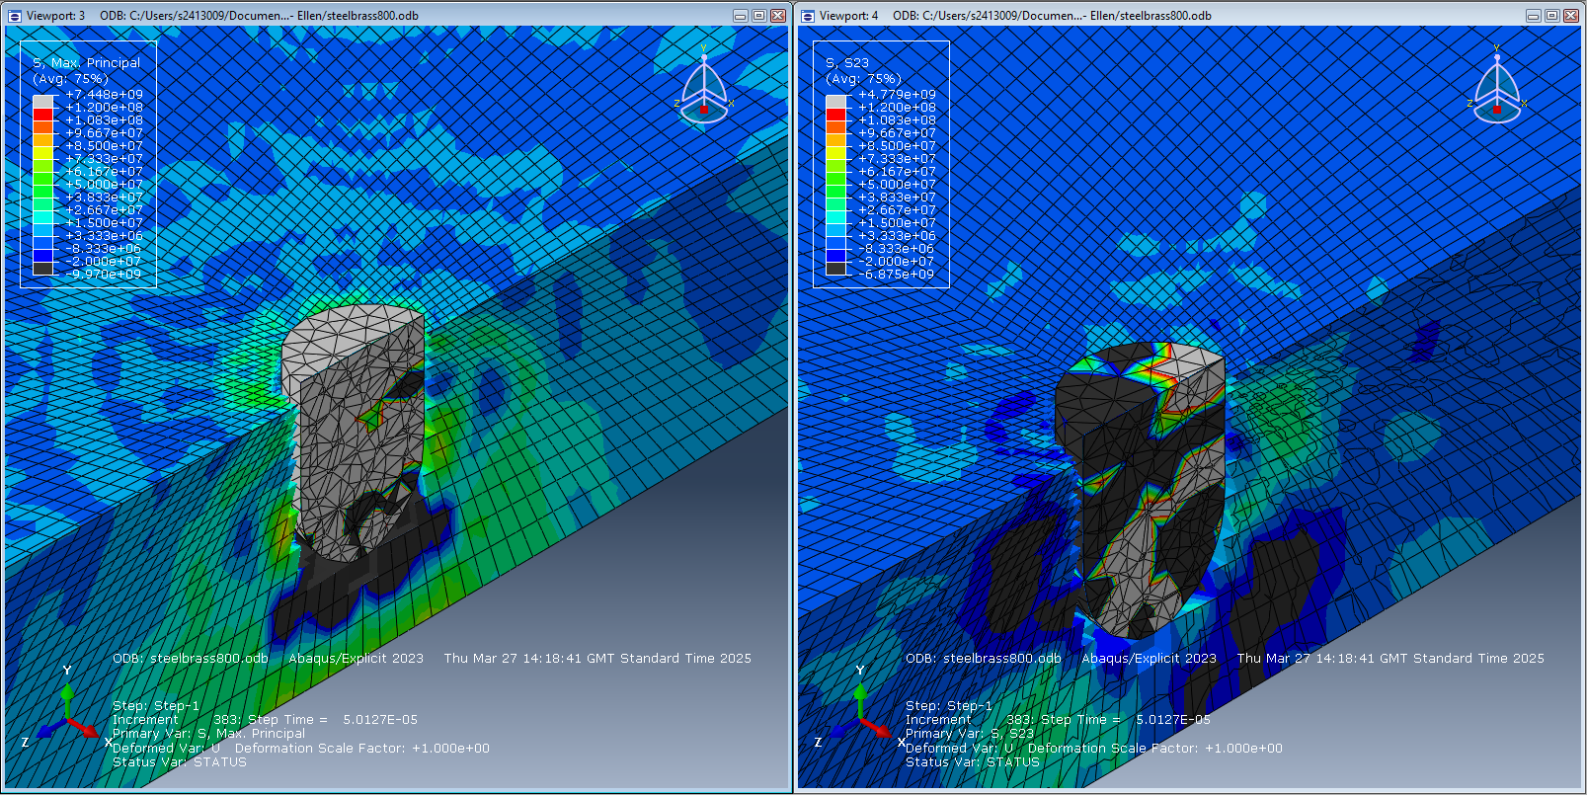
Figure 4 Penetration of plate stress distribution for brass and steel image 2.

Breakthrough

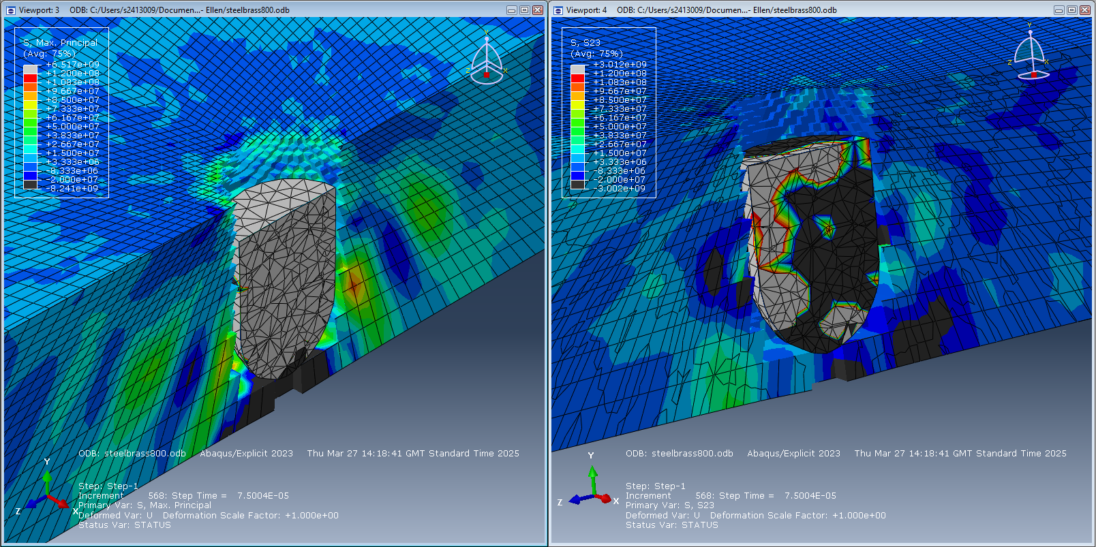
Figure 5 Breakthrough of plate stress distribution for brass and steel.

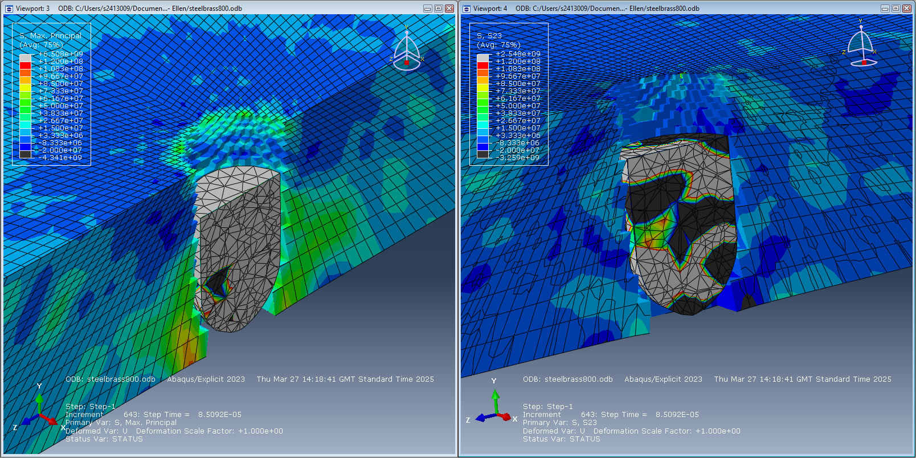
Figure 6 Full breakthrough of plate stress distribution for brass and steel.

Backplate

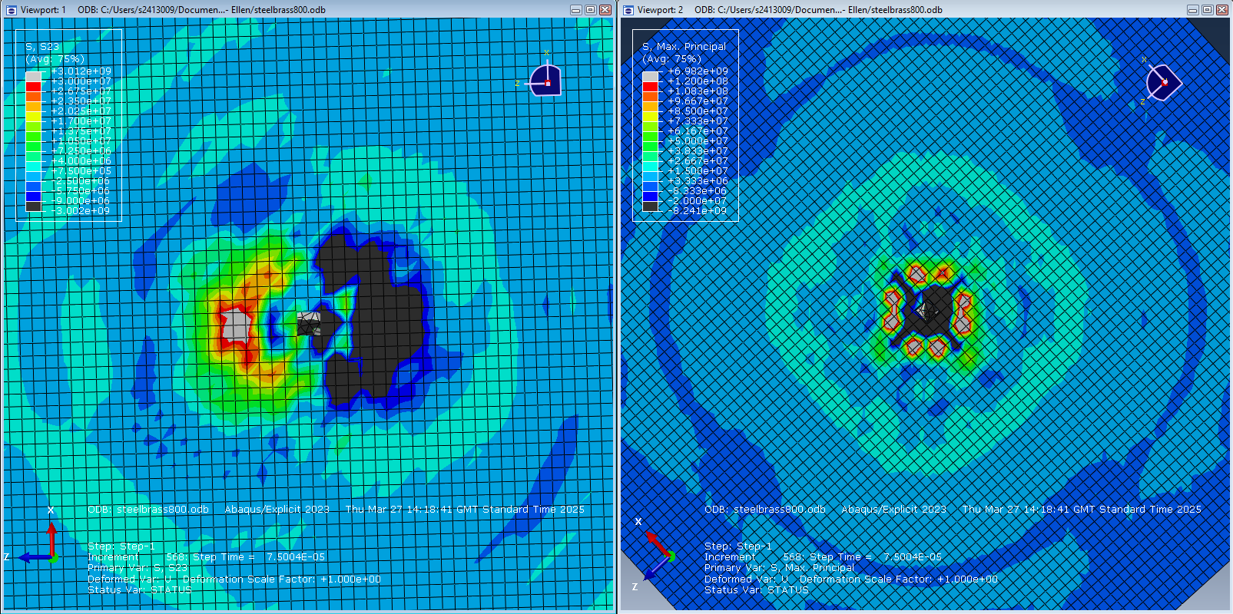
Figure 7 Backplate stress distribution for brass and steel.

Cartridge Brass Projectile and Ti-6AI-4 V Titanium Alloy Plate

Initial Impact

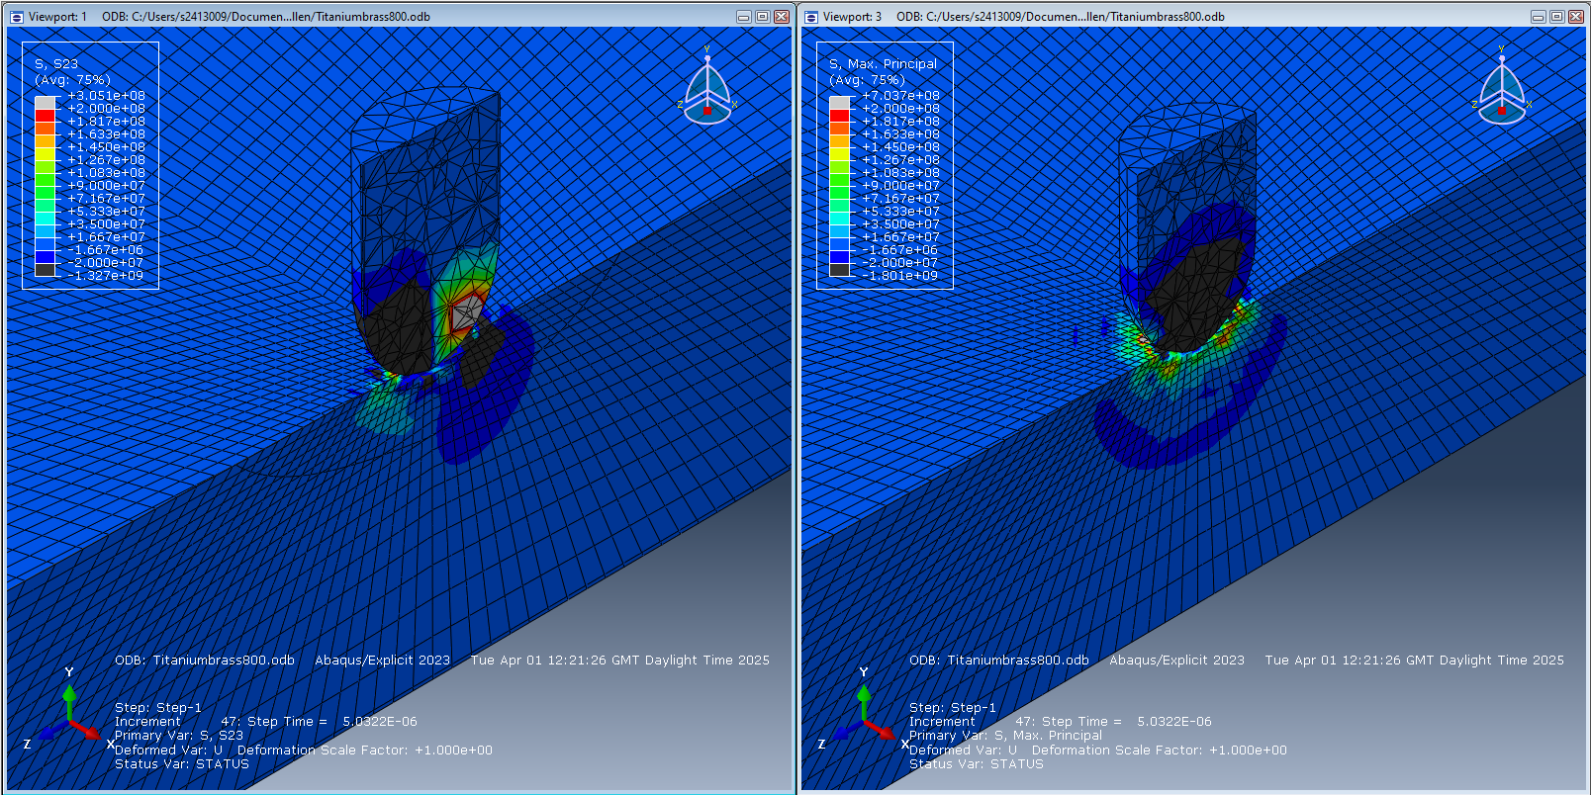
Figure 9 Initial impact of brass and titanium stress distribution.

Penetration

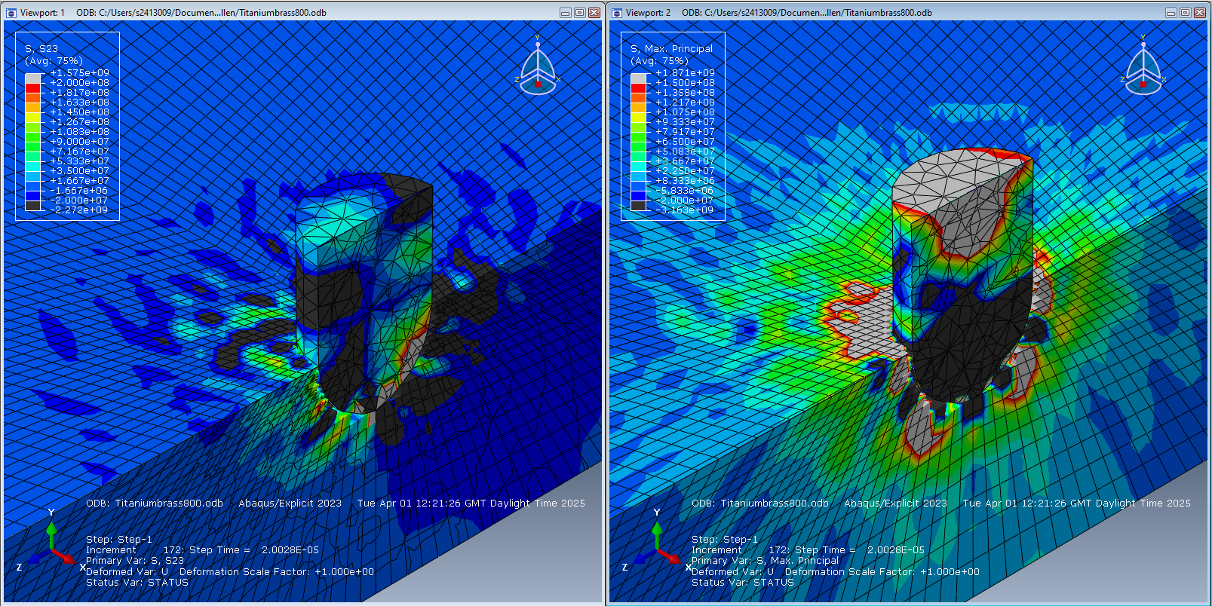
Figure 10 Penetration of brass and titanium stress distribution.

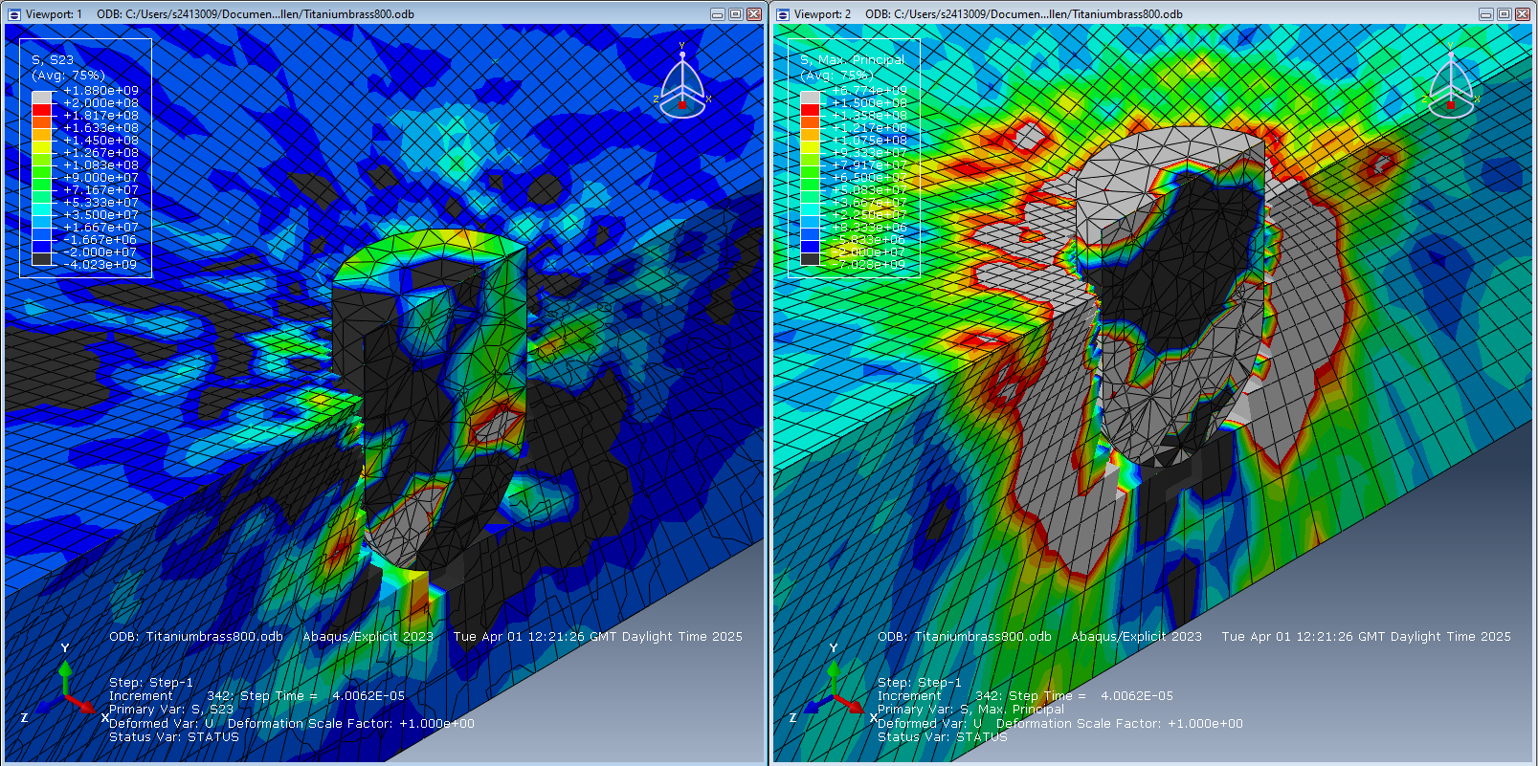
Figure 11 Penetration of brass and titanium stress distribution image 2.

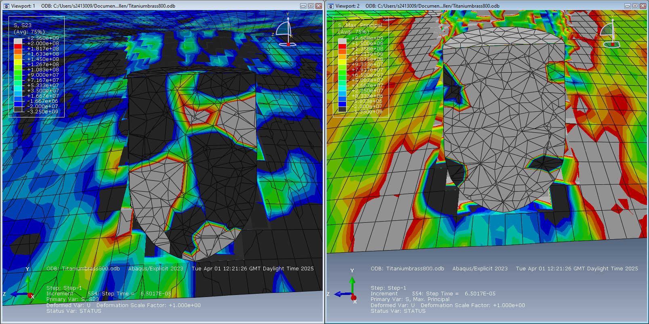
Figure 12 Penetration of brass and titanium stress distribution image 3.

Backplate breakthrough

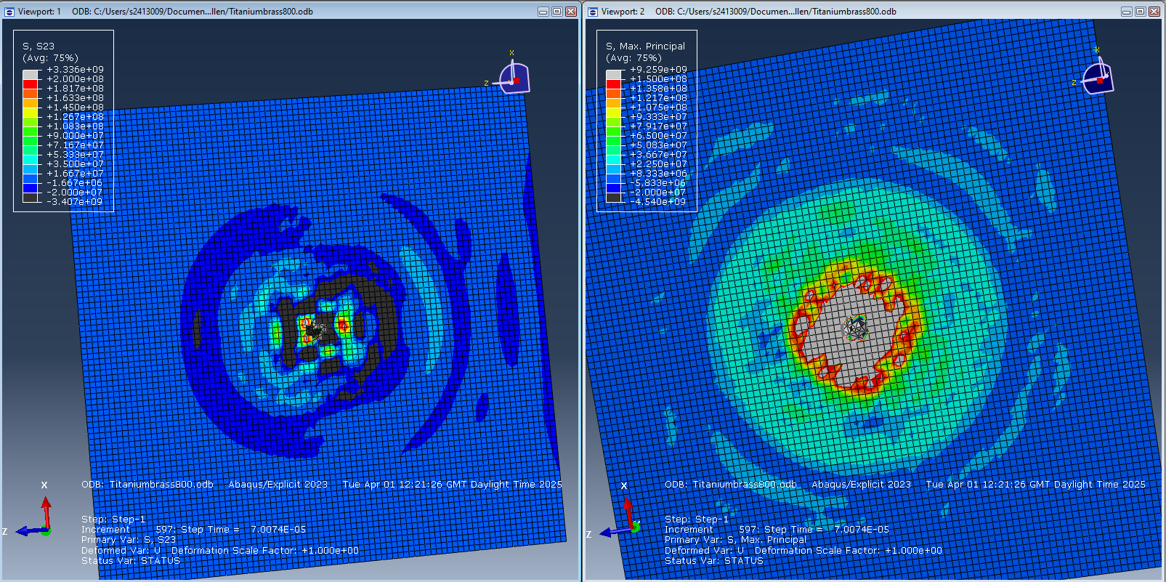
Figure 13 Backplate stress distribution for brass and titanium.

Cartridge Brass and Medium Steel Node Stress Probe

    - 93578 Node Due to Fail
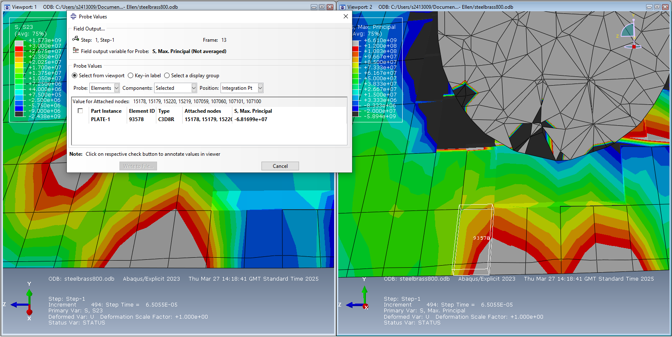
Figure 14 Max principal stress probe for node 93578.

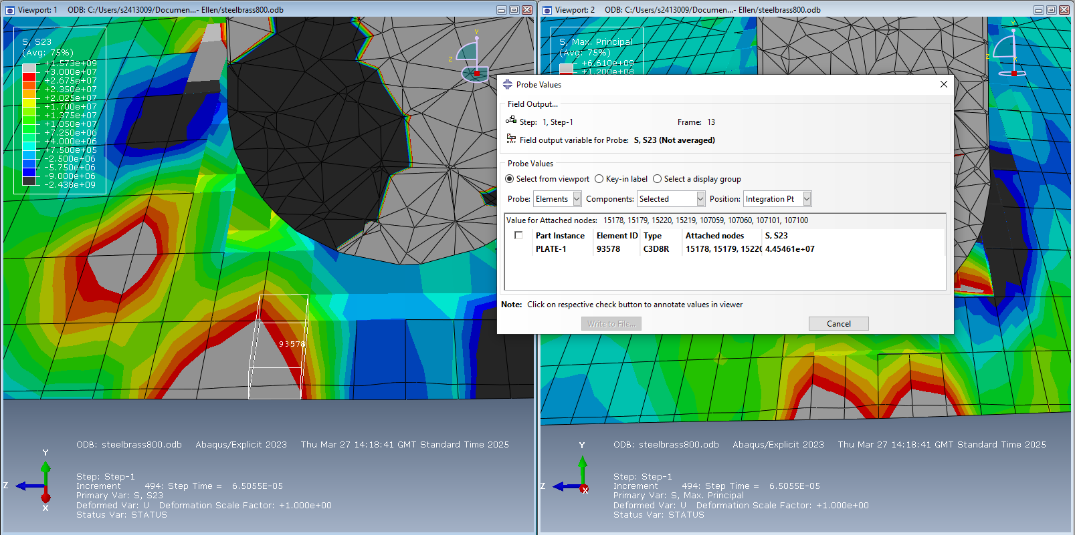
Figure 15 Shear stress probe for node 93578.

    - 86648 Node Due to Fail
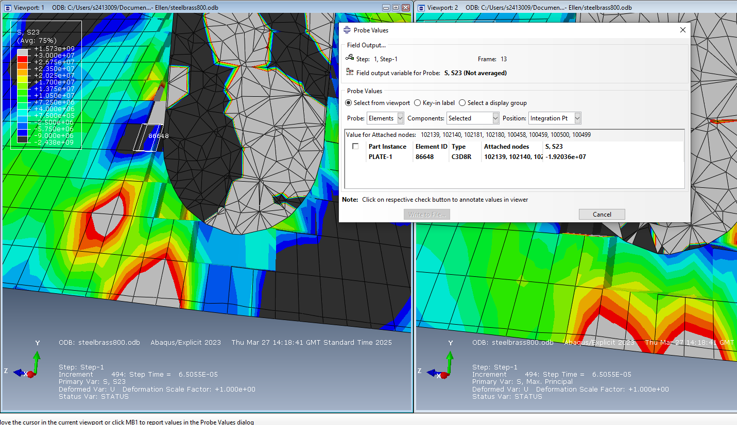
Figure 16 Shear stress probe for node 86648.

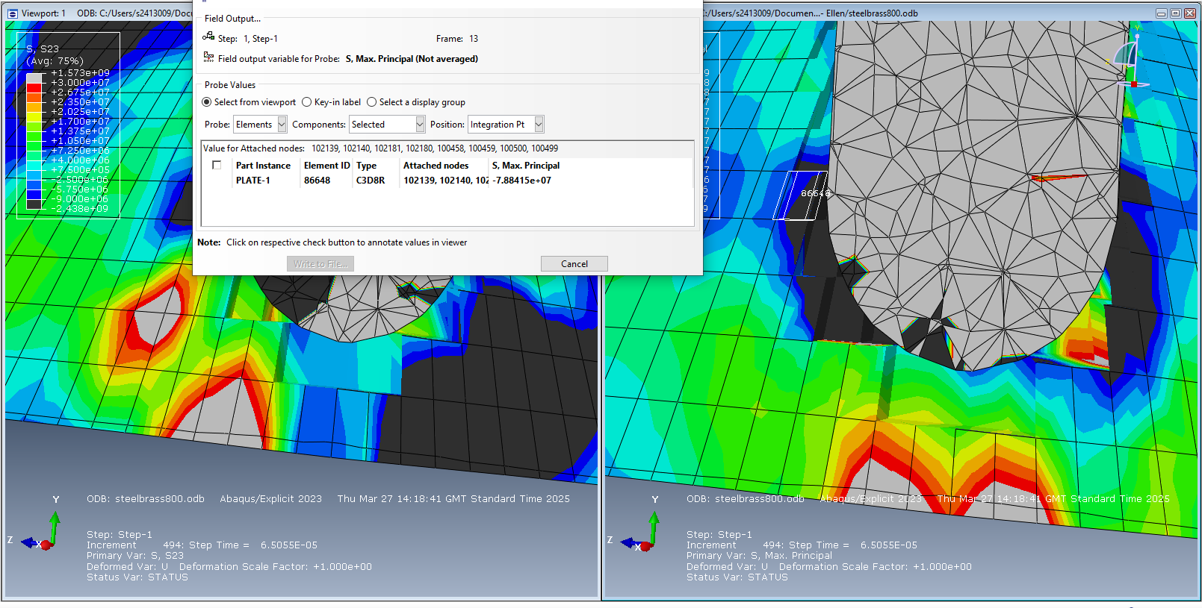
Figure 17 Max principal stress probe for node 86648.

    - 93620 Node Due to Fail
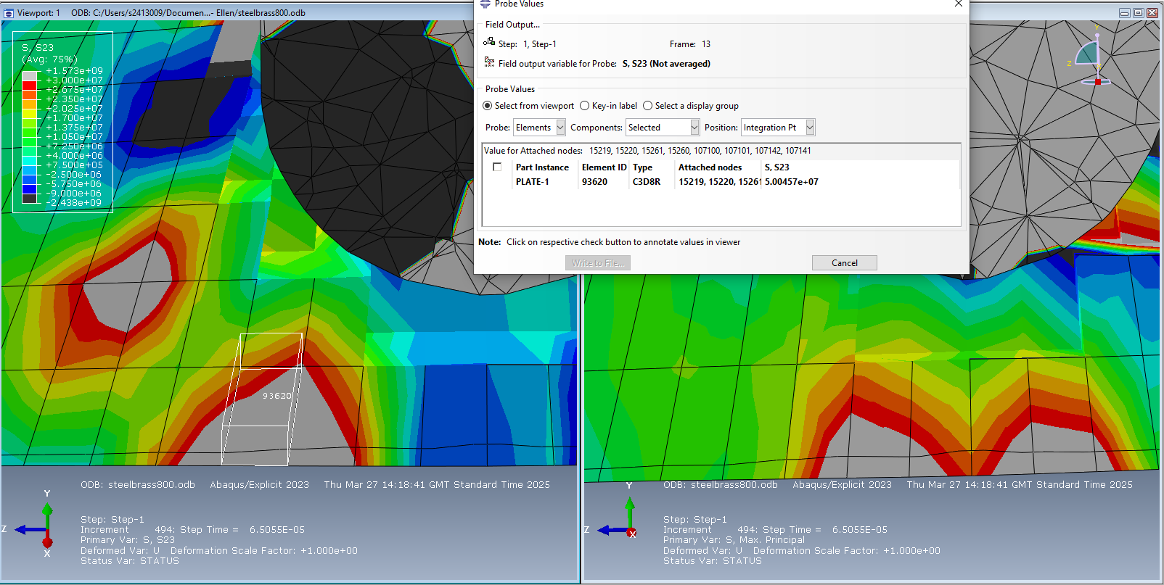
Figure 18 Shear stress probe for node 93620.

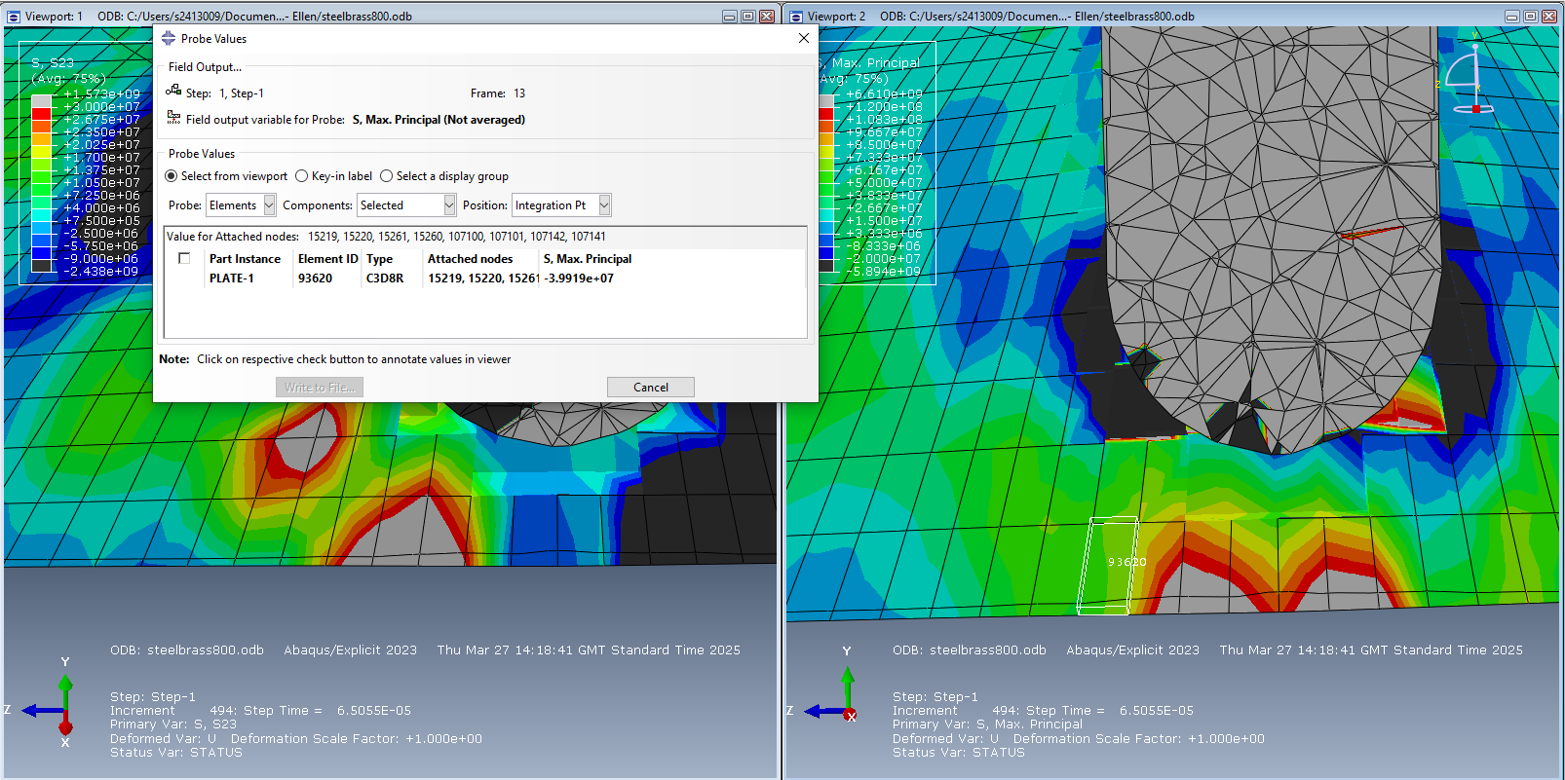
Figure 19 Max principal stress probe for node 93620.

91814 Node Due to Fail
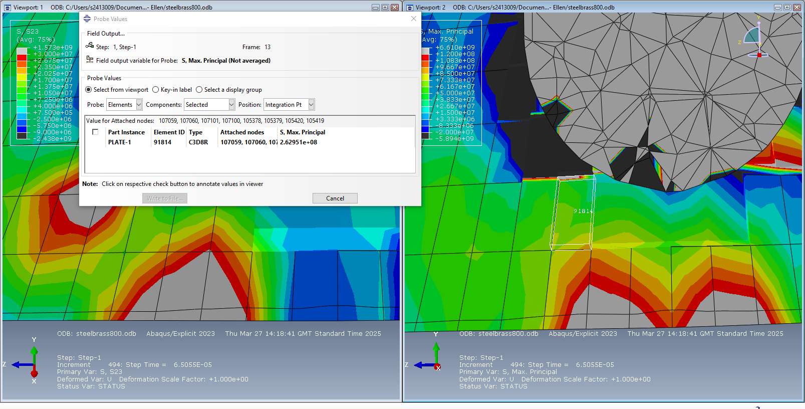
Figure 20 Max principal stress probe for node 91814.

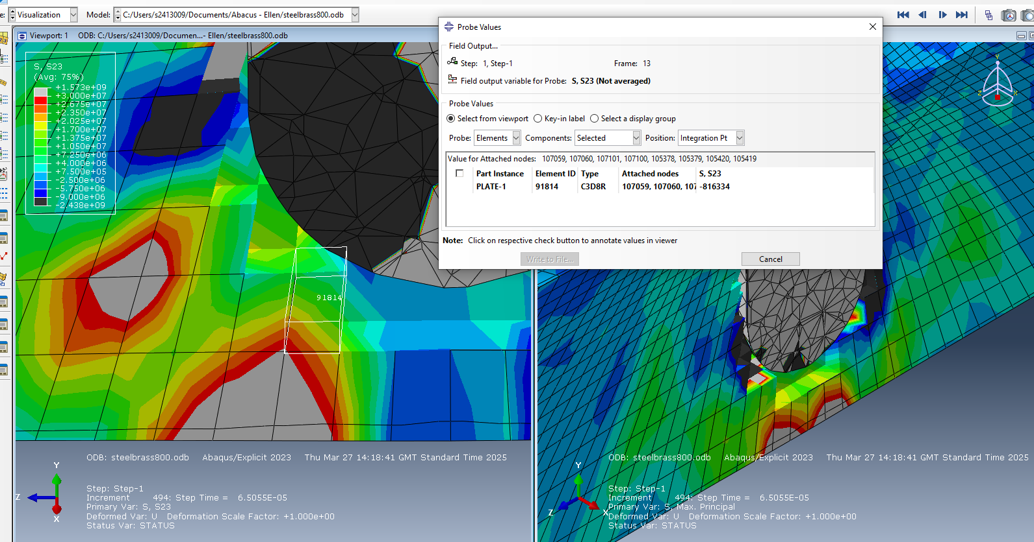
Figure 21 Shear stress probe for node 91814.

Cartridge Brass and Titanium Node Fail Probe

    - 91813 Node Due to Fail
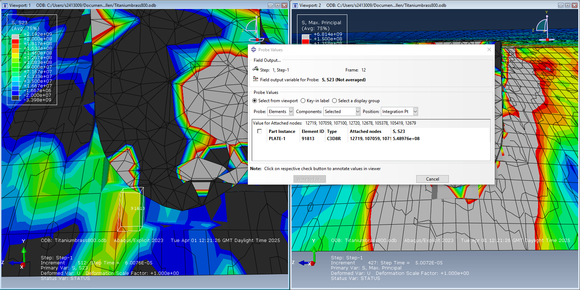
Figure 22 Shear stress probe for node 90049.

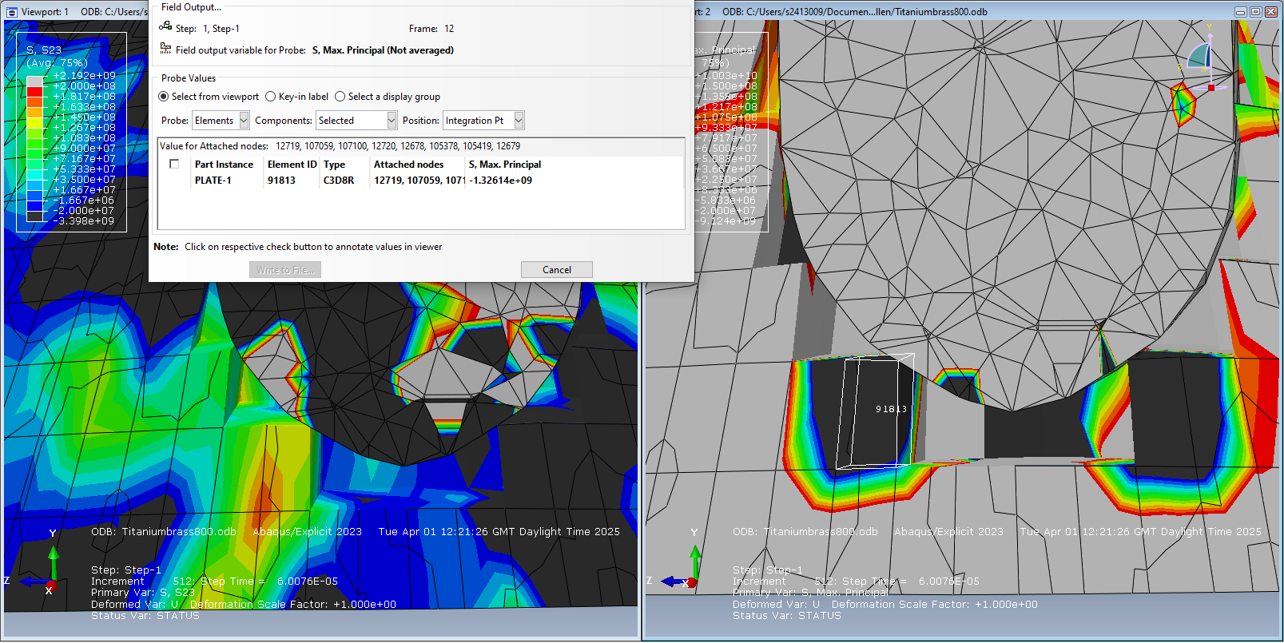
Figure 23 Max principal stress probe for node 91813.

    - 90049 Node Due to Fail
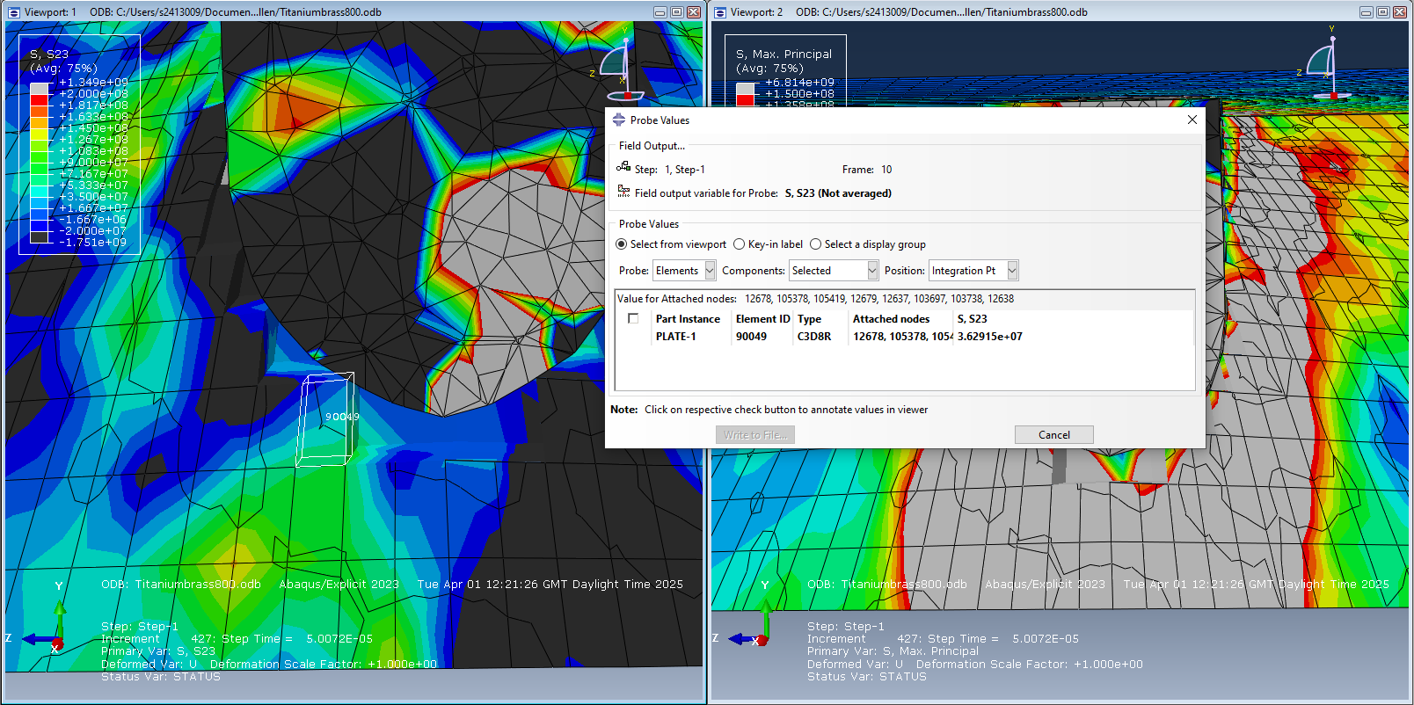
Figure 24 Shear stress probe for node 90049.
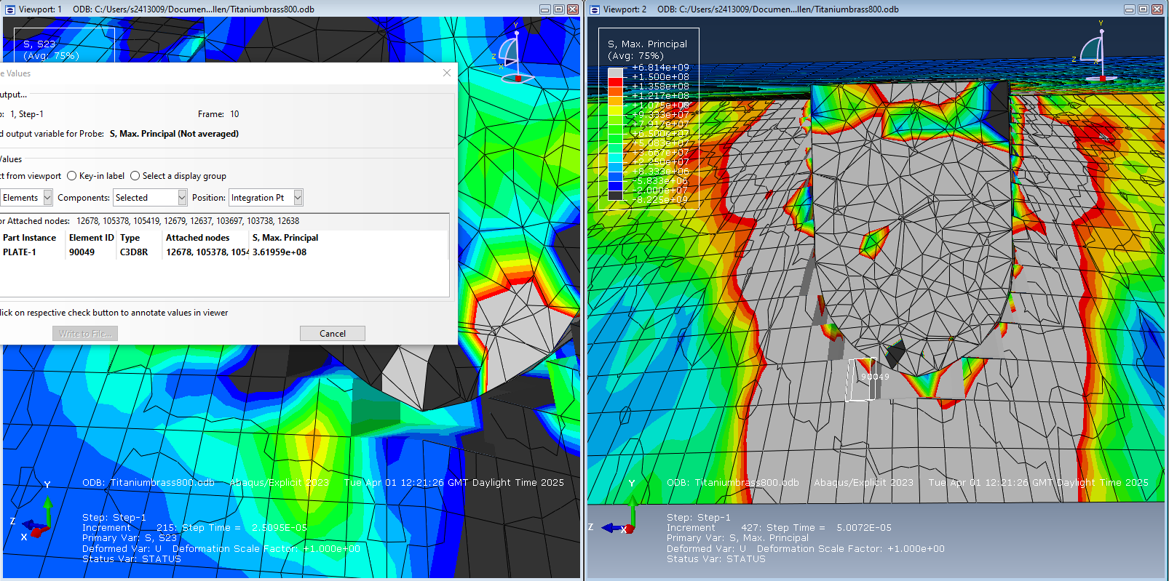
Figure 25 Max principal stress probe for node 90049.

    - 47634 Node Due to Fail
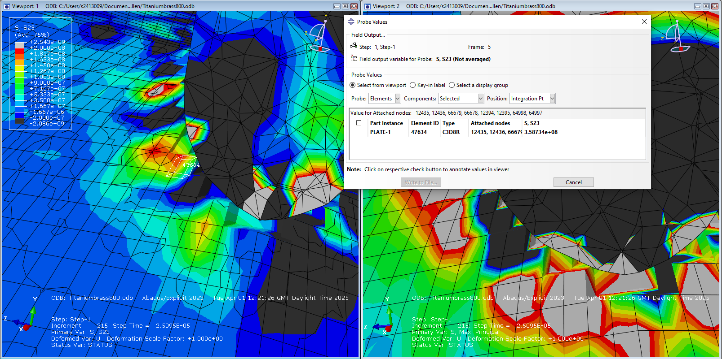
Figure 26 Shear stress probe for node 47634

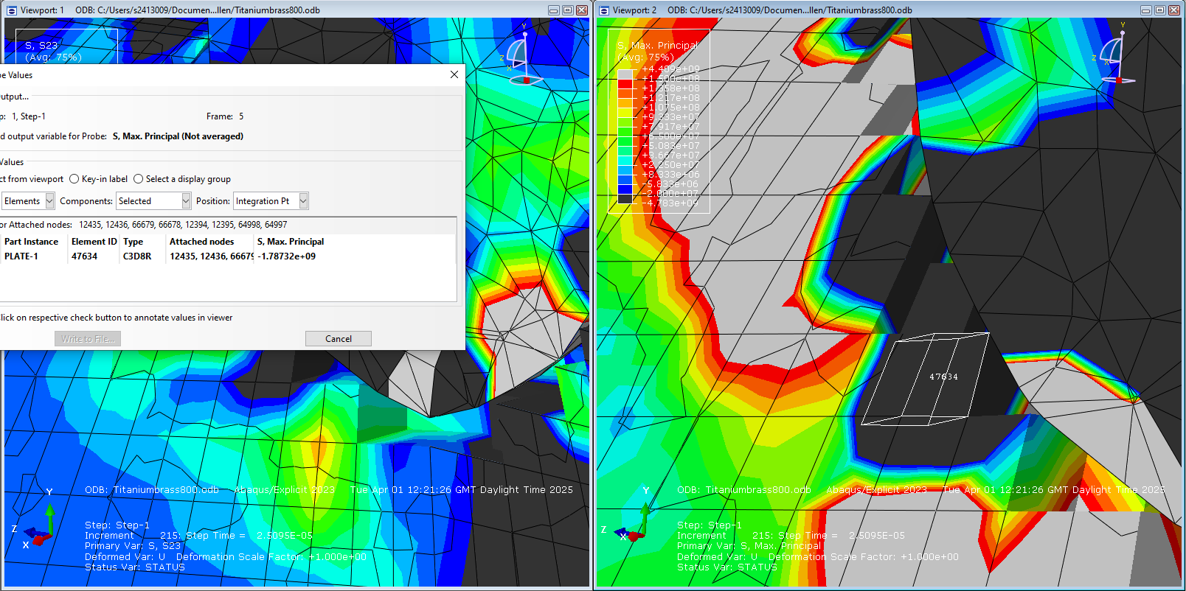
Figure 27 Max principal stress probe for node 47634.

Time VS Velocity Graph

Cartridge Brass and Medium Steel Graph

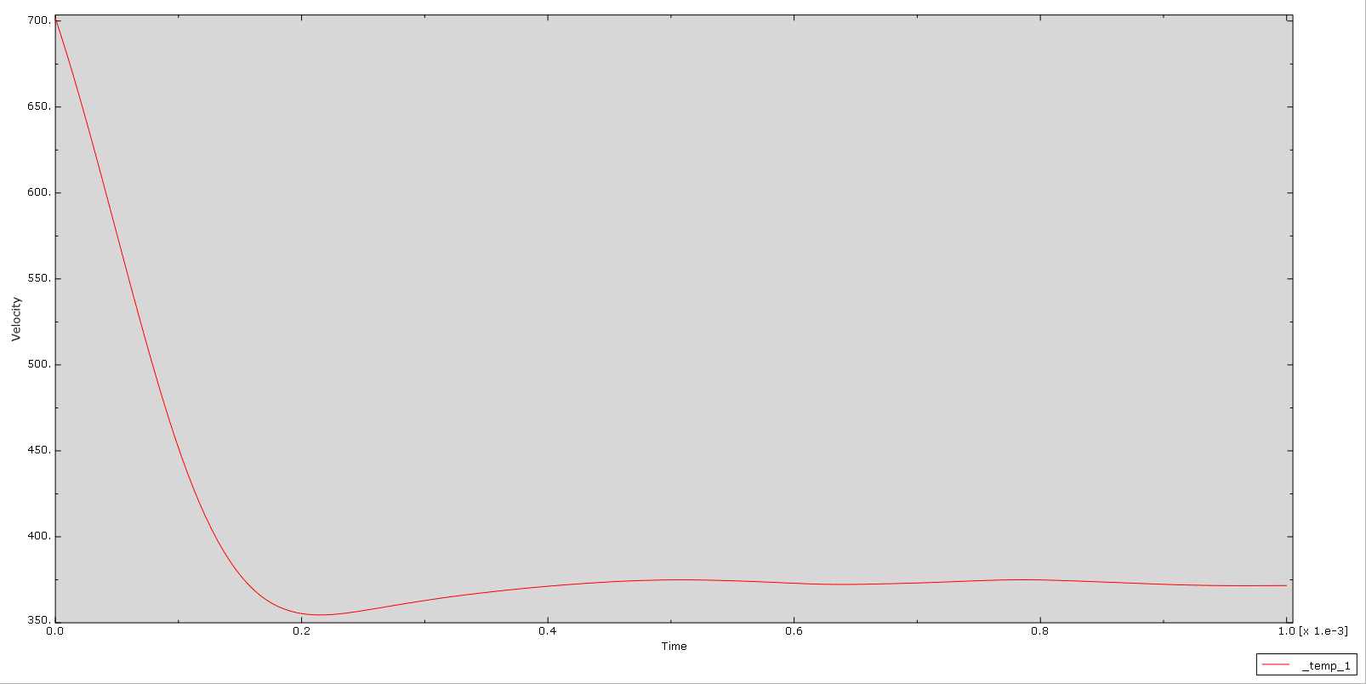
Figure 28 Velocity vs time graph for cartridge brass projectile and medium steel plate.

Brass and Titanium Graph

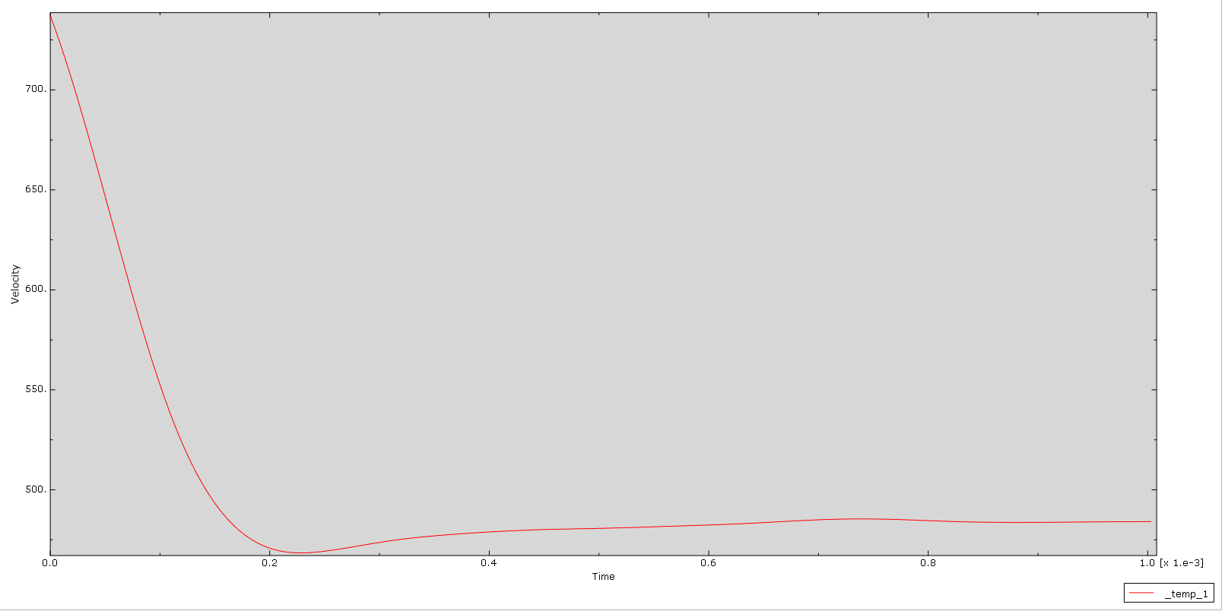
Figure 29 Velocity vs time graph for cartridge brass projectile and Titanium alloy plate.

Results Explained
The projectile exhibited rapid deceleration from 700m/s to around 350m/s within the first 0.2s of impact with the steel plate. The maximum principal stress during initial impact was compression stress at -3.66x10⁹ Pa and shear stress peaked at 5.24x10⁸ Pa. During penetration, compression stress peaked at -9.97x10⁹ Pa and shear stress peaked at 6.87x10⁹ Pa. At the initial breakthrough of the plate, the peak stresses were -8.24x10⁹ Pa for compression and 3.00x10⁹ Pa for shear stresses.
In comparison, the brass projectile exhibited a steeper deceleration from 750m/s to near dead stop, just longer than 0.2s in the titanium plate. The titanium plate showed lower compression stress at initial impact at 1.67x10⁶ Pa and much higher tensile stress of 7.17x10⁷ Pa. The sheer stress peak at initial impact was 1.33x10⁹. During penetration, the titanium plate exhibited a wider stress distribution than the steel plate, which contrasts with the initial impact stress distribution being a much smaller area. The maximum compression strength was 7.03x10⁹ Pa and the maximum shear stress was 4.02x10⁹ Pa.
When probing nodes for the cause of failure. The steel plate showed largely compression favourability at a maximum of -2.62x10⁸ Pa, but one node did show a higher shear stress at 5.00x10⁸ Pa. The titanium plate failing nodes showed a mixture of high tensile stress at 3.62x10⁸ Pa and compression stress at -1.7x10⁹ Pa compared to the shear stress at 3.9x10⁷ Pa.

Discussion
Figures 27 and 28 show the results of the velocity of the projectile versus time in the steel and titanium plates. The projectile in the titanium plate has a slightly steeper gradient compared to the steel plate, indicating that the projectile experienced a slightly faster rate of deceleration, and the projectile was also slowed down to a near stop compared to the steel plate, which slowed the projectile down to around 350m/s. This would imply that the titanium plate has a stronger impact force and absorbs almost all the projectile's kinetic energy. The slight increase in velocity after 0.2s in both graphs indicates that the projectile experienced a reduction in resistance after breaking through and continued into free space.
Generally, in both plates sheer stress is very high. There is no widening of the hole at the backplate, and the sheer stress in both cases does not radiate downward and outwards. This would therefore suggest that it is unlikely that the plates experienced Hertzian conical fracturing.
In terms of compression and tensile stress, the titanium plate experiences more of a radial stress distribution with tensile stress surrounding the impact zones at a peak of 6.77x10⁹ Pa. The steel plate, however, peaks slightly higher at -7.09x10⁹ Pa and displays this compression stress more concentrated directly below the impact site. This indicates a more localised deformation. The titanium plates' broader stress distribution could imply that it has greater energy absorption and ductility, which would be consistent with titanium’s material properties.
Sheer stress also differs significantly. The steel plate again shows high localised shear stresses, which could indicate concentrated material failure. Whereas the titanium plate experiences significantly higher peak shear stresses, these are, like the principal stresses, more evenly distributed around the impact region. This would indicate a wider plastic flow rather than immediate failure.
These conclusions would therefore indicate that titanium offers a better resistance to ballistic impact by absorbing more impact energy and delaying localised failure.
Further results when probing exact nodes due to fail support the findings in the graphs and images. In figures 13-16 and 19-20, the steel plate exhibits higher compression stress than shear stress, indicating that those nodes failed due to compression stress. However, figures 17/18 show a node failing due to shear stresses. For the titanium plate, the probed nodes in figures 21 to 26 show a mixture of nodes failing due to very high compression and tensile strengths compared to shear stress. These results therefore indicate that the steel plate succumbed largely due to compression and shear stresses, whereas the titanium plate nodes failed due to much higher tensile and compression stresses.

Conclusion

This study investigated the ballistic impact behaviour of two target plates: AISI–1045 Medium Carbon Steel and Ti-6AI-4 V Titanium Alloy, using a cartridge brass projectile. Using Abaqus, two simulations were used to analyse stress distribution, material behaviour and projectile deceleration under high-velocity conditions.
The results showed that the titanium alloy showed a broader stress distribution and a higher shear resistance compared to the steel, which showed localised stresses. Maximum principal stress of compression and tensile stresses, and shear stresses were recorded for both simulations, and it was found that the titanium alloy plate underwent higher stresses than the medium steel plate. The projectile's velocity vs time graphs for both simulations indicated that the titanium alloy experienced a faster rate of deceleration and almost succeeded in terminating the path of the projectile.
Failure behaviour differed between the two plates despite the projectile fully penetrating both plates. The findings suggest that the titanium alloy plate failed due to a broadly distributed tensile and compression stress, whereas the medium steel plate displays failure due to localised compression and shear stresses. This suggests that the titanium alloy plate offers better ballistic impact resistance and energy absorption.
Overall, the study demonstrated that material selection in high-velocity impact scenarios is crucial in the defence industry. These results largely align with the similar studies of Shasthri and Kausalyah (2020).

Potential limitations and further work on this study could include:
Only a cylindrical projectile was used. Different shapes and materials could be explored.
The two plate materials only represent a small selection of armour plate options, and therefore, the plate materials could be expanded.
Only the Johnson-Cook model was used, and therefore, alternative models which use different laws, such as the Johnson-Holmquist damage model for brittle materials, could be used if using a ceramic plate, for example.
A better mesh could be explored, and or more calibrated elements to capture better simulation results.
All impacts were perpendicular to the plate, and exploring oblique shots or different spins could change the failure model or penetration depth.
The simulations could also be running for a longer timeframe to potentially capture backplate deformation or projectile fragmentation.

References

[1] V. Kumar Reddy Sirigiri, V. Yadav Gudiga, U. Shankar Gattu, G. Suneesh, and K. Mohan Buddaraju, ‘A review on Johnson Cook material model’, Mater. Today Proc., vol. 62, pp. 3450–3456, Jan. 2022, doi: 10.1016/j.matpr.2022.04.279.

[2] N. Nordendale, W. Heard, and P. Basu, ‘Modeling of High-Rate Ballistic Impact of Brittle Armors with Abaqus / Explicit’, 2013. Accessed: May 11, 2025. [Online]. Available: https://www.semanticscholar.org/paper/Modeling-of-High-Rate-Ballistic-Impact-of-Brittle-Nordendale-Heard/9d7cd58bb66133cb354119222c09427ef0841b6a#citing-papers

[3] G. Sukumar et al., ‘A comparative study on dynamic deformation and ballistic impact response of Ti–4Al–2.5V–1.5Fe–0.25O and Ti–6Al–4V alloys’, Mater. Sci. Eng. A, vol. 889, p. 145727, Jan. 2024, doi: 10.1016/j.msea.2023.145727.

[4] ‘(PDF) Effect of ballistic impact on Ti6Al-4V titanium alloy and 1070 carbon steel bi-layer armour panel’, ResearchGate, May 2025, doi: 10.1108/IJSI-09-2019-0095.

[5] K. Yaqoob, F. Hashmi, and W. Hassan Tanveer, ‘Failure analysis of cartridge brass shell’, Eng. Fail. Anal., vol. 138, p. 106325, Aug. 2022, doi: 10.1016/j.engfailanal.2022.106325.

[6] A. Bracq, J.-S. Brest, J. A. de Sampaio, F. Moitrier, and Y. Demarty, ‘Characterization and modelling of the mechanical behaviour of metal rings: Application to a brass bullet jacket’, Forces Mech., vol. 4, p. 100030, Oct. 2021, doi: 10.1016/j.finmec.2021.100030.

[7] M. Murugesan and D. W. Jung, ‘Johnson Cook Material and Failure Model Parameters Estimation of AISI-1045 Medium Carbon Steel for Metal Forming Applications’, Materials, vol. 12, no. 4, Art. no. 4, Jan. 2019, doi: 10.3390/ma12040609.

[8] C. Salame, R. Bejjani, and P. Marimuthu, ‘A better understanding of cryogenic machining using CFD and FEM simulation’, Procedia CIRP, vol. 81, pp. 1071–1076, Jan. 2019, doi: 10.1016/j.procir.2019.03.255.

