

Module Name: Digital Skills for Personal Development and Business Growth
Module Code: BMSW4008
Assignment Name: An Ostrich Dream Sanctuary
Student Name: Mihaela Miculescu
Student Number: 2422449
Lecturer: Muhammad Cassamo
Word count: Task 1 – 1096
Word count: Task 2 - 807

AI Acknowledgement
I confirm that I have not presented any AI generated materials as my own work.
I confirm that I have copies of my drafts, notes, and other resources I used, which I may be asked to provide in evidence.

Task 1
Introduction:
This report presents deep analysis on a questionnaire, recently conducted to find out the customers thoughts about the development of an Ostrich farm. The passion for animals and environment inspired the creation of this project, aiming to foster awareness and education about biodiversity and sustainability in an engaging way (Trodd, 2013). The aim of the survey was to better understand the needs and the preferences of the visitors, regarding the prices, the ticket options and the level of comfort around the big birds. This type of information is crucial in shaping the concept of the business with the web page, marketing strategy and public segmentation. Incorporating visual data and academic references this report interprets the key tendency’s and discusses the implication. Young (2021) notes that "a clear alignment between mission and operations is vital for sustainability,"
- Public interest in Ostriches and its significance
Key Findings:
- Interest Level: 87% of respondents expressed a desire to learn more about ostriches (46 out of 53), while only 13% were not interested (7 out of 53).
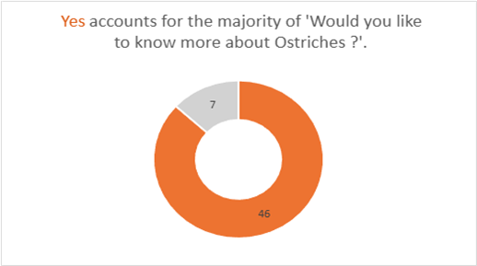
Implication:
This high level of curiosity indicates a strong potential market for educational and experiential tourism about ostriches. The enthusiasm suggests that the business should prioritize informative content, interactive experiences, and educational tours. The interest aligns with current trends in ecotourism and experiential travel, which emphasize learning and connection with nature (Marvell, 2002).
Influence on business concept:
- Focus on educational programs, guided tours, and interactive exhibits.
- The flyer distribution and word of mouth can help getting more customers.
- The following is a flyer with a business card (Canva).
- Incorporate storytelling and multimedia content to increase visitor engagement.

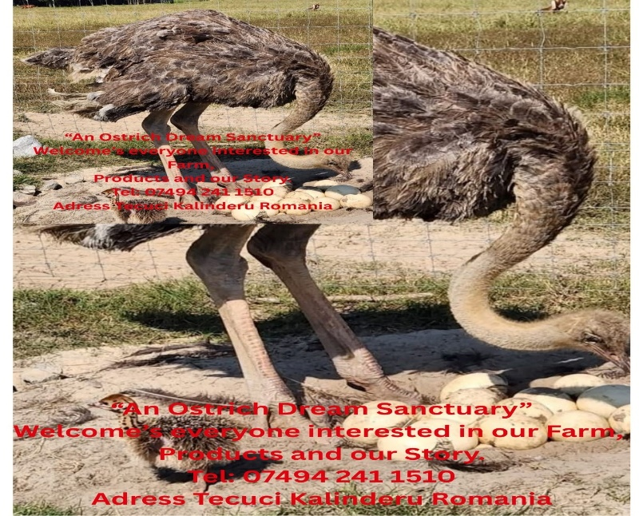



Impact on website design:
- Important feature sections on ostrich facts, videos, and testimonials. Create an attractive homepage that shows the educational aspect, encouraging visitors to explore further.
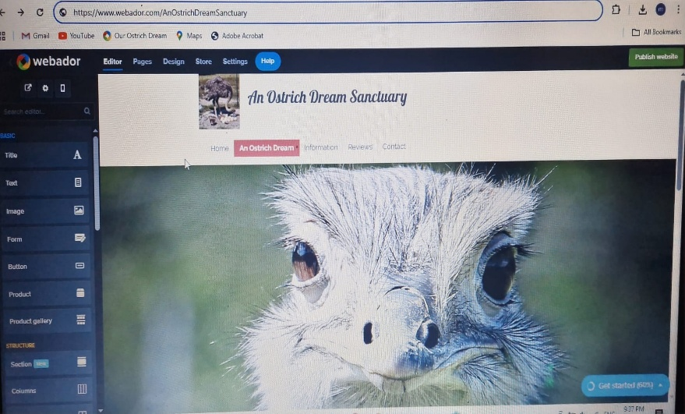
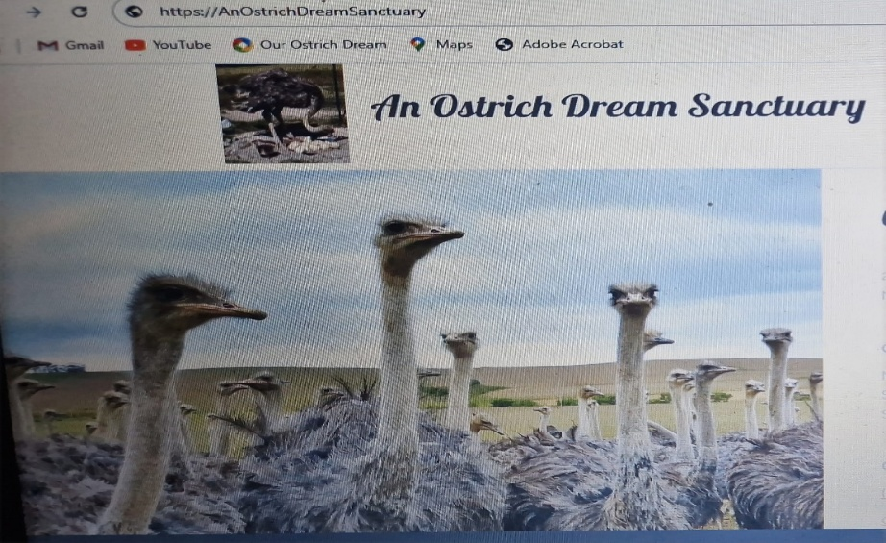

Travel Distance and Price Preferences
Key Findings:
- Availability to Travel: Preferred travel time is the longest (30-60 minutes) (although exact data is not fully detailed).
- Price expectations:
- £8-10 per adult ticket: 14 respondents
- £5-7: 8 respondents
- £11-15: 4 respondents
- Over £15: 2 respondents

Implications:
- Visitors are generally willing to travel within an hour, indicating a regional coverage area.
- The preferred ticket price range (£5-10) suggests price sensitivity but also demonstrates that visitors are willing to pay a moderate fee for a worthwhile experience.
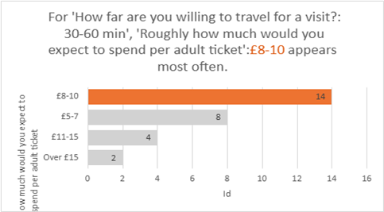

Influence on business concept:
- Position prices in the £5-10 range to attract budget-conscious visitors while maintaining profitability.
- Offer levelled ticket options, such as standard admission and premium experiences, to reach for different segments of willingness to pay.
Impact on marketing materials:
- Highlight affordability and value for money in promotional content.
- Emphasize convenient location and accessibility.
- Hooley et al. (2020) advocate that marketing strategies should incorporate digital platforms to effectively reach target audiences, especially families seeking eco-friendly experiences
- Ticket options and pricing strategy
Key Finding:
- Most prefer pay-per-visit tickets, indicating a preference for simple, single-entry options over passes or subscriptions.
Implications:
- This preference simplifies ticketing operations and aligns with casual, leisure-oriented visitors. It also supports a marketing strategy that encourages one-time visits, special events, or seasonal promotions.
Influence on website design:
- Clear buttons for online ticket booking.
- Detailed descriptions of ticket types and prices to avoid hesitation in buying the tickets.

- Comfort level around large birds
Key findings:
- Comfort levels vary:
- Very comfortable: 8
- Quite comfortable: 12
- Neither comfortable nor uncomfortable: 4
- Quite uncomfortable: 2
- Very uncomfortable: 1
Most of the respondents are very comfortable or quite comfortable around large birds with just a few uncomfortable

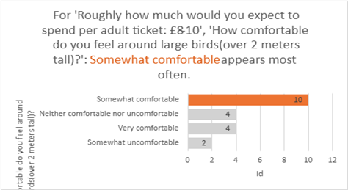

Implications:
The general ease amongst the respondents suggests that most of the visitors will be receptive to close Ostrich encounters, although a small percentage might need reassurance or different type of viewing.
Influence over the business concept and design:
- Design interactive areas that allow visitors to safely observe or feed the ostriches.
- Implement safety and comfort measures, including informative signage to ease anxiety.
- Finch (2022) states that understanding legal and regulatory requirements is essential to ensure compliance and avoid disruptions in operations
Marketing materials:
- Highlight safe and engaging ostrich experiences to attract curious visitors.
- Proactively address concerns in FAQs and promotional content.
- As Williams (2022) highlights, "effective marketing strategies should focus on unique selling propositions to differentiate the business in a competitive tourism and ecotourism landscape".

The segmentation strategy of the public
Based on survey this include:
- Educational tourists: interested to find out more about Ostriches probably families and scholar groups
- Residents: Looking for leisure activities between 30 – 60 min away. As Reuer et al. (2019) state, "strategic partnerships and community engagement are foundational to establishing a sustainable tourism business."
- Experience seekers: Visitors willing to pay premium prices for an outstanding encounter.
- Wildlife Enthusiasts: They are comfortable amongst big birds interested in close encounters.
By segmenting the public, it allows us to know what type of marketing messages we send, EX: “The educational place for families” and “interactive experience for adventure seekers”. Barrow and Brown (2021) recommend developing a step-by-step approach to business planning to address the various phases of business development systematically
SEO Strategy and Content Development
Targeting Keywords:
- “Farm visiting for families”, “Interactive encounters with big birds”, “Tours at ostrich farm”,” Local attractions with wildlife”.
Content focus:
- Events pages for seasonal or thematic experiences
- Storytelling and testimonials of the visitors which talk about safety and fun.
- Blog posts that explain Ostrich facts, care and farm activities. Armstrong et al. (2023) suggest that integrating environmental considerations into business operations not only supports sustainability but also appeals to eco-conscious consumers
Technical SEO on-site:
- Incorporate key words in Titles, in a natural way
- Use specific location Keywords to attract regional visitors
“Research indicates that local SEO and rich, informative content enhance visibility and visitor engagement (Jansen et al., 2003).”
Conclusion
The data from the research it shows significant opportunities for a business with an ostrich farm, concentrated on education, interactive experiences and regional accessibility. To find out more about ostriches and their comfort around these big birds indicates a receptive public who appreciates safety, accessibility and implication. This information has directly influenced my decision in opening this type of business putting aside my love and passion for animals. The web design, marketing strategy and the segmentation plan was made based on the research.
The business can create convincing marketing campaign, can optimize the on-line presence for local SEO and can develop experiences for the visitors aligned with their preferences. Understanding the visitors’ preferences and needs ensures that the farm will be on the right track on becoming the best local attraction which provides education, fun and inspiration.

The importance of Excel in the digital era.
Task 2
Introduction:
Since its beginning Microsoft excel has changed the way companies stored data, analysed information and took strategic decisions. As a powerful spreadsheet application excel became indispensable in different sectors, handling tasks from simple calculations to complex data. For my business An Ostrich family farm which offers educational tours, products and Eco touristic experiences – Excel can be a vital instrument for handling the operations, marketing, financial planning and strategic growth. Trodd (2013) underscores the importance of biodiversity and sustainable development, aligning with the eco-touristic aspect of my business. In this essay I will explore the history of the excel, its importance in the digital Era and the way my business can develop the capacity to succeed.
I created an Excel spreadsheet to project the finances of “An Ostrich Dream Sanctuary” over one year. I set up columns for each month and rows for different types of income and expenses. On the income side I included ticket sales from farm visits, workshop fees and sales of ostrich products, while on the expense side I added feed costs, insurance, wages, utilities, marketing and fuel. I then used basic formulas such as =SUM () to calculate total monthly income and total monthly expenses, and a simple profit or loss formula (total income minus total expenses) to see whether each month is in surplus or deficit. Microsoft (2023) recommends exactly this kind of structure when building a simple budget or financial plan in Excel for a small business.
History of Excel:
Microsoft Excel was first released in 1985 for the Macintosh, with a Windows version released in 1987. Developed by the Microsoft team led by Douglas Klunder, Excel was designed to improve on existing spreadsheet software, particularly Lotus 1-2-3. Its initial success stemmed from its easy-to-use interface, powerful calculation capabilities, and integration with other Microsoft Office applications. Over the years, Excel has evolved through numerous updates, introducing features such as pivot tables (1993), macro programming with VBA (Visual Basic for Applications, 1993), and advanced data analysis tools. The 2000s marked a significant expansion of Excel’s functionality, including the introduction of data visualization tools, Power Query, Power Pivot, and integration with cloud services.
Importance of Excell in the Digital Era:
In today’s digital era, data is considered a vital asset. As organizations generate a lot of information, tools like Excel enable businesses to organize, analyse, and interpret data efficiently. According to Reedy and Parker (2017), digital literacy—especially proficiency in tools like Excel—is fundamental for navigating the modern workplace. Excel’s allows users to perform tasks such as budgeting, forecasting, inventory management, and customer data analysis, all of which are critical for operational success. In the context of digital marketing, Excel assists in analysing campaign data, segmenting target audiences, and evaluating marketing ROI (Pinto & Guarda, 2020). As businesses become more reliant on digital platforms, proficiency in Excel becomes an essential skill for entrepreneurs to adapt rapidly adapt and maintain competitiveness.

Linking Excel to my Business:
My Ostrich farm success relies on strategic planning, efficient management and marketing all the areas in which the Excel can play a very important role. Here are a few examples:
Financial Management: Use Excel to create budgets, track expenses, and forecast revenues. This helps in maintaining financial health and planning for future investments, such as expanding tours or product lines. Williams (2022) provides insights into effective marketing strategies within ecotourism, which can inform targeted marketing efforts for my ostrich farm.
Inventory Tracking: Maintain real-time records of ostrich eggs, meat, and cosmetic products. Excel tables can automatically update stock levels, alerting you to reorder points, ensuring smooth operations.
Customer Data and Booking Management: Organize visitor information, booking schedules, and payment statuses. Pivot tables can analyse peak seasons or popular services, informing marketing strategies. Bencsik (2017) emphasizes the role of knowledge management initiatives in small and medium enterprises, highlighting how effective information management can lead to strategic advantages
Marketing and Sales Analysis: Evaluate the effectiveness of promotional campaigns by tracking sales data and website inquiries. Excel charts can visualize customer engagement trends, aiding targeted marketing efforts
Educational Program Planning: Manage workshop schedules, resource requirements, and participant feedback, enhancing the visitor experience.
Product Sales and Pricing Strategies: Analyse sales data to determine pricing strategies for eggs, meat, and cosmetics maximizing profitability.
Moreover, as highlighted by Sandhu (2020), digital tools like Excel facilitate innovative services and operational efficiency, which are crucial for small businesses competing in a digital-first environment.

Conclusion:
The significance of Excel in the digital era is marked by its development from a spreadsheet to a comprehensive data analysis. Its capabilities support businesses across diverse sectors, enabling efficient management, strategic planning, and data-driven decision-making. For my ostrich farm, integrating Excel into daily operations can enhance productivity, improve customer engagement, and foster sustainable growth. Sollanifar, Hughes, and Gocke (2021)

References Task 1

- Armstrong, G., Adam, S., Denize, S., and Kotler, P., 2023. Principles of Marketing. 8th ed. Pearson.
- Barrow, C., Barrow, P. and Brown, R. (2021) The Business Plan Workbook: A step-by-step guide to creating and developing a successful business. 10th edn. London: Kogan Page
- Finch, B., 2022. How to write a business plan: Win backing and support for your ideas and ventures. Kogan Page
- Hooley, G.J., Nicoulaud, B., Rudd, J.M. and Lee, N., 2020. Marketing strategy and competitive positioning. Seventh ed. Pearson.
- Jansen-Vullers, M.H., van Dorp, C.A. and Beulens, A.J.M. (2003) ‘Managing traceability information in manufacture’, International journal of information management, 23(5), pp. 395–413.
- Marvell, A. (2002) ‘The Encyclopedia of Ecotourism, edited by David B. Weaver. CABI Publishing, Wallingford, 2001. xiv + 668 pp. £95.00 (hardback). ISBN 0-85199-368-0’, The international journal of tourism research. Chichester, UK: John Wiley & Sons, Ltd, pp. 330–331
- Reuer, J.J., Matusik, S.F., and Jones, J., 2019. The Oxford handbook of entrepreneurship and collaboration. Oxford University Press.
- Trodd, L. (2013) Transitions in the Early Years: Working with children and families. London: SAGE Publications
- Williams, S., 2022. The Financial Times guide to business start-up 2021/2023. Pearson.
- Young, P., 2021. Essential Business Plan. Global Media Publications

Reference Task 2

- Bencsik, A. (2017). Knowledge Management Initiatives and Strategies in Small and Medium Enterprises.
- Pinto, F. M., & Guarda, T. (Eds.). (2020). Digital Marketing Strategies and Models for Competitive Business.
- Reedy, K., & Parker, J. (2017). Digital Literacy Unpacked. Facet Publishing
- Sandhu, K. (Ed.). (2020). Digital Transformation and Innovative Services for Business and Learning.
- Sollanifar, M., Hughes, M., & Gocke, L. (2021). Digital Entrepreneurship. Springer.
- Trodd, L. (2013). Biodiversity and Sustainable Development. Routledge.
- Williams, R. (2022). Effective Marketing Strategies in Ecotourism. Journal of Sustainable Tourism, 30(5), 789-805.

