Anna Bruce
P062172

Mdes Creative Venture

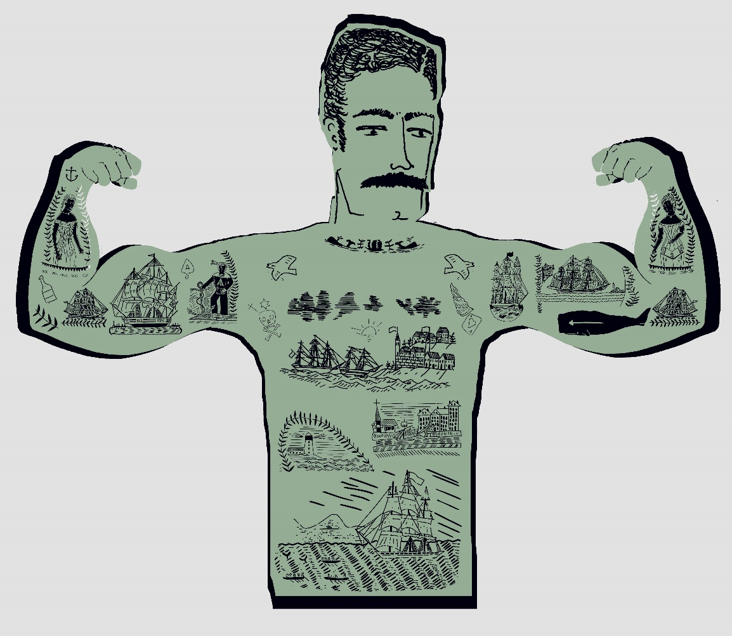

AC2 Evaluative Report

Contents

Executive Summary

Review of Research Methodology

Review of creative/enterprise strategy

Critical appraisal of the final proposition

Future Trajectories

Executive summary

In this report I will discuss my inspiration and how it has become an integral part of my lifestyle and outlook. I will outline the success of my draft presentation meeting with Willis Newson and how this achievement has shaped my practice. I will show how my form of research is paramount to my practice and the joy of visiting the Ravilious and Co. The Pattern of Friendship exhibition. I will explain the positives and negatives of my creative venture and why I feel I have started on a personal journey that is ultimately sustainable through continued development. My long-term goal of having a small independent business and the initial steps of attending local fairs are key points to my particular endeavours. I will outline what I have learnt from the experience of attending a fair and in what ways I would improve future events. I have included advice that I would give to myself or to someone about to begin their Mdes studies.

Review of research methodology & methods

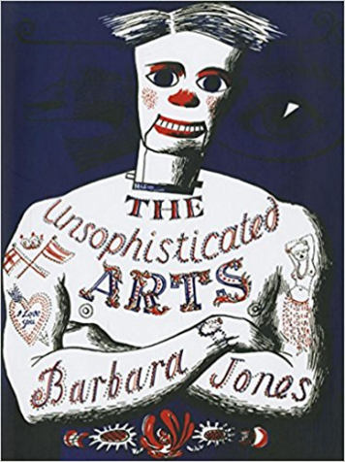
Figure 1. Barbara Jones Cover Art for ‘The unsophisticated Arts’

The initial exploration I undertook for the research methods and communications module remains fundamental to what sparks my curiosity and entices me to want to create. Contemporary designers and illustrators like Emily Sutton, Mark Hearld, Johnny Hannah, and Marthe Armitage are all richly creative people whom I find deeply inspiring. I have become immensely influenced by many mid-century illustrators, Paxton Chadwick, Jack Townend, John Minton and Charley Harper. My inquiry into Barbara Jones and her life-long research regarding what she considered British popular or vernacular art has been extremely significant when determining my own themes for the creative venture module. The museum trips and exhibition visits I regularly take are intrinsic and play a major role in feeding my creativity and help to generate ideas. Research into artists and companies I admire such as St Jude’s and Cambridge Imprint are effective as I find connections between them and many other artists that I respect. Much of my original research was on making sense of the theme British popular art and the best explanation for it came from Barbara Jones herself. Jones described it as being art created by ordinary people and fashioned to their taste and that usually, at its inception, it was sometimes crude and perhaps vulgar but with time becomes nostalgic and collectable (Jones, 2013). Helston and Torbay museum all have large collections that helped amplify Jones’s sentiments and I now have a large bank of imagery from which to draw inspiration. With collections of shells, butterflies, bird eggs, bicycles, guernsey jumpers, clay pipes, dolls houses, model ships, the list goes on and I love the impression these collections give of the passing of time and the efforts people have got to in collecting and preserving these every-day items. I have a growing collection of handmade bird calls from France. I love them because they are handmade and it would have taken time to perfect the call. I love them because they come in a handmade box with a simple illustration of the bird the call mimics on the front. And I also love them because they have a note inside that says they hope the user will only use them to good intent. This links into how I feel about art, that it’s for all the senses and there is a connection between nature and people and that things can be functional and beautiful and that the ordinary is quite extraordinary.
The Pattern of Friendship exhibition at Compton Verney is one of the most inspiring I have ever visited and being able to see the work of so many artist and designers that I greatly admire in one place was a visual treat. It was wonderful to see the sketches, drafts, prints, textiles, paintings, adverts, ceramics, wallpapers and dustjackets that these enormously talented individuals had produced. Edward Bawden and Eric Ravilious had much of the exhibition dedicated to them with Bawden’s large scale prints of Braintree Cattelmarket and beautifully curated dustjacket collection and Ravilious’s watercolours, Wedgwood pottery and submarine lithographs. Also displayed were textiles by Enid Marx, painting and prints by Tirzah Garwood and Paul Nash, Guinness lithographs and book cover illustration by Barnette Freedman and three rare original copies of the Curwen Press pattern book published in 1928. Visiting this exhibition was such an enormous pleasure that it did not feel like research and I am convinced I could visit it many times and find something new and inspiring. They were determined, hardworking and ambitious, all traits that I greatly admire and would like to cultivate in myself. I also saw the newly curated Marx & Lambert folk art collection and some large collages by Mark Hearld.
I visited the Ocean Liner exhibition at the V&A and felt that what was on display could easily be included as inspiration for a nautical collection. It also struck me as having a British popular art feel with its display of swimsuits, menus and poster advertising cruses. It was delightful to see textiles, tableware and a mural of ‘English Inn Signs’ all designed by Edward Bawden. The exhibition displayed a model of the Queen Mary paddle steamer that I subsequently included in a design depicting various other paddle steamers making an ocean crossing.
Recently published books ‘Are You Sitting Comfortably? The Book Jackets of Edward Bawden’ (Skipton, 2018)and ‘Edward Bawden at Home, A Working Life’ (Gallery, 2018)are excellent and since I always judge a book by its cover, I am really enjoying Bawden’s book jackets. I am really looking forward to seeing the current exhibition of his work at the Dulwich Picture Gallery.
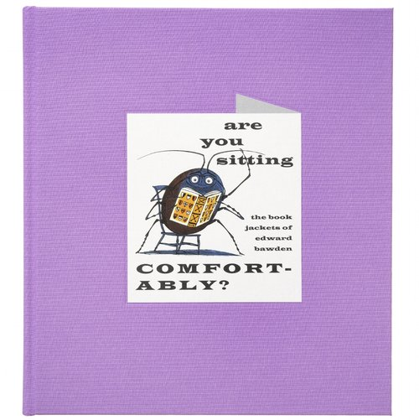
Figure 2. Cover art for ‘Are You Sitting Comfortable? The Book Jackets of Edward Bawden’

The actual areas that inspire me remain the same, however the ways in which I perceive them and the aspects that I take from my enquiries has undoubtedly grown. I now look and wonder how I can use what I am seeing in my own practice and as a consequence actively collect with this in mind.

Review of creative/enterprise strategy

Taking part in local and national fairs is something that I would like to make part of my practice and the creative enterprise and employability module had encouraged me to step out of my comfort zone and begin actively seeking opportunities to show at various fairs. The Newbury Priory Christmas fair was a very beneficial experience for me as I had positive responses from the public and other stall holders concerning my work. This was a big confidence booster in terms of how my work is received outside of a university setting and has reassured some of the worries I had about attending a fair. I was able to see how I could improve the displaying of my work and also which pieces I should take. My best-selling pieces were prints and in response to this I shall be focusing on more of this type of product and should I go back to Newbury this year I am considering designing a selection of festive printed cards particularly aimed at the Christmas market. The seasonal aspect of focusing my work has become very apparent and I may develop pieces to celebrate Easter, Midsummer, the equinoxes as well as Halloween and Christmas. At a fair the presentation and interaction with the public is highly important and to foster this I may perhaps purchase a travel press in order to have a demonstration element to my stand. Newbury was a family friendly event and I think a demonstration would have been well received by both parents and children. I am in the process of compiling a list of fairs suitable for my products and have registered as a trader for the Marina Market in Swansea. I would apply these improvements to any subsequent fairs that I might take part in.
During the creative venture module, I further developed work I had begun as part of a commission I was given by Willis Newson. The commission is to create a design that will be installed as a feature wall in the new palliative care unit that is being built at the Royal Glamorgan Hospital. Previously, I along with other designers, had organised a printmaking workshop with the focus of gaining an understanding of the views and scenes the patients would like to see in the new unit. I gave careful thought to keeping it simple and inviting for a mostly elderly group who had serious health constraints. I discussed this with the other artists and we agreed to produce a series of nature themed stamps which would be easy to handle. The activity was a wonderful experience as while we were all engrossed in the workshop I was able to talk to staff and patients in an informal setting about their lives, experiences and hopes for the new unit. The relaxed atmosphere was conducive to conversation and it became quickly evident that people found it therapeutic to talk and felt a deep value in sharing. This in turn was inspiring when creating my draft designs and allowed me to research themes and visit local areas that held personal meaning to many of the participants. A lot of what was expressed in the workshop had universal feelings of peace, safety and being outside in nature. This experience helped enormously and I have not considered my work being connected to people in this way.
The deadline for first drafts was in March and I was very nervous about this as I had to attend a meeting with patient representatives, Macmillan and Y Bwthyn staff, and the other artists that were also working on various commissions for the new unit. I have had lots of experience of showing my work to my tutors and peers and have on occasion felt hesitant but ultimately encouraged. Showing draft designs to a room of people was daunting but once I started my presentation I quickly felt relieved as it became obvious that what I had designed was being well received. I had very encouraging feedback and although this may not be a realistic outcome of every draft presentation, it still felt pretty good. This has so far been a beneficial experience as I am interested in being a portfolio based artist, I realise this is a big opportunity that I have been given and, at this early stage in my career as a designer, I have been very fortunate to receive such a large commission. Through participating in this, I have been made aware of the importance of the inclusion and involvement of the audience when designing for a public space. As I talked through the different aspects of my pieces and referred to references that had been made at the workshop, for example the inclusion of a walled garden, washing on a line etc. the response was overwhelming as the panel recalled the various conversations and were delighted to see their inclusion. I now more appreciate the value of consultation. When the service users can see that their opinions and places that they mentioned were consequently visited by me and then used as inspiration for the designs, a sense of value is instilled in the outcome which promotes connection and wellbeing. On a personal level I have gained a lot from the experience and feel I have achieved something genuinely meaningful through this commission.

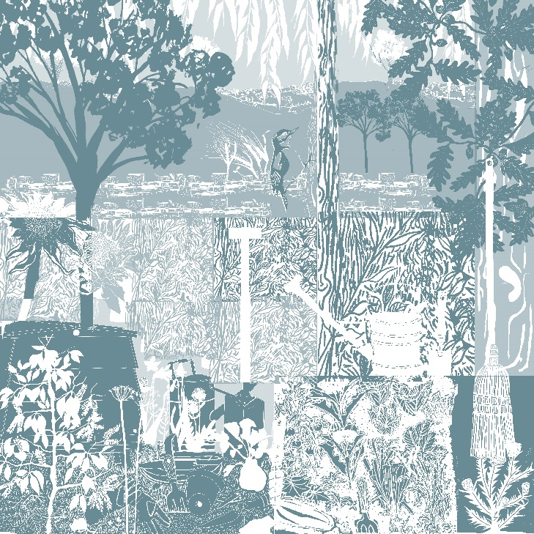
Figure 3. A draft design submitted to Willis Newson

On this occasion the artists involved all showed their drafts at the same presentation. I understand that this is unusual and I was asked if that would be acceptable as previously we were given individual time slots. However, seeing the other presentations and drafts summited allowed me to see what seasoned artists deem acceptable as a draft. I had concerns that the panel would not understand what I was trying to communicate and so wanted to provide detail and substance and was a bit taken aback at what the others had brought. It did not make me want to show less work as all the designing I had done will be used, but it did demonstrate to me that the more skilled you are at talking the less you might have to show. Having said that, I received great feedback as what I was posing was clear and easily visualised. The panel were able to comment on the colour pallet and seemed to enjoy finding things they recognised in the detail. It could not have gone better, as someone who finds it difficult to talk about their work, I was able to let my draft talk for me. I realise that becoming a more confident speaker is important and hopefully I will give myself more opportunities to work on this.
I was contacted, through Instagram, about a possible collaboration and was initially excited to have been noticed in a sea of images. The wording of the inquiry was difficult to respond to so I asked tutors for advice and was really supported by the incredibly detailed replies I received. This enabled me to present a professional and knowledgeable answer, although it has not yet lead to further communication. Next time I am contacted however, I shall have a bank of emails containing advice to draw upon that I was previously completely unware of. This will undoubtedly give me more confidence when embarking on future business negotiations. I hope that even after graduation I will be able to ask advice from my tutors should the need occur.

Critical appraisal of the final proposition

Originally, I was determined that my creative venture module would allow me to produce a new, interesting and dynamic portfolio. I had plans to create three collections, (nautical, rural living and miscellaneous) each being connected by the over-arching theme of British Popular Art. I had not decided on any particular outcomes but was confident that my imagery and ideas would flow and they would innately apply themselves. When completing work for my final major project last year I felt self-assured in my abilities and that after three years at university I had the skills to seek a starting position in the design industry. Unfortunately, I have been unsuccessful in achieving my initial creative venture goals. I can identify a few situations that caused me to waver, and my subsequent ‘overthinking’ made it difficult for me to overcome how I felt. I have received so much encouragement from tutors about my work and never not felt believed in. Ultimately, it became a lack of motivation on my part and a loss of perspective which lead me to feel a little disillusioned with what I was doing. The surface pattern course allows students to learn new skills and increase their understanding of design, with modern and traditional facilities the course offers the opportunity to become a highly competent and intelligent creative. There are ample occasions to excel and be productive and although this is a reflective report on my fourth-year experiences, If I were to reflect on my time here as a whole, it would be far more positive. I have learnt a great deal about myself and how I design, I feel I have come a long way in terms of my ability as a designer. I can see how I become pre-occupied and lose sight of my ambitions but also how I can regain confidence and determination. I believe I have a better understanding of what makes me happy and the ways in which I can create a sustainable practice. Writing this report has really helped in making me address not only the things that I should have done but also the things I have. I have ideas for prints and textiles that I would like to work on and am considering applying these to ceramics and perhaps embroidery.
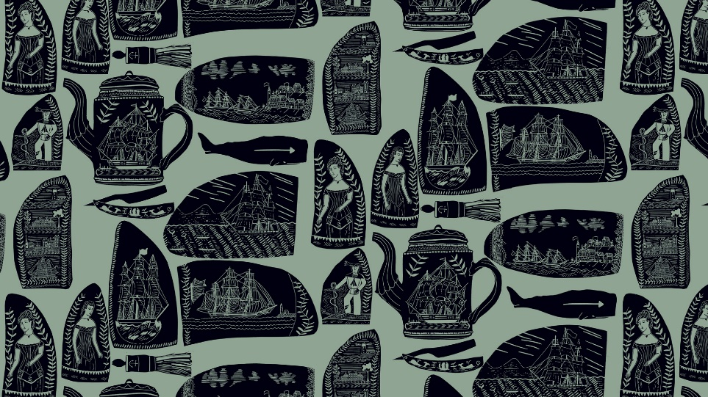
Figure 4. My scrimshaw design
I am very pleased with the nautical collection that I have designed. I am especially happy with the scrimshaw print and with further development of application will continue to improve this design. I gained a positive and engaging response when I posted the initial image on Instagram and feel that with more focused direction I could improve and enlarge this idea into a more dynamic collection. I had intended to design a rural collection that focused on nature and country living. I wanted it to have elements of outdoor activity and traditional imagery associated with the home and a slower more connected way of living. I had hoped it would celebrate some of festivals like the equinoxes, green man, and straw bear festivals or include some of the inspiration I have found in provincial and national museums. I produced two designs, quince trees and hunting whippet patterns, with the aim of including them in this collection. I have had some encouraging feedback, through my Instagram page, particularly about my whippet design and will continue to develop this collection further.

Future Trajectories

I am aware that I have caused myself to miss out on many creative opportunities this year but I don’t feel that these will ultimately go unaddressed. I am certain that by attending university and studying surface pattern, I am now equipped with the skills to embark on a lifelong creative venture. I will continue to practice traditional printmaking and further my understanding of the process as I find it very satisfying and think that’s it’s something I could become good at. I am lucky in that I already own a printing press and so there is really no excuse not to improve. I have been steady building a studio space for myself at home and have added a small amount of screen printing kit. I have been invited to the Marina Market twice but because of other commitments I have not been able to take part. With better time management this is a simple and incredibly easy fair for me to attend and I am keen to create connections locally. I have made sales through the Mission Gallery and last year was part of their Jane Phillips Student Showcase. I hope to build on and continue this relationship. I have also been invited back to Newbury Prior this Christmas.
New Designer might be a wonderful opportunity but I am not the best at articulating so am not convinced that this would be worth my while. I struggle to talk about my work and would find the idea of going stressful, I think this would only make it harder for me to express myself especially since there will be ambitious and outgoing people also attending. I know the level of work on display is high and having struggled this term to bring some of my intended ideas to fruition, I do not think I would stand out. Having said that I do not see this as completely negative as I intend to grow a reputation for myself through fairs, commissions and social media. I have also been looking for design jobs and placements. The long-term goal is that I would like to have my own small business and hope to achieve this through building a selection of carefully made products that represent my ethos as a designer. I truly believe the next steps I take will be what I make of them and that with the right frame of mind I can find success and recognition, I just need to focus, work hard and remember what my ideas of success are.
If I were to undertake the Mdes again the advice I would give to myself would be, make full use of the facilities and expertise that are on offer. If you begin to struggle take a moment to look at the bigger picture and what it is you are aiming for in the long run and do not allow yourself to get hung up on every small detail. When you need help ask for it as the SPD team will pretty much bend over backwards to try and resolve any issue you might have. Don’t take it all so seriously, have fun and see it as an adventure and that you are still learning and you cannot expect to get it right the first time, every time.

Bibliography

Gallery, T. F. A., 2018. Edward Bawden at Home A working Life. 1st ed. Essex: Random Spectacular.
Jones, B., 2013. The Unsophisticated Arts. 1st ed. Dorset: Little TollerBooks.
Skipton, P., 2018. Are You Sitting Comfortably? The Book Jackets of Edward Bawden. 1st ed. Norwich: Mainstonr Press.
List of Images
Figure 1. Barbara Jones Cover Art for ‘The unsophisticated Arts’
Figure 2. Cover art for ‘Are You Sitting Comfortable? The Book Jackets of Edward Bawden’
Figure 3. A draft design submitted to Willis Newson
Figure 4. My scrimshaw designs

