Professional Career Development in Health and Social Care (LCHS 4009)

ASSIGNMENT 2

Name of Student: Valinya Da costa

I.D. Number: 2512507

Name of Tutor: Christopher Mafuva

Acknowledgement of AI use: I confirm that I have / have not used AI to complete my work. (IF YES, ALSO WRITE I USED THIS SOURCE……. GIVE REFERENCE SUCH AS GRAMMERLY FOR EXAMPLE……TO………PROOF READ FOR EXAMPLE).

Table of Contents Page Number

Introduction: portfolio .......................................................................3

Task1: chosen job vacancy..............................................................4

Curriculum vitae................................................................................5

Task2: personal statement................................................................7

Task3: SWOT analysis and Personal development Plan....................8
3a: SWOT ANALYSIS...........................................................................8
Strengths................................................................................................8
Weakness...............................................................................................8
Opportunities...........................................................................................8
Threats.....................................................................................................8
3b: personal development plan.................................................................9
Montoring and evaluating,,,,,,,,,,,,,,,,,,,,,,,,,,,,,,,,,,,,,,,,,,,,,,,,,,,,,,,,,,,,,,,,,,,,,,,,,,,9
Task: reflection on complement 1 presentation..........................................10
Introduction................................................................................................10
Description...................................................................................................10
Feelings...........................................................................................................10
Evaluation..........................................................................................................11
Analysis..............................................................................................................11

Conclusion............................................................................................................11
Action plan...........................................................................................................11
Reference...............................................................................................................12

Practical Portfolio

Introduction:

Explain what is Portfolio with few words/sentences?
A portfolio is a collection of your work, projects or financial investment used to show off your skills or assets. It proves what you can do or what you own in one organized place. In this portfolio to showcase my suitability f
or a job as a care assistant I will provide my cv, outlining my own career goals and a SWOT analysis to find out my strengths and weakness. I will also use the Gibbs model (1988) to reflect on.

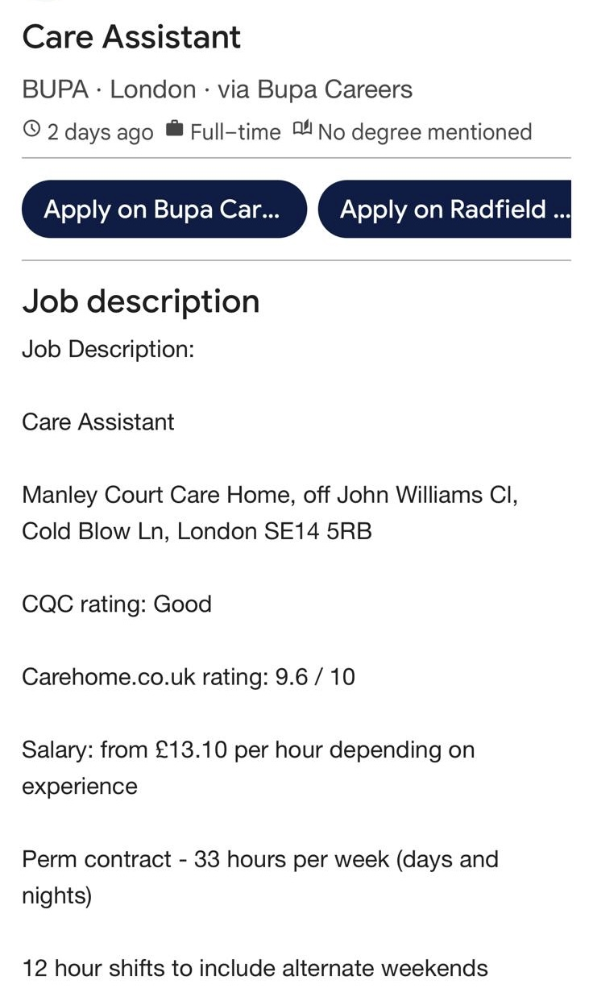
Task 1 of 4 Curriculum Vitae

Personal profile
Name: Valinya Da costa
Address: 64 Oswald Road Southall UB11HP
Phone: 07424187862
Email: dacostavalinya@email.com

I am a motivated and customer focused individual currently studying of higher education. I am known for my communication, good listener and with a natural ability to build trust and rapport. Also, I am always pleased to look after people, care for and take every chance to help them. I am eager to find a job that will help me look after people or assist them.

Education
University of Wales Trinity saint
. certificate of higher education for health and social Level
Oct 2025- present

Level 3 Diploma Business Management
Mar 2024-Feb 2025

West Thames College
. Beauty Therapy Level 1 & Level 2
Sept 2022-june 2024

Villiers High School
August 2022
. GCSE’S including Maths and English passed

Achievements
- Certificate of higher education health and social care.

Hobbies
Singing – enjoy performing solo and in groups it helps me build creativity and confidence.

Dancing - passionate about expressive movement and rhythm.

Sports – enjoy activities in teams and it helps me stay healthy and fit

Key skills
- Good at communicating which helps people understand what I am saying clearly
- Good at listening to people to make them know that I am listening and be ready to respond back.
- Taking care of people
- Being helpful
- Responsible
- Emotional resilience
Employment history
Retail assistant – shop from crisis, Ealing
30 sept- 30 dec 2025
- Customer service: welcoming customers, assisting with queries and helping them find specific items or styles items or style.

- Till operation: Processing sales, handling cash and process gift aid.

- Stock process: sorting through donations, valuing items, steaming clothes, pricing and rotating and rotating stocks on the shop

Reference
Available upon request

Task 2 of 4
Personal statement

I am hardworking, caring and motivated student studying for a certificate of higher education in health and social care. In the future my main goals are to work in health and social care as a care assistant to help people and provide good care. I enjoy helping people and improve their life’s. My studies have helped me understand many key skills like safeguarding, showing respect to the patience and help them physically and mentally, which will help me as a care assistant. I have a lot of experience when it comes to be with patience because when I completed level 1 and level 2 diplomas in beauty therapy in west Thames college, I learnt that you have to be gentle to the patient and be in a respectful manner, this will play a huge role in helping me in the job of care assistance. Also, when I was doing level 3 diploma in business management, I learnt how to be organised and time management.

When I used to work as a retail assistant at the shop from crisis charity store in Ealing gave me experience working with people. Working in this made me interact with people from different communities every day. In this period, I learn how to listen carefully to what a customer needs, show empathy and stay calm no matter no matter how busy it is. One skill that helped me a lot is staying calm and focused it helped be deliver the best help even under pressure. Working at the shop also helped me get real responsibility, such as operating till, organizing inventory and processing gift aid forms accurately.

My strengths are active listening, showing empathy and care for people and make them feel safe. I am very good at creating a safe and friendly area, so people cared and heard. I am very good when I communicate to others because it’s very clear and make it easy to understand for people who might not be as good as others in English. Some other things that I am good at outside of my studies is dancing, singing and sports which taught me how to work in teams which will be a crucial skill I need for care assistance.

I am very excited about the chance to apply for a job as a care assistant. All mu combined background in health and social care, business management and beauty therapy makes me well suited for the job of care assistance. I will use all my practical skills like communication, being focused and calm under pressure and many more essential skills for this job. I am aware that to be a good at my job I must be patience, give my best at every task, be kind and always give the best care a patient need. At last, I am very eager to join this job of care assistance, have the knowledge of what I should be able to do and be ready to face any challenges during the job.

Task 3 of 4 (approx. 800 words)

Strengths | Weakness
Active listening and clear communication are skills which I gained from the shop crisis charity store and beauty therapy.  Also, the customer service experience helped me in my communication and good communication is necessary to build trust and deliver care (Burch, 2020)  Studying health and social gave me knowledge on safety and fair treatment and understanding safeguarding and dignity supports safe practice (Lishman, 2015)  I am patient, kind and naturally able to stay calm in difficult situation. | Most of my experiences is in retail and customer service not in residential car homes and care assistant requires to work inside residential care home.  Need practice using electronic care software.  Skills like physical lifting training to move faster and lift residents safely.  I am still learning more medical words, so I don’t have a lot of medical knowledge.
Opportunities | Threats
Working alongside experienced nurses and workers allow me to learn practical skills directly on the job Cottrell (2015)  Free training opportunities in areas like dementia care or autism help me improve my awareness skills. (Skills for care). | Care homes do not have enough workers on a shift which makes the job very stressful (Kinman and teoh 2018)  Being around people who are already sick means I can catch the sickness (HSE 2018)  Inspectors come to check care homes, so we must follow every rule perfectly which is very difficult (DHSC 2022)  If a care home does not have a lot budget, we might not have enough supplies or training (Skills for care 2021)

My strengths show me that I have strong communication and listening skills from my retail and beauty therapy experience. My university course teaches me about safety and to respect patients with dignity.

My main weakness is that I do not have proper experience inside care homes yet and I need to practice using digital care and using physical lifting skills.

I have a lot of opportunities because employers provide free training like first aid and moving and handling. Care assistants are also in high demand which means I have a lot of opportunities.

Some threats that I might face are physical tiredness due to long shift when there are very few staff. Supporting sick people means you might get sick as well.

GOAL 1
My first goal is to achieve my care certificate, learning how to care for residential, learning first aid and doing safeguarding level 2. I need to train myself to look after people without hurting them or me (Health and safety executive, 2018). Safeguarding will help me learn how to protect people who are vulnerable from bad treatment (Skills for care,2021). These certificates will help me in my future career, do my job safely and follow the law. To this all I will first go in training classes, finish my online study units and practice various different skills I will need for this job in the first six months. I will always check my process to do that I will talk to my manager and ask him on how good I am doing in the job.

GOAL 2
My second goal that I also need to work on is to use the care home computer program to write notes on how the patient is doing every day. This very important thing because most care homes now use computers instead of paper now. Writing about how the patient is doing is a rule we must follow as a care assistant (Nursing and midwifery council, 2018). Good notes will help the next staff shift know about the resident and what they must next to keep the resident safe. To do this I will learn from experience workers, practicing writing my own shift notes and ask for help when I’m not sure about something. To check if I’m doing a progress the supervisor will check my written notes and if I’m doing it correctly or a mistake.

Goal 3
My third and final goal is to take short courses on how to help a resident when they are angry, confused and help them stay calm. This very important because some residents have dementia or mental health needs. Knowing how to talk to them calmly keeps everyone safe and respects their dignity (Social care institute for excellence,2020) To this I will ask my manager for extra training course and get more knowledge about dementia care. To check my progress, I will use Gibbs’ reflective model (Moon,2013) and talk about my progress with my manager.

My two-year personal development plan focuses on becoming a skilled care assistant. During the six months I will complete important qualifications including care certificates, moving and handling. Over months six to twelve, I will be good at digital care logging software. In my second I will complete Demetia and arrange extra training courses to support my residents respectfully.

Task 4 of 4
Introduction

In this essay I will reflect on my individual presentation which I did recently about important skills in the health and social care on and I chose reflection, so I had to present on why reflection is important in health and social care. To present this presentation was important because it was part of my module, it allowed me to reflect on my skills and how I can improve myself. The main purpose of reflection in healthcare is to look at what our experiences and find out what went well and learn how can do better in the future (Jasper, 2013: reflective practice). Reflection helps care worker be aware and find out ways on how they can improve and how they communicate with residents and team members. In the essay i will be using the GIBBS’ reflective cycle it has six main stages: description, feelings, evaluation, analysis, conclusion and action plan.

Description
During that task, I presented my individual presentation on why reflection is important within the health and social care sector. I used PowerPoint slides to speak in front of my classmates about how reflection helps improve the patient's safety, residents' safety and manage stress. I also said that reflection in the context of health and social care means look back at your practical experiences, action and decisions during the care work to understand what happened, why it happened how you can improve next time.

Feelings
Before starting my presentation, I was very worried, stressed and I was not confident to speak in front of everyone because it is usually very hard for me. I was most worried on talking too fast, not being loud and clear and make eye contact while presenting the presentation. When I started to present the slide, I was feeling less nervous and less stressed than before starting the presentation. Seeing everyone focused on what I was saying motivated me to give my best to present the presentation and gave me more confidence. After finishing the presentation, I was stress free and felt proud that I had done well on my presentation.
Evaluation
There were some good and bad things about my presentation and how presented it. Some positive things were that I maintained eye contact during the whole presentation i look at my classmates and at the screen balancing it properly. One more good thing was that I was loud enough so that everyone could hear me. Some negative things about the presentation were that i was speaking too fast which made it hard to understand. One more thing is that I was a bit bad at pronouncing some words.

Analysis
Reflecting on this experience tells me that my stress was the main reason i spoke to fast and speaking to fast means you might miss out words or say it incorrectly. Next time i would be less stressed and try to take my time so I do not miss out word or say it wrong and make it clear to understand.

Conclusion
Overall presenting on the topic of reflection was a very useful experience for my professional growth. Reflective practice is important in social care because it encourages care workers to improve each time and give patients the best care possible. This presentation showed me that I need to keep practicing my pace while talking and being confident to speak in public.
ACTION PLAN
- For future presentation I would practice word and read it out loud and learn how to pronounce some words.
- I will practice talking calmly and taking my time while talking so i do not speak to fast.

Reference
Burch, S. (2020) Communication skills in health and social care. London: Sage Publications.
Cottrell, S. (2015) Skills for success: Personal development and employability. 3rd edn. London: Palgrave Macmillan.
Department of Health and Social Care (DHSC) (2022) Health and social care integration: Joining up care for people, places and populations. London: GOV.UK.
Gibbs, G. (1988) Learning by doing: A guide to teaching and learning methods. Oxford: Further Education Unit, Oxford Polytechnic.
Health and Safety Executive (HSE) (2018) Health and safety in care homes. 2nd edn. Norwich: HSE Books.
Jasper, M. (2013) Beginning reflective practice. 2nd edn. Andover: Cengage Learning.
Kinman, G. and Teoh, K. (2018) What could make a difference to the working lives of NHS staff?. London: The British Psychological Society.
Lishman, J. (ed.) (2015) Handbook for practice learning in social work and social care: Knowledge and theory. 3rd edn. London: Jessica Kingsley Publishers.
Moon, J.A. (2013) Reflection in learning and professional development: Theory and practice. London: Routledge.
Nursing and Midwifery Council (NMC) (2018) The Code: Professional standards of practice and behaviour for nurses, midwives and nursing associates. London: NMC.
Skills for Care (2021) The state of the adult social care sector and workforce in England. Leeds: Skills for Care.
Social Care Institute for Excellence (SCIE) (2020) Dementia care: Communication and person-centred approaches. London: SCIE.

