The previous chapter of this dissertation achieved several of the aims of this paper however this chapter will review the best forms of research to use in order to achieve the remaining objections outlined. Research can be categorized as either primary or secondary research. Secondary research is data which has been produced by someone else and then used, analysed or interpreted by another (Fitchburg State University, 2023), this dissertation utilized secondary research for the previous chapter as it drew on data gathered by other sources. Primary research is data generated by the user for their own use (Fitchburg State University, 2023). This chapter will seek to identify the most the appropriate research approach to achieve the final objective of this dissertation. From reviewing the literature the topic of Mental Health within Counter-Terrorism officers is fairly new and therefore underdeveloped, which would lead to the conclusion that further information would be beneficial to the space provide a broader range of data. The remainder of this chapter will explore the methodology of this research project.

The research onion created by (Saunders, 2009) will be utilised to assist in the identification of the best method for the research project as it is considered an excellent tool for academic writing.
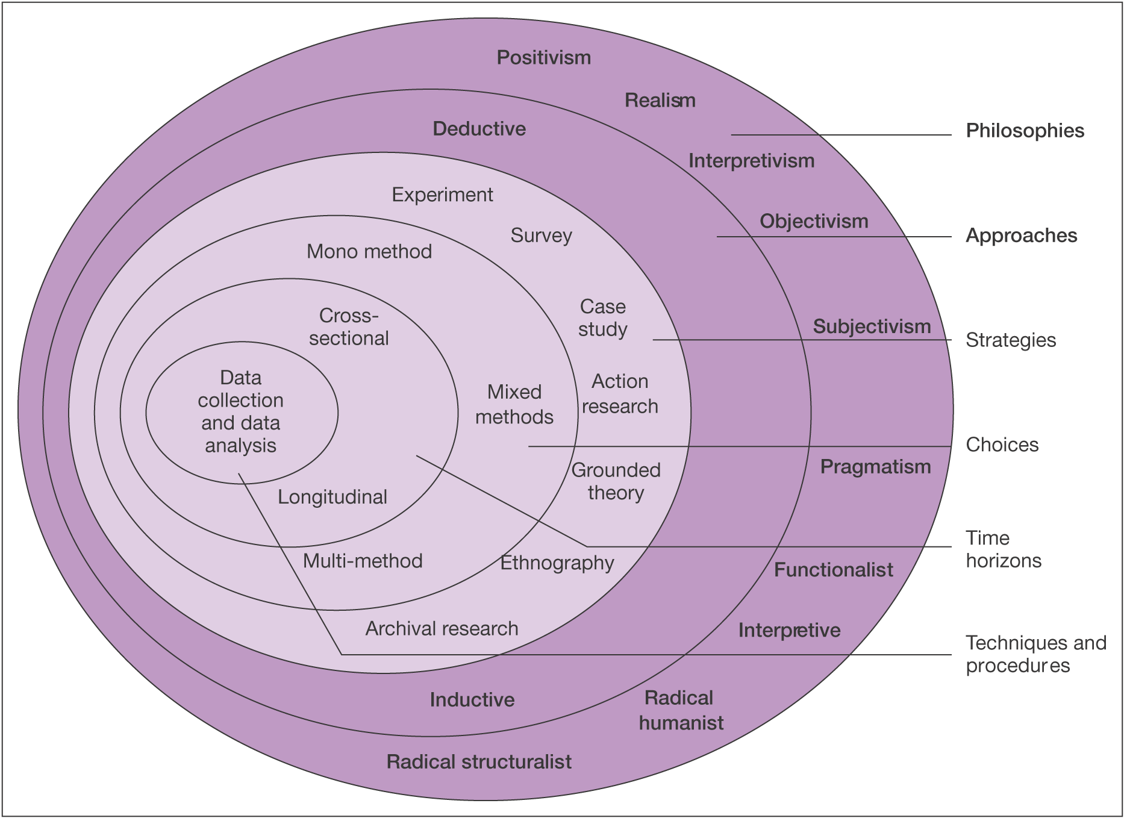

As can be viewed in the above diagram the research onion can be broken down into several layers the first of which is the research philosophy. This dissertation will adopt two main philosophies as the objectives listed can be split into two distinct categories, that being Positivism and Interpretivism.

Positivism is the philosophy of quantative data and can be described simply as the collection of data and is often associated with what is described as the hard sciences (Bryman, 2021). This philosophy will be used to assist in analysing the data on the number and severity of terrorist attacks as this data does not require nor benefit from any interpretation other than the numerical values.

Interpretivism is the polar opposite of Positivism and this philosophy takes on the opinions of individuals which can vary wildly from person to person (Bryman, 2021). As this dissertation is aiming to obtain the views and perceptions of the general public regarding the effectiveness of counter-terrorism it cannot simply look to hard data for the answers. Due to this necessity this dissertation must also look to the subjective as well and so must strike a balance between both philosophies despite their contrasting natures.

An inductive approach will be utilised during this research as it aims to utilize and review the data presented to create a theory rather than to begin with a theory and utilize data to either prove or disprove it’s theory as would be done through a deductive approach (Bryman, 2021).

Due to the multiple varieties of data gathered a mixed-method approach will have to be utilised for this research as it will provide a questionnaire that allowed for both numerical and interpretive data to be collected. The questionnaire provided to members of the public and to counter-terrorism will allow the opportunity to express their opinions on certain topics as well provide a simple scale to provide a more simplified and easily digestible viewpoint.

The final layer of the onion is that of Time Horizons, which is to say in it’s simplest form the time allotted to the research being conducted. Due to the limited time-frame in this study a Cross-Sectional approach is the most suitable as this study also hopes to lead into and benefit future studies (Saunders, 2009).

This Dissertation will utilize two questionnaires to collect data which will be accessible to participants anonymously and will offer similar questions to one another but will have slight variations.
Two main groups will be sampled during this dissertation, the first group will be a small portion sampled randomly from the general population and will be sampled largely from those who are convenient and volunteer themselves, though with the advent of social media making the sample of convenience possibly limitless, though the sample will have to be limited due to the limited time available to review all data. The second sample will be those officers currently working within the counter-terrorism sphere though again will be anonymous.

An important aspect of any study conducted is the reliability of the data it utilizes as well creates, and as explained by (Saunders, 2009) data collected must be reliable and credible and align with the aims of the research.

The greatest limitation within this study is the allotted time frame for this dissertation being only a few months. As such a complete and accurate picture of the opinions and feelings of the general public cannot be obtained and analysed due to the large diversity within the UK not only in terms of opinions but geographical locations as well as religious beliefs etc could play a significant role in their opinions.

Ethical considerations are an important factor within any study and as such prior to the commencement of this dissertation an ethics was completed and approved to ensure there was no ethical concerns. Prior to the collection of any data participants were informed how the data was going to be utilised and what the purpose of the data was to ensure informed consent. Participants were also notified that there participation was on a voluntary basis and that they had a right to withdraw at any point during the project. Participants were also informed that anonymity was granted and that no personal data would be collected to ensure privacy of individuals.

In conclusion, this chapter has successfully identified the most appropriate methodology for this dissertation and has successfully described the methodology that will be utilised.

Bibliography
Bryman, A. S. L. F. L. a. C. T., 2021. Bryman's Social Research Methods. 6th ed. Oxford: Oxford University Press.
Fitchburg State University, 2023. Educational Research. [Online]
Available at: https://fitchburgstate.libguides.com/c.php?g=839397&p=5996314#:~:text=Primary%20%3D%20original%2C%20first%2Dhand,interpret%20that%20other%20person%27s%20data.
[Accessed 18 03 2024].
Saunders, M. L. P. a. T. A., 2009. Research Methods for Business Students, England: Pearson Education Limited.

