
Digital Transformation in the Health and Care Professions (BMHP6026)
Component 1: Written Report
‘Telemedicine and Virtual Consultations: A Critical Evaluation of Digital Transformation in UK Health and Social Care’

Student name: Abdulai Kamara
Student number: 2328050
Lecturer’s Name: Dr Laila Surna

Table of Contents
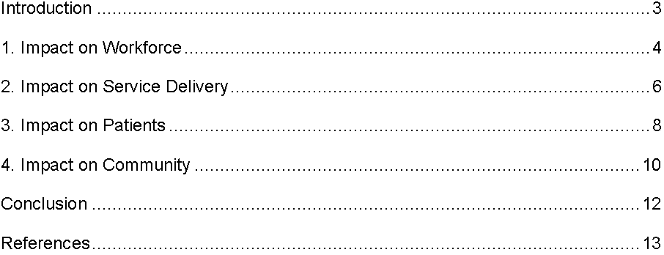

Introduction
The digital revolution has significantly contributed towards reshaping health and social care services in the United Kingdom. Telemedicine or virtual consultation is one of the most important. Telemedicine enables healthcare practitioners to deliver medical services off-site through video conferencing, telephone sessions, mobile app and e-secure systems (Rabbani et al., 2025). The use of it increased rapidly during the COVID-19 pandemic, as NHS England was increasing remote consultations to maintain essential services and prevent risks of infections. This move also aligns with the digital priorities in the NHS Long Term Plan, which recommends the use of technology in care delivery to increase access and system efficiency. This report presents a critical analysis of the application of telemedicine in the UK health and social care. Computerised programmes such as Attend Anywhere and eConsult can help in remote assessment, diagnosis and follow-up treatment in the primary and secondary setting. Telemedicine offers flexibility, convenience and can be less expensive to patients and providers. The report evaluates the following service delivery, workforce practice, and patient experience impacts.

1. Impact on Workforce
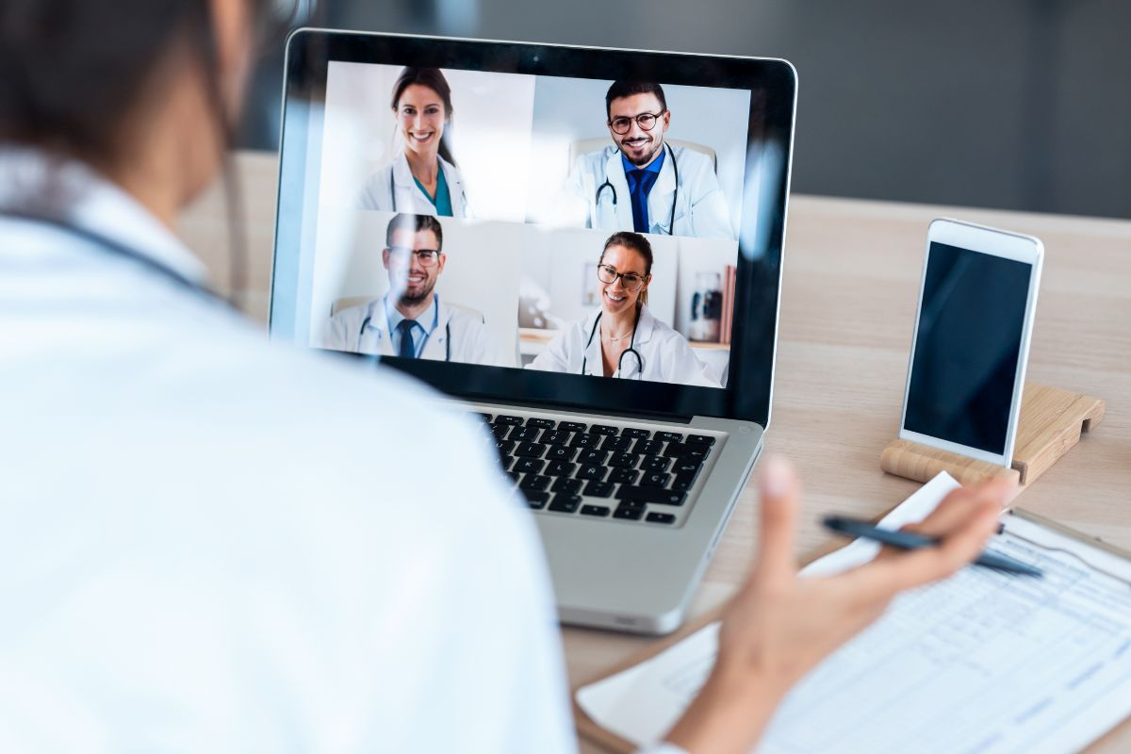
Figure 2: The Impact of Technology on Health and Social Care in the UK
Sources: https://www.belolaw.com/blog/
Telemedicine has changed the role and practice of health and social care professionals in the UK. Physical examination and close personal contact were traditionally considered the main aspects of clinical work (Wetzlmair et al., 2022). The breakthrough development of remote consultations forced practitioners to adapt more quickly to the discipline of technology-based care. This transition demanded a higher level of digital literacy and a conviction in the capacity to work on virtual platforms and analyse and assess patients without a practical assessment. This change was accelerated by NHS England instructions during the COVID-19 pandemic, through the integration of remote models into the routine services. Consulting skills have evolved significantly.
Clinicians are now incorporating structured questioning, explicit verbal communication and critical observation utilising video interfaces. It lacks physical examination and improves patient self-reporting and clinical judgement. This will not only be capable of strengthening listening skills and joint decision-making, but it will also increase diagnostic uncertainty in complicated or uncertain cases. The community nurses and general practitioners must apply the method of risk stratification to understand when they should reconsider the face-to-face. These changes are mental and require constant professional development.
Work patterns have been flexible as well. Remote clinics enable a portion of the workforce to work at home to enhance scheduling flexibility and provide caregivers with children or health conditions (Massaro, 2023). The flexibility of labour has also improved due to flexible work arrangements that enhance labour flexibility in times of instability. Nevertheless, work and personal life can be threatened by the presence of digital technology at any time. Online communication, remote meetings, and e-documents also have a history of long working hours and exhaustion. The importance of digital overload and administrative workload during the rapid adoption of technologies was reported.
New professional jobs have emerged to enable digital integration. These are telehealth coordinators, digital transformation leads and clinical informatics specialists, and they indicate that technology and healthcare are getting closer. These functions enable innovation and upgrade of the system (Adeghe et al., 2024). Despite these developments, it is still possible to observe disparity in digital competence. There are also anxious or resistant employees who do not like change. The difference in training and confidence could influence the consistency of services. Overall, telemedicine has increased flexibility and fostered new skills, yet has also increased performance pressure and the necessity to facilitate formal training, leadership, and well-being policies of the workforce.

2. Impact on Service Delivery
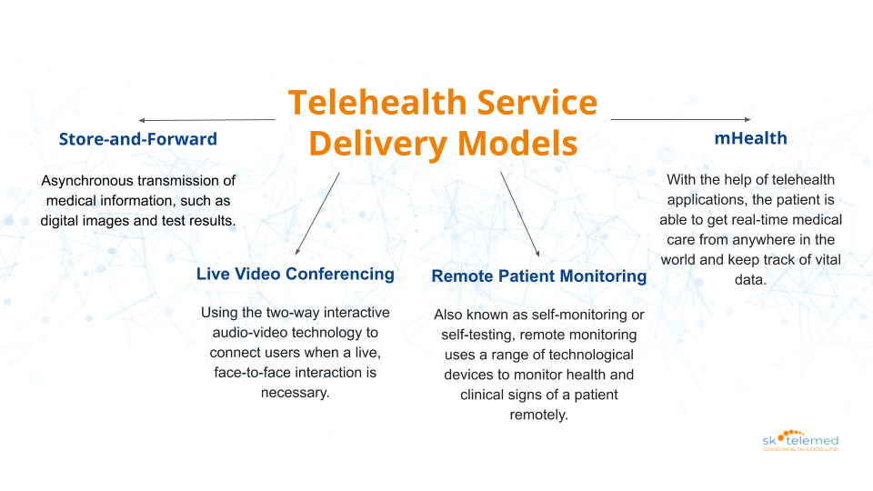
Figure 3: Telehealth Service Delivery Models
Sources: https://www.sk-telemed.co.at/
Telemedicine has radically transformed the process of service delivery in UK health systems. The traditional models were founded on physical assumptions and face-to-face appointments. The remote consultation trend has revolutionised the care model to digitally-enabled care, whereby patients can interact with professionals through online portals or telephone care (Husain, 2024). On such platforms as Attend Anywhere and eConsult, virtual triage, assessment, and follow-up are offered. This digital model enables the strategic objectives that are outlined in the NHS Long Term Plan that promote efficiency, which is technology-oriented and patient-centred care.
The major benefit is that of increased accessibility. Patients will be able to consult without necessarily having to travel, and this will help patients in rural areas, the physically disabled, and working patients. The practices can prioritise the cases according to their urgency using the digital triage systems, which can reduce the waiting time and unnecessary appointments made unnecessarily (Stoumpos et al., 2023). In the area of primary care, where the primary care provider operates under the model of digital-first, many practices reach out to the client first through the internet and subsequently arrange a physical-inspection visit accordingly. This model can streamline the working process and discover the means of maximising the use of resources.
Telemedicine increases readiness to infections and crises. Remote consultations reduced the pandemic exposure risk since they ensured preservation of the required services. This depicted how virtual infrastructure can be useful during a pandemic. Also, remote monitoring tools can help to manage long-term conditions and reduce hospitalisation. Despite the existence of these advantages, limits exist. Some of them cannot be virtually duplicated and require physical study, diagnostic testing or safeguarding evaluation. The overutilization of remote triage may result in the fact that there are no known symptoms or insufficient development of severe disease.
Care and patient satisfaction may be disrupted due to technical problems, including the unavailability of connectivity and software errors. Integration issues also influence service efficiency (Picón-Jaimes, 2024). The inconsistency with the digital platform and electronic health records may cause the duplication of data entry and slow down the communication process. Quality infrastructure, clear clinical guidance and good administrative structures are therefore needed. Telemedicine has made it easier and operationally more flexible, but the safety, equity, and quality standards require continuous assessment and improvement of the system.

3. Impact on Patients
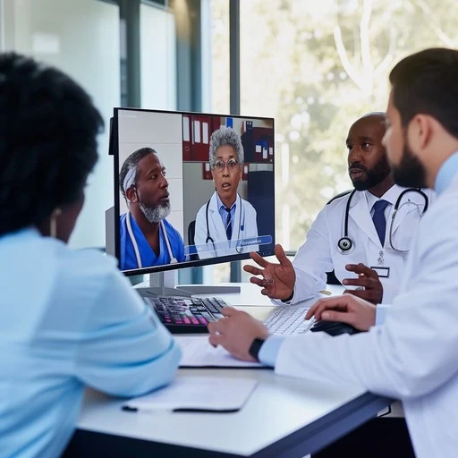
Figure 4: Virtual Medical Consultation
Sources: https://stockcake.com/i/virtual-medical-consultation_266238_52742
Telemedicine has altered the way patients interact with healthcare significantly in terms of access, experience and decision-making process. The most outstanding advantages are convenience. Virtual consultations save time and money on travelling, and the patients save time and money (Leone et al., 2022). This flexibility is especially favourable to the residents of rural or remote places, those with limited mobility, and working adults in general, because it allows arranging the visit in such a manner that would accommodate the time of the individual and the professional life of the latter. This availability can also elevate adherence to care plans and follow-up visits, which improves the overall health outcomes. E-health promotes patient autonomy and power, as well.
Online platforms often make the system of appointments, medical records, test results of tests, and educational materials available. A virtual environment might be less daunting compared with the classic clinical environment, where more open dialogue can be conducted, particularly when a sensitive or confidential health matter is at issue (Konopik & Blunck, 2023). In addition to these benefits, digital healthcare also exposes social and technological inequalities. The issue of digital exclusion is a trendy issue within the UK. It can be very challenging for the elderly, disabled people and less socioeconomically stable people and those who cannot access reliable internet services and appropriate devices. The absence of specific steps will ensure that these groups will experience the risk of reduced access to healthcare that will widen the existing disparities.
The other challenge is linked to patient experience and trust. Consultations via the Internet may be less personal, and without physical examination, they may undermine the quality of the clinical examination. Development of rapport and trust in the online setting is particularly difficult in the case of complicated cases or mental health appointments (Matthews et al., 2023). Some patients will feel that the relational aspect of care is compromised, which could impact their engagement and satisfaction in the long term. Another issue is privacy and confidentiality. The community or small residential patients will not be able to access privacy to conduct consultations. This can limit transparency and quality of care.
Health services need to be provided at a secure platform and counselling on maintaining it confidential at home. On the whole, telemedicine has a significant influence on access to healthcare, convenience, and patient empowerment, as compared to in-person healthcare. However, it is also characterised by equity, personal connection and privacy concerns. In order to achieve the maximum benefits, the healthcare systems should consider including strategies in the form of digital literacy support, infrastructure improvements with a specific focus, and design centred on patients.

4. Impact on Community
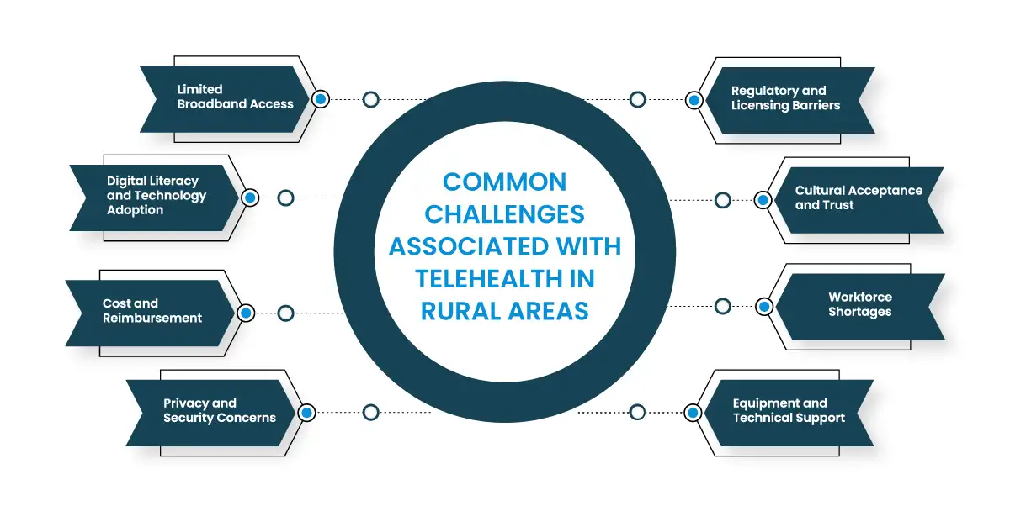
Figure 5: Telehealth's Impact on Rural Health Disparities
Sources: https://globalccm.us/telehealth-in-rural-areas/
Telemedicine has revolutionised the process of delivering healthcare at communal levels by offering an opportunity to improve access, sustainability and general health among the people. Virtual consultations are more efficient to serve remote, underserved, or vulnerable populations by reducing the reliance on physical healthcare facilities (Pickard Strange et al., 2023). Such a location elasticity encourages early intervention and preventive care that is the foundation of the public health agenda. Consultations, follow-ups, and chronic disease management may be provided to the previously disadvantaged communities and help the regions to reduce health disparities and improve population health.
The other significant impact is sustainability. Telehealth reduces the travel of patients and personnel and reduces the cost of transportation and carbon emissions. Telemedicine can also be used to monitor the trends in population health, in which healthcare providers can access real-time information about service consumption, chronic disease trends, and outcomes (Mijal et al., 2023). These insights support the evidence-based decision-making and support the strategies of population health. There is also enhanced community engagement through telemedicine. The residents can use online platforms and feedback systems to participate in the development of services and influence healthcare planning.
Co-production opportunity enables the communities to express their preferences, suggest improvements, and play their part in the manner of adjusting the services to fit the local demands. This involvement can build trust and increase patient satisfaction as well as make health interventions more sensitive to population needs. However, challenges remain. The digital infrastructure is unequal, and underprivileged neighbourhoods or populations have lower or no access to good internet and technology. This introduces disparities in the access and efficacy of telemedicine. Moreover, deprivation of face-to-face interaction may result in social isolation of some members of the community, particularly those who are older or have fewer support networks. Ensuring that the vulnerable groups are not marginalised by the digital services will be the most important aspect.
To maximise the benefits of telemedicine on the community level, infrastructure, digital literacy programs and support services investment is needed. The communities must be provided with tools and instruments that enable them to interact well with virtual care (Singh et al., 2021). Planning must consider social, technological, and environmental factors in order to bring about equitable outcomes. Overall, telemedicine strengthens access to care, sustainable delivery, and data-supported management of the health of the population. However, it may be employed to neglect its potential without certain investment and non-discriminatory policies. Telemedicine is an essential tool in the health system of the present century since it could significantly expand the scope of the community, improve health outcomes, and enable people to become active participants in healthcare delivery, under the right application.

Conclusion
In conclusion, telemedicine and virtual consultations have emerged in the past few years as one of the largest digital inventions in UK health and social care. NHS initiatives and the COVID-19 pandemic have led to a scenario where care is no longer provided through the traditional delivery of in-person care (Mishra & Sharma, 2022). This report has addressed the effects of this change at different levels. Digital care has brought new skills and flexibility to healthcare staff, but mental load and burnout. Remote consultations have simplified service delivery, made it more accessible and more resilient, whereas certain complex cases are not easily managed remotely. Digital barriers and a less close personal relationship with clinicians have created improved control and convenience in the care. Telemedicine can address more individuals on the community level and advance the sustainability of practices, yet it can widen disparities in the event of inadequate infrastructure. Overall, the potential of virtual care is great, and planning, training, and equitable access to the facilities should be planned to introduce it as a safe and efficient practice.

References
Adeghe, E.P., Okolo, C.A. and Ojeyinka, O.T., 2024. A review of emerging trends in telemedicine: Healthcare delivery transformations. International Journal of Life Science Research Archive, 6(1), pp.137-147.
Husain, L., 2024. The scale up of remote consultations in UK primary care and its implications for digital health disparities (Doctoral dissertation, University of Oxford).
Konopik, J. and Blunck, D., 2023. Development of an evidence-based conceptual model of the health care sector under digital transformation: integrative review. Journal of Medical Internet Research, 25, p.e41512.
Leone, E., Eddison, N., Healy, A., Royse, C. and Chockalingam, N., 2022. Do UK Allied Health Professionals (AHPs) have sufficient guidelines and training to provide telehealth patient consultations?. Human Resources for Health, 20(1), p.82.
Massaro, M., 2023. Digital transformation in the healthcare sector through blockchain technology. Insights from academic research and business developments. Technovation, 120, p.102386.
Matthews, M., Hamoni, R. and Watson, M., 2023. Digital Transformation: The Next Big Leap in Healthcare. Available at SSRN 4501812.
Mijal, M., Marczewska, M., Kostrzewski, M., Banka, M. and Kamiński, A., 2023. Digital transformation of healthcare and job roles changes. Procedia Computer Science, 225, pp.1957-1963.
Mishra, V. and Sharma, M.G., 2022. Digital transformation evaluation of telehealth using convergence, maturity, and adoption. Health Policy and Technology, 11(4), p.100684.
Pickard Strange, M., Booth, A., Akiki, M., Wieringa, S. and Shaw, S.E., 2023. The role of virtual consulting in developing environmentally sustainable health care: systematic literature review. Journal of Medical Internet Research, 25, p.e44823.
Picón-Jaimes, Y.A., 2024. Innovation and digital transformation in health education: opportunities to drive technological development in the training of future professionals. Inge CuC, 20(2), pp.99-105.
Rabbani, M.G., Alam, A. and Prybutok, V.R., 2025. Digital Health Transformation Through Telemedicine (2020–2025): Barriers, Facilitators, and Clinical Outcomes—A Systematic Review and Meta-Analysis. Encyclopedia, 5(4), p.206.
Singh, S., Bhatt, P., Sharma, S.K. and Rabiu, S., 2021. Digital transformation in healthcare: Innovation and technologies. In Blockchain for healthcare systems (pp. 61-79). CRC Press.
Stoumpos, A.I., Kitsios, F. and Talias, M.A., 2023. Digital transformation in healthcare: technology acceptance and its applications. International journal of environmental research and public health, 20(4), p.3407.
Wetzlmair, L.C., O'Carroll, V., O'Malley, A.S. and Murray, S., 2022. Teleconsultation in health and social care professions education: a systematic review. The Clinical Teacher, 19(5), p.e13519.

