Humanities Sprint 1 (Pillar 1)

General information to consider
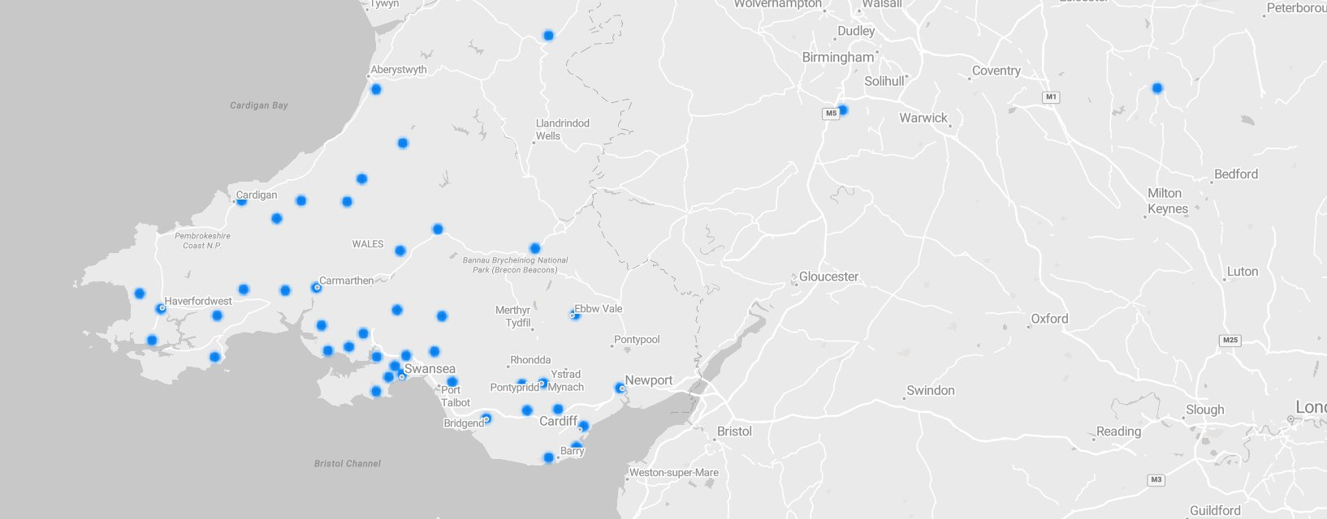Post-Covid Humanities discipline has attracted students primarily from West and South Wales.

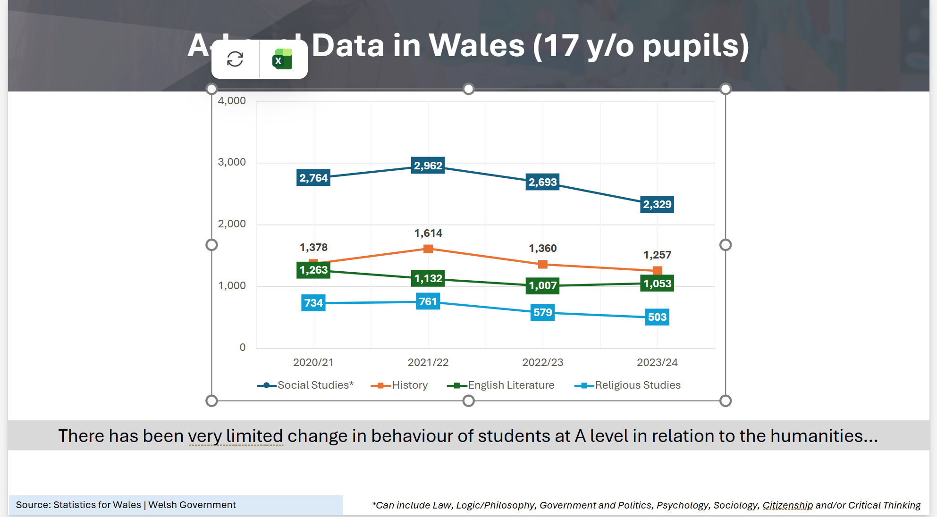
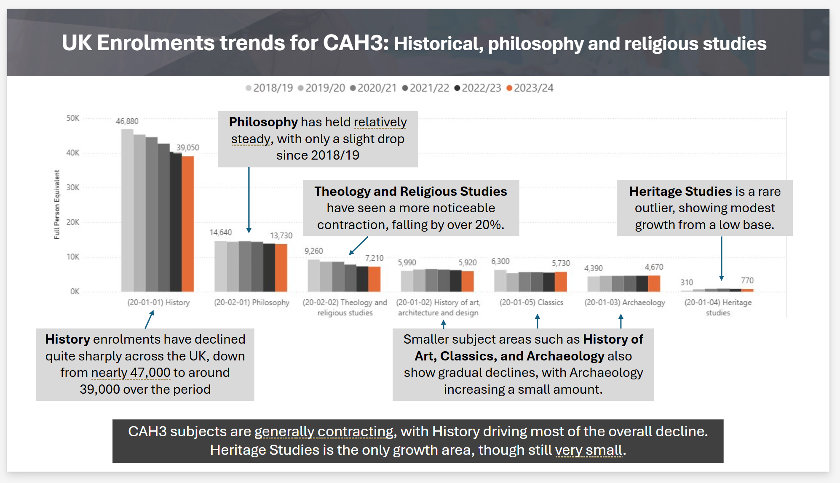

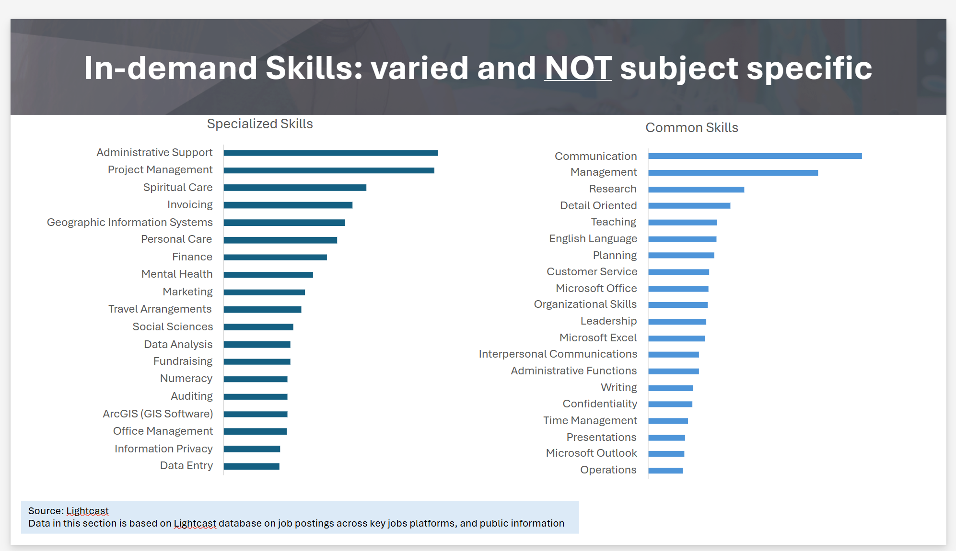

Main Competitors
For the humanities overall (in order of importance)
- S93 Swansea University
- C15 Cardiff University
- C20 Cardiff Metropolitan University
- W76 University of Winchester
- A40 Aberystwyth University

Swansea Offer (Pillar 1)
- 3 year BA
- 4 year with Year abroad
- 4 year with Year in industry
- Tariff: 128-112; ABB-BBC
- Across the board lower actual accepted grades
- Fieldtrip offer
History, BA (Hons) - Swansea University
Ancient and Medieval History, BA (Hons) - Swansea University
Ancient History, BA (Hons) - Swansea University
Classical Studies, BA (Hons) - Swansea University
Egyptology and Ancient History, BA (Hons) - Swansea University
American Studies and History, BA (Hons) - Swansea University

Cardiff Offer (Pillar 1)
- 3 year BA
- Tariff: ABB-BBC
- Across the board lower actual accepted grades
History (BA) - Study - Cardiff University
Archaeology (BA) - Study - Cardiff University
Archaeology and Ancient History (BA) - Study - Cardiff University – DISCONTINUED
Archaeology and Heritage Science (BSc) - Study - Cardiff University
Archaeology and History (BA) - Study - Cardiff University
Ancient History (BA) - Study - Cardiff University – DISCONTINUED

Cardiff Met Offer (Pillar 1)
None

Winchester Offer (Pillar 1)
- 3 year BA
- Tariff: 104-120
- Average grade of accepted: BBB
BA (Hons) History - University of Winchester
Offers placement, fieldtrip and year abroad options
BA (Hons) Ancient Classical and Medieval Studies - University of Winchester
Offers placement, fieldtrip and year abroad options
BA (Hons) Archaeology - University of Winchester
Take part in home and overseas fieldwork projects currently in Germany and the Republic of Georgia
BA (Hons) Classical Studies - University of Winchester
BA (Hons) History and Archaeology - University of Winchester
Fieldwork offered
BA (Hons) Medieval History - University of Winchester
Offers placement, fieldtrip and year abroad options
BA (Hons) Modern History - University of Winchester
Offers placement, fieldtrip and year abroad options
BSc (Hons) Archaeological Practice - University of Winchester
Option of four-year pathway with a professional placement year
Fieldwork projects in the UK and overseas
https://www.winchester.ac.uk/study/undergraduate/Courses/BSc-Hons-Archaeological-Practice-with-Professional-Placement/

Aberystwyth Offer (Pillar 1)
- 3 year BA
- Tariff: 96-120
- Average grade of accepted: CCC
Aberystwyth University - History and Welsh History VVC2 BA
Aberystwyth University - History V10F BA
- As part of your degree course, you will have the opportunity to study abroad at a partner university, to undertake Heritage sector work placements and to plan for your future career.
Aberystwyth University - Medieval and Early Modern History V190 BA
- As part of your degree, you will have the opportunity to study abroad at a partner university, to undertake Heritage sector work placements and to plan for your future career.
Aberystwyth University - Modern and Contemporary History V191 BA
- As part of your degree, you will have the opportunity to study abroad at a partner university, to undertake Heritage sector work placements and to plan for your future career.

