
OME – Chemistry (ACDA4011)

07/12/2020

Nathan Rowe - 1910544

Declaration
I declare that this report is the product of my own work and is not being submitted for any other degree etc.

Contents

1 Introduction 4
2 Background 4
2.1 Fragmentation Grenade 4
2.2 Explosive Train 5
2.3 Primer 5
2.3.1 Lead Styphnate 5
2.3.2 Barium Nitrate 6
2.4 Delay 7
2.4.1 Common Fuels: 7
2.4.2 Common Oxidizers 8
2.4.3 Barium Chromate 8
2.4.4 Potassium Perchlorate 9
2.5 Detonator 9
2.5.1 PETN – Pentaerythritol Tetranitrate 9
2.6 Main Charge 10
2.6.1 RDX - Cyclotrimethylenetrinitramine 10
3 Conclusion 11

References

[1] | The Oxford Essential Dictionary of the U.S.Military, Oxford University Press, 2002.
[2] | “ScienceMadness Wiki,” 13 05 2020. [Online]. Available: http://www.sciencemadness.org/smwiki/index.php/Lead_styphnate.
[3] | “ScienceMadness Wiki,” 29 06 2019. [Online]. Available: http://www.sciencemadness.org/smwiki/index.php/Barium_nitrate.
[4] | “DSIAC,” [Online]. Available: https://www.dsiac.org/resources/articles/a-titanium-based-igniter-system-for-hand-grenade-fuzes/#:~:text=The%20pyrotechnic%20delay%20formulations%20typically,lead%20chromate%2C%20and%20potassium%20perchlorate.. [Accessed 07 12 2020].
[5] | “Wikipedia,” 05 12 2020. [Online]. Available: https://en.wikipedia.org/wiki/Pentaerythritol_tetranitrate#:~:text=Pentaerythritol%20tetranitrate%20(PETN)%2C%20also,structurally%20very%20similar%20to%20nitroglycerin..

Introduction
Simple Explosive Devices have their place in many different areas of everyday life. They are present in even the most obscure of areas, but offer numerous different useful properties when controlled in a proper manner. Beyond the use of everyday life, Simple Explosives can be found in Industry, in places such as mining, demolition, construction, and manufacturing. The Armed Forces/Military also use these Explosives in many of the Munitions products which they use to defend the Nation.
This document reports the exploration of materials which can be used in Simple Explosive Devices. General physical and chemical properties, as well as heat capacities and exothermic interactions, alongside manufacturing methods will also be investigated.

Background
For the purposes of this document, a Hand Grenade (time-delay fragmentation anti-personnel hand grenade by its correct name) will be discussed. It is also important to state, that the terminology used throughout the industry for different sub components, is vast. For the purposes of this document, all terminology will be consistent.
.

Fragmentation Grenade
Hand Grenades are widely used throughout The Worlds’ Armed Forces, due to their power, effectiveness, low weight, and cost. Grenades are built up from many components. The Fuze sub assembly as seen in [Figure 1], is assembled into an explosively filled, Steel body [Figure 2]
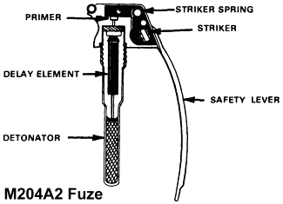
Figure 1 - M204A2 Fuze
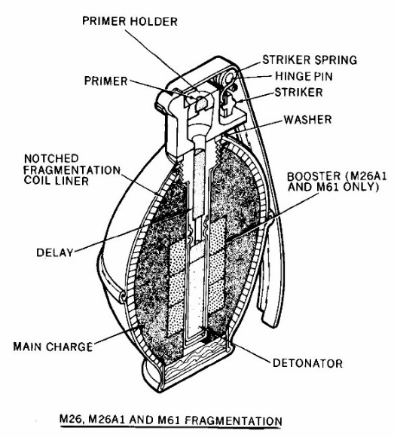
Figure 2 - M26 Hand Grenade
The basic functions throughout Hand Grenades, and namely the Fuze [Figure 1] are all fairly similar, such that a Primer is struck, this ignites the Delay which burns until it reaches the Detonator, which in turn initiates the Main Charge [Figure 2] – this is commonly referred to as the Explosive Train [Figure 3]. The Explosive Train is described further in Section 2.2.

Explosive Train
The Explosive Train, as defined by the Oxford Dictionary [1] as a succession of initiating and igniting elements arranged to cause a charge to function. These trains are generally multi-stage. In the case of the aforementioned Fragmentation Grenade, there are four [Figure 1]:
- Primer
- Delay
- Detonator
- Main Charge
Each part of the train provides sufficient energy in order to ‘take-over’ the next step. For example, with the detonator removed – the energy created by the Delay would not be great enough to initiate the Main Charge

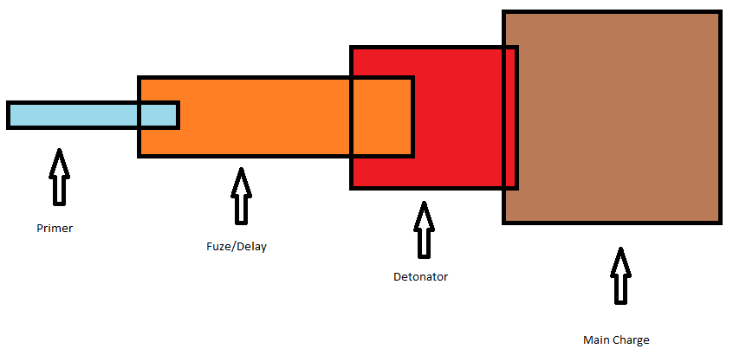
Figure 3 - Explosive Train diagram

Primer
The first part of the Explosive train. The Primer provides the initial burst of energy in order to start the train. The main chemicals used in these components are generally Lead Styphnate, and Barium Nitrate – though it is worth noting, that there are a number of Metal free/non-toxic Primer available.

Lead Styphnate
The Lead Salt of Styphnic Acid – commonly used as a Primary Explosive. Sensitive to heat, friction, and shock. It is reddish orange in appearance [Figure 2], and can be manufactured by reacting Styphnic Acid with Lead hydroxide or carbonate [2]. It is very stable at room temperature, but is very sensitive to static. Care must be taken to ensure no static is present during the manufacture and processing of Lead Styphnate.
It has a good shelf life in dry conditions, but like many primary explosive, it is unstable in the presence of water/moisture. It alone cannot be used as a detonator, as it is fairly resistant to initiating through impact.

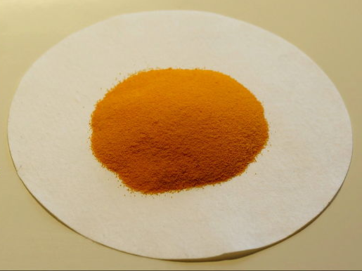
Figure 4 - Lead Styphnate
Chemical Formula | C₆HN₃O₈Pb
Chemical Structure | 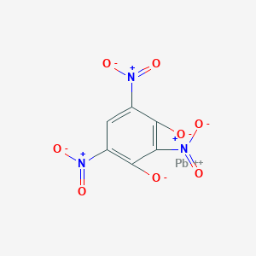
Molar Mass | 450.288g/mol
Odour | Odourless
Density | 3.06g/cm³
Boiling Point | Detonates
Solubility | Insoluble in most organic solvents
Figure 5 - Lead Styphnate Properties

Barium Nitrate
A compound, which acts as the oxidiser for the reaction. A hygroscopic solid which is white and odourless [Figure 4]. It can be manufactured by reacting and crystallising barium oxide, hydroxide, or carbonate, with citric acid [3]. As it is an oxidizer, it must be kept away from any sources of moisture, and can inadvertently ignite any combustible material if heated by flame.
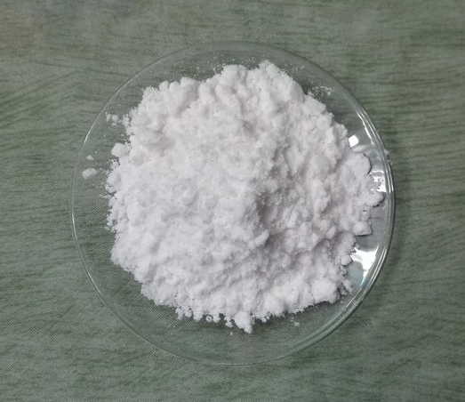
Figure 6 - Barium Nitrate
Chemical Formula | Ba(NO₃)₂
Chemical Structure | 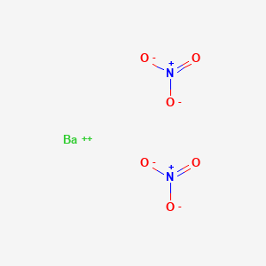
Molar Mass | 261.337g/mol
Odour | Odourless
Density | 3.24g/cm³
Boiling Point | Decomposes
Solubility | Insoluble in alcohols and hydrocarbons
Figure 7 - Barium Nitrate Properties

Delay
The Delay is the second part of the Explosive Train. Much like the Primer, this provides the Energy required for the next part of the Train. But, delay charges burn at a much slower and consistent rate. This quite simply, allows there to be a time delay, between the User initiating the Explosive Train, and the Main Charge initiating. A Fragmentation Grande which went off in the User’s hands would be less than ideal.

Common Fuels:
- Silicon
- Boron
- Manganese
- Tungsten
- Antimony

Common Oxidizers
- Lead dioxide
- Iron oxide
- Barium chromate
- Lead chromate
- Bismuth
DSIAC (Defense Systtems Information Analysis Centre) state that “typical Fragmentation Grenades fuzes use objectional chemical such as Barium Chromate, Lead Chromate, and Ptassium Perchlorate” [4]. For the purposes of this Grande, Barium chromate will be assessed.

Barium Chromate
Barium Chromate (also known as Barium Tetraoxochromate) is a yellow sand like powder [Figure 6]. Much like the Barium Nitrate previous discussed, the Chromate is a good oxidizer which is used in many type of Pyrotechnic delays. It is synthesised by reacting Barium Hydroxide or Chloride with Potassium Chromate.
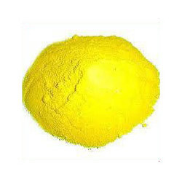
Figure 8 - Barium Chromate
Chemical Formula | BaCrO₄
Chemical Structure | 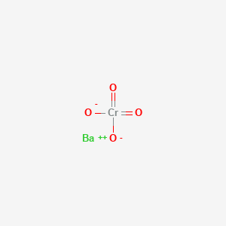
Molar Mass | 253.37g/mol
Density | 4.498g/cm³
Solubility | Soluble in strong acids
Figure 9 - Barium Chromate Properties

Potassium Perchlorate
Is a strong inorganic salt oxidizer, which reacts slowly with organic substances. It is colourless and has a heap of uses. It can often be found in Primers, as well as fireworks and sparklers. It can be produced through
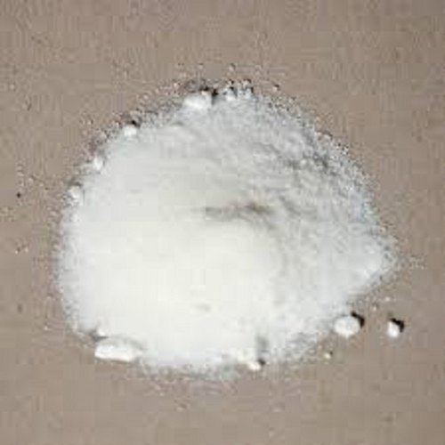
Figure 10 - Potassium Perchlorate
Chemical Formula | PClO₄
Chemical Structure | 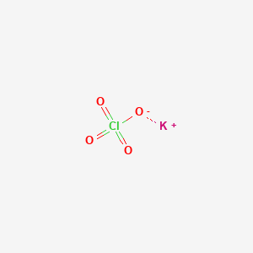
Molar Mass | 138.55g/mol
Density | 2.5239g/cm³
Solubility | Negligible in alcohol, insoluble in ether
Figure 11 - Potassium Perchlorate Properties

Detonator

PETN – Pentaerythritol Tetranitrate
Comes by many names, but commonly PETN. It is an explosive material, which is the nitrate ester of pentaerythritol. It can be manufactured by reaction of pentaerythritol and concentrated nitric acid [5]. It is more difficult to detonate than primary explosives, so makes a good bridge between the Delay and Main charge as discussed in Section 2.2.

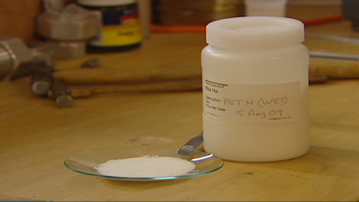
Figure 12 - PETN
Chemical Formula | C₅H₈N₄O₁₂
Chemical Structure | 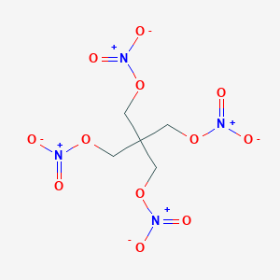
Molar Mass | 316.137g/mol
Density | 1.77g/cm³ @20°C
Detonation Velocity | 8400 m/s
Figure 13 - PETN Properties

Main Charge

RDX - Cyclotrimethylenetrinitramine
Also has a number of names, but most commonly referred to as RDX. It is obtained by treating hexamine with white fuming nitric acid. It is a white solid, which is tasteless and has no scent.
RDX composition dissociation from primary explosive initiation: C₃H₆N₆O₆ – 3CO + 3H₂O + 3N₂

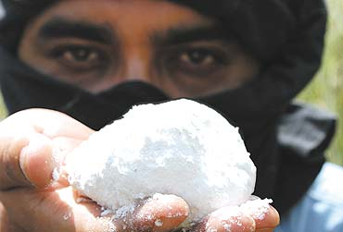
Figure 14 - RDX
Chemical Formula | (O₂N₂CH₂)₃/C₃H₆N₆O₆
Chemical Structure | 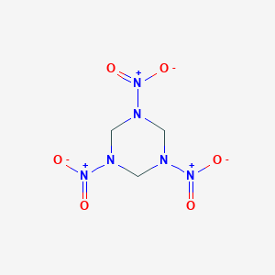
Molar Mass | 222.117g/mol
Density | 1.858g/cm³ @20°C
Detonation Velocity | 8750 m/s
Figure 15 - RDX Properties

Conclusion
Whilst it may not be deemed a conventional recipe for the contents of a Fragmentation Grenade. The Substances discussed should give sufficient reactions in order for the munition to function.

