James Dexter (1907923)
Tutor: Jessica Shore
Developing Social Enterprise
funding and finance

Riot Urban Sports Experience Workshops

Proposition to be submitted to: University of Wales Trinity Saint David’s Carmarthen



The Organisation chosen for this proposal: The Riot Urban Sports Park Project
Address: Park place, Tumble, Llanelli SA14 6EW

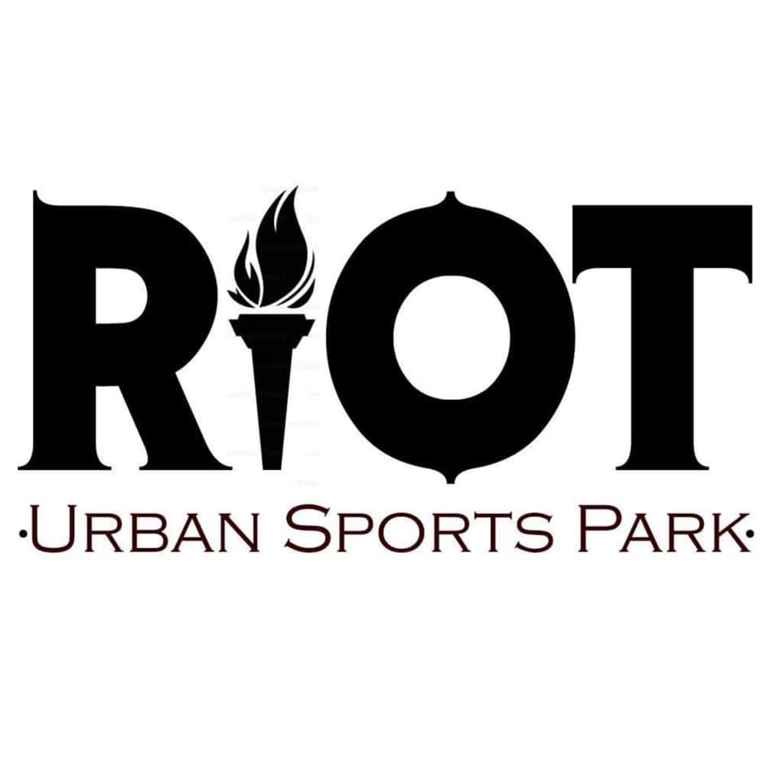

Contact information: James T Dexter
mobile number: 07498615603
Email: jamesdexter2@hotmail.co.uk

Workshop proposition summary

Riot Urban Sports Park Project is a relatively new social enterprise business based in Tumble Carmarthenshire. Riots main objective to their project is to provide a new urban sport park in a neglected mining area to help engage the local community and further afield. Riot has already managed to secure some funds from the local council to support the main project. Riot are constantly trying to find ways in which to generate income for their business but with the mindset of helping others in the process.

There are many issues facing communities all across the UK some of which are antisocial behaviour and socially excluded individuals. Social exclusion can defined as "what can happen when people or areas suffer from a combination of linked problems such as unemployment, poor skills, low incomes, poor housing, high crime, bad health and family breakdown" (Batty, 2002). Antisocial behaviour is a big problem and can be defined as “'behaviour by a person which causes, or is likely to cause, harassment, alarm or distress to persons not of the same household as the person'” (Thames valley police,2020).

Urban Sports are becoming more and more popular as even skateboarding is now being accepted into the Olympics. This means that there will be many people wanting to take up a new hobby like these but may not have the push to take it on.

This is where Riot want to play a part and help bring these sports and experiences across to schools and youth clubs across the UK by providing equipment and training in sessions for anyone who would like to be involved or had interests in these sports up to 10 participants per session. Urban sports have helped so many people in so many different ways and being able to give induvial experience and training in these sports may help their lives in all different kinds of ways. Some areas can be neglected with things for people to do leading to these social issues, by bringing these sessions to schools and youth clubs will help people become more involved in something new that will help them exercise as well as help communication skills and friendships. These urban sports can all be done individually so if someone doesn’t want to participate with others this can help them gain confidence for themselves to improve.

The income made from these sessions will be reinvested into riot to become a sustainable business to help others for years to come. This will include maintenance, new equipment, travel expenses pretty much anything to keep riot afloat and helping communities for years to come.

Contents page

Page 1. Title page……………………………………………………………………………..

Page 2. Summary………………………………………………..……………………………

Page 3. Contents page……………………………………………………………………….

Page 4. Proposal context……………………………………………………………………

Page 5-8. Process of proposal……………………………………………………………..

Page 9. Conclusion……………………………………………………………………………..

Workshop Proposal

Context

This Social enterprise funding proposal will be for a Mobile service that will allow members of the Riot Urban Sports Park project to create training and experience courses for skateboarding. This proposal will help people gain access to a sport they may not have access to due to rural areas or beaten down, rotting skateparks been left to be forgotten. For this idea to become a reality there are many things which have to be taken into consideration. Such things like pricing on equipment that will be needed for the sessions, transportation of this equipment, coaching awards for the chosen sport and also marketing materials. All of these factors must be thought about to make sure that the sessions will be efficient and worthwhile for participants but also to gain the best experience possible.

Due to social exclusion and antisocial behaviour in communities this has led to issues across the UK and worldwide. This is something that made the Riot brand initially start up as in Tumble there is a run-down kids park which is very small and rugby and football pitches that needed some TLC, not having a lot of things to do has led to issues with antisocial behaviour and social exclusion in this area. Part of a discussion to improve Tumble was a skatepark and this is what led to Riot. Riot with these issue in mind want to tackle this issue not just in tumble but most communities. This proposal has been produced to try and help engage people to participate in a sport that they wouldn’t normally have the chance to not only this but help give a chance to self-improve. Skateboarding has helped many people with different issues in life as seen from professional stories and even talking to anyone who is involved in urban sports. Sports like these can be done individually or in with others allowing plenty of room for self-progression and helping with some life skills.

These sessions if they were to go ahead will help communities and Riot themselves because of the revenue made from the sessions it would be used to allow more sessions to be held in the future along with replacement of broken equipment and outdated. Not only this but the urban sports park which is the main reason for the brand starting up will gain more money allowing it stay sustainable and open for the public as it is a free facility. Skateboarding going into the Olympics would help the hype for these sessions as people will want to represent their country in the Olympics as a dream and help keep the park running for many years with sport popularity.

Process

During this part of the report I will discuss the process and list the items and prices which the organisation will need to in order to make the sessions available for everyone.

Equipment list

A session for skateboarding will never be able to run without any equipment to offer so this would be the first step.
Skateboards – This part of the equipment is important to the sessions being held as this will skateboarding sessions will be advertised so will be much needed. During some research I have found reasonable priced complete skateboards that will be suitable for all learners, some are beginner boards and some more suited for older participants.

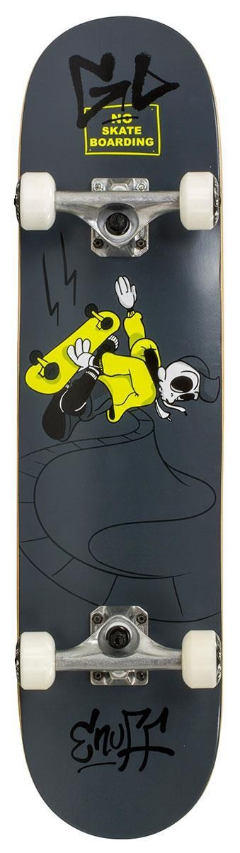
Figure 1

In figure 1 the picture of the skateboard is of a Enuff juniors complete skateboard. The board is ideal for beginners as its smaller in size than a full board so smaller people will be able to use these more effectively. Great for first time skaters. This will be ideal for school sessions for younger groups. These are priced at £39.95 per item. I would require 5 of these skateboards.

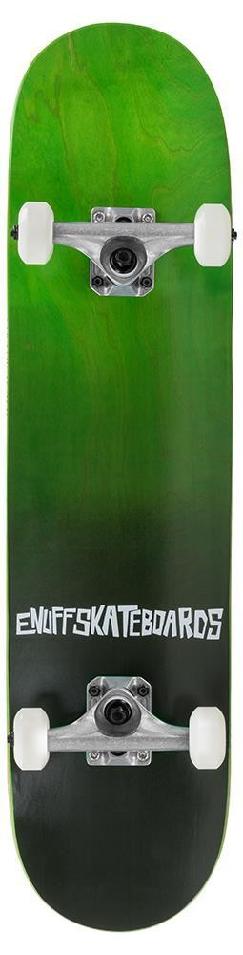
Figure 2 is of the same brand but the full-size version. These skateboards again are great for first time or beginner entry level. Being a longer board will help the bigger individuals stay more balanced and learn more efficiently. These boards are priced at £49.95 and would require 5 of these skateboards. The website order of 10 items from Skatewarehouse.co.uk would total: £449.50

Figure 2

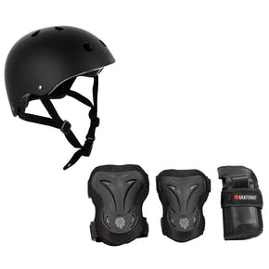
Protective gear – This equipment is something the organisation will definitely need to get covered as with this sport there are many risks and hazards. With such risks that come with skateboarding it has been made that anyone under the age of 18 must wear a helmet in and indoor skatepark at all times, although there can be exceptions for skateboarders and some others where they only have to be 14 to not wear a helmet (Rock City, 2020). Riot being very safety conscious is why the need for this certified protection is important to ensure maximum safety for participants. for everyone during the session. I have found some protective gear that will be suitable Skate hut have protective gear comes with a helmet knee pads, elbow pads and wrist pads, the cost of these are £23.99 per pack and come in different sizes. 2 extra small, 3 small, 3 medium and 2 large would be the chosen size. This would have more of a range for the participants so as many people can be part of the session as possible minimalizing people missing out. The total of this order from Skatehut.co.uk would be £239.99.
Figure 3

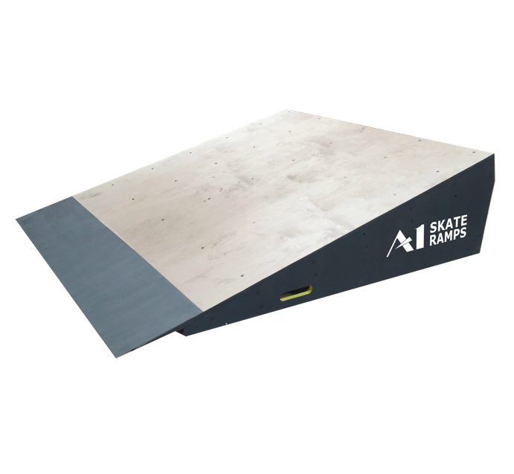
Skate ramps – Skate ramps are something that anyone with an interest who participates in skateboarding will come across. Ramps have always been known to help progress in the sport with dropping in to learning tricks on. As this will mainly be for schools and youth clubs these ramps will have to suitable from less experienced individuals to more experienced. A1 skate ramps build professional finished ramps that stock all kinds of different shape and sized ramps. For the sessions in mind I have found 2 suitable objects that will be amazing to start off with and once profit has been generated be able to reinvest into more objects to skate.
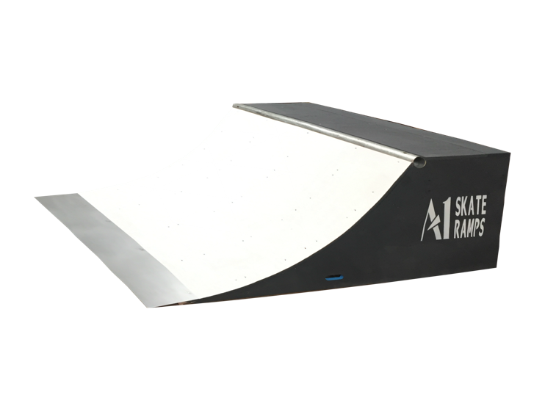

Figure 4
Figure 5

Figure 4 is what’s known as a quarter pipe one of the harder obstacles to drop in, this one is only 2ft high and 6ft long making it perfect beginners and fun for more experienced skaters. Figure 5 is what’s known as a flat bank one of the first ramps beginners will try, amazing to learn on as it won’t generate too much speed or too much of an angle. The total for both of these ramps from the same website is £560.

Coaching Award

A qualification within coaching skateboarding will have to be completed by anyone leading or shadowing the session. In the UK one qualification in skateboarding being Level 1 Coaching Skateboarding Session Course held by Skateboard England over two days for the price of £255. If the course is passed, then you will be able to coach from first steps to doing basic ramp tricks. The course does cover a lot more aspects of skateboarding though such as lesson planning (Skateboard England). This would make us qualified to teach people the sport as well as being prepared enough to spread our team members for bookings. 4 Riot team members would need to book onto this course totalling £1,020.

Transportation

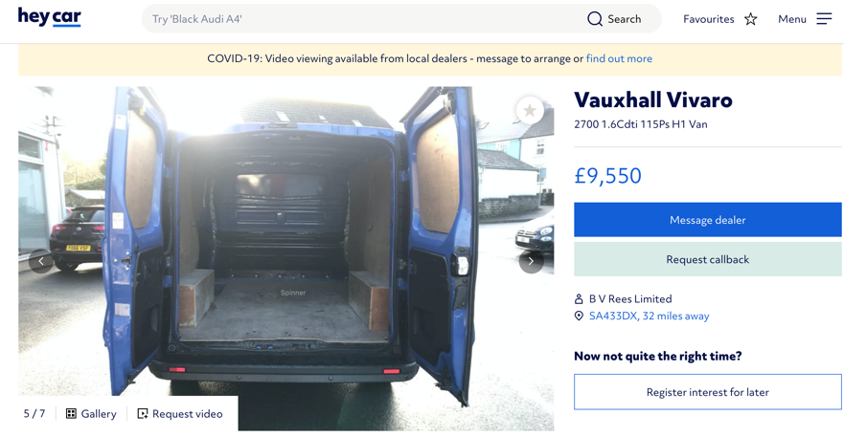
Once all the equipment has been purchased it will need to be transported to and from the sessions that take place. With so much equipment needing to be moved around and safely would require the hire or purchase of suitable sized van. A quick search into the purchase of a decent second-hand van that would be large enough and was mechanically sound would be around £10,000.
Figure 7
Figure 6
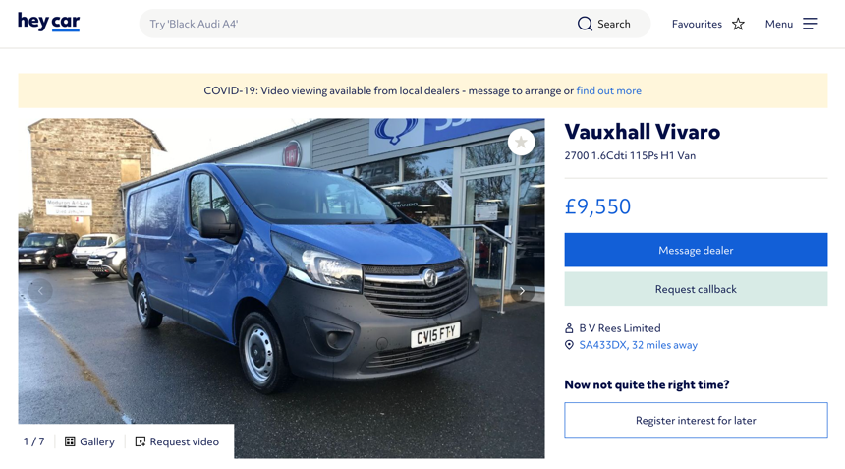

Marketing

There are many methods in which to market this proposal across especially in this day and age of technology. Riot already has a social media following on Facebook and on Instagram allowing the pages to engage with the community on a digital level for everyone able to sue the internet. This will allow the marketing to reach further afield as you can share something with everyone on your social media in seconds. Other methods of marketing will be advertisements on local radio stations. Radio Carmarthenshire (2020) rules allow you to advertise on their radio station for free if you’re a business that runs for non-profit. This way people driving anywhere with the radio tuned in will be able to find out and book the skate sessions.

Just Print in Cross Hands are a printing company that can help with the production of all kinds of ways to advertise the proposal, leaflets will be 1000xA5 for £41, business cards 1000 for £33 and A3 posters 250 for £83. The order total will be £157.

Venues to participate

Mentioned through-out this report has been mentioning about taking these sessions to schools and youth clubs. This will include areas that are quite neglected and in need of something to do and look forward to if they want to rebook again. Schools are always looking at new ways to diversify what sports they can offer the children learning. Youth clubs may already be familiar with antisocial behaviour and having new sessions brought into the club could allow tension to be taken off from repetitive club sessions. If the mobile skateboarding sessions take off, then I’m sure room for expansion can happen and even do parties for people. With schools and youth clubs they may be able to allow these sessions to run for free originally then charge after the first session.

conclusion

To make this idea become reality it will take a minimum of £13,000 of investment to cover all costs to set this up. Community is where the heart is and sometimes it’s hard to reach so we want to give that extra hand.

References

University of Wales Trinity Saint Davids picture University of Wales Trinity Saint David’s, 2020, https://www.uwtsd.ac.uk/undergraduate/

Riot Urban Sports Park Project, 28/06/2019, https://www.facebook.com/riot.usp/photos/a.1664330873630171/2387939401269311/?type=1&theater

David Batty, The Guardian, Social exclusion: the issue explained, 15/01/2002, https://www.theguardian.com/society/2002/jan/15/socialexclusion1

Thames Valley Police, what is antisocial behaviour, 2020, https://www.thamesvalley.police.uk/advice/advice-and-information/asb/af/antisocial-behaviour/

figure 1, Enuff skateboard,Sskate Warehouse, 2020, enuff fade complete skateboard, https://www.skatewarehouse.co.uk/enuff-fade-complete-skateboard-7-75-green.html

figure 2, Enuff skateboard, Skate Warehouse, 2020, enuff skully junior mini black complete skateboard, https://www.skatewarehouse.co.uk/enuff-skully-junior-mini-black-complete-skateboard-7-25.html

figure 3, Protective gear, Skatehut, 2020, https://www.skatehut.co.uk/brands/skate-hut/skatehut-protection/skatehut-helmet-pad-set-bundle.htm

Rock City, Skatepark Rules, 2020, https://rockcity.co.uk/skatepark-information/#

Figure 4, A1 Skate Ramps, 2020, https://a1skateramps.com/product/2ft-h-6ft-w-quarter-pipe/

Figure 5, A1 Skate Ramps, 2020, https://a1skateramps.com/product/4ft-w-wedge-ramp/

Skateboarding England, become a skateboard coach, 2020, https://www.skateboard-england.org/coaching

Figure 6, Hey car, Vauxhall Vivaro, 2020, https://heycar.co.uk/vehicle/vauxhall-vivaro-2015-2700-16cdti-115ps-h1-van-d46a07de

Figure 7, Hey car, Vauxhall Vivaro, 2020, https://heycar.co.uk/vehicle/vauxhall-vivaro-2015-2700-16cdti-115ps-h1-van-d46a07de

Radio Carmarthenshire, Post New What’s on, 2020, https://radiocarmarthenshire.wales/new-event/

just print, 2020, https://just-print.co.uk/50-posters

