Understanding and Engaging in the Customer Experience

BMSW 5103

Andrei Amzulescu
Student ID:2124638
Executive summary
The purpose of the report is to provide information about the famous online company Amazon. The company belongs to the American tech multinational that is working in the business of cloud computation, e-commerce, artificial intelligence and digital streaming. Then the information imparted about the marketing mix of an organisation simply describes the marketing strategies of the organisation. The basic strategies of a company lie in four vital topics. The concept of Ansoff Matrix deals with the market expansion grid. This is a framework used to manage the team members and a deep analysis of the workers which helps to prepare, plan and calculate the growth initiatives. Then the information provided about the customer relationship model, the Quality Competitive Index mainly focuses on managing and establishing relationships with its customer of Amazon. The consistency theory is based on the concept of humans love consistency. In simple terms, it deals with providing values, attitudes, and beliefs which help in providing support to each other. Six Sigma refers to the method which deals with providing an organisation with a tool which helps in improving its capability in the business process. This helps in increasing the performance and reducing the variation in the process. The kaizen It is the approach which helps in creating ongoing improvement which is based on the idea that any small positive change can lead to significant improvement.

Table of content
Introduction 4
Task 1 4
Brief introduction of the chosen organisation 4
Discuss the marketing mix, Ansoff Matrix, Communication Mix, stakeholder map and Porter’s 5 forces of Amazon. 5
Marketing mix 5
Ansoff Matrix 6
Communication mix 8
Porter’s 5 forces 9
Stakeholders map 11
Marketing and customer relationship management theories for the Amazon 12
Quality Competitive Index 12
Consistency Theory 13
SWOT Analysis 14
PESTLE Analysis 15
Task 2 17
Identification of Quality Process systems in meeting customer requirements and helping in maintaining customer relations. 17
Six Sigma 17
Kaizen 18
Conclusion 20
References 21

Introduction
The purpose of the study is to provide information about the description of Amazon along with its mission and objectives. Then the study deals with providing information about the main marketing theory which includes marketing mix, Communication mix, Ansoff mix, and Porter's five forces. The next part of the study provides information about the theory related to marketing management and customer relationship management. The Customer relationship management model helps the organisation in combining the strategies, practices and technology which is being used to manage and analyse the interaction of the customer. Then the study deals with analysing the SWOT and PESTEL analysis. Lastly, the study imparts information about the two quality process systems along with their merits and demerits and it is being applied on Amazon.

Task 1

Brief introduction of the chosen organisation
The famous online company Amazon was started in Bellevue, Washington. It started its journey from the garage of a rented house of Bezos. In 1995, it started its journey as an online bookseller and it became the largest bookseller globally. But slowly this company became the online seller of all necessary commodities. The company belongs to the American tech multinational that is working in the business of cloud computation, e-commerce, artificial intelligence and digital streaming (Aboutamazon, 2020b). Electronic devices are also available in the online store of the company. The company did not limit its business area to e-commerce. It is also successful in the streaming media. People all over the globe are enjoying the benefits of this online streaming through subscriptions. The company is considered a publicly traded company and the net value of its business is more than 458.54 billion Euro (Onepatch, 2023). The popularity of the company among customers is very high as the company is working as a customer-centric company. More than 310 million people are connected with this company (Hurst, 2023).

Discuss the marketing mix, Ansoff Matrix, Communication Mix, stakeholder map and Porter’s 5 forces of Amazon.
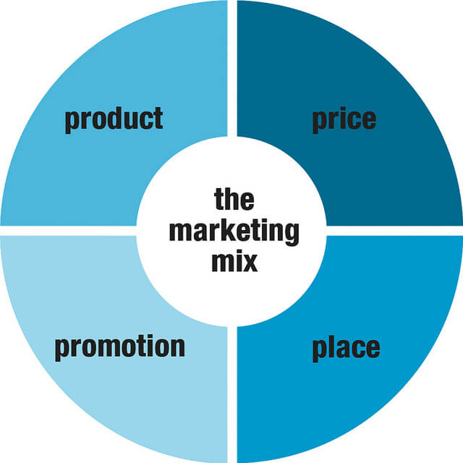
Figure 1: Marketing mix model
(Source: Cleverism, 2022)

Marketing mix
The marketing mix of an organisation simply describes the marketing strategies of the organisation. The basic strategies of a company lie in four vital topics. Those are a description of the product, its prices, the place where it has spread its business and the promotional strategies followed to develop the business (Išoraitė, 2016).
Product
This company is selling books, software, music, various electronic gadgets, tv, various beauty products, groceries, baby foods, branded clothes, watches, shoes, jewellery, musical instruments, kitchen items, industrial tools, musical instruments and various tools used in gardening. The company is more focused on the customer's daily needs. The Company is trying to launch new products which are more beneficial for the customers within a short gap and followed the development of a product approach called working backwards. More than 12 million products are sold by Amazon (Aboutamazon, 2020a).
Price
The famous company Amazon is following a dynamic pricing approach and it also can be called a repricing strategy. The company does not remain constant on the prices of the products which they are offering to their customers. The prices of the company are changed as per the demand and supply of products and the needs of products in the market or on the competitor's price. According to the report, the company's net worth in 2022 was around 421.86 billion euros (Bowman, 2023).
Promotion
The company has its website and app where the customers can easily purchase their necessary products and the delivery of the purchased products is received by the customers in their registered address. The company is following advertising, direct marketing, sales promotions and public relations as the strategies of promotional activity (Ferguson, 2023). Various social media like Instagram or Amazon UK have 135K followers, and more than 657 posts and 947 are following the page (Instagram, 2023).
Place
The company is mainly doing its business online. It is working in the Brick and mortar stores. It is spreading its business on websites, mobile apps, various social media platforms and its official websites. The customer has free access to its websites, app (Ferguson, 2023).

Ansoff Matrix
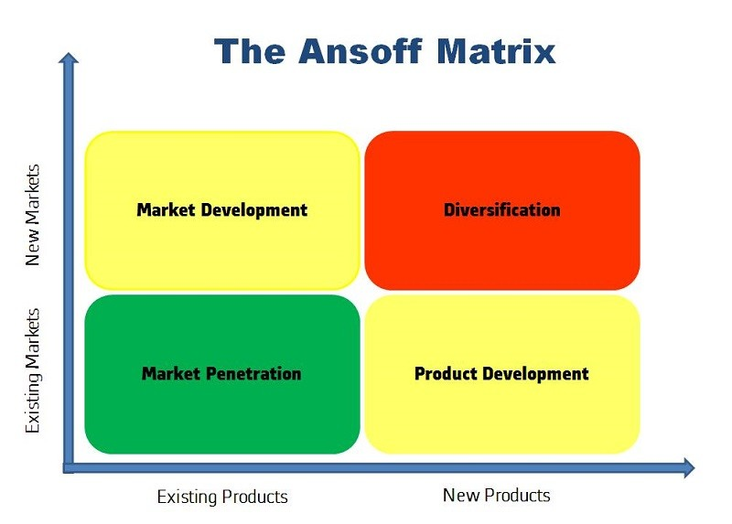
Figure 2: Ansoff Matrix model
(Source: Methven, 2023)
The concept of Ansoff Matrix deals with the market expansion grid. This is a framework used to manage the team members and a deep analysis of the workers which helps to prepare, plan and calculate the growth initiatives. Through this application, stakeholders can understand the level of risk connected with the different growth factors of the organisation (Loredana, 2016).
Market penetration
The Company Amazon is applying its market penetration positively. Various features which are applicable in the website of the company can help the company to develop its penetration strategies. The company stored the data of customers by applying advanced data science. The company stores the data relating to customers' gender, age, preferences, and address by using AI applications which helps the company to understand the nature of the market. The company launched Amazon Prime to its customers who are getting the subscription as premium members for giving them facilities regarding orders and prices and also showing them loyalty regarding its goods and services. The company also promotes some small brands in various markets (Adamkhankasi, 2020). As per the financial report of 2023 Flipkart, the market share of this company increased to 48% so Amazon also did the market penetration to increase its business (Minhas, 2023).
Product development
Product development of a company can grab more customers if the company modifies its product according to the needs of the customers and the market. Product development can be possible by changing its concept, design, and raw materials and by introducing new products in the market or rebranding any goods (Villamil et al. 2022).
Market development
Market development means finding new markets for the products which already existed in a company. By developing the market a company can reach its customers and expand its business and earn more profits (Khan et al. 2022).
Diversification
The company successfully plays an aggressive role in diversification strategies. The company is launching various new products to grab the attention of customers. Now the company is working as a single-handed online retail company that has media, software, advertising, logistics, and hardware. The company started its marketing with books and now it has more than 12 million goods for sale (Rahman, 2023) The company has to spread its business in different countries and launch new products as per their culture and needs to expand its market and productivity.

Communication mix
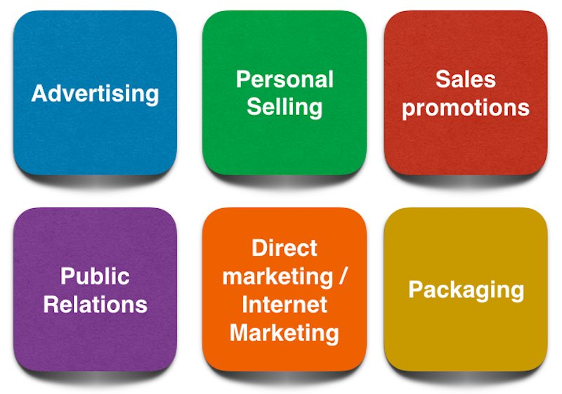
Figure 3: Communication Mix model
(Source: Bhasin, 2021)
Communication mix is a kind of business strategy used to communicate with its customers and effective consumers. A company can use various tools such as advertisement through social media, direct marketing of products, attractive packing of their goods and through exhibitions and events (Todorova, 2015).
Advertising
As an advertisement strategy, Amazon uses its media and print as a way of advertising its products and services. The company posts its newly launched products and offerable products through its websites, mobile apps and by messaging its customers or on Instagram. Amazon has made tv ads and 30-sec ads on Youtube to promote its products and services. The advertising revenue of Amazon has reached more than 37.7 billion dollars according to the report, 2022. (Bigcommerce, 2023).
Sales and promotion
Amazon has taken various initiatives to promote sales and goods or services. The company introduced seasonal sales portions like Christmas sales, new year sales etc. The company provides money off coupons to its customers at the time of sale regarding offerable products. The company provides loyalty cards to its customers. Amazon offers Prime membership to its customers to give them special benefits. The company offers 8.99 ponds per month to take its prime membership to its customer. (Quiroz, 2018).
Personal selling
The company has no products in its name. The company is selling the products taken from its various suppliers and selling them on its websites or mobile app. The company is doing its business by using its tools (Chaffey, 2023).
Public relation
Amazon takes the reviews and feedback from its customers after purchasing a product. The company gives the option to the customer to give ratings and a place to write about his or her feeling after getting the product. It helps the other customers before their purchase. The company also gives response to any questions asked by the customers or try to clear doubts regarding any products. The customer care service is also good for Amazon. It provides all the necessary facilities regarding return and refund policies (Chaffey, 2023).
Direct marketing
The company give instructions to its customer on their websites through different types of online marketing channels which are primarily targeted to grab the attraction of customers. Those channels are portal advertising, email marketing campaigns, associate programs and searching the sponsors and other necessary steps. The company has more than 500 billion sales in a year with its new business model to make the position secure in business (Quiroz, 2018).

Porter’s 5 forces
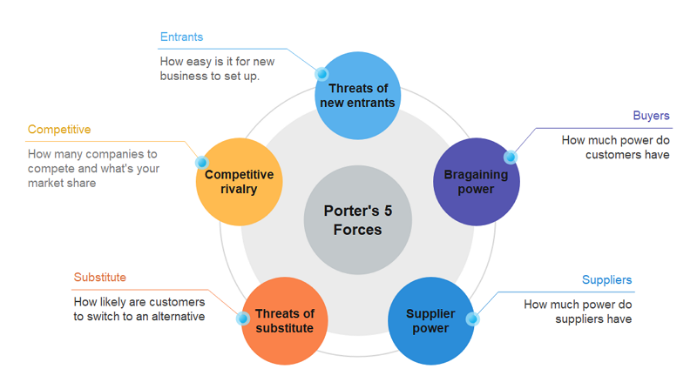
Figure 4: Porter’s 5 Forces Model
(Source: Edrawmax, 2023).
Porter’s five forces model consists of five factors and is also performed as a strategic framework. This model guides the company’s profitability by analysing those five points. It helps a company to take initiatives where the performance of the company is very low (Anton, 2015).
Competitive rivalry
From the beginning, the company faced competition in the business market. The competition of online retailers is increasing very fast. Amazon also has to deal with these rival companies to stay in its position in the business market. Small and startup companies are giving the best competition to Amazon with their low-pricing strategies (Greenspan, 2023). Various rival companies such as Flipkart, eBay, Alibaba, and Walmart are giving the best competition to Amazon. The annual net income of the company Walmart is 10.71 billion euros in 2023. Flipkart also has increased its net value to 59.61 billion Euro in 2023 which is a great threat for Amazon (Moneymint, 2023).
Supplier power
Suppliers have important control over business productivity. Amazon also depends upon the various hardware components and equipment for its cloud service to its suppliers. The company always talks about its supply chain as the business is very big and the company is switching its suppliers frequently. The bargaining power of the suppliers in the company is in moderate force (Edrawmax, 2023).
Buyer power
According to Porter’s 5 forces model the bargaining power of the buyer for Amazon is medium to high. The company’s success depends upon the quality of the product and how it satisfies the customer’s needs. Customers can easily get information about the products from the mobile app or its websites and they can easily search it on other e-commerce platforms which becomes a great threat for Amazon (Hivelr, 2023).
Threat of Substitution
Amazon is facing the threat of new substitutions of its products from various small brands. Those brands are providing the commodity at a lower price but the brand name Amazon gives the customers more loyalty as they are protecting their image for so many years as leaders of e-commerce. The organisation focuses on its infrastructure, service quality, warehouse network and distribution which becomes very hard to compete (Edrawmax, 2023).
The Threat of New Entry
The company has held a strong brand image in the e-commerce service for so many years. Amazon invested a huge amount in its logistics, customer service and eCommerce solutions so the new small industries can grab the attention of customers from small areas for its low pricing but the Amazon has no threats for any new entity in the business market (Greenspan, 2023).

Stakeholders map
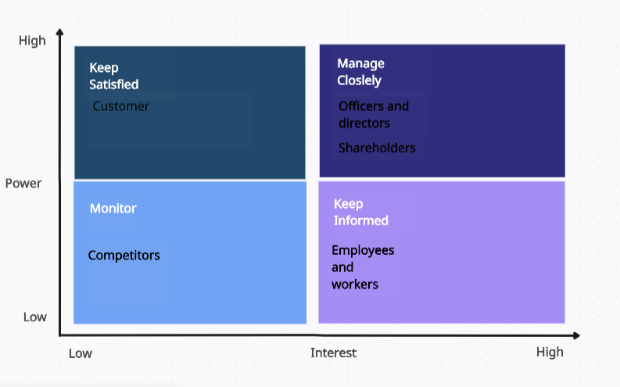
Figure 5: Shareholders Matrix.
(Sources; Self-Developed, 2023)
Customer: Customers are the external stakeholder of Amazon. Through research, it has been found that approximately 90% of the shoppers in the UK used Amazon. It is also found that 40% of the customer of the organisation avails of its prime subscription services. As per Mintel, it is found that approximately 15 million of its customers have subscribed for its prime members which cost £7.99 a month and provides the facility of one-day delivery. Through this information, it can be concluded that customers have High power with Low interest and should be satisfied with their needs (Butler, 2019).
Officers and directors: The role of the director and officers of Amazon is to apply their business judgement best, act in good faith and ensure the interest of other stakeholders in the best manner (Walker, 2022). The position of executive chair is held by Jeffrey P. Bezos made an effort in making the company offer low price items with fast delivery across 190 countries. The position of president was held by Andy Jassy who led Amazon Web Services till July 2021. Douglas J. Herrington holds the position of CEO from July 2022. The directors and officers of Amazon have a high interest in high power and should be managed closely (Aboutamazon, 2023).
Shareholders: The shareholder of Amazon helps in providing finance by purchasing the share of the company and becomes its part. The individual stakeholder of the company includes a 9.73% share of the company, followed by the Mutual fund holder with a 32.66 share of the company and a 27.94% share held by other institutions. Some of the shareholders of Amazon include T.Rowe Associate with 27.2 million shares of the company. GQG Partners LLC with 15.5 million shares of the company and then Morgan Stanley & co LLC with 12.2 million shares. The shareholders of Amazon have high power with high interest and should be managed closely (CNN, 2023).
Employees and workers: The employee and the worker of Amazon serve the main purpose of contributing towards the success of the company. Employees completed the task of the company as per the guidance of the management (Kantor et al. 2021). As per the data of Dec 2022, the company has a strength of 61,000 employees in the UK dealing in the activity of warehousing and logistics. In this matrix, the employees and the worker have Low power with high interest and should be well informed with the required information (Coppola, 2023).
Competitors: The main competitor of Amazon in the UK is Ebay with a global ranking of 551 and the country rank with 14. Followed by Argos with a 970 global ranking and 43 in the country ranking. The Johnlewis with a global rambling of 1,679 and a country ranking of 73. They are in need to look after the proceedings of Amazon as their strategy adopted affects the normal course of proceedings. They have low power and low interest and should be monitored closely (Similarweb, 2023).

Marketing and customer relationship management theories for the Amazon

Quality Competitive Index
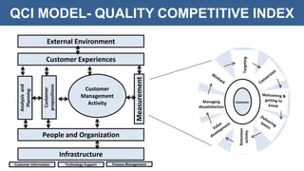
Figure 6: Quality Competitive Index
(Sources: Slideplayer, 2023).
As per the customer relationship model, the Quality Competitive Index mainly focuses on managing and establishing relationships with its customer of Amazon. To do it effectively it deals with components which are listed below (Krstić, 2023).
Analysis and planning: This component deals in filling the relevant data which are easily available and the behavioural gaps and figuring out the values that Amazon brings towards the customer (Freedman, 2023).
Proposition: This component deals with using the needs of the customer Amazon to determine the way to serve. After that this proposed approach to the customer (Freedman, 2023).
Information and technology: This component deals with looking at the technology used by Amazon which enables them to determine the way of adding the information of the customer to the CRM and analyse the relevant data (Freedman, 2023).
People and organisation: This deals with designating the employee of Amazon with the responsibility of managing its customer feedback which deals with online reviews (Freedman, 2023).
Process management: This component deals with ensuring the sales and the customer service team of Amazon provide effort in supporting customer needs. This helps in figuring out the issue and the way of resolving it (Freedman, 2023).
Customer management activity: This component deals with three different elements which include acquisition, penetration, and retention which helps Amazon in providing its service most efficiently (Freedman, 2023).
Effect measurement: It deals with analysing the performance of the Amazon team in respect of the volume of sales. The main focus of the team is to enhance the sales of the organisation (Freedman, 2023).
Customer experiences: This is the continuation of the previous process but it provides focus on the satisfaction of the Amazon customer rather than the sales volume (Freedman, 2023).
The main criticism of the customer relation model is that it lacks in determining which customer adds value to Amazon and it also lacks in obtaining new data through the interaction of the customer. It lacks customer intimacy and fails to collect new data which could prove to be effective in dealing with the customer satisfaction level (Freedman, 2023).

Consistency Theory
This theory is based on the concept of humans love consistency. In simple terms, it deals with providing values, attitudes, and beliefs which help in providing support to each other. This theory makes understanding the psychological process of the consumer of Amazon that they buy the product to obtain pleasure which helps them in avoiding the pain and the outcome to be achieved (Autoklose, 2021). This theory deals in making compatibility with Amazon related to the transpiring processes related to the mental condition of the consumer. This theory also provides concepts that emerge through the discussion of morality. It is efficient in exploration of the moral dilemmas. It helps in establishing the basic needs of the customer rather than the approach to satisfy the goals (Arvanitis, and Kalliris, 2020).
The criticism of the Consistency Theory leads to the distortion of the financial statement of the organisation. This statement is needed by Amazon in using the accounting policy about the different types of transactions. This does not help the organisation in recording the revenue and the expenses and fails to disclose the relevant information which is required to be kept confidential to its competitors and other concerned parties (Tomasetti, 2023).

SWOT Analysis
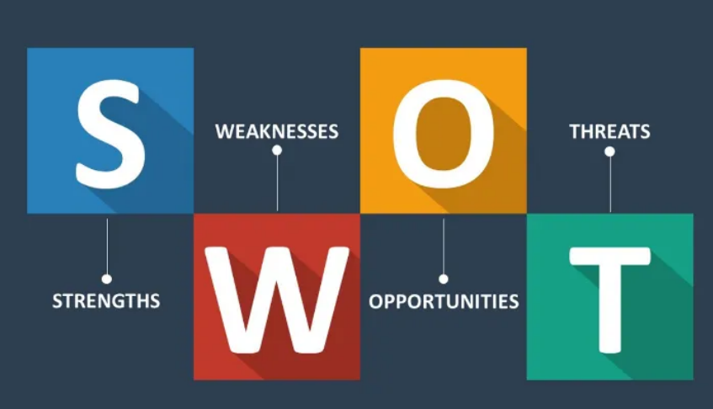
Figure 7: SWOT Analysis
(Sources: Jodie, 2017).
Strength: The main strength of Amazon is its strong recognition of the brand and reputation in the eye of the customer. Another strength of the company is that it deals in a diverse range of products. It offers its customers different products like clothing, household goods, electronic items, and books. Amazon holds the rank 2 in the list of Fortune's World’s most admired companies (Aboutamazon, 2022).
Weakness: The main weakness of Amazon is that the business model followed by the organisation can be easily copied. Services like fast shipping, offering a different range of products, and enhancing customer experience can be easily replicated by other companies. Through the study, it has been found that there are nearly 30 top sites which are just replicas of Amazon which includes eBay, Aliexpress, and Shop4world (TechBoomers, 2022).
Opportunity: The opportunity that stood in front of Amazon is to expand its business in physical stores and planning to enter into crypto. The expansion of the business in the physical stores helps Amazon in reaching out to new customers who are not familiar with the online platform of shopping and create tangible experiences related to shopping with them. It also helps companies compete better with traditional retailers in the market (Schaverien, 2018).
Threat: The main threat that Amazon faced is the regulatory issue and the stiff competition from its competitors. In the UK Amazon faced legal action due to the unlawful favouring of its product offers (Pankratz, 2020). The main threat of competitor to Amazon is eBay as they together hold 407 million visits every month and alone eBay make 298 million visits (Pool, 2023).

PESTLE Analysis
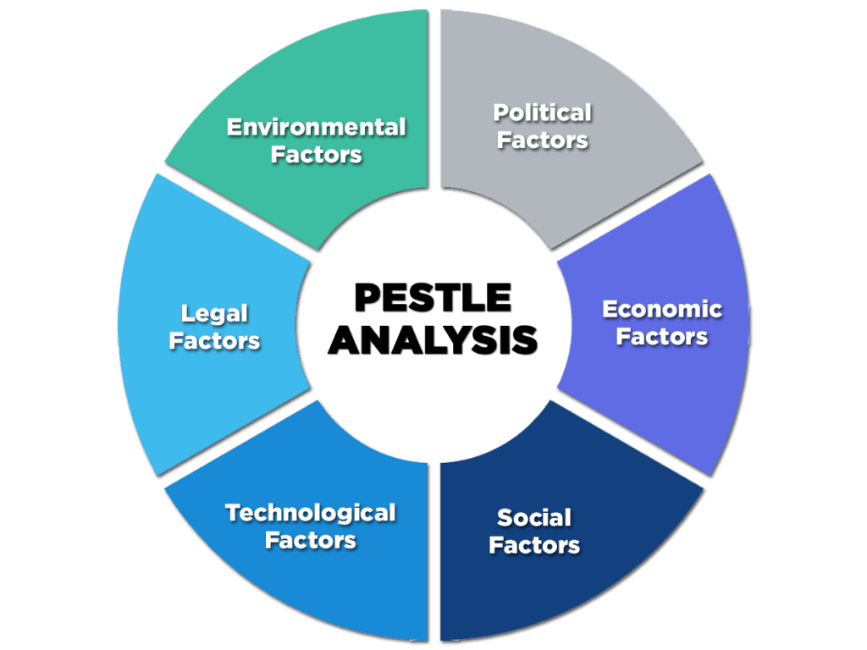
Figure 8: PESTLE Analysis
(Sources: Enterslice, 2020)
Political: The rules and policies of the government of the UK determine the growth rate of the Amazon in the country. As the UK political conditions are stable it provides a good opportunity for the company to expand its business. The latest value in the stability of the UK is 0.54 points which indicates the absence of any corruption and violence (the global economy, 2023).
Economical: As per the latest data the current inflation rate of the UK was 6.4% in June 2023. The CPIH all goods index rose by 8.5% as compared to the previous year. It is also noted about the movement in the CPI inflation rate which is 8.7%. So the economic condition of the UK is not stable and it lacks the opportunity to Amazon in its operation (Gooding, 2023).
Social: The social factor that Amazon needs to look at in the UK includes changes in the culture of the people, education level, and demographic structure of the people. As the change has been noted in consumer behaviour and can create social movements which inspire people towards making positive social and environmental changes. So society provides a favourable environment which helps Amazon to expand its business (SocialChange, 2023).
Technological: The UK is a technologically advanced nation which can pave the path to the success of the Amazon. The UK AI technology comes at the 3rd position in the AI publication rate. Uk has 19 universities which deal in the academic centre of excellence about cyber security. This technological advancement helps Amazon in expanding its operation and meeting the needs of its customers in the most effective way (Gov, 2023).
Legal: Amazon needs to comply with several laws implemented by the government of the UK which includes health & safety law, consumer law, and industry regulation. Compiling this law makes the company complex and not able to do it feely. So the UK legal sector does not prove to be beneficial for Amazon (RPC, 2023).
Environmental: Amazon needs to deal with the challenges like pollution and the problem of climatic changes. So the company has an opportunity to consider the good factors related to the environment through eco-friendly products. The problem is related to the plastic product which can be reduced by the company through effective steps. So this factor proved to be favourable to the company (Salas, 2023).

Task 2

Identification of Quality Process systems in meeting customer requirements and helping in maintaining customer relations.

Six Sigma
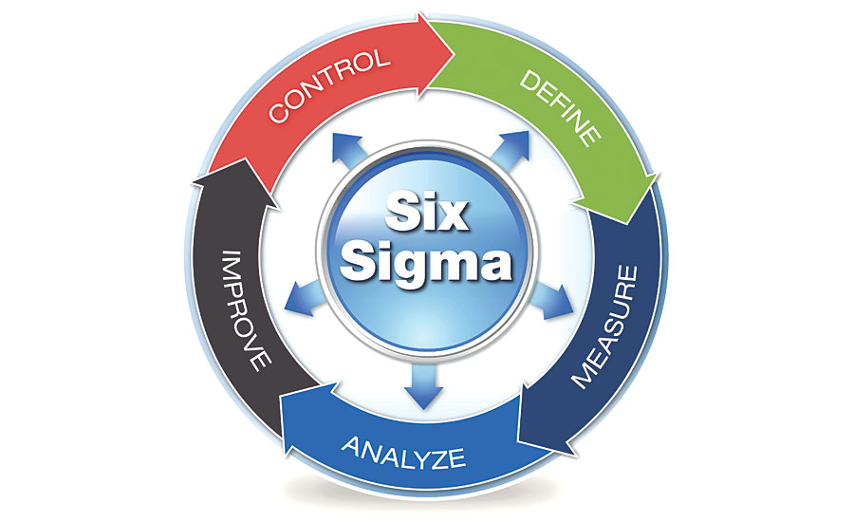
Figure 9: Six Sigma
(Sources: McMenamin, 2018).
Six Sigma refers to the method which deals with providing an organisation with a tool which helps in improving its capability in the business process (Pyzdek and Keller, 2018). This helps in increasing the performance and reducing the variation in the process. It also helps in the improvement of the profit, increasing the morale value of the employees and enhancing the quality of the product and service rendered. Through the implication of six sigma, the business can reduce its variation in the process and able to control its process by eliminating waste (ASQ, 2023).
Advantages of six sigma
Helps in decreasing waste: The advantage of six sigma is to focus on the reduction of waste generation in the quality process system (Karpinski, 2023).
Helps in increasing efficiency: Due to the reduction of waste the company can enhance its efficiency in the process of the manufacturing of the product (Karpinski, 2023).
Disadvantages of six sigma
Need to deal with the bulky data: Six Sigma deals in a step-by-step operating process which generates a large amount of data which needs to be considered for an effective result.
The company needs to find a six sigma institute to train its employees: The company needs to provide training to its employees to effectively implement the six sigma strategy in its organisation. This may lead to spending money (Muhoro, 2019).
Application of six sigma on Amazon
The application of six sigma on Amazon leads to the streamlining of its operation in day-to-day activity. With this implication, the company can deploy more of its manpower in its customer service centre which helps in keeping its service to the customer at a high level. Further, this six sigma will also help in the transportation method of the product and the package-related activity to be done without any wastage of the material (Sixsigmadaily, 2021).

Kaizen
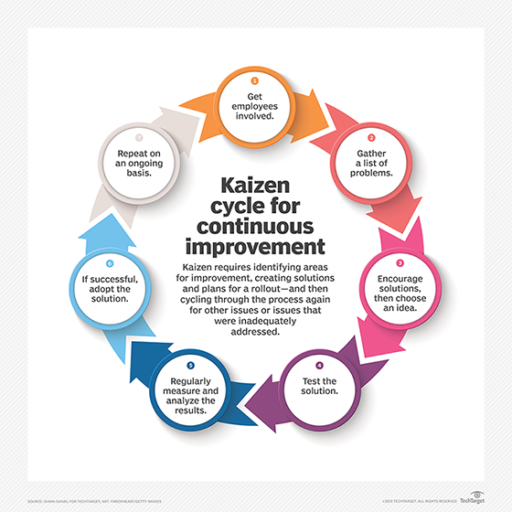
Figure 10: Kaizen
(Sources: Daniel, 2021)
It is the approach which helps in creating ongoing improvement which is based on the idea that any small positive change can lead to significant improvement. It is effective in the manufacturing sector which helps in lowering defects, eliminating wastage reduction, helps in boosting productivity, and can promote innovation. This theory leads to continuous improvement in association with methodology and the principle (Daniel, 2021).
Advantages of Kaizen
Helps in employee empowerment: This helps the employee by providing them with the best and improved way of doing their job. This helps the leader of the organisation in creating an environment in which employees feel empowered and make improvements in their job.
Enhancing the management of the organisation: The best reason why the company implements this theory as it enables the efficiency of the management in action and decision-making. This enables management to take long-term commitments towards continuous improvement (SafetyCulture, 2023).
Disadvantages of Kaizen
Making changes is difficult: The drawback of this theory is that people are always reluctant to change. The employee of the organisation is not ready to welcome the changes in their processing system. And sometimes management feels its implication is expensive.
Requirement of training is necessary: The implication of the kaizen in the existing process system required training for the employee to get familiar with the new system. It also involves time in dealing with the new system which reduces productivity (Drmahey, 2022).
Application of Kaizen on Amazon
The goal of Amazon is to be better and get better results by improving the operation process. Through the application of Kaizen, the organisation can focus on making its efficiency at maximum level to match the needs of its customer. With the implication of this, the company can process a maximum of 35 orders every second. Every distribution centre of the company must be assigned to continuous improvement to match the workflow. It also helps the company in managing its process and can give stiff competition to its competitors. In the year 2014, a total of 2,300 associates took part in the kaizen activity of continuous improvement (Aboutamazon, 2018).
Application of Six Sigma with AI
The implication of Six Sigma with AI helps in redefining the business to make improvements in its operation process in different ways. Six sigma with the help of AI enables to make major operational improvements in the processing system of the business along with reduction of wastage and increasing efficiency. It allows robots in the operation sector to absorb the knowledge and act as per the direction of the data. The combination of the two can serve as a potent tool which can assist the business in adopting important changes related to the operation. The improved processes are listed below (Lean Six Sigma Institute, 2023).
Helps in process mapping: Al can be used in analysing the data and helps in the identification of the process which is error-prone.
Helps in root cause analysis: AI can also help in analysing a large amount of data and identify the pattern which can be contributed to the related process issues.
Helps in controlling charts: With the use of AI and Six Sigma it can be used controlling chart data and identification of the factor related to the process to test (Lean Six Sigma Institute, 2023).

Conclusion
After completing this study the information imparted about the introduction of the Amazon. The company belongs to the American tech multinational that is working in the business of cloud computation, e-commerce, artificial intelligence and digital streaming. Further, the information provided about the internal and external factors which create an impact on the smooth proceeding of the business. Then the information about the theory related to management has been provided. Six Sigma refers to the method which deals with providing an organisation with a tool which helps in improving its capability in the business process. This helps in increasing the performance and reducing the variation in the process. The kaizen It is the approach which helps in creating ongoing improvement which is based on the idea that any small positive change can lead to significant improvement.

References
About amazon (2023) Officers and directors, Amazon.com, Inc. - Officers and directors. Available at: https://ir.aboutamazon.com/officers-and-directors/default.aspx
Aboutamazon (2018) Amazon Fulfillment Network, EU About Amazon. Available at: https://www.aboutamazon.eu/news/working-at-amazon/amazon-fulfillment-network
Aboutamazon (2022) Amazon ranks no. 2 on Fortune’s world’s most admired companies, US About Amazon. Available at: https://www.aboutamazon.com/news/workplace/amazon-ranks-no-2-on-fortunes-worlds-most-admired-companies
Aboutamazon, (2020a) What we do US About Amazon. Available at: https://www.aboutamazon.com/what-we-do
Aboutamazon, (2020b). Who we are: Amazon US About Amazon. Available at: https://www.aboutamazon.com/about-us
Adamkhankasi (2020) Ansoff matrix of Amazon, Ansoff Matrix. Available at: https://ansoffs.com/ansoff-matrix-of-amazon/
Anton, R., (2015). An integrated strategy framework (ISF) for combining Porter's 5-forces, Diamond, Pestel, and SWOT analysis. Link: https://mpra.ub.uni-muenchen.de/72507/1/MPRA_paper_72507.pdf
Arvanitis, A. and Kalliris, K., (2020). Consistency and moral integrity: A self-determination theory perspective. Journal of Moral Education, 49(3), pp.316-329. Link: https://www.tandfonline.com/doi/abs/10.1080/03057240.2019.1695589
ASQ (2023) Six sigma definition - what is Lean Six Sigma? | ASQ. Available at: https://asq.org/quality-resources/six-sigma
Autoklose (2021) 6 marketing theories you should know and how to apply them, Autoklose. Available at: https://www.autoklose.com/marketing-theories-you-should-know/
Bhasin, H. (2021) What is communications mix and its role in marketing?, Marketing91. Available at: https://www.marketing91.com/communications-mix/
Bigcommerce, (2023). What is Amazon Advertising? BigCommerce. Available at: https://www.bigcommerce.co.uk/ecommerce-answers/what-is-amazon-advertising/
Bowman, C. (2023) How much is Amazon Worth?, GOBankingRates. Available at: https://www.gobankingrates.com/money/business/how-much-is-amazon-worth/
Butler, S. (2019) Almost 90% of UK shoppers use Amazon, research reveals, The Guardian. Available at: https://www.theguardian.com/business/2019/mar/07/almost-90-of-uk-shoppers-use-amazon-research-reveals
Chaffey, D. (2023) Amazon Marketing Strategy Business Case Study, Smart Insights. Available at: https://www.smartinsights.com/digital-marketing-strategy/online-business-revenue-models/amazon-case-study/
Cleverism, (2022) Understanding the marketing mix concept - 4ps (2022) Cleverism. Available at: https://cleverism.com/understanding-marketing-mix-concept-4ps/
CNN (2023) AMZN, CNNMoney. Available at: https://money.cnn.com/quote/shareholders/shareholders.html?symb=AMZN&subView=institutional
Coppola, D. (2023) Amazon UK services: Number of employees 2022, Statista. Available at: https://www.statista.com/statistics/1049961/amazon-uk-services-number-of-employees/
Daniel, D. (2021) What is Kaizen (continuous improvement)?, ERP. Available at: https://www.techtarget.com/searcherp/definition/kaizen-or-continuous-improvement
Drmahey (2022) Kaizen advantages and disadvantages, Dr Aminu. Available at: https://draminu.com/kaizen-advantages-and-disadvantages/
Edrawmax, (2023). Amazon Porter’s Five Forces Analysis: EdrawMax Online Edrawsoft. Available at: https://www.edrawmax.com/article/amazon-porters-five-forces-analysis.html
Edrawmax, (2023). Free editable five forces diagram examples: EdrawMax Online Edrawsoft. Available at: https://www.edrawmax.com/article/five-forces-diagram-examples.html
Enterslice (2020) Pestle analysis: A mechanism for analysis of businesses, Enterslice. Available at: https://enterslice.com/learning/pestle-analysis-a-mechanism-for-analysis-of-businesses/
Ferguson, E. (2023) Amazon’s Marketing Mix (4P) analysis, Panmore Institute. Available at: https://panmore.com/amazon-com-inc-marketing-mix-4ps-analysis
Freedman, M. (2023) CRM models and how to use them, Business News Daily. Available at: https://www.businessnewsdaily.com/16098-crm-models.html
Gooding, P. (2023) Consumer price inflation, UK: June 2023, Consumer price inflation, UK - Office for National Statistics. Available at: https://www.ons.gov.uk/economy/inflationandpriceindices/bulletins/consumerpriceinflation/june2023
Gov (2023) Technology, Technology - great.gov.uk international. Available at: https://www.great.gov.uk/international/content/investment/sectors/technology.
Greenspan, R. (2023) Amazon Five Forces Analysis (Porter model), Panmore Institute. Available at: https://panmore.com/amazon-com-inc-five-forces-analysis-recommendations-porters-model
Hivelr, (2023). Amazon (AMZN): Porter’s five forces industry and competition analysis (2023) Hivelr. Available at: https://www.hivelr.com/2023/02/amazon-amzn-porters-five-forces-industry-and-competition-analysis/
Hurst, K. (2023) 9 takeaways from Amazon’s 2022 sustainability report, EU About Amazon. Available at: https://www.aboutamazon.eu/9-takeaways-from-amazons-2022-sustainability-report
Instagram, (2023) Login • instagram. Available at: https://www.instagram.com/amazonuk/?hl=en
Išoraitė, M., (2016). Marketing mix theoretical aspects. International Journal of Research-Granthaalayah, 4(6), pp.25-37. Link: https://d1wqtxts1xzle7.cloudfront.net/72600151/2505-libre.pdf?1634269555=&response-content-disposition=inline%3B+filename%3DMarketing_MIX_Theoretical_Aspects.pdf&Expires=1692605705&Signature=eRSzCHobfMga1-6ldgIzrcP766MCvS-nZ9NDCJDIHlQ-RUJMTaizmvnHs~X3Cp~P-Gr8rZV2vosCuPWfXMzLenxVXYW3TAWgeo25M2E-~YUXSK~2Xi1JTil1aRU-VLPNEgtfLSN2v85TkOpg~BvgHXg0yxEY2DdsYkkMnStaA7-zM5btvAhWIs~8u1VrUT6UYxSIJnl5szr34ZvgG1j8EL4K2LRFgXIjdJLELHoD-9SssLp5KM~KUKyV-0tw0lTiMWNQ4p-uUiD3SxaMHH4NWDMO62Pdcxuyd-NvXEF4XstBnlYUafJHmP8E79DAWhFf-w0q~y2yCoQHHdQZCURifw__&Key-Pair-Id=APKAJLOHF5GGSLRBV4ZA
Jodie, S. (2017) How to complete a personal SWOT analysis, Medium. Available at: https://medium.com/thrive-global/how-to-complete-a-personal-swot-analysis-2f8769aebd5e
Kantor, J., Weise, K. and Ashford, G., (2021). The Amazon that customers don’t see. The New York Times, 15. Link: http://www.kooriweb.org/foley/news/2000s/2021/june/nyt15june2021.pdf
Karpinski , K. (2023) Six benefits of Six sigma, Six Benefits of Six Sigma. Available at: https://business.csuohio.edu/professional-development-center/six-benefits-six-sigma
Khan, M.A., Haddad, H., Odeh, M., Haider, A. and Khan, M.A., (2022). Institutions, Culture, or Interaction: What Determines the Financial Market Development in Emerging Markets?. Sustainability, 14(23), p.15883. Link: https://www.mdpi.com/2071-1050/14/23/15883
Krstić, M., (2023). IMPROVING THE COMPETITIVENESS–DETERMINANTS AND SOLUTIONS FOR QUALITY OF LOCAL BUSINESS CONDITIONS. International Journal for Quality Research, 17(2), pp.529-554. Link: https://www.researchgate.net/profile/Milos-Krstic-2/publication/371558302_IMPROVING_THE_COMPETITIVENESS_-_DETERMINANTS_AND_SOLUTIONS_FOR_QUALITY_OF_LOCAL_BUSINESS_CONDITIONS/links/648a19729605ba270e44d805/IMPROVING-THE-COMPETITIVENESS-DETERMINANTS-AND-SOLUTIONS-FOR-QUALITY-OF-LOCAL-BUSINESS-CONDITIONS.pdf
Lean Six Sigma Institute (2023) The perfect match: Leveraging ai for lean and six sigma optimization, Lean Six Sigma Institute. Available at: https://leansixsigmainstitute.org/the-perfect-match-leveraging-ai-for-lean-and-six-sigma-optimization/
Loredana, E.M., (2016). The use of Ansoff matrix in the field of business. In MATEC Web of Conferences (Vol. 44, p. 01006). Link: https://www.utgjiu.ro/revista/ec/pdf/2017-02.Volumul_2_Special/21_EcobiciL.pdf
McMenamin, E. (2018) Back to basics: Six sigma, Quality Magazine RSS. Available at: https://www.qualitymag.com/articles/94429-back-to-basics-six-sigma
Methven, C. (2023) What’s the best way to grow your business? it’s simple..., LinkedIn. Available at: https://www.linkedin.com/pulse/whats-best-way-grow-your-business-its-simple-clare-methven
Minhas, (2023) Flipkart group: Share in e-retail market 2023, Statista. Available at: https://www.statista.com/statistics/1386666/flipkart-group-share-in-e-retail-market
Moneymint, (2023). Flipkart net worth, share price, revenue (2023) Moneymint. Available at: https://moneymint.com/flipkart-net-worth-share-price-revenue/
Muhoro, N. (2019) How to improve quality with lean manufacturing, Small Business - Chron.com. Available at: https://smallbusiness.chron.com/improve-quality-lean-manufacturing-75709.html
Onepatch, (2023). Why is Amazon so successful? (2023) OnePatch. Available at: https://onepatch.com/why-is-amazon-so-successful-market/
Pankratz, R., (2020). Duty to Disclose: Amazon's E-Commerce Platform, Private-Label, and the Need for Disclosure. Kan. JL & Pub. Pol'y, 30, p.162. Link: https://heinonline.org/HOL/LandingPage?handle=hein.journals/kjpp30&div=11&id=&page=
Pool, J. (2023) Online marketplaces in the UK: Amazon and eBay Dominate, Webretailer.com. Available at: https://www.webretailer.com/marketplaces-worldwide/online-marketplaces-uk/
Pyzdek, T. and Keller, P., (2018). Six sigma handbook. McGraw-Hill Education. Link: https://www.accessengineeringlibrary.com/content/book/9781260121827
Quiroz, M.A. (2018) Amazon.com’s Integrated Marketing Communications 2018, Medium. Available at: https://medium.com/@michaelangelo_q/amazon-coms-integrated-marketing-communications-901a6a2a77ef
Rahman, M. (2023) Ansoff matrix in Amazon (Amazon’s growth strategy), www.howandwhat.net. Available at: https://www.howandwhat.net/ansoff-matrix-amazon/
RPC (2023) What are the 8 key legal changes ahead for retailers in 2023?, RPC. Available at: https://www.rpc.co.uk/press-and-media/what-are-the-8-key-legal-changes-ahead-for-retailers-in-2023/
SafetyCulture (2023) Kaizen: Meaning, process, method, & principles, SafetyCulture. Available at: https://safetyculture.com/topics/kaizen-continuous-improvement/
Salas, E.B. (2023) Great Britain: Most important environmental issues 2020, Statista. Available at: https://www.statista.com/statistics/865223/great-britain-most-important-environmental-issues/
Schaverien, A. (2018) Five reasons why Amazon is moving into bricks-and-mortar retail, Forbes. Available at: https://www.forbes.com/sites/annaschaverien/2018/12/29/amazon-online-offline-store-retail/?sh=17a8147e5128
Similarweb (2023) Amazon.com competitors - top sites like Amazon.com | Similarweb. Available at: https://www.similarweb.com/website/amazon.com/competitors/
Sixsigmadaily (2021) Working backwards: Amazon uses Lean Six Sigma to improve customer satisfaction, Six Sigma Daily. Available at: https://www.sixsigmadaily.com/working-backwards-amazon-lean-six-sigma-customer-satisfaction/
Slideplayer (2023) Customer relationship management concepts and technologies - ppt download, SlidePlayer. Available at: https://slideplayer.com/slide/14703533/
SocialChange (2023) Inspiring change in people and Communities, Social Change. Available at: https://social-change.co.uk/
TechBoomers (2022) 30 best websites like Amazon in the UK for online shopping, TechBoomers.com. Available at: https://techboomers.com/websites-like-amazon-uk
TheGlobalEconomy (2023) United Kingdom political stability - data, Chart, TheGlobalEconomy.com. Available at: https://www.theglobaleconomy.com/United-Kingdom/wb_political_stability/
Todorova, G., (2015). Marketing communication mix. Trakia Journal of sciences, 13(1), pp.368-374. Link: http://www.uni-sz.bg/tsj/Vol.%2013,%202015,%20Suppl.%201,%20Series%20Social%20Sciences/SF/SF/Predpriem.%20i%20biznes/G.Todorova.pdf
Tomasetti , B. (2023) Consistency principle: Importance, advantages, examples, Carbon collective. Available at: https://www.carboncollective.co/sustainable-investing/consistency-principle
Villamil, C., Schulte, J. and Hallstedt, S., (2022). Sustainability risk and portfolio management—A strategic scenario method for sustainable product development. Business strategy and the environment, 31(3), pp.1042-1057. Link: https://onlinelibrary.wiley.com/doi/full/10.1002/bse.2934
Walker, S.P., (2022). The Peruvian Amazon Company: An Accounting Perspective. Enterprise & Society, pp.1-26. Link: https://www.cambridge.org/core/journals/enterprise-and-society/article/abs/peruvian-amazon-company-an-accounting-perspective/D6D7682FD58CAF2992A5E8A86EA97278

