

LOCATION: Swansea | LLEOLIAD: abertawe
LEVEL 4 | LEFEL 4
EXAMINATION PERIOD | CYFNOD ARHOLIADAU
May 2023 | MAI 2023

MODULE CODE: ACDA4013
Embedded C Practical
TIME: 2 HOURS
Complete all sections

you may access any previous work you have done on this course.
You may not access the internet for any external materials.

The proetus files names Embedded C Practical folder is available to you on moodle (ACDA4013_EES), please copy this folder to your desktop and unzip it on to the desktop.

Open the folder and goto the Proteus folder andd open the “Embedded C practical.pdsprj” file.

The circuit in front of you, shown below, contains a PIC18F25K22, a four line LCD, 7 leds, 3 potentiometers, a button and a motor.

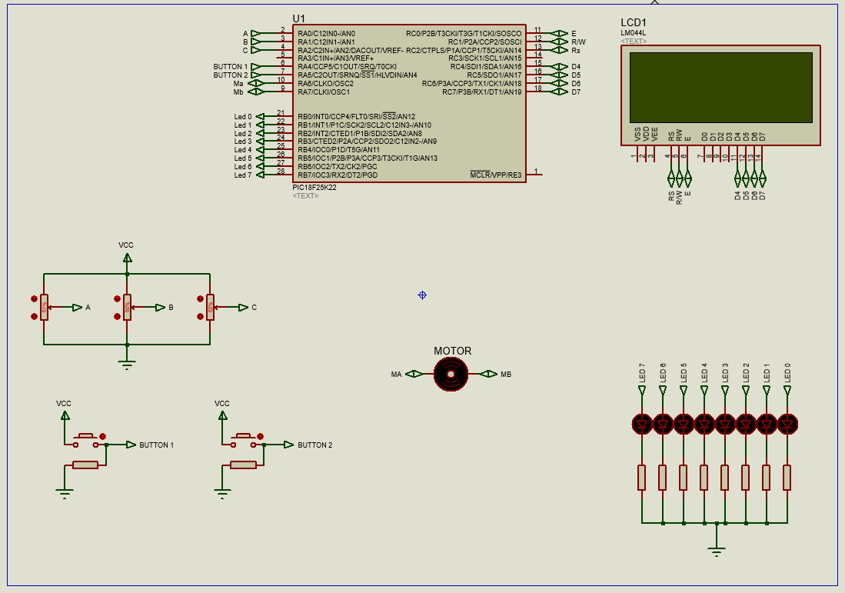

The program initial setup for the program is compete and the PIC uses 8 bit resolution for the analogue inputs marked A,B and C

Ensure that at least one of the sections utilises a switch statement.

You are required to : -

1.. display the conversion value of each potentiometer on it’s own LCD line. A on line 1, B on line 2 etc. please ensure that the output is centred as well as possible on each line.

2. When button1 is pressed sequentially on each button press do the following: -
- set the motor running counter-clockwise
- stop the motor.
- set the motor running clockwise.
- stop the motor
and repeat.

3. When button 2 is pressed, display the conversion value of each of the analogue signal on the LEDs sequentially @ 2 sec intervals.

This is a practical assessment during which you may access any previous work you have done.

