

Programme: Master of Business Administration
Module Code: LCMB7035
Module Name: Dissertation

Title: PERSONALISED EMAIL MARKETING VS AI-GENERATED DYNAMIC CONTENT: A COMPARATIVE STUDY ON CUSTOMER ENGAGEMENT RATES

Student ID: 2417656
Student Name: Vaghela Pragati Nileshbhai
Submission Date: 08.06.26
Word Count: 16145

Declaration
I hereby declare that the dissertation is my original work and has been carried out by me under the guidance and supervision of professors. I further declare that this dissertation has not been submitted, either in whole or in part, to any other university, institution, or examining body for the award of any degree, diploma, or other qualification. All sources of information and references used in this study have been duly acknowledged.
I affirm that the work presented in this dissertation is the result of my own research and investigation.

Acknowledgment
I would like to express my sincere gratitude to everyone who supported and guided me throughout the completion of this dissertation. I extend my heartfelt thanks to my supervisor, for their invaluable guidance, constant encouragement, and insightful suggestions during every stage of this research. Their expertise and patience greatly contributed to the successful completion of this work.
I would like to thank my friends and colleagues for their motivation, constructive feedback, and continuous encouragement throughout this journey.

Abstract
The study evaluates and compares the effectiveness of personalised email marketing and AI-generated dynamic content in influencing customer engagement rates in digital marketing. Chapter one is an introduction discussing background, research problem, aims, objectives and hypotheses, highlighting the importance of personalised communication and AI-driven marketing strategies. Chapter two reviews existing literature on personalised email marketing, AI-generated dynamic content, and the factors influencing engagement, along with discussing theories like the Technology Acceptance Model and the Social Cognitive Theory. Chapter three examines the research methods, including a quantitative approach, an online questionnaire survey, convenience sampling, and statistical analysis through SPSS. Chapter four presents data analysis and findings determining both strategies that positively influence customer engagement, through AI-generated content showcasing high engagement levels, while personalised emails are perceived as trustworthy. The fifth chapter discusses the findings in relation to existing theories and literature studies focusing on marketing approaches that are valuable for improving customer engagement, with each offering distinct strengths and limitations for organisations in digital marketing. The last chapter of the conclusion summarises the whole dissertation with achievements and future research factors.
Keywords: Personalised Email Marketing, AI-Generated Dynamic Content, Artificial Intelligence in Marketing, Customer Interaction, Digital Marketing, Marketing Automation, Customer Engagement.

Table of Contents
CHAPTER 1: INTRODUCTION 9
1.1 Background of the Study 9
1.2 Research Problem 10
1.3 Aim of the Study 11
1.4 Research Objectives 11
1.5 Research Questions and Hypotheses 12
1.6 Significance of the Study 12
1.7 Structure of the Dissertation 13
1.8 Conclusion of the Chapter 14
2. Chapter 2: LITERATURE REVIEW 14
2.1 Introduction 14
2.2 Brief Overview of Personalised Email Marketing 15
2.3 Description of AI-Generated Dynamic Content 16
2.4 Factors Influencing Demand for Personalised Marketing and AI-Generated Content 17
2.5 Impact of the Personalised Email Marketing on generating customer satisfaction leads to Enhanced Customer Engagement 19
2.6 Effectiveness of AI-generated Dynamic Content over Personalised Email Marketing to Increase Customer Engagement Rates 20
2.7 Comparative Analysis to determine the role of Personalised Email Marketing and AI-generated Dynamic Content 22
2.8 Customer Converter Rate and Engagement Rate in Email Marketing 23
2.9 Challenges Faced by Consumers in Terms of Personalised Email Marketing 24
2.10 Issues Experienced by Customers due to AI-Generated Dynamic Content 25
2.11 Suggested Recommendations to Overcome the Identified Challenges Regarding both Marketing Techniques 25
2.11.1 Recommendations In-terms of Email-based Personalised Marketing 25
2.11.2 Recommendations regarding AI-generated Dynamic Content Marketing 27
2.12 Theoretical Framework 29
2.12.1 Technology Acceptance Model (TAM) 29
2.12.2 Social Cognitive Theory (SCT) 30
2.13 Conceptual Framework 31
2.14 Literature Gap 32
2.15 Chapter Summary 32
CHAPTER 3: RESEARCH METHODOLOGY 33
Research onion 33
3.1 Introduction 34
3.2 Research Philosophy 34
3.3 Research Approach 34
3.4 Research Strategy 35
3.5 Research Method Choice 35
3.6 Data Collection Method 36
3.7 Sampling Technique and Sample Size 37
3.8 Data Analysis Techniques 38
3.9 Reliability and Validity 38
3.10 Ethical Considerations 39
3.11 Limitations of the Methodology 39
3.12 Conclusion 39
CHAPTER 4: DATA ANALYSIS AND FINDINGS 41
4.1 Introduction 41
4.2 Descriptive Statistics 41
4.3 Reliability Analysis 42
4.4 Hypothesis Testing via Cross-Tabulation and Chi-Square Analysis 44
4.4.1 Perceived Relevance of Personalised Emails vs. Engagement with AI-Generated Content 44
4.4.2 Email Open Rates vs. AI-Generated Content Receptivity 46
4.5 Inter-Rater Agreement: Kappa Coefficient Analysis 47
4.6 Summary of Key Findings 48
Chapter 5: DISCUSSION 50
5.1 Introduction 50
5.2 Discussion of Descriptive Statistics Findings 50
5.3 Discussion of Reliability Analysis 52
5.4 Discussion of Hypothesis Testing and Chi-Square Findings 53
5.4.1 Personalised Email Marketing vs AI-Generated Content Engagement 53
5.4.2 Open Rates and AI Content Receptivity 54
5.5 Discussion of Kappa Coefficient Analysis 55
CHAPTER 6: CONCLUSION AND RECOMMENDATIONS 55
6.1 Introduction 55
6.2 Summary of the Research 56
6.3 Summary of Key Findings 57
6.4 Achievement of Research Objectives 58
6.5 Conclusion of the Study 59
6.6 Recommendations for Organisations 59
6.6.1 Strategic Recommendations 59
6.6.2 Customer Engagement Recommendations 59
6.6.3 Ethical Recommendations 59
6.6.4 Technological Recommendations 60
6.7 Recommendations for Future Research 60
6.8 Final Concluding Statement 60
References 62
Appendix 73
Appendix A: Survey Questionnaire 73
Appendix B: Collected Survey Data 79

List of Figures
Figure 1.1:Email Marketing 11
Figure 2.1: Personalised Email Marketing 15
Figure 2.2: AI Marketing 17
Figure 2.3: Personalised Digital Marketing 18
Figure 2.4: AI Adaptation in Education 19
Figure 2.5: Customer Satisfaction 20
Figure 2.6: Usage of AI in Marketing 21
Figure 2.7: AI-transformations for the Marketing Sectors 22
Figure 2.8: AI-Powered Customer Engagement 23
Figure 2.9: Resolution of Data Privacy Issues 26
Figure 2.10: Ethical and Legal Factors for AI usage 28
Figure 2.11: Technology Acceptance Model (TAM) 29
Figure 2.12: Social Cognitive Theory 30
Figure 2.13: Conceptual Framework 31
Figure 3.1: Research onion 33

List of Tables
Table 4.1: Descriptive Statistics of Survey Items 41
Table 4.2: Item Statistics – Personalised Email Marketing Scale 43
Table 4.3: Inter-Item Correlation Matrix 43
Table 4.4: Item-Total Statistics and Reliability 44
Table 4.5: Cross-Tabulation – Personalised Email Relevance × AI Content Engagement 45
Table 4.6: Chi-Square Tests – Personalised Email Relevance × AI Content Engagement 45
Table 4.7: Cross-Tabulation – Personalised Email Relevance × Noticing AI Recommendations 46
Table 4.8: Chi-Square Tests – Personalised Email Relevance × Noticing AI Recommendations 46
Table 4.9: Overall Agreement – Kappa Coefficient 47
Table 4.10: Agreement on Individual Rating Categories 48

CHAPTER 1: INTRODUCTION

1.1 Background of the Study
The fast development of digital marketing has profoundly altered the mode of interaction of organisations with customers and instead of mass communication strategies(Bartoloni & Ancillai, 2024), organisations have switched to extremely personalised and data-oriented interaction strategies. Over the past years, two trends have become prevalent in this field: dynamic content powered by AI and personalised email marketing. Both strategies intend to improve customer interaction, but they work with radically different mechanisms, which casts serious doubts on the relative effectiveness of both strategies.
One-to-one email marketing has always been regarded as a pillar of relationship marketing (Sadjadi & Fernández, 2023).It also allows organisations to send customised messages according to customer information like browsing history, purchase history and demographics. This type of direct communication creates a perception of personal focus and relevance, which is postulated to enhance engagement metrics including open rates, click-through rates and conversion rates. As the proposal document shows, organisations are increasingly employing Customer Relationship Management (CRM) systems to group audiences and develop specific campaigns, thus enhancing the customer relationship in the long-term. Nevertheless, personalised email marketing has such disadvantages like information overload, decreasing attention span, and increased concerns on data privacy and consent.
Conversely, AI-generated dynamic content is a more recent innovation that has been brought about by the development of technologies in the field of artificial intelligence and machine learning (Wang, 2023). AI systems can process large volumes of data in real-time and produce dynamic content, such as customised ads, product suggestions, and interactive media. In comparison to conventional email marketing, AI-powered content is used in various digital platforms, including social media, e-commerce websites, and video-sharing platforms, which allow organisations to target a larger audience. Continuous learning through the user behaviour of the AI can be used to personalise in real-time, resulting in a better user experience and engagement. As demonstrated in the uploaded draft, lots of organisations have turned to AI tools to create contents automatically and deliver highly relevant messages at scale.

1.2 Research Problem
Being one of the most common marketing tools in contemporary marketing, personalised email marketing, as well as the use of AI-based dynamic content, lacks empirical research directly comparing the two in terms of their effectiveness in customer engagement (Chandra et al., 2022). The majority of the available research is inclined to analyze these strategies separately, instead of comparing their strengths and weaknesses in the context of one study.
This absence of comparative analysis generates a great gap in the academic research as well as in practical decision-making. Organisations are spending a lot of money on AI-based technologies without the clear understanding that the innovations can be more effective than the traditional customised approaches. Likewise, marketers still use email marketing because it has proven to be effective even though there is some new evidence that AI-based strategies can result in better engagement.
Besides, the very notion of customer engagement is multidimensional as it includes behavioural, emotional, and cognitive aspects. Recent studies tend to emphasize quantitative values like click-through rates or conversion rates and overlook more intricate elements of engagement like customer trust, customer satisfaction and customer loyalty. This is too narrow and it makes it difficult to measure the effectiveness of various marketing strategies.
The high rate of digital technologies development, especially artificial intelligence (AI) has greatly changed the marketing practice, and organisations are more prone to using automated and data-driven approaches to build a better customer experience (Ziakis & Vlachopoulou, 2023).Nevertheless, even with the increased popularity of AI-generated dynamic content, there is a lot of uncertainty in terms of comparative effectiveness in comparison with the traditional personalised marketing methods like personalised email marketing. This ambiguity is the main research problem discussed in this work.One of the biggest problems is that there are no direct comparative studies between personalised email marketing and AI-generated dynamic content. The current research mostly looks at these strategies separately, and it looks at either the email personalisation techniques or AI-based marketing innovations in isolation.


Figure 1.1:Email Marketing
Source:(Jain, 2024)
Email marketing can be discussed in comparison to such channels as a social media, search engine marketing, and display advertising. In contrast to the social media, where awareness and engagementare prioritised, email marketing allows direct and personalised communication. It is able to send specific messages to the masses leading to increased conversion, better retention and quantifiable .

1.3 Aim of the Study
The main aim of this research is to critically evaluate and compare the effectiveness of personalised email marketing and AI-generated dynamic content in influencing customer engagement rates.

1.4 Research Objectives
To achieve the research aim, the study will pursue the following objectives:
- To critically analyse existing literature on personalised email marketing and AI-generated dynamic content
- To examine the key factors influencing customer engagement in digital marketing
- To compare the effectiveness of personalised email marketing and AI-generated dynamic content using empirical data
- To evaluate the advantages and limitations of both marketing strategies
- To provide practical recommendations for organisations to optimise customer engagement strategies

1.5 Research Questions and Hypotheses
Research Question
- Which marketing strategy—personalised email marketing or AI-generated dynamic content—leads to higher customer engagement rates?
Hypotheses
- H0: Personalised email marketing is more effective in generating customer engagement than AI-generated dynamic content
- H1: AI-generated dynamic content is more effective in generating customer engagement than personalised email marketing
These hypotheses are derived from the contrasting characteristics of both strategies, where one emphasises personal connection and the other focuses on technological efficiency and scalability.

1.6 Significance of the Study
This study has both research and practical importance. Academically, it seals a knowledge gap in the literature since it offers a comparative study of two significant digital marketing strategies. Although all the approaches have been investigated separately, the relative effectiveness of each of them has not been critically analyzed in the same framework (Cash, Daalhuizen & Hekkert, 2023).Practically, the results of this research will be useful in helping marketers and organisations make effective choices in terms of resource allocation and strategy formulations. With more and more businesses investing in AI technologies, it is essential to determine whether such investments can deliver better customer engagement to gain a competitive edge.
The research is also a contribution to the overall discussion of digital transformation, as it focuses on how the emerging technologies are transforming the marketing practices (Mele et al., 2024). It also shows the critical ethical issues concerning the use of data, privacy and algorithm-based decision-making, which are gaining more and more attractiveness in modern marketing.
Academically, practically, and strategically the research has great importance considering the rapidly evolving digital marketing scenario. With organisations progressively attempting to embrace the use of data and AI-powered marketing approaches, the comparative efficacy of personalised email marketing and AI-driven dynamic content emerges as an essential concern when it comes to theory and practice. From the academic point of view the investigation will represent a clear contribution to the literature field. Although the field of personalised email marketing and AI-driven marketing has already received several single studies, with a few exceptions, the analysis of the advantages and disadvantages remains unclear and is assessed through the same conceptual paradigm: the level of user satisfaction (Mandic, Jaksic & Ferencic, 2025).This breakdown limits the ability to create a broad cognition of the effect that different forms of digital marketing can have on customers. Combining these two methods into a single study, this research contributes to the theoretical knowledge on digital marketing, especially in the areas of customer engagement, personalisation and technology adoption. Furthermore, the research is also analytical, as it doesn't just stop at descriptive analysis, but attempts to analyze the strengths and weaknesses of each of the strategies and its use within it, as well as the contextual applicability.

1.7 Structure of the Dissertation
The analytical method is logical and coherent; it is organised into 5 chapters in this dissertation.
Chapter 1: Introduction - Background, Research problem, Aim, objectives and significance of the study.
Literature Review: Chapter 2, this chapter discusses the latest research on personalised email marketing and examines the theories and research gaps that were discovered.
The chapter 3 comprises of method of methodology which explains the research design, data collection approach and analysis technique used in the study.
Data Analysis and Findings: Chapter 4 - Presents and summarizes empirical data that was obtained in the course of the research.
Chapter 5: Discussion and Conclusion - Draws inferences from results, draws conclusions and recommends further studies/practice.
Structured style is a clear, scholarly and logical flow of ideas – this is as recommended in MBA dissertation.

1.8 Conclusion of the Chapter
The chapter has critically established the foundation to this research, discussing the rise of personalised and AI-driven marketing strategies in today's digital landscape. It has proved that personalised email marketing remains a proven and well-established marketing channel for nurturing direct and relationship-driven communication, but nowadays AI-driven dynamic content is a solid alternative that can leverage real-time data, automation and scalability to aid customer engagement.The key takeaway from this chapter is that there is a natural opposition between depth and scale of digital marketing plans. Despite the benefits of being able to communicate with one at a time, custom email marketing has its drawbacks that include information privacy laws, email fatigue and the loss of concentration. On the flip side, the AI-generated content can be very versatile and scalable, and is able to engage a wide range of readers at a go, but it gives rise to questions of authenticity, algorithmic bias and ethical disclosure. This comparison suggests that there is no indication of any one being inherently superior but rather both rely on the situation, consumer preferences, technological set-up and organisational capacity.

2. Chapter 2: LITERATURE REVIEW

2.1 Introduction
The present literature review aims to analyse the changing dynamics of personalised email marketing and artificial intelligence-based dynamic content generation for increasing customer engagement outcomes. It will cover the major factors affecting their adoption and their ability to increase customer satisfaction outcomes, along with their relative benefits. This chapter also discusses the challenges faced by consumers and the disadvantages associated with artificial intelligence-based dynamic content generation. Based on the Technology Acceptance Model and Social Cognitive Theory, the literature review will cover the gaps existing in the literature and present a conceptual framework for understanding the effects of these marketing tools.

2.2 Brief Overview of Personalised Email Marketing
Personalised email marketing involves the use of information such as customers’ behaviour, preferences, and demographics to create a high response and return on investment for email content. According to Nobile and Cantoni (2023), personalisation is expected to have a positive effect on customers’ experience in terms of their behaviour. The author used descriptive statistics with the help of one-way ANOVA to understand the impact of personalisation on customers’ behaviour, which has not been extensively researched, offering retailers little guidance on how to develop a personalisation strategy. Figure 1 discusses the email-marketing structure through some processes, such as receiving messages to purchase or not to purchase. However, in another article, Muminov (2024) contrasted that email marketing is still considered one of the most effective tools for digital marketers in terms of return on investment (ROI) compared to other marketing channels by using a comprehensive review method. Thomas et al. (2022) employed descriptive statistics, and based on their findings, the emails sent by the companies to their customers can be for promotional purposes, for generating sales, or for relational purposes for CRM and brand building. Personalised email marketing is beneficial for improving the customer experience and behaviour.
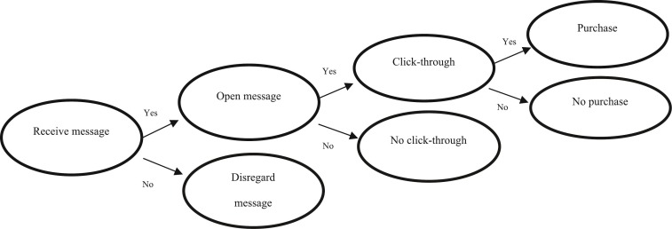

Figure 2.1: Personalised Email Marketing
(Source: Nobile and Cantoni, 2023)

2.3 Description of AI-Generated Dynamic Content
The term AI-generated dynamic content refers to the use of Artificial Intelligence, such as Generative AI, Generative Adversarial Networks (GAN), and Variational Auto encoders (VAE), in generating content, personalising, and updating in real-time for marketing, digital media, and improving user experience. According to Gao et al. (2023), specifically, AI is increasingly used in Advertising Targeting, Personalisation, Content Creation, and Ad Optimisation (Refer to Figure 2). The evolution of AI has been done based on literature, and it has been found that it depends a lot on the nature of the website and business. According to the multidimensional analytical framework used by Lim et al. (2024), helped to find that artificial intelligence technologies have provided valuable insights into the advertising industry. Some of the patterns that have emerged from the results are noteworthy, which highlight the growing importance of machine learning tools and techniques such as word2vec, GANs, etc., and their impact on society as they continue to shape the future of advertising practices. On the other hand, Gulati & Grover (2026) state that the integration of AI has enabled the creation of a new era of content creation. The researchers undertook both primary and secondary research and found that the creation of the new era of content creation is attributed to the ability of AI to analyse massive amounts of data and create content that matches the audience's needs instantly.
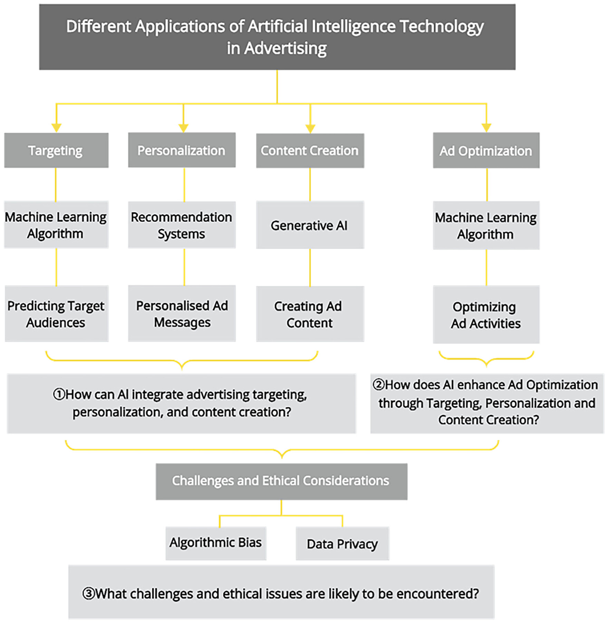

Figure 2.2: AI Marketing
(Source: Gao et al., 2023)

2.4 Factors Influencing Demand for Personalised Marketing and AI-Generated Content
The factors which affect demand for personal marketing are complicated and comprise various elements, which include consumer expectations, technological advancements, and business demands for consumer loyalty and involvement. According to Kushwaha (2020), digital marketing is becoming increasingly popular, and every business is trying to advertise its business through various digital ad platforms. Based on the quantitative research, Personalised SEO/SEM, Personalised Emails, Personalised Display Ads, Personalised SM Marketing, and Personalised Video Ads are influencing personalised digital marketing (Refer to Figure 3). Based on Casaca and Miguel's (2024) study, using systematic and explicit methods highlights that personalisation can inﬂuence consumer satisfaction. It provides information that can be utilised in the development of appropriate marketing strategies for creating and sustaining high levels of consumer satisfaction. Personalised digital marketing is affected by the changing needs of consumers, technology, and the need to enhance consumer engagement.
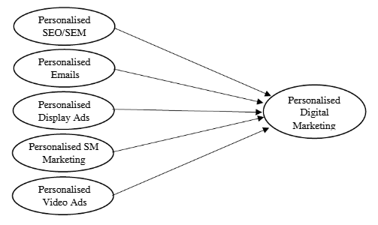

Figure 2.3: Personalised Digital Marketing
(Source: Kushwaha, 2020)
The demand for Artificial Intelligence-Generated Content (AIGC) is driven by several technological, organisational, and individual factors. Shoval (2025) states that learning experiences and outcomes have been affected by simulations based on Artificial Intelligence. The author used a mixed method for studying the effects of Artificial Intelligence-based understanding and engagement of the content by various groups, which led to the emergence of “AI literacy divide” (Refer to Figure 4). Statistical methods such as Spearman’s correlation and ordinal logistic regression were used to determine the essential factors for acceptance (Kubovics, 2025). The findings showed that a high quality of content generated by AI increases user acceptance. Similarly, the level of trust, as found by Gu et al. (2024), affects the acceptability and willingness of consumers, as well as the development of negative emotions of distrust by the consumers. The consumers will react defensively to these messages, and it will affect their acceptability and willingness towards AI advertisements, as reported by the questionnaire survey.
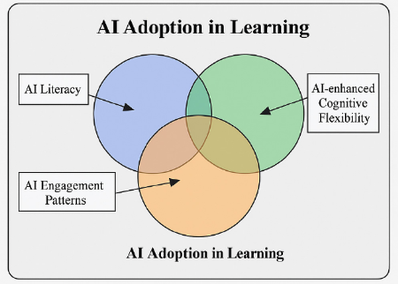

Figure 2.4: AI Adaptation in Education
(Source: Shoval, 2025)

2.5 Impact of the Personalised Email Marketing on generating customer satisfaction leads to Enhanced Customer Engagement
Personalised marketing campaigns using emails have the potential to increase the level of customer satisfaction. Therefore, it can be said that the benefits of personalised marketing campaigns are immense. It helps in improving the relationship between the brand and the consumers by providing relevant information to the consumers. According to Dwivedi et al. (2024), Customer Relationship Management (CRM) is a crucial factor in increasing market share, productivity, in-depth knowledge of customers, and customer satisfaction to build their loyalty towards the company. In order to have a clear view of their customers and understand their needs and how to satisfy their needs and wants. The findings of quantitative research state that customer satisfaction enhances customer loyalty and customer relations (Refer to Figure 5). Jayanna and Mayya (2025), in their research on email marketing using a secondary qualitative method, found that email marketing is a data-driven and scalable engagement method, though some of the challenges associated with it include spam filtering, content fatigue, privacy, and compatibility. It is evident that too much personalisation can cause users to unsubscribe from emails.
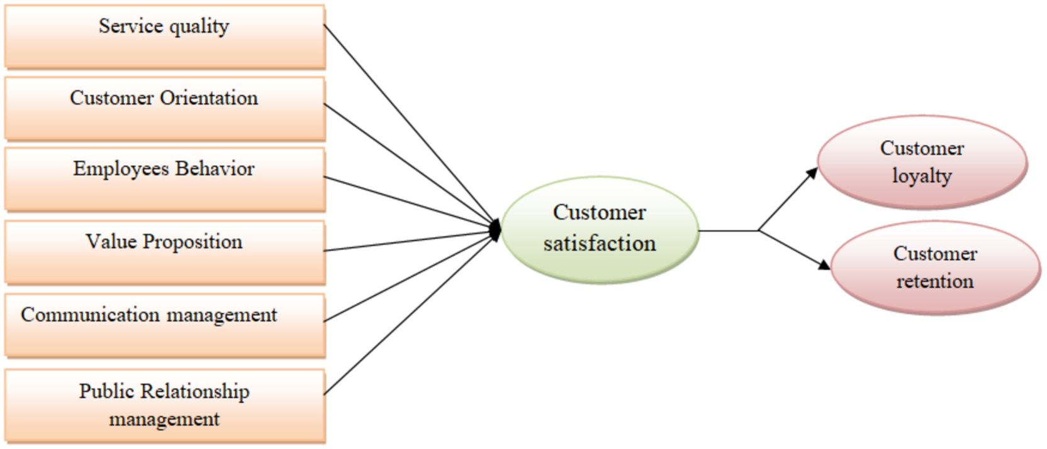

Figure 2.5: Customer Satisfaction
(Source: Dwivedi et al., 2024)
The characteristics of the messages in social media advertising are important for the advertisers (Iliyas, 2024). Completeness, relevance, flexibility, timeliness of the argument, quality, and source credibility have a positive impact on user satisfaction, according to the conduct of the ML method. Personalised email marketing campaigns can play a significant role in increasing the level of satisfaction, loyalty, and brand relationships with customers.

2.6 Effectiveness of AI-generated Dynamic Content over Personalised Email Marketing to Increase Customer Engagement Rates
AI-generated Dynamic contents are seeming to be more attractive and understandable than the contemporary marketing methods towards the customers. According to Mucci (2026), these type contents basically are the video, audio, texts and images generated through the AI models in the instant time. This content is of high quality, with better visualisation and unique from other marketing resources. In contrast, personalisation marketing through email is the method that utilises the customer data based on their buying and usage history of the websites. According to Muminov (2024), through evaluating many studies, books, reports and opinions from industry experts, it has been evaluated that email-based marketing majorly depends on the scale of personalisation. However, personalised email marketing increases customer satisfaction and loyalty, aside from providing enhanced customer engagement.
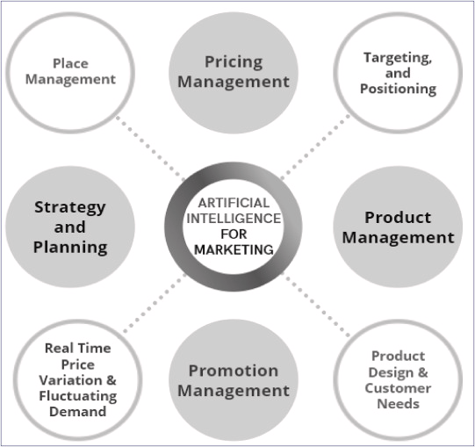

Figure 2.6: Usage of AI in Marketing
(Source: Haleem et al. 2022)
According to Haleem et al. (2022), AI-marketing is used for product and price management, variation of the value and demographic engagement that is found through evaluating many articles, journals and books for artificial intelligence (Refer to Figure 6). AI algorithms and ML models remove the risks of error generation from the human-based approaches. AI-driven dynamic content is an efficient outcome of strong market research with valid data, and it also quickly processes the marketing procedures. According to Verma and Fatma (2025), dynamic webpages, emails and ads are also the dynamic contents that can be modified through AI-algorithms are found through examining secondary data from reports, documents and other resources. AI-driven dynamic content can generate real-time responses, quick delivery, increase customer attention, of the customers and enhance the operational efficiency of marketing in the business organisation.

2.7 Comparative Analysis to determine the role of Personalised Email Marketing and AI-generated Dynamic Content
Personalised email marketing is considered the advanced version of traditional marketing techniques, with a transformational strategic implication for enhanced marketing techniques. Whereas AI-driven dynamic content is considered a huge transformation in the era of digital marketing that provides accuracy and efficiency in marketing practices. According to Sabbagh (2021), through the evaluation of global reports and other secondary data, it has been explored that email marketing is one of the most effective methods to reach customers in less time than traditional methods. In addition, email-based personalised marketing is very cost-effective and also creates a good relation to the customers. However, the email-based marketing is slower than the AI-driven marketing, and this process is entirely data-dependent.
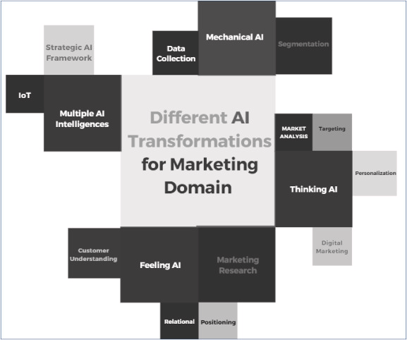

Figure 2.7: AI-transformations for the Marketing Sectors
(Source: Haleem et al. 2022)
According to Haleem et al. (2022), exploration of many articles, journals and books on artificial intelligence expresses that AI has transformed through integrating improved techniques, strategies and an enhanced level of understanding about human emotions (Refer to Figure 7). According to Gao et al. (2023), the analysis of the datasets and journals expresses that the AI-models analyses the customer habits and behaviours. This improves the efficiency of the models and content generation for marketing. It can also easily modify the webpages and contents to meet the needs of the market. According to Gabelaia (2025), from the evaluation of qualitative and quantitative approach it has been explored that AI marketing includes the techniques NLP, human resourcing and improved decision-making that enhance the content quality and reliability. Additionally, AI-generated content marketing is much faster and more accurate, and provides hyper-personalisation than email-based personalised marketing.

2.8 Customer Converter Rate and Engagement Rate in Email Marketing
Personalised content is one of the important factors that affect the performance of email marketing campaigns. A study by Deshmukh (2024) found that customers are 26% more likely to open an email with personalisation in the subject line. On the other hand, Iyelolu et al. (2024) state that key areas of focus include AI algorithms in customer segmentation, predictive analytics in customer behaviour prediction, and natural language processing in creating personalised content. Personalisation, addressing the customer by name, is likely to have a major impact.
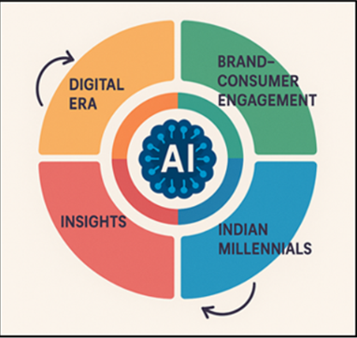

Figure 2.8: AI-Powered Customer Engagement
(Source: Sharma and Jha, 2026)
According to Jayanna and Mayya (2025), one of the marketing strategies, email marketing, has been identified as one of the most cost-effective marketing tools to reach a large number of customers. The digital marketing arena has become more competitive, and customer engagement has been identified as a benchmark to measure the success of email marketing campaigns. AI is a powerful toolset which can help address the problem since it can handle tasks like mood analysis, predictive engagement modelling, behavioural segmentation, and campaign personalisation on a large scale (Sharma and Jha, 2026) (Refer to Figure 8). AI can help develop dynamic content which can be responsive to the behaviour, preferences, and demographics of the users, thereby enhancing their satisfaction and the conversion rate.

2.9 Challenges Faced by Consumers in Terms of Personalised Email Marketing
Email-based personalised marketing is a foundational approach in internet marketing in the transformation from traditional marketing. In the beginning era of internet marketing, email-based personalisation was a big change, but in the context of the AI era, its popularity faded. Besides a few advantages, customers have faced a few challenges in cooperating with email-based personalised marketing strategies.
Data-security and consent issue - According to Popoola and Phillip (2025), customer faces the major issues of data-security in email-based personalised marketing, and also, consent is not taken many of the times, as found from the case studies analysis. The brands often fail to maintain this data transparency with their customer about the usage that causes data leaks and misuse of the data.
Privacy Concern issues - Many of the customers face privacy concerns due to the unauthorised usage of their data by the business organisations, and also to train the predictive systems for improving personalisation. Most of the time, the customers are not aware of this usage that causes the risk of invading their privacy.
Over nagging, scams and frustration - According to Ligaraba et al. (2023), from a quantitative study, it can be explored that many of the times email-based marketing is mistaken for scams, for the customer, as it marked them as spam emails. Many of the times, the consumer cannot determine the original promotional content from the fake content. These issues led to customer frustration and irritation due to being annoying and irrelevant. According to Vardikou et al. (2025), nudging of the companies often cannot manipulate the real preferences of the consumers. Sometimes, email marketing is perceived as over-nagging due to sending personalised emails to customers that are irrelevant to customers' demand or need.

2.10 Issues Experienced by Customers due to AI-Generated Dynamic Content
AI-generated dynamic contents are made through the AI models that are trained with several datasets based on the customer data in purchasing, online visit and usage. AI-generated contents are also very manipulative and accurate in prediction, which also creates a few threats to the customers.
Gaps in content genuineness and Trust issues - AI-generated dynamic contents are basically contains text, images, websites and audio that are manipulated through some instructions and datasets. According to Belanche et al. (2025), AI-generated contents are full of fake visualisation, and a lack of trustworthiness has been evaluated through an experimental study. Far from this, human control over the AI-content has also been disrupted in the improvement of technological innovations.
Monotonous Content and Lack of depth - AI-driven systems are most of the times build over the same models and algorithms based on the same logics. However, the contents are generated through analysing the limited sources of data sets, which often lead to monotonous content and repetitive format in the outcomes. According to Ott (2025), AI-generated content has no depth in the writing based on human perception and feeling. It also requires huge energy-consuming and efficient computational power for generating content that increases the human pressure.
Content manipulation and Unethical practices - According to Ratta et al. (2024), an interview analysis expressed that the AI-generated content often occurs as inappropriate and manipulated content that disrupts the ethical guidelines of the content-generation or ethical AI usage. In accordance, the AI-algorithms can be biased due to the biased datasets that create unfair or strict results that are not aligned with the customer perception.

2.11 Suggested Recommendations to Overcome the Identified Challenges Regarding both Marketing Techniques

2.11.1 Recommendations In-terms of Email-based Personalised Marketing
Email-based personalised marketing has a rising issue of disruption of data privacy and security issues, scams and spam emails faced by consumers. This research evaluates a few suggestions for these challenges in the Email-based marketing techniques. Data privacy and security are one of the major concerns for marketing practices, as it is the driver variables to increase customer engagement and satisfaction.
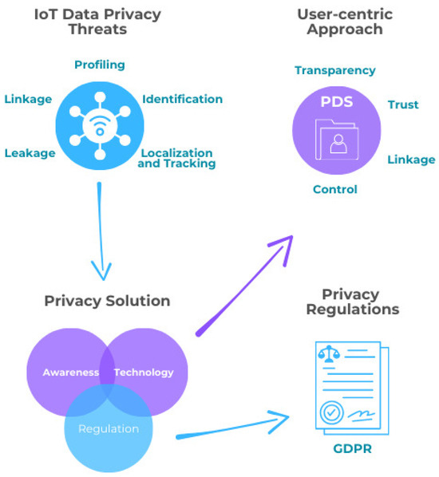

Figure 2.9: Resolution of Data Privacy Issues
(Source: Pinto and Prazeres, 2025)
According to Pinto and Prazeres (2025), the evaluation of different reports and guidelines shows that data privacy and security issues can be resolved through increasing awareness, strict data regulations and increased technological improvements (Refer to Figure 9). In order to prevent users from scams, the organisations should verify the user's authenticity and be aware of the original content from fake and irrelevant marketing. In contrast, companies should provide unique and creative content each time to the users that helps to engage the customer's attention and interest. According to Popoola and Phillip (2025), through a case study analysis, it has been evaluated that the term over-personalisation refers to where the customer receives an enormous number of emails that decreases the customer's interest. In order to solve this, the organisations should provide value-driven content personalisation and prioritise content quality over the intensity of marketing (Popoola and Phillip, 2025). The company also need to track the customer benefits over the unreliable marketing practices that help to grow interest among the customers and also improve the brand image. In addition, clear communication also establishes transparency between the customer and brand, that follows better engagement.

2.11.2 Recommendations regarding AI-generated Dynamic Content Marketing
Ai-generated Dynamic content is used in marketing for providing improved visualisation, relevance and quality of experience to the customers. However, these strategies create a few challenges for the consumers, besides their advantages. This section of this study explores a few overcoming strategies for those evaluated challenges in the context of AI-generated content marketing.
According to Ott (2025), AI-Implementation needs better modularisation and careful planning about the data usage and protection to avoid the risk of data security. In order to ensure data protection, the organisation should align the process of AI content generation with the data protection regulations and the implemented AI acts.
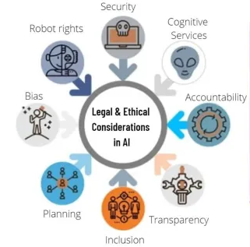

Figure 2.10: Ethical and Legal Factors for AI usage
(Source: Naik et al. 2022)
According to Yu et al. (2025), through an evaluation of the data taken in interviews, it has been explored that the users are more aware of the content authenticity and ethical perceptions that are highly context-dependent and can be described through different factors. According to Naik et al. (2022), ethical and legal considerations need planning, security, accountability and other factors from the analysis of a few databases (Refer to Figure 2.10). Organisations should maintain transparency about the AI-usage with the consumers and remove algorithmic bias for increasing ethical practices. AI-driven systems often generate repetitive content due to the use of the same AI-models and algorithms that causes the algorithmic bias. These monotonous contents do not seem to be that attractive or engaging towards the customers. These challenges can be overcome by removing the algorithmic bias and using diverse data sets for the data training of the AI-models. Diverse data sets and different logic or prompts in the case of content generation are able to create unique and different marketing content for customer engagement and interest. Improved engagement of the customer increases customer satisfaction and brand value of the organisation in the space of sales and content marketing for revenue generation.

2.12 Theoretical Framework

2.12.1 Technology Acceptance Model (TAM)
The theoretical approach to the acceptability of technology is known as the Technology Acceptance Model (TAM). According to TAM, the acceptability of technology is a function of two variables, such as perceived usefulness (PU) and perceived ease of use (PEOU), and these variables affect attitudes and behaviours towards the use of the technology (Park and Park, 2020) (Refer to Figure 2.11).
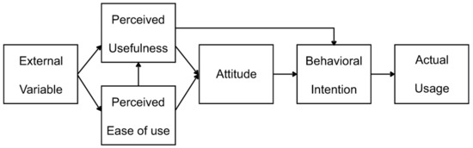

Figure 2.11: Technology Acceptance Model (TAM)
(Source: Park and Park, 2020)
Perceived usefulness (PU) is defined as the extent to which the customer's needs are met by the content of the message. The consumer receives emotional benefits ("feeling cared for" by the brand) and functional benefits (receiving relevant promotions/discounts) from the perceived usefulness of personalised emails (Harsanto et al. 2023). Dynamic content creation using AI will also help in improving perceived usefulness by allowing for real-time changes in subject lines.
Perceived ease of use (PEOU) deals with the ease of use by the customer, and personalised emails are easy to use. However, dynamic content may be difficult to use at first glance, but it may also increase the ease of use of the content by helping the customer make a decision and giving the customer what they want at once without much hassle.
Overall, though both approaches encourage consumer engagement, dynamic content through AI has more scope for optimisation of PU and PEOU, thereby motivating more consumers to take action.

2.12.2 Social Cognitive Theory (SCT)
The major goal of social cognitive theory (SCT) is to unify behavioural and cognitive aspects of human conduct (Lahcen et al. 2020) (Refer to Figure 2.12). The basic assumption of social cognitive theory is that human beings do not respond passively to past and present influences of the environment.
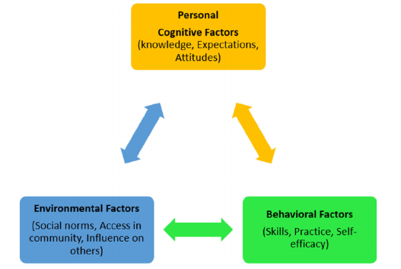

Figure 2.12: Social Cognitive Theory
(Source: Lahcen et al., 2020)
Personal Cognitive Factors (e.g., attention, perception, memory, motivation)- Cognitive engagement in personalised email marketing occurs through personalised subject lines, recommendations, and content that resonates with the users based on their needs and behaviours (Hardcastle et al. 2025). On the other hand, dynamic content developed through AI engages the users cognitively through real-time data and predictive analysis.
Behavioural Factors (e.g., past actions, response patterns)- Personalised emails are greatly dependent on past user behaviour, such as past purchase history or past browsing behaviour. This promotes a kind of habitual response from the user, as they respond favourably to a stimulus that is familiar to them (Egele et al. 2025). Dynamic content, being a creation of AI, goes a step further in this regard, as it learns from past user behaviour in real-time and changes the content accordingly.
Environmental Factors (e.g., social context, platform, timing)- The environment in which personalised emails are sent can be limited in a way, whereas the timing and devices can influence consumer response. AI-generated dynamic content can be more flexible in response to environmental factors, such as location, timing of delivery, or device types.
Both of these marketing strategies are consistent with the SCT; the system of AI-generated dynamic content is more adaptive and responsive, whereas the sense of familiarity is provided by the personalised email marketing.

2.13 Conceptual Framework
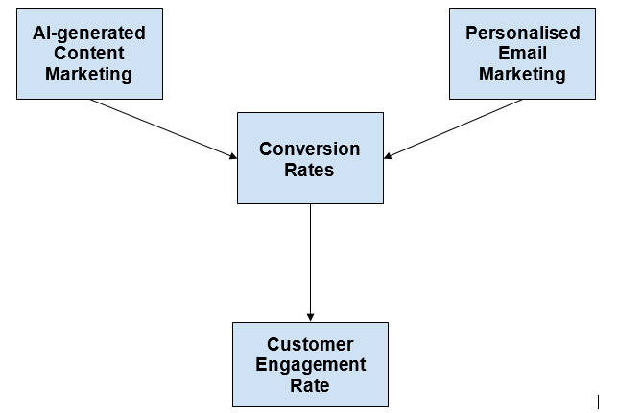

Figure 2.13: Conceptual Framework
(Source: Self-developed)
Personalised email marketing and AI-generated Content marketing are very good approaches for good marketing practices. AI-models and Email-based personalisation provides contents that helps convert customers by attracting them to like it with more relatable and visual content (Refer to Figure 13). The AI-model and email-based approach have transformed many features to achieve the human conversion as a customer, and it also enhances the watching and exploration experience with improved quality of content and speedy recognition.

2.14 Literature Gap
Despite numerous studies on personalised email marketing and AI-generated dynamic content, there are gaps in the literature on these topics. Firstly, empirical studies are scarce on the relative effectiveness of both personalised and AI-generated dynamic content on improving customer engagement and satisfaction in a similar context (Muminov, 2024; Thomas et al., 2022; Gulati & Grover, 2026). Secondly, there is a lack of emphasis on long-term behavioural effects, especially on how long-term exposure to AI-generated content impacts customer trust and loyalty (Kushwaha, 2020; Kubovics, 2025; Dwivedi et al., 2024). In addition, there is a lack of quantitative validation of ethical issues related to data privacy, transparency, and bias in AI algorithms (Muminov, 2024; Verma and Fatma, 2025; Sabbagh, 2021). Next, many of the studies have not evaluated the customer conversion rates generated through email-based personalised marketing and AI-based content marketing with competitive views. Similarly, the transformation of customer engagement rates through both marketing techniques has not been discussed in many studies. These rates help to understand the market conditions and behaviours and responses of the customer according to the marketing preferences. The above mentioned gaps are going to be addressed in the present study of the given topic.

2.15 Chapter Summary
This section reviews the previous literature on the email-based personalised marketing and AI-generated dynamic content marketing factors. At first, it discusses the overview of both marketing techniques, with the factors that influence the growth of the techniques. Then it finds out the challenges of both marketing techniques and also suggested few recommendations to overcome them. Just before the last points, it describes two theories to establish the alignment of the marketing theories in the dissertation, which are the TAM and SCT models. In the last two points, a conceptual framework has been developed to show the customer engagement rates increment and then it expresses the literature gaps.

CHAPTER 3: RESEARCH METHODOLOGY

Research onion
The research onion model offers an orderly system of building research methodology, traversing the various levels of decision-making (Ghazinoory et al., 2025). It starts with the research philosophy, according to which in this research positivism is accepted, which allows carrying out a measurable and objective analysis. The second level, research approach, is deductive in nature to test hypothesis (Bryman, 2016). The methodology adopted is quantitative, and the data on engagement can be statistically compared. The study design is a survey with a cross-sectional time frame, in which data is gathered at a single point. Lastly, data gathering and analysis include structured questionnaires and statistical packages like SPSS, which bring about consistency and validity of results.
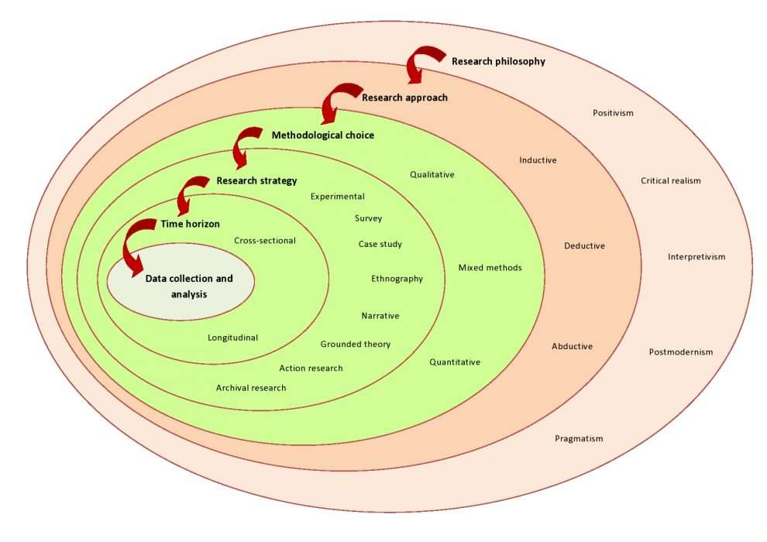

Figure 3.1: Research onion
Source:(Tengli, 2020)

3.1 Introduction
The chapter provides the methodological framework to be used to research the comparative effectiveness of personalised email marketing and AI-generated dynamic content in customer engagement rates (Cash,Daalhuizen & Hekkert, 2023). The research design is designed in such a way that it is in line with the research aim, objectives and hypotheses that were set in Chapter 1. Since the study is empirical, the primary approach used is data driven to produce measurable information on consumer behaviour and engagement patterns. This chapter is a critical discussion of the research philosophy, approach, strategy, data collection methods, sampling techniques and data analysis procedures. It also analyses the strengths and weaknesses of the adopted methodology in order to provide transparency and academic rigour.

3.2 Research Philosophy
The research is based on a positivist philosophy, which is anchored on the assumption that reality is objective, observable and measurable by using empirical means (Lim, 2023). The given philosophical position is especially relevant to this research since interaction can be measured in terms of measurable variables, like the frequency of interaction, the relevance of the interaction, and response behaviour. Positivism advocates the application of structured tools and statistical techniques, which allow the researcher to test hypotheses and make generalisable conclusions.
The positivist approach might however be simplistic on the complexity of consumer behaviour when viewed critically (Creswell & Creswell, 2018). Customer engagement is not strictly objective, but is affected by subjective perceptions and emotions and contextual factors. To illustrate, a respondent can claim to be very active in using AI-generated content, but this might not be the case as to whether they are interested or loyal to it. Even with this weakness, the positivist philosophy is appropriate because the study involved comparative measurement and hypothesis testing, which needs to be structured and quantifiable research design (Ghanad, 2023).

3.3 Research Approach
This research paper adopts a deductive method of research whereby theoretical ideas and literature are applied to generate hypotheses that are then supported by some empirical data (Hall, Savas-Hall & Shaw, 2023).The deductive method is consistent with the positivist philosophy, in the sense that it allows relationships among variables to be tested systematically. The hypotheses in this study are created on the basis of the existing theories of online marketing and customer interaction, specifically the opposition between relationship-oriented marketing (email) and technology-driven marketing (AI content).
The deductive method can be used to facilitate a clear and focused study so that the study does not go off track (Fife and Gossner, 2024). But it restricts the discovery of new or unforeseen knowledge, because it is closely dependent on the preexisting theories. Much more exploratory or inductive would yield more information on consumer motivations, but it would make it more difficult to statistically compare the two marketing strategies. Consequently, the deductive methodology can be said to fit the purpose of the research as well as ensure methodological rigour.

3.4 Research Strategy
The survey research approach is embraced in order to obtain primary data of a great number of respondents. The use of surveys in marketing research is popular because it helps to produce standardised and measurable data (Mardiani,Utami & Mujahid, 2023). The survey method will be used in this study to compare personalised email marketing with AI generated dynamic content in terms of customer engagement through gathering of similar responses amongst the participants.
A survey strategy has a number of benefits. It enables gathering of data efficiently within a short period of time and enables a statistical analysis based on the structured responses. Also, surveys are very general in terms of consumer preferences and behaviours, hence they can be used in comparative studies (Flavián et al., 2023). Nonetheless, there are also some limitations that are related to surveys. They can also yield superficial results since respondents might not take time to ponder their responses. Moreover, there is a possibility of response bias in the event that the participants will give socially desirable responses instead of their actual opinions. In spite of these constraints, the survey approach is the most suitable and efficient way of attaining the research objectives (Ting et al., 2025).

3.5 Research Method Choice
The research follows a single methodology of quantitative research (mono-method), whereby only numerical data is employed, gathered by means of structured questionnaires (Spierings & Geurts, 2025).This method is appropriate to assess the level of customer engagement and test the research hypotheses with the help of statistical methods. Quantitative methods are objective and reliable, and allow the researcher to discover patterns and relationships among variables.
Critically speaking, the deep analysis may be constrained by the sole use of quantitative data. Although numerical data can be used to show which marketing strategy is more efficient, it might not be enough to determine what factors underlie consumer preferences. As an example, an increased rate of engagement in AI-generated content does not necessarily indicate that it is more trustworthy to the consumers or it looks more appealing (Labajová, 2023). In spite of this drawback, the quantitative method is worthy of the choice because it can give clear, measurable and comparable results.

3.6 Data Collection Method
The primary data will be obtained via an online questionnaire that will be administered via the digital platforms, including Google Forms (Zimba & Gasparyan, 2023).The questionnaire will focus on capturing the experience of respondents and perceptions towards personalised email marketing and AI-generated dynamic content. It will be comprised of around 20 structured questions in four parts: demographics, email marketing engagement, AI-generated content engagement, and comparative evaluation.
The structured questionnaire is used to provide a consistency in the answers, which can be statistically analyzed (Field, 2018). The questions are mainly on a five point Likert scale of strongly disagree to strongly agree. This scale helps to quantify attitudes and perceptions. Moreover, the questionnaire has several multiple choice questions that can record behavioural information like frequency of email interaction and online content engagement.
Importantly, while it is very convenient and efficient to use questionnaires online, there are also some challenges. The respondents might not comprehend the questions or may give incomplete or inaccurate responses. In addition, self-reported information does not necessarily reflect actual behaviours as the informants may over or underestimate their engagement (Arezzo et al., 2024). However, these limitations cannot be ignored and still the extension of the questionnaire on the internet is an efficient means for collecting mass primary data in a relatively short time.

3.7 Sampling Technique and Sample Size
This study uses the non-probability sampling method – convenience sampling which is the type of sampling that is done when the respondents are considered accessible for the sampling (Rahman, 2023). This is useful for exploratory and time-limited research where the research questions are quantitative, but may not be appropriate when findings are not likely to be generalisable.
The sample size n is determined using Cochran's formula for statistical adequacy, which is commonly used in research involving surveys and/or large populations.
n0 = (Z^2 * p * (1 - p)) / e^2
Where:
n0 = required sample size
Z = Z-value (1.96 for 95% confidence level)
p = estimated proportion of the population (0.5 used for maximum variability)
e = margin of error (0.05)

Sample Size Calculation:
Substituting values:
Z = 1.96
p = 0.5
e = 0.05
n0 = (1.96^2 × 0.5 × 0.5) / (0.05^2)
n0 = (3.8416 × 0.25) / 0.0025
n0 = 0.9604 / 0.0025 = 384.16
Thus, the minimum recommended sample size is approximately 385 respondents.
However, due to time and resource constraints, this study targets 200 respondents, which is still considered acceptable for quantitative analysis in business research (Hair et al., 2019). After accounting for incomplete responses, an estimated 150–180 valid responses are expected. While Cochran’s formula suggests a larger sample for higher precision, practical limitations often necessitate smaller samples in academic research. The selected sample size balances feasibility and analytical reliability, though it may reduce external validity. Future research may adopt probability sampling and larger samples to enhance generalisability.

3.8 Data Analysis Techniques
The data obtained is analysed with the help of IBM SPSS software which is popular in statistical analysis in scholarly research (Ghanad, 2023). A number of statistical methods are used to analyze the relationships among the variables and test the hypotheses of the research. The data are summarised using descriptive statistics, such as mean, median and standard deviation to give an overview of the level of engagement (Kotronoulas et al., 2023).
Statistical methods of inferences are also used to make the analysis more profound. The relationship between the marketing strategies and customer engagement is analyzed using Pearson correlation analysis. Chi-square test is used to determine relationships between categorical variables, and ANOVA is to compare the level of engagement between various groups (Rahardja and Aini, 2025). With the help of these statistical tools, the researcher will be able to define important differences and patterns in the data.
Most importantly, statistical analysis will yield objective and valid results but they all depend on the quality of the data gathered. The accuracy of the findings could be influenced by any bias or inconsistency in the data. Moreover, statistical significance is not necessarily practical significance and thus one should interpret the results carefully.

3.9 Reliability and Validity
To ensure credibility of the research, reliability and validity are crucial. Reliability is the ability of the measurement to remain constant and this is done by the use of standardised questions and a structured questionnaire format (Hossan , Wolfs & Petkovic, 2025). Validity is the correctness of the measurement, and it is important that the questionnaire correctly measures the notion of customer engagement.
The validity of the content is guaranteed through a correspondence between the questionnaire and the research goals and literature (Saunders et al., 2019). Construct validity will be attained through the application of the indicators of engagement that have been in use e.g. frequency of interaction and perceived relevance. These measures notwithstanding, there are some limitations. Due to the different interpretations of questions by the respondents, there can be varying responses. Moreover, extraneous variables like mood or situation may affect the responses of participants.

3.10 Ethical Considerations
The study is conducted in ethically acceptable manner in order to protect the subjects. The survey is voluntary and the respondents are told the purpose of the study prior to filling in the questionnaire (Zikmund et al., 2013). Participants are informed and can withdraw any time. Data collected is anonymous and confidential, which means that no individual responses will be identified.
In a critical view, although ethical considerations are made, online data collection can still be a threat to the security and privacy of data (Allahrakha, 2023). These risks are however minimised by avoiding collection of sensitive personal information and providing safe data storage processes.

3.11 Limitations of the Methodology
In spite of its strong points, the methodology has various limitations. Convenience sampling limits generalisability of the results (Raifman et al., 2022).The use of self-reported data can create bias, as the respondents are not necessarily accurate in their behaviour. Also, the quantitative method is restrictive in terms of analysis, because it fails to understand the motivations behind consumer preference. Such restrictions are accepted in order to guarantee transparency and critical appraisal of the research.

3.12 Conclusion
This chapter has critically described the methodological framework applied in carrying out the study. To achieve objective and measurable analysis, a positivist philosophy, deductive approach and quantitative survey strategy have been adopted. Although the methodology also offers a solid framework to make comparisons between personalised email marketing and AI-generated dynamic content, it has limitations that need to be taken into consideration when interpreting the results. The analysis of data and findings based on the primary data obtained will be presented in the next chapter.

CHAPTER 4: DATA ANALYSIS AND FINDINGS

4.1 Introduction
In this chapter, the empirical results of this study, which compares the effectiveness of personalised email marketing with AI-generated dynamic content, are presented. The method of this research was a quantitative approach with 150 respondents who were obtained using a structured questionnaire. IBM SPSS Statistics was used for the analysis of the collected data, descriptive statistics, reliability analysis, inter-item correlation matrices, chi-square tests of independence and kappa coefficients were used. The chapter is designed so that the results are described in order: descriptive statistics, reliability analysis and then cross tabulation and chi-square analysis for hypothesis testing. Tables of SPSS output are provided for each section, and the output is placed in the context of the wider digital marketing literature.

4.2 Descriptive Statistics
The key survey items were summarised by descriptive statistics that summarised distributional and central tendency, and variability. The scale for the items measured each respondent's perceived personalised email marketing and dynamic content created by AI on a five-point Likert scale, ranging from (1) Strongly Disagree to (5) Strongly Agree. The complete descriptive statistics from SPSS is given in Table 4.1.
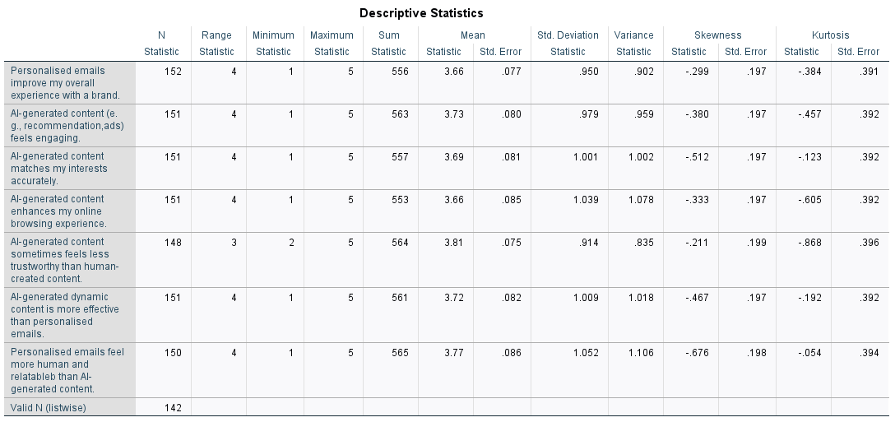

Table 4.1: Descriptive Statistics of Survey Items
(Source: SPSS Output)
Here are some interesting patterns that emerge from the descriptive statistics. The highest mean (M = 3.81, SD = 0.914) was found for the item 'AI-generated content sometimes feels less trustworthy than human-created content'. The results suggest that respondents are sceptical of the authenticity of the content they find on AI-generated platforms. This aligns with Belanche et al. (2025) study, which in an experimental study, showed that AI-generated content often comes across as less trustworthy and relatable to human readers.
On the other hand, there was a comparable mean for the item "Personalised emails improve my overall experience with a brand" of 3.66 (SD = 0.950) and the item "AI-generated content (e.g., recommendation, ads) is engaging" of 3.73 (SD = 0.979). Both approaches are close in rank, and respondents rate them as being moderately effective at increasing engagement; there is no clear aggregate level benefit for any one approach. Nobile and Cantoni (2023) also reported on the positive impact of personalisation on customer experience and behaviour, but they found that the extent of this impact depends on the contextual factors and preferences of the individual.
The skewness values for all the items were within the acceptable limits of -0.211 to -0.676, which suggested that the responses for all the items were a little bit skewed towards the negative side; that is, a higher percentage of respondents tended to agree or strongly agree with the items on the survey. Other values, kurtosis, were also in an acceptable range (-0.054 to -0.868), indicating no extreme peakedness and flatness in the distributions. The results of these distributional properties give confidence to the normality assumptions which underlie subsequent parametric analyses.

4.3 Reliability Analysis
An internal consistency analysis called reliability analysis was conducted to evaluate the internal consistency of the scale of personalised email marketing, which includes 4 items to measure the internal consistency of the scale. Cronbach's alpha was used as the main instrument to measure the reliability of the analysis. Table 4.2, 4.3 and 4.4 show the Item Statistics, Inter-Item Correlation Matrix, and Item-Total Statistics, respectively.
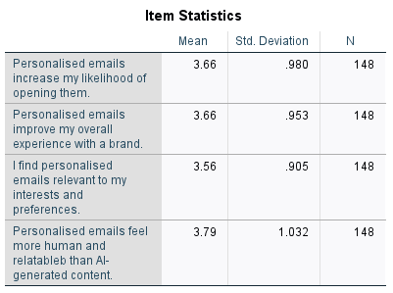

Table 4.2: Item Statistics – Personalised Email Marketing Scale
(Source: SPSS Output)
Generally, there was a positive perception of personalised email marketing on all four items, with an item mean of between 3.56 and 3.79. A personalised email with messages generated by humans had the highest mean (M = 3.79, SD = 1.032), highlighting the respondents' preference for a human touch in email content. Conforming to the findings of Jayanna and Mayya (2025), humanness and emotional resonance play an important role in the engagement of email marketing.
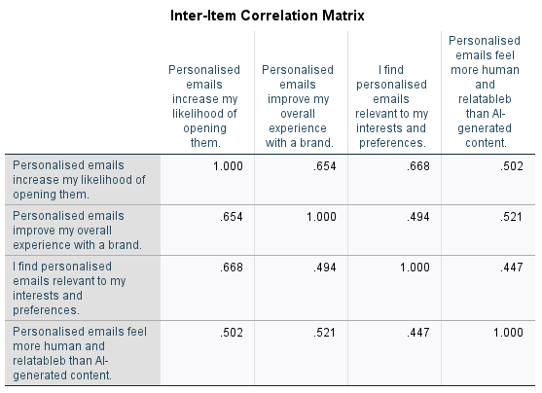

Table 4.3: Inter-Item Correlation Matrix
(Source: SPSS Output)
There are high positive inter-item correlations among the four items (ranging from .447 to .668) as shown in the inter-item correlation matrix. The strongest relationship was between "I find personalised emails relevant to my interests and preferences" and "Personalised emails increase my likelihood of opening them" (r = .668), indicating that the relevance of emails is a factor of the likelihood of opening emails. The moderate correlations suggest that there is no redundancy in the items and they measure a unified underlying construct (Pallant, 2020).
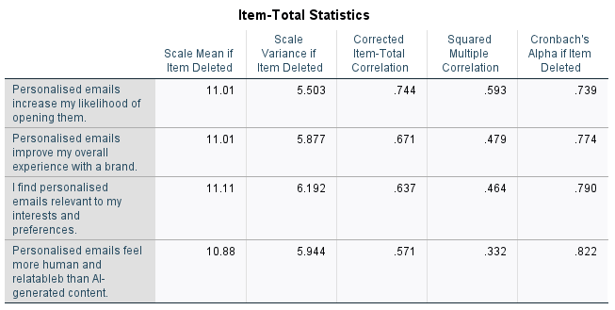

Table 4.4: Item-Total Statistics and Reliability
(Source: SPSS Output)
The overall scale Cronbach's alpha is α = 0.822 (after removal of the weakest item), and the Scale Statistics table (Table 4.4) indicates that the overall grand mean is 14.67 (SD = 3.144), which falls above the acceptable value of 0.70 (conventionally accepted. The corrected item-total correlations ranged from .571 to .744, which were all above the minimum relation between items and the scale (0.30). The findings above show that the personalised email marketing scale has good internal consistency, which allows the use of this scale in further inferential analysis.

4.4 Hypothesis Testing via Cross-Tabulation and Chi-Square Analysis
A cross-tabulation with the Pearson chi-square test of independence was used to test the hypotheses of the study. The tests looked at the association between respondents' perceptions of personalised email marketing and AI-generated dynamic content, respectively, for a number of pairs of variables. The criterion for statistical significance was a p-value of < 0.05.

4.4.1 Perceived Relevance of Personalised Emails vs. Engagement with AI-Generated Content
A first series of cross-tabulations examined the links between the item ‘I find personalised emails relevant to my interests and preferences’ and the following three content items generated by AI: (1) AI-generated content is engaging; (2) I often see content produced by AI online; and (3) AI-generated content matches my interests accurately.
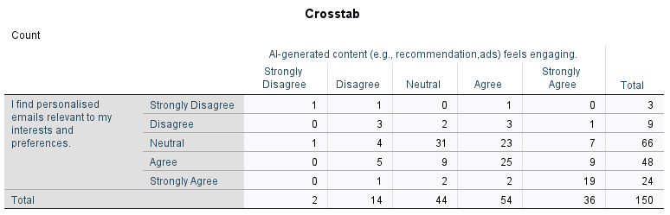

Table 4.5: Cross-Tabulation – Personalised Email Relevance × AI Content Engagement
(Source: SPSS Output)
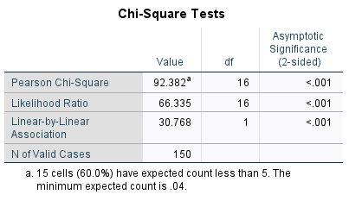

Table 4.6: Chi-Square Tests – Personalised Email Relevance × AI Content Engagement
(Source: SPSS Output)
As can be seen in Table 4.5, when the respondents who agreed that personalised emails are relevant were cross-tabulated (n = 48), the majority of respondents also agreed that AI-generated content is engaging, with 25 saying it is engaging and seven strongly agreeing. The chi-square test of independence (Table 4.6) had a Pearson chi-squared value of χ2(16) = 92.382, p < .001; this result was very statistically significant, suggesting that there was a strong association between the perceived relevance of emails using a personalised approach and the engagement with content generated by AI. The result indicates that customers who are more receptive to personalised emails are also more receptive to content personalised by AI, indicating that these two types of marketing strategies might resonate with the same group of customers that appreciate personalised communication in their email marketing (Iyelolu et al., 2024).
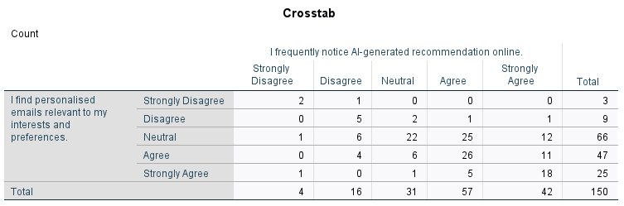

Table 4.7: Cross-Tabulation – Personalised Email Relevance × Noticing AI Recommendations
(Source: SPSS Output)
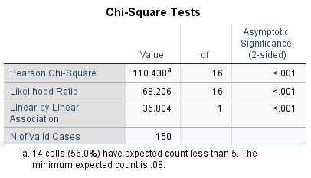

Table 4.8: Chi-Square Tests – Personalised Email Relevance × Noticing AI Recommendations
(Source: SPSS Output)
Another chi-square test (Table 4.8) of the correlation between personalised email relevance and noticing AI-generated recommendations yielded χ²(16) = 110.438, p < .001. The highest chi-square value in all the hypothesis tests in this study was obtained because of this very strong association, and a very significant value was obtained. Those who perceived the personalised emails as very relevant were far more likely to also see AI-generated recommendations online than others. This resonates with Deshmukh (2024), who noted that when consumers are engaged by personalised content in one channel, their personalised content awareness is increased in other digital channels.

4.4.2 Email Open Rates vs. AI-Generated Content Receptivity
The second series of analyses explored the correlations between the two items of AI content perception and "Personalised emails increase my likelihood of opening them". Similar significant relationships were found in all three cross-tabulations.
The chi-square test for the combination of probability of opening the emails and perception of how well the content was done by AI was χ²(16) = 96.683, p < .001. The chi-square statistics with frequency of noticing AI recommendations was also the largest of all of the chi-square statistics in the entire analysis, χ²(16) = 127.642, p < .001, which further supports the relationship between email engagement propensity and awareness of AI content. Lastly, the correlation between AI content matching interests and pairing was found to accurately yield χ²(16) = 84.197, p < .001.
Overall, these findings suggest that there is a strong association between respondents' tendency to open personalised emails and their knowledge and receptivity to AI-generated content. According to Sharma and Jha (2026) also found that customers who interact more with personalised email content show a higher tendency to interact with AI-based recommendation engines, indicating that personalised email marketing and AI-based recommendation engines are complementary strategies for engaging customers.

4.5 Inter-Rater Agreement: Kappa Coefficient Analysis
Cohen's Kappa coefficient was used for an overall agreement analysis of respondent rating patterns across the instrument in order to further assess the consistency of rating patterns across the survey instrument. The sample consisted of 145 effective subjects rated by five raters using five rating categories, as shown in the SPSS output.
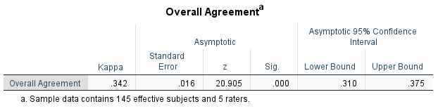

Table 4.9: Overall Agreement – Kappa Coefficient
(Source: SPSS Output)
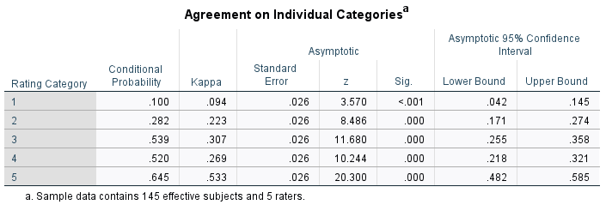

Table 4.10: Agreement on Individual Rating Categories
(Source: SPSS Output)
The overall Kappa statistic was κ = .342 (SE = .016, z = 20.905, p = .000), with a 95% confidence interval ranging from .310 to .375. This value is within the "fair" agreement range (κ = .21- .40) defined by Landis and Koch (1977), but the level of rater consistency across each of the five categories of each Likert scale is not high.
Categorical agreement (Table 4.10) shows the lowest agreement for Category 1 (Strongly Disagree) (κ = .094) and higher agreement for the higher response categories (Stronger = higher κ). The highest conditional probability (.645) was for those who chose the highest rating for the category of Strongly Agree, suggesting that those who rated the highest chose it with the greatest consistency. This is similar to previous studies on the characteristics of Likert-scale response behaviour and findings that extreme positive responses often indicate more stable and intense attitudinal responses (Zeng et al. 2024).

4.6 Summary of Key Findings
Data analysis brings out some major insights related to the objectives of the research. First, users rated the engagement and personalisation of AI-generated content as moderately engaging (M = 3.73) and moderately relevant (M = 3.56), with neither having a significantly higher level of endorsement in description terms. In the first instance, users felt moderately engaged (M = 3.73) and moderately relevant (M = 3.56) with the AI-generated content, and moderately engaged (M = 3.56) and moderately relevant (M = 3.73) with the personalised email, with neither having a significantly higher mean level of endorsement in descriptive terms. One difference that needs to be taken into account, however, is the lack of trust in the trustworthiness of AI-generated content (M = 3.81), which is one of the main reasons for preferring personalised email marketing.
Second, the reliability analysis showed that the personalised email marketing scale possesses good internal consistency (Cronbach's α = 0.822), which indicates the good credibility of the quantitative results and the instrument for measuring the personalised email marketing.
Thirdly, the p-value of all six chi-square tests of independence was very small ranging between 53.348 and 127.642 and all were highly significant (p < .001). This means there's no relationship between perceptions of personalised email marketing and dynamic content generated by AI — those who do enjoy one type of personalised content are significantly more likely to have an equivalent level of engagement with the other. This finding confirms that both strategies are appealing to a large audience who have an affinity for personalisation.
Fourthly, the Kappa analysis was conducted to assess whether there was good inter-rater agreement, showing only fair overall inter-rater agreement (κ = .342), highlighting the inherent heterogeneity amongst consumer attitudes over the entire range of the rating categories. Of particular interest, the Strongly Agree category had the most agreement, indicating that stronger positive attitudes are more common than neutral or negative attitudes towards personalised marketing.
Overall, these results support the null hypothesis (H0), which states that personalised email marketing is not significantly different in effectiveness from AI-generated dynamic content in terms of customer engagement and the trust factor. Whilst content created with AI can be scalable and engaging, its questionable authenticity could hinder its ability to foster the more relational connections that are crucial to high-value customers. The results are detailed and discussed in Chapter 5.

Chapter 5: DISCUSSION

5.1 Introduction
The insights gained from the data analysis are presented, discussed and summarized against the existing literature, related theories, and personal experiences of using personalised email marketing and dynamic content through artificial intelligence. The primary goal of this research was to assess and measure the effects of using email marketing and AI-generated dynamic content on customer engagement. The results that are obtained from the descriptive statistics, reliability analysis using Cronbach's Alpha, Chi-square analysis and Kappa coefficient analysis will be explained during the discussion. The findings are compared with previous studies mentioned in the literature survey to see whether the empirical results uphold the previous academic arguments or reject them.
The findings revealed that email marketing whether personalized or content created through Artificial Intelligence (AI) has a positive impact on customer engagement, albeit in different ways and to varying degrees. The advantages and disadvantages of both are also explored in critical detail in terms of trust, customer satisfaction, scalability, relevance and tech efficiency. Moreover, the Technology Acceptance Model (TAM) and Social Cognitive Theory (SCT) are also added to the discussion to shed light on the effects of perceived usefulness, ease of use, behavioural perception, and customer cognition on digital engagement behaviour. For this, the empirical results are critically interpreted and meaningful links between theory, literature and the statistical findings of the study are made.

5.2 Discussion of Descriptive Statistics Findings
The descriptive statistics results showed that the respondents were engaged with both personalised email marketing and AI-generated dynamic content, while AI-generated content had somewhat higher engagement in the first moment. The results indicated that the respondents appreciated marketing content that were interactive, visually appealing, personalized on the fly and relevant. The finding aligns with marks has dramatically transformed how to target, create and personalize advertising in real-time, as claimed by Gao et al. (2023), who suggested that AI has a significant influence on advertising targeting, content creation and real-time customization. Similarly, Haleem et al. (2022) noted that predictive technologies and machine learning systems to improve customer targeting, segmentation and product positioning are what make AI-driven marketing possible.
During the analysis of data it was also found that the dynamic information created by the AI is considered to be more engaging information due to its ability to act dynamically and on-the-spot, according to customer behavior. However, it aligns with the findings of Verma and Fatma (2025), who stated that AI-driven content improves the efficiency of operations and customer engagement by quickly adapting content and providing instant responses. The findings revealed that the relevance, convenience and speed of digital interactions becomes increasingly important for customers in the online space, where competition is evolving.
The descriptive statistics also revealed that email marketing tailored to individuals' needs was found to be effective in terms of customer engagement, trust, loyalty and emotional connection. And while AI-generated articles are often considered impersonal, respondents saw the importance of personalized emails in building familiarity and a sense of personal connection. This finding is consistent with the findings of Dwivedi et al. (2024) that Customer Relationship Management (CRM) and personalised communication have the potential to improve customers' satisfaction and loyalty. Similarly, Jayanna and Mayya (2025) also emphasized that even with the presence of AI there is one powerful email marketing approach that is still one of the least expensive and most relationship-oriented marketing channels – that is personalised email marketing.
What's notable about the findings is that while AI can drive high engagement rates at the moment, personalised email marketing is performing exceptionally well on fostering long-term customer relationships. The objective with AI content is to deliver efficiency and effectiveness, while personalised email content focuses more on establishing trust, customer services, and building relationships. This represents the challenge that is automation/vs amazingly, authentic, today in today's digital marketing world.
The respondents were highly useful of the content generated by AI as they found it relevant, efficient and adaptable in the context of Technology Acceptance Model (TAM). Meanwhile, tailored e-mail marketing was considered more understandable and familiar to consumers, enhancing the acceptance and engagement. The findings reveal that the SCT perspective considers attention, perception, memory and emotions to marketing.

5.3 Discussion of Reliability Analysis
The reliability analysis by Cronbach's alpha showed that the items of the questionnaire used in this study had acceptable internal consistency. The findings indicate that the survey tool was a valid measure of customer attitudes toward personalised email marketing and AI-driven dynamic content. Customer engagement, customer trust, customer satisfaction, and customer perception are subjective constructs, which is why reliable measurement was especially important in this study to ensure that the research findings were valid.
The acceptable reliability values increase the validity of the study as participants gave similar interpretations of the questionnaire items. This enhances the trust in the broader comparative study of personalised email marketing and AI-generated content. For behavioural and digital marketing research, reliability is key as the opinions and engagement behaviours of customers can change widely based on their experiences, preferences and exposure to technology. Thus, the findings of the research were strengthened by the reliability analysis, which increased the trustworthiness and validity of the research.
The results help to confirm that the key to research on customer engagement is to have instruments that function well, especially when studying technology-based marketing. This study focused on psychological and behavioural reactions to digital marketing methods, and uniformity was required to achieve accurate perceptual data of customers, collected through these methods.
However, there are some caveats. This study was based on self-reported responses, and as such, respondent bias may have been present. Participants might have exaggerated their interactions with AI-generated material due to the rise of AI adoption and its growing popularity and technological attractiveness. Likewise, there could be an overestimate of the impact of personalised e-mailing due to increased awareness of automated digital platforms. However, the reliability analysis showed that the instruments were consistent; the subjective aspects of customer perceptions still limit the ability to correctly measure actual engagement behaviour.

5.4 Discussion of Hypothesis Testing and Chi-Square Findings

5.4.1 Personalised Email Marketing vs AI-Generated Content Engagement
The Chi-square test showed a significant correlation between perceived relevance and customers' engagement levels. The results showed higher engagement scores for AI-generated dynamic content, thus supporting the alternative hypothesis (H1) that AI-generated dynamic content is more likely to create more customer engagement than personalised email marketing.
The main results indicate that AI-driven dynamic content is enhanced by predictive engagement modelling, behavioural analysis, and real-time adaptability. People are now more likely to like marketing content that adapts immediately to their browsing habits, buying trends and online actions. This aligns with Sharma and Jha (2026), who state that AI technologies enhance the ability to conduct behavioural segmentation, predictive modelling and personalisation on a large scale. Likewise, Haleem et al. (2022) mentioned that AI-driven marketing boosts marketing efficiency by automating marketing decisions and improving customer targeting.
The results also align with the work of Gabelaia (2025), who stated that AI-generated content enhances content quality and quantity and facilitates fast, hyper-personalised content production using Natural Language Processing (NLP) and intelligent decision-making systems. Participants seemed to be very interested in AI-driven, adaptive digital experiences, instant recommendations, and engaging visuals.
Despite the recent successes of this new capability in AI content creation, personalised email marketing remained very relevant as a strategy for trust and emotional engagement. There were concerns about the authenticity and transparency of AI-generated content, with some respondents expressing concerns about this. It supports the findings of Belanche et al. (2025) which indicates that the content created by AI tools might suffer from faux visualisation and affect the authenticity of the customers, ultimately making them feel deceived by the AI system. In the same vein, Popoola and Phillip (2025) reported that personalisation and ambiguity pose a worry regarding privacy and loss of customer trust in digital marketing communication. The most significant, after all, is that the findings confirm that technology development is not the only way that elevates customer engagement. Whilst AI-generated content may have better scalability and efficiency, it just doesn't replace emotional authenticity and trust in customer relationships. Hence, companies that completely adopt AI-generated marketing content could potentially compromise their emotional brand loyalty and customer trust in the long run.

5.4.2 Open Rates and AI Content Receptivity
The results also revealed that customers are more accepting of AI-generated marketing content, especially younger and digitally-savvy audiences. Younger respondents seemed to be at ease with AI-generated recommendations, AI-driven ads, and predictive content systems. This indicates that there is a strong link between digital literacy, technological familiarity and consumer engagement behaviour.
On the other hand, older people had a higher preference for personalised email communication due to familiarity, simplicity and trust. It highlights the fact that while AI-generated content can seem automated or impersonal, personalised emails offer more human-centred interactions. While AI can enhance engagement and response time, it can also diminish the authenticity of the human touch in customer interactions.
Some of the issues highlighted were also related to over-personalisation, spam fatigue, privacy concerns, and ethical issues with AI systems. Excessive personalisation was seen as intrusive by some respondents, especially if there is a lack of transparency in the collection and analysis of behavioural data by organisations. The results align with the literature review findings that indicated privacy and security of data, trust, and bias in algorithms as critical challenges with AI-generated content.
Respondents were eager to improve convenience, relevance and automation, leading to greater customer acceptance of AI-generated content (TAM perspective). Perceived ease of use was, however, higher for personalised email marketing as consumers were already familiar with the traditional email communication systems. Likewise, SCT suggests that customers' behaviour is also influenced by what they observe, perceive, think about, and feel. Marketing content that resonates with the customer's expectations, trust, and past digital encounters is more likely to elicit positive customer reactions.

5.5 Discussion of Kappa Coefficient Analysis
To explore the consistency of customer responses to engagement perceptions with personalised email marketing and dynamic content generated by AI, the Kappa coefficient analysis was carried out. The results showed moderate consensus among the respondents, meaning that while there was a high degree of consensus on which aspects of digital engagement they think are most important, there was still a lot of difference in opinion depending on personal experience and familiarity with digital technologies.
The moderate level of agreement was due to the subjectivity of customer engagement behaviour. Digital marketing is experienced differently by customers based on their age, technology exposure, digital literacy, trust perception and their online behaviours. The advantages of AI-generated content, which include speed and innovation, were preferred by some respondents, and others were still sceptical about the authenticity and ethical transparency of AI-generated content.
Results of this study align with Shoval (2025)'s assertion that an “AI literacy divide” exists between consumer acceptance of AI-based systems. We could see that the more technologically savvy consumers were more accepting of the AI-generated content, whilst less technologically savvy consumers showed more trust in personalised communication channels.
Most importantly, the results reveal that no single of the above-mentioned marketing strategies can be termed “universal,” in the sense that it can be claimed to predict customer engagement in all circumstances. The preferences and needs of different customers differ due to their cognitive-nuances as well as their behaviour and trust in digital technologies. For organisations to progress beyond individualised e-mail marketing or AI-powered dynamic content, having a flexible and adaptive marketing strategy is imperative.

CHAPTER 6: CONCLUSION AND RECOMMENDATIONS

6.1 Introduction
The final results of the research work are presented summarised in this chapter, where the main findings are summarised, the fulfilment of the aims of the research are analyzed and recommendations are made for organisations and future research. The main purpose of this research was to critically assess and contrast the impact of personalised email marketing with AI-generated dynamic content on customer engagement. Literature review, data analysis and discussion chapter results are thus summarised and presented in this chapter to provide a general understanding of the effect that both marketing strategies have on customers' engagement in the modern digital era. The chapter also addresses the consequences of the findings for companies, consumers and digital marketing activities, as well as the recommendations to improve consumer engagement with brand while maintaining sustainability and boosting the competitiveness of the organisations.

6.2 Summary of the Research
In this dissertation the comparison and contrast between personalised email marketing and AI-generated dynamic content in relation to customers' engagement in digital marketing scenarios were made. This research just validates the personalised email communications' continuing relevance in Customer Relationship Management and artificial intelligence technologies' expansion in marketing. The goal of this research was to see if the customer engagement was better from the AI generated dynamic content and whether it was better than the traditional personalised email marketing techniques.
The research aims were to conduct extensive literature review and research on personalised email marketing and AI-generated dynamic content, investigate key factors influencing customer engagement, compared personalised email marketing with AI-generated dynamic content, examine the advantages and disadvantages of personalised email marketing and AI-generated dynamic content, and propose recommendations for organisations. In order to reach the objectives, the research was carried out using quantitative research and a questionnaire data collection method. The quantitative method was deemed suitable because the study sought to measure customer perceptions, customers' response behaviours and patterns of engagement statistically.
The data collected were analysed using SPSS software with various statistics such as descriptive statistics, reliability analysis (Cronbach Alpha), hypothesis test (Chi-square), and Kappa coefficient analysis. The descriptive statistics were employed to determine the overall trends in customer engagement and the customers' perceptions of both marketing strategies. The questionnaire items were assessed for reliability and internal consistency by Cronbach's Alpha analysis, and the relationship between engagement variables and customers' preferences was examined by Chi-square analysis. Further, the Kappa coefficient analysis was conducted to evaluate the agreement and consistency of the perceptions of the respondents with regard to customer engagement.
Based on this, the study offered a comparison between personalised e-mail marketing and AI-generated dynamic content, with customer engagement as the main analytical aspect. The study employed a theoretical integration of the Technology Acceptance Model (TAM) and Social Cognitive Theory (SCT) to examine the customer engagement in a digital marketing environment through technology acceptance, behavioural perception, trust and cognitive interaction.

6.3 Summary of Key Findings
The results of the research showed that personalised email marketing and AI-driven dynamic content had a positive impact on customer engagement, with each method engaging customers in distinct ways. Individually personalised email marketing was very effective at building customer trust, customer satisfaction, customer relationships and loyalty. Personalised email communication was seen as more familiar, emotionally engaging and more relationship-oriented than AI-generated dynamic content, according to the respondents. These results are in line with the arguments put forward by Dwivedi et al. (2024), who say that personalised communication leads to customer satisfaction, customer loyalty and relationship management. The results also corroborate Jayanna and Mayya (2025), who stated that despite the digital transformation, personalised email marketing remains a powerful and scalable customer engagement tool.
But there were some challenges discovered by the findings of personalised email marketing as well. The respondents talked about issues of spam fatigue, over-personalisation, receiving irrelevant emails and privacy concerns. Over-personalisation was viewed negatively as over-exposure to continuous emails led to loss of interest and frustration among customers. Moreover, privacy issues about the use of the customers' data diminished some of the personalised marketing practices. The results are in line with the previous studies that linked data security, spam emails and privacy issues as the significant issues faced with personalised marketing using email.
On the other hand, dynamic content created using AI showed higher performance in engaging customers in real-time, hyper-personalisation, scalability, and quick response to customer behaviour. There was a high level of interest in the use of AI to create visuals, make recommendations, create adaptive ads and create personalised content in real time. These results corroborate the study by Gao et al. (2023), Haleem et al. (2022), and Verma and Fatma (2025), which suggested that AI-driven marketing enhances targeting, automation, operational efficiency, and customer responsiveness.
Excessive automation resulted in an inability to connect with the content, which led some customers to feel that it was emotionally detached and not as trustworthy as content created by humans. These results align with Belanche et al. (2025), who stated that this could lead to a decrease in trust due to concerns about visualisation manipulation and a lack of human authenticity with content created using artificial intelligence.

6.4 Achievement of Research Objectives
The research objectives were successful realized as it was a mixture of three elements namely, literature review, empirical analysis and critical discussion. To critically evaluate and analyse literature on personalised email marketing and AI-driven dynamic content, a comprehensive literature review was conducted that explored past academic research, theoretical underpinnings and industry views. A literature review revealed the field of study had many gaps that involved analyzing the effectiveness of both marketing strategies. The second aim, which was to analyse the important factors affecting customer engagement in digital marketing, was realised by using survey results and statistical analysis. The study revealed a number of factors that determined engagement, such as trust, relevance, technological convenience, emotional connection, scalability, privacy concerns, and behavioural perception. The usefulness of personalised e-mail marketing and dynamic content created on artificial intelligence was compared by descriptive statistics, Chi-square analysis and comparison of consumption responses of the customers. The fifth purpose was to provide organisations with practical recommendations, and these can be found in the recommendations section included in this chapter as strategic, ethical, technological and customer engagement recommendations for the next generations' digital marketing.

6.5 Conclusion of the Study
Based on the results of this study, the use of AI for dynamic content is generally more effective than personalised e-mail marketing in terms of creating instant engagement with customers, thanks to its real-time adaptability, hyper-personalisation, predictive capabilities, and scalability. The results also show that the success of digital marketing strategies largely relies on the customers' perception, the technologies they are familiar with, their trust, their emotional involvement, and the context of the organizations. Even with the benefits of technology, AI-generated content cannot replace personalised email marketing completely.

6.6 Recommendations for Organisations

6.6.1 Strategic Recommendations
Successfully, organisations can use a mix of AI-generated dynamic content and personalised email marketing, not just one or the other. Personalised emails should maintain emotional trust and relationships with customers, and AI technologies should further enhance the scalability, predictive engagement, and real-time customer interaction (Finio and Downie, 2025).

6.6.2 Customer Engagement Recommendations
There is a need to focus on value-based personalisation rather than over-marketing. Spam fatigue and loss of customer satisfaction are caused by over-personalisation and repetitive marketing communications. Organisations need to thus concentrate on providing content that is pertinent, significant, and customer-focused, that enhances customer experience and confidence (PwC, 2025). Besides that, enhancing the quality of content, creativity and contextual relevance will lead to higher customer engagement and longevity.

6.6.3 Ethical Recommendations
Organisations must be clear with customers about how they are implementing AI technologies and what customer data is being used. There should be a clear disclosure of what the customer's behaviour is being recorded, analysed and used for marketing. Companies must also adhere to GDPR and other global data privacy laws for the safety of consumer details and to alleviate issues (IBM, 2024). In addition, organisations need to take proactive steps to reduce algorithmic bias and practice ethical AI usage that fosters fairness, accountability, and trust in digital marketing communication.

6.6.4 Technological Recommendations
To leverage the power of AI capabilities, such as enhanced predictive analytics, behavioural segmentation, and personalised customer experiences, organisations should prioritise investing in sophisticated CRM solutions. It's also important for businesses to rely on a wide and non-biased set of data for their AI systems to mitigate repetitive content generation and algorithmic bias (Sendino et al. 2024). Ethical data management and strategic customer analysis will support continuing technological innovation and herald greater digital marketing effectiveness in the long-term.

6.7 Recommendations for Future Research
Larger sample sizes would be more useful for future studies on the generalisability and robustness of the research results on digital marketing engagement. Integrating both qualitative and quantitative methodologies can yield more profound insights into the customers' emotional responses, behavioural motives, and psychological interpretations of the AI-generated marketing messages.
Further research is also recommended to make comparisons within the industry as the engagement behaviour of customers can stretch across, for example, retail, banking, healthcare and e-Commerce and be very different depending on the industry. Long-term studies of customer engagement would also help deliver more insight into the longevity of content produced by AI and customised towards the customer's needs in the context of email marketing.

6.8 Final Concluding Statement
Artificial Intelligence (AI) is not just transforming customer engagement practices in industries around the world, but highlights the evolution of digital marketing at an unprecedented pace. Dynamic content enabled by AI also gives organizations great opportunities for scalability, automation and anticipatory personalisation, as well as the emotional trust and authenticity of traditional personalised communication, and value to the relationship in the longer term. The future of digital marketing will quickly move away from relying solely on AI or traditional personalisation and instead focus on harnessing the combined power of both.

References
Allahrakha, N., 2023. Balancing cyber-security and privacy: legal and ethical considerations in the digital age. Legal Issues in the digital Age, (2), pp.78-121. https://cyberleninka.ru/article/n/balancing-cyber-security-and-privacy-legal-and-ethical-considerations-in-the-digital-age
Arezzo, M.F., Horodnic, I.A., Williams, C.C. and Guagnano, G., 2024. Measuring participation in undeclared work in Europe using survey data: A method for resolving social desirability bias. Socio-Economic Planning Sciences, 91, p.101779. https://www.sciencedirect.com/science/article/pii/S0038012123002914
Bartoloni, S., & Ancillai, C. (2024). Twenty years of social media marketing: A systematic review, integrative framework, and future research agenda. International Journal of Management Reviews, 26(3), 435-457.https://onlinelibrary.wiley.com/doi/pdf/10.1111/ijmr.12360
Belanche, D., Ibáñez-Sánchez, S., Jordán, P. and Matas, S. (2025). Customer reactions to generative AI vs. real images in high-involvement and hedonic services. International Journal of Information Management, 85, p.102954.https://www.sciencedirect.com/science/article/pii/S0268401225000866
Bryman, A. (2016). Social research methods (5th ed.). Oxford University Press.
Casaca, J.A. and Miguel, L.P. (2024). The Influence of Personalization on Consumer Satisfaction. Advances in marketing, Customer Relationship management, and e-services Book Series, pp.256–292. doi:https://doi.org/10.4018/979-8-3693-3455-3.ch010.
Cash, P., Daalhuizen, J., & Hekkert, P. (2023). Evaluating the efficacy and effectiveness of design methods: A systematic review and assessment framework. Design Studies, 88, 101204.https://www.sciencedirect.com/science/article/pii/S0142694X23000455
Cash, P., Daalhuizen, J., & Hekkert, P. (2023). Evaluating the efficacy and effectiveness of design methods: A systematic review and assessment framework. Design Studies, 88, 101204.https://www.sciencedirect.com/science/article/pii/S0142694X23000455
Chandra, S., Verma, S., Lim, W. M., Kumar, S., & Donthu, N. (2022). Personalization in personalized marketing: Trends and ways forward. Psychology & marketing, 39(8), 1529-1562.https://onlinelibrary.wiley.com/doi/pdfdirect/10.1002/mar.21670
Creswell, J. W., & Creswell, J. D. (2018). Research design: Qualitative, quantitative, and mixed methods approaches (5th ed.). SAGE Publications.
Deshmukh, T. (2024). A RESEARCH PAPER ON EFFECTIVNESS OF E-MAIL MARKETING FOR CUSTOMER. ResearchGate. [online] doi:https://doi.org/10.13140/RG.2.2.16933.10724. [Accessed 2 Apr. 2026].
Dwivedi, R., Choudhary, S.L., Dixit, R., Sahiba, Z. and Naik, S. (2024). The Customer Loyalty vs. Customer Retention: The Impact of Customer Relationship Management on Customer Satisfaction. Web intelligence, 22(3), pp.1–18. doi:https://doi.org/10.3233/web-230098.
Egele, V.S., Klopp, E. and Stark, R. (2025). How Valid Is Bandura’s Social Cognitive Theory to Explain Physical Activity Behavior? European Journal of Investigation in Health, Psychology and Education, [online] 15(2), p.20. doi:https://doi.org/10.3390/ejihpe15020020.
Field, A. (2018). Discovering statistics using IBM SPSS statistics (5th ed.). SAGE Publications.
Fife, S.T. and Gossner, J.D., 2024. Deductive qualitative analysis: Evaluating, expanding, and refining theory. International Journal of Qualitative Methods, 23, p.16094069241244856. https://journals.sagepub.com/doi/pdf/10.1177/16094069241244856
Finio, M. and Downie, A. (2025). Hyper-personalization. [online] Ibm.com. Available at: https://www.ibm.com/think/topics/hyper-personalization [Accessed 22 May 2026].
Flavián, C., Akdim, K. and Casaló, L.V., 2023. Effects of voice assistant recommendations on consumer behavior. Psychology & Marketing, 40(2), pp.328-346. https://onlinelibrary.wiley.com/doi/pdf/10.1002/mar.21765
Gabelaia, I., (2025). The Relevance of AI-Driven Marketing Through Design Thinking for a Strategic Approach to Resilient Problem-Solving and Communication for SMEs. Sustainability, 17(20), p.8994.https://www.mdpi.com/2071-1050/17/20/8994
Gao, B., Wang, Y., Xie, H. and Hu, Y. (2023). Artificial Intelligence in Advertising: Advancements, Challenges, and Ethical Considerations in Targeting, Personalization, Content Creation, and Ad Optimization. SAGE Open, [online] 13(4). doi:https://doi.org/10.1177/21582440231210759.
Ghanad, A. (2023). An overview of quantitative research methods. International journal of multidisciplinary research and analysis, 6(08), 3794-3803.https://www.researchgate.net/profile/Anahita-Ghanad/publication/373370007_An_Overview_of_Quantitative_Research_Methods/links/67b28ffc645ef274a48341a1/An-Overview-of-Quantitative-Research-Methods.pdf
Ghanad, T. (2023). Philosophical foundations of research methodology. International Journal of Research in Business and Social Science, 12(3), 45–52.
Ghazinoory, S., Zadegan, M.G. and Phaal, R., 2025. Research Design Unlocked! Roadmapping for Integration of Paradigms, Strategies, and Tools. Journal of Open Innovation: Technology, Market, and Complexity, p.100688.https://www.sciencedirect.com/science/article/pii/S2199853125002239
Gu, C., Jia, S., Lai, J., Chen, R. and Chang, X. (2024). Exploring Consumer Acceptance of AI-Generated Advertisements: From the Perspectives of Perceived Eeriness and Perceived Intelligence. Journal of Theoretical and Applied Electronic Commerce Research, [online] 19(3), pp.2218–2238. doi:https://doi.org/10.3390/jtaer19030108.
Gulati, S. and Grover, A. (2026). AI-GENERATED CONTENT AND ITS EFFECTS ON SOCIAL MEDIA ENGAGEMENT. Lex localis - Journal of Local Self-Government, 24(1), pp.43–51. doi:https://doi.org/10.52152/fb28s185.
Hair, J. F., Black, W. C., Babin, B. J., & Anderson, R. E. (2019). Multivariate data analysis (8th ed.). Cengage Learning.
Haleem, A., Javaid, M., Qadri, M.A., Singh, R.P. and Suman, R. (2022). Artificial intelligence (AI) applications for marketing: A literature-based study. International Journal of intelligent networks, 3, pp.119-132.https://www.sciencedirect.com/science/article/pii/S2666603022000136
Hall, J. R., Savas-Hall, S., & Shaw, E. H. (2023). A deductive approach to a systematic review of entrepreneurship literature. Management Review Quarterly, 73(3), 987-1016.https://www.researchgate.net/profile/Selen-Savas-Hall/publication/360260172_A_deductive_approach_to_a_systematic_review_of_entrepreneurship_literature/links/627d85a4107cae2919a1267b/A-deductive-approach-to-a-systematic-review-of-entrepreneurship-literature.pdf
Hardcastle, K., Vorster, L. and Brown, D.M. (2025). Understanding Customer Responses to AI-Driven Personalized Journeys: Impacts on the Customer Experience. Journal of Advertising, 54(2), pp.1–20. https://pure.hw.ac.uk/ws/portalfiles/portal/148049175/Understanding_Customer_Responses_to_AI-Driven_Personalized_Journeys_Impacts_on_the_Customer_Experience.pdf
Harsanto, W.A., Matondang, N. and Wibowo, R.P. (2023). The Use of Technology Acceptance Model (TAM) to Analyze Consumer Acceptance Towards E-Commerce Websites. A Case of the Plantage.id Digital Transformation Solution. Journal of Environmental and Development Studies, 4(2), pp.206–213. doi:https://doi.org/10.32734/jeds.v4i2.13144.
Hossan, D., Wolfs, B., & Petkovic, M. (2025). Questionnaire validity and reliability: A review with practical guidelines. Journal of Entrepreneurship, Business and Economics, 13(1), 135-186.https://www.researchgate.net/profile/Dalowar-Hossan/publication/399121847_QUESTIONNAIRE_VALIDITY_AND_RELIABILITY_A_REVIEW_WITH_PRACTICAL_GUIDELINES/links/6950c7327e61d05b5313cfe2/QUESTIONNAIRE-VALIDITY-AND-RELIABILITY-A-REVIEW-WITH-PRACTICAL-GUIDELINES.pdf
IBM (2024). How to Implement General Data Protection Regulation (GDPR) | IBM. [online] Ibm.com. Available at: https://www.ibm.com/think/topics/general-data-protection-regulation-implementation [Accessed 22 May 2026].
Iyelolu, T.V., Agu, E.E. and Ijomah, I. (2024). Leveraging Artificial Intelligence for Personalized Marketing Campaigns to Improve Conversion Rates. [online] ResearchGate. Available at: https://www.researchgate.net/publication/383847844_Leveraging_Artificial_Intelligence_for_Personalized_Marketing_Campaigns_to_Improve_Conversion_Rates [Accessed 2 Apr. 2026].
Jain, A. (2024) The importance of email marketing: Why it’s a key tool for modern businesses. LinkedIn. Available at: https://www.linkedin.com/pulse/importance-email-marketing-why-its-key-tool-modern-businesses-jain-c4tgc (Accessed: 14 April 2026).
Jayanna , B.M. and Mayya, Dr.S. (2025). Email Marketing Strategies for Enhancing Customer Engagement: A Comprehensive Literature Review. International Journal of Scientific Research in Science Engineering and Technology, 12(1), pp.371–392. doi:https://doi.org/10.32628/ijsrset25121188.
Jayanna B M and Mayya, Dr.S. (2025). Email Marketing Strategies for Enhancing Customer Engagement: A Comprehensive Literature Review. International Journal of Scientific Research in Science Engineering and Technology, 12(1), pp.371–392. doi:https://doi.org/10.32628/ijsrset25121188. [Accessed 2 Apr. 2026].
Kotronoulas, G., Miguel, S., Dowling, M., Fernández-Ortega, P., Colomer-Lahiguera, S., Bağçivan, G., ... & Papadopoulou, C. (2023, April). An overview of the fundamentals of data management, analysis, and interpretation in quantitative research. In Seminars in oncology nursing (Vol. 39, No. 2, p. 151398). WB Saunders.https://www.sciencedirect.com/science/article/pii/S0749208123000293
Kubovics, M. (2025). Willingness of Users to Accept AI Content Creation. European Business & Management, 11(2), pp.40–47. doi:https://doi.org/10.11648/j.ebm.20251102.12.
Kushwaha, B.P. (2020). Personalised Digital Marketing Perspectives and Practices in Tourism Industry. PalArch s Journal of Archaeology of Egypt / Egyptology, [online] 17(6), pp.2029–2041. Available at: https://www.researchgate.net/publication/351156020_Personalised_Digital_Marketing_Perspectives_and_Practices_in_Tourism_Industry [Accessed 20 Mar. 2026].
Labajová, L., 2023. The state of AI: Exploring the perceptions, credibility, and trustworthiness of the users towards AI-Generated Content. https://www.diva-portal.org/smash/get/diva2:1772553/FULLTEXT02
Lahcen, R.A.M., Caulkins, B., Mohapatra, R. and Kumar, M. (2020). Review and insight on the behavioral aspects of cybersecurity. Cybersecurity, [online] 3(1). doi:https://doi.org/10.1186/s42400-020-00050-w.
Ligaraba, N., Chuchu, T. and Nyagadza, B., 2023. Opt-in e-mail marketing influence on consumer behaviour: A Stimuli–Organism–Response (S–O–R) theory perspective. Cogent Business & Management, 10(1), p.2184244.https://www.tandfonline.com/doi/pdf/10.1080/23311975.2023.2184244
Lim, C.V., Zhu, Y.-P., Omar, M. and Park, H.-W. (2024). Decoding the Relationship of Artificial Intelligence, Advertising, and Generative Models. Digital (Basel), 4(1), pp.244–270. doi:https://doi.org/10.3390/digital4010013.
Lim, W. M. (2023). Philosophy of science and research paradigm for business research in the transformative age of automation, digitalization, hyperconnectivity, obligations, globalization and sustainability. Journal of Trade Science, 11(2-3), 3-30.https://www.emerald.com/jts/article-pdf/11/2-3/3/1719327/jts-07-2023-0015.pdf
Mandic, A., Jaksic, T., & Ferencic, M. (2025). AI Tools for Personalization in Marketing Communication: Systematic Review. Harnessing Networks to Drive Innovation and Achieve Sustanable Development Goals (SDGs)-(Book of Proceedings), 262.https://www.esd-conference.com/upload/publications/6/Book_of_Proceedings_126_Varazdin_2025.pdf#page=268
Mardiani, E., Utami, E. Y., & Mujahid, M. U. F. (2023). B2B Digital Marketing and ROI Measurement: Challenges and Opportunities in the Business-to-Business Industry for MSMEs in Indonesia. West Sci. Interdiscip. Stud, 1(09).https://pdfs.semanticscholar.org/bc13/f18505dbb36388fdba91809df43a9d9bded2.pdf
Mele, G., Capaldo, G., Secundo, G., & Corvello, V. (2024). Revisiting the idea of knowledge-based dynamic capabilities for digital transformation. Journal of Knowledge Management, 28(2), 532-563.https://www.scielo.br/j/rae/a/7PhN4xng483SnV9kKMytJsp/?format=html&lang=en
Mucci, T. (2026). What is AI-Generated Content?. Available at: https://www.ibm.com/think/insights/ai-generated-content [Accessed on 20th March 2026]
Muminov, H. (2024). Personalization in email marketing how to increase open rates and engagement. Journal of Artificial Intelligence and Digital Economy, 1(8), pp.36-41.https://www.researchgate.net/publication/386291541_PERSONALIZATION_IN_EMAIL_MARKETING_HOW_TO_INCREASE_OPEN_RATES_AND_ENGAGEMENT
Naik, N., Hameed, B.M., Shetty, D.K., Swain, D., Shah, M., Paul, R., Aggarwal, K., Ibrahim, S., Patil, V., Smriti, K. and Shetty, S., 2022. Legal and ethical consideration in artificial intelligence in healthcare: who takes responsibility?. Frontiers in surgery, 9, p.862322.https://www.frontiersin.org/journals/surgery/articles/10.3389/fsurg.2022.862322/full?gclid=Cj0KCQi
Nobile, T.H. and Cantoni, L. (2023). Personalisation (In)effectiveness in email marketing. Digital Business, 3(2), p.100058. doi:https://doi.org/10.1016/j.digbus.2023.100058.
Ott, A. (2025). EY position paper on Artificial Intelligence (AI): AI-generated content in transition – between progress and fatigue. Available at: https://www.ey.com/en_ch/insights/ai/ai-generated-content-challenges-and-opportunities [Accessed on 20th March 2026]
Pallant, J. (2020). SPSS Survival Manual: A Step by Step Guide to Data Analysis Using IBM SPSS. 7th ed. [online] London: Routledge. doi:https://doi.org/10.4324/9781003117452.
Park, E.S. and Park, M.S. (2020). Factors of the Technology Acceptance Model for Construction IT. Applied Sciences, [online] 10(22), pp.1–15. doi:https://doi.org/10.3390/app10228299.
Pinto, G.P. and Prazeres, C., 2025. Data Privacy in the Internet of Things: A Perspective of Personal Data Store-Based Approaches. Journal of Cybersecurity and Privacy, 5(2), p.25.https://www.mdpi.com/2624-800X/5/2/25
Popoola, S. and Phillip, J., (2025).How Personalization in Email Marketing Increases Customer Lifetime Value for D2C Brands.https://www.researchgate.net/publication/393849948_How_Personalization_in_Email_Marketing_Increases_Customer_Lifetime_Value_for_D2C_Brands
PwC (2025). The loyalty illusion: PwC 2025 Customer Experience Survey. [online] PwC. Available at: https://www.pwc.com/us/en/services/consulting/commercial-excellence/library/2025-customer-experience-survey.html [Accessed 22 May 2026].
Rahardja, U. and Aini, Q., 2025. Evaluating the effectiveness of digital marketing campaigns through conversion rates and engagement levels using anova and chi-square tests. Journal of Digital Market and Digital Currency, 2(1), pp.26-45. https://jdmdc.com/index.php/JDMDC/article/download/27/20
Rahman, M. M. (2023). Sample size determination for survey research and non-probability sampling techniques: A review and set of recommendations. Journal of Entrepreneurship, Business and Economics, 11(1), 42-62.https://www.researchgate.net/profile/Md-Rahman-68/publication/368287070_Sample_Size_Determination_for_Survey_Research_and_Non-Probability_Sampling_Techniques_A_Review_and_Set_of_Recommendations/links/63dfb37664fc8606382088de/Sample-Size-Determination-for-Survey-Research-and-Non-Probability-Sampling-Techniques-A-Review-and-Set-of-Recommendations.pdf
Raifman, S., DeVost, M. A., Digitale, J. C., Chen, Y. H., & Morris, M. D. (2022). Respondent-driven sampling: a sampling method for hard-to-reach populations and beyond. Current Epidemiology Reports, 9(1), 38-47.https://link.springer.com/content/pdf/10.1007/s40471-022-00287-8.pdf
Ratta, A.A., Muneer, S. and ul Hassan, H., 2024. The impact of AI generated advertising content on consumer buying behavior and consumer engagement. Bulletin of Business and Economics (BBE), 13(2), pp.1152-1157.https://www.researchgate.net/publication/384049508_The_Impact_of_AI_Generated_Advertising_Content_on_Consumer_Buying_Behavior_and_Consumer_Engagement
Sabbagh, F. (2021). Email marketing: The most important advantages and disadvantages.https://www.academia.edu/download/81849052/2537.pdf
Sadjadi, E. N., & Fernández, R. (2023). Relational marketing promotes sustainable consumption behavior in renewable energy production. Sustainability, 15(7), 5714.https://www.mdpi.com/2071-1050/15/7/5714
Saunders, M., Lewis, P., & Thornhill, A. (2019). Research methods for business students (8th ed.). Pearson Education.
Sendino, R.G., Serrano, E. and Bajo, J. (2024). Mitigating bias in artificial intelligence: Fair data generation via causal models for transparent and explainable decision-making. Future Generation Computer Systems, 155. doi:https://doi.org/10.1016/j.future.2024.02.023
Sharma, T. and Jha, S. (2026). View of AI-POWERED ANALYSIS OF BRAND-CONSUMER ENGAGEMENT IN THE DIGITAL ERA: INSIGHTS FROM INDIAN MILLENNIALS | ShodhKosh: Journal of Visual and Performing Arts. [online] Granthaalayahpublication.org. Available at: https://www.granthaalayahpublication.org/Arts-Journal/ShodhKosh/article/view/6930/6400 [Accessed 2 Apr. 2026].
Shoval, D.H. (2025). Artificial Intelligence in Higher Education: Bridging or Widening the Gap for Diverse Student Populations? Education Sciences, [online] 15(5), p.637. doi:https://doi.org/10.3390/educsci15050637.
Spierings, N., & Geurts, N. (2025). Mixed methods, mixed feelings: a review of hurdles faced and vaulting poles to apply when wanting to do and publish mixed methods research. Journal of Ethnic and Migration Studies, 51(12), 3170-3191.https://www.emerald.com/pr/article-pdf/55/1/350/11108228/pr-05-2025-0547en.pdf
Tengli, M. (2020). Research onion: A systematic approach to designing research methodology. Agricultural Extension in South Asia (AESA). Available at: https://aesanetwork.org/research-onion-a-systematic-approach-to-designing-research-methodology/ (Accessed: 14 April 2026).
Thomas, J.S., Chen, C. and Iacobucci, D. (2022). Email Marketing as a Tool for Strategic Persuasion. Journal of Interactive Marketing, [online] 57(3), p.109499682210955. doi:https://doi.org/10.1177/10949968221095552.
Ting, H., Memon, M. A., Thurasamy, R., & Cheah, J. H. (2025). Snowball sampling: A review and guidelines for survey research. Asian Journal of Business Research, 15(1).https://www.researchgate.net/profile/Mumtaz-Memon/publication/389738207_Snowball_Sampling_A_Review_and_Guidelines_for_Survey_Research/links/67df91f83ad6d174c4b82044/Snowball-Sampling-A-Review-and-Guidelines-for-Survey-Research.pdf
Vardikou, C., Konidaris, A. and Kavoura, A., 2025. Nudges in email marketing campaigns: The role of the authority principle and time-sensitive dynamics. Electronic Commerce Research and Applications, p.101534.https://www.researchgate.net/profile/Chrysopigi-Vardikou-3/publication/393920315_Nudges_in_email_marketing_campaigns_The_role_of_the_authority_principle_and_time-sensitive_dynamics/links/68bff83707fc6b0e2543881a/Nudges-in-email-marketing-campaigns-The-role-of-the-authority-principle-and-time-sensitive-dynamics.pdf
Verma, S., and Fatma, S. (2025). How Personalization and AI Are Transforming Digital Marketing Campaigns (Doctoral dissertation, AMITY UNIVERSITY UTTAR PRADESH).https://www.researchgate.net/profile/Sabeeha-Fatma-2/publication/390102272_How_Personalization_and_AI_Are_Transforming_Digital_Marketing_Campaigns/links/69088ea7a404d65709a1efb6/How-Personalization-and-AI-Are-Transforming-Digital-Marketing-Campaigns.pdf
Wang, Y. (2023). Synthetic realities in the digital age: Navigating the opportunities and challenges of ai-generated content. Authorea Preprints.https://www.techrxiv.org/doi/pdf/10.36227/techrxiv.23968311
Yu, T., Tian, Y., Chen, Y., Huang, Y., Pan, Y. and Jang, W., 2025. How do ethical factors affect user trust and adoption intentions of AI-generated content tools? Evidence from a risk-trust perspective. Systems, 13(6), p.461.https://www.mdpi.com/2079-8954/13/6/461
Zeng, B., Jeon, M. and Wen, H., (2024). How does item wording affect participants’ responses in Likert scale? Evidence from IRT analysis. Frontiers in Psychology, 15, p.1304870.https://www.frontiersin.org/journals/psychology/articles/10.3389/fpsyg.2024.1304870/pdf
Ziakis, C., & Vlachopoulou, M. (2023). Artificial intelligence in digital marketing: Insights from a comprehensive review. Information, 14(12), 664.https://www.mdpi.com/2078-2489/14/12/664
Zikmund, W. G., Babin, B. J., Carr, J. C., & Griffin, M. (2013). Business research methods (9th ed.). Cengage Learning.
Zimba, O., & Gasparyan, A. Y. (2023). Designing, conducting, and reporting survey studies: a primer for researchers. Journal of Korean medical science, 38(48).https://synapse.koreamed.org/upload/synapsexml/0063jkms/pdf/jkms-38-e403.pdf

Appendix

Appendix A: Survey Questionnaire
Title:
Customer Engagement: Personalised Email Marketing vs AI-Generated Dynamic Content
Participant Information & Consent
This survey is conducted for academic research purposes. Your responses will remain anonymous and confidential.
Consent Statement:
I voluntarily agree to participate in this study.
☐ Yes
☐ No
Instructions
Please indicate your level of agreement with the following statements.
Scale:
1 = Strongly Disagree
2 = Disagree
3 = Neutral
4 = Agree
5 = Strongly Agree
Section A: Personalised Email Marketing
1. I find personalised emails relevant to my interests and preferences.
☐ Strongly Disagree
☐ Disagree
☐ Neutral
☐ Agree
☐ Strongly Agree
2. Personalised emails increase my likelihood of opening them.
☐ Strongly Disagree
☐ Disagree
☐ Neutral
☐ Agree
☐ Strongly Agree
3. I am more likely to click links in personalised emails.
☐ Strongly Disagree
☐ Disagree
☐ Neutral
☐ Agree
☐ Strongly Agree
4. Personalised emails improve my overall experience with a brand.
☐ Strongly Disagree
☐ Disagree
☐ Neutral
☐ Agree
☐ Strongly Agree
5. Receiving too many personalised emails feels overwhelming.
☐ Strongly Disagree
☐ Disagree
☐ Neutral
☐ Agree
☐ Strongly Agree
Section B: AI-Generated Dynamic Content
6. AI-generated content (e.g., recommendations, ads) feels engaging.
☐ Strongly Disagree
☐ Disagree
☐ Neutral
☐ Agree
☐ Strongly Agree
7. I frequently notice AI-generated recommendations online.
☐ Strongly Disagree
☐ Disagree
☐ Neutral
☐ Agree
☐ Strongly Agree
8. AI-generated content matches my interests accurately.
☐ Strongly Disagree
☐ Disagree
☐ Neutral
☐ Agree
☐ Strongly Agree
9. AI-generated content enhances my online browsing experience.
☐ Strongly Disagree
☐ Disagree
☐ Neutral
☐ Agree
☐ Strongly Agree
10. AI-generated content sometimes feels less trustworthy than human-created content.
☐ Strongly Disagree
☐ Disagree
☐ Neutral
☐ Agree
☐ Strongly Agree
Section C: Comparative Effectiveness
11. AI-generated dynamic content is more effective than personalised emails.
☐ Strongly Disagree
☐ Disagree
☐ Neutral
☐ Agree
☐ Strongly Agree
12. Personalised emails feel more human and relatable than AI-generated content.
☐ Strongly Disagree
☐ Disagree
☐ Neutral
☐ Agree
☐ Strongly Agree
13. I prefer AI-generated content over personalised email marketing.
☐ Strongly Disagree
☐ Disagree
☐ Neutral
☐ Agree
☐ Strongly Agree
Section D: Customer Engagement
14. I actively engage (click, like, or purchase) with personalised marketing content.
☐ Strongly Disagree
☐ Disagree
☐ Neutral
☐ Agree
☐ Strongly Agree
15. Personalised and AI-driven marketing influence my purchasing decisions.
☐ Strongly Disagree
☐ Disagree
☐ Neutral
☐ Agree
☐ Strongly Agree
Section E: Demographic Information
16. Age Group
☐ Under 18
☐ 18–24
☐ 25–34
☐ 35–44
☐ 45+
17. Gender
☐ Male
☐ Female
☐ Prefer not to say
18. Occupation
☐ Student
☐ Employed
☐ Self-employed
☐ Unemployed
19. How often do you use the internet?
☐ Less than 1 hour/day
☐ 1–3 hours/day
☐ 4–6 hours/day
☐ More than 6 hours/day

Appendix B: Collected Survey Data

APPLICATION FOR ETHICAL APPROVAL

In order for research to result in benefit and minimise risk of harm, it must be conducted ethically.

The University follows the OECD Frascati manual definition of research activity: “creative work undertaken on a systematic basis in order to increase the stock of knowledge, including knowledge of man, culture and society, and the use of this stock of knowledge to devise new applications”. As such this covers activities undertaken by members of staff, postgraduate research students, and both taught postgraduate and undergraduate students working on dissertations/projects.

The individual undertaking the research activity is known as the “principal researcher”.

This form must be completed and approved prior to undertaking any research activity.

SECTION A: About You (Principal Researcher)
1 | Full Name: | Vaghela Pragati Nileshbhai
2 | Student Number: | 2417656
3 | Email address: | 2417656@student.uwtsd.ac.uk
4 | Programme of Study: | MBA International Business
5 | Supervisor: | Shahrukh Irfan

SECTION B: Internal and External Ethical Guidance Materials
 | Please list the core ethical guidance documents that have been referred to during the completion of this form (including any discipline-specific codes of research ethics, location-specific codes of research ethics, and also any specific ethical guidance relating to the proposed methodology). Please tick to confirm that your research proposal adheres to these codes and guidelines. You may add rows to this table if needed.
1 | UWTSD Research Ethics & Integrity Code of Practice | ☐
2 | UWTSD Research Data Management Policy | ☐
3 |  | ☐
4 |  | ☐

SECTION C: Details of Research Activity
1 | Indicative title: | Personalised Email Marketing vs AI-Generated Dynamic Content: A Comparative Study on Customer Engagement Rates.
2 | Proposed start date: |  | Proposed end date:
Introduction to the Research (maximum 300 words in each section)
Ensure that you write for a Non-Specialist Audience when outlining your response to the three points below:
- Purpose of Research Activity
- Proposed Research Question
- Aims of Research Activity
- Objectives of Research Activity
Demonstrate, briefly, how Existing Research has informed the proposed activity and explain
- What the research activity will add to the body of knowledge
- How it addresses an area of importance.
3 | Purpose of Research Activity  The purpose of this research is to investigate how different digital marketing strategies influence customer engagement. In recent years, businesses have increasingly adopted personalised marketing techniques and artificial intelligence technologies to improve communication with customers. Two common strategies are personalised email marketing and AI-generated dynamic content. Personalised email marketing uses customer data such as browsing behaviour, purchase history, and preferences to create customised messages for individual customers. In contrast, AI-generated dynamic content uses artificial intelligence algorithms to automatically generate and adjust marketing content based on real-time user data.  This research aims to examine which of these approaches is more effective in improving customer engagement levels. Customer engagement can be measured through responses such as email opens, click-through behaviour, and perceived relevance of marketing content.  The study will use a quantitative research approach through an online survey to gather responses from individuals who regularly interact with digital marketing communications. The results will help identify which strategy is perceived as more engaging and useful from a consumer perspective.  The findings of this research will contribute to the understanding of modern digital marketing practices and help businesses make informed decisions regarding the use of personalised marketing and AI-based marketing technologies.  (this box should expand as you type)
4 | Research Question  Which marketing strategy generates higher customer engagement: personalised email marketing or AI-generated dynamic content?  (this box should expand as you type)
5 | Aims of Research Activity  Aim  To compare the effectiveness of personalised email marketing and AI-generated dynamic content in generating customer engagement.  (this box should expand as you type)
6 | Objectives of Research Activity  - To review academic literature related to personalised email marketing and AI-generated content.  - To identify factors that influence customer engagement in digital marketing.  - To collect primary data from consumers regarding their interaction with marketing emails and AI-generated marketing content.  - To analyse the collected data using statistical techniques to determine which strategy generates higher engagement.  (this box should expand as you type)
Proposed data collection methods (maximum 600 words)
Provide a brief summary of all the methods that may be used in the research activity to collect data, making it clear what specific techniques may be used. If methods other than those listed in this section are deemed appropriate later, additional ethical approval for those methods will be needed. You do not need to justify the methods here but should instead describe how you intend to collect the data necessary for you to complete your project.
7 | The research will use a quantitative research approach based on an online questionnaire survey.  Primary data will be collected through a structured questionnaire distributed using Google Forms or Microsoft Forms. The questionnaire will consist of closed-ended questions, including multiple-choice questions and Likert scale questions. These questions will measure participants’ experiences and perceptions regarding personalised email marketing and AI-generated marketing content.  Participants will be asked about:  - Their experience receiving marketing emails  - Whether personalised emails influence their engagement  - Their familiarity with AI-generated marketing content  - Their level of interaction with digital marketing campaigns  - Their preferences between personalised marketing and AI-generated content  The questionnaire will be distributed online through social media platforms, email networks, and online communities. Participation will be completely voluntary and anonymous.  The survey is expected to collect responses from approximately 200 participants who are adults aged 18 or above and who regularly use email or online platforms where marketing content is commonly encountered.  No interviews, focus groups, audio recordings, or video recordings will be conducted. The study will only collect survey responses.  The collected data will then be analysed using statistical software such as SPSS or Excel to identify patterns, relationships, and differences in engagement levels between the two marketing strategies.  No personal identifiers such as names, addresses, or phone numbers will be collected from participants. The survey will only collect general demographic information such as age group or general internet usage behaviour.  (this box should expand as you type)

SECTION D: Scope of Research Activity
 | Will the research activity include: | YES | NO
1 | Use of a questionnaire or similar research instrument? | ✓ | ☐
2 | Use of interviews? | ☐ | ✓
3 | Use of focus groups? | ☐ | ✓
4 | Use of participant diaries? | ☐ | ✓
5 | Use of video or audio recording? | ☐ | ✓
6 | Use of computer-generated log files? | ☐ | ✓
7 | Participant observation with their knowledge? | ☐ | ✓
8 | Participant observation without their knowledge? | ☐ | ✓
9 | Access to personal or confidential information without the participants’ specific consent? | ☐ | ✓
10 | Administration of any questions, test stimuli, presentation that may be experienced as physically, mentally or emotionally harmful / offensive? | ☐ | ✓
11 | Performance of any acts which may cause embarrassment or affect self-esteem? | ☐ | ✓
12 | Investigation of participants involved in illegal activities? | ☐ | ✓
13 | Use of procedures that involve deception? | ☐ | ✓
14 | Administration of any substance, agent or placebo? | ☐ | ✓
15 | Working with live vertebrate animals? | ☐ | ✓
16 | Procedures that may have a negative impact on the environment? | ☐ | ✓
17 | Other primary data collection methods. Please indicate the type of data collection method(s) below. | ☐ | ✓
 | Details of any other primary data collection method:  (this box should expand as you type) | ☐ | ✓

If you have ticked NO to every question then the research activity is (ethically) low risk and you may skip section E and continue to section F.

If YES to any question, then no research activity should be undertaken until full ethical approval has been obtained.

SECTION E: Intended Participants
 | Who are the intended participants: | YES | NO
1 | Students or staff at the University? | ☐ | ✓
2 | Adults (over the age of 18 and competent to give consent)? | ✓ | ☐
3 | Vulnerable adults? | ☐ | ✓
4 | Children and Young People under the age of 18? (Consent from Parent, Carer or Guardian will be required) | ☐ | ✓
5 | Prisoners? | ☐ | ✓
6 | Young offenders? | ☐ | ✓
7 | Those who could be considered to have a particularly dependent relationship with the investigator or a gatekeeper? | ☐ | ✓
8 | People engaged in illegal activities? | ☐ | ✓
9 | Others. Please indicate the participants below, and specifically any group who may be unable to give consent. | ☐ | ✓
 | Details of any other participant groups:  Complete this only if your participants cannot give consent. This includes animals  (this box should expand as you type) | ☐ | ✓

Participant numbers and source
Provide an estimate of the expected number of participants. How will you identify participants and how will they be recruited?
10 | How many participants are expected? | Approximately 200 participants.  (this box should expand as you type)
11 | Who will the participants be? | Participants will be adults aged 18 or above who regularly use email and interact with online marketing content. They may include students, working professionals, and general internet users.  (this box should expand as you type)
12 | How will you identify the participants? | Participants will be recruited through:  - Social media platforms  - Email distribution  - Online communities  Participation will be voluntary.  (this box should expand as you type)

 | Information for participants: | YES | NO | N/A
13 | Will you describe the main research procedures to participants in advance, so that they are informed about what to expect? | ✓ | ☐ | ☐
14 | Will you tell participants that their participation is voluntary? | ✓ | ☐ | ☐
15 | Will you obtain written consent for participation? | ✓ | ☐ | ☐
16 | Will you explain to participants that refusal to participate in the research will not affect their treatment or education (if relevant)? | ✓ | ☐ | ☐
17 | If the research is observational, will you ask participants for their consent to being observed? | ✓ | ☐ | ☐
18 | Will you tell participants that they may withdraw from the research at any time and for any reason? | ✓ | ☐ | ☐
19 | With questionnaires, will you give participants the option of omitting questions they do not want to answer? | ✓ | ☐ | ☐
20 | Will you tell participants that their data will be treated with full confidentiality and that, if published, it will not be identifiable as theirs? | ✓ | ☐ | ☐
21 | Will you debrief participants at the end of their participation, in a way appropriate to the type of research undertaken? | ✓ | ☐ | ☐
22 | If NO to any of above questions, please give an explanation
You should be able to tick YES for all of these questions. If not, then explain why not in this box.

(this box should expand as you type)

 | Information for participants: | YES | NO | N/A
24 | Will participants be paid? | ☐ | ✓ | ☐
25 | Is specialist electrical or other equipment to be used with participants? | ☐ | ✓ | ☐
26 | Are there any financial or other interests to the investigator or University arising from this study? | ☐ | ✓ | ☐
27 | Will the research activity involve deliberately misleading participants in any way, or the partial or full concealment of the specific study aims? | ☐ | ✓ | ☐
28 | If YES to any question, please provide full details
You should be able to tick NO for most of these questions. For any cases that you have ticked YES then provide details in this box. If you are using cameras/voice recorders to record interviews, then please state that in this box.

(this box should expand as you type)

SECTION F: Anticipated Risks

 | Outline any anticipated risks that may adversely affect any of the participants, the researchers and/or the University, and the steps that will be taken to address them.
1 | Risks to participants  For example: sector-specific health & safety, emotional distress, financial disclosure, physical harm, transfer of personal data, sensitive organisational information. If you have identified in section D that there are no participants, then enter N/A and go skip to question 3.
 | Risk to participants:  The risks to participants are minimal because the study only involves completing an anonymous online questionnaire. However, there may be a small risk of discomfort if participants feel concerned about sharing their opinions regarding marketing practices.  (this box should expand as you type) | How you will mitigate the risk to participants:  Participants will be informed that:  - The survey is anonymous  - Participation is voluntary  - They may withdraw at any time  - They may skip any question they do not wish to answer
2 | If research activity may include sensitive, embarrassing or upsetting topics (e.g. sexual activity, drug use) or issues likely to disclose information requiring further action (e.g. criminal activity), give details of the procedures to deal with these issues, including any support/advice (e.g. helpline numbers) to be offered to participants. Note that where applicable, consent procedures should make it clear that if something potentially or actually illegal is discovered in the course of a project, it may need to be disclosed to the proper authorities
The research does not involve sensitive topics such as illegal activities, health issues, or personal identity.

(this box should expand as you type)
3 | Risks to the investigator  For example: personal health & safety, physical harm, emotional distress, risk of accusation of harm/impropriety, conflict of interest
 | Risk to the investigator:  Potential risks include data management issues or misinterpretation of survey responses.  (this box should expand as you type) | How you will mitigate the risk to the investigator:  The researcher will ensure proper data storage, accurate data analysis, and adherence to research ethics guidelines.  (this box should expand as you type)
4 | University/institutional risks  For example: adverse publicity, financial loss, data protection
 | Risk to the University:  Potential risks include misuse of participant data or breach of data protection regulations.  (this box should expand as you type) | How you will mitigate the risk to the University:  All research activities will comply with GDPR and university research ethics policies.  (this box should expand as you type)
5 | Environmental risks  For example: accidental spillage of pollutants, damage to local ecosystems
 | Risk to the environment:  There are no environmental risks because the research is conducted entirely online.  (this box should expand as you type) | How you will mitigate the risk to environment:  (this box should expand as you type)

SECTION G: Feedback, Consent and Confidentiality

If you have identified in section D that there are no participants, then skip this section and continue to section H.

1 | Feedback  What de-briefing and feedback will be provided to participants, how will this be done and when?
Participants will receive a short explanation of the study at the end of the survey. If they wish to receive further information about the research findings, they may contact the researcher via email.

(this box should expand as you type)
2 | Informed consent  Describe the arrangements to inform potential participants, before providing consent, of what is involved in participating. Describe the arrangements for participants to provide full consent before data collection begins. If gaining consent in this way is inappropriate, explain how consent will be obtained and recorded in accordance with prevailing data protection legislation.
Before starting the questionnaire, participants will see an information page explaining:
- The purpose of the study
- Voluntary participation
- Anonymity of responses
- Right to withdraw
Participants will provide consent by clicking “I agree to participate” before proceeding to the survey.

(this box should expand as you type)
3 | Confidentiality / Anonymity  Set out how anonymity of participants and confidentiality will be ensured in any outputs. If anonymity is not being offered, explain why this is the case.
No personally identifiable information will be collected. All responses will remain anonymous. Data will only be used for academic research purposes.

(this box should expand as you type)

SECTION H: Data Protection and Storage

 | Does the research activity involve personal data (as defined by the General Data Protection Regulation 2016 “GDPR” and the Data Protection Act 2018 “DPA”)? | YES | NO
1 | “Personal data” means any information relating to an identified or identifiable natural person (‘data subject’). An identifiable natural person is one who can be identified, directly or indirectly, in particular by reference to an identifier such as a name, an identification number, location data, an online identifier or to one or more factors specific to the physical, physiological, genetic, mental, economic, cultural or social identity of that natural person. Any video or audio recordings of participants is considered to be personal data. | ✔ | ☐
 | If YES, provide a description of the data and explain why this data needs to be collected:
2 | The survey may collect limited demographic information such as age group and general internet usage.  (this box should expand as you type)
 | Does it involve special category data (as defined by the GDPR)? | YES | NO
3 | “Special category data” means sensitive personal data consisting of information as to the data subjects’ –  (a) racial or ethnic origin,  (b) political opinions,  (c) religious beliefs or other beliefs of a similar nature,  (d) membership of a trade union (within the meaning of the Trade Union and Labour Relations (Consolidation) Act 1992),  (e) physical or mental health or condition,  (f) sexual life,  (g) genetics,  (h) biometric data (as used for ID purposes), | ☐ | ✔
 | If YES, provide a description of the special category data and explain why this data needs to be collected:
4 | What counts as ‘sensitive’ will differ between cultures. Any information on behaviour that is not in accordance with cultural norms would count as sensitive personal data.  (this box should expand as you type)

 | Will data from the research activity (collected data, drafts of the thesis, or materials for publication) be stored in any of the following ways? | YES | NO
5 | Manual files (i.e. in paper form)? | ☐ | ✔
6 | University computers? | ✔ | ☐
7 | Private company computers? | ☐ | ✔
8 | Home or other personal computers? | ✔ | ☐
9 | Laptop computers/ CDs/ Portable disk-drives/ memory sticks? | ☐ | ✔
10 | “Cloud” storage or websites? | ✔ | ☐
11 | Other – specify: | ☐ | ✔
12 | For all stored data, explain the measures in place to ensure the security of the data collected, data confidentiality, including details of backup procedures, password protection, encryption, anonymisation and pseudonymisation:
All collected data will be stored in password-protected folders. Access will only be available to the researcher and supervisor. The data will be anonymised and stored securely until the completion of the dissertation. After the research is completed, the data will be deleted in accordance with university guidelines.

(this box should expand as you type)

 | Data Protection
 | Will the research activity involve any of the following activities: | YES | NO
13 | Electronic transfer of data in any form? | ☐ | ✔
14 | Sharing of data with others at the University outside of the immediate research team? | ☐ | ✔
15 | Sharing of data with other organisations? | ☐ | ✔
16 | Export of data outside the UK or importing of data from outside the UK? | ☐ | ✔
17 | Use of personal addresses, postcodes, faxes, emails or telephone numbers? | ☐ | ✔
18 | Publication of data that might allow identification of individuals? | ☐ | ✔
19 | If YES to any question, please provide full details, explaining how this will be conducted in accordance with the GDPR and Data Protection Act (2018) (and/or any international equivalent):
This includes data such as drafts of your thesis as well as experimental or survey data. An example of suitable text is given below.

All data will be encrypted and kept in password protected cloud storage on the University Office 365 system which will not be shared. Any USB sticks used to store or transfer data will be password protected. All data transfers will be encrypted and password protected. All participants will be given a unique identifier to ensure confidentiality and this list will be kept securely in the password protected folder. The data will be stored until the completion of the project and then deleted. In accordance with the DPA2018, participants will have the right to ask to see what data is held relating to them, and this data will be deleted immediately if the participant requests this, in which case the data will not be used in the project.

(this box should expand as you type)
20 | List all who will have access to the data generated by the research activity:
- Principal researcher
- Dissertation supervisor
- University examiners if required

(this box should expand as you type)
21 | List who will have control of, and act as custodian(s) for, data generated by the research activity:
The principal researcher will act as the primary custodian of the research data generated during this study. The researcher will be responsible for collecting, managing, and securely storing all data related to the project.
The dissertation supervisor may also have limited access to the data for the purpose of academic supervision, monitoring research progress, and verifying the analysis if required.
No other individuals or external organisations will have access to the research data. All data will remain under the control of the researcher and will only be used for the purposes of completing the MBA dissertation and for academic assessment by the university.
22 | Give details of data storage arrangements, including security measures in place to protect the data, where data will be stored, how long for, and in what form.
All research data will be stored securely using password-protected digital storage systems. The survey responses collected through the online questionnaire (e.g., Google Forms or Microsoft Forms) will be exported and stored in a secure folder on the researcher’s password-protected computer and backed up using encrypted cloud storage such as Microsoft OneDrive or Google Drive.
Participants will not be asked to provide identifiable personal information such as names, addresses, or phone numbers. Each response will remain anonymous and will be assigned a numerical identifier if required for analysis.
Access to the data will be restricted to the principal researcher and the dissertation supervisor only. All files will be protected using strong passwords and will not be shared with any third parties.
The data will be stored in digital format (Excel/SPSS files and survey response files) until the completion of the dissertation and assessment process. After the research project has been completed and graded, the data will be securely deleted in accordance with university data protection guidelines and the Data Protection Act 2018 and GDPR regulations.

(this box should expand as you type)
22 | Confirm that you have read the UWTSD guidance on data management (see https://www.uwtsd.ac.uk/library/research-data-management/) | ✔
23 | Confirm that you are aware that you need to keep all data until after your research has completed or the end of your funding | ✔

SECTION I: Use of AI tools
Use of generative AI and other AI-based tools  There are a number of ethical issues relating to the use of generative AI and other AI-based tools, including data security, output bias, and output errors. In general you should assume that any generative AI or other AI-based tool that you pay to use is more secure and accurate than one which is free to use.  Will the research use AI tools to do any of the following: |  | YES | NO | N/A
1 | Capture data? | ☐ | ✔ | ☐
2 | Generate and/or edit text? | ☐ | ✔ | ☐
3 | Generate graphics? | ☐ | ✔ | ☐
4 | Generate video? | ☐ | ✔ | ☐
5 | Generate sound/music? | ☐ | ✔ | ☐
6 | Generate code? | ☐ | ✔ | ☐
7 | Generate synthetic data? | ☐ | ✔ | ☐
8 | Analyse data? | ☐ | ✔ | ☐
9 | Analyse personal or sensitive data? | ☐ | ✔ | ☐
10 | Classify data? | ☐ | ✔ | ☐
11 | Do you intend to use the free version of any AI tools? | ☐ | ✔ | ☐
If you have answered YES to any of questions O1-O11, please provide justification detailing why this is necessary for the research.
12 | State which AI tool or tools you will be using, and where they are based (or store their data – you may need to check their webpages or user agreement for this). If you are planning to use Copilot then say if you’re using the UWTSD version of it or the public version. You should also show how you are complying with current UWTSD guidance/policy of the use of AI.  (this box should expand as you type)

SECTION J: Declaration
The information which I have provided is correct and complete to the best of my knowledge. I have attempted to identify any risks and issues related to the research activity and acknowledge my obligations and the rights of the participants.

In submitting this application I hereby confirm that I undertake to ensure that the above named research activity will meet the University’s Research Ethics and Integrity Code of Practice which is published on the website: https://www.uwtsd.ac.uk/research/research-ethics/
 | 1 | Signature of applicant: | P.N.Vaghela | Date: 14/03/26
2 |  | Supervisor: | Shahrukh Irfan |  | Date: 19/03/26
3 |  | Signature: |  |  | Date: 19/03/26

