

Data Security, Governance and Compliance Report for FinSure Bank (FSB)
Module: ACCA7028 – Data Security, Governance and Compliance
Student Name: Shaidhul Hasan
Student ID: 2442113

Abstract
FinSure Bank (FSB) is a digital-first financial institution that relies extensively on cloud computing and mobile banking platforms to deliver services across international markets. While this digital model enables rapid scalability, operational efficiency, and enhanced customer accessibility, it simultaneously exposes the organisation to complex cybersecurity risks, including data breaches, identity theft, insider threats, and cloud misconfigurations [1], [3]. At present, FSB operates without a unified governance framework and lacks a formalised risk management strategy, resulting in fragmented security practices and increased exposure to regulatory non-compliance [6], [14].
This report critically evaluates three established frameworks—ISO/IEC 27001, the NIST Cybersecurity Framework (CSF), and ITIL—to assess their applicability within FSB’s operational context. Based on this evaluation, a hybrid governance and security model is proposed, integrating the strengths of each framework. Furthermore, the report examines the evolving role of regulatory requirements, particularly GDPR, in addressing modern cybersecurity challenges. The findings demonstrate that the integration of governance, operational security, and service management, supported by Zero Trust Architecture (ZTA), enables FSB to transition from a reactive security posture to a proactive, resilient, and compliance-driven model [2], [7], [11].

1. Introduction
The global financial sector has undergone rapid digital transformation, driven by advancements in cloud computing, mobile applications, and online banking technologies. These developments have significantly improved operational efficiency and customer engagement. However, they have also expanded the attack surface, making financial institutions increasingly vulnerable to sophisticated cyber threats [3].
FinSure Bank (FSB) operates within this highly dynamic environment, where large volumes of sensitive financial data are processed daily. Its reliance on cloud-based infrastructure and mobile platforms introduces multiple entry points for attackers, including third-party integrations, remote access systems, and employee-owned devices. As a result, FSB faces a heightened risk of cyber incidents such as phishing attacks, ransomware, and unauthorised data access.[1]’[3]
A critical weakness within FSB is the absence of a centralised governance structure. Security policies are inconsistently applied, and risk management practices lack standardisation. This fragmented approach not only increases operational inefficiencies but also creates vulnerabilities that can be exploited by attackers. Furthermore, it complicates compliance with regulatory frameworks such as GDPR, which require consistent and accountable data protection practices [4].
The increasing use of Bring Your Own Device (BYOD) policies and third-party service providers further intensifies these risks. Without robust access controls and monitoring mechanisms, these external factors can significantly compromise organisational security.

1.1 Aim and Objectives
The primary aim of this report is to develop a comprehensive and structured approach to data security, governance, and compliance for FinSure Bank.
The key objectives are:
- To critically evaluate leading cybersecurity frameworks
- To analyse the security risks and governance challenges within FSB
- To design an integrated and practical security model
- To assess the importance of evolving regulatory requirements

2. Strategic Assumptions
To ensure contextual relevance, the following assumptions are applied:

Area | Assumption
Organisation | Medium-to-large multinational financial institution
Infrastructure | Multi-cloud architecture
Workforce | Hybrid model with remote access
Budget | Adequate for enterprise-level security implementation
Compliance | GDPR and international financial regulations
Security Maturity | Developing but improving
These assumptions are supported by current industry trends in cloud adoption, hybrid working environments, and regulatory requirements within the financial sector [3], [6], [14]. They provide a realistic foundation for the proposed security architecture, ensuring that recommendations are both practical and scalable within a modern banking environment. Furthermore, aligning assumptions with regulatory expectations such as GDPR strengthens the relevance and applicability of the proposed governance model.

3. Critical Evaluation of IT Frameworks

3.1 ISO/IEC 27001: The Governance Foundation
ISO/IEC 27001 is an internationally recognised standard for Information Security Management Systems (ISMS), providing a structured and risk-based approach to managing sensitive information [5].
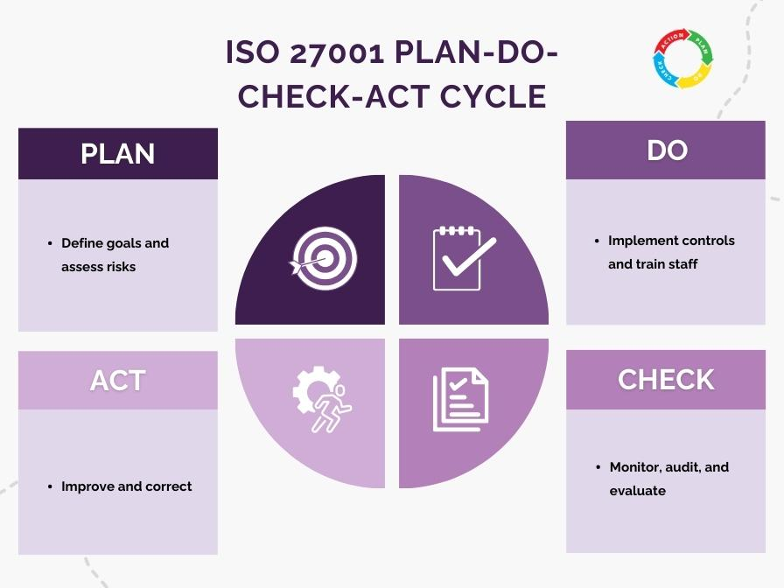

Figure 1: ISO/IEC 27001 PDCA Cycle

Critical Evaluation
ISO 27001 is particularly valuable for FSB as it establishes a formal governance structure and promotes accountability across all organisational levels. By enforcing a risk-based approach, it ensures that security decisions are aligned with business priorities rather than being reactive.
However, as argued by Sabillon et al. [6], the framework’s structured nature can introduce complexity and may slow down rapid innovation, especially in cloud-based environments where agility is critical.

3.2 NIST Cybersecurity Framework (CSF): Operational Security
The NIST Cybersecurity Framework provides a flexible and practical approach to managing cybersecurity risks through five core functions: Identify, Protect, Detect, Respond, and Recover [7].

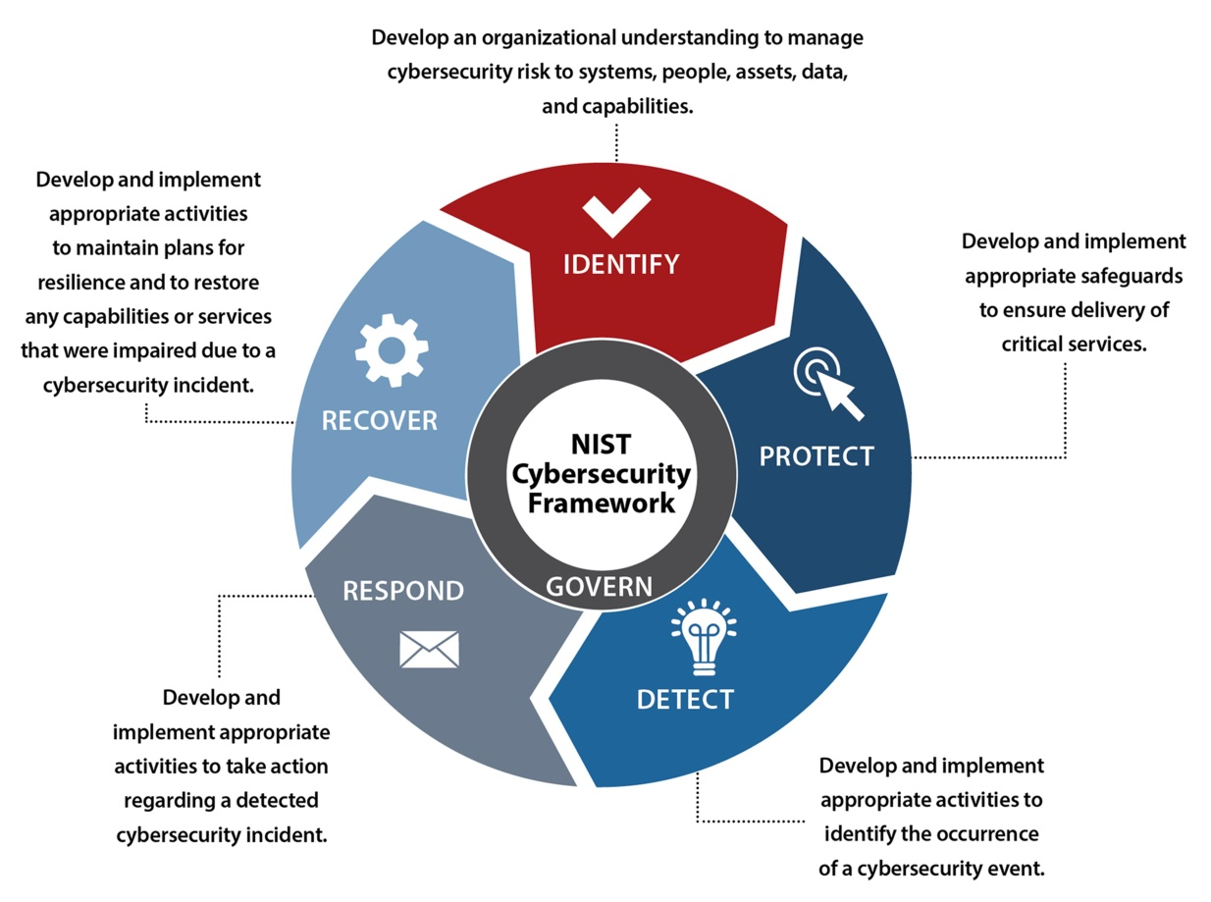

Figure 2: NIST Cybersecurity Lifecycle

Critical Evaluation
The NIST framework is highly effective for operational security within FSB. Its emphasis on real-time threat detection and response is particularly relevant in the context of mobile banking, where immediate action is required to prevent financial loss.
Nevertheless, the absence of formal certification limits its ability to demonstrate compliance to external stakeholders. This reinforces the importance of integrating NIST with governance frameworks such as ISO 27001 to achieve both operational efficiency and regulatory assurance [8].

3.3 ITIL: Service Management and Business Alignment
ITIL provides a structured approach to IT service management, ensuring that IT processes align with business objectives and customer expectations [9].

Evaluation
ITIL plays a supporting role by ensuring that security measures do not negatively impact service quality. For example, effective incident management processes minimise downtime and maintain customer trust.

However, ITIL does not provide comprehensive security controls, making it insufficient as a standalone solution. Its value lies in enhancing the effectiveness of other frameworks by improving coordination and service delivery.

3.4 Integrated Framework Perspective
Function | Framework | Strategic Role
Governance | ISO 27001 | Policy and compliance
Operations | NIST CSF | Threat management
Services | ITIL | Service efficiency

This comparison highlights that no single framework is sufficient to address the full spectrum of cybersecurity challenges. ISO 27001 ensures governance and compliance, NIST CSF provides operational security capabilities, and ITIL supports service efficiency. Therefore, their integration is essential to achieve a balanced and comprehensive security strategy for FSB.

3.5 Critical Reflection: Limitations of Traditional Frameworks
While ISO/IEC 27001, NIST CSF, and ITIL provide valuable guidance, a critical limitation lies in their fundamentally static and framework-driven nature. These models are often implemented as structured compliance mechanisms rather than adaptive security systems. As a result, organisations may achieve certification or alignment while remaining vulnerable to rapidly evolving cyber threats.
A key concern is the emergence of “compliance-driven security”, where organisations prioritise meeting regulatory or audit requirements over addressing real-time risks. This creates a false sense of security, particularly in cloud-native and highly dynamic environments such as FinSure Bank (FSB). For example, ISO 27001 emphasises governance and documentation but does not inherently guarantee effective threat detection or response capabilities.
Similarly, while the NIST Cybersecurity Framework provides strong operational guidance, it lacks enforceable compliance mechanisms, limiting its effectiveness in demonstrating regulatory adherence. ITIL, on the other hand, focuses on service management but may introduce procedural rigidity, potentially slowing down incident response in time-critical scenarios.
A critical limitation lies in the emergence of compliance-driven security, where organisations prioritise audit requirements over actual risk mitigation [6], [14].

4. Proposed Information Security & Governance Model

4.1 Adaptive Security Governance Model (ASGM) – Proposed Innovation
To address the limitations identified in traditional frameworks, this report proposes an Adaptive Security Governance Model (ASGM).The Adaptive Security Governance Model integrates governance, intelligence, and continuous monitoring into a dynamic system.
This approach is supported by modern cybersecurity research emphasising AI-driven threat detection, SIEM systems, and adaptive security models [1], [7], [9].

Key Principle
ASGM shifts security from:
- Reactive → Proactive
- Static → Dynamic
- Compliance-driven → Intelligence-driven

ASGM Architecture Overview
Layer | Function | Technologies
Governance Layer | Policies & compliance | ISO 27001
Intelligence Layer | Threat analysis | SIEM, AI analytics
Control Layer | Security operations | NIST CSF
Service Layer | Service delivery | ITIL
Trust Layer | Access control | Zero Trust Architecture
Compliance Layer | Continuous monitoring | Automated auditing
The layered structure of the Adaptive Security Governance Model (ASGM) demonstrates how governance, intelligence, and operational controls interact within a continuous security ecosystem. By incorporating real-time monitoring and AI-driven analytics, the model ensures that security measures remain adaptive to emerging threats rather than static and compliance-focused.
Critical Contribution:
ASGM introduces continuous feedback loops, ensuring that security controls evolve dynamically in response to emerging threat

4.2 Hybrid Framework Architecture
This model reflects a defence-in-depth and layered governance approach, ensuring resilience across both technical and organisational dimensions.

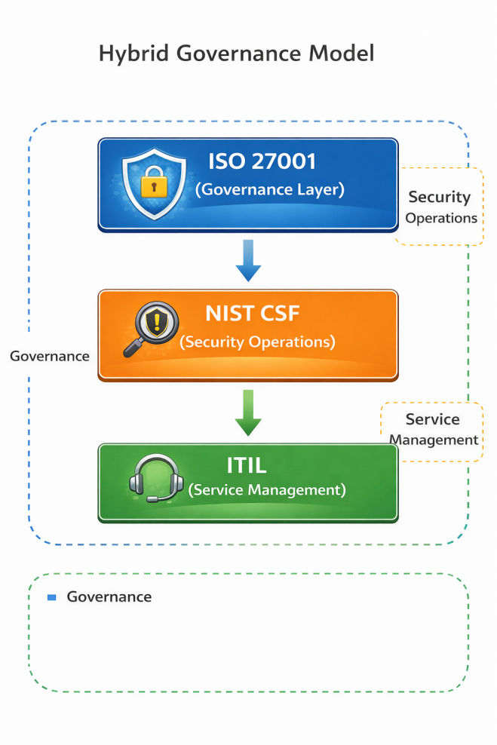

Figure 3: Integrated Hybrid Governance Model combining ISO 27001, NIST CSF, and ITIL

Advanced Critical Analysis
The proposed hybrid model addresses FSB’s key weaknesses by integrating governance, operational security, and service management into a unified framework.
From a strategic perspective, this integration eliminates fragmentation by ensuring that policies, processes, and operations are aligned. ISO 27001 provides the governance backbone, NIST ensures continuous threat management, and ITIL supports efficient service delivery.
Importantly, this model enables FSB to shift from a reactive approach—where actions are taken after incidents occur—to a proactive model focused on prevention and continuous improvement.

4.3 Governance Structure

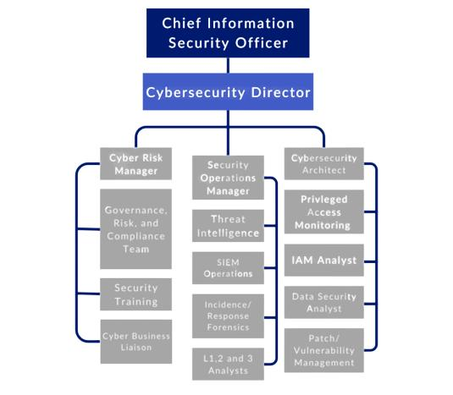

Figure 4: Governance Hierarchy
This structure ensures clear accountability and effective decision-making [10].

4.3 Zero Trust Architecture (ZTA)

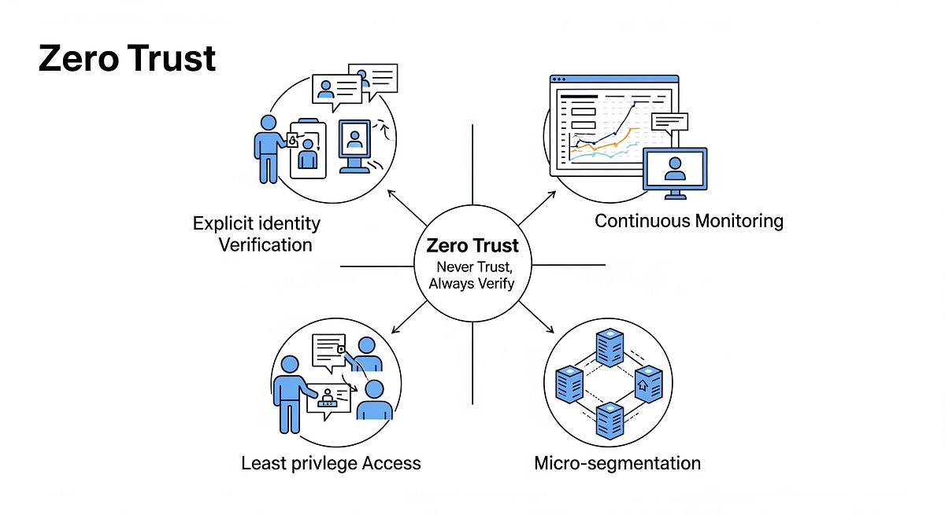

Figure 5: Zero Trust Model

Critical Insight
Zero Trust represents a fundamental shift from traditional security models. Instead of assuming trust within the network, it requires continuous verification. For FSB, this is particularly important due to remote working, BYOD usage, and third-party access.
By implementing Zero Trust, FSB reduces the risk of insider threats and unauthorised access, significantly improving overall security [11].

4.3.1 Advanced Zero Trust Implementation
The implementation of Zero Trust Architecture (ZTA) within FSB should extend beyond basic authentication mechanisms to include:
- Continuous user and device verification [11]
- Micro-segmentation of network resources
- Context-aware access control (location, behaviour, device health)
This ensures that access decisions are dynamically evaluated, significantly reducing the risk of lateral movement within the network.

4.4 Real-World Application Scenario

Consider a scenario where an attacker gains access to employee credentials:

- NIST enables detection of unusual behaviour
- Zero Trust prevents automatic access
- ISO 27001 ensures predefined response policies
- ITIL ensures minimal service disruption
This demonstrates how the integrated model functions effectively in practice.

4.5 Risk Management and Technical Security Controls
The risk management approach at FSB must evolve from a periodic assessment model to a continuous, intelligence-driven process.

Advanced Risk Assessment Table
Risk | Impact | Likelihood | Risk Level | Adaptive Mitigation
BYOD breach | High | High | Critical | MDM + device encryption + remote wipe
Cloud misconfiguration | High | Medium | High | CSPM automation tools
Insider threat | High | Medium | High | Behaviour analytics (UEBA)
Phishing attacks | Medium | High | High | AI-based email filtering
AI-based filtering is supported by modern threat intelligence research [1].This risk assessment illustrates that the most critical threats to FSB originate from both technical vulnerabilities and human factors, such as BYOD usage and phishing attacks. The inclusion of adaptive mitigation strategies demonstrates a shift towards proactive and intelligence-driven risk management, enabling faster detection and response to evolving threats

Layered Technical Security Architecture
Security Layer | Technology | Implementation
Identity Layer | IAM + RBAC | Least privilege access
Authentication | MFA (Biometric + OTP) | Applied to all users
Device Layer | MDM | Secures BYOD devices
Network Layer | IDS/IPS + Firewalls | Real-time threat detection
Cloud Layer | CASB + CSPM | Cloud access control
Monitoring Layer | SIEM | Real-time alerting

These technologies are widely recognised in cybersecurity frameworks for enhancing threat detection and risk mitigation [7], [9], [6], [14]. This layered security architecture reflects a defence-in-depth strategy, where multiple security controls operate across different levels of the system. Such an approach reduces single points of failure and ensures that even if one layer is compromised, additional controls remain in place to protect critical assets and data.

Critical Insight
Traditional risk management approaches are insufficient in dynamic environments. FSB must adopt continuous risk monitoring, where threats are detected and mitigated in real time rather than through periodic reviews.

4.6 Service Level Agreement (SLA) and Security Commitments
Metric | Target | Strategic Importance
System uptime | 99.9% | Ensures service availability
Incident detection | < 5 minutes | Minimises damage
Incident response | < 1 hour | Rapid containment
Data recovery | < 4 hours | Business continuity

These service level targets establish measurable security and performance benchmarks, ensuring accountability and operational resilience. By defining clear response and recovery times, FSB can minimise the impact of security incidents and maintain service continuity, which is critical in the financial sector.

4.7 Contingency Planning and Resilience Strategy
To ensure operational resilience, FSB must implement:
- Disaster Recovery Plan (DRP)
- Business Continuity Plan (BCP)
- Encrypted data backups (daily replication)
- Incident response playbooks
- Automated failover systems[13][14]

5. Critical Discussion: The Evolution of Regulations
Cybersecurity regulations are continuously evolving in response to the increasing complexity and frequency of cyber threats. As financial institutions such as FinSure Bank (FSB) adopt advanced technologies including cloud computing, artificial intelligence, and digital banking

platforms, traditional regulatory frameworks must adapt to address new vulnerabilities and risks [12].
From a strategic perspective, regulations such as the General Data Protection Regulation (GDPR) play a critical role in establishing minimum standards for data protection, privacy, and organisational accountability. GDPR requires organisations to implement strong data protection measures, ensure transparency in data processing, and report breaches within strict timeframes. For FSB, compliance with GDPR is not only a legal requirement but also a key factor in maintaining customer trust and protecting brand reputation [2], [4].

5.1 Benefits of Evolving Regulations
The continuous development of cybersecurity regulations provides several important benefits for organisations like FSB:
- Enhanced Data Protection: Updated regulations ensure that organisations adopt modern security practices to protect sensitive data from emerging threats.
- Improved Accountability: Regulatory frameworks enforce clear responsibilities, ensuring that organisations take ownership of their security practices.
- Increased Customer Trust: Customers are more likely to engage with organisations that demonstrate compliance with recognised standards.
- Standardisation of Security Practices: Regulations create a consistent approach to cybersecurity across industries, reducing uncertainty and risk.
These benefits are particularly important in the financial sector, where trust and reliability are essential for business success.

5.2 Challenges and Limitations
Despite their benefits, regulatory frameworks also present several challenges. One major issue is the cost and complexity of compliance. Implementing and maintaining compliance requires significant investment in technology, staff training, and auditing processes. For FSB, this may create financial and operational pressure, particularly during rapid expansion.
Another limitation is that regulations often lag behind technological advancements. For example, emerging threats related to artificial intelligence or cloud-native architectures may not be fully addressed by existing regulatory frameworks. This creates a gap between compliance and actual security effectiveness.
Furthermore, strict regulatory requirements can sometimes limit organisational flexibility and innovation. For a digital-first bank like FSB, excessive controls may slow down the development of new services or delay system updates, potentially reducing competitiveness in a fast-moving market [13].

5.3 Strategic Implications for FSB

For FinSure Bank, the key challenge is to balance compliance with innovation. Rather than viewing regulations as a constraint, FSB should treat them as a strategic tool for improving security and governance.
To achieve this, FSB should:
- Integrate compliance into its governance framework (ISO 27001)
- Use automation tools to reduce compliance burden
- Align regulatory requirements with operational practices (NIST CSF)
- Ensure that compliance processes support, rather than hinder, business objectives
Critical Insight:
Organisations that embed compliance into their overall security strategy are more resilient and better prepared to respond to future regulatory changes.

5.4 Future Outlook of Cybersecurity Regulations
Looking forward, cybersecurity regulations are expected to become more dynamic and technology-focused. Governments and regulatory bodies are increasingly emphasising:
- Real-time monitoring and reporting
- Stronger penalties for non-compliance
- Greater focus on third-party and supply chain risks
- Integration of AI-driven security requirements
For FSB, this means that compliance cannot remain static. Instead, it must adopt a continuous compliance approach, where regulatory requirements are regularly reviewed and updated in line with technological changes.

5.5 Overall Critical Evaluation
In conclusion, while evolving regulations introduce challenges such as increased costs and operational complexity, their benefits significantly outweigh the limitations. They provide a structured foundation for improving security, enhancing accountability, and building customer trust.
For FinSure Bank, the successful integration of regulatory compliance into its hybrid governance model will not only ensure legal adherence but also create a competitive advantage in the increasingly digital financial landscape.

6. Conclusion and Recommendations
FinSure Bank (FSB) operates within a complex and high-risk digital environment where traditional, fragmented approaches to security are no longer sufficient. The organisation’s reliance on cloud computing, mobile banking, and third-party integrations significantly increases its exposure to modern cyber threats, making a structured and strategic approach to data security, governance, and compliance essential
The integration of ISO 27001, NIST CSF, and ITIL provides a comprehensive solution to FSB’s security challenges.By embedding governance, operational security, and compliance into a unified model, FSB can achieve a proactive and resilient security posture supported by Zero Trust principles [6], [11].
This report has critically evaluated three key frameworks—ISO/IEC 27001, the NIST Cybersecurity Framework, and ITIL—and demonstrated that no single framework is sufficient to address the full range of challenges faced by FSB. ISO 27001 provides a strong governance and compliance foundation, NIST CSF enhances operational security and incident response capabilities, and ITIL ensures that security measures align with service delivery and business objectives. However, their individual limitations highlight the necessity of an integrated approach.
The proposed hybrid model offers a comprehensive solution by combining the strengths of all three frameworks into a unified structure. This integration not only resolves the current fragmentation within FSB but also enables a shift from a reactive security posture to a proactive and resilient model. The inclusion of Zero Trust Architecture further strengthens this approach by ensuring continuous verification of users and devices, thereby addressing critical risks associated with remote access, BYOD policies, and insider threats.
From a strategic perspective, the role of evolving regulations such as GDPR is equally significant. While compliance introduces challenges in terms of cost and operational complexity, it also provides a structured framework for improving accountability, enhancing data protection, and building customer trust. For FSB, the key to success lies in embedding compliance within its governance and operational processes rather than treating it as a separate obligation.

Key Recommendations
To achieve long-term security and organisational resilience, FSB should:
- Establish a centralised governance framework based on ISO 27001 to ensure consistency and accountability
- Implement the NIST CSF to strengthen real-time threat detection and incident response capabilities
- Adopt ITIL practices to maintain service efficiency and minimise operational disruption
- Deploy Zero Trust Architecture to enhance access control and reduce insider and external threats

- Integrate compliance processes into daily operations using automation and continuous monitoring

Final Strategic Insight
Ultimately, cybersecurity should not be viewed as a purely technical function but as a strategic business enabler. By adopting a holistic and integrated approach, FinSure Bank can not only mitigate risks but also gain a competitive advantage in the digital financial sector. A well-governed, secure, and compliant environment will strengthen customer confidence, support innovation, and ensure sustainable growth in an increasingly complex threat landscape.

References
[1] European Union Agency for Cybersecurity (ENISA), ENISA Threat Landscape 2023, 2023.
[2] K. Martin, A. Borah, and R. Palmatier, “Data privacy: Effects on customer and firm performance,” Journal of Marketing, vol. 86, no. 1, pp. 1–21, 2022.
[3] N. Kshetri, “Cybercrime and cybersecurity in the global financial sector,” Computer, vol. 56, no. 2, pp. 20–27, 2023.
[4] European Commission, General Data Protection Regulation (GDPR), 2022.
[5] International Organization for Standardization (ISO), ISO/IEC 27001:2022 Information Security Management Systems, Geneva, Switzerland, 2022.
[6] R. Sabillon, J. Serra-Ruiz, and J. Cavaller, “Cybersecurity frameworks and standards: A review,” Computer Standards & Interfaces, vol. 75, 2021.
[7] National Institute of Standards and Technology (NIST), Framework for Improving Critical Infrastructure Cybersecurity, Version 2.0, 2023.
[8] AXELOS, ITIL Foundation: ITIL 4 Edition, London, UK, 2023.
[9] Y. Zhang, L. Wang, and X. Luo, “Insider threat detection in organisations: A review,” IEEE Access, vol. 10, pp. 12345–12360, 2022.
[10] R. von Solms and J. van Niekerk, “From information security to cybersecurity,” Computers & Security, vol. 38, pp. 97–102, 2022.
[11] S. Rose, O. Borchert, S. Mitchell, and S. Connelly, Zero Trust Architecture, NIST Special Publication 800-207, 2020.
[12] R. Smith, “Evolving challenges in data protection and privacy,” Information Security Journal, vol. 31, no. 4, pp. 200–210, 2022.
[13] W. Stallings, Network Security Essentials: Applications and Standards, 7th ed. Pearson, 2021.
[14] M. Whitman and H. Mattord, Principles of Information Security, 7th ed. Cengage Learning, 2021.

