Programme: Certificate of Higher Education Skills for the Workplace (Health & Social Care)

Module: Introduction to Health and Social Care
Module code: LCHS4003

Lecturers name: Tsiwani Khumalo

Part A – Poster
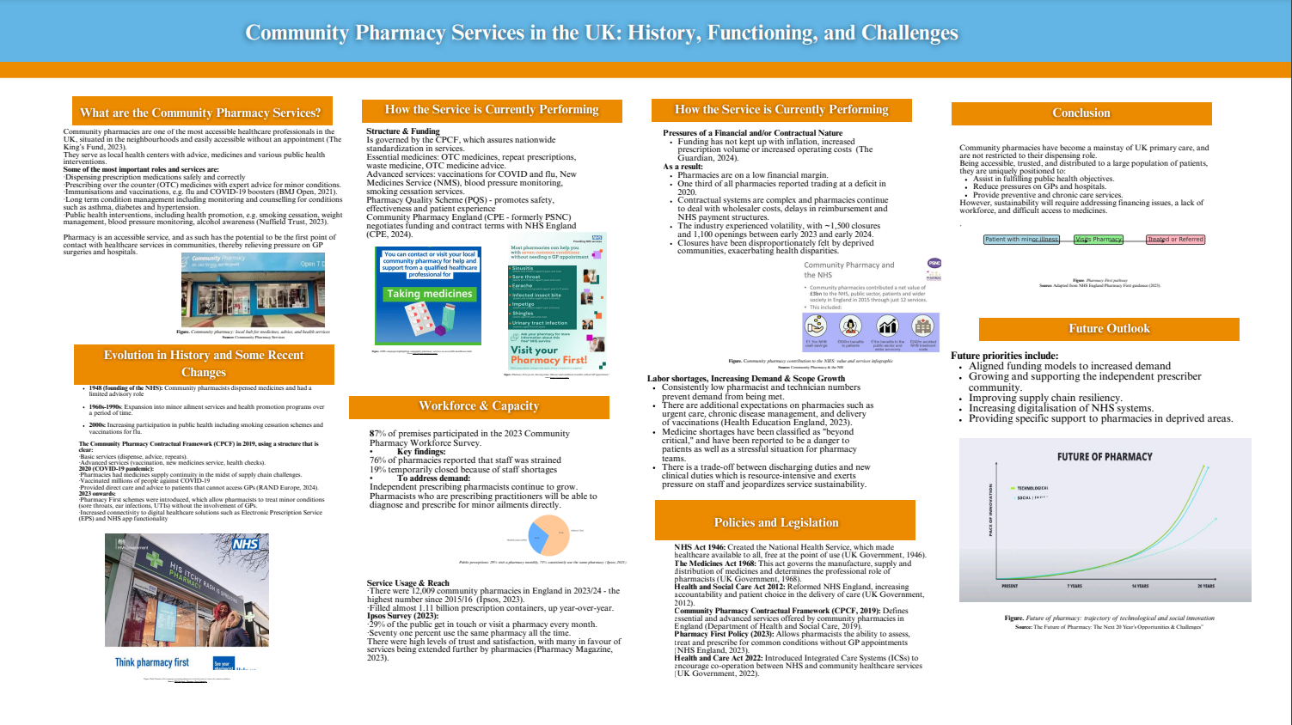

Part B - Essay
1. Introduction
The National Health Service (NHS) has been regarded as one of the most significant contributions of contemporary British society. It was founded in 1948 and was constructed on the core principles of universality, comprehensiveness, and services free at the point of use, which was mainly funded by taxing (The King’s Fund, 2023). This Essay discusses the background of the NHS and analyses its present-day structure and issues critically.
2. Origins of the NHS
The NHS concept was influenced by the post-war period, when the majority of people lived in poverty, and their health conditions were not satisfactory. In 1942, the Beveridge Report suggested addressing the five giants of want, disease, ignorance, squalor, and idleness, and suggested a welfare state, which would be underpinned by universal healthcare (Timmins, 2021). The Minister of Health, Aneurin Bevan, followed up on this fact by passing the NHS Act 1946 and on 5 July 1948, the service began (Klein, 2021).
The NHS was established using three principles: that it must serve the needs of every person; it must be free of charge at its point of dispensation, and it must be founded on clinical need instead of paying capability (Ham, 2020). This model, standing out as a replacement for the previously existing disjointed system of voluntary hospitals and insurance schemes, has guaranteed equity and fair play in the provision of healthcare. Controversial at the time, the NHS soon became popular among the population and emerged as one of the staples of social welfare in Britain.
3. Current Structure and Functioning
The NHS today is a devolved system that runs within England, Scotland, Wales and Northern Ireland. The overall policy is established by the Department of Health and Social Care (DHSC) in England, which distributes funds, and daily services are rendered by NHS England, as well as they conduct cooperation with the Integrated Care Boards (ICBs) to plan and provide care locally (NHS England, 2022).
The NHS services are delivered in 4 areas:
Primary care: General practitioners (GPs), community pharmacies, dentists, and optometrists.
Secondary care: services in the hospital, such as emergency care and elective surgery.
Tertiary care: extremely specialised care like organ transplants.
Community care and public health: vaccination, screening and mental care (Majeed et al., 2022).
The investment is mainly based on general taxation, and the NHS England budget is PS165.9 billion in 2022/23 (UK Parliament, 2023). This notwithstanding, the rising demand from the ageing population and chronic conditions has put pressure on resources.
4. Critical Examination of Challenges
Despite the NHS being faithful to its principles of formation, the service is undergoing a number of urgent challenges. Among the most urgent ones is workforce shortages, where more than 110,000 vacancies were registered in 2022, both in nurses and doctors, directly related to patient care (BMA, 2023). Elective procedures and emergency care waiting times have been at record levels that were exacerbated by the COVID-19 pandemic (The King's Fund, 2023).
The reforms like Integrated Care Systems (ICSs) are tailor-made to enhance cooperation, lessen disparities, and emphasis on prevention. Their effectiveness is, however, questionable due to inconsistent implementation and scarcity of resources (Majeed et al., 2022). Moreover, political discourses focus on privatization, funding deficit, and sustainability. Although digital solutions to health, like telemedicine and digital prescriptions, offer efficiency opportunities, they need additional financing and equal availability (RAND Europe, 2024).
5. Conclusion
To sum up, the NHS was created with the purpose of providing free and universal access to healthcare according to need and not the ability to pay. Although its structure has developed into an intricate, devolved mechanism that offers a multitude of services, it has many problems, especially the labour shortage, fiscal pressure, and increased demand. These concerns can be tackled in the long run by making investments, planning the workforce, and digital transformation and will also be relevant in ensuring that the NHS will still be able to deliver on its founding vision.

Essay Reference
BMA (2023) NHS workforce: Key facts and trends. Available at: https://www.bma.org.uk (Accessed: 18 October 2025).
Ham, C. (2020) The NHS at 70: Reform, Renewal and Refocus. London: The King’s Fund.
Klein, R. (2021) The New Politics of the NHS: From Creation to Reinvention. 8th edn. Abingdon: Routledge.
Majeed, A., Maile, E. J. and Bindman, A. B. (2022) ‘The future of the NHS: challenges and opportunities after COVID-19’, The Lancet, 399(10327), pp. 1851–1860.
NHS England (2022) Integrated care boards and systems explained. Available at: https://www.england.nhs.uk (Accessed: 18 October 2025).
Nuffield Trust (2023) Community pharmacy explained. Available at: https://www.nuffieldtrust.org.uk (Accessed: 18 October 2025).
Pharmacy Magazine (2023) Number of community pharmacies in England increases to 12,009. Available at: https://www.pharmacymagazine.co.uk (Accessed: 18 October 2025).
RAND Europe (2024) Evaluation of clinical services under the Community Pharmacy Contractual Framework. Available at: https://www.rand.org (Accessed: 18 October 2025).
The King’s Fund (2023) The NHS explained: how the health system works. Available at: https://www.kingsfund.org.uk (Accessed: 18 October 2025).
Timmins, N. (2021) The Five Giants: A Biography of the Welfare State. London: HarperCollins.
UK Parliament (2023) NHS funding and expenditure 2022/23. Available at: https://commonslibrary.parliament.uk (Accessed: 18 October 2025).
UK Parliament (2024) Community pharmacy sector report. Available at: https://commonslibrary.parliament.uk (Accessed: 18 October 2025).

Poster References
BMJ Open (2021) ‘A rapid realist review of the role of community pharmacy in the public health response during the pandemic’. BMJ Open, 11(6). Available at: https://bmjopen.bmj.com (Accessed: 2 October 2025).
BMA (2023) NHS workforce: recruitment, retention and vacancies. Available at: https://www.bma.org.uk (Accessed: 2 October 2025).
Community Pharmacy England (2024) Briefing on reduced openings and closures of community pharmacies. Available at: https://www.cpe.org.uk (Accessed: 2 October 2025).
Department of Health and Social Care (2019) The Community Pharmacy Contractual Framework 2019–2024: Implementation Plan. London: DHSC. Available at: https://www.gov.uk/dhsc (Accessed: 2 October 2025).
Guardian (2024) Pharmacies in England close as poorer areas hit hardest. Available at: https://www.theguardian.com (Accessed: 2 October 2025).
Ham, C. (2020) The NHS at 70: Reform, Renewal and Revolution. Bristol: Policy Press.
Health Education England (2023) Community Pharmacy Workforce Survey 2023: Key findings. Available at: https://www.hee.nhs.uk (Accessed: 2 October 2025).
Ipsos (2023) Public Perceptions of Community Pharmacy 2023. Available at: https://www.ipsos.com (Accessed: 2 October 2025).
Klein, R. (2021) The New Politics of the NHS: From Creation to Reinvention. 8th edn. Abingdon: Routledge.
Majeed, A., Maile, E. J. and Bindman, A. B. (2022) ‘The future of the NHS: challenges and opportunities after COVID-19’, The Lancet, 399(10327), pp. 1851–1860.
NHS England (2022) Integrated care boards and systems explained. Available at: https://www.england.nhs.uk (Accessed: 2 October 2025).
NHS England (2023) Pharmacy First: Policy and Implementation Guidance. London: NHS England. Available at: https://www.england.nhs.uk (Accessed: 2 October 2025).
Nuffield Trust (2023) Community pharmacy explained. Available at: https://www.nuffieldtrust.org.uk (Accessed: 2 October 2025).
Pharmacy Magazine (2023) Number of community pharmacies in England increases to 12,009. Available at: https://www.pharmacymagazine.co.uk (Accessed: 2 October 2025).
RAND Europe (2024) Evaluation of clinical services under the Community Pharmacy Contractual Framework. Available at: https://www.rand.org (Accessed: 2 October 2025).
The King’s Fund (2023) The NHS explained: how the health system works. Available at: https://www.kingsfund.org.uk (Accessed: 2 October 2025).
Timmins, N. (2021) The Five Giants: A Biography of the Welfare State. London: HarperCollins.
UK Government (1946) National Health Service Act 1946. London: His Majesty’s Stationery Office (HMSO).
UK Government (1968) Medicines Act 1968. London: The Stationery Office (TSO).
UK Government (2012) Health and Social Care Act 2012. London: The Stationery Office (TSO).
UK Government (2022) Health and Care Act 2022. London: The Stationery Office (TSO).
UK Parliament (2023) NHS funding and expenditure 2022/23. Available at: https://commonslibrary.parliament.uk (Accessed: 2 October 2025).
UK Parliament (2024) Community pharmacy sector report. Available at: https://commonslibrary.parliament.uk (Accessed: 2 October 2025).

