Daniel Griffiths 23187131

Building Survey
ACBA4017

Contents
1. Introduction 2
2. Objectives of a building a survey and scope. 3
1. Objectives of the building survey 3
2. Scope of a building survey 3
3. Selection of Digital Tools and Technology 4
Digital surveying tools 4
1. Drone Survey 4
2. Laser Scanners 5
3. Thermal Imaging cameras 6
Tool Selection 7
4. Survey Planning 8
1. Plan for conducting a building survey and Methodology 8
5. Potential Challenges and how to over come or mitigate. 8
6. Conclusion 9
References 9

Figure 1 Drone image (Royal Institution of Chartered Surveyors , 2023) 4
Figure 2 Leica RTC360 LT 3D (Leica-geosystems, 2024) 5
Figure 3 Leica BLK2GO handheld scanner (Leica-geosystems, 2024) 5
Figure 4 Thermal Imaging camera showing underfloor heating (NHBC Foundation, 2020) 6
Figure 5 blue area shows heat loss around French doors, this suggests poor installation. (NHBC Foundation, 2020) 6

Introduction
This report will highlight the importance of building surveying and the benefits of using digital surveying technology.
Building surveying is crucial to understanding the condition of a building and highlighting any defects whether they are minor or major. They can provide information regarding the building’s construction. A building survey will look at all accessible parts of a building.
The use of digital surveying technology has increased the speed and accuracy of building surveying. It has also reduced the amount of errors within a survey. Digital surveying has allowed for 2D and 3D drawings to be created which give greater detail than traditional methods of surveying and can help eliminate errors when drafting a survey over to a plan.
The purpose of this assessment is to demonstrate how a building survey is carried out. The survey will focus on the type of building, its location and any specific area of the building that needs to be focused on.
(The Royal Institution of Chartered Surveyors , 2024) (JDB Surveying and Architectural, 2024)

Objectives of a building a survey and scope.

Objectives of a building survey
Building surveys are undertaken to give a highly detailed assessment of a buildings, external and internal condition. A building survey will recommend any repairs or preventative maintenance that maybe necessary to maintain the buildings structural integrity. A building survey can also give details into the method of a building’s construction, give details of the materials used and the main structural components. Building surveys can estimate the costs associated with repairs or any preventative maintenance.
The building that is being surveyed is the Fforum building at the University of Wales Trinity Saint David SA1 Campus.
(Royal Institution of Chartered Surveyors, 2024) (Thorpe, 2023) (London Surveyors and Valuers Ltd, 2021)

Scope of a building survey
The Fforum building is located at the University of Wales Trinity Saint David’s SA1 campus in Swansea. The building is currently used as the university’s library at the SA1 Campus.
The Fforum Building is constructed from a Reinforced concrete frame on the ground floor and first floor and infilled with an external facing brick cavity wall with aluminium double-glazed windows. The second floor is constructed from a steel frame, with aluminium framed glass panels at the gable ends, and aluminium framed double-glazed windows. The roof is constructed from a steel frame and clad in box profile sheeting. The roof is insulated with a mineral wool type insulation, this is seen from construction photographs.
The Fforum Building is located off Island Road Swansea SA1 8EW, the main entrance is east facing but has an additional entrance which is west facing. The south side of the Fforum building faces towards the sea and has most of its exposure to the weather on the southwest area of the building. The building is built on an area that was formally a part of Swansea docks.
The primary areas of the building that may need more investigation would be the roof and south and southwest elevations of the building due to the building’s exposure to high winds and rainfall coming from the sea.
(David, 2018)

Selection of Digital Tools and Technologies

Digital surveying tools

Drone Survey
Drones otherwise known as unmanned aerial vehicles (UAVs) have become an essential tool for surveying buildings. Drones allow effective and accurate surveys of roofs and higher-level parts of a building, without the need for surveyors to gain access to these areas. Drones can also survey hard to access areas of buildings that have sustained structural damage where it is not safe for surveyors to access.
Drone surveys have massively improved the speed and accuracy of building surveys. Drones can be equipped with high resolution cameras, thermal scanners and laser scanners that make them a very versatile tool as they can give top-down imagery and data, and images and data from different angles, which then can be used to create 2D and 3D models. Drones have reduced the health and safety risk to surveyors and lowered surveying costs, as surveys can now be done from the ground and has eliminated the cost for access equipment such as scaffolding.
(Royal Institution of Chartered Surveyors , 2023) (Sky Scan Surveys, 2024) (Leica-geosystems, 2024)
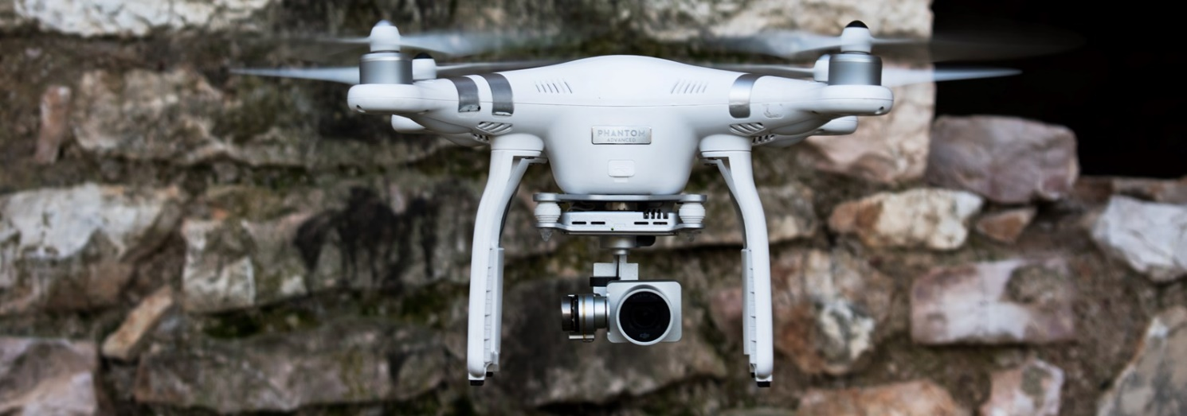
Figure 1 Drone image (Royal Institution of Chartered Surveyors , 2023)

Laser Scanners
Laser scanners are a highly accurate and efficient way of surveying buildings internally and externally. Laser scanners can be handheld, mounted on a tripod, drone mounted, or robot mounted. Laser scanners will capture every element of a building using a high number of data points and also capture images that can then be used to create a 3D model of a building.
As every element of a building is captured during scanning it is possible to revisit the data and look at other elements that may not have been needed during the initial survey, this can help reduce surveying time and costs. It should be noted that the data collected during building surveys is only accurate up to the point when the survey was taken as elements can change due to different factors.
Laser scanners give highly detailed assessments of buildings, defects can be identified easily, especially in difficult to access areas. The detail and accuracy of laser scanners make them a great tool for historic building projects, for example where the facade of a building needs to be maintained or rebuild to the same style and dimensions before work started.
Survey data from laser scanning can be used to create Revit models for BIM (Building Information modelling).
(Leica-geosystems, 2024) (Leica-geosystems, 2024) (Survey solutions, 2024)
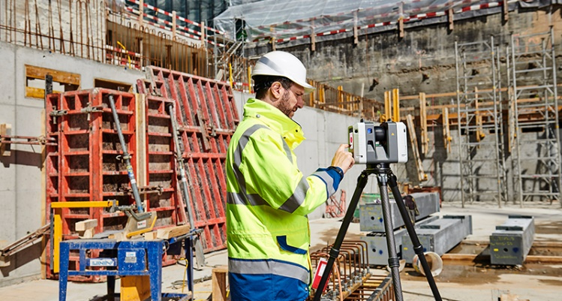

Figure 2 Leica RTC360 LT 3D (Leica-geosystems, 2024)
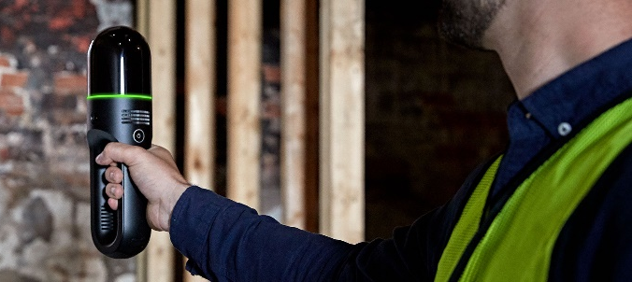

Figure 3 Leica BLK2GO handheld scanner (Leica-geosystems, 2024)

Thermal Imaging cameras
Thermal imaging cameras can be an essential tool for building surveying. Thermal imaging cameras work by detecting Infrared radiation that cannot be detected by the human eye. Data is then compiled into a Thermographic survey.
Thermal imaging cameras can be used to detect areas of a building where there maybe cold air finding its way into a building through defects to the building or items within a building that may be generating to much heat such as electrical fittings.
Thermal imaging can pick up issues with insulation breakdown or poor installation by detecting cold patches on external walls, once detected further investigation can be conducted. Issues with damp or leaks can also be detected without causing damage to the building, these will show as cold spots on the camera.
( Portable Appliance Safety Services, 2022) (NHBC Foundation, 2020)
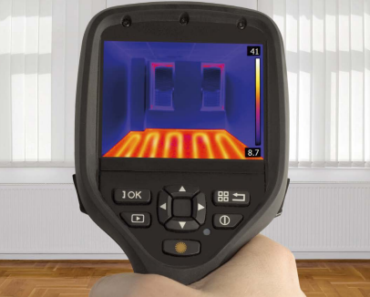

Figure 4 Thermal Imaging camera showing underfloor heating (NHBC Foundation, 2020)
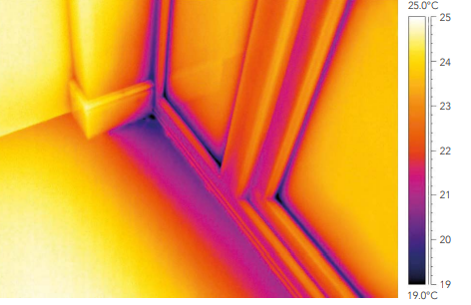

Figure 5 blue area shows heat loss around French doors, this suggests poor installation. (NHBC Foundation, 2020)

Tool Selection
Drone, Laser and thermal scanners have been chosen to aid in the survey of The Fforum building.
The drone survey will be used to survey the roof and higher parts of the building externally for any damage or potential maintenance issues. The drone will be able to collect vast amounts of data very quickly and safely, which can then be input into 2D and 3D models.
Tripod mounted laser scanners such as the Leica RTC360 LT 3D will be used to survey lower-level external areas of The Fforum building and on all three floors internally. The handheld laser scanner such as the Leica BLK2GO will be used to survey smaller and more confined areas and internal areas of The Fforum building. The laser scanners will give a high number of data points and images witch can be used to identify any defects or maintenance issues with The Fforum building. The laser survey can then be combined with the drone survey.
The thermal imaging camera will be used to identify if there are any cold spots, leaks, overheating electrical fittings or insulation problems. Thermographic surveys can help identify issues that may not be seen by laser scanning. A thermal scanner can also be mounted to a drone to complete roof surveys and surveys of higher external parts of the building.

Survey Planning

Plan for conducting a building survey and Methodology.
When conducting a building survey these are the key points that should be undertaken.
A desk top study of the building should be done. This should give information about the property such as its location, previous uses of the area it has been built on, any hazards near the building, and any as built drawings that may be available. The survey may need to be done at times where there are less people present to avoid disruptions to the building’s occupants or to the survey itself.
Look for any potential risks to yourself or others before starting the survey. The building survey should start externally on the ground and then progress to the roof. Once the external survey is complete, the internal survey can be done. Care must be taken not to miss any parts of the building.
Weather can influence surveys as high winds can make it unsafe to conduct a drone survey. If the building has a leak, it may be best to do the survey when it is raining.
Once the surveying on site is complete, the data can then be used to create 2D and 3D plans or models.
All the data collected from the drone, laser scanner and thermal imaging camera will be compiled into a 3D Model. Any issues with maintenance or defects can be highlighted and then put into a report and further investigation can then be done should any issue be discovered.

(Royal institution of Chartered Surveyors , 2021)

Potential Challenges and how to over come or mitigate.
There can be many potential challenges when undertaking a building survey.
Poor weather or incorrect weather may prevent a survey from being conducted, for example if there is a leak coming from a roof it maybe best to survey on a wet day, or if winds are too high, drone surveys should be postponed until wind speed drops.
Areas where the survey is being conducted maybe crowded, this can affect the data and images collected. To help avoid this, multiple scans may need to be done, or the survey could be done at various times of day where there maybe less people there.
Surveys should be rearranged if any building work is being undertaken as this can influence the outcome off the survey.

Conclusion
Imagery and data collection have made identification of issues much easier especially when combined with thermal imaging. It has also enabled diagnosis of an issue without needing to expose the area of the building in question. This now allows for repairs to be done more efficiently.
Digital surveying tools have helped reduce risk to surveyors and the public as there is little need to work at height or use access equipment to conduct surveys. This has also reduced disruption for users of the buildings. Building surveying reports are now more accurate and detailed. 3D building models can make identifying the location of an issue much easier.
In conclusion digital surveying tools are having a significant impact on the speed, accuracy, and cost of building surveys. Digital surveying tools have helped reduce the amount of errors when surveying and are now a key part of building surveying and as technology improves so will the efficiency and accuracy of building surveys.

References
Portable Appliance Safety Services. (2022). Retrieved from PASS-Thermal.co.uk: https://www.pass-thermal.co.uk/thermal-camera-applications-building
David, U. o. (Director). (2018). The Forum - Y Fforwm [Motion Picture]. Retrieved from https://www.facebook.com/UWTSDLib/videos/the-forum-y-fforwm/2162624177103854/
JDB Surveying and Architectural. (2024). Types of Building Survey. Retrieved from https://jdbsurveys.com/: https://jdbsurveys.com/services/types-building-survey/
Leica-geosystems. (2024). Grow your business with 3D laser scanning. Retrieved from https://leica-geosystems.com/: https://leica-geosystems.com/en-gb/industries/pure-surveying/get-inspired-to-grow-your-business/laser-scanning
Leica-geosystems. (2024). Scanners. Retrieved from leica-geosystems.com: https://leica-geosystems.com/en-gb/products/laser-scanners/scanners
London Surveyors and Valuers Ltd. (2021, December 14). What is a building survey and how do I get one? Retrieved from www.londonssurveyors.co: https://www.londonssurveyors.co/what-is-a-building-survey
NHBC Foundation. (2020). Thermal imaging report guide.
Royal institution of Chartered Surveyors . (2021). The RICS Home Survey Level 3 .
Royal Institution of Chartered Surveyors . (2023, October 06). How have drones impacted building surveying? Retrieved from www.ricsfirms.com: https://www.ricsfirms.com/residential/moving-home/surveys/how-have-drones-impacted-building-surveying/
Royal Institution of Chartered Surveyors. (2024, n/m n/d). Building surveying: Your guide to becoming a building surveyor. Retrieved from rics.org: https://www.rics.org/surveyor-careers/surveying/what-surveyors-do/what-is-a-building-surveyor
Sky Scan Surveys. (2024). www.skyscansurveys.co.uk. Retrieved from Drone Roof Inspection in Bury: https://www.skyscansurveys.co.uk/locations/drone-roof-inspection-bury/
Survey solutions. (2024). Laser scanning . Retrieved from www.survey-solutions.co.uk: https://www.survey-solutions.co.uk/building-survey/laser-scanning/
The Royal Institution of Chartered Surveyors . (2024, November 06). RICS Tech Partner Panel Discussion: The Future of Building Surveying. Retrieved from rics.org: https://www.rics.org/news-insights/the-future-of-building-surveying
Thorpe, S. (2023, August 05). Building Condition Survey: A Guide to Assessing Your Property. Retrieved from constructionwiki.co.uk: https://constructionwiki.co.uk/2023/08/05/building-condition-survey/

