New Build Dwelling: Technical report with drawings

Prepared for:
Gavin Traylor

Created by:
Lloyd wilson
2211509

Date completed:
April 2023
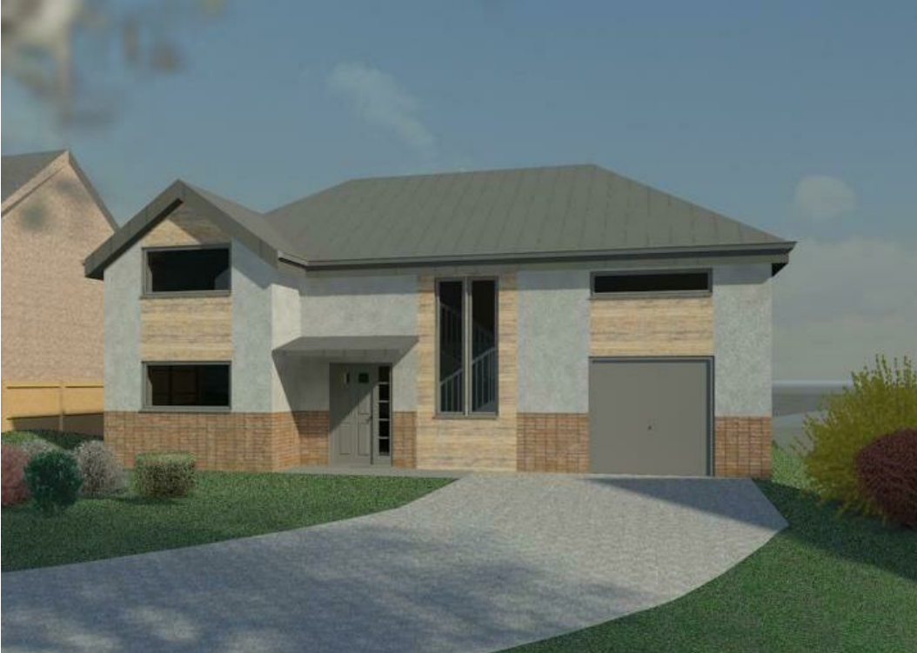

Word count: 2322

Table of Contents
2. Introduction 2
3. Detailed Drawings 3
3.1 Ground floor 3
3.2 Window opening 5
3.3 Eaves detailing and roof covering. 7
3.4 Main roof structure 9
4. Roof space conversion 11
5. Offsite solutions 12
5.1 Offsite definition 12
5.2 Four main Categories offsite construction 12
6. Conclusion 13
7. References 14

Introduction

In this presentation I will present detailed sketches of sections of the building, detailing the building elements. Following the sketches will be a description of the different layers and materials used to show case to Miss client A. Also on the report will be guidance on a proposal change to the roof structure and look at the advantages or disadvantages relating to the proposal. Offsite solutions are explained with the different categories of these disciplines defined.

Detailed Drawings

Ground floor

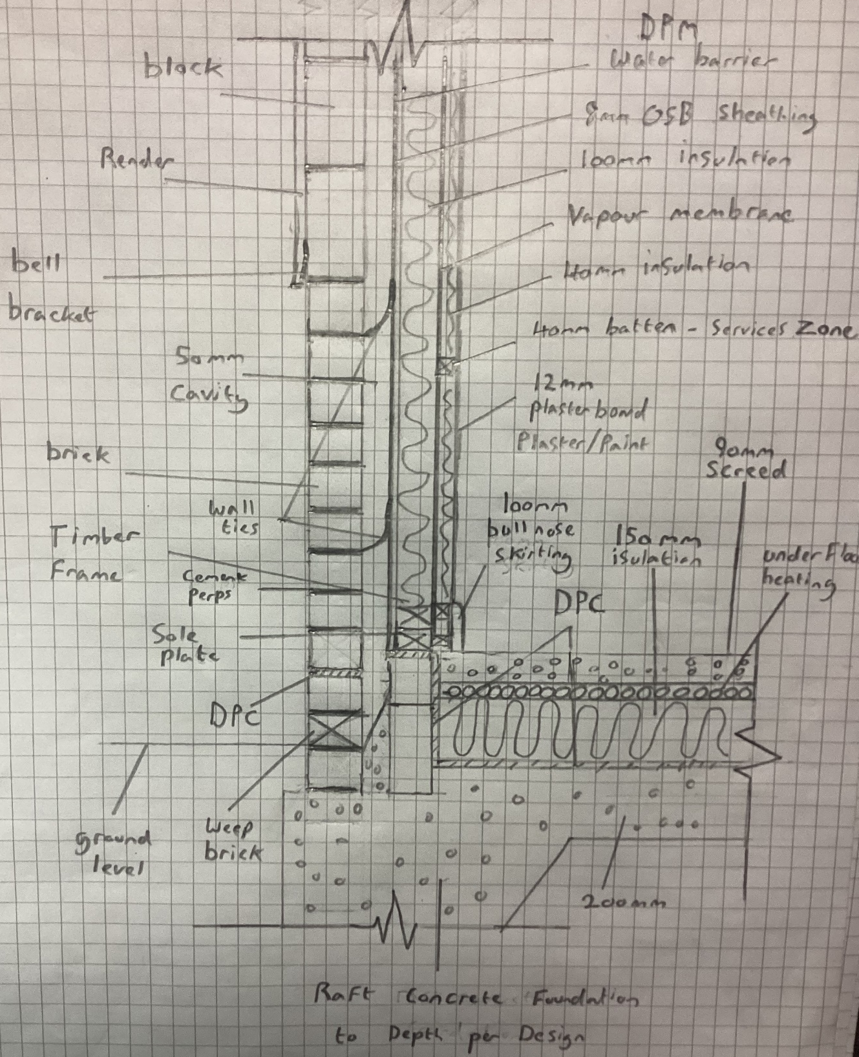
Illustration: Ground floor detail sketch, Lloyd wilson
25/04/2023
The foundation is a raft type that supports the super structure above, it consists of concrete with a mesh of steel laid on top of compacted ground specifications on how this should be done, and concrete types are on (NHBC, 2023) website. Wrapping the internal slab into the cavity space is a DPC this prevents any moisture traveling up through the slab to inside the internal of the building. Depending on the site survey a Radon barrier may also need to be incorporated depending on the site investigation. 150mm of rigid insulation is laid on top of the DPC which helps reflect the heat back into the structure. The underfloor heating is laid spanning the ground floor but spilt into zones that can be controlled for heating the house. A screed layer of 90mm laid on top that is the usable layer to put coverings on top of such as carpets, wooden flooring, or even left and polished finish effect. The internal stud wall is placed above the DPC on the sole plate that is C16 grade 4x2 timber, this forms the base to which the internal stud wall is fixed into. The stud wall is filled with insulation and has an additional service zone that is adding another 40mm of insulation. The insulation not only holds in the heat but deflects heat in warmer seasons keeping the house cooler. The insulation also is reducing external sound entering the building and sound escaping that can be a nuisance to neighbours so must be in line (part E, 2022) regulations. The Internal stud wall spans 140mm in width consisting of:
40 mm service zone: 40 mm batten, plasterboard, vapour check membrane, electric cables, plumbing and filled with 40 mm rigid insulation.
100mm stud frame: C16 4x2 timber frame with 400mm spacing of upright timbers, timber noggins in between uprights to prevent twisting, 100mm rigid insulation and a OSB sheathing lined with DPM in the cavity to prevent water ingress from the cavity.
The external wall is made up from face brick that is stack bonded with cement mortar, it and the block work above is wall tied to the inner skin wall across the cavity. At the base the weep vents allow for any water to escape the cavity to the outside of the building, there is a layer of DPC at 150mm from ground level. At the 1m mark the brick changes to block work, block work is used as it’s a cheaper material. The blocks are faced with a scratch coat and render finish that is painted to the design specifications this repeals the outside elements such as rain or wind entering the building that affects the performance of the building.

Window opening

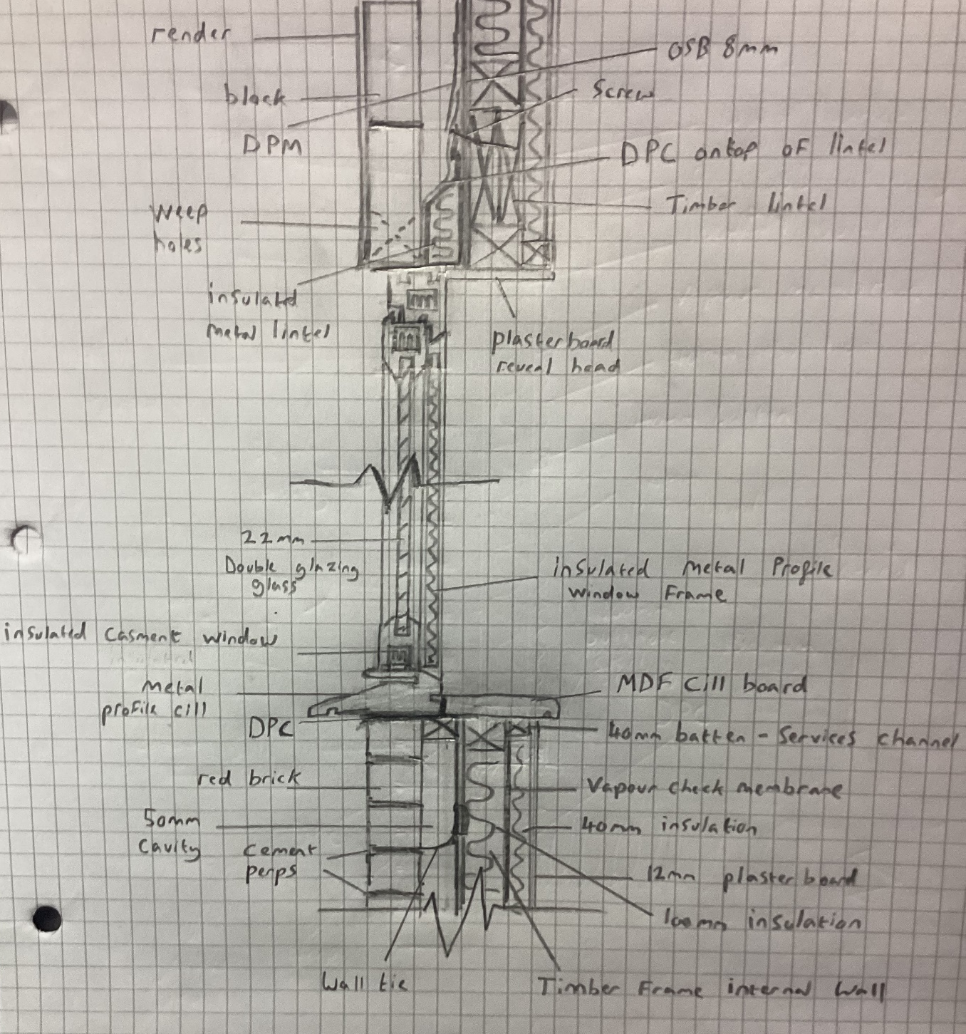
Illustration: Window detail sketch, Lloyd wilson
25/04/2023
The external wall has a finish that is painted with a masonry paint, on top of a cement render above the one-meter mark from ground level. The render will be mixed with SBR to help prevent it from breaking down in cold conditions, which makes the material bond together better. The render is on top of a scratch coat of cement that bonds the render to the block work. The block work has been laid to incorporate openings such as the window frame to be placed inside of it. It’s vital that the core of the aluminium frame is insulated to prevent bridging of cold transfer of outside to in, which could cause damp/condensation issues internally. The aluminon windowsill is used for the frame to sit on top of and spans across the cavity to the timber internal framework. Not only does it provide a mountable surface for the window frame but if any water gets inside it can escape across the sill, through built in weep holes. The hole frame is secured with frame fixing screws and mastic sealed that colour matches the frame. Above the frame I have used an insulated box lintel that spans the opening, taking the weight of the above structure by dispersing the dead load across the length down the sides of the opening through to the block work. Again, this must be insulated to prevent bridging to the inside of the building that can caused condensation or damp to appear on the internal walls in line with (part C, 2017). The lintel grade is chosen by the strength calculated to take weight of the above structure as in line with (Part A, 2017), the block work above sits on top of the lintel and has weep holes in the between mortar to allow for the water to escape. The lintel has a DPC on top of it and is dressed to allow any water that may enter out from the cavity. The Block work is connected to the inner timber frame with wall ties in the mortar that spans the cavity and fixed into the internal stud wall. The number of these is calculated at the design stage, they tie in the inner and outer walls which prevents the walls from bowing or even collapse. The cavity is 50mm wide and has DPM connected to the OSB on the stud internal wall, this protects it from any penetrating water. The stud wall is made up of a membrane, OSB board, a timber frame/stud that is filled with 100mm rigid insulation spanning the framework. Above the window frame on the internal wall there will be a timber made lintel to support the weight above and the steel lintel can be fixed to this with brackets as shown in the illustration. A vapour barrier is used on the inside of the stud wall as seen in the illustration, this prevents the transfer of moister from the inside of the property damaging the stud framework. 40mm Counter battens are then used this will act as a service area so cabling and plumbing can be mounted in these spaces with this space also having another layer of 40mm insulation. To finish it off 12mm plaster board will be mounted on the battens which will have a skim plaster finish that can be painted to the choice of the internal design of the building/rooms. Superstructure details can be found on (NHBC, 2023) I recommend cross referencing the build with these guidance notes to ensure correct building practises are followed.

Eaves detailing and roof covering.

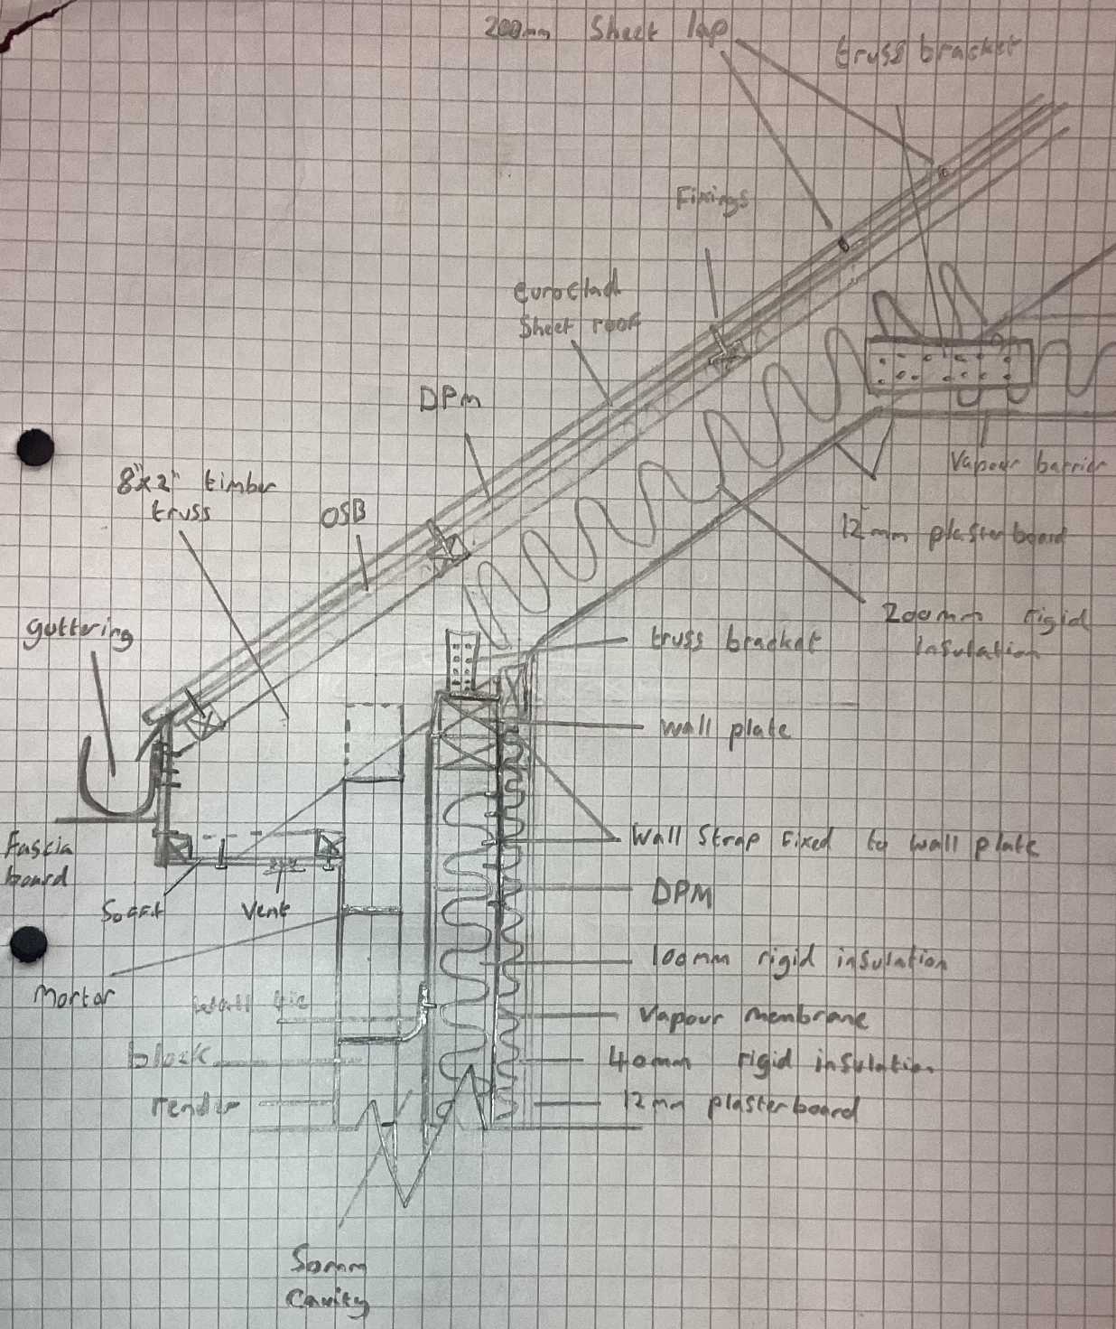
Illustration: Eaves detail sketch, Lloyd wilson
25/04/2023
Euroclad Vieo Metal warm profile roof is a type of roof covering that is quick to install once the roof trusses are prepared, more information can be found on the website (euroclad group, 2023). Using the Vieo roof system it requires different layers to get the correct HEAT/water resistance performance out of the product. The system has a lip that overlaps the adjoining sheet that is clamped and is sealed tight to prevent water ingress. The finish is smooth which allows rainwater runoff easily into the profiled guttering so can be dispersed of down the downpipes into the grey water system. Clip/brackets/screws and waterproof membrane are fixed on top of the OSB board through to the counter battens underneath. Foil type rigid insulation Celtex is used to the depth of the rafters/truss this also deflects heat away and heat back into the property. A vapour membrane is laid across the underneath of the joists with 18mm plaster board on top, this is skimmed and painted to your colour choice.
Eaves have an overhang which the aluminium soffit board spans across, this will have a vent fitted in it across its length to allow the transfer of air into the attic space preventing condensation in the attic. This helps the attic space breathe and water droplets don’t cause condensation in the attic which effects insulation and could cause rot in the timbers. The facia board is a metal profile type which is fixed into the overhanging trusses, the guttering is also secured using a bracket that is laid across the edge of the trusses on top of the OSB board. The truss itself is laid on top of the wall plate and is secured by screws and brackets to the wall plate. The wall plate is laid level along the top of the inner stud wall and has straps that are also securing it down these are placed sporadically per the technical design drawing that fix into the internal wall upright timbers.

Main roof structure

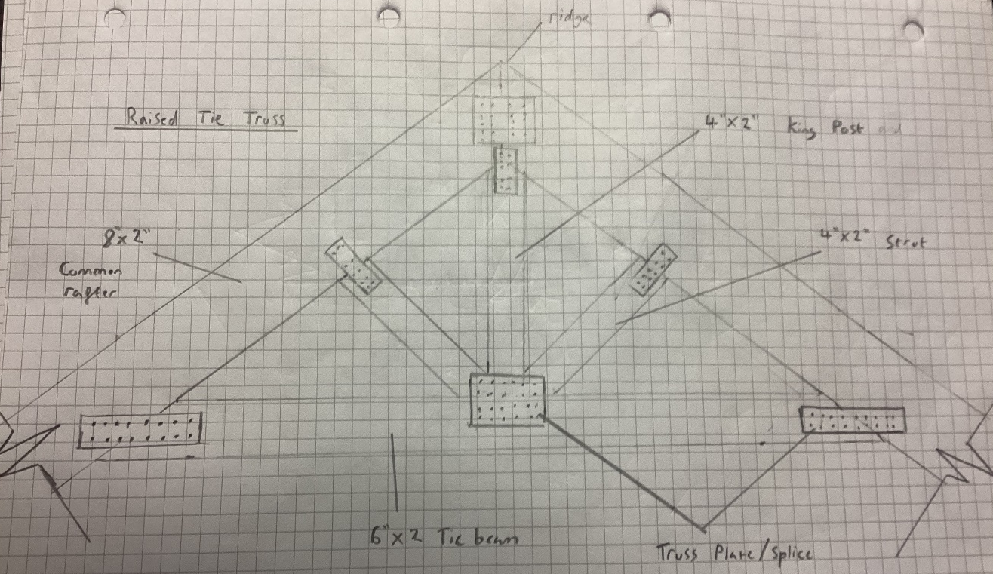
Illustration: Truss detail sketch, Lloyd wilson
25/04/2023

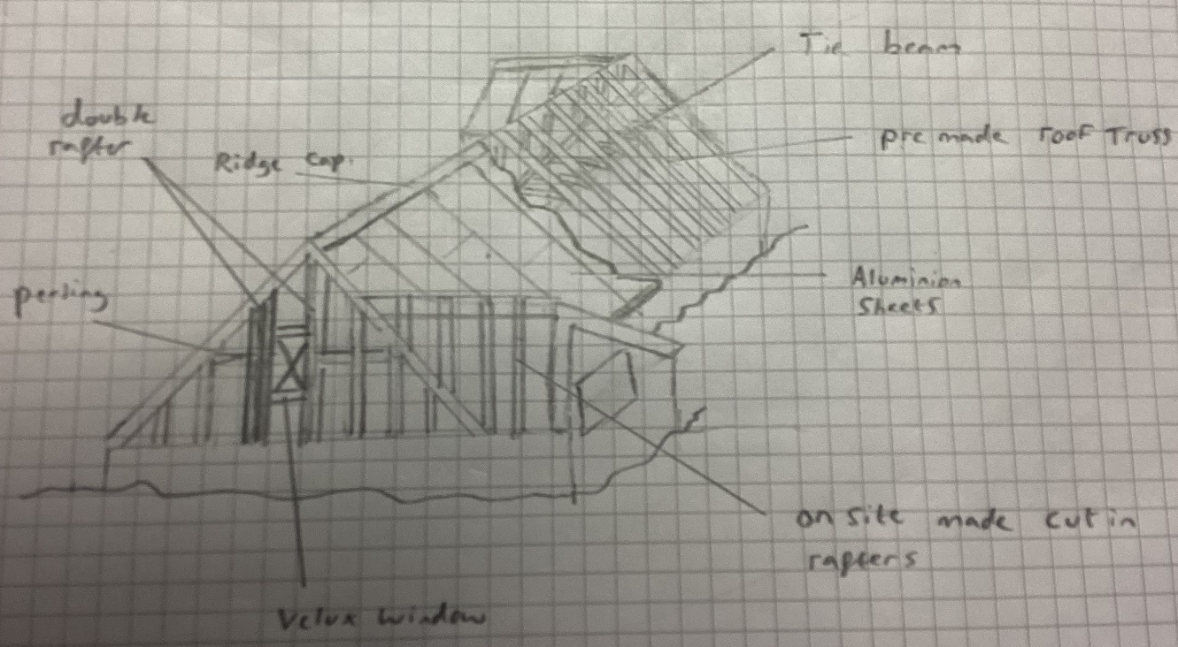
Illustration: Roof structure detail sketch, Lloyd wilson
25/04/2023

The Roof structure will comprise of premade raised tie roof trusses as the main frame with other components built off it. Hip and valley rafters will be added on site by the carpenters once the main trusses are set out along the wall plate as per design specifications in line with (Building regulations guidance: workmanship and materials, 2020) this also covers the type of materials and there grades or kitemarks. The front and rear elevations both have a form of dormer extension connected to the main roof; this is allowing extra ceiling height in these rooms. The other rooms will have a sloped ceiling following the truss angle but will lose a little bit of usable space. Where the velex windows are these trusses will need to be double trusses either side and the sky light space cut out the trusses. Bracing is used across the trusses to tie the roof all together making it rigid, its usually 4x1 unsawn timber that is used. The trusses themselves will be birds mouth cut over the wall plate that is fixed with screws and truss brackets that fix onto the truss and wall plate. There is great guidance notes of technical details of roofs on (NHBC 7, 2023) website and installation should be followed to meet current building regulations. Once the roof is up it will be wrapped in the waterproof membrane ready for the metal profile roof.

Roof space conversion

There is limited space in the current design in the attic but if an attic truss was used it could be done. Looking at the site plans the ridge height is below adjoining properties so should go through with a change in the planning application. This would delay the current build and would have to be passed off by the local council building control department, it is not a fast process and would add costs. If this method was used proper access to the room would be needed to suit building regulations (Part A, 2017) and also more fire preventive measures in place that comply with (part B volume 1, 2021).
I would suggest if the additional room is needed that the space on the first floor is utilised more efficiently though reducing the impact of the living rooms double height ceiling. Where the office/study is there could be a hall way into the new room but would reduce the office space and loose the vaulted ceiling. Additionally the rear elevation would have to mimic the rear dormer which would be symmetrical to the opposite side of the rear elevation.
The second option would be the most cost saving process but would dampen the wow factor in the living room with the additional light from the skylights above.

Offsite solutions

Offsite definition

Offsite construction is a procedure of construction that takes place away from the site and constructed in a workshop type environment. Elements/components are then transported to site to be assembled at a faster rate than normal on-site practises/methods.

Four main Categories offsite construction

- Volumetric construction
Also called Modular construction is a construction technique or method that are frames that are made in a factory setting, that get transported to site for easy assembly. This is great for implementing quality control as methods of this type of construction can have third party accreditation. Pods are commonly used for premade rooms or structures that have all the services and finishes pre-installed at the build stage. In the house project the dormer windows could be premade and transported to site for ease of assembly regarding the roof structure.

- Panelized Construction
These are flat panel units that form roofs, walls or floor panels that are combined together when on site to create a structure. A good example would be a flat pack shed that gets delivered from a warehouse factory via a lorry and then is constructed in sections that form a structure (shed). It is again another fast way of construction and can are built with precision and have services in place prior to delivery. In the house project the aluminium conservatory would be made this way in the form of a kit to assemble on site with the glass inserts being the walls.

- Hybrid construction
Hybrid is a mix of the above two examples, but the units/pods are fully finished that require placement on the site/construction to form rooms. Panelling is also used to complete the main structure so combines both methods to complete the build or project.

- Sub-Assemblies and Accessories systems
Is when components are made off site as per design drawings then installed on site forming the structure. In this example the roof trusses would be sub assembled and the onsite team would use them to form a part of the roof structure.

Conclusion

Summarising the findings caution must be made to decide the proper building methods that are in line with the British building regulations. Correct materials must be used to prevent defects in the final build and keeping the building safe for its predicted life cycle. Environmental impacts are considered for choice of materials and labour with reducing the CO2 emissions impact as much as possible. Offsite construction is becoming more common as sections/modules are built to precision with guarantees of testing performance, so the client would know a more precise evaluation of overall performance.

References
Building regulations guidance: workmanship and materials, 2020. Building regulations guidance: workmanship and materials. [Online]
Available at: https://www.gov.wales/building-regulations-guidance-workmanship-and-materials
[Accessed 26 4 2023].
euroclad group, 2023. euroclad group residential. [Online]
Available at: https://www.eurocladgroup.com/gb/en/sector/residential/
[Accessed 24 04 2023].
NHBC 7, 2023. 7.2 Pitched roofs. [Online]
Available at: https://nhbc-standards.co.uk/7-roofs/7-2-pitched-roofs/
[Accessed 26 4 2023].
NHBC, 2023. 3.1 Concrete and its reinforcement. [Online]
Available at: https://nhbc-standards.co.uk/3-general/3-1-concrete-and-its-reinforcement/
[Accessed 26 4 2023].
NHBC, 2023. Superstructure (excluding roofs). [Online]
Available at: https://nhbc-standards.co.uk/6-superstructure-excluding-roofs/
[Accessed 26 4 2023].
Part A, 2017. Building regulations guidance: part A (structural safety). [Online]
Available at: https://www.gov.wales/building-regulations-guidance-part-structural-safety
[Accessed 24 04 2023].
part B volume 1, 2021. Building regulations guidance: part B (fire safety). [Online]
Available at: https://www.gov.wales/building-regulations-guidance-part-b-fire-safety
[Accessed 24 04 2023].
part C, 2017. Building regulations guidance: part C (resistance to contaminants and moisture). [Online]
Available at: https://www.gov.wales/building-regulations-guidance-part-c-resistance-contaminants-and-moisture
[Accessed 26 4 2023].
part E, 2022. Building regulations guidance: part E (resistance to the passage of sound). [Online]
Available at: https://www.gov.wales/building-regulations-guidance-part-e-resistance-passage-sound
[Accessed 26 4 2023].

