
BACHELOR OF ARTS BUSINESS MANAGEMENT

ENTREPRENEURSHIP
(LCBB5001)

LECTURER
Dr. AMER KAREEM

COMPONENT 1 :
PRESENTATION AND REPORT

STUDENT NAME : OANA LACATUSU - RADOSU
STUDENT ID : 2234422

Table of Contents
Introduction 3
Evaluating business idea and motivating factors 4
Entrepreneurship skills, traits, and behaviour 6
Self-Assessment to become an entrepreneur 8
SWOT Analysis 8
Skills Audit 8
Areas of Improvement 9
Extensive market research 10
PEST Analysis 10
Porter’s Five Forces 10
Conclusion 12
References 13
Appendix 15
Task A: Presentation 15

Introduction
This task evaluates EduTech Montessori's AI-based personalised learning business model. This entrepreneurial goal's motivations, skills, and habits will be examined. It will involve significant market research and a UK educational technology PEST assessment. A statistical investigation will show macro-environmental trends and opportunities. Industrial strategy and competition are examined by Porter's Five Forces. These assessments will give EduTech Montessori a business landscape view and strategic insights to help it grow sustainably in the evolving educational technology market.

Evaluating business idea and motivating factors
EduTech Montessori encourages AI-customized learning. AI-powered educational tools will transform instruction. This technology tailors instruction to student learning styles and competencies to improve engagement and teaching (Zhai et al., 2021). AI will personalise and improve education by modifying curriculum and teaching methods based on student performance and learning habits.

Figure 1: Services and Motivational Factors
Source: (Chan, 2023)
There were several reasons to choose this business idea, including the future. First, technology may alter education. AI can solve education issues including standardised teaching approaches that don't meet needs. AI helps EduTech Montessori educators customise training for a more inclusive and supportive learning environment (Holmes and Tuomi, 2022). School improvement and innovation drive me. Ai-driven EduTech Montessori learning solutions aim to improve education. This commercial venture uses cutting-edge technology to improve education. The strategy reflects worldwide education digital transformation. Technology requires new educational techniques that prepare students for the digital world. EduTech Montessori leads this trend with scalable and flexible AI solutions for educators, students, and schools.
EduTech Montessori founders value educational equity and accessibility. AI-powered personalised learning can close academic gaps for different students. EduTech Montessori prioritises diversity and social effect. AI customises learning at EduTech Montessori. This method improves grades and meets student needs (Chan, 2023). Traditional schools struggle with different learning styles and speeds. To improve engagement and efficacy, EduTech Montessori uses AI algorithms to tailor instructional materials and assess student data. Teaching will alter with AI. Unlike previous methods, AI uses real-time input and data analysis to make improvements. A student who excels in arithmetic but fails in literature can utilise AI to identify literature materials and challenges. This customised strategy improves academic achievement, motivation, and confidence.
AI's potential to democratise high-quality learning boosts its education attractiveness. To help various socioeconomic youngsters compete, EduTech Montessori offers customised help and solutions. Fairness and inclusivity enhance education equity. EduTech Montessori also drives educational technology. New AI apps can change learning for students and teachers (Holmes, Bialik and Fadel, 2019). AI helps EduTech Montessori revolutionise education and stand out in a competitive business. EduTech Montessori adapts their business model to worldwide digital learning and technology. Online and hybrid learning has increased due to the COVID-19 pandemic, stressing the necessity for digital education infrastructure. Scalable and flexible AI technologies are ideal for educational transformation.

Entrepreneurship skills, traits, and behaviour
In educational technology, EduTech Montessori entrepreneurs need several skills. Educational technology innovation, growth, and success demand specific talents, attitudes, and behaviours.
1. Visionary thinking: EduTech Montessori must be visionary to recognise educational technology prospects. This experience helps entrepreneurs set long-term goals and see how AI and tailored learning might change education (Berendt, Littlejohn and Blakemore, 2020). EduTech Montessori's visionary entrepreneurs may innovate learning methods by predicting technology's impact on education.
2. Adaptability: Educational technology responds to new technology, market developments, and educational laws. Entrepreneurs at EduTech Montessori must adapt strategy, goods, and operations to shifting conditions (Arora, 2021). The company maintains competitiveness in a fast-changing environment because of this skill.
3. Innovation: EduTech Montessori's ventures focus on AI-powered personalised learning. To fulfil educators' and students' evolving demands, entrepreneurs can promote innovation and provide new features and functions to products and services (Gillani et al., 2023). EduTech Montessori is a thought leader in educational technology, pioneering new standards and practices that change education.
4. Leadership: Leadership motivates EduTech Montessori teams to work together. Start-up leaders define objectives, assign tasks, and encourage innovation and success. EduTech Montessori executives cultivate talent, attract top talent, and form cohesive teams to meet organisational goals by fostering trust and responsibility (Perrotta and Selwyn, 2019). Strategic alignment and good decision-making are essential for momentum and sustainability in the competitive educational technology market.
5. Resilience: EduTech Montessori businesses must be resilient to overcome obstacles. Persistence, adaptability, and strength help entrepreneurs overcome technology disruptions, market volatility, and regulatory changes (Vincent and Vlies, 2020). This trait boosts organisational tenacity, stakeholder trust, and educational technology effectiveness.
Entrepreneurship Skills, Traits, and Behaviours | Importance for EduTech Montessori
Visionary Thinking | - Anticipates future trends in educational technology, and aligns strategic goals with long-term objectives.
Adaptability | - Responds effectively to technological advancements and market shifts, and maintains competitiveness (Selwyn, 2022).
Innovation | - Drives the development of AI solutions and fosters continuous improvement and differentiation.
Leadership | - Guides growth, inspires teams and fosters collaboration towards organizational goals.
Resilience | - Overcomes challenges, maintains perseverance, and sustains momentum in a dynamic market.

Educational technology success requires entrepreneurial skills, attitudes, and behaviours from EduTech Montessori. Visionary thinking helps entrepreneurs spot and capitalise on trends, linking strategy to future possibilities. Adaptability allows quick market reactions and adaptability to technological and pedagogical changes. Ongoing innovation and differentiation allow EduTech Montessori to build cutting-edge AI solutions for teachers and kids (Zhai et al., 2021). Leadership promotes teamwork to attain goals and sustain progress. EduTech Montessori overcomes obstacles to revolutionise education with AI-driven individualised learning and resilience. EduTech Montessori entrepreneurs may overcome obstacles, seize opportunities, and invent educational technology employing these entrepreneurial skills, attitudes, and behaviours. The company leads AI-powered personalised learning.

Self-Assessment to become an entrepreneur

SWOT Analysis
Strengths | Weaknesses
- Strong background in educational technology | - Limited experience in marketing and sales
- Innovative AI-driven learning solutions | - Lack of scalability in current infrastructure
- Established partnerships with educational institutions | - Dependency on third-party AI technology providers
Opportunities | Threats
- Growing demand for personalized learning solutions | - Intense competition from established EdTech companies
- Expansion into international markets | - Regulatory Changes Affecting Educational Technology
- Collaborations with AI research institutions | - Potential cybersecurity threats

Skills Audit
My Skills | Example
Leadership | - Led a student project team to develop an educational app
Innovation | - Developed a new AI-based learning module at the university
Strategic planning | - Managed budget and resources for a charity event
Team collaboration | - Coordinated cross-functional teams in a start-up (Vincent and Vlies, 2020).
Problem-solving | - Resolved technical issues during the internship
Communication | - Presented research findings at a conference
Adaptability | - Successfully adapted to new software tools at work

Areas of Improvement
Areas of Improvement | How?
Marketing | - Admit to online courses on digital marketing
Sales | - Attend sales workshops and role-play scenarios
Financial management | - Take a course in finance or work closely with a mentor
Negotiation | - Practice negotiation skills in mock scenarios
Data analysis | - Complete online courses in data analytics (Selwyn, 2022).
Public speaking | - Join a public speaking club or Toastmasters
Time management | - Implement time-blocking techniques in daily routine
Conflict resolution | - Participate in conflict resolution training workshops
Project management | - Gain certification in project management

Extensive market research

PEST Analysis
PEST studies business-related political, economic, social, and technical variables. This study highlights macro-environmental factors affecting strategy and operations.
Political Factors: Political stability strongly impacts UK education regulation. Government education funding and tech integration matter. The UK education budget rose 1.2% in real terms from 2020 to 2021, indicating a commitment to resource and facility improvements (ONS, 2023).
Economic Factors: GDP and inflation strongly influence educational technology spending. UK GDP grew by 6.5% in 2021 after the pandemic (GOV.UK, 2024). Economic stability boosts digital infrastructure and education tech spending.
Social Factors: Cultural views regarding education technologies and demographic changes affect market demand. In 2021, 71% of UK students used online learning platforms weekly (Holmes and Tuomi, 2022). It appears schools are using digital solutions increasingly.
Technological Factors: AI and machine intelligence drive educational technology innovation. UK's Digital Strategy improves education with ICT. AI-powered educational tools are used in 87% of UK schools (Perrotta and Selwyn, 2019).

Porter’s Five Forces
Threat of New Entrants: The UK educational technology sector faces modest newcomer competition. Digital enterprises have low entry hurdles, encouraging competition despite the need for technology competence, AI, and educational platform investment. 78% of UK schools actively seek innovative digital solutions, a significant requirement that may attract newcomers (Gillani et al., 2023).
Bargaining Power of Suppliers: AI and educational content vendors have great bargaining power due to their expertise and limited resources. Three AI software companies control 65% of education (Chan, 2023). Due to concentration, supplier costs and service agreements affect EduTech Montessori's cost structure and operational flexibility.
Bargaining Power of Buyers: Educational Technology Educational institutions have moderate to strong buyer negotiating power. Digital learning options and affordable solutions let buyers negotiate pricing and customise instruction. In 2021, 62% of UK schools compared digital learning suppliers on cost and performance (Arora, 2021).
Threat of Substitute Products or Services: Substitute goods and services endanger educational technologies. Digital platforms rival offline learning materials. 89% of UK schools utilise AI-powered personalised learning systems to reduce substitution risk through interactive and adaptive learning (Zhai et al., 2021).
Industry Competition: UK educational technology companies fight hard. Many start-ups and established companies battle for market share and innovation. As digital education spending climbs 8.4% annually, competitive advantage and success in a dynamic business require innovation, product uniqueness, and strategic collaborations (ONS, 2023).

Conclusion
EduTech Montessori will use AI to personalise learning. Entrepreneurship involves creativity, leadership, and adaptability. These traits and extensive market research will help EduTech Montessori navigate the educational sector. EduTech Montessori meets and exceeds children, educators, and educational technology stakeholders' increasing requirements with these insights. Continuous improvement and market response can help EduTech Montessori grab opportunities and overcome challenges in a competitive market. AI and innovation can help EduTech Montessori offer personalised, flexible learning. EduTech Montessori wants to grow economically and transform education by personalising it to develop kids' abilities and goals.

References
Arora, V. (2021). Artificial Intelligence in Schools. Routledge.
Berendt, B., Littlejohn, A. and Blakemore, M. (2020). AI in education: learner choice and fundamental rights. Learning, Media and Technology, 45(3), pp.312–324. Available at : https://doi.org/10.1080/17439884.2020.1786399. (Accessed 2nd July 2024).
Chan, C. (2023). A comprehensive AI policy education framework for university teaching and learning. International Journal of Educational Technology in Higher Education, 20(1). Available at : https://doi.org/10.1186/s41239-023-00408-3. (Accessed 4th July 2024).
Gillani, N., Eynon, R., Chiabaut, C. and Finkel, K. (2023). Unpacking the ‘Black Box’ of AI in Education. Educational Technology & Society, [online] 26(1), pp.99–111. Available at : https://www.jstor.org/stable/48707970. (Accessed 5th July 2024).
GOV.UK (2024). New research paves way for Artificial Intelligence in education. [online] GOV.UK. Available at: https://www.gov.uk/government/news/new-research-paves-way-for-artificial-intelligence-in-education . (Accessed 28 June 2024).
Holmes, W., Bialik, M. and Fadel, C. (2019). Artificial intelligence in education : promises and implications for teaching and learning. Boston, Ma: The Center For Curriculum Redesign.
Holmes, W. and Tuomi, I. (2022). State of the art and practice in AI in education. European Journal of Education, 57(4), pp.542–570. Available at : https://doi.org/10.1111/ejed.12533. (Accessed 29th June 2024).
ONS (2023). Public awareness, opinions and expectations about artificial intelligence - Office for National Statistics. www.ons.gov.uk. Available at: https://www.ons.gov.uk/businessindustryandtrade/itandinternetindustry/articles/publicawarenessopinionsandexpectationsaboutartificialintelligence/julytooctober2023 (Accessed 6th July 2024).
Perrotta, C. and Selwyn, N. (2019). Deep learning goes to school: Toward a relational understanding of AI in education. Learning, Media and Technology, 45(3), pp.1–19. Available at : https://doi.org/10.1080/17439884.2020.1686017. (Accessed 7th July 2024).
Selwyn, N. (2022). The future of AI and education: Some cautionary notes. European Journal of Education, 57(4). Available at : https://doi.org/10.1111/ejed.12532. (Accessed 8th July 2024).
Vincent, S. and Vlies, R. van der (2020). Trustworthy artificial intelligence (AI) in education: Promises and challenges. OECD iLibrary. Available at: https://www.oecd-ilibrary.org/content/paper/a6c90fa9-en . (Accessed 9th July 2024).
Zhai, X., Chu, X., Chai, C.S., Jong, M.S.Y., Istenic, A., Spector, M., Liu, J.-B., Yuan, J. and Li, Y. (2021). A Review of Artificial Intelligence (AI) in Education from 2010 to 2020. Complexity, 2021(8812542), pp.1–18. Available at : https://doi.org/10.1155/2021/8812542 . (Accessed 9th July 2024).


Appendix

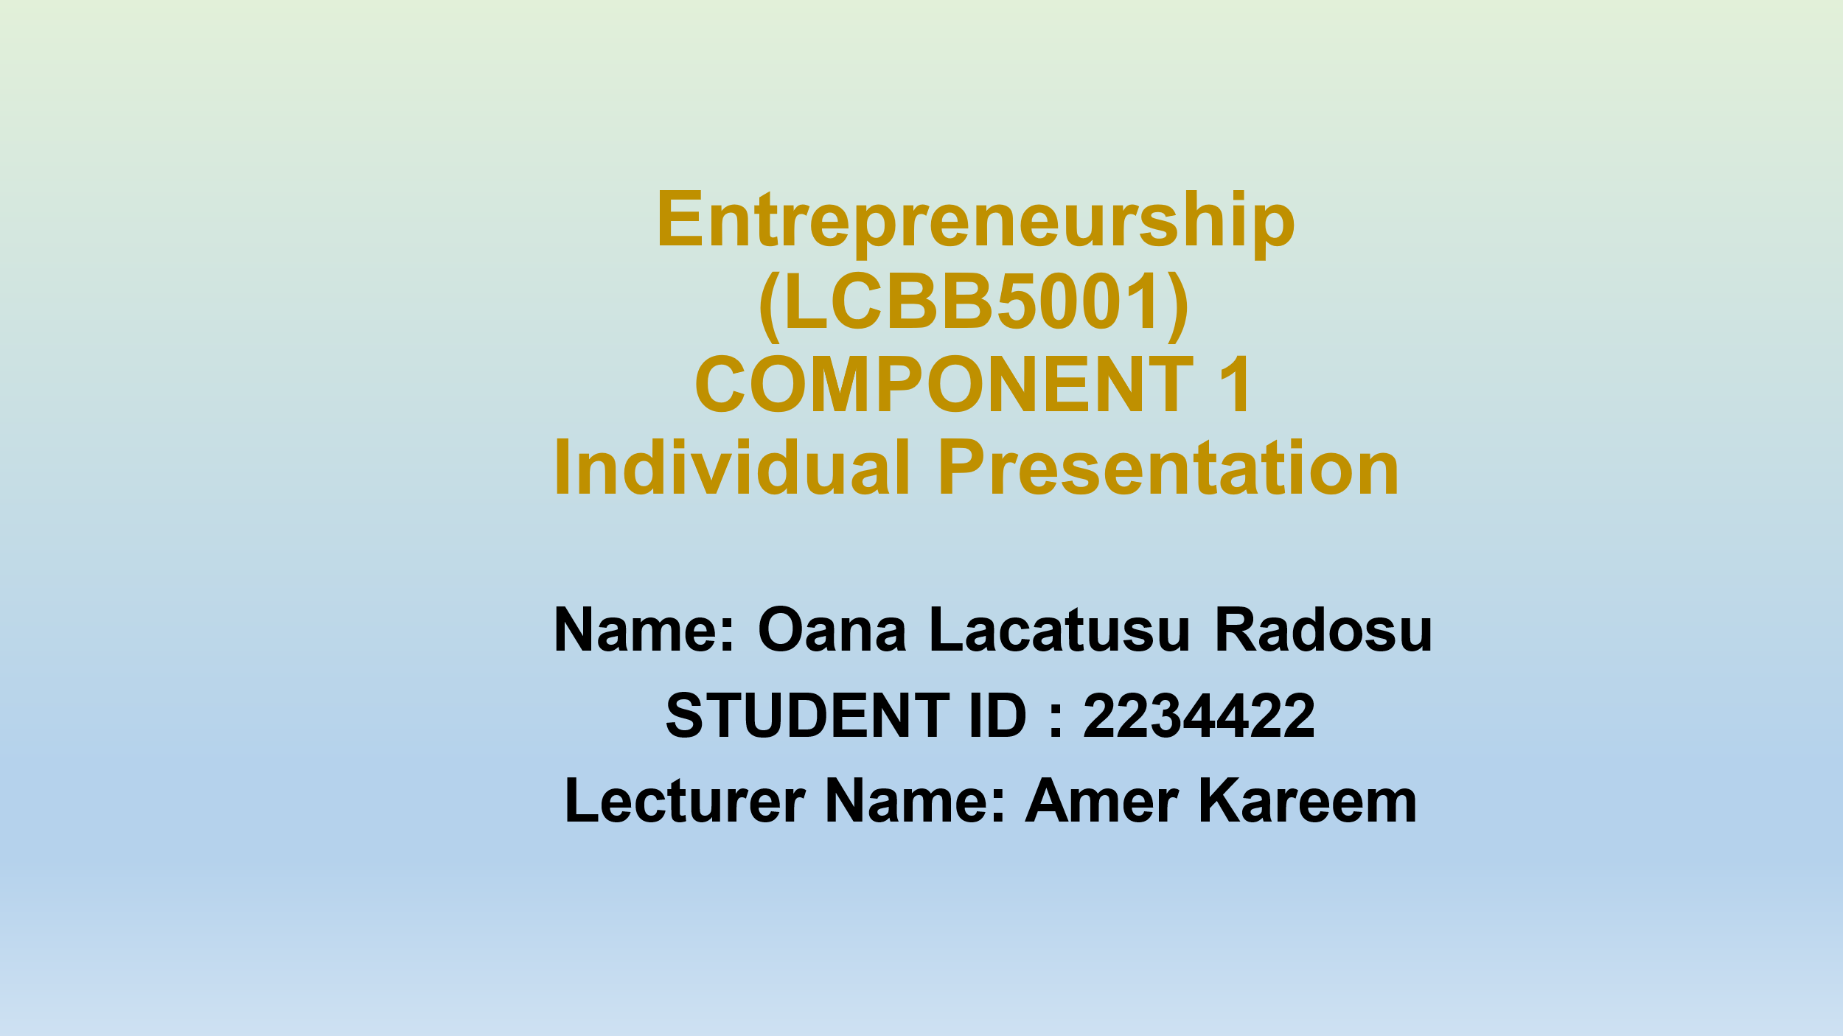
Task A: Presentation



