ECONOMICS OF SUSTAIBABILITY – BMSP6007

ASSIGNMENT ONE – REPORT.
HANNAH THOMAS
1703882

Contents Page:
- Executive summary
- Introduction
- The impact of smoking on the human body and environment
- Smoking as a market failure
- Analysis of the solution to the market failure
- Conclusion

Executive Summary:
For the purpose of this report, a research into the market failure of the consumption of smoking and passive smoking within the UK will be conducted and how it causes an impact to the environment and the population. Exploration into how the market was failing prior to a solution that was found in order to combat the externality. Real evidence will be used within the report to demonstrate the effect of passive smoking on the UK, gaining an understanding of the costs that weren’t factored into the externalities of the failing market.

Introduction:
Over past decades, environmental pollution has become more apparent to businesses, becoming more visible and one of the main purposes of decision making etc. The world has become more aware of their environment and the impacts that various industries are having on climate change and the ecological damages. Due to people becoming more aware and sensitive to the matters of the impacts on the environment, people have begun changing their consumption patterns and taking responsibility for the changes in the environment. (Callan & Thomas, 2021).
A variety of economic productions can cause environmental change, which can cause impact globally in countries, whether they have high or low-income and whether the economies are market or command-oriented. Environmental change impacts not only climate change, but also impacts the people. (KhanAcademy, 2021). During this report, research into passive smoking as an externality will be conducted within the United Kingdom. An externality is considered as a form of “spill over” that occurs when an exchange takes place between buyer and seller that impacts a third party who isn’t part of the exchange e.g. individuals, organisations, property owner. A negative externality is referred to as an “external cost”. There are negative and positive externalities to consider. Some externalities arise from consumption e.g. house hold waste and others arise from production e.g. carbon emissions causing pollution. (EconomicsOnline, 2021).
Market failure is known as a situation where a specific market causes a reduction in societal welfare. Being able to address market failure is key rationale for government intervention, this is through urging industries to reduce their levels of pollution to reduce the impact on society and the environment. “If there is no mechanism to force the manufacturer to pay, then there is little incentive for them to limit or change their polluting activities” (Finch, Briggs, & Tallack, 2020).
Cigarettes are considered to be a demerit good, which is a good that is over provided by the market with the consumption of this good being harmful to our society. They are considered to be a harm to society as they produce a negative externality through consumption, creating a spill over impact on third parties with no compensation being paid by anyone.
People who chose to smoke, consume the nicotine and tobacco willingly as its their choice. However, the impacts of passive smoking can be unavoidable. Passive smoking occurs through inhaling the cigarette smoke of others, when the individual isn’t actually consuming the cigarette themselves. The consumption of cigarettes by the consumer is a greater benefit to them as an individual than the benefits for society. (Machacea, 2014).
In 2019, statistics show that 14.1% of people aged 18 years and over smoke within the UK, which equates to 6.9 million of the country’s population. (ONS, 2019). This is a high amount of the population smoking, therefore we must consider how much of the population is being impacted by passive smoking? Statistics show, that 106,000 people within the UK are killed by smoking every year which equates to 1 in 5 deaths. This is due to people becoming addicted to the nicotine and tobacco within the cigarettes. The tobacco smoke, contains more than 4,000 chemicals which causes impact on the human body, causing the average smoker to lose 10 years of their life due to the habit. (Spacetobreathe, 2021).

The impacts of smoking on the human body and the environment.
The impacts of smoking increases an individuals risk of having a serious illness, where the main deaths caused by smoking are due to Lung Cancer, COPD and Cardiovascular disease. This is caused by consuming the thousands of chemicals that are within the cigarettes. Smoking, is by far the most avoidable risk for developing many cancers. People within the UK are aware of the impacts that the act has on their bodies and environment, however continue to smoke. Smoking not only increases the risk of cancer, it also impacts other areas such as appearances, fertility, breathing etc. (BUPA, 2021).
The impacts of passive smoking are just as great as the impacts of direct consumption of cigarettes. The impacts of second hand smoking can also cause individuals health implications that include cancer, heart disease including other conditions. We must consider that there is no safe level of passive smoking, and it is dangerous for children and those who are pregnant as it can impact the unborn child. There are two different types of passive smoking:
- Mainstream smoke – smoke that is exhaled by an individual who smokes
- Side-stream smoke – smoke that comes from the lit end of the product
There are short and long term impacts whilst considering passive smoking. The externality of the health benefits on individuals, whether it be due to consuming the product directly or passively isn’t factored into the market place. (CancerResearch, 2021).
Whilst there are multiple risks to smoking, there is also an impact caused on the environment. We know that cigarettes contain tobacco and nicotine and a report from 2018 demonstrated that the six trillion cigarettes produced yearly impact the environment through toxicity, water and land use including impacting our climate change. The curing of tobacco leaves to produce dry tobacco for the cigarettes uses a high amount of energy (such as coal or wood burning) which contributes to greenhouse gas emissions and deforestation which has a knock on effect to wildlife. Along with this, the production of tobacco also uses more than 22 billion tonnes of water. (Dunning & Wilson, 2018). When consumers decide to smoke, they are only considering the benefit that they are getting from the product. They do not consider that impacts that they are having to those around them including our environment.
Smoking as a Market Failure.
The consumption of cigarettes is considered to be an externality by causing an increase of health problems within the health care system which include second hand smoking (also known as passive smoking), respiratory illnesses and a reduce in worker productivity. When a smoker decides to consume a cigarette, they are not considering the societal impact that they are having on themselves and others, including the environment itself, thus leading to a loss in social welfare.
When an externality exists and the need to bargain between individuals must take place to reach a solution on their own can be difficult, due to high transaction costs. This is due to producers not having an incentive to implement solutions within their productions to reduce the externality of the harm on societal welfare within their cost. Therefore, in order to reduce the impacts of smoking consumption, government intervention would be more beneficial through facilitating the internalization of the externalities through implementing a tax. This is achieved through increasing the cost of cigarettes and reducing the consumption due to the increased cost. (Guhl & Hughes, 2021).
The action of smoking has become less popular over the years in the developed world, as people have more social awareness of the problems that are caused by smoking, where governments are attempting to reduce tobacco consumption to minimise social costs. One of the world biggest tobacco producers (BAT – British American Tobacco) have implemented CSR strategies in attempts to reduce the negative effects of tobacco, along with governments and supranational organisations such as the World Health Organisation working to hamper tobacco use by putting bans in place. Smoking is considered as a demerit good, which results in a negative impact on society. Governments attempt to reduce the consumption of a demerit good through using legal restrictions, as individuals aren’t fully aware of the harm that they are causing to themselves, others and the environment. It impacts the consumer including third parties which is the society. (Para, 2014). The social cost of consuming this demerit good is not factored into the cost, as it results in increased health care expenses for the consumer, including those who are non-smokers due to passive smoking.
Smoking costs the UK Government £12.6 billion a year, where £1.4 billion is used on social care for smoking related care needs, £2.5 billion is used within the NHS and £8.6 billion is due to lose productivity within businesses. The price of smoking cigarette’s has also increased for the consumer, with the average smoker consuming 10 cigarettes a day and the average pack costing £10.80, resulting in smokers spending roughly £37.80 per week. (OneSmallStep, 2021). The cost of smoking also adds £760 million to local authorities in the UK due to the demand of the NHS and social care needs. Nevertheless, these externalities are not factored into the costs of the market. ASH (ASH, 2018) argue that, tobacco producers in the UK should be forced to pay in order to address the harm that it causes, in line with “polluter pays” principle as it is estimated that tobacco companies in the UK generate a collective annual profit of roughly £1 billion.
Figure 1 below, demonstrates the negative externality of consumption with cigarettes. It explains that within a free market, we achieve Q1 output, however at this level the social marginal cost is greater than the social marginal benefit, as no solution has been implemented to overcome the market failure. The red triangle shows the welfare loss within society. Therefore, when a solution has been implemented such as government intervention, the social efficiency occurs a lower output of Q2. This is where society pays more for the demerit good due to the taxation etc, however also gain benefit of reducing the externality consumption. (Pettinger, 2017).
Figure 1.
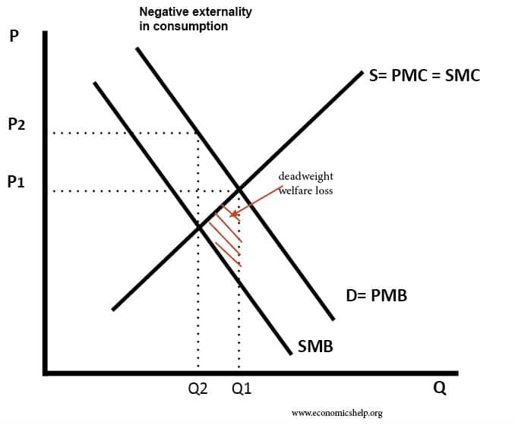

Solution to the market failure
In order to reduce the levels of consumption of cigarettes in the UK, there has been a number of solutions to reduce the externality. Both taxes and direct regulations/laws have been implemented within the UK to reduce the behaviour that gives rise to the negative externality.
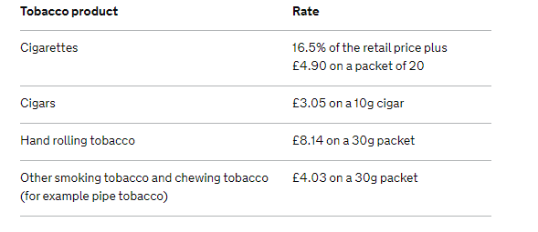
Consumers within the UK pay a standard rate VAT of 20% on alcohol and tobacco products, which is known as the tobacco duty. The rate differs on different tobacco products, figure 2 below demonstrates the various prices. (GOV, 2021).
Figure 2.
Implementing an indirect tax on cigarettes is one of the most common uses to reduce smoking rates across the UK, increasing the tobacco price is widely recognised within the country. By increasing the price, evidence has proven that it has effectively reduced the use of cigarettes. (Whitehead & Etal, 2018). Whitehead Et al, also explains on the other hand there is also evidence indicating that the full public health benefit of tobacco taxation is not always achieved, due to the approach being open to industry circumvention. The cheaper tobacco product price, has not altered over the last 15 years, whereas the tax has only been implemented on the premium products, due to tax increases not being passed onto the lower end products. This therefore resulted in acting to maintain or widen the health inequalities as the consumer would opt for the cheaper option.
“A meta-analysis of tobacco price elasticity suggests that a price rise of 10% would lead to around 4% reduction in smoking in high-income countries” (Whitehead & Etal, 2018).
Price increase on tobacco has the potential to reduce health implications, also having a greater impact on the quitting rates for consumers, it also represents an approach that is popular with the younger generation due to the price sensitivity. WHO state that implementing higher tax rates provide countries with the funding to enforce tobacco control policies and pay for other public health and social problems. (WHO, WHO Report on the Global Tobacco Epidemic, 2008: The MPOWER Package, 2008). In 1999, tobacco taxation brought the UK over £9 thousand million annually in duty and VAT.
There has also been other Government intervention with smoking, which is known as direct regulations suggesting laws and bans have been put in place. England 2007, a smoke-free legislation was introduced, where smoking was banned within nearly all workplaces and public spaces, with similar bans introduced in Wales and Scotland. It is the responsibility of the local authorities to ensure that the legislation is implemented. (HSE, 2021). In 2008, the UK became the first EU nation to introduce picture warnings on all tobacco packaging and a report by WHO in 2008 urged that without urgent action, the global death toll from tobacco will exceed 8 million per year by 2030.
Everyone has the fundamental right to breath clean air, therefore by implementing smoke-free places is essential in protecting non-smokers and encouraging smokers to quit. Any country, regardless of income, has the ability to implement smoke-free laws effectively, however only 5% of the global population is protected by smoke-free legislation. (WHO, WHO Report on the Global Tobacco Epidemic, 2008: The MPOWER Package, 2008).

Figure 3 below, demonstrates the gradual decrease of smokers within the UK, caused by tobacco taxation, causing the consumer having to pay more for their tobacco products. However, another report from WHO has stated, even though the number of people smoking has been decreasing over the years, individuals who use the cheaper tobacco products and hand-rolled cigarettes is increasing slightly. (WHO, Report on Tobacco Taxation in the UK , 2002).

Figure 3.
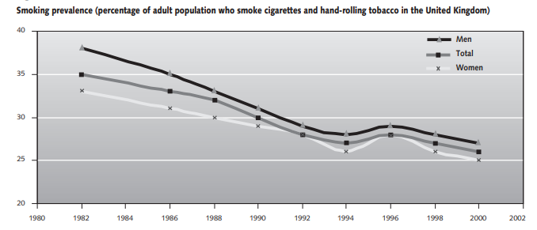

Whilst considering the solutions that have been implemented to reduce tobacco consumption within the UK, the externality of increased health care costs and environmental was never factored into the production cost of tobacco products.
The use of tobacco taxation, direct regulations/laws being implemented and the use of tobacco packaging warnings has decreased the use of tobacco products within the UK gradually over time. Smoking isn’t as convenient as it used to be, when being able to smoke inside a public place e.g. pubs and restaurants. It is more of an inconvenience now that the smoker has to remove themselves and go outside to be able to consume a cigarette.
A tax should be implemented on a good that equals the external marginal cost, meaning that the consumer will end up paying the full social marginal cost. The tax enables harmful effects of the externality to be internalised. Figure 4 below shows, through implementing the tobacco tax and direct laws, the output of the good falls from Q1 to Q2, this is where it becomes socially efficient as the level of Q2 is where the social marginal benefit equals the social marginal cost. (Economicshelp, 2021).

Figure 4.
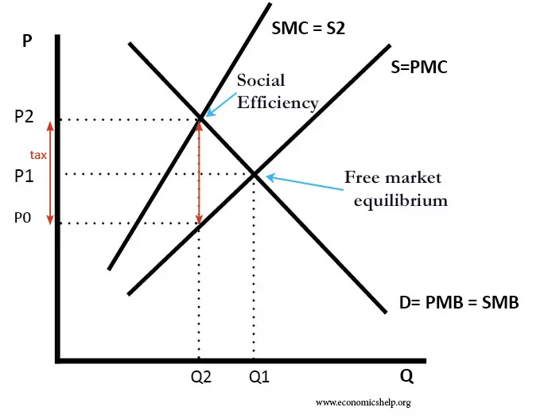

Statistics show, that smoking in the UK has decreased, as in 1975 46% of the population smoked, whereas in 2018, it showed that only 14.7% would consume a tobacco product. Through implementing the direct laws and regulations of the smoking ban, it has helped reduce the number of deaths related to second hand smoking across the UK by 50%. The UK Government issued a statement in 2019, stating that as a nation we have the lowest smoking rate in the EU and they have plans in place in making tobacco obsolete in England by 2030. This is hoped to be achieved through implementing strategies such as “Polluter pay Schemes”, monitoring health impacts of E-Cigarettes and maintaining the high duty rates on tobacco products to make smoking less affordable to the public. (Bhandari, 2019). Smokers who decide to stop their smoking actions are able to approach their GP to provide medication to aid them stopping. Statistics have shown that:
- There has been a 75% decline in stop smoking treatments in England that is prescribed by the GP.
- The number of treatments have fallen by two thirds within Wales.
- Scotland has seen a 40% decline in the number of treatment prescribed within just two years.
Seeing this decline in treatments, emphasises the decline in the number of people who are smoking across the UK. (BHF, 2021).
Conclusion:
To conclude this report, the market failure of smoking consumption within the UK has been present for decades and continues to be a negative externality. The cost of smoking has increased drastically over time, making it less affordable for the consumer, along with the smoking ban, smoking has become more of an inconvenience as consumers must find an appropriate place to use tobacco products. Smoking is seen as a nasty habit by many people, however it is also an addiction that has never been factored into the market failure. By implementing solutions to the negative externality, the number of smokers within the UK has been gradually decreasing, suggesting that the publics health has been improving from the impacts of tobacco products. There are several health charities within the UK that aid smokers to quit and to help them with any smoking related diseases. Statements by the UK Government hope to see the statistics on smoking even lower by the year 2030. Therefore the UK awaits to see further Government intervention on this market failure.

References
ASH. (2018). Retrieved from https://ash.org.uk/media-and-news/press-releases-media-and-news/true-cost-of-smoking-revealed-in-advance-of-world-no-tobacco-day/.
Bhandari, A. (2019). Retrieved from https://patient.info/news-and-features/can-the-uk-really-be-smoke-free-by-2030.
BUPA. (2021). Retrieved from https://www.bupa.co.uk/health-information/lungs-breathing/effects-of-smoking.
Callan, S., & Thomas, J. (2021). Environmental Economics and Management. .
CancerResearch. (2021). Retrieved from https://www.cancerresearchuk.org/about-cancer/causes-of-cancer/smoking-and-cancer/what-is-passive-smoking.
Dunning, H., & Wilson, J. (2018). Retrieved from https://www.imperial.ac.uk/news/188406/cigarettes-have-significant-impact-environment-just/.
Economicshelp. (2021). Retrieved from https://www.economicshelp.org/micro-economic-essays/marketfailure/tax-negative-externality/.
EconomicsOnline. (2021). Retrieved from https://www.economicsonline.co.uk/Market_failures/Externalities.html.
Finch, D., Briggs, A., & Tallack, C. (2020). Retrieved from https://www.health.org.uk/publications/long-reads/improving-health-by-tackling-market-failure.
GOV. (2021). Retrieved from https://www.gov.uk/tax-on-shopping/alcohol-tobacco.
Guhl, N., & Hughes, D. W. (2021). Retrieved from https://www.westga.edu/~bquest/2006/cigarette06.pdf.
HSE. (2021). Retrieved from https://www.hse.gov.uk/contact/faqs/smoking.htm#:~:text=Smoke%2Dfree%20legislation%20was%20introduced,responsible%20for%20enforcing%20the%20legislation.
KhanAcademy. (2021). Retrieved from https://www.khanacademy.org/economics-finance-domain/microeconomics/market-failure-and-the-role-of-government/environmental-regulation/a/the-economics-of-pollution-cnx.
Machacea. (2014). Retrieved from https://blogs.oregonstate.edu/econ439/2014/02/07/advertising-externalities-cigarettes/.
OneSmallStep. (2021). Retrieved from https://onesmallstep.org.uk/the-cost-of-smoking/#:~:text=The%20cost%20of%20smoking%20to,of%20lost%20productivity%20in%20businesses*.
ONS. (2019). Retrieved from https://www.ons.gov.uk/peoplepopulationandcommunity/healthandsocialcare/healthandlifeexpectancies/bulletins/adultsmokinghabitsingreatbritain/2019#:~:text=In%20the%20UK%2C%20in%202019,2018%20to%2014.1%25%20in%202019.
Para, A. (2014). Retrieved from https://www.researchgate.net/publication/272020790_Negative_externalities_in_demerit_goods_as_a_cause_of_market_failure_-_case_study_of_British_American_Tobacco.
Pettinger, T. (2017). Retrieved from https://www.economicshelp.org/blog/805/economics/diagram-for-negative-externality/.
Spacetobreathe. (2021). Retrieved from https://www.spacetobreathe.org.uk/content/smoking-facts.
Whitehead, R., & Etal. (2018). Strengths and limitations of tobacco taxation and pricing strategies.
WHO. (2002). Report on Tobacco Taxation in the UK .
WHO. (2008). WHO Report on the Global Tobacco Epidemic, 2008: The MPOWER Package.

