

Assessment 1 – Reading Task Template
PART 1: Upload your photo of your A3 in-class notes here:
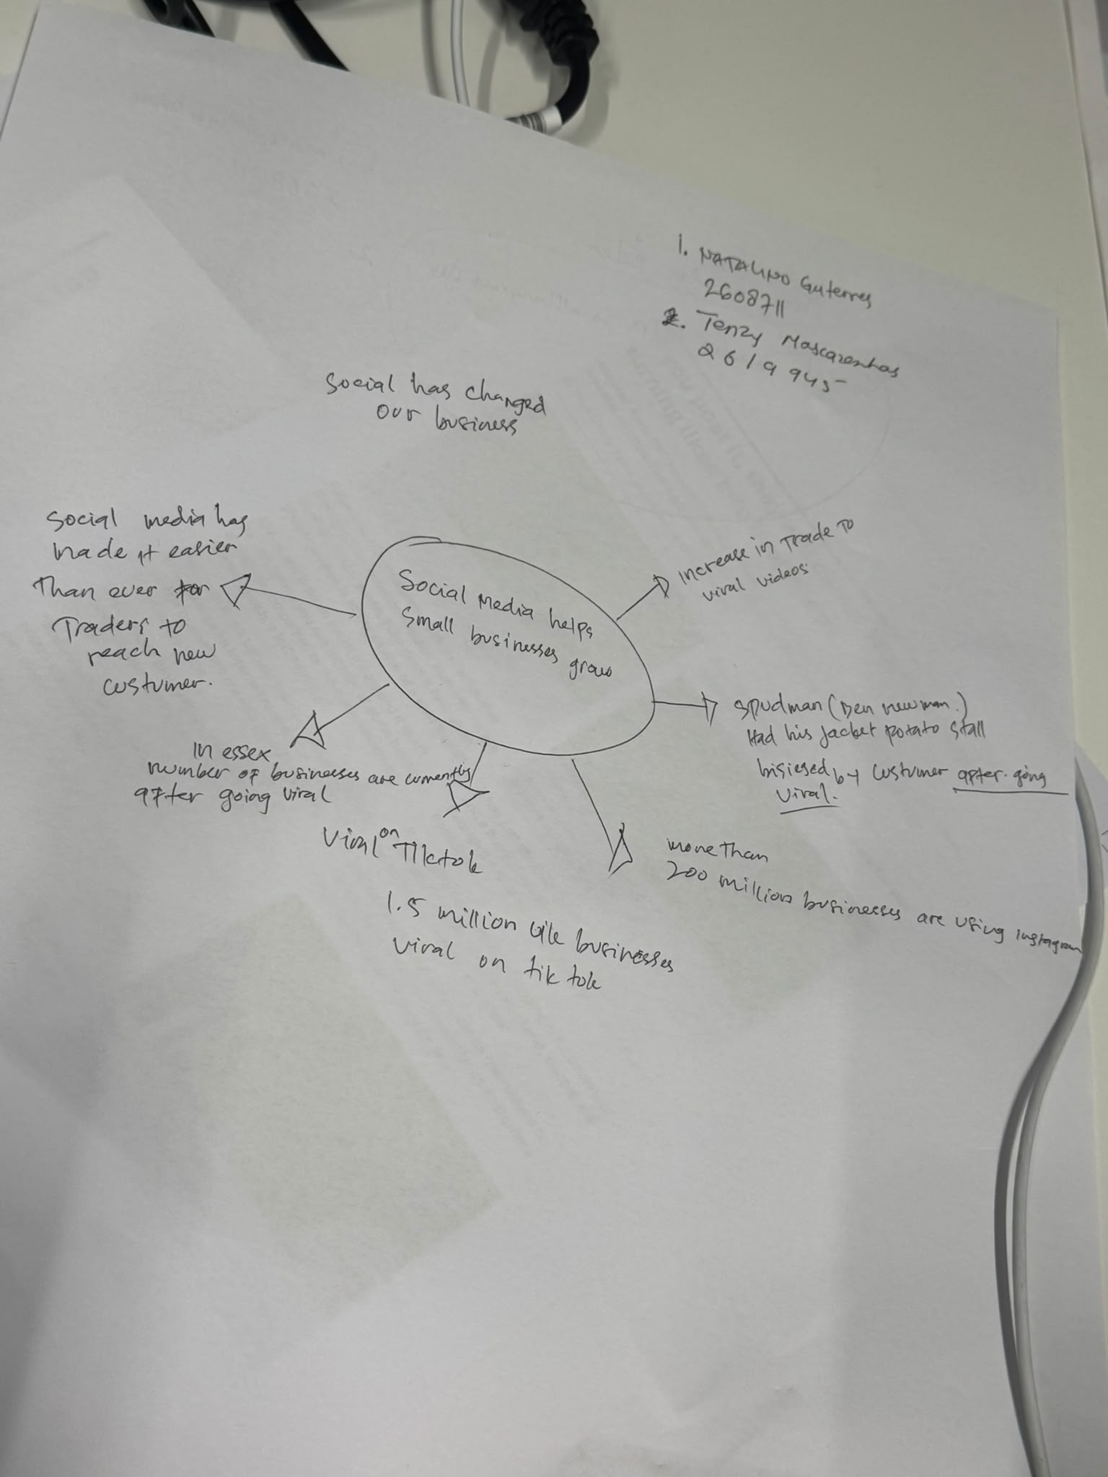

PART 2:
- Answer every question below in 1-3 full sentences.
- Use your own words. Do not use generative AI to answer these questions.
- Include a specific detail from the text when asked.
REMINDER
- The main idea is the overall message of the whole text.
- A key point helps to explain the main idea.
- A specific detail or example from the text shows that the key point is true.

- What is the main idea of the whole text?
Ans: How social media has changed our business. The effect of social media in terms of helping small businesses to grow.

- What is one key point that supports the main idea, and which specific example from the text shows this?
Ans: One key point that supports this idea is the ‘increase in trade to viral videos.’ The jacket potato stall by Spudman (Ben Newman) was besieged with customers after becoming viral which boosted the business’ popularity and increased sales.

- What is a different key point that supports the main idea, and which specific example from the text shows this?
Ans: A different key point that supports the main idea is how traders easily reach their new customers through social media. More than 200 million businesses are now using Instagram and 1.5 million businesses in the UK are now viral on TikTok which reaches new customers and possible customers around the world. Many businesses in Essex are enjoying this boost in sales and visits after going viral.

- Which part of the text do you think is most important, and why?
Ans: The effect of social media where reaching new customers makes it easier for traders because it promotes a business to a wider audience, present the product easily, and makes faster communication to customer.

Reflection:
- What did you find difficult in this task (including in-class components), and why was it difficult?
Ans: I overthought giving an example for the 3rd question which is why I added more than one to make sure that I gave the idea of my answer to that question.

- What helped you with this difficulty, and how did it help you?
Ans: I looked at it from a different angle to make sure that I gave the idea of my answer to the question using articles online from the BBC.

