
Applied Leadership and Management in the Workplace
Module Assignment Submission
Student Name: | Hollie Willmott
Student Number: | 2434208
Module No: | BMSK4011
Module Title: | Continuous Professional Development

Statement of Confirmation of Authenticity
By the act of making this submission, the student declares that this is the work of the student named above. The work has not, in whole or in part, been knowingly presented elsewhere for assessment, or where assessment has been built on an earlier assessment, this has been found. Where materials have been used from other sources it has been properly acknowledged. If this statement is untrue, the student acknowledges that an assessment offence has been committed.
Attention is drawn to the plagiarism and unfair practice policies of both the University and of ILM.

Table of Contents
Introduction 3
1.0 Identify learning styles for self and another 3
1.1 Development needs for self & another 5
1.2 Potential barriers to learning and Strategies for overcoming them 9
1.3 Development options 11
1.4 support mechanisms for the development of self & another 12
1.5 Plan of action 15
1.6 Monitor progress 18
1.7 Conclusion 18
Reflection on the Recruitment process 19
References 21
A Curriculum Vitae 23

B Continuous Professional Development Record 24

Introduction

In this assignment I will be exploring continuous professional development. CPD is a continual process of developing and improving your skills across our careers. I will be identifying my own learning styles and the learning styles of my colleague. I will also be identifying development needs for myself and my colleague. We will be looking at any potential learning barriers we may come across and strategies for overcoming these barriers. I aim to discuss development options and support mechanisms for myself and another. I intend to make a personal development plan for us both and figuring out how to monitor our progress. Once I have completed this part of this assignment I will be reflecting on the recruitment process.

Identify learning styles for self and another

Learning styles
To identify my learning style, I have completed three learning assignments. (Honey & Mumford 1986, VARK Fleming, 1987 and Dantec ,2006.)
Firstly, completing Honey & Mumford (1986) learning style questionnaire my result came back that I am a pragmatic learner. A pragmatic learner is someone who learns by being hands on and practising in real life situations. Pragmatic learners also like to have a read step-by-step instructions and then go off and give it a go themselves. When reflecting on this outcome for myself this is an exact reflection of how I learn and how I complete tasks within a work environment and a home environment. Pragmatist learners also intend to not learn as-well listening to lectures and I lose concentration very quickly. As I have now found my learning style, I can also make my own manager/teacher aware of this, so they are able to adapt their learning to my needs (Honey and Mumford, 1986).
I then moved on to completing my VARK learning style assessment, the results have come back that I am a visual learner. As a visual learner I enjoy watching demonstrations, looking at pictures and benefit from being provided with hand outs. A visual learner is a person who will work well from reading instruction. I tend to struggle with verbal instruction and having to read copious amounts of text which can develop boredom and loss of concentration (Fleming, 1987).
Finally, I completed the Dantec learning style assessment and my result came back that I am a reflective learner. My preferred learning activities as a reflector are to watch demonstration and observing/listening to group discussions. As a reflector my less preferred activities are to be made to feel under pressure and being put into the spotlight and I also do not like to be forced into deciding quickly (Dantec and Mozzon-McPherson 2006).

My colleague has also completed two learning style assessments which were Honey and Mumford and VARK. The first learning style assessment shows that she is a visual learner. My colleague prefers to learn by using flow charts, mind maps and watching tutorials. To be a visual learner my colleague has a good visual memory too. My colleagues less preferred activities to learn would be listening to group discussions without any sort of handouts, notes or viewing a PowerPoint presentation.
The second learning style assessment that my colleague completed was VARK. Results from this questionnaire have show she has a kinaesthetic learning style. As a kinaesthetic learner she prefers to learn by being hands on and practical. She also prefers to learn by preforming role play and live demonstrations. Kinaesthetic learners struggle to learn by reading books or being involved in lengthy discussions and lectures (Fleming, 1987).

It is important for me as a manager to understand how my colleagues learn best so I can tailor my teaching ways to suit there needs. I understand that I will have many team members that I could separate into groups to teach depending on there learning style.

Development needs for self & another

Kolb’s learning cycle is a four-step process which covers the experience, the reflection, conceptualisation, and experimentation. This then leads to a new learning experience, and the cycle is once again repeated. (Kolb, 1984)
Concrete experience

Active extermination

Reflection

Abstract conceptualisation

Using Panagiotou (2003) SWOT analysis tool I have been able to recognise my self and my colleague’s strengths weakness opportunities and threats.

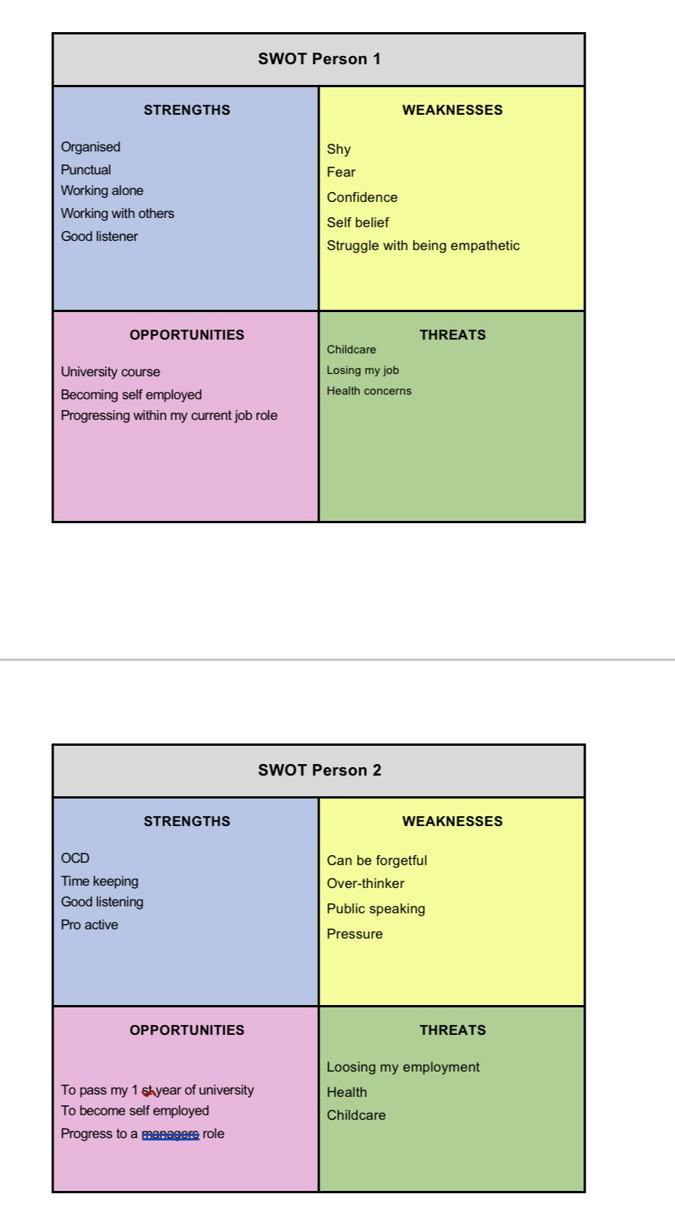

Using the SWOT I have found my strengths and weaknesses but to further my self awareness I have used I have used the johari window model (Luft & ingham, 1955). Using the models four quadrants that stands for several aspects of your professional identity.
My open area I can link to my strengths of being a good listener, organised and punctual. Working with others using self reflective tools I have learned more about my blind spot, which would be struggling to find out who I am since becoming a parent and how to be in a more professional job, which CPD and this course will help with.
I feel I do not have much confidence so will hide some of myself from others, but once I have built trust with people, I can be more open. The unknown area will be explored through new challenges (luft and Ingham 1955)
Gap Analysis –
A GAP analysis is a tool that is used identify the gap between your current state of performance with your desired future state to find what is missing to get you to where you want to be. Using a GAP analysis, you can show what you need to improve on and to make an action plan. (Scott,1980)

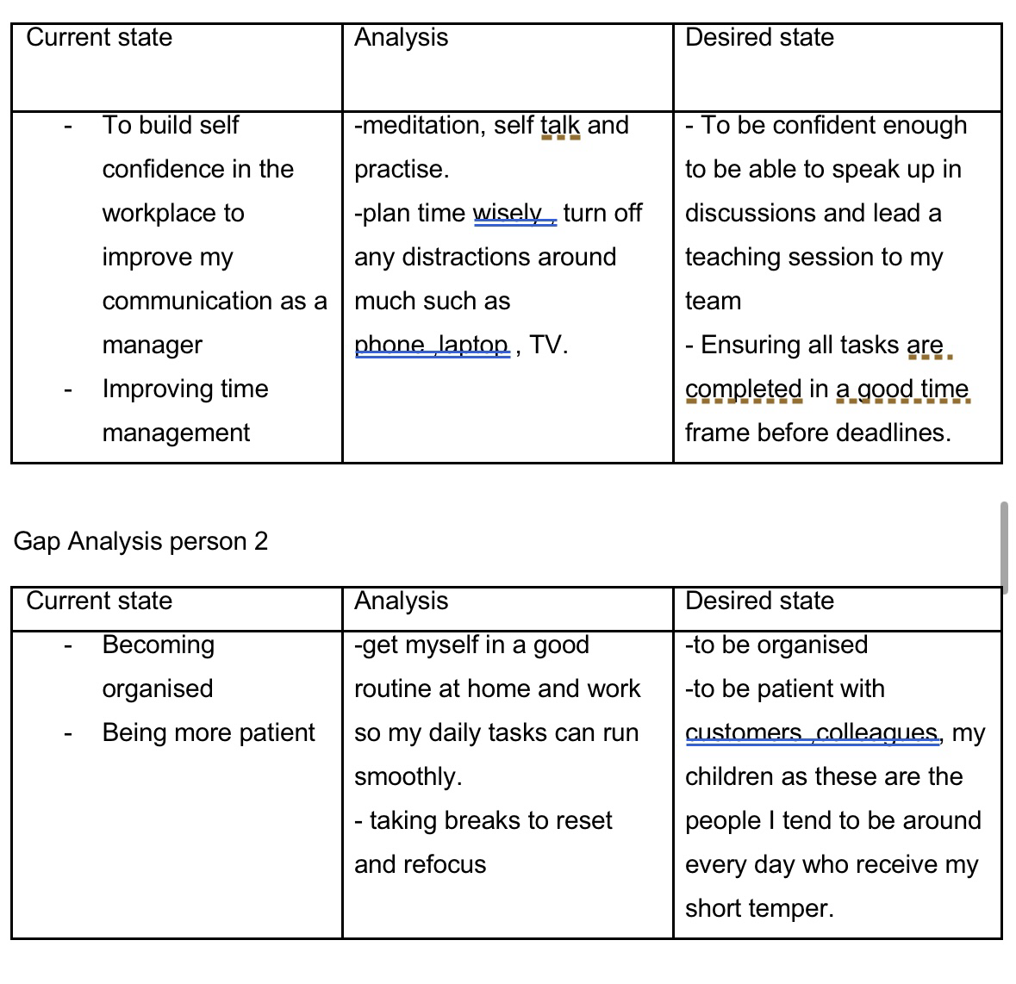

1.2 Potential barriers to learning and Strategies for overcoming them

I have found potential barriers to learning for myself and a colleague by using the table above to analyse the internal and external barriers we may face. Internal barriers are personal issues I may come across, and external barriers are issues that come from the learners. My internal learning barriers are recognised as low confidence, lack of knowledge and health concerns. My external barriers have been recognised as family responsibilities, time, and my learning environment. As I have now found my internal barriers this gives me the chance to work out what I can do to overcome them. I will be breaking down my goals into small achievable tasks to help me progress

I will also work on gaining more knowledge and understanding of the subject by reaching out for support from others such as managers teachers and friends which will hopefully then also boost my confidence.
I have also found potential barriers to learning for a colleague. My colleague also has internal and external barriers which may affect learning. My colleagues' internal barriers to learning have been recognised as stress, a busy lifestyle, and the lack of motivation. Her external barriers have been recognised are commitments and transport. My colleague will be able to overcome these barriers by achieving goals she has set for herself. Her main goal is to pass her driving test which would cause less stress for her having to currently rely on family members to transport her around. Once she has passed her driving test and bought a vehicle this can be removed off her internal barriers table. We have also discussed by my colleague having support for friends' family and other colleagues, speaking to medical professionals and how to deal with stress in her own way this may bring her stress levels down which will then reflect on her lack of motivation.

As a manager to my team, it is great for me to understand everyone’s barriers to learning as I will be able to support them in overcoming these issues. I can do this by researching useful courses to refer my team on such as courses to deal with stress or how to gain confidence as this type of support will help my team grow and become more successful. By helping myself and my team to overcome barriers I hope it will bring about a more positive environment to work in.

1.3 Development options

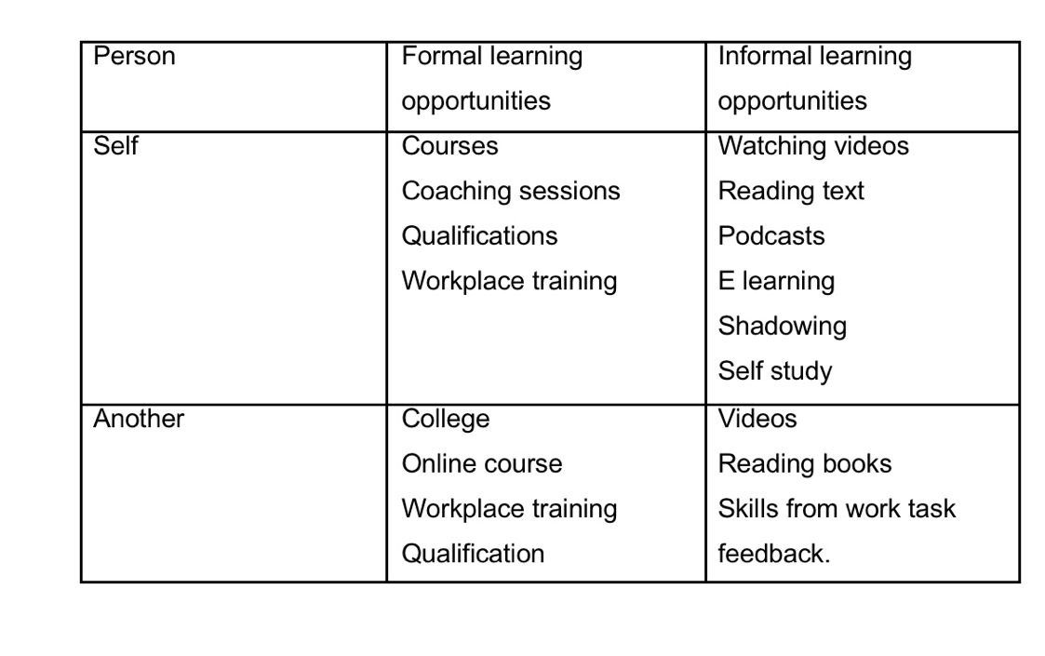
There are many ways to learn, and we often use a mixture of methods based on people’s goals and learning styles. Learning can happen through formal opportunities and informal opportunities. Below I have found formal and informal learning opportunities for myself and my colleague.

On reflection of my formal and informal learning opportunities I prefer to learn informally. I prefer to learn informally because I meant better when I am placed in a relaxed environment. When learning informally I can go at my own pace, I can learn about what specifically I need to be focusing on. I learn best by practicing and trying out what I have learnt other than listening to others throwing information at me. I feel that learning in this way allows me to be in control to focus on what I need to develop.

After discussing with my colleague, we concluded that she prefers to learn formally. Being able to learn in a clear, structured environment motivates my colleague as she felt when she is sent away, she cannot focus on tasks by herself. My colleague also said she likes to be recognised with certificates as this also strengthens her confidence and supports with progressing in her career. Formal learning can help when looking to track progress and achieving goals.

1.4 support mechanisms for the development of self & another

When analysing support mechanisms with CPD they are the network, materials and people that support learners develop their knowledge and skills within their class/career. These can be internal and external elements.
Examples of internal factors would be class learning in groups, e-learning or coaching from mentors. Examples of external factors would include a teaching course or an online course that has been sourced from outside workplace or organisation. I have found below support mechanisms for myself and my colleague. I have also explained how we will be supported (CPD UK, 2025).

Person | Support mechanisms available | How they help
Self | -Parents  -Tutor  -Peers | - parents will support me by babysitting for my children whilst I am studying and working  -My tutor will be teaching and guiding me what I need to learn and providing me with feedback  My Peers will provide me with motivation and confidence to keep going.
Another | -Partner  -Nursery | - My colleague told her partner is a support to her with childcare, transport, and emotional support.  - Due to my colleague having children she has noted that the nursery would be a support to her.

The Go MAD (go make a difference) model is a structure that can support the learner to achieve their goals. Go MAD uses internal and external triangles which shows where the support is coming from. The internal triangle are elements that you as an individual can control such as skills, confidence, and knowledge. Internal factors support you in staying focused on reaching what you you would like to achieve. The external triangles are factors from the outside influence which could be tutors, managers, and family/friends. This model guides you to take responsibility for your growth and development (Gilbert and Chakravorty, 2002).

To progress within work and to graduate and receive my certificate

I rate my self belief a 7
My peers, tutor and parents will support me

10

I want to pass my 1st year to move onto my 2nd year.
-attend classes
-submit assignment on time and to a pass level
To complete my certificate for 1st year university course by August

1.5 Plan of action

Person 1

Using the S.M.A.R.T goal methodology I have been able to define specific, measurable, attainable, related and time bound goals (Dorian,1981).

What do I want to learn? | What do I have to do? | What support and resources will I need? | How will I measure success? | Target Date for Review
To become more confident within my workplace to help passing my assignment | Learn what I am good at and what I need to develop in | Class, peers, research, self belief sessions | Pass results on assignment and passing modules within my work role | 23 November 2026
Time management | Using S M ART to track progress | Coaching sessions, e learning | Feedback, ticking off goals | October 2026
Increase self belief | Practise, self talk, gaining feedback | Tutor for feedback | Qualifications | October 2026

Personal Objectives

Short Term Goals (next 12 months)
To pass my assignment
To pass work training courses
Increase of Self belief
Medium Term Goals (2-3 years)
Progress within my career
To pass level 1 and continue to level 2 university course

Long Term Goals (3-5 years)
To graduate my university course
To become self employed

Person 2
What do I want to learn? | What do I have to do? | What support and resources will I need? | How will I measure success? | Target Date for Review
Become a successful manager | Continue to learn and develop my skills in work | Management, supervisors, learning course, mentors | Management feedback | 1/11/2026
Listening skills | Research and practise | Reading and resource online videos | Feedback from others | 1/11/2026
Increase Microsoft excel skills | Further learning course and face to face support | Peer support | Knowledge of excel | 1/5/2026

Personal Objectives

Short Term Goals (next 12 months)
To be able to listen in a group with out loosing concentration
Dealing with pressure

Medium Term Goals (2-3 years)
To progress to a management role

Long Term Goals (3-5 years)
To become a positive leader
To have development my skills that need improvement

1.6 Monitor progress

I will monitor progress from my personal development plan as I now have clear goals that I am able to track my progress from. I will track my progress by having regular weekly meetings with a monthly performance review and informal chats. Each of my steps can be checked off once I have received positive feedback and felt I have achieved my goal over the space of a few months. By checking off a goal once completed this means I can monitor the change over a period of time. I will also be requesting feedback from peers around me and managers to see if there are any other points I could improve on and add to my personal development plan.

As a manager i would also be monitoring the progress of my team by having regular check ins, teams meetings in groups and 121’s with each team member.i will also praise and celebrate each small goal that has been reached as this also counts towards great feedback and will give my team the motivation to keep up the good work they are achieving. If my team and colleagues are struggling at any point, we can also look at introducing coaching sessions in ways that can suit there learning style preference. With my colleague we have also discussed that the PDP can be continuous and if not achieved it is not the end of the line.

1.7 Conclusion

In conclusion I have learnt about the different learning styles available and how as a manger we can tailor our teaching sessions to the individual style groups to support with learning. I have found my strengths, weaknesses for myself and another. Learning my strengths and weaknesses have given me the chance to develop what I have found that I am struggling with. I have learnt how to overcome any potential barriers to learning and what my development options may be. I have also completed a PDP so I am able to track my progress over the coming months and years. Finally, I gained knowledge on CV writing to give me the best chance at gaining an interview.

Reflection on the Recruitment process

To reflect on the recruitment process I have used Gibbs cycle of reflection (1988) model, the experience was that I applied for a customer service role with the organisation Maximus. To apply for this job role, I had to complete a very lengthy application form on the Maxmius website that I was directed to complete via indeed. The application took me over an hour to complete with around 40 + pages of information and questions to answer. For this job role I also had to send across my curriculum vitae.
After evaluating this process, I can understand why a lot of candidates may not apply for this role due to the recruitment process of the time-consuming application. Once my application had been sent, I received an email inviting for an informal 15-minute chat the following day. The next day I received my phone call from a supervisor at maxmius. The interviewer was very friendly and made me feel at ease from the beginning of the call. Whilst on this call the supervisor briefly explained the role to me and then offered for me to come in for a face-to-face interview. I was also advised after the interview I would be given the chance to call listen to give me a good understanding of what I would be expecting if I were to be offered a position.
I accepted the invite for the interview and sent across the relevant information I needed to attend the interview which was then booked in for a few days later. The day of the interview came around, and I was feeling extremely nervous and full of anxiety. I tend to struggle with self esteem and confidence which then reflects in how i communicate- I can become very shy and start to feel sick. As I was expecting to be interviewed by the lady I spoke with earlier in the week which she said was the case I did not feel as stressed. I arrived at the main reception where I was told to sort and wait whilst they pass on the message that I had arrived. 35 minutes later I was approached and asked if anyone had spoken with me yet to which I replied to no. As I had waited so long, I already had a bad instinct about this company. Eventually I was called into my interview to find 4 staff members sat around the table eating their lunch which I would say was very unprofessional. The interview started to which they referred to me as Sophie and had a Sophie’s CV in-front of them. This then added to my bad instinct about this company. I was in and out of my interview within 10 minutes after I was briefly told about the role, talked about the start date and that I was to expect an acceptance email within a few hours.
After leaving my interview and reflecting on what has just happened, I felt they did not know me at all, they new nothing about me and was rushed through the basic details and offered a position. It came across to me that they were desperate for staff and would employee anyone. This did not reflect of the one-hour application that I had completed and was expecting a more formal interview. In the email I had received about attending this interview I was advised I would have a 30-minute interview, followed by a tour of the contact centre, and a time period of call listening which I was looking forward to. I decided that I would be declining this offer with Maximus due to the unprofessional approach to my interview. I declined the role via email and gave them feedback of the situation that had happened at my interview.
Reflecting on this process I feel the application being so long was a selection process and felt pointless especially when they clearly did not even know look at my CV. When applying for jobs in future I will research the company and make sure I want to work with them and investigate the recruitment process. I will have practice interviews with friends and family to make sure I am confident going into the process.

To hand over a good CV you should make sure it is clear and up to date. You would like your CV to stand out from others, so it is also a promising idea to tailor your CV each time you are an applying to separate roles. A CV should always be an honest CV. Bullet pointing is a useful tool I would recommend using as long paragraphs can come across very boring. Another point for a good CV would be to check your spelling and grammar. You should make sure the headings and relevant information you are telling is clear. Your profile – education and work experience should be compressible. I have reflected on my own CV and since doing my research on what a good CV looks like I have attached the CV in appendix A. I HAVE ADDED TO APPENDIX A MY CPD PLAN.

References

https://www.cpduk.co.uk/explained

Gilbert, A & chakravtory, I. (2002) go mad about coaching. Go Mad.

Gibbs, G. (1988) learning by doing: A guide to teaching and learning methods. Further education unit.

Dorian, G.T(1981). There’s a S.M.A.R.T way to write management’s goals and objectives. Management review. AMA FORUM, 70 (35)
Luft, j; Ingham, H. (1955)” The johari window , a graphic model of interpersonal awareness”. Proceedings of the western training laboratory in group development
Scott, M.J. (1980) GAP, GAP analysis project. University of Idaho.
Honey,P., & Mumford,A.(1992). The manual of learning styles. Ardingly house
Fleming,N.D.(1995).” I am different :not dumb” modes of presentation (VARK) in the tertiary class room. Research and development in higher education and research development society of australasia , 18(18)

Kolb, D.A., & Fry, R. (1975). Toward an applied theory of experimental learning. In theories of group process. John Wiley.
ILM, Continuous professional development , Available at https://www.cpdstandards.com/sectors/institute-of-leadership-and-management-ilm/(accessed 13.11.2025)

Panagiotou,G,(2003).Bringing SWOT into focus. Business strategy review, 14(2), 8–10. https://doi.org./10.1111/1467-8616.00254

Dantec,c., & Mozzon- McPherson, M. (2006) supporting independent learning through explicit strategy – based training. In supporting independent language Learning: issues and interventions. Peter Lang.

A Curriculum Vitae

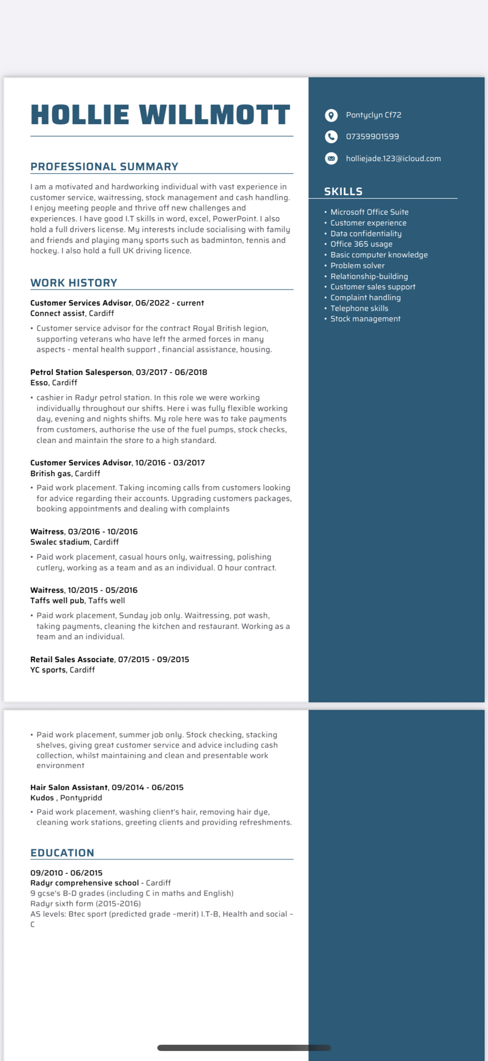

Appendix B Continuous Professional Development Record

Continuous Professional Development Plan – Hollie Willmott
Formal | Informal | Date | Duration | Status | Details
ILM Level 4 Diploma in Leadership and Management |  | 2025 | 1 Year | In Progress | ILM
L4 Certificate of HE Applied Leadership and Management |  | 2025 | 1 Year | In Progress | University of Wales Trinity Saint David
Empathy training - connect assist |  | 2025 | Day course | In progress | Connect assist

