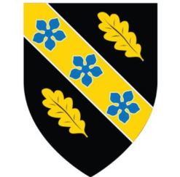

Emma Biggs
Student Number: 2308431

Work Based Group Project Portfolio (ACDA5022)

School of Applied Computing

Ordinance Munitions and Explosives

BEng

Academic Year: 2025 - 2026

Abstract
This report explores the human and organizational factors contributing to the development of the Rapid Explosive Detection and Path Harmonization (REDPATH) landmine clearance solution. Systems engineering tools were used by the project team to translate stakeholder requirements into critical functionality and refine design features.
Within the team, members were assigned specialist roles spanning Research and Development, Test and Evaluation, Safety and Legislation, Manufacturing, and Disposal. The report evaluates how their interactions and communication channels shaped the decision-making process as well as the individual contributions of the Safety Lead to the project.
Although the team produced a cohesive output, the analysis highlights significant challenges regarding inconsistent engagement and individual accountability faced during the process. The report concludes with an after-action review, identifying specific ways in which both the technical concept and the team's final presentation could be improved.

Table of Contents
Abstract 2
Table of Contents 3
Table of Figures 3
1 Introduction 5
2 Role Interaction and Communication Methods 6
3 Project Progress and Decision Making 9
4 Individual Contribution of the Safety Lead 11
5 Reflection and After-Action Review 13
6 Conclusions 16
7 References 17

Table of Figures
Figure 1 - Layout of team SharePoint created by the Safety Lead 5
Figure 2 - Examples of post meeting actions distributed by both the Safety and T&E Leads 6
Figure 3 - Examples of problematic communication by the R&D Lead responsible for the development of the thermite neutralisation solution 7
Figure 4 - Example of slide created by the Safety Lead within the Presentation, using independent research 9
Figure 5 - Example of a slide displaying unnecessary information in a small font 12

1 Introduction
In response to a provided time sensitive operational scenario featuring OZM-72 anti-personnel and M15 anti-tank threat articles; transportation limitations and a harsh desert environment, the project team developed the Rapid Explosive Detection and Path Harmonization (REDPATH) concept. This concept was based on a semi-autonomous unmanned arial platform incorporating dual sensor mine detection, georeferenced navigation and a thermite-based neutralisation sub system.
To complete this design task, members of the team were assigned specialist roles via a random generator due to the minimal variation in apprenticeship pathways represented within the group. These roles included two Research and Development (R&D) Leads, with one focusing on the drone platform and the other on the thermite neutralisation system; a Manufacturing and Procurement Lead; Test and Evaluation (T&E) Lead; Breakdown and Disposal Lead as well as the Safety and Legislation lead. For the duration of the project, the author acted as the Safety and Legislation Lead, requiring sustained interaction with the wider team to ensure evolving concepts remained safe, legally informed and operationally viable.
This report details how the project progressed, inter team communication methods, interactions between specialist roles as well as covering how the Safety Lead demonstrated the teamwork and attributes necessary for a successful delivery. A reflection on the outcomes of the presentation delivered by the team in addition to an after-action review is also included.

2 Role Interaction and Communication Methods
Although roles were clearly allocated to facilitate each member of the team to have a defined functional responsibility within the project as described in the introduction, the direct implications of design choices on other areas prevented the project to be progressed in isolation. Examples of these cross-concept relationships included the impact of platform selection on operational use and legislative compliance as well as the thermite subsystem design’s effect on manufacturing controls, operator safety, testing regimes and disposal processes. As a result of these interdependencies, design choices were made as a group based on individual research rather than parallel individual tasks.
Communication during project work was managed through both formal and informal channels established by the T&E and Safety Leads respectively. Day-to-day communication was directed through a WhatsApp group chat created by the T&E Lead, supporting coordination between in-person meetings, distribution of updates and future project actions. To support this, the Safety Lead established a Microsoft Teams channel with an associated SharePoint site to ensure that suitable document-management procedures and access arrangements were in place. This created a central location for shared research, meeting records and presentation content while reducing the risk of uncontrolled document versions.
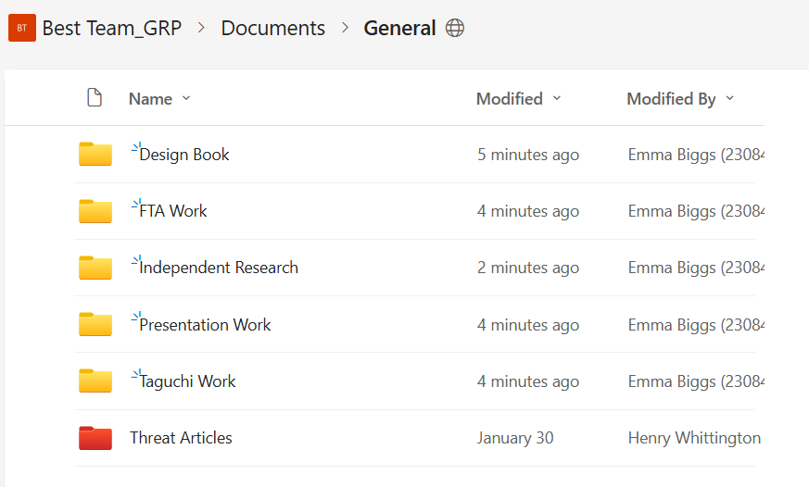
Figure 1 - Layout of team SharePoint created by the Safety Lead
Following major discussions, key decisions and actions to be completed prior to the next meeting were recorded by either the Safety or T&E Lead before being circulated to the wider group. This supported accountability for the completion of actions as well as ensuring discussions produced identifiable follow up tasks rather than remaining as informal conversations.
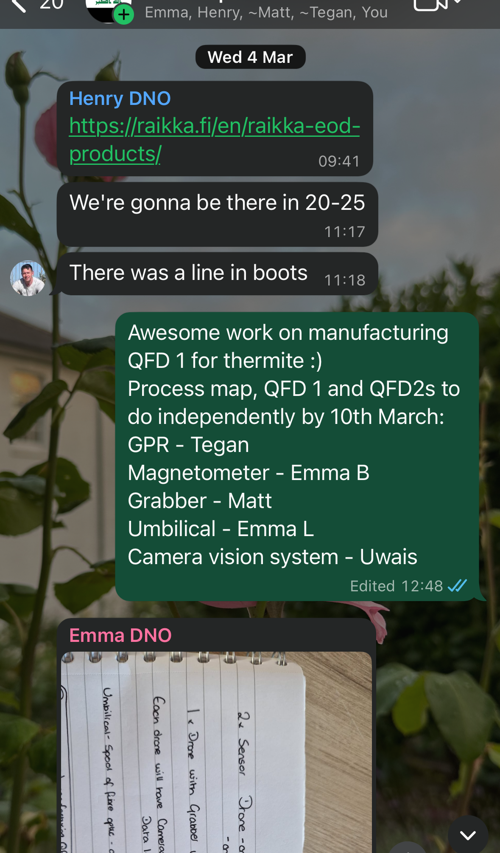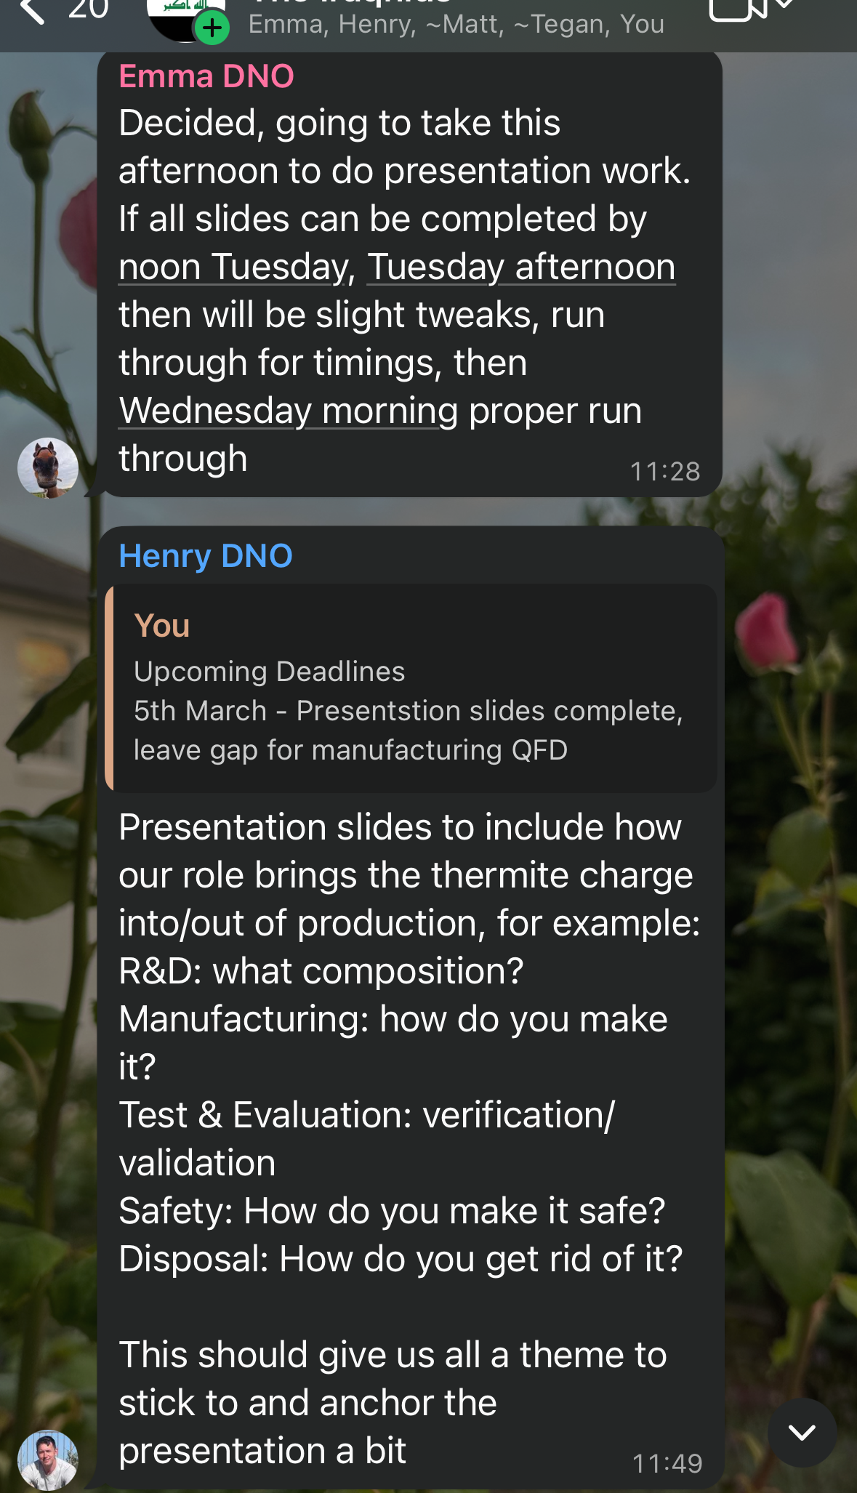
Figure 2 - Examples of post meeting actions distributed by both the Safety and T&E Leads
The integration of a formal document management system enabled effective knowledge sharing within the team. This was demonstrated by the T&E lead who conducted extensive research into the threat articles identified in the project brief including both online and engagement with Explosive Ordnance Disposal (EOD) subject matter experts (SMEs). The information gather during this research was shared through the Teams channel to provide the project team with access to a common source of threat intelligence to inform design, safety and testing decisions. The creation of this information data base provided the opportunity all leads to work from the same information, aiding in unified decision-making during concept development.
Interactions between roles happened continuously throughout the duration of the project to facilitate the required distribution of information. A particularly positive example of these interactions arose between the Safety Lead and the R&D Lead responsible for the drone platform. Foundational research into suitable unmanned arial platforms was carried out by the previously describe R&D Lead before being shared with the Safety Lead. This facilitated the Safety Lead to review the proposed commercial off the shelf (COTS) solutions against operational safety and legal requirements for the use of an unmanned aerial system (UAS) as opposed to just the technical suitability appraisal conducted by the R&D Lead.
To ensure information regarding the safe operating procedures of the UAS were aligned with current processes implemented within Industry and the military, the Safety Lead consulted a current drone operator within the Royal Marines and the Private Sector. The information gained from these consultations was shared with the wider team to improve understanding of realistic operating procedures such as the requirement for a qualified drone operator to act as an observer to improve situational awareness during the operation. The information handover process between leads supported the assurance of both regulatory compliance and operational suitability for the proposed solution.
However, role interaction was not consistently effective across all areas of the project. The R&D Lead responsible for the thermite focused aspect of the project repeatedly failed to engage in group discussion or complete the expected level of research pertaining to thermite and its manufacture. Due to the fact that the thermite subsystem affected all other areas of the project, the limited research conducted significantly restricted the depth of interdisciplinary exchange of information in a critical aspect of the design. The team encouraged participation through the established communication channels by incorporating interactive features including poles, but limited engagement from the R&D Lead reaming a problem. This highlighted that despite appropriate communication systems being established, project progress and communication is highly dependent on the responsiveness and accountability of individuals within the team.
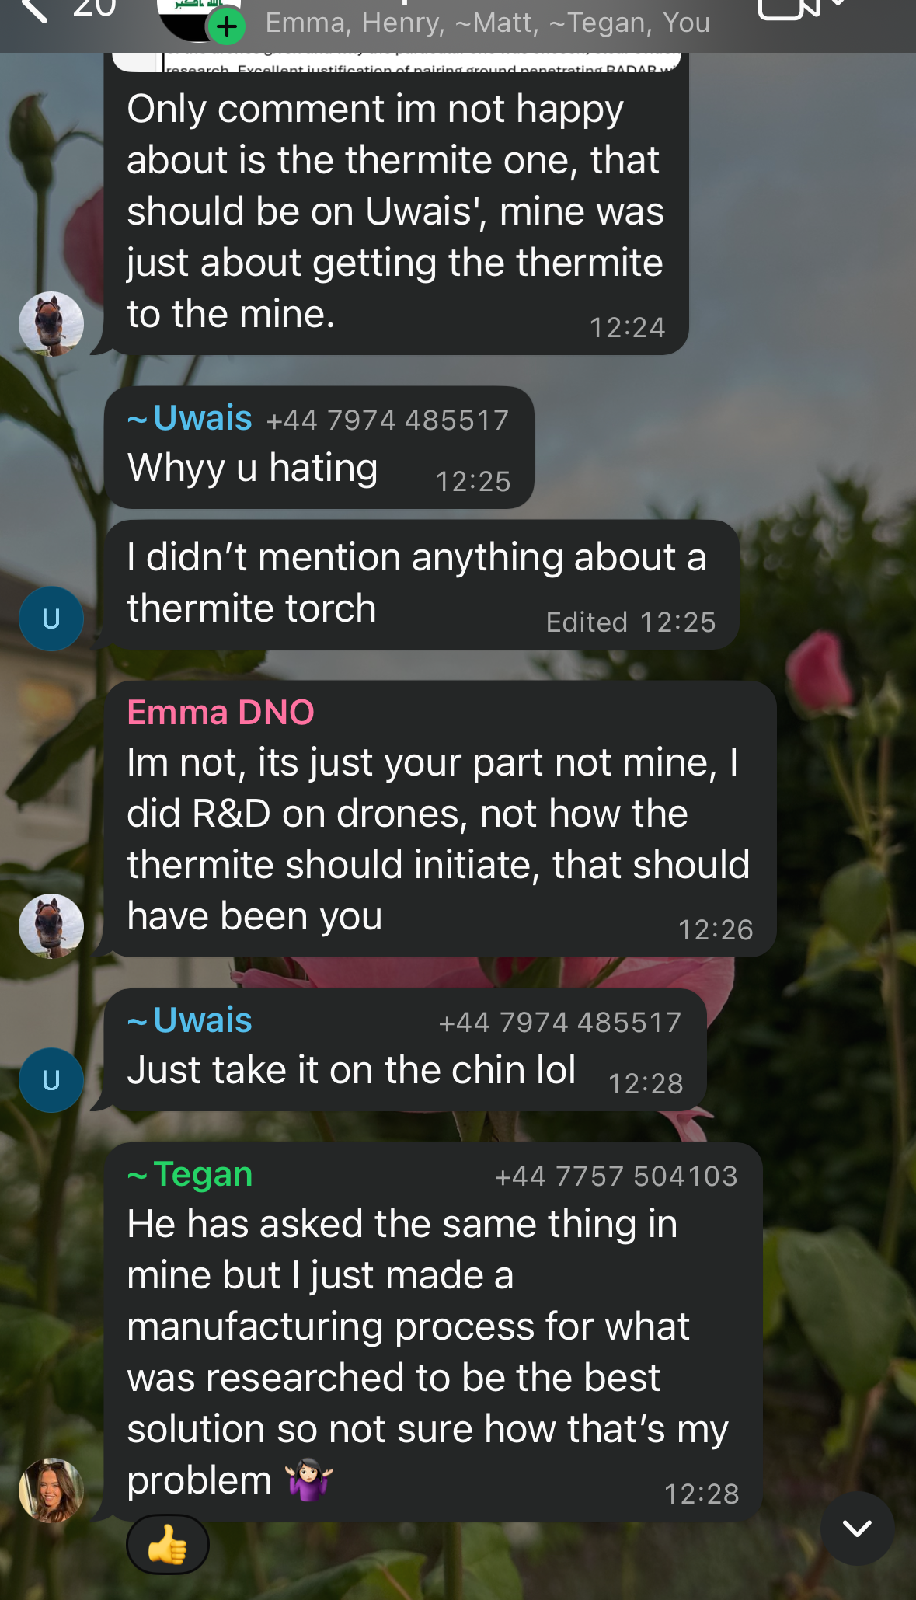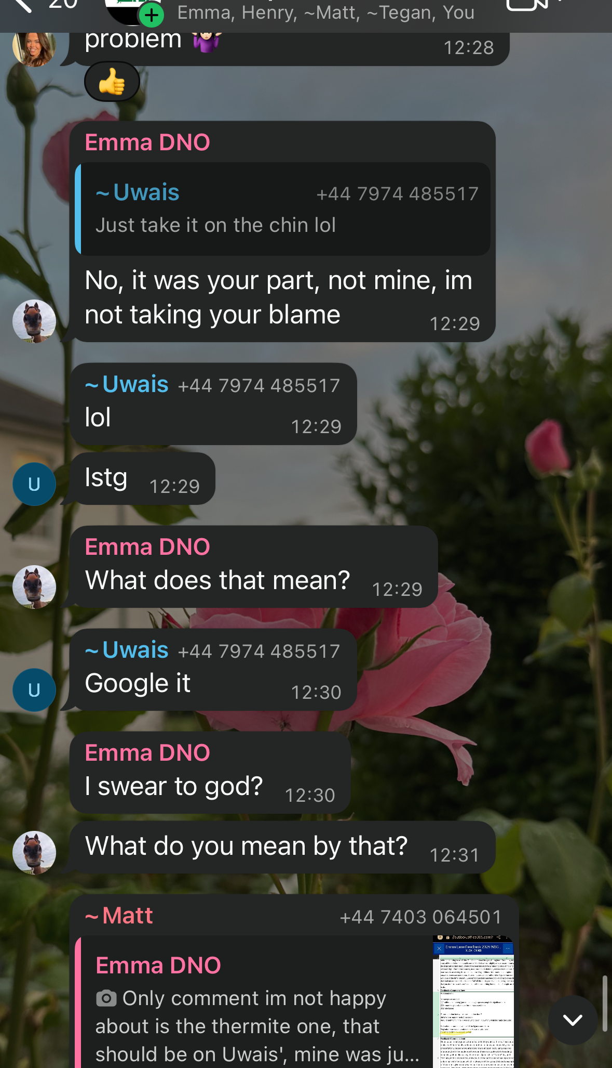
Figure 3 - Examples of problematic communication by the R&D Lead responsible for the development of the thermite neutralisation solution

3 Project Progress and Decision Making
Project development occurred through a series of structured stages with decision making embedded throughout rather than being treated as a separate exercise. To begin, the team focused on understanding the operational problem and the development of a requirement set that would later define a viable solution. As demonstrated within the presentation, the team considered not only the need to identify, locate and clear the threat articles, but also additional stakeholder requirements relating to safety, maintainability, environmental impact, transport and storage compliance as well as the need to operate within a desert environment while meeting regulatory and legislative standards. This initial stage established a shared understanding of the problem and formed the bases of justification for later design decisions.
After formalising the requirements, the team translated them into an operational understanding of the system. Functions including deployability, movement, command reception, mine detection, communication of mine location, clearance of mines, recoverability and disposability were identified and weighted in relation to the requirements set.
Each member of the team was then tasked with creating a concept and presenting it back to the group, justifying their design choices. This required each person to engage with the problem, factoring their role into design decisions rather than relying on a single solution emerging through general discussion. Once presented, the group compared generated concepts and traditional demining techniques against the identified requirements utilising a Pugh matrix to establish effectivity. The team collectively selected REDPATH as the concept to be taken forward based on the previously described evidence-based process.
The concept selection phase of the project also exposed a limitation to project progress. The R&D Lead responsible for the thermite neutralisation process failed to contribute a solution for selection. Although the team was able to evaluate the available concepts, the absence of that contribution limited the degree of challenge applied to the neutralisation solution at an early stage.
Upon decision to progress with the REDPATH concept, individual team members focused on detailed development of their respective areas. The platform focused R&D Lead refined the platform selection and sensing choices; the Manufacturing Lead considered procurement and assembly of equipment; the T&E lead structured verification and validation trials; the Safety Lead considered operational hazards and regulatory constraints; and the Breakdown Lead addressed through life implications. Individual research was highlighted in the role specific portions of the presentation.
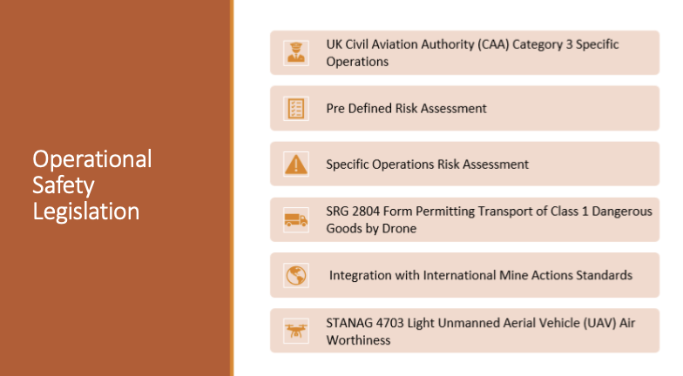
Figure 4 - Example of slide created by the Safety Lead within the Presentation, using independent research
Major decisions during the design phase were made through a collaborative approach, incorporating individual research to create a design informed by all disciplines. The discussion of individual research facilitated the justification of decisions rather than just simply accepting an outcome based on an isolated opinion.
A strength of this approach was that it promoted shared ownership of the concept built on a foundation of individual research and group discussion. This resulted in a shared understanding of the concept rather than being confined to an individual specialist, aiding in the team being able to cohesively justify decisions in the presentation. However, the quality of this process was restricted by the consistency of engagement across all roles meaning that where a lead failed to contribute sufficiently, the evidence base for justification was less robust. This was evident in the thermite neutralisation sub system element of the presentation.

4 Individual Contribution of the Safety Lead
The Safety Lead contributed to both the technical and organisational development of project REDPATH. The role of Safety Lead required the interpretation and application of legislative and safety requirements governing the production and operation of the system. As identified in the requirements phase of the project, it was necessary for the system, its manufacture, transportation and storage to be compliant with the relevant legislation and standards including International Mine Action Standards (IMAS) [1][2][3]; Control of Substances Hazardous to Health (CoSHH) Regulations 2002 [4]; Registration, Evaluation, Authorisation, and Restriction of Chemicals (REACH) [5]; International Carriage of Dangerous Goods Regulations (ADR) [6]; NATO Standardisation Agreements (STANAGs) [7]; Joint Service Publications (JSPs) [8] and Health and Safety Executive (HSE) requirements [9].
A particularly important contribution of the Safety Lead was the decision to implement the UK Civil Aviation Authority (UKCAA) regulations as the principal regulatory framework for the arial system [10]. Although the operational scenario was in a desert environment, UK UAV legislation was selected due to its comparatively stringent and comprehensive nature. It was believed that if the concept could be assessed against a higher domestic standard, it would likely remain viable across a wider range of operational settings opposed to following a less demanding standard.
As part of this legislative framework, it was identified by the Safety Lead that the selected platform must operate under the UKCAA Category 3 Specific Operations regulations [10]. This includes the requirement for a Predefined Risk Assessment (PDRA), Specific Operations Risk Assessment (SORA) as well as integration with STANAG 4703 for light UAV airworthiness.
The applied legislative framework also influenced the requirements for the thermite-based neutralisation system by mandating the completion of a SRG 2804 application to carry Class 1 Dangerous Goods by drone [11][12]. Considerations of how ADR, CoSHH and REACH regulations applied to the wider system including manufacture, transport and storage were also made, influencing the decision to produce a field mixed composition [13]. This decision fed into discussions with the Manufacturing Lead regarding process controls, contamination prevention and handling precautions. This demonstrated that the Safety Lead considered how dangerous goods would be handled, transported, stored and integrated into the wider concept.
From an organisational perspective, the Safety Lead contributed to the effective running of the project by establishing formal lines of communication used for document management and version control. This created a structure for the storage of shared documents which provided clarity when working with a wide range of specialist roles. The Safety Lead also helped to record and distribute agreed actions following team discussions through the group chat, supporting accountability and continuity between meetings.
Finally, the Safety lead demonstrated adaptability upon discovery of the shortcomings within the thermite aspect of the project. In the absence of sufficient role specific research from the relevant R&D Lead, late notice additional input was provided by both the Safety and Manufacturing Leads to ensure project progress continued and the presentation was completed. This helped ensure the final product presented remained safe, legally informed and operationally credible.

5 Reflection and After-Action Review
The group project demonstrated the team’s capability to work effectively when responsibilities were clearly understood, subject to communication and engagement remaining active throughout the development process. The presentation provided a coherent account of the operational problem, the rationale behind the chosen concept as well as the progression of the design from initial requirements to the final proposal. The structure of the presentation supported a clear narrative and enabled the audience to follow the progression of the project in a logical manner.
The team responded constructively to questioning, engaging professionally with areas of challenge and supporting one another to provide comprehensive answers where appropriate. This indicated that despite previously described inconsistencies in preparation, the group possessed a broad understanding of the overall concept, rather than approaching the task as a collection of isolated individual contributions.
Although the presentation was deemed to be effective overall, several aspects could have been improved to achieve a more professional standard. For example, some slides contained a greater than appropriate volume of text resulting in a small text size being utilised, reducing readability from an audience perspective. Limiting the information on the slides to only include key information would increase accessibility of the slide pack.
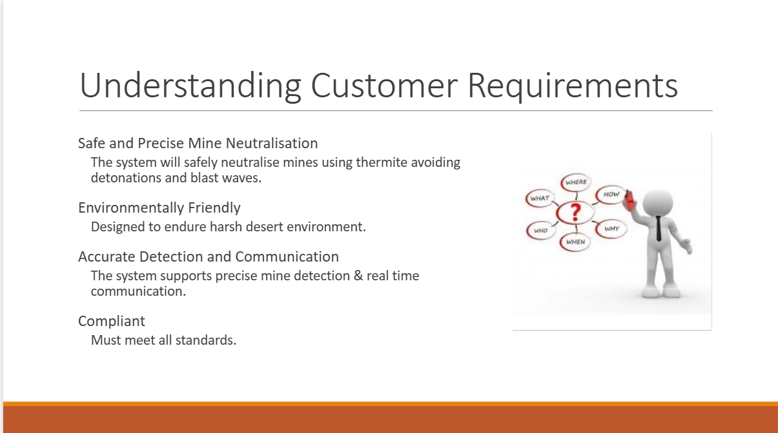
Figure 5 - Example of a slide displaying unnecessary information in a small font
In addition, the presentation exceeded the specified time limit which reduced the time available for the disposal section and impacted the overall balance of delivery. More disciplined time management of individual sections should have been implemented throughout group rehearsals to ensure the presentation did not over run. The inclusion of a reference slide at the end of the presentation would have also improved the output by ensuring that source acknowledgement was explicit.
The weakest area of the project concerned the thermite-based neutralisation system. Questions raised after the presentation highlighted that this aspect of the project had not been developed to the same depth as other areas of the design. For example, the lack of consideration to issues such as the method of ignition, field mixing and the requirement for the incorporation of a binder significantly impacted confidence in the operational feasibility and stability of the concept. Since the solution was not presented as a reliable or suitably developed concept, the safety case was subsequently weakened due to an incomplete understanding of the formulation and its associated hazards and mitigations.
This weakness was directly related to the uneven contribution of independent research within the team. The R&D lead responsible for the development of the thermite solution did not provide the level of input expected throughout the project. As a result, other members of the team had to compensate for missing work at a late stage, creating an avoidable weakness. This increased pressure applied to other members of the group to achieve a functional design and reduced time available to strengthen the technical foundation of the neutralisation solution.
To reduce the impact of this issue, the team could have implemented earlier progress checks to identify missing contributions before they became critical. Despite setting interim deadlines for the completion of follow up actions, accountability was not accepted by all members of the team. More formal interim deadlines including internal reviews of individual work could have been utilised to raise awareness of areas requiring support and ensure gaps in contributions were captured earlier. Following these deadlines, responsibilities could have been redistributed sooner, allowing team members greater time to build the missing knowledge. While these methods would have not removed the difficulty in its entirety, they would have reduced the stress placed on other members of the team and minimised the effect on the final output.
The presentation also provided an opportunity for self-evaluation for the Safety Lead. When speaking about specialist material including legislation, hazards and mitigations, the Safety Lead demonstrated confidence with a clear delivery highlighting a strong understanding of the subject. This was also emphasised by open body language and engagement with the audience. However, confidence was visibly lower during the concept overview given by the Safety Lead, denoted by a reliance on notes. It was noted in feedback that this was not a result of poor preparation, rather nervousness at the beginning of delivery. In future, this could be improved by increased rehearsals and a more structured approach to managing presentation anxiety to create a stronger first impression and produce a more standardised delivery.
Overall, the presentation demonstrated the team’s ability to produce a feasible product incorporating the systems engineering framework. The critical lesson learnt was the importance of consistent team input, early management of developing problems and concentrated presentation practice to ensure the delivery of a professional presentation.

6 Conclusions
The REDPATH project demonstrated that successful design is dependent on the project team’s understanding of the requirements relating to the problem space, effective and reliable communication between roles, as well as a structured decision-making process provided by the systems engineering framework. The application of this framework facilitated design choices to remain linked to original requirement set, ensuring a final product that was operationally viable.
The communication of the team through both formal and informal channels allowed both rapid coordination of team activities as well as controlled document management and shared access to individual research. Major decisions within the project were made through independent role-based research followed by collective discussion, allowing members to justify their reasoning behind design decisions. The Safety Lead provided a substantial contribution to this process through the establishment of the formal digital environment, recording and distribution of follow-up actions, as well as internal and external liaison.
However, the project also demonstrated that communication systems and collaborative structures are only fully effective when team members engage with them consistently. The weakness in the thermite-based aspect of the design highlighted the effect of single role non-participation on the quality of the wider design process and quantity of avoidable pressure placed on other members of the team. Despite this, the team demonstrated resilience and professionalism in adapting to those challenges to create a final concept that was legally informed and operationally viable.

7 References

[1] International Mine Action Standards, United Nations Mine Action Service. 2013. [Online]. Available: https://www.mineactionstandards.org/standards/03-30/
[2] International Mine Action Standards, United Nations Mine Action Service. 2013. [Online]. Available: https://www.mineactionstandards.org/standards/03-40/
[3] International Mine Action Standards, United Nations Mine Action Service. 2024. [Online]. Available: https://www.mineactionstandards.org/standards/07-13/
[4] Control of Substances Hazardous to Health, Health and Safety Executive. 2002. [Online]. Available: https://www.hse.gov.uk/coshh/
[5] UK Registration, Evaluation, Authorisation and Restriction of Chemicals, Health and Safety Executive. 2021. [Online]. Available: https://www.hse.gov.uk/reach/new-registration.htm
[6] ADR 2021 Volume 1, United Nations Economic Commission for Europe. 2022. [Online]. Available: https://unece.org/transport/documents/2021/01/standards/adr-2021-volume-1
[7] STANAG 4586 –Standard Interfaces of UAV Control System (UCS) for
NATO UAV Interoperability, Mario Monteiro Marques. 2007. [Online]. Available: https://publications.sto.nato.int/publications/STO%20Educational%20Notes/STO-EN-SCI-271/EN-SCI-271-03.pdf
[8] JSP 0-30.2 Unmanned Aircraft Systems, Ministry of Defence. 2017. [Online]. Available: https://assets.publishing.service.gov.uk/media/667d6f155b0d63b556a4b437/ARCHIVE-UAS_JDP_0_30_2.pdf
[9] Health and Safety at Work etc. Act 1974, Health and Safety Executive. 1974. [Online]. Available: https://www.legislation.gov.uk/ukpga/1974/37/contents
[10] Airspace Policy Concept: Airspace Requirements for the Integration of Beyond Visual Line of Sight (BVLOS) Unmanned Aircraft, UK Civil Aviation Authority. 2023. [Online]. Available: https://www.caa.co.uk/publication/download/20293
[11] Application for Approval to Transport Dangerous Goods by Air - Operators of UK Registered Aircraft, UK Civil Aviation Authority. 2025. [Online]. Available: https://www.caa.co.uk/publication/download/13782
[12] Guidance on the Carriage of Dangerous Goods as Cargo for UAS/RPAS Operators in the Specific Category, UK Civil Aviation Authority. 2023. [Online]. Available: https://www.caa.co.uk/publication/download/20558
[13] Guidance on the manufacture, storage and carriage of thermites and thermite
containing articles, Health and Safety Executive. 2024. [Online]. Available: https://www.hse.gov.uk/explosives/assets/docs/guidance-manufacture-storage-carriage-of-thermites.pdf

