Student Name: Rhys Alexander Davies

Student Number: 1803152

Module Code: ACCA6027

Lecturer: Mike Dacey

Module Name: Software Engineering Principles and Practice

Contents
Introduction 4
The Agile Approach 5
What is the agile approach? 5
Strengths: 6
Weaknesses 6
The authors experience: 7
Software Design Techniques 8
Wireframe Diagram 8
Wireframe Evaluation 8
User Stories Map 9
The benefit of user story maps. 9
Class responsibility collaboration cards 10
What are CRC cards and why are they useful? 10
UML Approach 10
Acceptance Criteria 10
Evaluation of CRC cards 11
Software Development Approaches 12
Testable Code 12
Single Responsibility Principle (SRP) 12
Open-Closed Principle (OCP) 12
Liskov Substitution Principle (LSP) 12
Interface Segregation Principle (ISP) 12
Dependency Inversion Principle (DIP) 13
White-box Testing 13
Black-box Testing 14
Version Control 15
What is version control? 15
The Authors Opinion 15
Conclusion 17
References 18
Appendix 21
Git Log 21
Connect Four Code: 22
Program.cs 22
PlayerInfo.cs 23
Menu.cs 25
DisplayGrid.cs 27
PlayConnect.cs 30
Check.cs 33
XUnitTesting 42
UnitTest1.cs (Testing Grid Code) 42
UnitTest2.cs (Testing Entering Counter) 44

Introduction
In the international journal on computer science and engineering the authors stated that,
“In software development life cycles, there are two main considerations, one is to emphasize on process and the other is the quality of the software and process itself. Agile software processes are an iterative and incremental based development, where requirements are changeable according to customer needs” [1].
The quote states that the agile methodology is a looping process with incremental changes according to the client’s needs which is what will be discussed in the following report. A non-bias research into the strength and weaknesses of the agile approach followed by the design techniques used in the agile methodology such as user story maps and class-responsibility-collaboration cards with example designs created in an agile team. A section on white and black box showing examples of each and version control. For closure a conclusion to summarise the research carried out.

The Agile Approach

What is the agile approach?
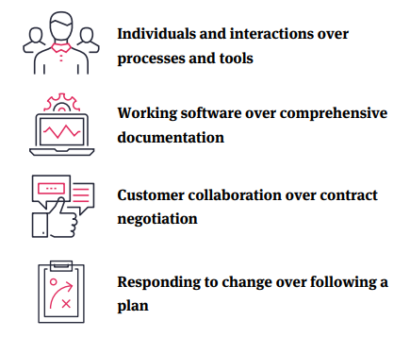
Figure 1, Shows the agile values from the agile manifesto [2].
The agile approach which was formally launched in 2001 with the intentions of developing better software. Taymor Emerson’s agile handbook shows the four main values for the agile approach, as taken from the agile manifesto, demonstrating how these values can prepare an agile team for the unpredictability of software development and breaking down projects into smaller chunks making it easier for the team to embrace [2]. Using the manifesto’s values a collection of twelve principles were produced to make the agile approach more understandable, these are:
- “Our highest priority is to satisfy the customer through early and continuous delivery of valuable software” [3].
- “Welcome changing requirements, even late in development. Agile processes harness change for the customer's competitive advantage” [3].
- “Deliver working software frequently, from a couple of weeks to a couple of months, with a preference to the shorter timescale” [3].
- “Businesspeople and developers must work together daily throughout the project.” [3].
- “Build projects around motivated individuals. Give them the environment and support they need and trust them to get the job done” [3].
- “The most efficient and effective method of conveying information to and within a development team is face-to-face conversation” [3].
- “Working software is the primary measure of progress” [3].
- “Agile processes promote sustainable development. The sponsors, developers, and users should be able to maintain a constant pace indefinitely” [3].
- “Continuous attention to technical excellence and good design enhances agility” [3].
- “Simplicity--the art of maximizing the amount of work not done--is essential” [3].
- “The best architectures, requirements, and designs emerge from self-organizing teams” [3].
- “At regular intervals, the team reflects on how to become more effective, then tunes and adjusts its behaviour accordingly” [3].

The Agile methodology’s goal is to develop a better-quality product this can be done by following the principles. As mentioned in the twelve principles it is important developers to interact with clientele allowing them to collaborate their vision for the project meeting the needs and satisfying the customer. Agile promotes a more communal approach to developing as mentioned by Lyssa Adkins, a software project manager, who used the phrase “Take it to the team” [4] when developers within the team encountered issues or thought of ideas with the project as opposed to going straight to the project manager supporting what the principles above. As with any methodology there will be both strengths and weaknesses to the approach. The following strengths and weaknesses will be the general strengths and weaknesses of using this methodology.

Strengths:
- The software gets incrementally better and tested more thoroughly over a series of collaborations with the client granting a better-quality product at the end of the development cycle.
- Gives developers an opportunity to work in teams of usually between 3-9, promoting friendly relationships within a team to develop a better-quality product and provides great opportunity for developers to learn off their team members when it comes to tasks providing a wider learning knowledge.
- Agile prepares for unpredictability, such as clients adding new features, breaking the project down into more manageable chunks so that the project is overbearing prioritizing discovery and experimentation.
- Agile focuses on solving problems rather than coding the whole system which supports sustainable development and pushing a constant pace, again so the project is not overbearing.
- Agile promotes face to face conversation to get across a message, as the best way for a message to be understood is by reading emotion and reading facial features to gain an understanding and of the team’s thoughts on a particular message stimulating a healthy more comfortable environment.

Weaknesses
- Highly reliant on communication, if communication is not adequate the project will suffer as the review periods will not be as detailed as they need to be.
- Agile is designed for small teams (3-9) to adapt and overcome together within their team however the agile principles do not scale up well to larger teams of more the 9.
- Agile does not support a set-in stone roadmap. Roadmaps require certain features to be complete before moving on to the next stage whereas agile being more versatile sacrifices that degree of predictability.

The authors experience:

Context:
Tasked with producing User stories, CRC cards and a wireframe for a connect four web application, which will be discussed in a further section. In an agile team of three developers the team took to Miro to work through the broken-down chunks of the project together.

Strengths:
- Working in a team allowed for idea’s to be bounced around and by combining knowledge sets and coming up with a more fulfilled and detailed design.
- The agile methodology also allowed for detailed discussions about the wireframe and class responsibility collaborator cards (CRC cards) prompting thoughts from everyone that we might not have had without being in a group.

Weaknesses:
- Communication was initially limited between the team due to not having set times for working on the project together causing development to be slow.
- Agile, personally, does not work as effectively online as it would in person as there is no complete way to know if your team fully understand the task at hand or if they are agreeing to please everyone.

Software Design Techniques

Wireframe Diagram
A wireframe is a blueprint, usually in skeletal form, to produce an application whether that is a web application or phone app. Wireframes at its basic form is to show the intended behaviours each induvial aspect of the application, the functionality and most notably the layout. Wireframing is used to show the important features and how they will work, such as a carousel on a website, which is used to give stakeholders or clients a brief design idea into what the product may look like by its final complete form. Wireframes can act as a visual flow diagram of functionality displaying the individual processes of each page of a website, or in the case of connect four each key screen the user will encounter when playing. Wireframes tend not to use colour or including minor design details like animation of icons and little details like this, wireframes are kept as simplistic as possible in regard to the colours aspect as it is just a skeletal design of the future product. Wireframing comes under UX/UI design which will be the bases for the designer to go and create fully fledged designs based off the wireframe they have drawn up [5] [6] [7]. 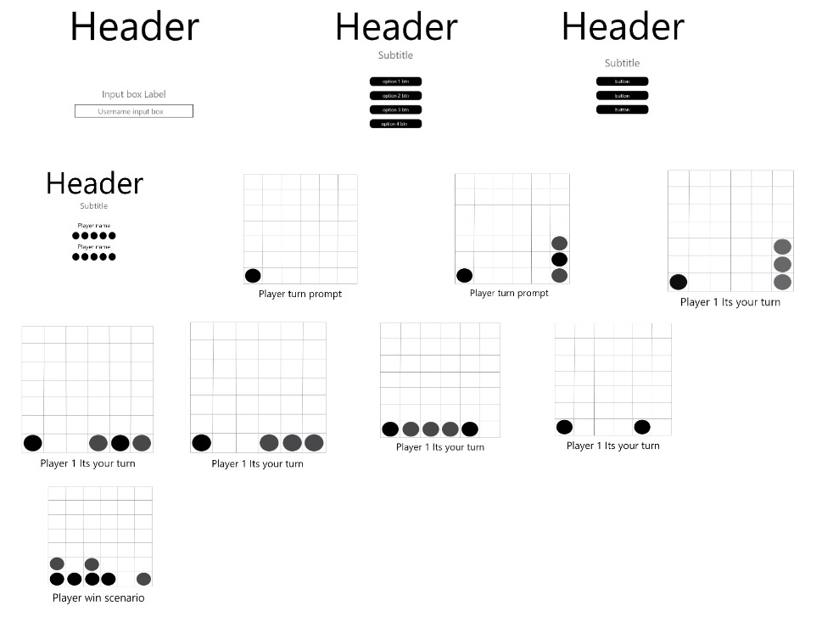
Figure 2, Shows the wireframe design produced in an agile team.

Wireframe Evaluation
The wireframe displayed in figure 2 was created under the context of creating a connect four web application. The wireframe design was devised from the user story maps and as researched above displays a basic visual flow diagram displaying the functionality that the user story maps required. The basic flow shows the key functionalities the user would encounter when playing the game such as the initial username screen followed by the menu screen where they user can choose what game mode of connect four, they wish to play. The design is simple enough to just display the key features and functionality of the web application to give stakeholders or clients a general idea of what the finished product would look like once completed.

User Stories Map
What are user story maps?
User story mapping is a dynamic process used in the agile approach which and can give the agile team working on the project an understanding of the user’s needs and how to prioritize them. User story mapping is the users journey through the application describing the functionalities that will be valuable to the user in the rough order of priority or the order in which you would describe activities to explain the behaviour of the system [8]. User story mapping directly relates to the agile process as communication is important for a coherent and detailed story map that directly reflects the user requires. User story maps can have many releases in which the user can add many more stories as agile is an iterative design process. User story mapping also makes use of a backlog section which is for features that are note essential for the application to work however if there is time within the project they can be added in and brought to the forefront [9] [10].

The benefit of user story maps.
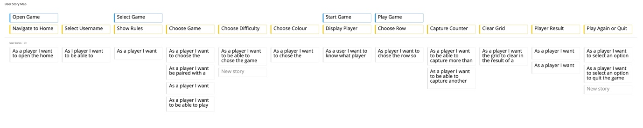
Figure 3, Shows user story map for connect four game.
{Disclaimer: Miro cuts off the end of the story’s, please visit for full board: https://miro.com/app/board/o9J_lbmPJpg=/ }
User story maps are beneficial to developers planning an application as they show the users journey through the program or website and in which order the user will carry out specific actions when using the application. An example the basic flow the user will follow through the connect four game, as shown in figure 3, is shown on the top row where the user will start by opening the game up, then selecting the game mode before then starting and playing the game. This is beneficial to a team and to developers as it shows the main flow in which the application will take.
User story maps further investigate the tasks within the main flow. They make room for processes such as asking for username which falls in between the user opening the game and before they select which game to play, as shown in figure 3 example. This takes shape on the second row. This is beneficial as it allows developers to piece together the code in which they need to create in order to have a working application that suffices the agile promise for a better-quality product.
The releases, the third row in figure 3, display why the user would want to do these tasks and the benefits they gain for doing such as having a username as the player wishes to be identified in the figure 3 example. The releases section is beneficial to an agile team and developers as it allows the developers to gauge and see what features the user wishes to have in the product such as in choose game section of the story map where there are four different game modes the user wishes to choose between.

Class responsibility collaboration cards

What are CRC cards and why are they useful?
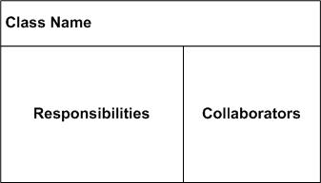
Figure 4, shows a CRC card model.
CRC cards, otherwise known as class responsibility collaboration cards, are heavily bridged with the world of object orientation and give developers a good understanding of what classes interact with each other. CRC cards are divided in the 3 sections as shown in figure 4. These three sections each give information about the class. Initially the class name which gives a general idea what the class contains. The responsibilities in which that class will have which generally refers to the functions that class contains, more simply what the class knows or does. Finally, the collaborators refer to the other classes that this class interacts with to fulfil its role. It is important that the CRC cards contain enough detail so that code can be implemented using them as they are derived from the user stories [11] [12] [13].

UML Approach
Unified modelling language (UML) is a “semantically and syntactically rich visual modelling language for the architecture, design, and implementation of complex software systems” [14]. UML utilizes sequence diagrams which is an alternative to the CRC card approach supporting object-oriented notation however the principles from the UML approach are applicable to the CRC approach given that the CRC approach is a version of object orientated design.

Acceptance Criteria
Acceptance criteria is related to user stories and are the criteria that the software must meet and be accepted by the user or other parties involved. The acceptance criteria are specified in the user story as “I want to do something” given this the software must meet this need for it to reflect the acceptance criteria. Acceptance criteria that are written well lead to less mistakes in development and a more complete product to impress the user, however how well the acceptance criteria are written is based on the communication between user and development team [15].

Evaluation of CRC cards
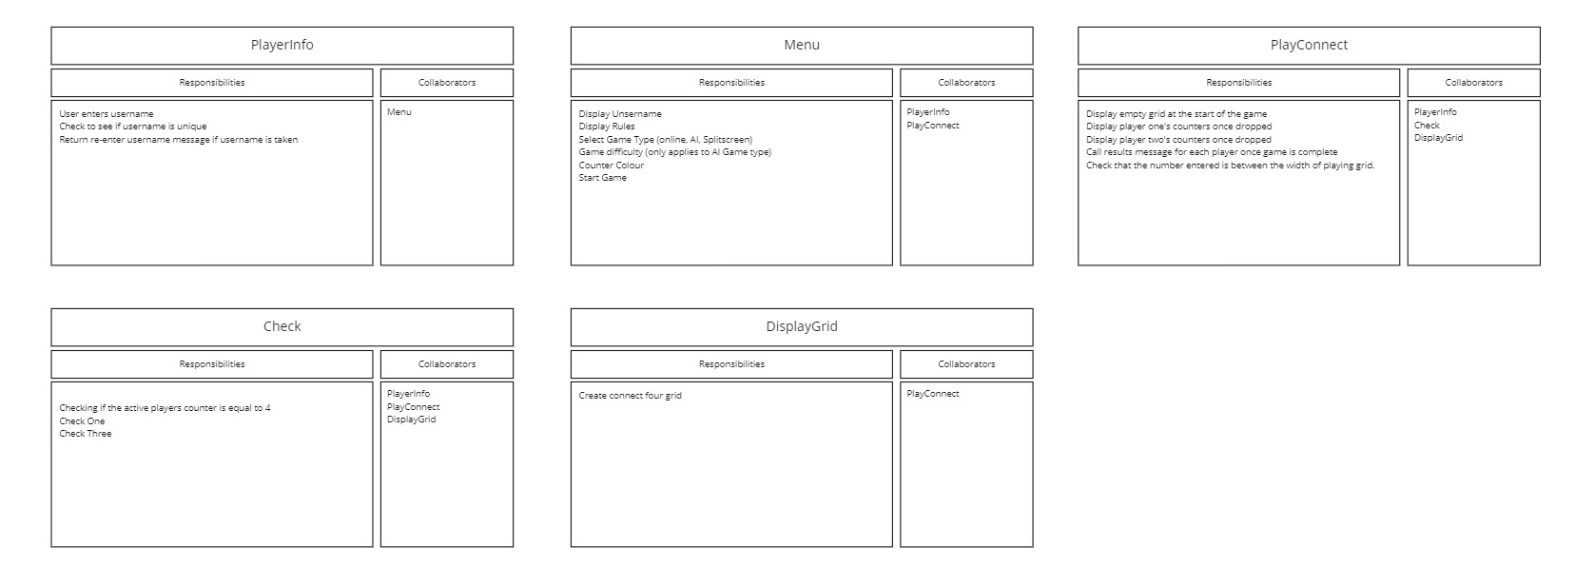
Figure 5, shows CRC cards created from user stories for connect four game.
The CRC cards displayed in figure 5 are classes derived from the user stories as discussed above. The CRC card diagram is laid out in an understandable manner following the card model displayed in figure 4. The CRC cards must contain enough detail within them so that the code for functions within the classes can be implemented but also tested which the CRC cards in figure 5 satisfy, in the ‘PlayerInfo’ class which has the responsibly of getting the user to enter their username and ensuring it is unique otherwise it must be re-entered. The group decided that the responsibilities in this class are sufficiently detailed to create a class that will do each of them things and can be tested for which can be backed up by the code written based off the CRC cards in the appendix of this document. There were slight alterations to the CRC cards when developing as it made some of the responsibility’s classes had made more sense to be elsewhere such as the displaying the grid function not being a part of the ‘DisplayGrid’ class which was an oversight from the group when designing. Another further oversight was not including the clear grid responsibility, for if the user filled the grid with no winner, in the ‘DisplayGrid’ class which was mentioned in the user stories. Using the user story maps it was clear of the acceptance criteria needed for the program to be complete and up to the quality required by the user. The CRC cards designed by the group meet the acceptance criteria set in the user stories by including all the features the user wanted to be able to do in the application.

Software Development Approaches

Testable Code
Testable code is the process of writing code that can be easily tested. Testable code is very important in software engineering as to ensure software works it will have to go through rigorous testing. Using the SOLID principles, it can help the developer write code to be more dynamic and modular which increasing the testability of the code and making it more practical and important in software engineering by using object-oriented notation. The solid principles are as followed [16]:
- SOLID Single-Responsibility Principle (SRP)
- Open-Closed Principle (OCP)
- Liskov Substitution Principle (LSP)
- Interface Segregation Principle (ISP)
- Dependency-Inversion Principle (DIP)

Single Responsibility Principle (SRP)
This principle ensures that a class only carries out its single responsibility. Classes that have too many responsibilities coded into them are known as ‘badly written code’. The single responsibility principles enable testing to be more effective as by testing a class carries out it is one intended purpose and does it well it can not cause any further problems in the program and makes it easier for the code to be refactored in turn making it more testable [17].

Open-Closed Principle (OCP)
According to Robert Martin the Open-Closed principles is “the most important principles of object-oriented design” [18]. It is said to be the most important as when a change is made to code it can cause a cascade of changes to the related classes however with OCP applied the code is not changed but rather extended. Open part of the principles means that the code can be extended with new behaviours. Closes meaning that the class is closed for modification so that there are no changes in the base code [16] [18].

Liskov Substitution Principle (LSP)
This principle is based upon abstraction and states that functions that use pointers or references to base classes must be able to use objects of the derived classes without knowing it [19]. Developers should model classes based on behaviours not on properties and model data based on properties and not on behaviours.

Interface Segregation Principle (ISP)
To understand the principle, it is important to know what an Interface is. An interface is a set of abstractions that contain behaviours that a class that inherits can access and may possibly do different things depending on the class. The principles states that a client should not be exposed to methods it does not need. This principle wants developers to clean up bulky interfaces so that they only contain the methods relevant [20] [21].

Dependency Inversion Principle (DIP)
The definition for the dependency inversion principle is that “high-level modules should not depend on low-level modules. Both should depend on the abstraction. Abstractions should not depend on details. Details should depend on abstractions” [22].

White-box Testing
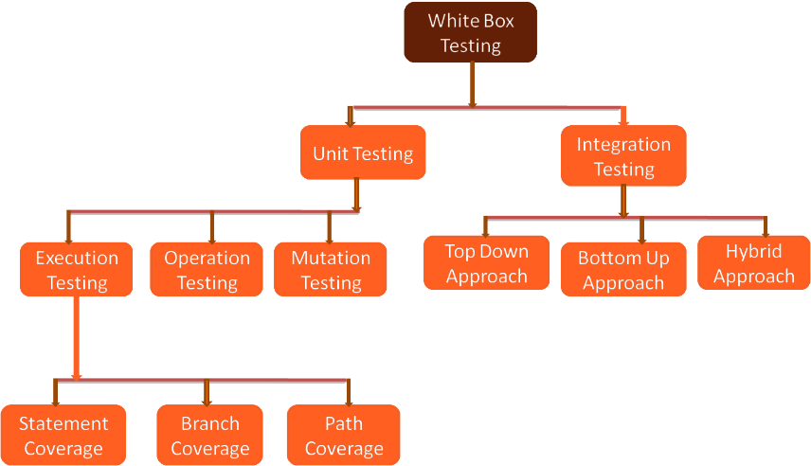
Figure 6, shows flow of the different white box testing techniques [23]
White box testing also known as clear box, open box, transparent box, code based, and glass box testing designs test cases based off the source code of the application and focuses on the data flow of the program. White box testing is usually carried out by the developer of the code and therefore knows what the code looks like, hence alias name of clear box, and what to look for in the code and writes tests by executing methods with certain parameters. When white box testing there are specific tests that are carried out on the software to provoke the following [24]:
- Internal security holes.
- Broken or poorly structured paths in the coding processes.
- The flow of specific inputs through the code.
- Expected output.
- The functionality of conditional loops.
- Testing of each statement, object, and function on an individual basis [25].
There are many types of white box testing, as displayed in figure 6, one of these are unit testing. Unit testing is testing a single unit to find bugs in the first round of testing. An example of white box testing can be found in figure 7.
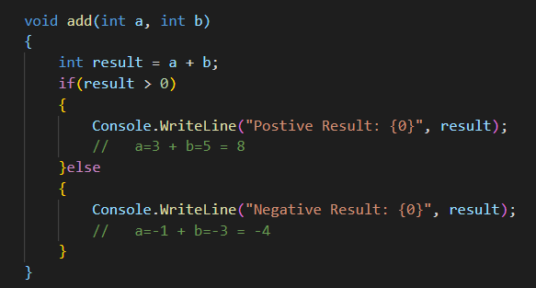
Figure 7, shows a simple white box test.
The white box test shown in figure 7 tests each of the statements in the above function using the test cases written in comments for the expected results of that test case.

Black-box Testing
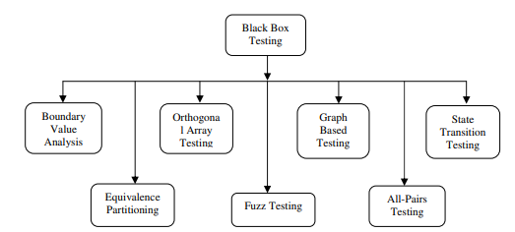
Figure 8, shows flow of the different white box testing techniques [26].
Black box testing, unlike white box testing, is a testing method in which the application is tested with the testing having no prior knowledge of the code, hence the name black box indicating that you cannot see in. Black box testing is “mainly record and playback tools which record test case”. When black box testing the tester is only aware of the input and the required output [26]. The steps followed in successfully using the black box testing method are:
- Initially, the requirements and specifications of the system are examined.
- Tester chooses valid inputs (positive test scenario) to check whether SUT processes them correctly. Also, some invalid inputs (negative test scenario) are chosen to verify that the SUT can detect them.
- Tester determines expected outputs for all those inputs.
- Software tester constructs test cases with the selected inputs.
- The test cases are executed.
- Software tester compares the actual outputs with the expected outputs.
- Defects if any are fixed and re-tested [27].
An example of black box testing would be a search engine, where the text is entered into the textbox, for example ‘penguins’, and the expected result will be what was searched for and the test will pass else it will fail.

Version Control

What is version control?
Version control is important in programming and all e-documents that undergo alteration many times, especially by different users. In its simplest form version control is important as it allows the user to compare, identify and merge changes in the files and is particularly important when working as an agile team as it allows the team to keep track and work together on a project submitting changes as well as monitoring what team member made that change before a merge.
The benefits of version control are that there is traceability allowing for the editors of documents/ files to be identified, this is useful as team leaders, in a software development scenario, can see the developer that has last edited the file and see the progress they have made. This extends to be useful into possible performance reviews allowing for a backlog of data to be shown with identification for the work produced. Version control also reduces duplication of work as out of date documents/ files can be deleted on the main branch of work. This benefits the storage costs of projects making them cheaper to house. Version control software, such as GIT, allows for comments detailing the changes to the file which can give another developer meaningful understanding of any bugs or changes in the file. Version control also acts as a backup allowing developers to pull previous files from other versions of their uploaded files [28] [29] [30]. GIT has 3 stages modified, staged and committed. These stages indicate the status of the files in the repository. Modified means that a file in the repository has been changed since the previous commit. Staged status means that a modified file has been marked and its current version will be uploaded on the next commit. Finally, committed which commits the files to the repository [31].
The statement “Version control software is a key tool in the software development process” is proven to be true, based on the advantages above, with many companies and developers using a form of version control software when developing. The advantages arisen discuss how beneficial version control can be and the time it will save developers by being able to backlog and track files including the ability to see the editors of the files creating a whole backlog, an example of which can be shown in figure 9.
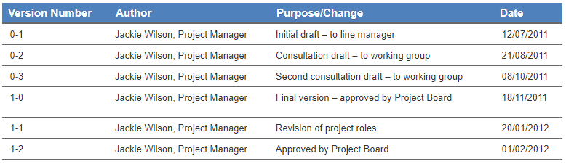
Figure 9, Shows an example of a version control table [29].

The Authors Opinion
“Version control software is a key tool in the software development process”
GIT and other version control systems are an incredibly useful tool in more than just the software development process however for the topic of software development YES version control is a key tool as it provides more than just a platform for users to control their code it allows teams to collaborate and push and merge updates to the same branch, allows comments of changes made in the most recent push. It allows developers to share code with other developers. Furthermore, it does what it intends to do and allows for developers to make mistakes while coding and be able to refer to a previous working version of their code. With this in mind, agreeing with the above statement is the only logical answer as it provides so many benefits to software developers.

Conclusion
In conclusion the research carried out to develop an understanding of agile methodology including all the connecting design and development approaches that agile uses, demonstrated with a connect four example using the techniques researched within an agile team of three. The techniques researched and evaluated as part of this report such as user story mapping, CRC cards and wireframe diagrams were demonstrated on Miro before then using the design technique to creates the CRC cards. White and black box testing were also investigating in particular white box unit testing which was a method used to test the connect four game that was coded. A researched discussion on version control shed light on the advantages of using such systems and why they are beneficial in software development, in particular GIT which is widely known and used. Overall, the report enabled many new findings about software development and testing in that of the agile methodology and is something that transferred from paper to practice easily.

References

[1] | “Agile Processes and Methodologies: A Conceptual Study,” International Journal on Computer Science and Engineering, vol. 4, no. 5, pp. 892-898, 2012.
[2] | E. Taymor, “The Agile Handbook,” [Online]. Available: http://agilehandbook.com/agile-handbook.pdf. [Accessed 01 01 2021].
[3] | K. Beck, M. Beedle, A. van Bennekum, A. Cockburn, W. Cunningham, M. Fowler, J. Grenning, J. Highsmith, A. Hunt, R. Jeffries, J. Kern, B. Marick, R. . C. Martin, S. Mellor, K. Schwaber, J. Sutherland and D. Thomas, “Manifesto for Agile Software Development,” 2001. [Online]. Available: http://agilemanifesto.org/. [Accessed 02 01 2021].
[4] | L. Adkins, Coaching Agile Teams, Pearson Education, 2010.
[5] | H. Jaye, “What Exactly Is Wireframing? A Comprehensive Guide,” 01 08 2019. [Online]. Available: https://careerfoundry.com/en/blog/ux-design/what-is-a-wireframe-guide/. [Accessed 02 01 2020].
[6] | ExperienceUX, “What is wireframing?,” [Online]. Available: https://www.experienceux.co.uk/faqs/what-is-wireframing/. [Accessed 02 01 2020].
[7] | S. Climer, “What Is a Wireframe? 7 Reasons Why Wireframing Is Important In Web Design,” [Online]. Available: https://www.orbitmedia.com/blog/7-reasons-to-wireframe/. [Accessed 02 01 2020].
[8] | J. Patton and P. Economy, “Story Mapping,” Agile Alliance, [Online]. Available: https://www.agilealliance.org/glossary/storymap/#q=~(infinite~false~filters~(postType~(~'page~'post~'aa_book~'aa_event_session~'aa_experience_report~'aa_glossary~'aa_research_paper~'aa_video)~tags~(~'story*20mapping))~searchTerm~'~sort~false~sortDirection. [Accessed 03 01 2021].
[9] | M. Cohn, User Stories Applied For Agile Software Development, Addison-Wesley, 2004.
[10] | J. Bowes, “An introduction to user story mapping,” 01 06 2017. [Online]. Available: https://manifesto.co.uk/user-story-mapping/. [Accessed 03 01 2021].
[11] | S. Ambler, “CRC Modeling: Bridging the Communication Gap Between Developers and Users,” AmbySoft Inc, 1998.
[12] | Agile Modeling, “Class Responsibility Collaborator (CRC) Models: An Agile Introduction,” [Online]. Available: http://agilemodeling.com/artifacts/crcModel.htm. [Accessed 04 01 2021].
[13] | Agile Alliance, “CRC Cards,” [Online]. Available: https://www.agilealliance.org/glossary/crc-cards/#q=~(infinite~false~filters~(postType~(~'page~'post~'aa_book~'aa_event_session~'aa_experience_report~'aa_glossary~'aa_research_paper~'aa_video)~tags~(~'crc*20card))~searchTerm~'~sort~false~sortDirection~'as. [Accessed 04 01 2021].
[14] | LucidChart, “What is Unified Modeling Language,” [Online]. Available: https://www.lucidchart.com/pages/what-is-UML-unified-modeling-language#:~:text=UML%20is%20a%20combination%20of,methodology%20that's%20easier%20to%20use.. [Accessed 04 01 2021].
[15] | Altexsoft, “Acceptance Criteria: Purposes, Formats, and Best Practices,” 28 07 2018. [Online]. Available: https://www.altexsoft.com/blog/business/acceptance-criteria-purposes-formats-and-best-practices/. [Accessed 04 01 2021].
[16] | P. Camara, “Writing Testable Code,” 30 04 2019. [Online]. Available: https://medium.com/feedzaitech/writing-testable-code-b3201d4538eb. [Accessed 05 01 2021].
[17] | A. Fayzrakhmanov, “Single Responsibility Principle: A Recipe for Great Code,” [Online]. Available: https://www.toptal.com/software/single-responsibility-principle. [Accessed 05 01 2021].
[18] | R. C. Martin and M. Martin, Agile Principles, Patterns and Practices in C#, Prentice Hall, 2006.
[19] | R. Carr, “Liskov Substitution Principle,” [Online]. Available: http://www.blackwasp.co.uk/lsp.aspx. [Accessed 05 01 2021].
[20] | M. Sharma, “Everything You Need to Know About the Interface Segregation Principle,” [Online]. Available: https://reflectoring.io/interface-segregation-principle/. [Accessed 05 01 2021].
[21] | J. Thorben, “SOLID Design Principles Explained: Interface Segregation with Code Examples,” 18 04 2018. [Online]. Available: https://stackify.com/interface-segregation-principle/. [Accessed 05 01 2021].
[22] | TutorialsTeacher, “Dependency Inversion Principle,” [Online]. Available: https://www.tutorialsteacher.com/ioc/dependency-inversion-principle. [Accessed 05 01 2021].
[23] | Testbytes, “What is White Box Testing? Techniques, Examples and Types,” 17 12 2019. [Online]. Available: https://www.testbytes.net/blog/white-box-testing/. [Accessed 05 01 2021].
[24] | S. Nidhra, “Black Box and White Box Testing Techniques,” Research Gate, 2012.
[25] | Guru99, “What is WHITE Box Testing? Techniques, Example & Types,” [Online]. Available: https://www.guru99.com/white-box-testing.html#1. [Accessed 05 01 2021].
[26] | M. E. Khan, “DIFFERENT APPROACHES TO BLACK BOX TESTING TECHNIQUE FOR FINDING ERRORS,” International Journal of Software Engineering & Applications, vol. 2, no. 4, pp. 31-40, 2011.
[27] | Guru99, “What is BLACK Box Testing? Techniques, Example & Types,” [Online]. Available: https://www.guru99.com/black-box-testing.html#1. [Accessed 05 01 2021].
[28] | N. N. Zolkifli, A. Ngah and A. Deraman, “Version Control System: A Review,” in Computer Science and Computational Intelligence, Malaysia, 2018.
[29] | University Of Leicester, “Version Control,” 11 12 2019. [Online]. Available: https://www2.le.ac.uk/services/research-data/old-2019-12-11/organise-data/version-control. [Accessed 01 01 2020].
[30] | D. Young, “Choosing a version control system,” Alabama, 2017.
[31] | GIT, “Getting Started - What is Git?,” [Online]. Available: https://git-scm.com/book/en/v2/Getting-Started-What-is-Git%3F. [Accessed 06 01 2021].

Appendix

Git Log
Rhys@DESKTOP-JNP11BU MINGW64 /d/Software Principles and Testing/ConnectFour/ConnectFour (master)
$ git log
commit a6af3dae58763e026f12bbe5c5b5f3a46cbf1ee4 (HEAD -> master, Check)
Author: Rhys Davies <rhys4899@hotmail.com>
Date: Wed Jan 6 15:04:13 2021 +0000

Adding checking class to project

commit 52ed6eb6d89848daf49aac621160cb3cd0755575 (DisplayGrid)
Author: Rhys Davies <rhys4899@hotmail.com>
Date: Wed Jan 6 15:01:22 2021 +0000

Creating Display Grid Class

commit da5d361c420ffb58b3686d2126a8dee1a63f0036 (PlayConnect)
Author: Rhys Davies <rhys4899@hotmail.com>
Date: Wed Jan 6 14:57:17 2021 +0000

Adding PlayConnect Class

commit dad53f32ce3e7f314fe9851219c9b80e346d595e (PlayerInfo)
Author: Rhys Davies <rhys4899@hotmail.com>
Date: Wed Jan 6 14:53:52 2021 +0000

Adding Player info class

commit 42638b07002905bb3de41fdf8fbd252cfa39f535 (Menu)
Author: Rhys Davies <rhys4899@hotmail.com>
Date: Wed Jan 6 14:51:00 2021 +0000

Adding Menu Class

commit af981887b30d2cbdc8969110e898326fed513776
Author: Rhys Davies <rhys4899@hotmail.com>
Date: Wed Jan 6 14:43:40 2021 +0000

Connect Four
(END)

Connect Four Code:

Program.cs
using System;

namespace ConnectFour
{
class Program
{
static void Main(string[] args)
{
PlayerInfo.GetUsername();
}
}
}

PlayerInfo.cs
using System;
using System.Collections.Generic;
using System.Text;

namespace ConnectFour
{
public class PlayerInfo
{
// Attributes
private string _userName;
private char _counter;

// Constructors
public PlayerInfo(string username)
{
_userName = username;
_counter = 'X';
}

public PlayerInfo(string username, char counter)
{
_userName = username;
_counter = counter;
}

// Properties
public string getUsername
{
get { return _userName; }
}

public char getCounter
{
get { return _counter; }
set { _counter = value; }
}

// Method
public static void GetUsername()
{
Console.WriteLine("Please enter your username: ");
CheckUsername(Console.ReadLine());
}

static void CheckUsername(string player)
{
string[] usernames = { "CieranCatFish", "IwanIguana", "RhysRhino", "CompoundCuban", "MarkyMustard", "ShamShamalam" }; //acting as database in webapp scenario

foreach (string user in usernames)
{
if (player == user)
{
Console.WriteLine("This Username is taken please enter another one!");
CheckUsername(Console.ReadLine());
}
}

PlayerInfo User = new PlayerInfo(player);
Console.Clear();
Menu.PlayMenu(User);

}
}
}

Menu.cs
using System;
using System.Collections.Generic;
using System.Text;

namespace ConnectFour
{
public class Menu
{
// Attributes

// Constructors
public Menu()
{

}

// Properties

// Method
public static void PlayMenu(PlayerInfo player)
{
PlayConnect Game = new PlayConnect(player);
Console.WriteLine("Connect 4 Menu \n" +
"Welcome! " + player.getUsername + "\n\n" +
"1. Play Splitscreen \n" +
"2. Play Bots \n" +
"3. Play Online \n" +
"4. Quit \n");
switch (int.Parse(Console.ReadLine()))
{
case 1:
Game.PlayConnectFour();
break;
case 2:
Console.WriteLine("Currently Unavailable ");
Console.ReadKey();
Console.Clear();
PlayMenu(player);
break;
case 3:
Console.WriteLine("Currently Unavailable ");
Console.ReadKey();
Console.Clear();
PlayMenu(player);
break;
case 4:
Environment.Exit(0);
break;
default:
// code block
break;
}

}
}
}

DisplayGrid.cs
using System;
using System.Collections.Generic;
using System.Text;

namespace ConnectFour
{
public class DisplayGrid
{
// Attributes
public char[,] _board;
int _rows;
int _columns;

// Constructors
public DisplayGrid()
{
_rows = 7;
_columns = 6;
_board = new char[12, 12]; //enough space in array to when it comes to checking
}

// Properties
public char[,] getBoard{
get { return _board; }
set { _board = value; }
}

public int getColumns
{
get { return _columns; }
}

public int getRow
{
get { return _rows; }
}

// Method

public void ShowGrid()
{
for (int i = 1; i <= _rows; i++)
{
Console.Write("|");
for (int k = 1; k <= _columns; k++)
{
if (_board[i, k] != 'X' && _board[i, k] != 'O')
{
_board[i, k] = '-';
}
Console.Write(" {0} " ,_board[i, k]);

}
Console.Write("| \n");
}
}

public void ClearGrid()
{
for (int i = 1; i <= _rows; i++)
{
for (int k = 1; k <= _columns; k++)
{
_board[i, k] = '-';
}
}
}

public char GetBoardCounter(int a, int b)
{
return _board[a, b];
}

// Testing

public bool IsIdentical(char[,] testBoard, int width, int height)
{
// Check the dimensions of boards are identical
if (_columns != width || _rows != height)
{
return false;
}

for (int column = 6; column >= _columns; column--)
{
for (int row = 7; row >= _rows; row--)
{
if (_board[column, row] != testBoard[column, row])
{
return false; // Found a difference
}
}
}
return true; // Identical
}

}
}

PlayConnect.cs
using System;
using System.Collections.Generic;
using System.Text;

namespace ConnectFour
{
public class PlayConnect
{
// Attributes
private static DisplayGrid _ConnectGrid;
private static PlayerInfo _ActivePlayer;
private static List<PlayerInfo> _PlayerLobby;
// Constructors
public PlayConnect(PlayerInfo currentPlayer)
{
_ConnectGrid = new DisplayGrid();
_ActivePlayer = currentPlayer;
_PlayerLobby = new List<PlayerInfo>();
}
// Properties

// Method
public void PlayConnectFour()
{
bool win = false;
Console.Clear();

// Creates player 2 object.
PlayerInfo playerTwo = new PlayerInfo("Player 2", 'O');

// Adds players to list to avoid repeated code for each player. Allows cycling through code for each player for their individual turn.
GameLobby(_ActivePlayer);
GameLobby(playerTwo);
do
{
foreach(PlayerInfo player in _PlayerLobby)
{
_ConnectGrid.ShowGrid();
InputCounter(_ConnectGrid, player);
_ConnectGrid.ShowGrid();
win = Check.CaptureOne(_ConnectGrid, player);

if (win == true)
{
Win(player);
Menu.PlayMenu(_ActivePlayer);
}
}

} while (win != true);
}

public static void CallGrid()
{
_ConnectGrid.ShowGrid();
}

// wet code
//public void PlayConnectFour()
//{
// bool win;
// Console.Clear();
// PlayerInfo playerTwo = new PlayerInfo("Player 2", 'O');
// _ConnectGrid.ShowGrid();
// do
// {
// //Player 1 Turn
// InputCounter(_ConnectGrid, _ActivePlayer);
// _ConnectGrid.ShowGrid();
// win = Check.CheckFour(_ConnectGrid, _ActivePlayer);

// //Player 2 Turn
// InputCounter(_ConnectGrid, playerTwo);
// _ConnectGrid.ShowGrid();
// win = Check.CheckFour(_ConnectGrid, playerTwo);

// } while (win != true);
//}

static void InputCounter(DisplayGrid grid, PlayerInfo currentPlayer)
{
int Choice;
Console.WriteLine("Its, " + currentPlayer.getUsername + "'s turn (" + currentPlayer.getCounter + "). \n");

//Check to ensure counter is betwen 1-6 (Should maybe be in check class.)
do
{
Console.WriteLine("Where do you wish to put counter. (1-6)");
Choice = int.Parse(Console.ReadLine());
while(grid.getBoard[1, Choice] == 'X' || grid.getBoard[1, Choice] == 'O')
{
Console.WriteLine("This Column is full, Choose another column!");
Choice = int.Parse(Console.ReadLine());
}
} while (Choice < 1 || Choice > 6);

Check.EnterCounter(grid, currentPlayer.getCounter, Choice);

}

static void GameLobby(PlayerInfo add)
{
_PlayerLobby.Add(add);
}

static void Win(PlayerInfo player)
{
CallGrid();
Console.WriteLine(player.getUsername + "'s Wins!!!\n" + "Press any key to return to menu! ");
Console.ReadKey();
Console.Clear();
}
}
}

Check.cs
using System;
using System.Collections.Generic;
using System.Text;

namespace ConnectFour
{
public class Check
{
// Attributes
private static char[] __opCounter = { 'X', 'O' };
private static char _opCounter;

// Constructors
public Check()
{

}

// Properties

// Method
public static void EnterCounter(DisplayGrid grid, char counter, int c)
{
bool turn = false;

do
{
for (int i = 7; i >= 1; i--)
{
if (grid.getBoard[i, c] != 'X' && grid.getBoard[i, c] != 'O')
{
grid.getBoard[i, c] = counter;
turn = true;
break;
}
}

} while (turn == false);

//do
//{
// // Checking where the counter should fall. If there are no counters it will fall at the max row length and return true else if a counter is found it takes one off the length untill there is a free spot.
// if (grid.getBoard[r, c] != 'X' && grid.getBoard[r, c] != 'O')
// {
// grid.getBoard[r, c] = counter;
// turn = true;
// }
// else
// {
// --r;
// }
//} while (turn != true);

}

static void CheckFall(DisplayGrid grid)
{
char counter;

for (int i = 7; i >= 1; i--)
{
//For Loop - Search Through Columns = X or O and checking variant wins
for (int k = 6; k >= 1; k--)
{
if (grid.getBoard[i, k] != '-')
{
if (grid.getBoard[i, k - 1] != 'X' && grid.getBoard[i, k - 1] != 'O')
{
counter = grid.GetBoardCounter(i, k);
grid.getBoard[i, k] = '-';
EnterCounter(grid, counter, k);
}
}
}
}
}

public static bool CaptureOne(DisplayGrid grid, PlayerInfo player)
{
bool result = false;

//For Loop to select Row
for (int i = 1; i <= 9; i++)
{
//For Loop - Search Through Columns = X or O and checking variant wins
for (int k = 1; k <= 8; k++)
{
//VERTICAL
// Check if there is 4 in a row vertically down
foreach(char counter in __opCounter)
{
if (counter == 'X')
{
_opCounter = 'O';
}
else
{
_opCounter = 'X';
}
if (grid.getBoard[i, k] == counter && grid.getBoard[i - 1, k] == _opCounter && grid.getBoard[i - 2, k] == counter)
{
grid.getBoard[i - 1, k] = counter;
Console.Clear();
Console.WriteLine(_opCounter + " Counter Captured");
PlayConnect.CallGrid();
System.Threading.Thread.Sleep(1500);
}
//// Check if there is 4 in a row vertically up

if (grid.getBoard[i, k] == counter && grid.getBoard[i + 1, k] == _opCounter && grid.getBoard[i + 2, k] == counter)
{
grid.getBoard[i + 1, k] = counter;
Console.Clear();
Console.WriteLine(_opCounter + " Counter Captured");
PlayConnect.CallGrid();
System.Threading.Thread.Sleep(1500);
}

//HORIZONTAL
// Check if there is 4 in a row horizontally left
if (grid.getBoard[i, k] == counter && grid.getBoard[i, k - 1] == _opCounter && grid.getBoard[i, k - 2] == counter)
{
grid.getBoard[i, k - 1] = counter;
Console.Clear();
Console.WriteLine(_opCounter + " Counter Captured");
PlayConnect.CallGrid();
System.Threading.Thread.Sleep(1500);
}

if (grid.getBoard[i, k] == counter && grid.getBoard[i, k + 1] == _opCounter && grid.getBoard[i, k + 2] == counter)
{
grid.getBoard[i, k + 1] = counter;
Console.Clear();
Console.WriteLine(_opCounter + " Counter Captured");
PlayConnect.CallGrid();
System.Threading.Thread.Sleep(1500);
}

//DIAGONAL
// Check if there is 4 in a row diagonally
if (grid.getBoard[i, k] == counter && grid.getBoard[i - 1, k - 1] == _opCounter && grid.getBoard[i - 2, k - 2] == counter)
{
grid.getBoard[i - 1, k + 1] = counter;
Console.Clear();
Console.WriteLine(_opCounter + " Counter Captured");
PlayConnect.CallGrid();
System.Threading.Thread.Sleep(1500);
}
// Check if there is 4 in a row diagonally
if (grid.getBoard[i, k] == counter && grid.getBoard[i - 1, k + 1] == _opCounter && grid.getBoard[i - 2, k + 2] == counter)
{
grid.getBoard[i - 1, k + 1] = counter;
Console.Clear();
Console.WriteLine(_opCounter + " Counter Captured");
PlayConnect.CallGrid();
System.Threading.Thread.Sleep(1500);
}
}
}
}
result = CaptureThree(grid, player);

return result;
}

static bool CaptureThree(DisplayGrid grid, PlayerInfo player)
{
bool result = false;

//For Loop to select Row
for (int i = 1; i <= 9; i++)
{
//For Loop - Search Through Columns = X or O and checking variant wins
for (int k = 1; k <= 8; k++)
{
foreach (char counter in __opCounter)
{
if (counter == 'X')
{
_opCounter = 'O';
}
else
{
_opCounter = 'X';
}
//VERTICAL
// Checks the initially found counter if the ones below or corresponding based on other directions has the opposing counter 3 times followed by the players counter in order to have a capture activated.
if (grid.getBoard[i, k] == counter && grid.getBoard[i - 1, k] == _opCounter && grid.getBoard[i - 2, k] == _opCounter && grid.getBoard[i - 3, k] == _opCounter && grid.getBoard[i - 4, k] == counter)
{
// Sets Initial counter and the three captures counterse to - to indicate they have been destroyed
grid.getBoard[i - 1, k] = grid.getBoard[i - 2, k] = grid.getBoard[i - 3, k] = '-';
Console.Clear();
Console.WriteLine(_opCounter + " Counter Destroyed");

// Initial counter then needs to be rentered into the grid so that it follows the rules and falls unless its stacked upon another.
CheckFall(grid);

// Calls grid to show user the updated grid after capture
PlayConnect.CallGrid();

// Gives users a second to view capture before it is their turn again.
System.Threading.Thread.Sleep(1500);
}

if (grid.getBoard[i, k] == counter && grid.getBoard[i + 1, k] == _opCounter && grid.getBoard[i + 2, k] == _opCounter && grid.getBoard[i + 3, k] == _opCounter && grid.getBoard[i + 4, k] == counter)
{
grid.getBoard[i + 1, k] = grid.getBoard[i + 2, k] = grid.getBoard[i + 3, k] = '-';
Console.Clear();
Console.WriteLine(_opCounter + " Counter Destroyed");
CheckFall(grid);
PlayConnect.CallGrid();
System.Threading.Thread.Sleep(1500);
}

//Horizontal
if (grid.getBoard[i, k] == counter && grid.getBoard[i, k - 1] == _opCounter && grid.getBoard[i, k - 2] == _opCounter && grid.getBoard[i, k - 3] == _opCounter && grid.getBoard[i, k - 4] == counter)
{
grid.getBoard[i, k - 1] = grid.getBoard[i, k - 2] = grid.getBoard[i, k - 3] = '-';
Console.Clear();
Console.WriteLine(_opCounter + " Counter Destroyed");
CheckFall(grid);
PlayConnect.CallGrid();
System.Threading.Thread.Sleep(1500);
}

if (grid.getBoard[i, k] == counter && grid.getBoard[i, k + 1] == _opCounter && grid.getBoard[i, k + 2] == _opCounter && grid.getBoard[i, k + 3] == _opCounter && grid.getBoard[i, k + 4] == counter)
{
grid.getBoard[i, k + 1] = grid.getBoard[i, k + 2] = grid.getBoard[i, k + 3] = '-';
Console.Clear();
Console.WriteLine(_opCounter + " Counter Destroyed");
CheckFall(grid);
PlayConnect.CallGrid();
System.Threading.Thread.Sleep(1500);
}

//DIAGONAL
if (grid.getBoard[i, k] == counter && grid.getBoard[i - 1, k - 1] == _opCounter && grid.getBoard[i - 2, k - 2] == _opCounter && grid.getBoard[i - 3, k - 3] == _opCounter && grid.getBoard[i - 4, k - 4] == counter)
{
grid.getBoard[i - 1, k - 1] = grid.getBoard[i - 2, k - 2] = grid.getBoard[i - 3, k - 3] = '-';
Console.Clear();
Console.WriteLine(_opCounter + " Counter Destroyed");
CheckFall(grid);
PlayConnect.CallGrid();
System.Threading.Thread.Sleep(1500);
}
// Check if there is 4 in a row diagonally
if (grid.getBoard[i, k] == counter && grid.getBoard[i - 1, k + 1] == _opCounter && grid.getBoard[i - 2, k + 2] == _opCounter && grid.getBoard[i - 3, k + 3] == _opCounter && grid.getBoard[i - 4, k + 4] == counter)
{
grid.getBoard[i - 1, k + 1] = grid.getBoard[i - 2, k + 2] = grid.getBoard[i - 3, k + 3] = '-';
Console.Clear();
Console.WriteLine(_opCounter + " Counter Destroyed");
CheckFall(grid);
PlayConnect.CallGrid();
System.Threading.Thread.Sleep(1500);
}
}
}
}

result = CheckFour(grid, player);

return result;
}

static bool CheckFour(DisplayGrid grid, PlayerInfo player)
{
bool result = false;

//GLITCH ---- Player can win on other persons turn and it will say active player won.

//For Loop to select Row
for (int i = 1; i <= 9; i++)
{
//For Loop - Search Through Columns = X or O and checking variant wins
for(int k = 1; k <= 8; k++)
{
//VERTICAL
// Check if there is 4 in a row vertically down
if(grid.getBoard[i,k] == player.getCounter && grid.getBoard[i - 1, k] == player.getCounter && grid.getBoard[i - 2, k] == player.getCounter && grid.getBoard[i - 3, k] == player.getCounter)
{
result = true;
}
// Check if there is 4 in a row vertically up
if (grid.getBoard[i, k] == player.getCounter && grid.getBoard[i + 1, k] == player.getCounter && grid.getBoard[i + 2, k] == player.getCounter && grid.getBoard[i + 3, k] == player.getCounter)
{
result = true;
}

//HORIZONTAL
// Check if there is 4 in a row horizontally left
if (grid.getBoard[i, k] == player.getCounter && grid.getBoard[i, k - 1] == player.getCounter && grid.getBoard[i, k - 2] == player.getCounter && grid.getBoard[i, k - 3] == player.getCounter)
{
result = true;
}
// Check if there is 4 in a row horizontally right
if (grid.getBoard[i, k] == player.getCounter && grid.getBoard[i, k + 1] == player.getCounter && grid.getBoard[i, k + 2] == player.getCounter && grid.getBoard[i, k + 3] == player.getCounter)
{
result = true;
}

//DIAGONAL
// Check if there is 4 in a row diagonally
if (grid.getBoard[i, k] == player.getCounter && grid.getBoard[i - 1, k - 1] == player.getCounter && grid.getBoard[i - 2, k - 2] == player.getCounter && grid.getBoard[i - 3, k - 3] == player.getCounter)
{
result = true;
}
// Check if there is 4 in a row diagonally
if (grid.getBoard[i, k] == player.getCounter && grid.getBoard[i - 1, k + 1] == player.getCounter && grid.getBoard[i - 2, k + 2] == player.getCounter && grid.getBoard[i - 3, k + 3] == player.getCounter)
{
result = true;
}

}
}

Console.Clear();
return result;

}

}
}

XUnitTesting

UnitTest1.cs (Testing Grid Code)
using System;
using Xunit;
using ConnectFour;

namespace XUnitTestProject1
{
public class UnitTest1
{
// already linked 2 projects in same solutions
// linked the dependency

// NEED each of the testing classes, an arrage section where you put in the attributes
// THEN an act where you put acitons
// ASSERT see if action matches what you expected.

// TWO ways of showing what you expect... Fact and Theory
// Fact = Should always be true or else fails.
// Theory = Only true for a certain set of data. depends on circumstances. (Data Driven)

// WE use FACT because we are testing the expected results of the method.

[Fact]
public void ShouldPrintGrid()
{
// Arrange
int _rows = 7;
int _columns = 6;
char[,] testBoard = new char[12, 12];
DisplayGrid grid = new DisplayGrid();

// Act
testBoard = TestShowGrid(testBoard, _rows, _columns);

// Assert
Assert.True(grid.IsIdentical(testBoard, _columns, _rows));

}

// Testable Setup code

public char[,] TestShowGrid(char[,] board, int row, int col)
{
for (int i = 1; i <= row; i++)
{
Console.Write("|");
for (int k = 1; k <= col; k++)
{
if (board[i, k] != 'X' && board[i, k] != 'O')
{
board[i, k] = '-';
}
Console.Write(" {0} ", board[i, k]);

}
Console.Write("| \n");
}
return board;
}
}
}

UnitTest2.cs (Testing Entering Counter)
using System;
using Xunit;
using ConnectFour;

namespace XUnitTestProject1
{
public class UnitTest2
{
[Fact]
public void CounterShouldFall()
{
// Arrange
int choice = 2;
char counter;
DisplayGrid grid = new DisplayGrid();

// Act
TestEnterCounter(grid, 'X', choice);
counter = TestFindCounter(grid);
// Assert
Assert.True(grid.getBoard[2, 7] == counter);
}

void TestEnterCounter(DisplayGrid grid, char counter, int c)
{
for (int i = 7; i >= 1; i--)
{
if (grid.getBoard[i, c] != 'X' && grid.getBoard[i, c] != 'O')
{
grid.getBoard[i, c] = counter;
break;
}
}
}

char TestFindCounter(DisplayGrid grid)
{
Console.WriteLine(grid.getBoard[2, 7]);
return grid.getBoard[2, 7];
}

}
}

