Zuhua Liu (1706153)

Investigating Data and Development of EUC within an MIS

Name: Zuhua Liu
Student P Number: 1706153
Module Title: End User Computing
Assignment Title: Investigating Data and Development of EUC within an MIS
Lecturer’s Name: Beverley Holland

Content
1 Introduction 4
2 Development environment and tools 5
3 Healthy system design 6
3.1 System planning 6
3.2 system design method 7
3.3 System design process 8
3.4 Flow chart for this system 10
4 System analysis 11
4.1 Percentage of occupations 11
4.2 Percentage of total healthy state 12
4.3 Percentage of healthy state for same occupations. 13
5 Advantages and disadvantages of End User Development 16
5.1 Advantages 16
5.2 Disadvantages 17
5.3 Suggestions for disadvantages 18
6 Conclusion 19
References 20

Introduction
End user computing [1] is that people who do not know computer programming and have not professional skills for programming create systems by themselves for company or some business analysis. These systems often are built by fourth – generation programming languages, such as VBA.
Management information [2] system is a system composed of people, computers, etc. that can collect, transfer, store, process, maintain and use information in order to meet the needs of modern management. It is a user machine system based on computer hardware and software, manual operation, analysis, planning, control and decision making. It provides information to support the operation, management, and decision-making functions of an enterprise or organization. Management information system makes people and computers give full play to their own advantages, and give information processing to the computer, which make modern management more convenient.
The aim of this report is to create a healthy system to analyze the healthy state for higher occupations, lower occupations, never worked and long-term unemployed and full time students in Swansea. The technologies of this system include VBA and spreadsheet (MS-excel). This essay will concentrate on how use EUD to create a healthy system, how get the useful advice from data and chart so that organization can put up some policies and analyzing the advantages and disadvantages of EUD (End User Development).

Development environment and tools
To build this system, MS-excel, VBA and Power map are required to the process of system.
Visual Basic for Applications (VBA) [3] is a macro language of Visual Basic that can be used primarily to extend the functionality of Windows applications. It can also be said to be an application-based Basic Script. The popularization of Microsoft Office software makes that Word, Excel, Access, Powerpoint in the common Office software can use VBA, which makes the application of these software more efficient. For example, through a piece of VBA code, the switching of the picture and statistics of complex logic can be realized.
Power map [4] is a new Excel plug-in for 3D visualization that lets you explore data transformations in geography and time dimensions to discover and share new insights. The Power Map was first introduced in a new feature in SQL Server 2014, formerly known as GeoFlow. Under Power Map, it's easy to turn address-based information into a very cool 3D map of the map, and you can also see how the data changes over time based on the time dimension.

Healthy system design
This healthy system will analyze the data downloaded from UK data service and get some information for government and people. The system is designed through some steps, such as system planning, system design method, system design process and system test.

3.1 System planning
In order to create a Swansea health analysis system, system must have the following aspects:
- From the system service concept, the aim of whole information system is to better analyze different population health in Swansea area. Therefore, when designing the whole health system, some important and necessary information should be displayed on the platform, and the system should be more intelligent. VBA should be used to record different macros to make the work more intelligent.
- System contains three worksheets, which are Main menu, GeneralhealthNS_SeC and Description. The free handover should be completed between the three tables.
- Using the geography map to make the analysis more convenient. Through geographic map, users can more directly analyze the characteristics of different regions and different groups of people, so that relevant organizations can take pertinent measures better.
- Using the knowledge of statistics [5] . The health status of the corresponding population is reflected by the mean, standard deviation and the percentage of each part.

3.2 system design method
There are a lot of approaches [6] to develop a system such as SDLC [7] (systems development life cycle), Prototyping and End User Development (figure 1). End User Development [8] is that Users themselves use development tools to develop the various systems that they need. It consists of 3 stages and is a cycle of development process: system analysis and then back to the system of system development, system maintenance, system analysis. This method is very different from SDLC (figure 2) and is more convenient for non-programmers.
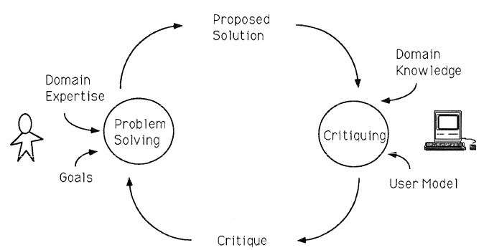
Figure 1 system process for End User Development
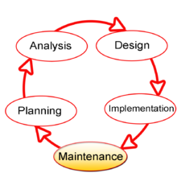
Figure 2 system process for SDLC (systems development life cycle)

System design process
To build this system [9] , several steps are included. Firstly, a main menu sheet (figure 3) should be created and it automate the user activities through recording micro. Data need to download from UK data service and health maps wales.
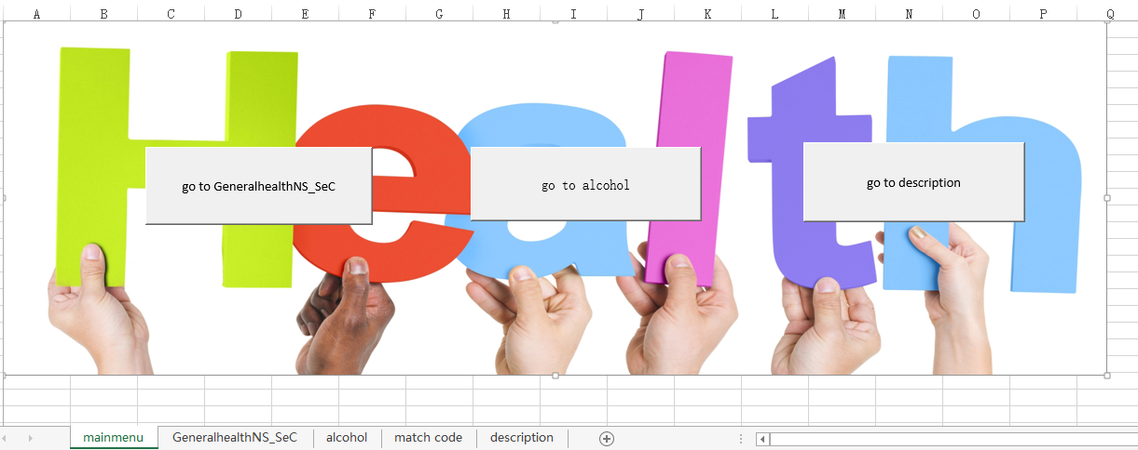
Figure 3 main menu work sheet.
Then analyzing this data is the next step. Calculating some percentage, means and standard deviation (figure 4) is essential to analyze the trends and get some results for healthy state in Swansea. However, other people may want to use this system to do their work and there are some columns meaning that they don’t know possibly. So a description worksheet (figure 5) should also be created.
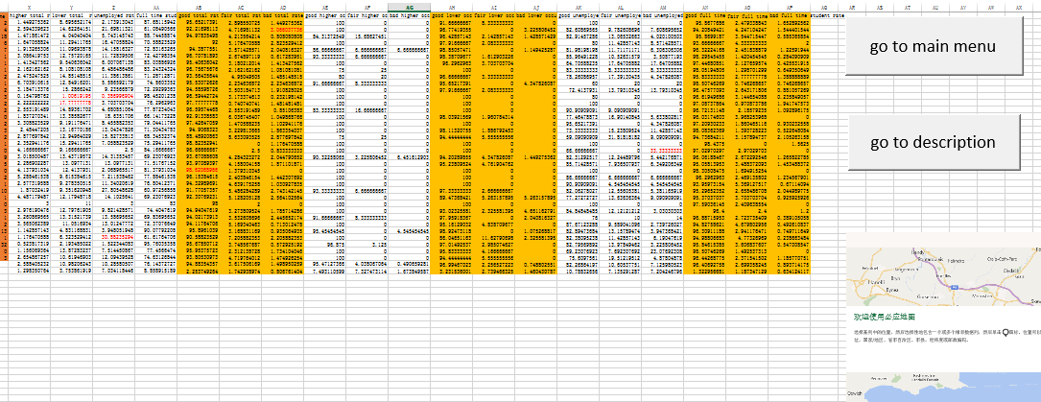
Figure 4 health analysis worksheet
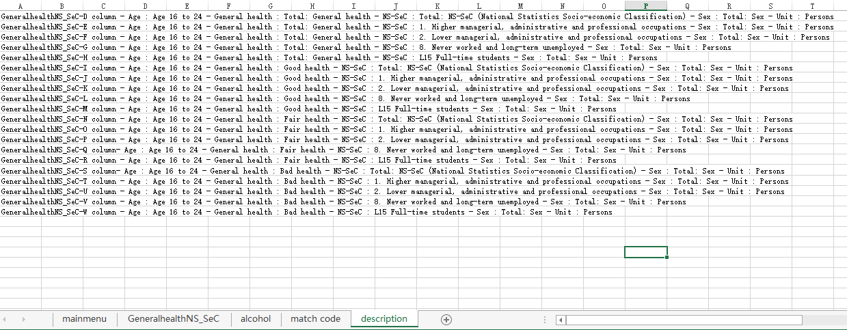
Figure 5 description worksheet
Then match the place code to analyze which class people may lead to alcohol (figure 6). Firstly, A match code file was needed. Then match the code between these two tables. For example, Swansea 001 match Pontardulais.
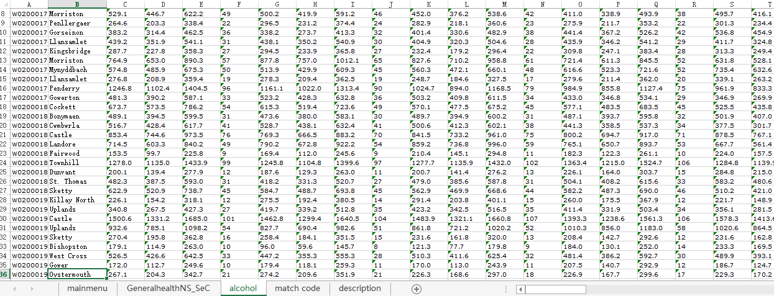
Figure 6 alcohol analysis worksheet

3.4 Flow chart for this system
In conclusion, this is the Flow chart for this system (figure 7).
Figure 7 flow chart for this system

System analysis
This report uses power map to make data visualization and analyze data from three aspects: percentage of occupations (higher occupations, lower occupations, unemployed and full time student), percentage of total healthy state (good, fair, bad) and percentage of healthy state for same occupations.

Percentage of occupations
The proportion of different occupations is different and different regions have different proportion for same occupations.
In Swansea, most people are full time student and less people occupy in higher and professional occupations. Higher occupations need higher educations and skills. This illustrates that there are not enough people who have professional skills and government should encourage people to learn more skills.
AS for different regions (figure 8), Townhill has the highest unemployed rate and Killay North has the least unemployed rate. Gower has the most people who occupy in higher occupations and Killay North has the least people for this.
When it comes to Lower managerial, administrative and professional occupations rate, Killay South has the highest rate.
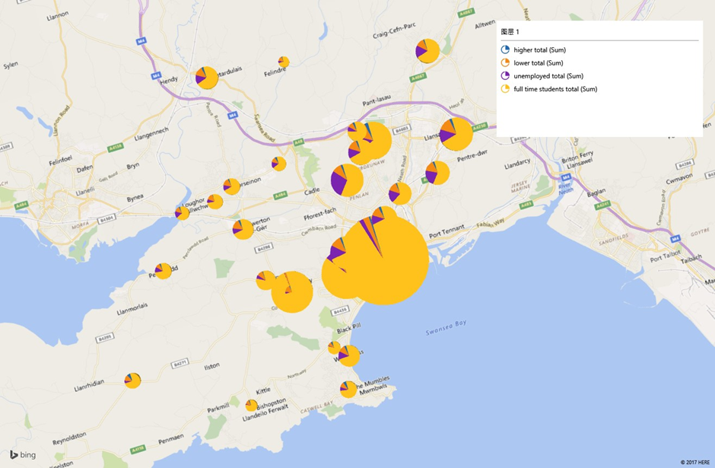
Figure 8 percentage of occupations

Percentage of total healthy state
Most people are enough healthy in most regions. However there are still some regions(figure 9) which have high rate for bad health state, such as Bonymaen..
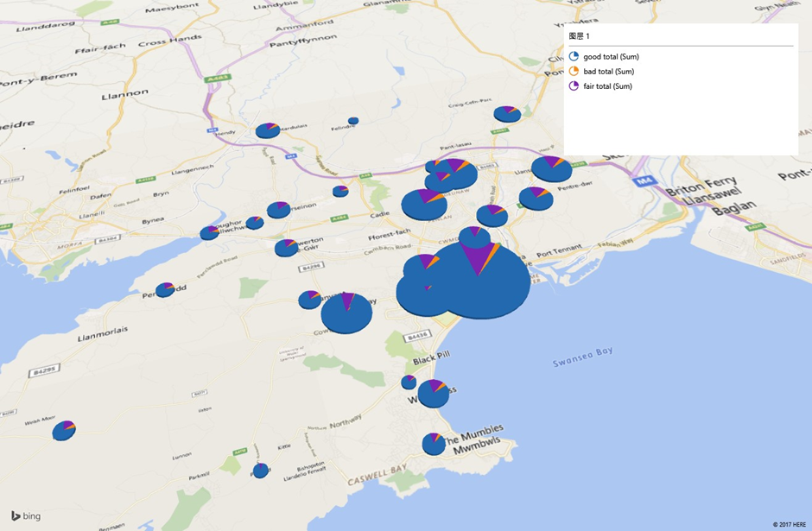
Figure 9 percentage of total healthy state

Percentage of healthy state for same occupations.
People who have different occupations may have different health state. From power map chart, most people are pretty healthy.
For higher occupations, Lower occupations and full time students (figure 10,11,12), their body are in good conditions Although different regions are different, there is no significant fluctuation in general. These people are not particularly inclined to alcohol
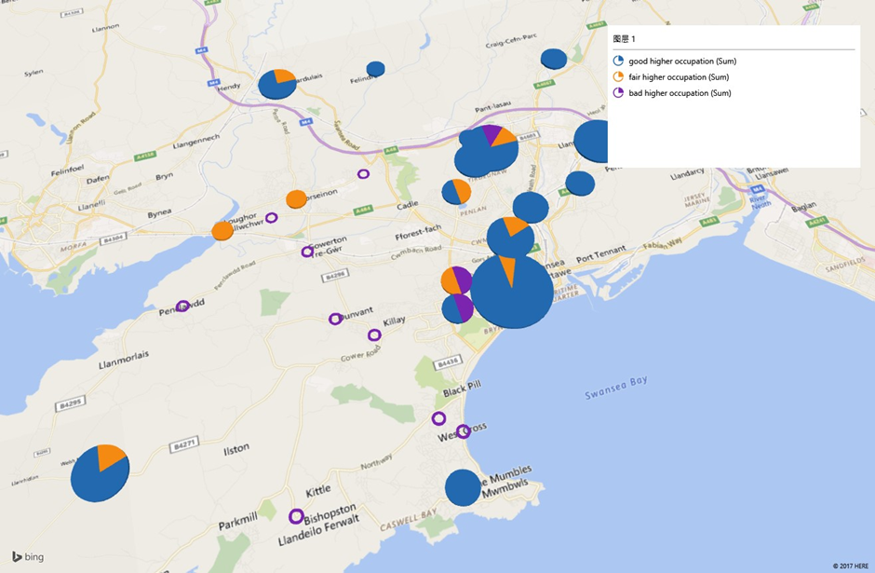
Figure 10 higher occupations health rate

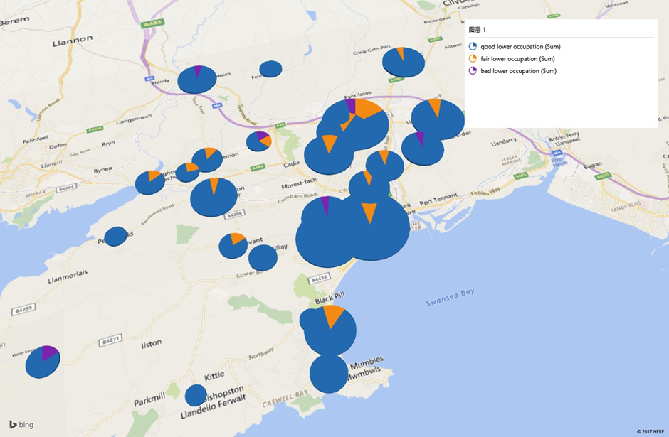
Figure 11 lower occupations health rate
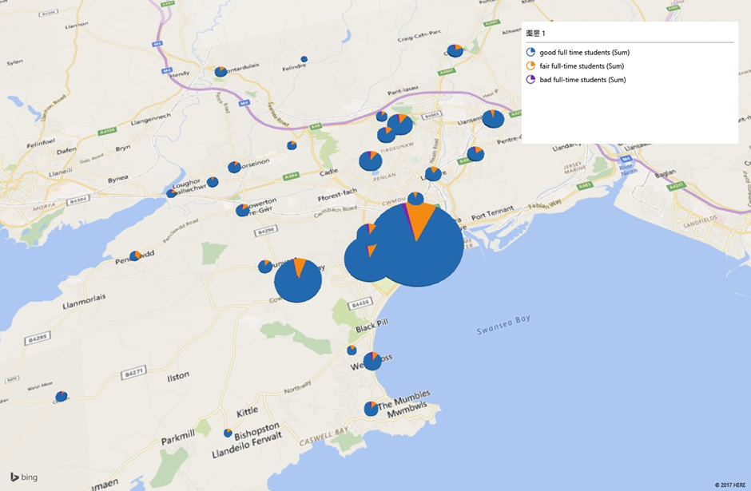
Figure 12 full time students occupations health rate
However, unemployed people’s health state(figure 13) is bad. Only 82% are in good health and there are almost 10% people who are not healthy. Comparing to people who have job and can live by themselves, unemployed people have more pressure than these people and they need to consider more thing about life. This also lead them to alcohol which can cause some diseases. For different region, unemployed people in Mayals has the highest rate to bad health and alcohol.
From power map, it is clear for people to find different regions health state. Government and some organizations can get some policies from these data. For example, they can offer more jobs for some regions and encourage people to education and learn more skills.
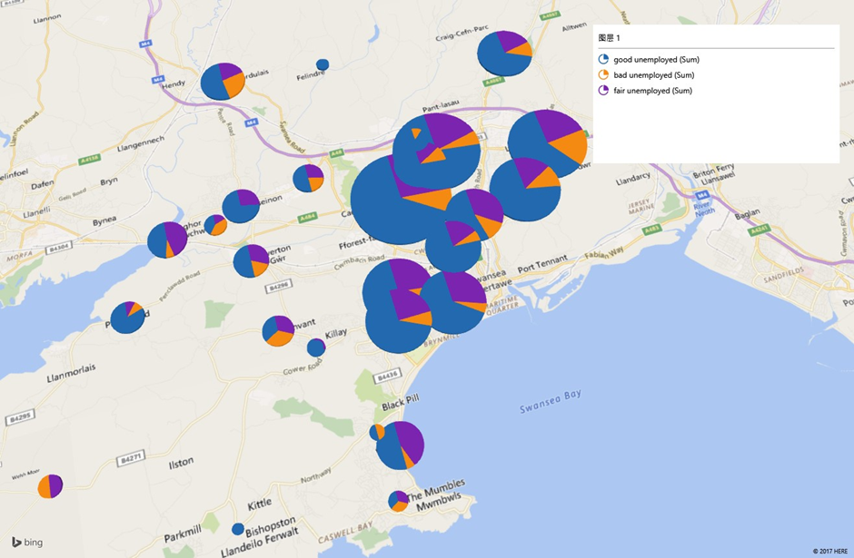
Figure 13 unemployed occupations health rate

5 Advantages and disadvantages of End User Development
From the healthy system in Swansea, a lots of advantages [10] [11] can be concluded for end user development. Everything likes a coin and they have both sides. There are also some disadvantages [12][13] for end user development. To conquer this shortcomings, this report also give some advice for its disadvantages.

5.1 Advantages
1. Users themselves determine the needs of the system to improve the needs and avoid misunderstandings.
2. Users participate in and meet the needs of the user, which makes the system easier to be accepted and more willing to be used.
3. The user controlling the development process of system eliminates the system development barrier between the user and the programmer in the traditional method.
4. Data that only programmers can get before, can be easily obtained in Excel, but Excel also provides abundant map display support, which provides more choices for self service business intelligence, and also reduces the threshold of business intelligence. Big data is not far from users, and it will not be just a patent for the future. With the help of Microsoft's Power BI, it will be closer to users.
5. May help reduce the hidden backlog. End user development overcomes the application software system development method when enterprise cannot independently. According to the actual needs of enterprises, the enterprise developers develop and maintain the management information system, which can adapt to the actual situation of the enterprise. The user are more receptive and willing to use system for their design and development. At the same time, repeating the analysis, development and maintenance, and then analysis the several steps, can enhance the staff of enterprise management information system awareness and understanding. This is conducive to the development and maintenance of the system. Because the responsibility of the development system is transferred from the information system professionals to the end users, the system developed by users helps to reduce the backup resources of the application system.

5.2 Disadvantages
1. Due to the lack of standardized information system analysis, the application system developed by users is lack of independent external evaluation, and there is no independent problem analysis or alternative source, so it is hard for users to fully and comprehensively explain their needs by the system designed by themselves.
2. The professional level of the enterprise staffs varies from person to person and systems are often quickly established. If there is not a formal development method, this kind of system often lack of standards, quality control and proper protection process, may not be used to test and submit the document specification. Systems developed by users may also lack control over integrity and legality of input and update audit records, and lack of operation control, target control and control of interface standards between subsystems.
3. Data are difficult to control.
4. Users can use development tools to build their own private information systems, which can cover some information for other members of the organization. Once the system developers leave their posts, this non - Document private system will not be easily transferred to others.

5.3 Suggestions for disadvantages
Strategy one: The Information Center
Establish an information center [14] in the enterprise as an institution that provides training and support for the end user computer applications.

Strategy two: Management of end user applications
The establishment of multiple small information centers, according to the needs of different business sectors and business functions, provide training and development tools to meet the needs of all types of end-user application developers. At the same time, the organization should incorporate the end user system into the plan to manage and control the end user application development.

Conclusion
In summary, end user development is very useful for non-programmers and pretty simple to create. According to this health system, users can get a lot of information and realize what they should do in the next step. This method is available for end user and more functions can be added in. In the future, this system can be improved by adding more things, such as using VBA language and research more regions.

References
[1] S. Clarke, Evolutionary concepts in end user productivity and performance : applications for organizational progress. Information Science Reference, 2009.
[2] I. Dziac Miu-Jan Manolescu et al., “CCC Publications.”
[3] John Walkenbach, “Defining VBA and Its Uses - dummies.” [Online]. Available: http://www.dummies.com/programming/visual-basic/defining-vba-and-its-uses/. [Accessed: 27-Dec-2017].
[4] “Power Mapping: A Tool for Utilizing Networks,” Power to End Poverty.
[5] G. J. G. Upton, I. (Ian T. . Cook, and Oxford University Press., A dictionary of statistics. Oxford University Press, 2008.
[6] “Software development approaches.” [Online]. Available: http://www.purplezeus.com/software-development-approaches.html. [Accessed: 21-Dec-2017].
[7] R. Kay, “QuickStudy: System Development Life Cycle,” Computerworld, May 2002.
[8] C. Scaffidi, M. Shaw, and B. Myers, “Estimating the Numbers of End Users and End User Programmers,” in 2005 IEEE Symposium on Visual Languages and Human-Centric Computing (VL/HCC’05), 2005, pp. 207–214.
[9] B. A. Nardi, A small matter of programming : perspectives on end user computing. MIT Press, 1993.
[10] “What are the various approaches to developing information systems.” [Online]. Available: https://www.uky.edu/~dsianita/320/ch4.html. [Accessed: 21-Dec-2017].
[11] “End-User Development - Advantages and Disadvantages.” [Online]. Available: http://www.kulzick.com/endusrad.htm. [Accessed: 27-Dec-2017].
[12] M. Koch, “End-user development,” WIRTSCHAFTSINFORMATIK, vol. 48, no. 6, pp. 455–455, Dec. 2006.
[13] B. A. Johnsson and B. Magnusson, “Towards end-user development of graphical user interfaces for internet of things,” Futur. Gener. Comput. Syst., Oct. 2017.
[14] D. Lizcano, G. López, J. Soriano, and J. Lloret, “Implementation of end-user development success factors in mashup development environments,” Comput. Stand. Interfaces, vol. 47, pp. 1–18, Aug. 2016.

