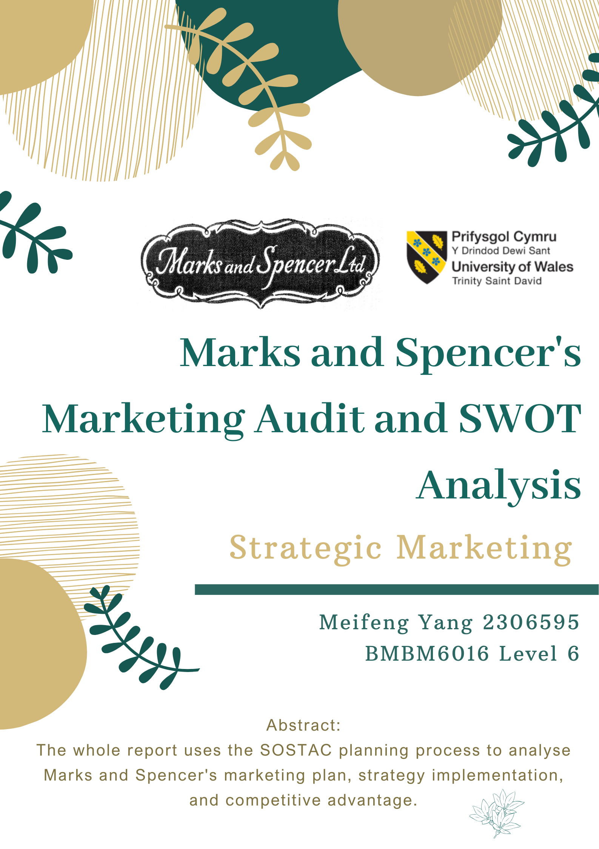
Executive Summary
The whole report uses the SOSTAC planning process to analyse Marks and Spencer's marketing plan, strategy implementation, and competitive advantage. The purpose of this report is to help the business to prevent potential threatening factors and to identify more market opportunities, which will help the business to achieve sustainability in the future.
This report specifically uses PESTEL Analysis to identify that the threatening factor for the business is the change in consumer habits caused by the economic unrest. Porter's Five Forces has been used to identify the competitive factors of the business, which include their strengths in cooperating well with their suppliers but also their weaknesses such as ignoring their competitors who will expand their market reach before they do. The opportunity for the business to gain a competitive advantage through the McKinsey 7 Framework analysis could be the establishment of international partnerships so that they are able to gain access to new customer groups in new markets and increase revenue.
These are all part of the SWOT analysis and the aim is for the business to understand the expansion opportunities in the current market as well as the threats they are facing from external factors. This report will give relevant recommendations which will help the business to improve their current predicament.

Contents Page
1.0 Introduction 4
2.0 Macro Environmental Audit 6
2.1 PESTEL Analysis 6
3.0 Micro Entertainment Audit 7
3.1 Porter’s Five Forces 7
3.2 McKinsey 7 Framework 9
4.0 Internal Audit 11
4.1 SWOT Analysis 11
5.0 Recommendations 13
6.0 Conclusions 15
Reference List 18

1.0 Introduction
The best way to assess the future sustainability and competitive advantage of the business is to use a Marketing Audit. "Marketing Audit refers to a comprehensive and objective analysis of a business's current marketing environment, functions, and activities. The purpose of this is to investigate the effectiveness of marketing activities, deficiencies in marketing strategies, and to improve the return rate and competitiveness of the business by developing strategies (Mokwa, 1986)."

One of the most effective planning process is SOSTAC, which helps companies to develop every important stage in their marketing plan (Reed , 2014).
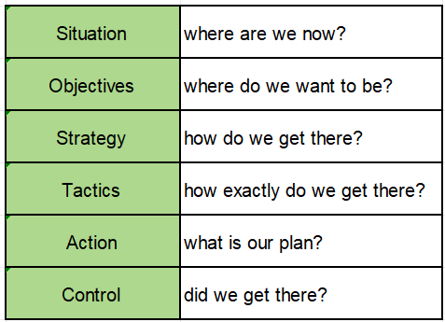
This shows that the planning framework is helpful for companies to analyse the impacts that present in Macro, Micro and Internal, as well as helping companies to plan and control the process of implementing their strategies.

According to the global economic trends, the grocery retail industry is facing many threats and challenges such as the lack of talent in the labour market, lack of available supplies, unstable climate change and political reforms. All these factors are putting a lot of pressure on the retail industry, so there are many small businesses that are facing closure (Ricadela, 2023).

The main subject of this report is Marks and Spencer. "The business was started in 1884 by Michael Marks in partnership with Tom Spencer and is one of the largest retailers located in the UK (M&S, 2022)."
"The vision of the business is to make every moment special for customers providing an exceptional shopping experience through their high quality, own-brand food, clothing, and household products (M&S Carrers, 2023)."

M&S's sustainability plan includes Plan A, which refers to becoming a net zero business across the value chain by 2040. The aim of this programme is that the business wants to reduce carbon emissions, avoid impacts on the climate and support lower-carbon lives (M&S, 2023). This shows that the company is calling on their partners to work together to achieve socially and environmentally beneficial programmes. Such high values can be supported by non-profit organisations and business leaders, and can also help companies gain a competitive advantage.

Of course, a sustainability programme is not enough to prove that a company has a sufficient competitive advantage. The whole report will use the SOSTAC planning process to analyse Marks and Spencer's marketing plan, strategy implementation, and competitive advantage. This will help the organisation to avoid potential threatening factors, identify more business opportunities, and achieve greater sustainability in the future.

2.0 Macro Environmental Audit

2.1 PESTEL Analysis
PESTEL analysis is used by marketers to analyse and monitor how organisations are affected by macro-environmental factors during their operations. This framework includes Political, Economic, Social, Technological, Environmental, and Legislative (Citilci and Akbalik, 2020).

"According to Thissen et al. (2020), the post-Brexit impact of the UK mainly consists of a reduction in UK per capital income by almost £2,000 in 2023 and a reduction in jobs by around two million." This shows that the UK's Brexit has caused a huge unrest in the economic market and it has not fully recovered until now. This factor will also have a direct impact on M&S's annual revenue and performance because most of their revenue comes from the British market.

Also, COVID-19 in 2020 has led to an increase in the price of food in the retail sector, while most consumers desire the same quality and affordable products. For example, Aldi and Lidl took most of the market share in the American market and achieved rapid expansion because customers preferred such quality assured and cheap supermarkets (Ashby and De Leon, 2019). This means that after being through the recession and the epidemic, consumers' habits have changed to crave for cheaper and same quality items. This is a threatening factor for M&S because their products are positioned as high quality, so expensive products are not able to attract a new group of customers, which indirectly leads to a decrease in sales.

3.0 Micro Entertainment Audit

3.1 Porter’s Five Forces
Porter 's Five Forces serves to guide organisations in determining the strength of competition and potential profitableness of the current industry, so it helps organisations to better perceive their strengths and weaknesses. These Five Forces are threat of new entrants, threat of substitutes, bargaining power of suppliers, bargaining power of buyers, and competitor rivalry (Grundy, 2021).

Bargaining power of suppliers means that suppliers have the right to determine the amount of supply and the price of their products to the business, so it is a partnership that the business needs to address and negotiate (Cook, 2023). M&S's bargaining power of suppliers is reflected in the fact that they have a good model of co-operation with their current suppliers. They are able to do work together to develop the uniqueness of the products which is the primary consideration of quality assurance. The products and services of M&S include excellent food quality that meets the modern fashion of the clothing and household business (Grayson, 2011). This shows that the business has a wide range and high quality of the current product range to satisfy the needs and preferences of the customers.
They do not consider lowering the prices to get the attention of the customers because they spend a lot of money to ensure the quality of the products from their suppliers in order to make a good shopping experience for the customers (Ottosson, 1998). This shows that companies want to create unique products and they also want to fulfil the requirement of high quality and creativity in order to gain competitive advantages.

Competitor rivalry is reflected in the fact that they have the ability to diversify and grow more potential in the industry (MaRS, 2019). The weaknesses of M&S in the face of competition from their peers are reflected in the fact that they are excessively focussed on the profitability of the British market. According to Smith (2023), M&S's global total revenue is approximately 11.9 billion, and the most of this comes from 1,064 shops locally in the UK, and only 406 shops around the world. This data proves that the company's business expansion plans are still being implemented slowly, but the highly competitive market will not wait for them to grow. Many of their competitors already have shops all over the world, which could leave the business permanently limited to the local British market, so this could reduce their potential for business growth.

3.2 McKinsey 7 Framework
The McKinsey 7 Framework is used to help organisations to analyse and assess the functioning of all departments and to enable organisations to achieve their targets. These seven elements include strategy, structure, systems, skills, staff, style, and shared values (Singh, 2013). In this, hard areas are used for identification and management while soft areas are the foundation of the organisation. These different areas can help companies to create sustained competitive advantage (Odrakiewicz, 2011).

Currently the best way for companies to gain competitive advantage can be to establish new international partnerships because they do not have a wide enough presence in different regions to attract new customer groups. The opportunity for companies is to find good and trustworthy suppliers in different regions to work with on a long term relationship, and the benefits of this is to expand the companies' reach into new markets and build new customer groups.

M&S's current long-term franchise partners have indicated that the Middle East is a prime location with a strong presence and there is valuable retailer expertise to be learnt in the region (M&S, 2014). This shows that the market conditions in the Middle East are excellent, so businesses should certainly focus on expanding their presence in the Middle East, and ideally build relationships with local suppliers to support this growth plan.

Of course, companies wanting to achieve this strategy need to meet shared values, which means for the core values that are used to build the culture of the organisation. The business has to give norms and standards for the behaviour and decision making of workers and leaders in different regions (Porter and Kramer, 2011). "For example, M&S is committed to paying fair prices to suppliers, supporting local communities and ensuring good working conditions for everyone in their business and supply chain. At the same time, companies' suppliers must meet codes of conduct such as basic ethical and environmental standards (Marks and Spencer, 2023)." This shows that companies expect their good multinational suppliers to meet basic codes of conduct because their willingness to cooperate comes from a desire to meet the needs of more consumers and to provide them with safe and healthy products. They are also willing to commit themselves to providing excellent benefits to their partners and workers, which can increase team loyalty and achieve shared values.

4.0 Internal Audit

4.1 SWOT Analysis
SWOT analysis is used to summarise the key messages from the audit and to analyse the organisation's current competitive position through internal and external factors. This framework specifically analyses the organisation's strengths, weaknesses, opportunities, and threats (Gurel, 2017).

By analysing the internal and external factors of M&S through SWOT, the strengths of the organisation are reflected in the fact that they have a good relationship with their current suppliers. They are able to work together to create branded products with uniqueness for the business and achieve quality and innovation to win competitiveness in the industry.

The weaknesses of the business are that they are overly focussed on the profitability of the British market, which has led to them neglecting their plans for shop expansion in other regions. M&S already has a high quality product, so they are well placed to invest in new markets to increase their profitability. If they continue to maintain the current situation, it will reduce the possibility of finding new potential customers, which will affect their growth rate.

The best opportunity for M&S now is to establish new partnerships across borders because this will help them to learn new and useful retailer expertise in different regions. At the same time, new regions can also bring new sources of customers and good revenues to the business, so companies should immediately expand their business scope towards external market regions. Of course, an integral part of this plan is the formation of a trustworthy supplier management team to help the business work together to achieve the desired targets.

The biggest threat to the business at the moment is the economic unrest in the market because Britain has experienced the Brexit policy and the COVID-19 crackdown. These external factors have led to a change in consumer shopping habits towards cheaper and well quality products which is a huge threat to M&S which is positioned for high quality products. If companies fail to deal with this threatening factor they will lose their competitive advantage and affect their position in the industry.

5.0 Recommendations
Firstly, M&S can use product development and innovative service delivery to meet customer needs. For example, the current predicament of the business includes the fact that their fashion style is not recognised by their customers because their clothing style tends to be conservative and most of the young people do not like the design style which does not have fashionable elements and monotonous colours (Hobbs, 2016). If they want to change this, companies can collaborate with online retailers to include styles of dressing that are consistent with young people and teenagers. They can also provide training and research for the fashion department to do a questionnaire to find out what young customers like. This will better meet the needs of their customers and grow their influence in the industry.

The second suggestion is that in order to prevent external factors such as epidemic closure and control, companies can partner with multiple delivery platforms to provide same day delivery services to their customers. Currently, e-commerce is a big trend in the retail industry because consumers prefer this fast and convenient service (Lumpkin, Droege and Dess, 2002). For example, Amazon covers a wide range of branded products, cheaper prices, and free delivery of most products and other advantages (Onggowidjojo and Ellitan, 2023). This suggests that online shopping and delivery services can better provide convenience to customers and deliver to their doorsteps immediately.
Currently, M&S's home delivery service partner is Deliveroo and this covers 130 products from the business (Plummer, 2020). If the business is able to partner with more platforms, this can support more customers from different regions to place orders for M&S products. Also, companies need to make agreements with local delivery suppliers for the delivery of their items, which can speed up the efficiency of the distribution operation. The business also needs to take good measures to sterilise their items during the epidemic period, this is to safeguard the health and well-being of their staff and consumers. This strategy can increase the number of customer visits to M&S's webpage and placing orders, while increased purchasing power of customers equates to a boost in the marketing amount of the business, so this is a good marketing strategy.

The current dilemma for the business includes an over-focus on the profitability of the British market, which is affecting their plans for multinational shop expansion. So the third recommendation is that in order to prevent the business from making sustained losses, they should immediately expand the supermarket's brand to other regions such as the Middle East and China. Major cities in China are looking for a high quality of life and this fits in with M&S's mission to provide customers with a high quality shopping experience. At the same time, Chinese consumers love to shop online and companies can push more products to be sold on local online platforms in China (Hu and Johnson, 2015). In the long term, this will be a new market with great growth potential, so companies should quickly look at other markets where they have a competitive advantage to improve their performance targets.

6.0 Conclusions
The aim of the whole report is to use Marketing Audit to assess the future sustainability of M&S and achieve competitive advantage.

Through PESTEL Analysis, the economic unrest has caused a decrease in the national income and this has affected the change in habits of the consumer group. The products of the business are generally more expensive, so this will cause their customers to move to other competitors, which will cause a decrease in sales.
Through Porter's Five Forces, the strengths of the business are reflected in the fact that their good relationships with their suppliers have led them to work together to develop these exceptional products, which attracts customers who are focused on eating healthy and living a quality life, which leads to a competitive advantage.
The weaknesses of the business are that their competitors have already reached multinational expansion of shops faster than they have, which could displace M&S's influence in the industry because they have remained in the British market and their global number of shops is not extensive enough.

The opportunity for the business to gain competitive advantage through the McKinsey 7 Framework analysis is to build good relationships with new multinational partners and enter into long term collaborations. New markets can bring in new customers to M&S, so the business should take the opportunity to expand into other market areas.

One of the recommendations to the business is to work with online retailers to incorporate new services and to design new areas of the business in consultation with the operations team by training and researching the favourites of young consumers, which will help to satisfy customer needs.

The second suggestion is for businesses to prevent external factors from causing their marketing volume to be damaged again. They could offer a delivery service to increase the rate of orders from customers because ordering online offers convenience to customers and this would be a good marketing strategy.

The third suggestion is for the business to immediately expand the supermarket's brand into other markets to seek a competitive advantage, such as in China and the Middle East. Consumer groups in these countries have a demand for high-quality products, and companies can also expand their sales channels by promoting their products to local online platforms.

Finally, companies should look towards long-term targets and seek out markets with potential rather than settling for the current situation. Their sustainability programmes need the support of their partners, so they should make strategic changes and work with their suppliers to achieve a marketing plan that will make them more competitive in the industry.

Reference List
Ashby, L. and De Leon, C. (2019). Increasing Access to Food: a Comprehensive Report on Food Increasing Access to Food: a Comprehensive Report on Food Supply Options Supply Options URSP 666 (Commercial Revitalization). [online] VCU, pp.145–148. Available at: https://core.ac.uk/download/pdf/289120945.pdf#page=144 [Accessed 17 Mar. 2024].

Citilci, T. and Akbalik, M. (2020). The Importance of PESTEL Analysis for Environmental Scanning Process. Advances in Marketing, Customer Relationship Management, and E-Services, [online] 16(1), pp.336–357. doi: https://doi.org/10.4018/978-1-7998-2559-3.ch016 [Accessed 18 Mar. 2024].

Cook, B. (2023). Bargaining Power of Suppliers: Overview & Strategy. [online] tipalti.com. Available at: https://tipalti.com/financial-operations-hub/bargaining-power-of-suppliers/ [Accessed 18 Mar. 2024].

Grayson, D. (2011). Embedding Corporate Responsibility and sustainability: Marks & Spencer. Journal of Management Development, 30(10), pp.1017–1026. doi: https://doi.org/10.1108/02621711111182510 [Accessed 18 Mar. 2024].

Grundy, T. (2021). Rethinking and Reinventing Michael Porter’s Five Forces Model. Strategic Change, [online] 15(5), pp.213–229. doi: https://doi.org/10.1002/jsc.764 [Accessed 18 Mar. 2024].

Gurel, E. (2017). SWOT analysis: a Theoretical Review. Journal of International Social Research, 10(51), pp.994–1006. doi: http://dx.doi.org/10.17719/jisr.2017.1832 [Accessed 21 Mar. 2024].

Hobbs, T. (2016). M&S Targets Attitude Not Age to Rebuild Fashion Business – Marketing Week. [online] Marketing Week. Available at: https://www.marketingweek.com/ms-dismisses-segmentation-saying-fashion-attitudes-are-ageless/ [Accessed 19 Mar. 2024].

Hu, T. and Johnson, E. (2015). Marks & Spencer Investment into Greater China. [online] Marks & Spencer. Available at: https://corporate.marksandspencer.com/media/press-releases/marks-spencer-investment-greater-china [Accessed 21 Mar. 2024].

Lumpkin, G.T., Droege, S.B. and Dess, G.G. (2002). E-Commerce Strategies: Achieving Sustainable Competitive Advantage and Avoiding Pitfalls. Organizational Dynamics, [online] 30(4), pp.325–340. doi: https://doi.org/10.1016/s0090-2616(02)00065-7 [Accessed 17 Mar. 2024].

M&S (2014). Mark & Spencer Officially Unveils Its Largest International Store at the View in Kuwait. [online] Marks & Spencer. Available at: https://corporate.marksandspencer.com/media/press-releases/marks-spencer-officially-unveils-its-largest-international-store-view-kuwait [Accessed 21 Mar. 2024].

M&S (2022). Our History. [online] Marks & Spencer. Available at: https://corporate.marksandspencer.com/about-us/our-history [Accessed 17 Mar. 2024].

M&S (2023). Plan A: Our Planet. [online] Plan A: Our Planet. Available at: https://corporate.marksandspencer.com/sustainability/plan-a-our-planet [Accessed 17 Mar. 2024].

M&S Carrers (2023). Who We Are. [online] jobs.marksandspencer.com. Available at: https://jobs.marksandspencer.com/who-we-are [Accessed 17 Mar. 2024].

Marks and Spencer (2023). Human Rights & Our Supply Chain. [online] Marks & Spencer. Available at: https://corporate.marksandspencer.com/sustainability/human-rights-our-supply-chain [Accessed 18 Mar. 2024].

MaRS (2019). Industry Rivalry & Competition | Porter’s Five Forces. [online] MaRS Startup Toolkit. Available at: https://learn.marsdd.com/article/industry-rivalry-and-competition-using-five-forces/ [Accessed 18 Mar. 2024].

Mokwa, M.P. (1986). The Strategic Marketing Audit: an Adoption/Utilization Perspective. Journal of Business Strategy, 6(4), pp.88–95. doi: https://doi.org/10.1108/eb039136 [Accessed 17 Mar. 2024].

Odrakiewicz, P. (2011). The 7-S-McKinsey Model: an Implementation Tool of a Destination Marketing Strategy in the Czech Republic. Global Maanagement Journal, [online] 3(1), pp.46–49. Available at: https://d1wqtxts1xzle7.cloudfront.net/31469002/GMJ_Vol.3-No.-1-2-2011-libre.pdf?1392332431=&response-content-disposition=inline%3B+filename%3DThe_Effectiveness_of_Performance_Apprai.pdf&Expires=1710799837&Signature=eFzGY2fFyF~obwiDo~l04qPt5pCjdwpv9q6W9UWtb21Oh7Jqm0l2S~Ubz2jcJpy4XJFvf1VY-nfKJDMKGjdXxCFEmDbdMkCh1xMx44nu3nFDGS5AFzc5dDGYiwk2R142-WE69A~LU3kS-27D~q78aBtlzMz9mjCPby339DVHQdHmVaabJ-TzmhydLJ~aMlpZghOsz4dU1K0jQqzsf51VmnfhVmvUgCQNBHTOyh9QChEZ7SDCx0k5UQ7KdjHe4iRldObyY7i8QLPgmX33yhBLe89Xvo7pAeGDedvVdfHT8ZGwNYCr7DEQXhkS44zMM7aOlHBqYy-lCX2JyVG1P0xLzg__&Key-Pair-Id=APKAJLOHF5GGSLRBV4ZA#page=46 [Accessed 18 Mar. 2024].

Onggowidjojo, V. and Ellitan, L. (2023). Strategies for Achieving Competitive Advantage: the Case of Amazon. Zenodo (CERN European Organization for Nuclear Research), 10(9), pp.252–253. doi: https://doi.org/10.5281/zenodo.8373836 [Accessed 17 Mar. 2024].

Ottosson, S. (1998). Strategic Considerations of the Interplay between R&D and M&S. Technovation, [online] 18(4), pp.235–244. doi: https://doi.org/10.1016/s0166-4972(97)00122-3 [Accessed 18 Mar. 2024].

Plummer, R. (2020). Marks and Spencer Extends 30-minute Home Delivery Service. BBC News. [online] 5 May. Available at: https://www.bbc.co.uk/news/business-52545028 [Accessed 21 Mar. 2024].

Porter, M. and Kramer, M. (2011). Creating Shared Value How to Reinvent capitalism-and Unleash a Wave of Innovation and Growth. [online] HBR.ORG, pp.6–7. Available at: https://moodle.luniversitenumerique.fr/pluginfile.php/6274/mod_folder/content/0/8.%20La%20valeur%20partage%CC%81e%20-%20Micheal%20Porter.pdf [Accessed 18 Mar. 2024].

Reed , D. (2014). SOSTAC: the Guide to the Perfect Digital Marketing Plan. Journal of Direct, Data and Digital Marketing Practice, [online] 16(2), pp.146–147. doi: https://doi.org/10.1057/dddmp.2014.79 [Accessed 17 Mar. 2024].

Ricadela, A. (2023). Economic Impact on Supermarkets and Grocery Stores. [online] Oracle.com. Available at: https://www.oracle.com/retail/grocery/grocery-stores-economy/ [Accessed 17 Mar. 2024].

Singh, A. (2013). A Study of Role of McKinsey’s 7S Framework in - ProQuest. Organization Development Journal, [online] 31(3), pp.39–50. Available at: https://www.proquest.com/docview/1467437673?pq-origsite=gscholar&fromopenview=true&sourcetype=Scholarly%20Journals [Accessed 18 Mar. 2024].

Smith, P. (2023). Marks & Spencer Revenue 2010-2018 | Statistic. [online] Statista. Available at: https://www.statista.com/statistics/413349/group-revenue-marks-and-spencer-mands/ [Accessed 18 Mar. 2024].

Thissen, M., van Oort, F., McCann, P., Ortega-Argilés, R. and Husby, T. (2020). The Implications of Brexit for UK and EU Regional Competitiveness. Economic Geography, [online] 96(5), pp.1–25. doi: https://doi.org/10.1080/00130095.2020.1820862 [Accessed 18 Mar. 2024].

