University of Wales Trinity St David

Wales Institute of Science & Art



Engine Performance Characteristics

Motorsport Technology (ACHA4012)

Hugo Upsall

2205193

March 2023

Table of Contents
Introduction 2
Equipment and Methodology 3
Equipment 3
Methodology 5
Results 6
Data Comparison Graphs 9
Conclusion 13
Evaluation 14
References 15

Introduction
An engine dynamometer test was conducted on a 1988 Honda 1.6L D16 engine to gather data surrounding its engine performance characteristics for analysis. The gathering of this information allows potential for observation into the characteristics of the engine under varying levels of stress, and for comparisons to be drawn between different data points such as Torque (measured in Nm) and Engine Speed (measured in RPM).

Further calculations and conclusions can then be made based off of these findings surrounding the natural performance characteristics of this engine.

Equipment and Methodology

Equipment
The engine dynamometer used was a Schenck WS230 made in 2018 (figure 1), and the engine used for testing was a 1988 Honda 1.6L D16 (figure 2). These had attached to them an exhaust extraction system, fuel supply board, flow meter, lambda sensor, and sensor recording modules.
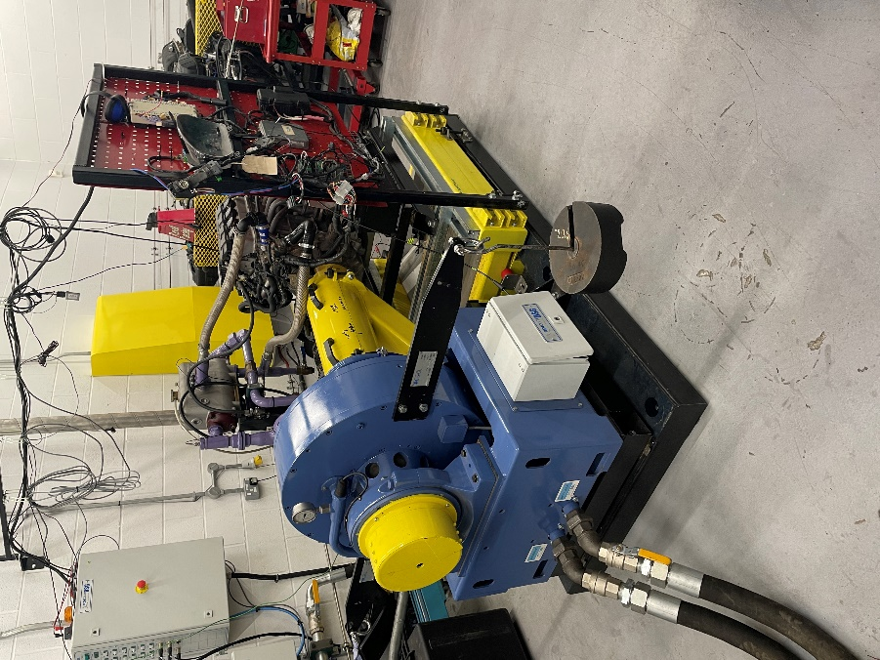
Figure 1
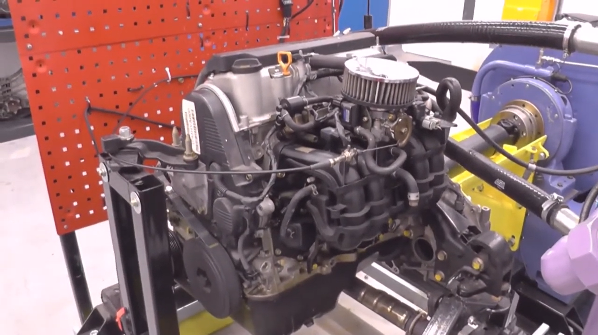
Figure 2 - (Fall, 2020)

The engine was then controlled and monitored from the dynamometer cell using computers.

Methodology
To begin the test the engine was started and brought to idle. It was then possible to adjust the engine speed (RPM) and torque load supplied by the dynamometer (Newtons) manually. Both engine speed and torque load were gradually increased to allow for steady stream of accurate data collection.

Once a certain point was reached torque load began to be slowly decreased while engine speed continued to be increased. This then remained the same until the engine speed reached around 5500rpm, at which time the data required from the engine had been gathered successfully.

The engine speed and torque load were then gradually decreased until the engine was brought back to idle, and then shut off.

Results
Here, the raw results gathered from the test are presented in a table (figure 3). This also includes further calculations made to determine values for Power, Torque, Work Done (WD), Mean Effective Pressure (MEP), Specific Fuel Consumption (SFC), and Thermal Efficiency, which are all values not originally collected from the test.

Load | Dyno Speed | Fuel Flow Rate | Lambda | Power | Power | Torque | WD | MEP | SFC | Thermal Efficiency
Newtons | rpm | l/min | Lambda | kW | BHP | Nm | J | Pa | kg/kWh | %
102.275 | 1000 | 0.0704 | 1.2658 | 8.737135 | 11.71667 | 83.43349 | 524.2281 | 659227.5785 | 0.362590992 | 0.275793393
102.756 | 1050 | 0.0724 | 1.26783 | 9.217137 | 12.36036 | 83.82588 | 526.6935 | 662327.9301 | 0.353472732 | 0.28290782
103.689 | 1100 | 0.0737 | 1.27344 | 9.743723 | 13.06653 | 84.587 | 531.4758 | 668341.7099 | 0.34037367 | 0.293795346
104.209 | 1150 | 0.0728 | 1.28476 | 10.2377 | 13.72897 | 85.0112 | 534.1411 | 671693.4415 | 0.319994232 | 0.312506258
105.811 | 1200 | 0.0744 | 1.29181 | 10.84705 | 14.54611 | 86.31807 | 542.3525 | 682019.3528 | 0.308655991 | 0.323985936
107.51 | 1250 | 0.07895 | 1.29729 | 11.48044 | 15.3955 | 87.70408 | 551.061 | 692970.4909 | 0.309461837 | 0.323142268
109.488 | 1300 | 0.079 | 1.29895 | 12.15932 | 16.3059 | 89.31768 | 561.1996 | 705719.962 | 0.292368821 | 0.34203442
111.797 | 1350 | 0.0796 | 1.29469 | 12.89328 | 17.29015 | 91.20131 | 573.0347 | 720602.939 | 0.277819669 | 0.359946437
114.268 | 1400 | 0.0835 | 1.2855 | 13.66634 | 18.32683 | 93.21709 | 585.7003 | 736530.1094 | 0.274946157 | 0.363708302
115.783 | 1450 | 0.0847 | 1.27818 | 14.34209 | 19.23303 | 94.45299 | 593.4657 | 746295.2502 | 0.265756839 | 0.376284578
116.985 | 1500 | 0.08865 | 1.2795 | 14.99067 | 20.10279 | 95.43356 | 599.6267 | 754042.9065 | 0.266116095 | 0.375776595
117.788 | 1550 | 0.0932 | 1.27766 | 15.59668 | 20.91547 | 96.08862 | 603.7426 | 759218.7535 | 0.268903842 | 0.37188089
118.471 | 1600 | 0.0959 | 1.28235 | 16.19316 | 21.71535 | 96.6458 | 607.2435 | 763621.1239 | 0.266501962 | 0.37523251
118.772 | 1650 | 0.09875 | 1.29028 | 16.74162 | 22.45085 | 96.89135 | 608.7863 | 765561.2608 | 0.265431787 | 0.376745382
118.656 | 1700 | 0.10005 | 1.29942 | 17.2321 | 23.10859 | 96.79672 | 608.1917 | 764813.5669 | 0.261271662 | 0.382744149
118.861 | 1750 | 0.10305 | 1.31053 | 17.76957 | 23.82935 | 96.96395 | 609.2425 | 766134.9226 | 0.260966288 | 0.383192024
119.584 | 1800 | 0.1093 | 1.3149 | 18.38845 | 24.65928 | 97.55376 | 612.9483 | 770795.1185 | 0.267478218 | 0.373862967
119.934 | 1850 | 0.11415 | 1.31849 | 18.95455 | 25.41844 | 97.83928 | 614.7423 | 773051.0916 | 0.271004005 | 0.368998975
120.176 | 1900 | 0.11745 | 1.31892 | 19.50612 | 26.1581 | 98.0367 | 615.9827 | 774610.9359 | 0.270953968 | 0.369067118
120.948 | 1950 | 0.12055 | 1.31484 | 20.14804 | 27.01893 | 98.66648 | 619.9398 | 779586.9681 | 0.269245065 | 0.371409593
122.157 | 2000 | 0.12555 | 1.31653 | 20.87122 | 27.98873 | 99.65275 | 626.1367 | 787379.7439 | 0.270696227 | 0.369418521
122.845 | 2050 | 0.12785 | 1.32098 | 21.51349 | 28.85002 | 100.214 | 629.6631 | 791814.3425 | 0.267425753 | 0.373936313
123.796 | 2100 | 0.1309 | 1.32287 | 22.20882 | 29.78247 | 100.9898 | 634.5377 | 797944.1438 | 0.265233013 | 0.377027726
124.794 | 2150 | 0.13435 | 1.32164 | 22.9209 | 30.73739 | 101.804 | 639.6531 | 804376.89 | 0.263766323 | 0.379124214
125.137 | 2200 | 0.1377 | 1.31652 | 23.51841 | 31.53866 | 102.0838 | 641.4112 | 806587.7437 | 0.263474968 | 0.379543456
126.028 | 2250 | 0.14105 | 1.30465 | 24.22418 | 32.48511 | 102.8106 | 645.9782 | 812330.8067 | 0.262021765 | 0.381648448
126.66 | 2300 | 0.14495 | 1.29646 | 24.88667 | 33.37353 | 103.3262 | 649.2176 | 816404.4497 | 0.262098623 | 0.381536533
126.822 | 2350 | 0.14985 | 1.28229 | 25.46021 | 34.14265 | 103.4583 | 650.0479 | 817448.6429 | 0.26485497 | 0.37756588
126.69 | 2400 | 0.1537 | 1.27304 | 25.97485 | 34.8328 | 103.3507 | 649.3714 | 816597.8188 | 0.266277291 | 0.375549112
126.552 | 2450 | 0.15565 | 1.26984 | 26.48711 | 35.51975 | 103.2381 | 648.664 | 815708.3208 | 0.264440438 | 0.378157746
126.438 | 2500 | 0.1596 | 1.27446 | 27.00332 | 36.21199 | 103.1451 | 648.0797 | 814973.5181 | 0.265967824 | 0.375986081
126.239 | 2550 | 0.1626 | 1.27876 | 27.50004 | 36.8781 | 102.9827 | 647.0597 | 813690.8363 | 0.266072907 | 0.375837589
126.161 | 2600 | 0.16805 | 1.27634 | 28.02193 | 37.57797 | 102.9191 | 646.6599 | 813188.0765 | 0.269869551 | 0.370550141
125.847 | 2650 | 0.17145 | 1.28027 | 28.48973 | 38.20529 | 102.663 | 645.0504 | 811164.1463 | 0.270808685 | 0.369265114
124.911 | 2700 | 0.17465 | 1.28371 | 28.81138 | 38.63663 | 101.8994 | 640.2528 | 805131.0296 | 0.272783427 | 0.366591919
123.927 | 2750 | 0.1784 | 1.2812 | 29.11375 | 39.04212 | 101.0967 | 635.2091 | 798788.5223 | 0.275746532 | 0.362652611
123.689 | 2800 | 0.18005 | 1.27448 | 29.58616 | 39.67564 | 100.9025 | 633.9892 | 797254.4606 | 0.273853223 | 0.365159844
123.389 | 2850 | 0.1831 | 1.26036 | 30.04145 | 40.28618 | 100.6578 | 632.4515 | 795320.7693 | 0.274271625 | 0.364602791
122.519 | 2900 | 0.1879 | 1.2531 | 30.35296 | 40.70392 | 99.94806 | 627.9922 | 789713.0646 | 0.278573101 | 0.358972922
121.837 | 2950 | 0.19255 | 1.23943 | 30.70441 | 41.17523 | 99.3917 | 624.4965 | 785317.1398 | 0.282199442 | 0.354360021
121.709 | 3000 | 0.199 | 1.22735 | 31.19202 | 41.82912 | 99.28728 | 623.8404 | 784492.0982 | 0.287093241 | 0.34831959
121.123 | 3050 | 0.20605 | 1.2193 | 31.5592 | 42.32152 | 98.80924 | 620.8367 | 780714.9547 | 0.293805554 | 0.340361844
121.124 | 3100 | 0.21005 | 1.20692 | 32.07683 | 43.01567 | 98.81005 | 620.8419 | 780721.4003 | 0.294675906 | 0.339356554
120.851 | 3150 | 0.21605 | 1.19274 | 32.52073 | 43.61096 | 98.58735 | 619.4426 | 778961.7412 | 0.298956024 | 0.334498027
120.596 | 3200 | 0.21795 | 1.18481 | 32.96723 | 44.20971 | 98.37932 | 618.1355 | 777318.1037 | 0.29750059 | 0.336134459
120.84 | 3250 | 0.22305 | 1.17378 | 33.55008 | 44.99133 | 98.57837 | 619.3862 | 778890.8392 | 0.29917272 | 0.334255744
121.633 | 3300 | 0.2255 | 1.16118 | 34.2898 | 45.9833 | 99.22528 | 623.4508 | 784002.2298 | 0.295934112 | 0.337913732
122.181 | 3350 | 0.2285 | 1.15104 | 34.96617 | 46.89033 | 99.67233 | 626.2597 | 787534.4392 | 0.294070569 | 0.340055111
122.933 | 3400 | 0.2342 | 1.14117 | 35.70647 | 47.88309 | 100.2858 | 630.1142 | 792381.5586 | 0.295157167 | 0.338803224
123.475 | 3450 | 0.23605 | 1.12669 | 36.39131 | 48.80147 | 100.7279 | 632.8923 | 795875.0941 | 0.291890335 | 0.342595105
123.428 | 3500 | 0.24195 | 1.11975 | 36.90467 | 49.4899 | 100.6896 | 632.6514 | 795572.1492 | 0.29502426 | 0.338955854
124.205 | 3550 | 0.24545 | 1.10622 | 37.66752 | 50.51289 | 101.3235 | 636.6341 | 800580.4095 | 0.293230705 | 0.341029089
124.066 | 3600 | 0.25505 | 1.09697 | 38.1553 | 51.16701 | 101.2101 | 635.9216 | 799684.4659 | 0.300804194 | 0.332442839
123.967 | 3650 | 0.25755 | 1.09401 | 38.65436 | 51.83627 | 101.1293 | 635.4142 | 799046.3478 | 0.299830935 | 0.333521957
123.815 | 3700 | 0.26445 | 1.09659 | 39.13583 | 52.48193 | 101.0053 | 634.6351 | 798066.6109 | 0.304076197 | 0.328865597
123.767 | 3750 | 0.2651 | 1.09808 | 39.64931 | 53.17052 | 100.9661 | 634.389 | 797757.2203 | 0.300875923 | 0.332363583
123.509 | 3800 | 0.2693 | 1.09907 | 40.09422 | 53.76715 | 100.7557 | 633.0666 | 796094.2458 | 0.302251171 | 0.330851324
122.672 | 3850 | 0.27375 | 1.10533 | 40.34649 | 54.10544 | 100.0729 | 628.7764 | 790699.2472 | 0.305324597 | 0.327520943
122.157 | 3900 | 0.2759 | 1.11704 | 40.69888 | 54.57802 | 99.65275 | 626.1367 | 787379.7439 | 0.30505811 | 0.327807053
121.184 | 3950 | 0.28285 | 1.12259 | 40.89234 | 54.83744 | 98.859 | 621.1494 | 781108.1385 | 0.311263104 | 0.321272257
120.004 | 4000 | 0.28455 | 1.12461 | 41.00674 | 54.99086 | 97.89638 | 615.1011 | 773502.2863 | 0.31226026 | 0.320246323
118.734 | 4050 | 0.2871 | 1.1222 | 41.07993 | 55.089 | 96.86035 | 608.5915 | 765316.3266 | 0.314497292 | 0.317968397
117.442 | 4100 | 0.28895 | 1.12394 | 41.13456 | 55.16227 | 95.80636 | 601.9691 | 756988.5629 | 0.316103456 | 0.316352758
116.5 | 4150 | 0.29305 | 1.12233 | 41.30224 | 55.38712 | 95.0379 | 597.1408 | 750916.7723 | 0.319287226 | 0.313198249
115.931 | 4200 | 0.2949 | 1.12179 | 41.5957 | 55.78066 | 94.57373 | 594.2243 | 747249.2046 | 0.319036036 | 0.313444843
115.034 | 4250 | 0.29715 | 1.12456 | 41.76521 | 56.00799 | 93.84198 | 589.6265 | 741467.4677 | 0.32016542 | 0.312339165
114.391 | 4300 | 0.3022 | 1.12278 | 42.02037 | 56.35015 | 93.31743 | 586.3307 | 737322.9228 | 0.323629415 | 0.308996017
114.016 | 4350 | 0.30605 | 1.11943 | 42.36962 | 56.81851 | 93.01152 | 584.4086 | 734905.8087 | 0.325050745 | 0.307644887
113.871 | 4400 | 0.3092 | 1.11986 | 42.80213 | 57.39851 | 92.89323 | 583.6654 | 733971.1913 | 0.325077951 | 0.30761914
113.985 | 4450 | 0.3099 | 1.11873 | 43.33185 | 58.10888 | 92.98623 | 584.2497 | 734705.994 | 0.321830872 | 0.310722832
113.306 | 4500 | 0.31445 | 1.11563 | 43.5577 | 58.41175 | 92.43232 | 580.7694 | 730329.4061 | 0.324862826 | 0.307822848
113.074 | 4550 | 0.3171 | 1.10953 | 43.9515 | 58.93984 | 92.24306 | 579.5802 | 728834.0182 | 0.324665342 | 0.308010087
112.195 | 4600 | 0.3194 | 1.10569 | 44.08906 | 59.12432 | 91.52599 | 575.0747 | 723168.3028 | 0.325999863 | 0.306749209
111.061 | 4650 | 0.32055 | 1.09782 | 44.11782 | 59.16288 | 90.6009 | 569.2622 | 715858.9498 | 0.326960349 | 0.305848095
109.973 | 4700 | 0.3207 | 1.09558 | 44.15536 | 59.21323 | 89.71333 | 563.6855 | 708846.0962 | 0.326835235 | 0.305965176
108.654 | 4750 | 0.32485 | 1.08827 | 44.08988 | 59.1254 | 88.63733 | 556.9247 | 700344.3003 | 0.331556375 | 0.301608437
107.076 | 4800 | 0.32455 | 1.08396 | 43.90691 | 58.88005 | 87.35003 | 548.8364 | 690173.0843 | 0.332630507 | 0.300634482
105.24 | 4850 | 0.3257 | 1.08221 | 43.60358 | 58.47327 | 85.85227 | 539.4257 | 678338.8937 | 0.336131351 | 0.297503341
103.632 | 4900 | 0.3277 | 1.0846 | 43.38 | 58.17344 | 84.5405 | 531.1836 | 667974.3086 | 0.339938475 | 0.294171467
102.335 | 4950 | 0.32845 | 1.08823 | 43.27419 | 58.03155 | 83.48244 | 524.5356 | 659614.3167 | 0.341549547 | 0.292783875
101.106 | 5000 | 0.3287 | 1.08687 | 43.18635 | 57.91376 | 82.47985 | 518.2362 | 651692.6282 | 0.342504759 | 0.29196733
99.3149 | 5050 | 0.32985 | 1.0891 | 42.84551 | 57.45669 | 81.01871 | 509.0556 | 640147.8468 | 0.346437217 | 0.288653168
97.5815 | 5100 | 0.3297 | 1.09185 | 42.51451 | 57.01281 | 79.60465 | 500.1707 | 628974.9787 | 0.348975647 | 0.28655352
95.8486 | 5150 | 0.33095 | 1.09407 | 42.16893 | 56.54937 | 78.19099 | 491.2885 | 617805.3334 | 0.353169526 | 0.283150704
94.8033 | 5200 | 0.3338 | 1.09346 | 42.11399 | 56.4757 | 77.33826 | 485.9306 | 611067.7085 | 0.356675578 | 0.280367387
93.0976 | 5250 | 0.3313 | 1.08804 | 41.75393 | 55.99285 | 75.94679 | 477.1877 | 600073.3846 | 0.357056947 | 0.28006793
91.7886 | 5300 | 0.3324 | 1.08339 | 41.55891 | 55.73133 | 74.87894 | 470.4782 | 591636.0451 | 0.35992353 | 0.277837351
90.5938 | 5350 | 0.3308 | 1.08007 | 41.40491 | 55.52481 | 73.90425 | 464.3541 | 583934.7973 | 0.359523334 | 0.27814662
89.6374 | 5400 | 0.3388 | 1.07895 | 41.35067 | 55.45208 | 73.12404 | 459.4519 | 577770.1896 | 0.368700928 | 0.271223076
88.9256 | 5450 | 0.3438 | 1.07923 | 41.40215 | 55.52111 | 72.54337 | 455.8034 | 573182.1848 | 0.373677033 | 0.267611309
88.6474 | 5500 | 0.3488 | 1.08366 | 41.65127 | 55.85518 | 72.31642 | 454.3775 | 571389.0085 | 0.376844017 | 0.265362313
Figure 3

Further calculations beyond that of original data gathered from the dynamometer were made using formulas provided by Summerfield in 2020:

Power (kW):
Torque (Nm): T = WR

W.D (J): W.D = 2πT

MEP (Pa): $MEP= \frac{2W.D}{LAn}$

SFC (kg/kWh):

Thermal efficiency (%): $η_{t}=\frac{BP (kW)}{S.F.C ×C.V}$

(Summerfield, 2020)

Data Comparison Graphs
In figure 4 a plotted graph is shown comparing Engine Speed to SFC using the data above.

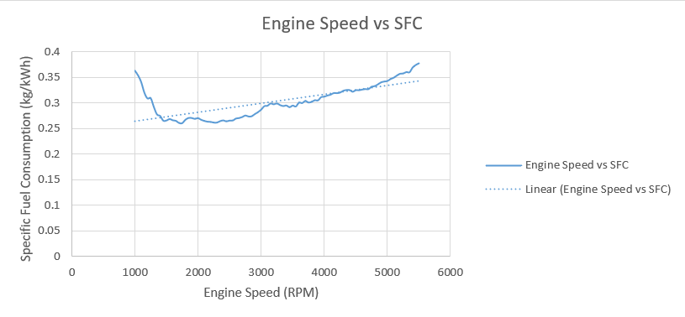
Figure 4
SFC is a measure of how efficient an engine is at producing energy from its fuel over a given time frame (Summerfield, 2020). The lower this value, the more efficient an engine is at producing power while using less fuel.

As can be observed above, when the engine speed is 1000rpm the SFC value is relatively high at 0.37 kg/kWh. This is likely due to there being incomplete combustion of fuel at very low RPM, however as engine speed increases the SFC decreases. As RPM increases slightly it allows for a more complete combustion of fuel, meaning the engine becomes more efficient at producing energy.

When engine speed is increased to around 5000rpm the SFC also rises to about 0.34 kg/kWh. According to Thomaz et al in 2020, higher engine speeds result in an increase of frictional losses and thus lead to a decrease in engine efficiency (Thomaz & Baeta, 2020).

As a result, figure 4 above takes a very similar shape to that of many other engines and is what can be generally expected when comparing SFC to engine speed. It can be assumed that, in general, SFC of this engine increases with engine speed as indicated by the trendline, since a car under normal driving conditions will likely spend the majority of its time above 1000rpm.

In figure 5 a plotted graph is shown comparing Torque to Engine Speed using data from the results table.

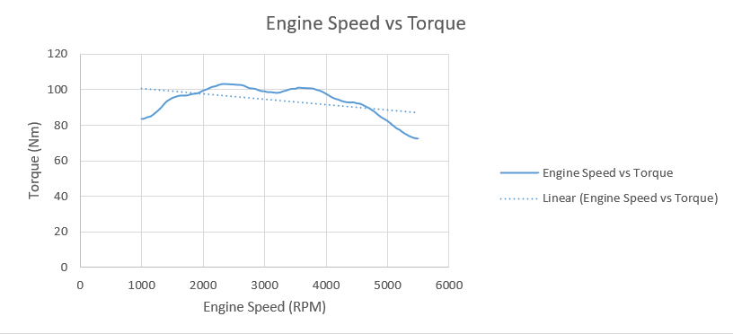
Figure 5
At the minimum engine speed of 1000rpm the torque reads at roughly 83Nm, however at 2500rpm the torque produced increases to around 102Nm. This increase in torque in accordance with a rise in engine speed is likely due to a more efficient burning of the fuel. Torque levels then remain the same until they start to decrease once engine speeds climb to around 4000rpm, dropping significantly to just over 60Nm once engine speeds reach 5500rpm.

Similar to the relationship between engine speed and SFC, this reduction in torque at higher engine speeds is a result of an increase in frictional losses inside the engine. According to Susilo in 2020, higher engine speeds can also result in imperfect cylinder filling due to a smaller overall volume of air to fuel mixture. This can lead to ‘floating’, which is where suction and exhaust valves struggle to close in time and cannot create the desired level of vacuum or suction, thus resulting in a reduction of torque (Susilo, 2020).

In figures 6 and 7 plotted graphs are shown comparing Brake Power to Engine Speed using data from the results table. Figure 6 shows Brake Power measured in kW, and figure 7 shows Brake Power measured in BHP.

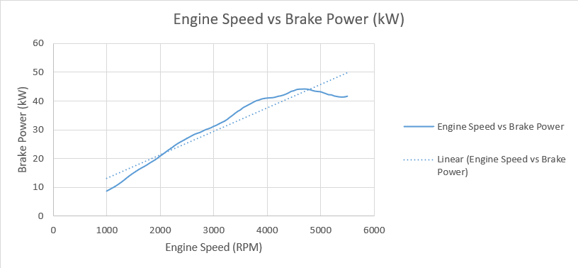
Figure 6
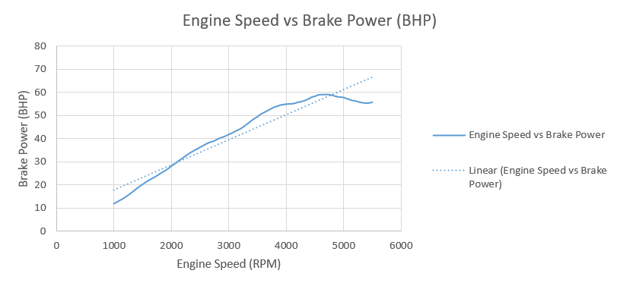
Figure 7
In these graphs the general trend for this engine is that brake power increases as engine speed increases, until engine speed reaches about 4500rpm. Here, brake power plateaus temporarily at around 44kW until speeds of 4800rpm are achieved, at which point brake power decreases to about 41kW.

Power increases in this fashion due to the engine speed increasing, in turn the engine is expected to draw in more air and fuel, the cylinders moving and filling correctly, allowing for a greater output of power. However, engine speeds reach a certain point that, while rpm can still increase, will not result in a gain in power. This is down to increased frictional losses due to the engine working faster.

In general, it can be seen that this graph generated when comparing engine speed to brake power is consistent with that which can be found from other cars. For example, figure 8 shows a graph containing engine speed compared to power and torque from a 6.2L Hemi Hellcat engine.

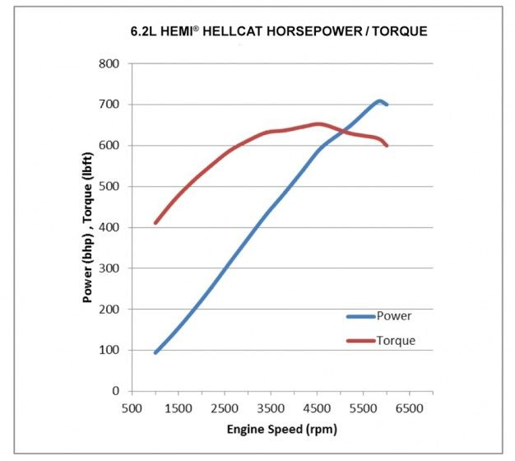
Figure 8 - (Sherman, 2016)

When compared with the engine used for our testing purposes, similarities can be seen between the graphs. For example, in figure 8 the engine power keeps climbing until an engine speed of 5300rpm is achieved. Beyond this, the power drops marginally from just over 700bhp to exactly 700bhp. As a result, it can be concluded that engine power losses occur when engine speeds reach near their respective limit, and that this loss is consistent across the vast majority of internal combustion engines. However, levels of power losses may differ from engine to engine.

Conclusion
In conclusion, it can be observed that an increase in engine speed results in an increase of many other data values. This includes power, torque, work done, MEP, and fuel flow rate. However, some values decrease with increased engine power, such as lambda.

This measures the level of oxygen in a vehicle’s exhaust gases, and the closer the value measured to 1 the better. Over 1 indicates a rich fuel-air mixture and that there is not enough air, resulting in less efficiency. Under 1 indicates a lean fuel-air mixture and that there is too much air, also giving the same result.

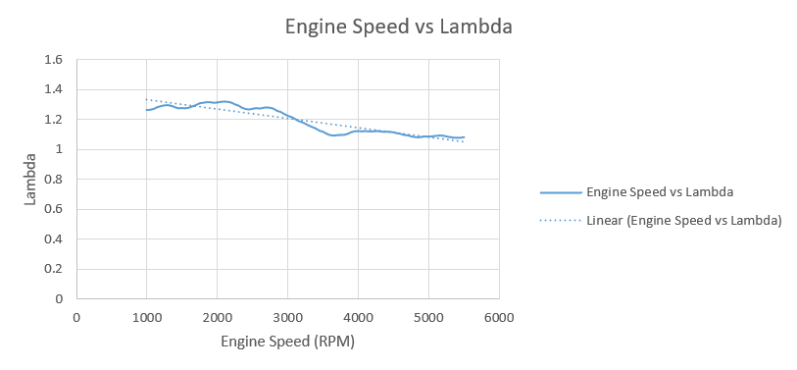
Figure 9
In figure 9, a comparison between engine speed and lambda reading is made. This shows that the higher the engine speed, the closer to 1 lambda levels became. As a result, it can be concluded that lambda levels decrease, becoming closer to 1, in response to an increase in engine speeds, meaning the fuel mixture becomes more efficient.

This somewhat correlates with increases in power and torque that can be observed around 3700rpm in figures 5 and 6, as this is the engine speed at which the lambda levels suggest fuel mixture becomes most efficient at around 1.1.

As it can be seen from the lambda readings that the fuel-air mixture runs slightly rich throughout lower and higher engine speeds, it could be safe to assume that this particular engine is marginally restricted, or detuned. As a result, the fuel-air mixture will remain slightly rich due to the engine not drawing in as much air as it would have done originally, prior to being detuned.

Evaluation
On a whole, the test could have been improved through the use of a variety of different testing methods. This would have provided a larger, more comprehensive spread of data, meaning results gathered would have likely been more accurate.

Furthermore, the engine used was from 1988. As a result, slight discrepancies or anomalies in data may not be fixed through more thorough testing and instead may be down to the wear this engine has experienced overtime.

References
Fall, M., 2020. Engine Dynamometer Overview. [Online]
Available at: https://www.youtube.com/watch?v=-WajOAp2LUE
[Accessed 23 3 2023].
Sherman, D., 2016. Horsepower Vs. Torque: What's the Difference?. [Online]
Available at: https://www.caranddriver.com/news/a15347872/horsepower-vs-torque-whats-the-difference/
[Accessed 24 3 2023].
Summerfield, A., 2020. Handout Master 2020 Part 1, s.l.: s.n.
Susilo, S. H., 2020. The Effect of Cyclone Surface Area towards Engine Performance, Intake Manifold Pressure and Exhaust Gas Emission. International Journal of Mechanical and Production Engineering Research and Development, 10(3), pp. 2249-6890.
Thomaz, F. & Baeta, J. G. C., 2020. Effects of Engine Speed on the Performance at Extreme Vehicle Driving Conditions, United States: SAE International.

