Homework week 4 p75

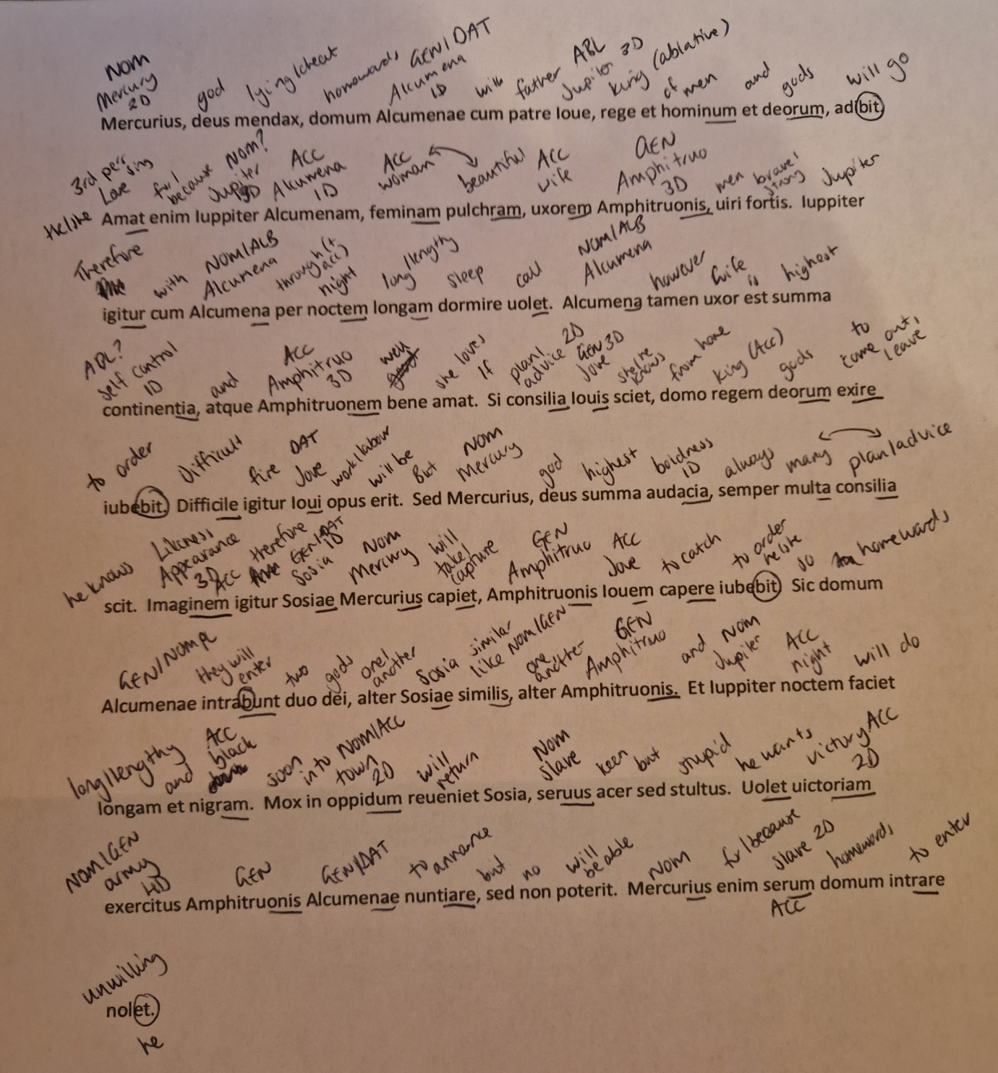
Mercury, a cheating god, will go towards Alcumena’s house with father Jupiter, king of men and gods. Jupiter has love for Alcumena, a beautiful woman, wife of Amphitruo, a strong man. Jupiter therefore wants to sleep through the long night with Alcumena. Alcumena however is a wife of highest self control, and she has great love for Amphitruo. If she knew Jupiter’s plan, she would order the king of gods to leave the home. Therefore it will be difficult work for Jupiter. But Mercury, god of the highest boldness, always knows many plans. Therefore Mercury will take the likeness of Sosia, to order Jupiter to capture Amphitruo. So towards Alcumena’s home the two gods go, one similar to Sosia, another Amphitruo. And Jupiter will make the night long and black. Soon into the town Sosia will return, the slave is keen but stupid. Amphitruo wants to announce to Alcumena a victorious army, but will not be able. Because Mercury does not want to enter the house late.

