ACCA5026

Databases and Application Development

Database Design & Implementation

Name:
Radu Cristian Boros

ID:
2319948

Module Tutor: Divya Chidambaram

Database Design and Implementation – MedAssist Clinic (Part A)

Table of Contents

Contents
Database Design and Implementation – MedAssist Clinic (Part A) 2
Table of Contents 2
1. Introduction 4
2. Database Requirements 4
3. Database Design 5
3.1 Entities and Attributes 5
3.2 Entity Relationship Diagram 5
3.3 Normalisation 6
4. Database Implementation 7
4.1 Database and Table Creation 7
4.2 Constraints and Data Integrity 7
4.3 Sample Data 8
4.4 Constraint Validation 9
5. Stored Procedures and Transactions 10
5.1 CRUD Stored Procedures 10
5.2 Appointment Booking Transaction 11
5.3 Conditional Rollback 11
5.4 Treatment Transaction 12
6. Triggers, Functions and Auditing 13
6.1 Audit Trigger 13
6.2 Database Function 13
6.3 Benefits of Auditing and Automation 14
7. Performance Tuning Enhancement 14
7.1 Performance-Critical Queries 14
7.2 Secondary Indexes 14
7.3 Query Performance Testing 15
8. Testing and Results 16
9. Conclusion and Reflection 17
10. References 18

Introduction

MedAssist Clinic is a private healthcare facility in the United Kingdom that provides outpatient consultations, diagnostic services and specialist referrals. As the clinic grows, managing patient records, staff schedules, appointments and treatment histories through separate files can lead to duplicated data, booking conflicts, missing information and slow access to records. Healthcare information must also remain accurate because administrative and clinical decisions depend on reliable patient and appointment data.
This project designs and implements a relational database prototype for the clinic. The system stores patient, doctor, department, schedule, appointment, treatment and feedback data in linked tables. It also uses stored procedures, transactions, triggers, functions and indexes. COMMIT and ROLLBACK protect multi-step operations, auditing records important changes, and indexes support frequent searches. The prototype is intended for controlled multi-user use by administrative staff and medical professionals. Its overall aim is to provide a reliable, consistent and maintainable structure for the clinic’s operational information.

Database Requirements

The database must support the clinic’s main activities and provide consistent information for administrative staff and medical professionals. Administrative users need to register patients and maintain details such as name, date of birth, contact information, address, medical history, registration date and active status. Each patient requires a unique identifier to prevent duplicate records and allow appointments and treatments to be traced accurately.
The system must store doctors and the departments in which they work. One department can contain several doctors, but each doctor belongs to one department. Doctor schedules must record working dates, start and end times, and availability so appointments can be booked only when a doctor is working.
Appointment records connect a patient and doctor for a specific date and time and store the reason for the visit and status. The database must prevent the same doctor being booked twice in one time slot. Status values such as Booked, Completed, Cancelled and No Show allow the clinic to track the progress and outcome of bookings.
After consultation, medical staff must record diagnosis, prescription, treatment notes and follow-up information. Patients may submit optional ratings and comments. Treatment and feedback must be connected to valid appointments so that information cannot be stored without the relevant consultation.
Data integrity is maintained through suitable data types, primary keys, foreign keys, unique constraints, NOT NULL rules and CHECK constraints. Stored procedures control CRUD operations and transactions. Triggers support auditing, while indexes improve searches for doctor availability, patient history and appointments. A full production system would also require role-based permissions and stronger protection for sensitive medical information, but the prototype focuses on the database functions required by the brief.
Because several users may access the system, the design must preserve consistent data when records are added or updated at the same time. Centralised storage also gives authorised users one current version of patient and appointment information rather than separate copies.

Database Design

Entities and Attributes

The design contains eight entities: Patient, Department, Doctor, DoctorSchedule, Appointment, Treatment, Feedback and AuditLog.
Patient stores personal, contact and medical-history information. Department stores department names and locations. Doctor stores medical staff details and includes department_id as a foreign key. DoctorSchedule records the dates and times when each doctor is available. Appointment connects a patient and doctor and stores the appointment date, time, reason and status. Treatment stores the outcome of a completed appointment, including diagnosis, prescription, notes and follow-up details. Feedback stores an optional rating and comment for an appointment. AuditLog records selected database changes, including the affected table, record ID, operation, previous and new values, user and time.
Surrogate integer identifiers were selected because they remain stable even when names, email addresses or other business details change. AuditLog is kept as a technical table rather than connected through a strict business foreign key, because it may record changes across different tables.

Entity Relationship Diagram

Figure 1 presents the Entity Relationship Diagram. Department has a one-to-many relationship with Doctor, and Doctor has a one-to-many relationship with DoctorSchedule. Patient and Doctor each have a one-to-many relationship with Appointment. These relationships reflect the clinic process: one patient may return for several consultations, and one doctor may attend many patients over time.
Appointment has an optional one-to-one relationship with Treatment and Feedback. A booked, cancelled or missed appointment may not have treatment, and feedback is not compulsory. The appointment_id column is unique in both dependent tables, preventing more than one treatment or feedback record for the same consultation in this prototype. Primary keys uniquely identify rows, while foreign keys ensure that dependent records cannot reference missing patients, doctors, departments or appointments.
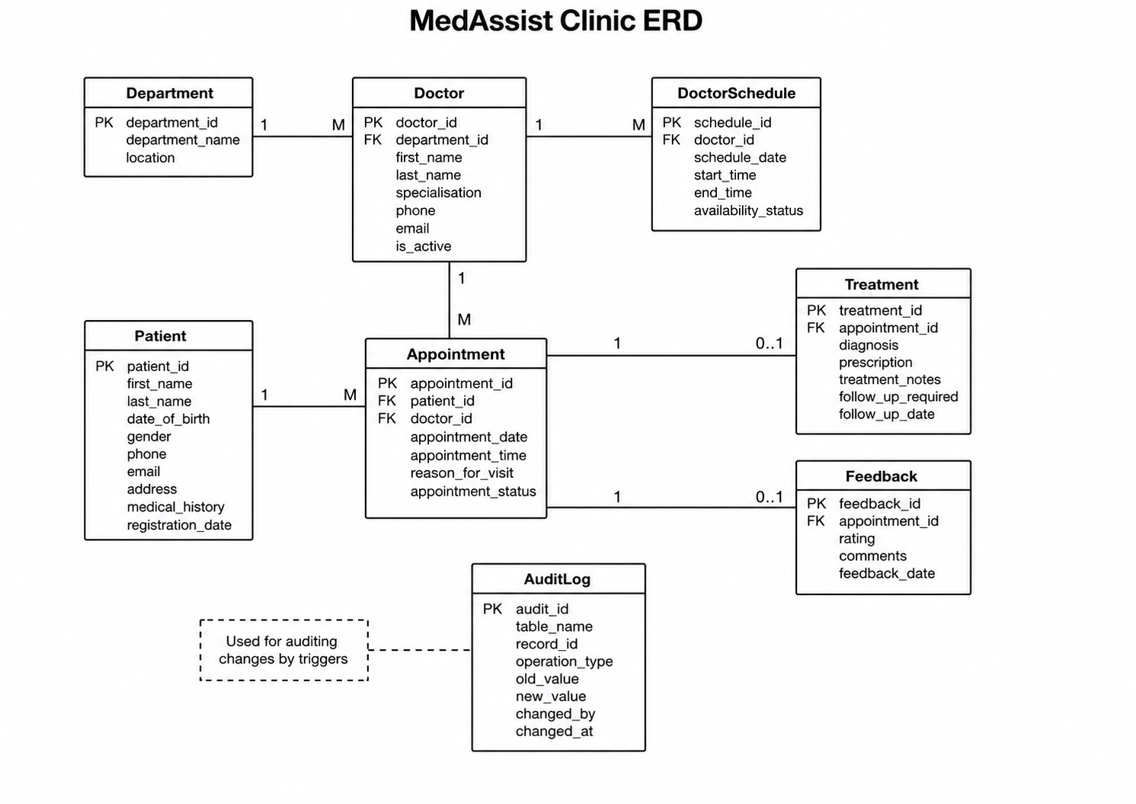
Figure 1: Entity Relationship Diagram for the MedAssist Clinic database

Normalisation

The design was normalised to Third Normal Form to reduce redundancy and update anomalies [1], [2]. In First Normal Form, each field contains one value and each table has a primary key. In Second Normal Form, non-key attributes depend on the complete key; the design uses single-column primary keys, avoiding partial dependencies. In Third Normal Form, non-key attributes depend only on the primary key. For example, department information is stored once in Department rather than repeated for every doctor, and patient details are not repeated in Appointment. Treatment, Feedback and schedules are also separated because they describe different subjects and can occur independently. This structure reduces duplication and makes insertion, updating and deletion more consistent.

Database Implementation

4.1 Database and Table Creation

The database was implemented in MySQL using the ERD as the implementation plan. The SQL script first removes an earlier test copy, creates the MedAssistClinic database and then creates the eight related tables in an order that respects foreign-key dependencies. Integer fields are used for identifiers, VARCHAR and TEXT for names and descriptive information, DATE and TIME for schedules and appointments, and DATETIME for creation and audit timestamps.
CREATE DATABASE MedAssistClinic;
USE MedAssistClinic;
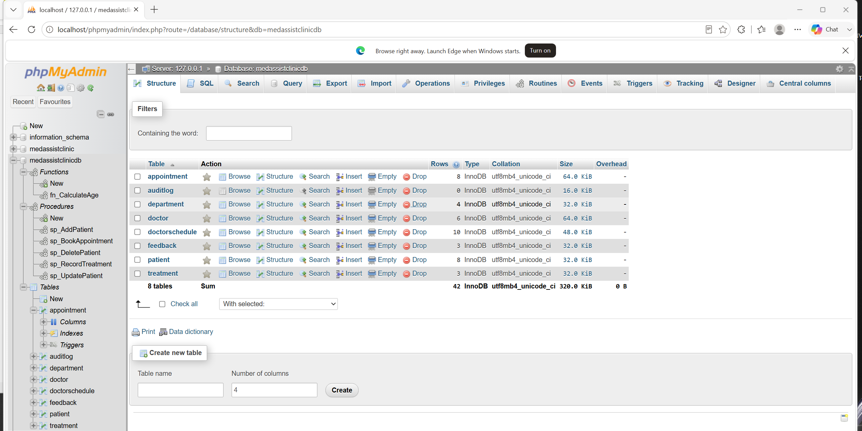Figure 2: Tables created in the MedAssistClinic database

4.2 Constraints and Data Integrity

Primary keys uniquely identify records. Foreign keys connect Doctor to Department, DoctorSchedule to Doctor, Appointment to Patient and Doctor, and Treatment and Feedback to Appointment. Referential actions were selected to protect important clinical history. For example, a patient or doctor with related appointments cannot be deleted accidentally, while schedule records can be removed with their doctor. Treatment and feedback records are removed if their parent appointment is intentionally removed.
Constraints improve data quality. Important fields use NOT NULL, email addresses are unique, and the Feedback rating is restricted using CHECK (rating BETWEEN 1 AND 5). Appointment includes UNIQUE (doctor_id, appointment_date, appointment_time), preventing two bookings for the same doctor and slot. DoctorSchedule checks that end_time is later than start_time. Treatment requires a follow-up date when follow_up_required is true. ENUM values restrict gender, availability and appointment status to recognised options.

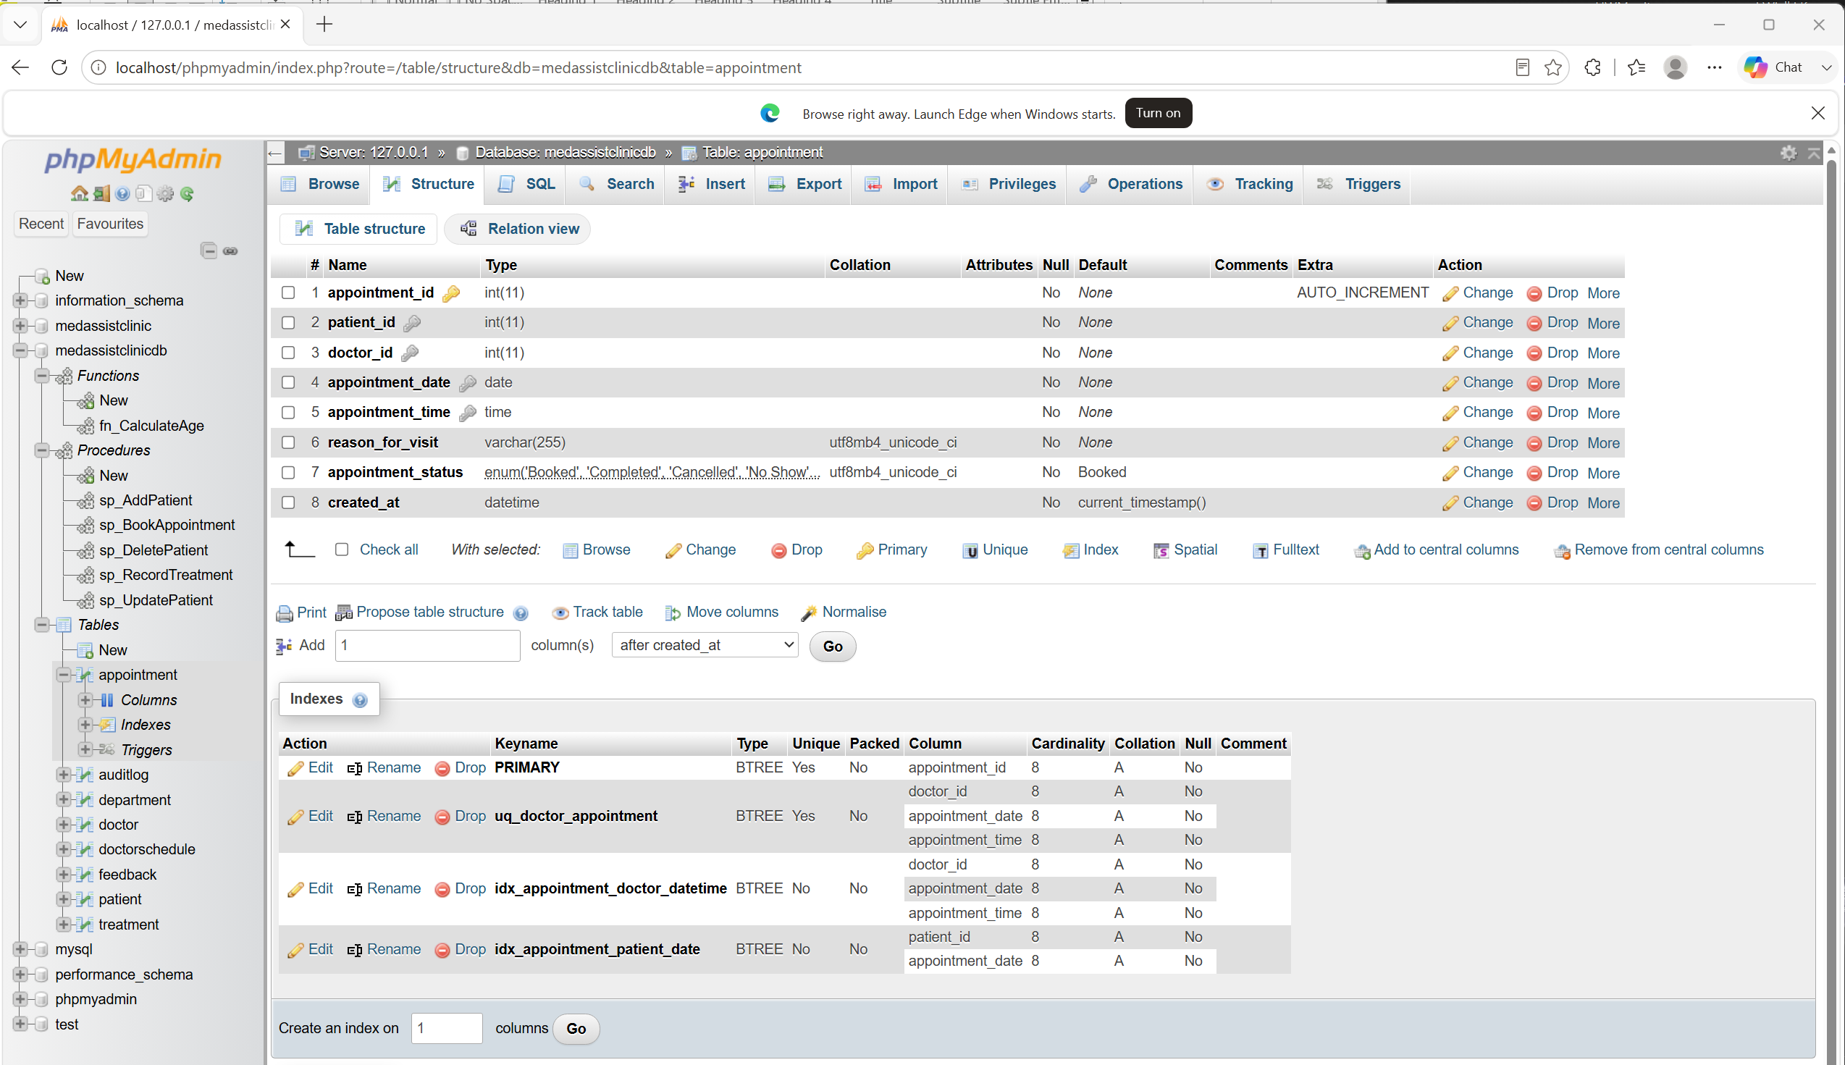Figure 3: Structure and constraints of the Appointment table

4.3 Sample Data

Realistic data was inserted for departments, doctors, patients, schedules, appointments, treatments and feedback. Departments include General Medicine, Dermatology, Physiotherapy and Cardiology. The data contains completed, booked, cancelled and missed appointments so different operations can be tested. Valid inserts confirm that table relationships work, while invalid inserts demonstrate constraint enforcement.
The sample dataset contains four departments, six doctors, eight patients, ten schedule records, eight initial appointments, three treatments and three feedback records. This is sufficient to demonstrate all relationships while keeping the prototype easy to inspect during a demonstration.
The implementation script also contains business queries that join patient, doctor, department, appointment and treatment data. These queries demonstrate that the normalised tables can be combined to produce useful views, such as appointment lists, treatment histories and doctor feedback averages.
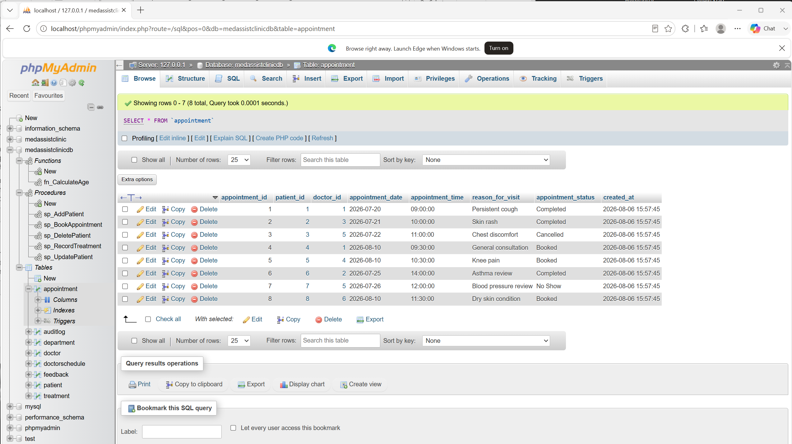Figure 4: Sample patient and appointment data

4.4 Constraint Validation
Constraint tests deliberately attempt to insert an invalid feedback rating and a duplicate doctor booking. MySQL should reject both operations, confirming that the rules are enforced at database level rather than relying only on application input.

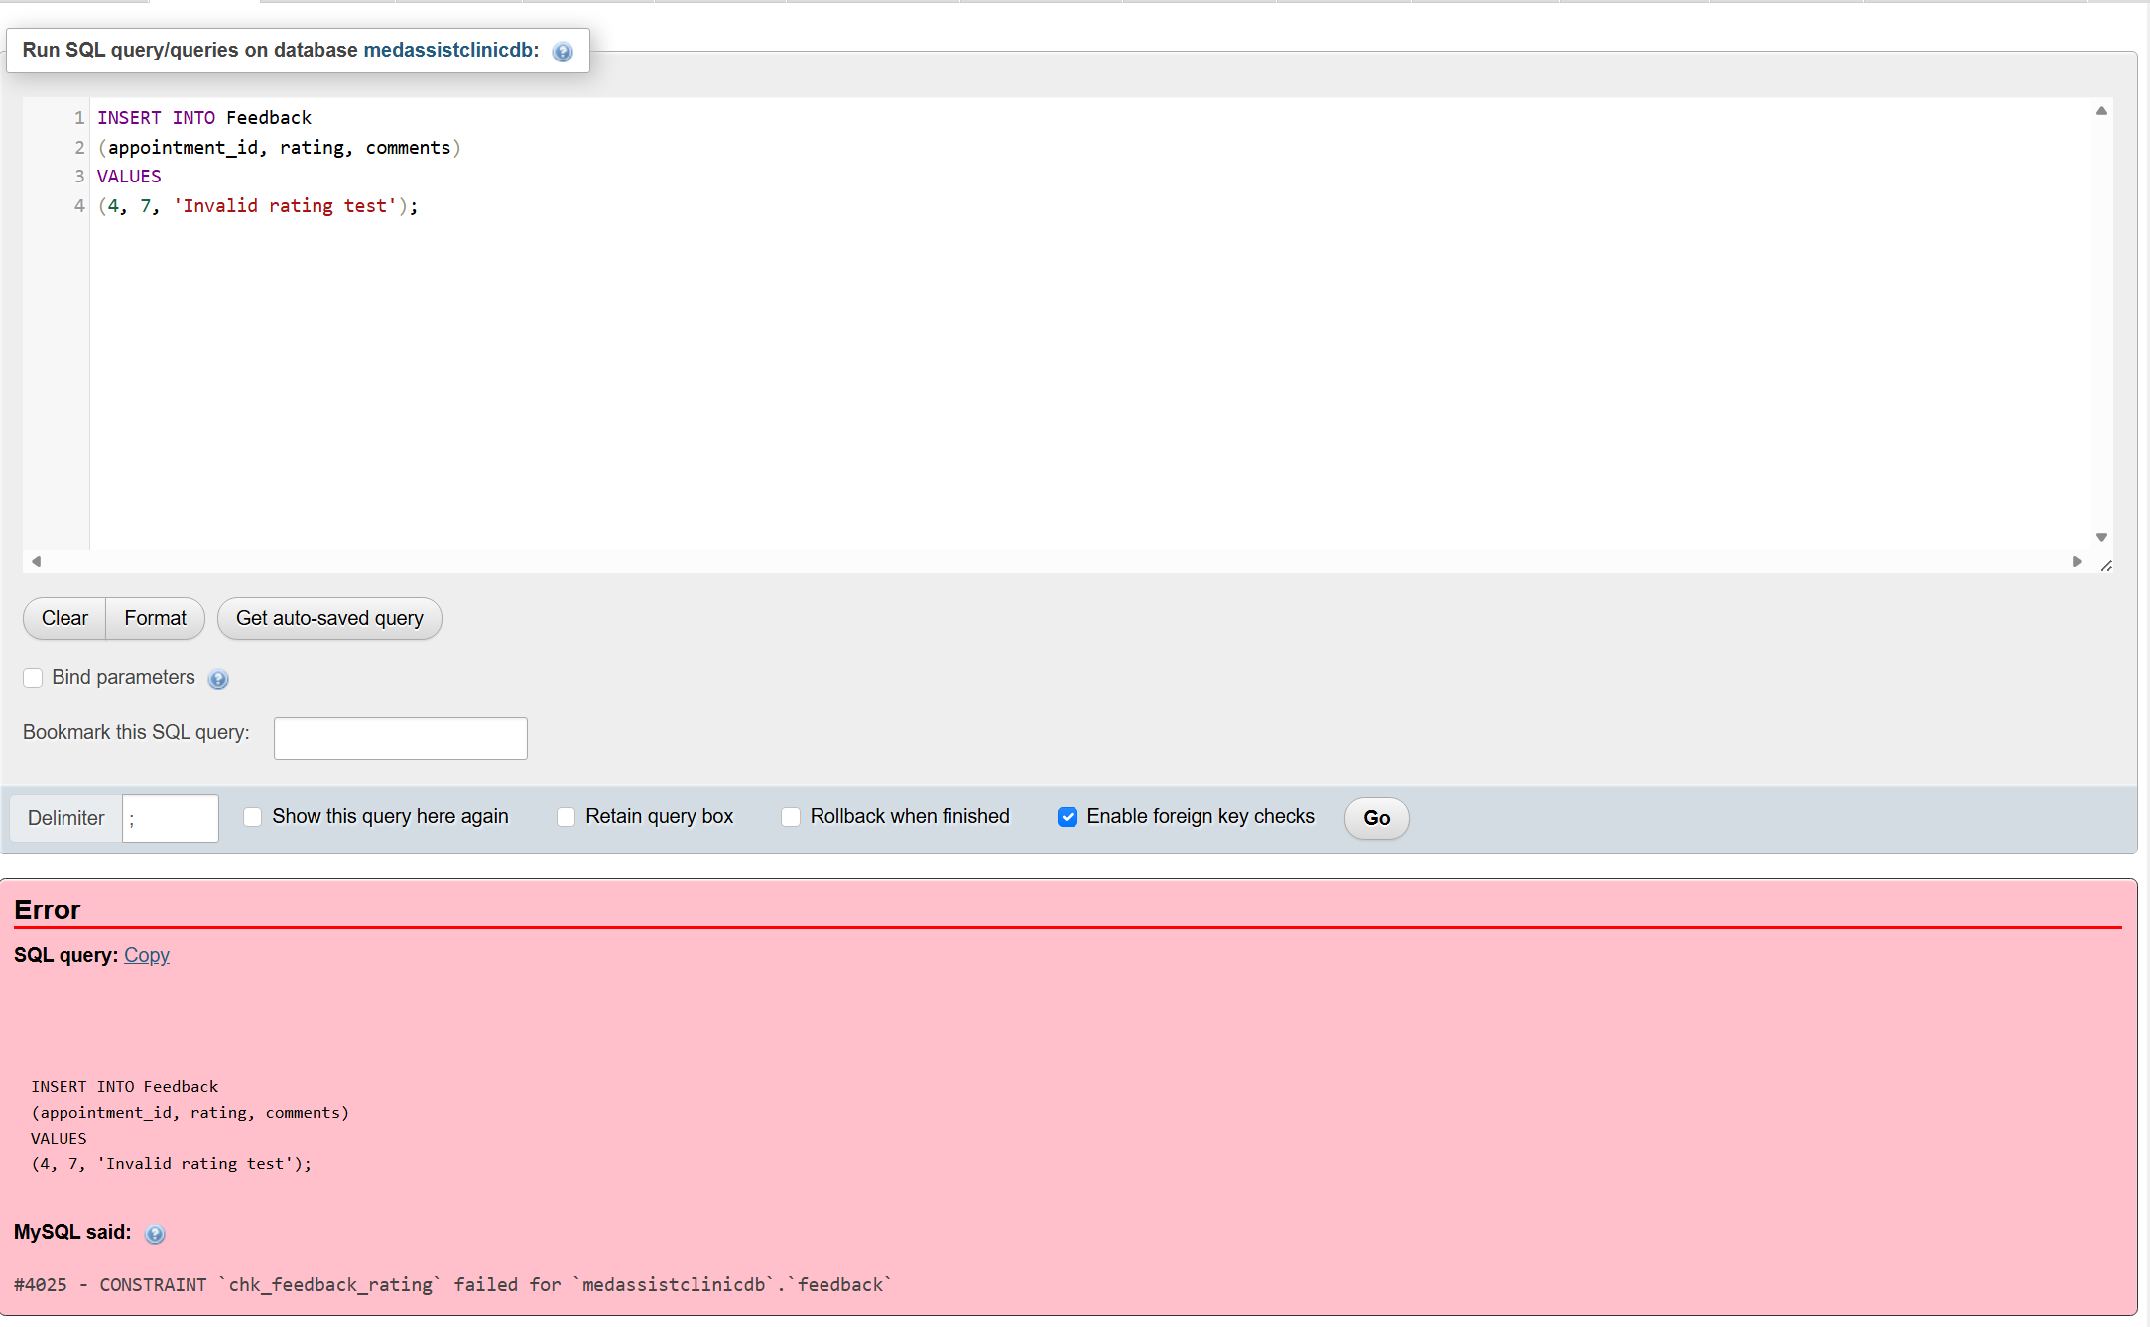
Figure 5: Constraint validation error

Stored Procedures and Transactions

5.1 CRUD Stored Procedures

Stored procedures were created for common CRUD operations and for processes requiring transaction control. sp_AddPatient inserts a new patient and returns the generated identifier. sp_UpdatePatient checks that a patient exists before changing contact or medical-history information. sp_DeletePatient allows deletion only when no appointment records exist, preserving the clinic’s historical information. Each procedure contains an SQL exception handler that performs ROLLBACK and returns the original error if the operation fails.
The exception handlers use RESIGNAL after rollback so MySQL returns a clear error to the user rather than hiding the cause. Validation is performed before the INSERT, reducing the chance of unnecessary changes and making commit or rollback decisions easy to justify.

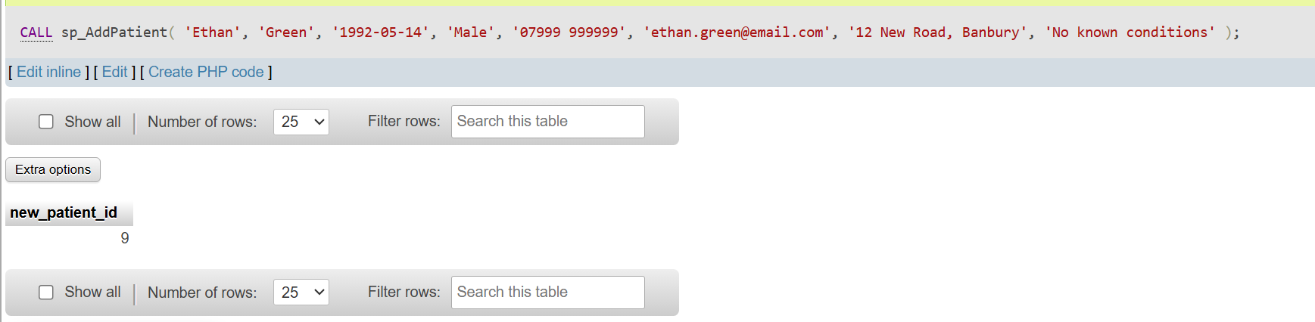Figure 6: Successful execution of a patient stored procedure

5.2 Appointment Booking Transaction

The main transactional scenario is sp_BookAppointment. It begins a transaction and checks that the patient is active, the doctor exists and is active, the selected time falls within an available DoctorSchedule record, and the doctor is not already booked. When all checks pass, the procedure inserts the appointment, records an audit entry and uses COMMIT. This makes the booking and its audit information permanent as one controlled operation.
CALL sp_BookAppointment(1, 2, '2026-08-10', '13:30:00', 'Headache and fatigue');
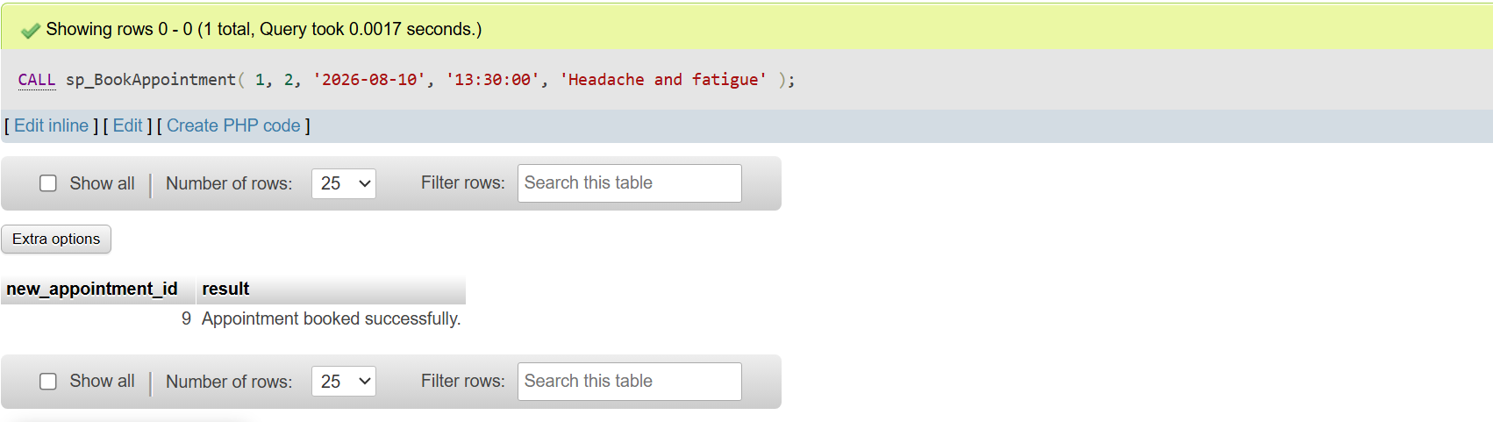Figure 7: Successful appointment transaction and COMMIT

5.3 Conditional Rollback

If any validation or SQL operation fails, the procedure raises an error and the handler executes ROLLBACK. Therefore, the database cannot contain an appointment without the related checks and audit record. A successful test books patient 1 with doctor 2 on 10 August 2026 at 13:30 and returns the new appointment ID. A failed test attempts to book doctor 1 at 09:30 on the same date, when that slot is already occupied. The procedure signals an error and rolls back the transaction. This demonstrates atomicity: all required steps succeed together or none are saved [3].

CALL sp_BookAppointment(2, 1, '2026-08-10', '09:30:00', 'Duplicate booking test');
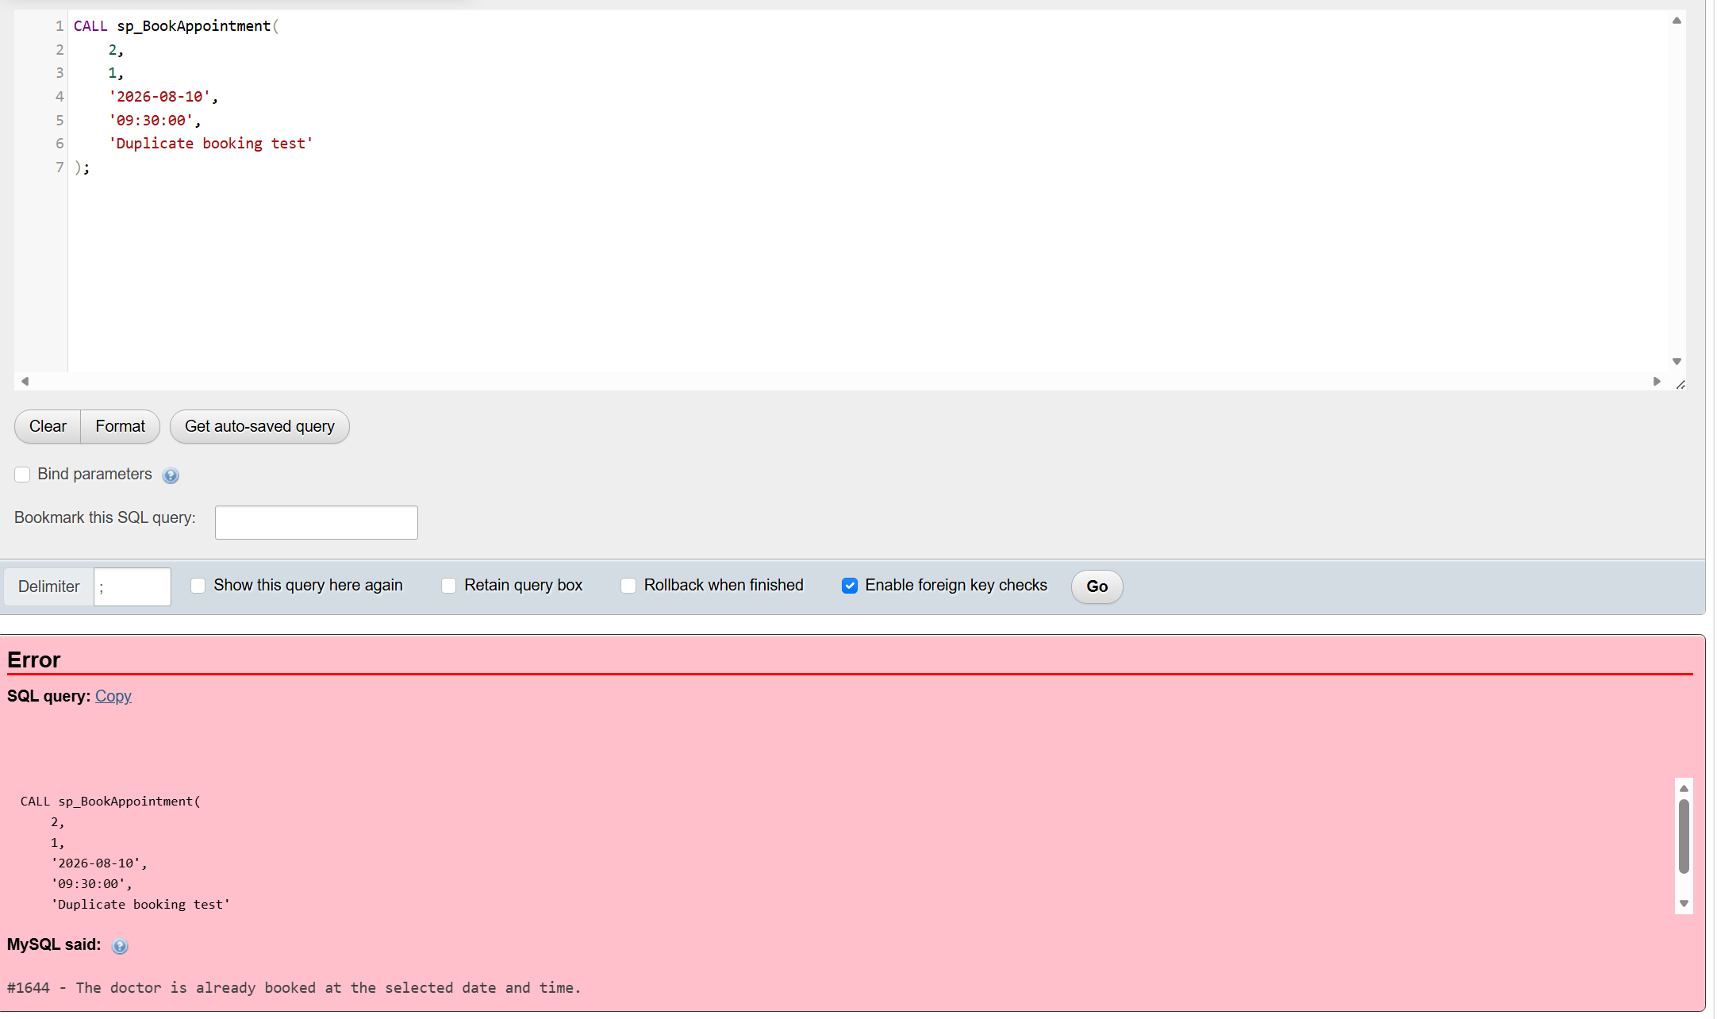Figure 8: Failed appointment transaction and ROLLBACK

5.4 Treatment Transaction

sp_RecordTreatment provides a second multi-step transaction. It verifies that an appointment exists, is currently Booked and has no existing treatment. If follow-up is required, a date must be provided. The procedure then inserts the treatment and changes the appointment status to Completed. Both changes are committed together. If the treatment cannot be saved, the status update is also cancelled, preventing a completed appointment without a treatment record.

Triggers, Functions and Auditing

Audit Trigger

The trg_Appointment_AfterUpdate trigger runs automatically after an Appointment record is changed. It inserts an AuditLog row containing the appointment ID, operation type, previous values, new values, database user and timestamp. The old and new appointment details are stored in a structured JSON format inside text columns. This creates a traceable history without relying on users to enter audit information manually, supporting accountability and later review [5].

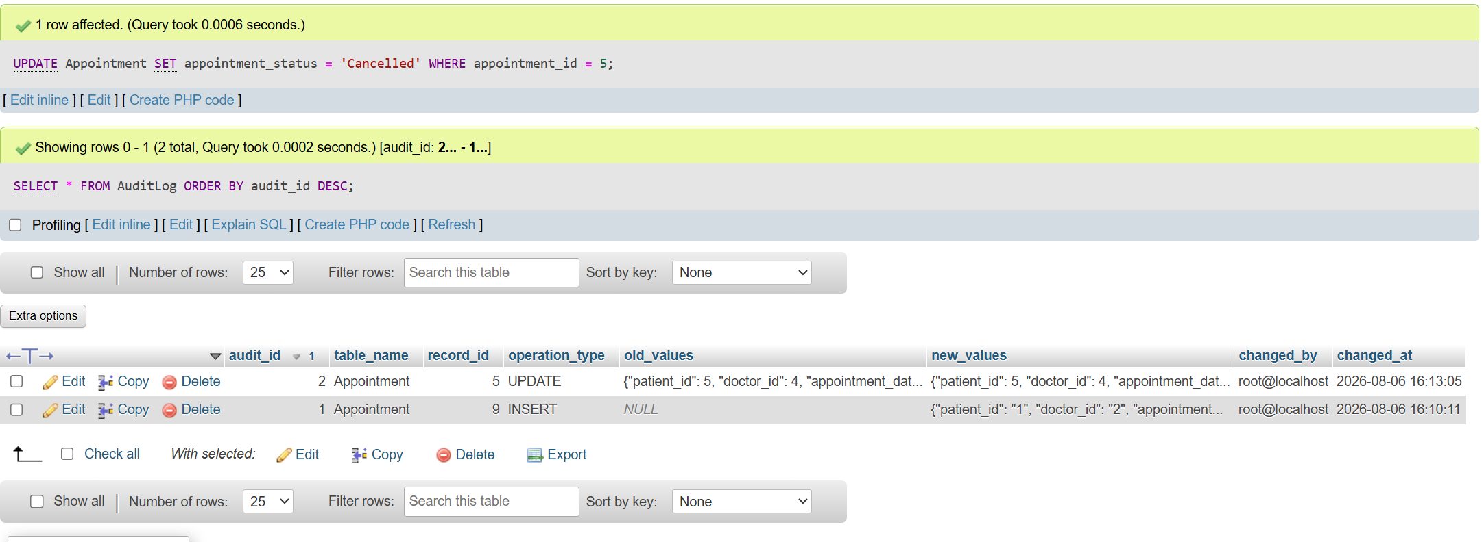Figure 9: Appointment update and automatic AuditLog record

6.2 Database Function

The fn_CalculateAge function uses TIMESTAMPDIFF to calculate a patient’s age from date_of_birth and the current date. Keeping the calculation in one reusable function avoids repeating the same expression in different queries and produces consistent results whenever age information is required.
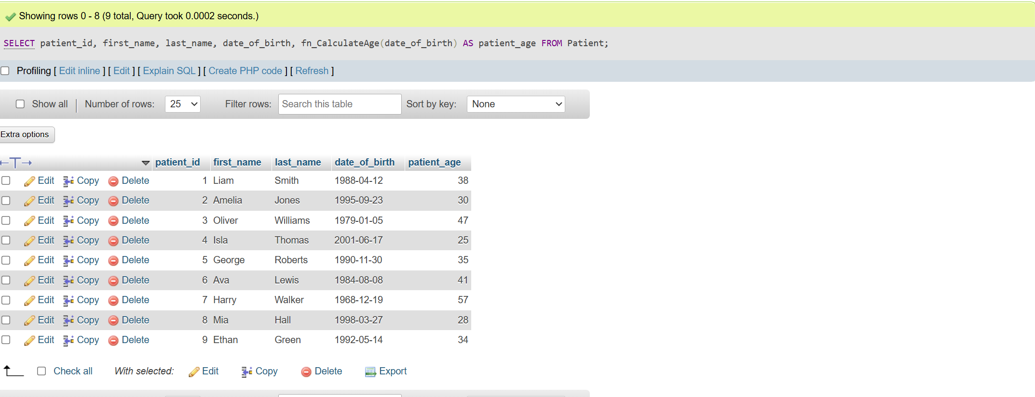Figure 10: Result of the patient age function

6.3 Benefits of Auditing and Automation

The trigger is tested by changing an appointment status and selecting the latest AuditLog records. The function is tested by displaying each patient together with the calculated age. In a larger system, additional triggers could audit patient and treatment changes, but one clear appointment trigger is sufficient to demonstrate the required auditing feature.

Performance Tuning Enhancement

7.1 Performance-Critical Queries

Frequent operations include checking a doctor’s bookings and availability, viewing a patient’s appointment history, and listing doctors by department. These queries commonly filter or join using doctor_id, patient_id, department_id, appointment dates and schedule dates.

7.2 Secondary Indexes

Secondary indexes were added to Appointment (doctor_id, appointment_date, appointment_time), Appointment (patient_id, appointment_date), Doctor (department_id), and DoctorSchedule (doctor_id, schedule_date).
The composite appointment index matches the columns commonly used together during booking checks. The patient index supports history searches ordered or filtered by date, while the department and schedule indexes improve joins and availability queries. B-tree indexes allow matching rows to be located more efficiently than scanning an entire table [6].

7.3 Query Performance Testing

MySQL EXPLAIN is used to inspect the access path selected for a query that filters Appointment by doctor, date and time [4], [7]. The key column should show either the unique appointment constraint or the secondary composite index, because both begin with the columns used by the query. The rows estimate indicates how many records MySQL expects to examine.
With a small prototype the measured time difference may be limited, but indexing becomes increasingly useful as the number of appointments grows. Unnecessary indexes were avoided because indexes consume storage and may add overhead to INSERT, UPDATE and DELETE operations [8]. The selected indexes therefore support known operational queries rather than indexing every column.
EXPLAIN SELECT * FROM Appointment WHERE doctor_id = 1 AND appointment_date = '2026-08-10' AND appointment_time = '09:30:00';
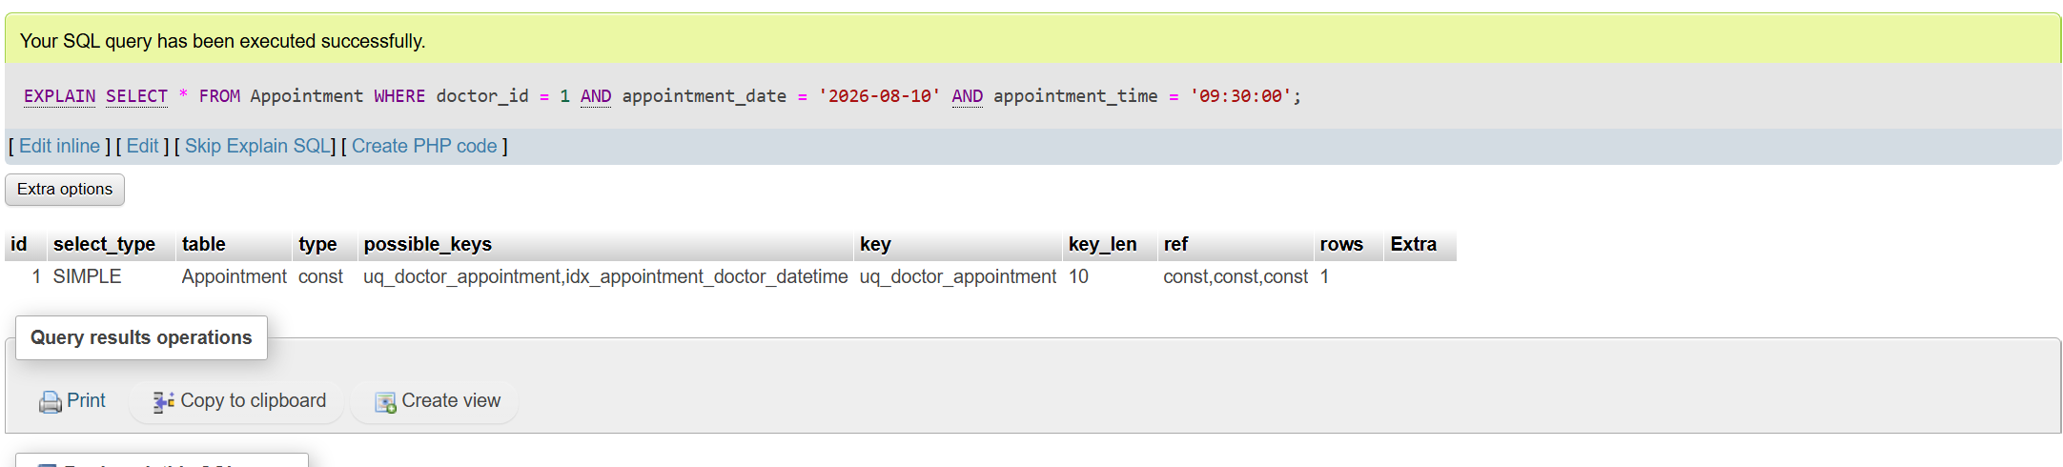Figure 11: EXPLAIN result showing index usage

8. Testing and Results

Testing covered tables, data, constraints, stored procedures, transactions, auditing, functions and indexing. After import, MySQL created all eight tables and inserted the sample records. Joins between departments, doctors, patients, appointments, treatments and feedback returned the expected related information, showing that the foreign-key links were correct.
Constraint testing used invalid data. A rating of 7 was rejected because Feedback accepts only values from 1 to 5. A second appointment for doctor 1 on 10 August 2026 at 09:30 was rejected by the unique constraint. These tests show that invalid values and conflicting bookings cannot be stored. The schedule time and follow-up constraints provide similar protection for invalid working hours and incomplete follow-up information.
CRUD procedures were tested with valid patient data. Add and update operations completed successfully, while deletion was blocked when appointment history existed. The booking procedure committed a valid appointment and rolled back a conflicting appointment. A follow-up SELECT can confirm that only the successful appointment was inserted. The treatment procedure inserted a treatment and changed the associated appointment to Completed as one transaction.
The audit trigger generated a new AuditLog row after an appointment status update, including both the previous and new status. fn_CalculateAge returned an age for each patient. EXPLAIN showed that MySQL could use an available index for the doctor, date and time lookup instead of relying only on a full table scan.
For each test, the report records the command, the expected result and the observed database response. Successful tests show saved records, while negative tests deliberately produce an error and verify that no invalid row remains. This makes the screenshots evidence of both functionality and integrity enforcement.
Together, the tests show that the prototype maintains referential integrity, rejects invalid data, controls multi-step changes, records important updates and supports efficient searches. The screenshot evidence for these tests is presented in Figures 2-11. The tests use a small sample dataset, but they cover the principal functional and integrity requirements of the scenario.

9. Conclusion and Reflection

The final MedAssist Clinic prototype meets the main requirements of the case study. It manages patients, departments, doctors, schedules, appointments, treatments and feedback through a relational structure that reduces duplication and protects links between records. Primary keys, foreign keys, unique constraints and validation rules prevent common data-quality problems, including invalid ratings and duplicate doctor bookings.
Stored procedures provide controlled CRUD operations, while COMMIT and ROLLBACK protect appointment booking and treatment recording from incomplete changes. The trigger creates an automatic history of appointment updates, the function provides a reusable age calculation, and carefully selected indexes support frequent operational queries.
A key challenge was balancing sufficient functionality with a database that remained understandable and easy to demonstrate. This was addressed by selecting the central clinic entities and implementing one clear example for each major requirement. Transaction handlers were particularly important because related changes must not leave inconsistent records. Another challenge was choosing indexes that help important queries without creating unnecessary maintenance overhead.
Future development could add staff accounts, role-based permissions, encryption for sensitive medical information, automated appointment reminders and a more detailed patient medical-history model. A PHP interface could also provide easier access for administrators and clinicians. Overall, the solution demonstrates database design, normalisation, integrity constraints, CRUD procedures, transaction management, auditing, reusable functions, testing and performance tuning.

10. References

[1] E. Akadal and M. H. Satman, “A novel automatic relational database normalization method,” Acta Informatica Pragensia, vol. 11, no. 3, pp. 293–308, 2022.
[2] C. Coronel and S. Morris, Database Systems: Design, Implementation, and Management, 14th ed. Cengage, 2023.
[3] Oracle Corporation, “START TRANSACTION, COMMIT, and ROLLBACK statements,” MySQL 8.4 Reference Manual, 2026.
[4] Oracle Corporation, “Optimizing queries with EXPLAIN,” MySQL 8.4 Reference Manual, 2026.
[5] F. Ullah, J. He, N. Zhu, et al., “Blockchain-enabled EHR access auditing: Enhancing healthcare data security,” Heliyon, vol. 10, no. 16, Art. no. e34407, 2024.
[6] Oracle Corporation, “Column indexes,” MySQL 8.4 Reference Manual, 2026.
[7] J. Kossmann, T. Papenbrock, and F. Naumann, “Data dependencies for query optimization: A survey,” The VLDB Journal, vol. 31, pp. 1–22, 2022.
[8] V. Šalgová, “Effect of indexes on DML operations,” Transportation Research Procedia, vol. 55, pp. 1368–1372, 2021.

