Vehicle Tech 2 – Vehicle Structure & Aerodynamics
Stone-James, VT2-2018
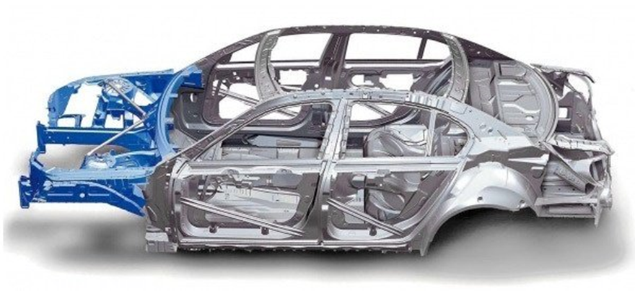
Word count: 2,007

Q1

Steel monocoque chassis is a one-piece structure which dictates the overall body of the car, allowing for greater stiffness due to the form being a composite structure. As the vehicle moves the stress is distributed around the body this helps prevent the risk of deformation from potential localised stresses. The suspension also benefits from this as the torsional stiffness of the chassis is high due to the stress being shared around the body. The structure works as an outer shell (as seen in the image above), which is another ‘pro’ for this choice of chassis as it produces far more space inside the car.
In addition to space efficiency, the production cost to manufacture this compared to other chassis’ is particularly low, making it cheap for mass production, which is a key reason why it is the predominant choice in cars on the road today. However, with the exception of Porsche it is almost impossible for small-volume production due to the expensive equipment needed. A monocoque chassis is also proficient in crash protection as a crumple zone can be built because of the vast amount of metal in the structure. A crumple zone is a section of the vehicle located at the front or rear of the car which absorbs the main impact from a crash, as it ‘crumples’. However, the large quantity of metal results in a far heavier structure which would affect the overall performance of the car unless you chose to use the Ultra Light Steel Auto Body (ULSAB) monocoque body instead.
If you use the ULSAB monocoque instead off the conventional steel monocoque chassis you have a far lighter and stronger alternative, with the same production cost. However, this option is still not viable for sports cars, as it is still simply too heavy and too weak.
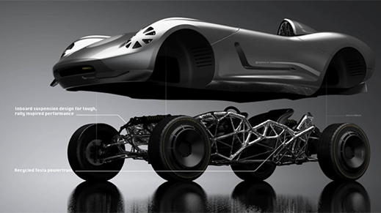
The second chassis alternative is through generative design. This revolutionarily new approach in manufacturing uses technology to amplify our abilities as humans to design a material which would otherwise be impossible to make. The computer produces a design from algorithms relevant to the final function of the product, ranging from anything from medical equipment to a car chassis. This final outcome would be a 3D printed form with maximum performance and zero wastage. The Image to the right demonstrates the work from the Hack Road team (All3DP, 2018) who have already began to explore the possibilities of combining generative design with car engineering.
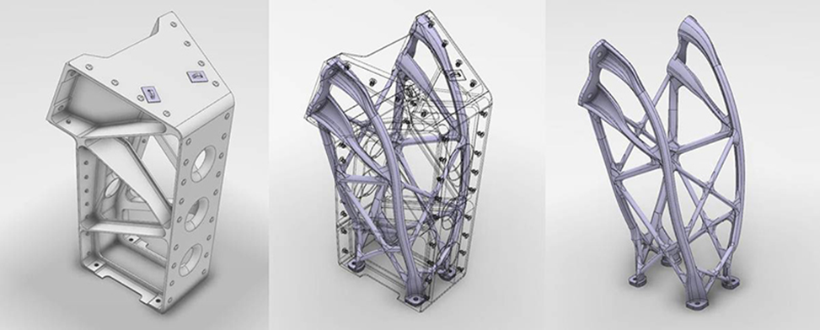
Generative design uses Autodesk softwares to digitally design an idea in the most efficient and aesthetically pleasing form; for example, as seen below the conventional structure is transformed into a
lighter and stronger form, removing unnecessary weight and arriving at a final shape which supports where the direction of the pressure is coming from.
Digital manufacturing companies such as Hack Rod and the Bandito Brothers have experimented in ways of producing car chassis’ using generative design’s ‘Dream catcher’ programme. They used lasers to capture the colour and reflexions of the environment before the computer produced thousands of variations in structures which would be too complex for a human to calculate, with different ways of combining the elements. The Bandito Brothers used the same programme, however they did this whilst they drove the car during the developing stages of the design process on a track. Meanwhile a computer was recording a live reading of the results, sending more than four billion data points from each force the car experienced as it turned or braked. This allowed for a generative design chassis to be created perfectly for the vehicle’s purpose. A negative for this process, however, would be the continual testing on a track as the computer will never learn in the same way a human would, meaning this process of driving the car and finding a generative design in a computer would have to repeated constantly instead of just once.
Q2.
Aerodynamics is the interaction between a moving object travelling through the air, drag is the resistance that the object creates. The other resulting forces the vehicle experiences during motion from the wind range from lift to side force, rolling movement, yawing movement and pitching movement. Wind resistance is the conflict between air as the vehicle drives through it, as the speed of the car increases so do the amount of air particles which limit the manoeuvrability of the car.
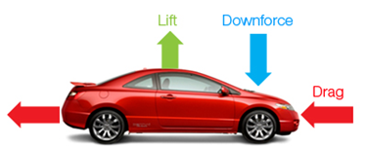
The lift force is present when there is pressure skimming over the vehicle, which ‘lifts’ the vehicle up. This is certainly clear in the case of aircraft as they speed up on the runway for take-off. The opposite force is downforce, which generates pressure and pushes the car down. The image helps highlight these key forces (New Emerging Automobile Technologies, 2018).
Improving the flow which goes past the vehicle body will improve fuel consumption, comfort characteristics and driving characteristics.
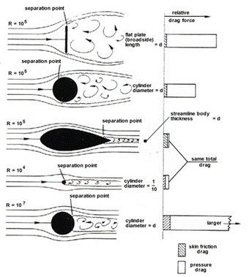
To help slice through the wind more efficiently, which will overall significantly improve the performance of the car and the mileage, you would optimise the shape and have a more streamlined body. Streamlining in design was introduced between 1920 to 1970 before optimising the form in the early 1990s. This change in design can be identified by attached flow,(reference ara) with the flow of air being undisturbed, due to the share of pressure forces in the drag force. If you compare this to a buff body, the drag is significantly larger, which is caused by pressure forces. The image to the left demonstrates these forces. (Pinterest, 2018)
These designs can be tested by methods such as using wool turfs or more commonly by using a wind tunnel.
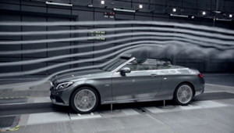
Wind tunnels work by producing an airstream which flows over a vehicle such as a car or an aircraft, which tests the aerodynamics. This helps to make a more fuel-efficient and faster design as it helps to prevent the build up of unnecessary pressure when the car is in motion. (YouTube, 2018).
However, testing the air flow on the car these can have a negative impact on the vehicle's drag and wind resistance. These range from blockage, scale or errors due to having a road in motion on a stationary floor in the tunnel. If you were to use a scale model the larger proportions would also result in a lower drag. There are also additional problems such as ‘The moving road problem’. This is due to the car being raised above the tunnel floor on a ground board, leaving a small boundary layer underneath. This can result in higher pressure causing circulation problems. In addition to ground boards which benefits family and commercial vehicles, wind tunnels can also function with a belt or a porous floor and suction method which is mechanically far simpler.
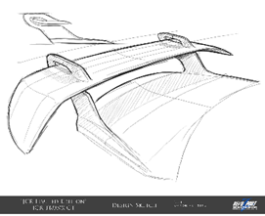
In addition to a streamlined design, modifications on the car can improve major areas of performance. Ground effect is a key factor in this, creating downforce by a series of different methods of aerodynamics. The first example I will talk about are spoilers and wings. Located at the rear of the car, the spoiler reduces lift by reshaping how the air interacts with the vehicle. This diffuses the flow of air. Wings on the other hand are positioned higher up on the car and instead add greater downforce which helps to decrease drag at high speeds. These modifications can also be deployable and function as brakes by directing the air. (Revozport, 2018).
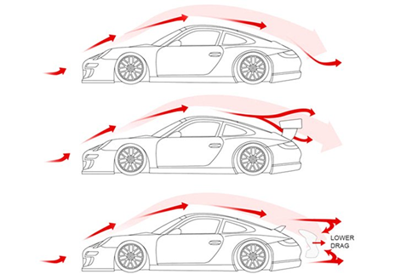
Spoilers are frequently seen on sports cars, to improve the performance and increase the chances of winning a race. However, they can also be seen on more commercial cars for styling purposes, which can worsen the aerodynamics. (Theseus.fi, 2018).
The diagram to the left (DESIGNS and Posts, 2018) shows the affect of air flow on three examples which contours around the vehicles as it accelerates and how the spoilers correspond with this turbulence. The car at the top lacks a spoiler and as a result the air flow produces more drag force. This has a negative impact on the stability and braking of the car. To overcome this force the driver would have to reach a higher speed, which would be the less fuel efficient option.
As seen underneath, this example shows the cars with a spoiler adjust the air flow to reduce drag and increase downforce. The spoiler does this by turning the air particles into turbulence as they merge together after hitting the spoiler. This creates more force around the rear of the vehicle which overall improves the performance of the car by pushing the tyres to the ground adding traction on the road. (Katz, 2006).
It is worth mentioning that several fatalities occurred in 1998 from people driving Audi TT Coupes, all because of the unstable aerodynamics of the cars as they reached high speeds. To fix this Audi recalled 40,000 of the TT models worldwide the following year to fit a rear spoiler, as well as altering the suspension, costing them just under £200 million. A clear example of an advantage a simple spoiler can have on the overall performance of the car.
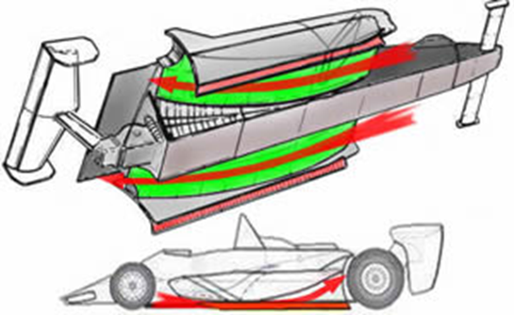
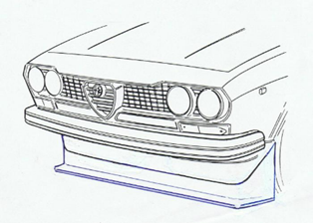
Ground effect is also vital in improving the car's performance. Introduced into Formula One in the early 1980s, mechanics began to sculpture the underbodies of the cars to interact with the airflow and enhance downforce (Formula1-dictonary.net, 2018). It is key in racing vehicles to maximise downforce in order to achieve the shortest lap time. Diffusers, air dams and splitters are all additions which help in ground effect. Air dams limit the airflow under a vehicle which successfully reduces the pressure as the air velocity increases. A splitter is rather self-explanatory as this prevents air ‘spilling’ beneath the vehicle. An example of this can be seen on the left (Alfabb.com, 2018). If this is used in combination with rounded leading edges the amount of drag would be significantly decreased. The most successful way to reduce drag would be by rounding up the horizontal and vertical edges at the front of the car (Lajos, 2018).
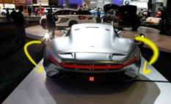
Another straight forward way of improving the performance of the car can be achieved by lowering the car body closer to the ground. This helps to direct the flow of air up and around the body instead of underneath, which would impede the car and result in the vehicle being unable to remain on the road. As well as designing the rear of the car to come inwards (boat tailing) as seen in the photo of the right of the Mercedes. This, too, is another method of reducing drag.
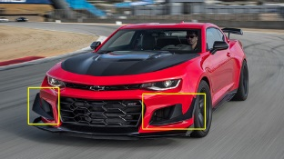
Dive panes (seen on the image to the right, (Package, 2018)) helps to achieve greater downforce. It does this by guiding the flow of air upwards, preventing air from going underneath the car. In addition to this you can also optimise your car’s performance by adding Vents and Air intakes.
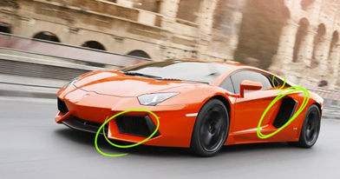
Air vents help reduce air resistance as it channels the flow of air when the car reaches high speeds. Clear visual examples are those in the design of the Lamborghini Aventador. Although the function of the air vents has been exaggerated for the purpose of the aesthetic, the car flaunts the use of vents at the front and at the side of the performance car which is visually self explanatory. It quite plainly indicates how the vents have a positive impact on the overall performance of the car as well as visual statement.
Overall, although steel monocoque design is the more conventional choice of car chassis today, as 3D printing technology advances in all fields, including introducing biodegradable materials into architecture, it is not just generative automotive design which is being influenced. This trend in design will develop from extraction to a more aggregated process, and product design will become much more influenced by 3D printing due to the vast advantages of its finished product. Also, by allowing computers to work out the best theoretical design, which a human can simply no longer do, these algorithms would improve the engineering of the car and the design to improve major areas of performance.

Your Bibliography: Lajos, P. (2018). Basics of vehicle aerodynamics. [online] Available at: https://www.ara.bme.hu/oktatas/letolt/Vehicleaerodyn/Vehicleaerodyn.pdf [Accessed 30 Apr. 2018].
All3DP. (2018). La Bandita: Hackrod and Siemens Partner to Develop Self-Designing Car | All3DP. [online] Available at: https://all3dp.com/self-driving-cars-yesterday-self-designing-cars-future-thanks-hackrod/ [Accessed 30 Apr. 2018].
Conti, M. (2018). The incredible inventions of intuitive AI. [online] Ted.com. Available at: https://www.ted.com/talks/maurice_conti_the_incredible_inventions_of_intuitive_ai [Accessed 30 Apr. 2018].
Oxman, N. (2018). Design at the intersection of technology and biology. [online] Ted.com. Available at: https://www.ted.com/talks/neri_oxman_design_at_the_intersection_of_technology_and_biology [Accessed 30 Apr. 2018].

Google.co.uk. (2018). aerodynamics car forces - Google Search. [online] Available at: https://www.google.co.uk/search?rlz=1C1GGRV_enGB783GB783&biw=1419&bih=947&tbm=isch&sa=1&ei=auDmWtPvEsvAgAam0LyoBQ&q=aerodynamics+car+forces&oq=aerodynamics+car+forces&gs_l=psy-ab.3...1119.2678.0.2781.7.7.0.0.0.0.57.325.7.7.0....0...1c.1.64.psy-ab..0.3.160...0j0i30k1j0i8i30k1.0.mLRlHcnbozs#imgrc=QwszGWO6GpYIPM: [Accessed 30 Apr. 2018].

Howarth, D. (2018). Generative design software will give designers "superpowers". [online] Dezeen. Available at: https://www.dezeen.com/2017/02/06/generative-design-software-will-give-designers-superpowers-autodesk-university/ [Accessed 30 Apr. 2018].
quora. (2018). What is a monocoque chassis and how exactly does it differ from a conventional one?. [online] Available at: https://www.quora.com/What-is-a-monocoque-chassis-and-how-exactly-does-it-differ-from-a-conventional-one [Accessed 30 Apr. 2018].
Revozport, G. (2018). GTR. [online] Gtr.revozport.com. Available at: http://gtr.revozport.com/jcr.html [Accessed 30 Apr. 2018].
Oponeo.co.uk. (2018). Car aerodynamics: combatting air resistance » Oponeo.co.uk. [online] Available at: https://www.oponeo.co.uk/tyre-article/car-aerodynamics-and-air-resistance [Accessed 30 Apr. 2018].
CarsDirect. (2018). What Does a Spoiler Do for Aerodynamics?. [online] Available at: https://www.carsdirect.com/aftermarket-parts/what-does-a-spoiler-do-for-aerodynamics [Accessed 30 Apr. 2018].
Build Your Own Race Car!. (2018). Car Aerodynamics Basics, How-To & Design Tips ~ FREE!. [online] Available at: http://www.buildyourownracecar.com/race-car-aerodynamics-basics-and-design/ [Accessed 30 Apr. 2018].
New Emerging Automobile Technologies. (2018). Vehicular Aerodynamics. [online] Available at: https://gr8autotech.wordpress.com/2013/06/16/vehicular-aerodynamics/ [Accessed 30 Apr. 2018].
Pinterest. (2018). CO2 car. [online] Available at: https://www.pinterest.co.uk/pin/293789575667740700/?autologin=true [Accessed 30 Apr. 2018].
YouTube. (2018). 2016 Mercedes-Benz C-class Wind Tunnel Test. [online] Available at: https://www.youtube.com/watch?v=1lszpNisyQI [Accessed 30 Apr. 2018].
DESIGNS, A. and Posts, V. (2018). Spoiler selection!. [online] ASHIQ DESIGNS. Available at: https://ashiqdesign.wordpress.com/2017/05/26/spoiler-selection/ [Accessed 30 Apr. 2018].
Formula1-dictionary.net. (2018). Ground Effect. [online] Available at: http://www.formula1-dictionary.net/ground_effect.html [Accessed 30 Apr. 2018].
Alfabb.com. (2018). Alfa 116 GTV Fibreglass Race Spoilers, Flares, Guards, and Panels Available. - Alfa Romeo Bulletin Board & Forums. [online] Available at: http://www.alfabb.com/bb/forums/alfetta-gtv6-1972-1986/173118-alfa-116-gtv-fibreglass-race-spoilers-flares-guards-panels-available.html [Accessed 30 Apr. 2018
Package, 6. (2018). 6th Gen Chevrolet Camaro OEM Zl1 1le Dive Plane Package. [online] GScreations. Available at: http://www.gscreations.com/6th-gen-chevrolet-camaro-oem-zl1-1le-dive-plane-package/ [Accessed 30 Apr. 2018].].
Theseus.fi. (2018). [online] Available at: https://www.theseus.fi/bitstream/handle/10024/85925/Composite%20Car%20Rear%20Spoiler.%20Original.pdf?sequence=1&isAllowed=y [Accessed 30 Apr. 2018].

