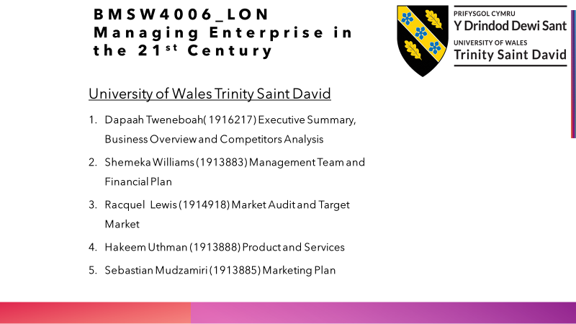

1.EXECUTIVE SUMMARY

Company Overview
5star fish and chips is a new company which is joint owned by five people and it will be registered as a limited company. It will be located at a very busy area in Stratford in east London. 5star will be offering it customers a quality food and affordable price. We will also offer kebabs, chicken and chips, burgers and salat. Its location is very close to Stratford train and bus station and close to schools. 5star aimed to target low income customers. We are focused to expand the business in two years. We aimed to add African dishes to our menu in a later date as many African’s live in the area.
COMPETITORS ANALYSIS
5star competitors are lighthouse fish and chips, chunky chicken, Bombay kebab original and peppers Piri. Lighthouse fish and chips is own by two brother and they have been in business for three years, they offer the same product as we do and they do only take away, the offer we provide include given customers the option of eating at our spacious premises, that alone give us advantage over lighthouse fish and chip. Chunky chicken has been in operation for two years six months and is own by two friends. They offer both take away and eating inn, but their space can only take two table and four chairs which is not enough for their customers. They offer a price of £1.00 for chicken and chips which attracts school children but 5star will be offering the same food for £1.20 but it will come with a drink which we believe will attract more people who are looking for affordable food price.
Management Team
Our management team is made up of five share owners with a very good professional team. Trying to give our best at what we do by leading in the direction giving both staff and customers the best. The five owners are going to be the employees at 5star fish and chips.
Financial Plan
For financial plan we are trying to keep our budget and borrowing low, knowing we are just a fish and chips shop. We aim to turn over as much profit we can in the first year to see what things may look like in years ahead.
Market Audit
It is all about the company wellbeing, the company is comprising of five individuals who have a wealth of experience in the restaurant industry. 5star fish and chips ltd short-term goal is within a year we are expecting the business to move forward in profit and to reduce all overhead cost, the business will effectively compete with competitors and overall be known for our good food and customer service, In Target Market 5star fish and chips ltd has strategically located the business in Stratford east London E20 busy and bustling area near train, train and underground station to target persons entering and exiting the stations. Our prices are affordable without compromising the quality of our products, the business will be opening from Monday to Saturday 11.30am to 8pm and on Sundays 12pm to 5pm.
Product and Services
At 5star fish and chips we aim to produce the best product and services to the best of our ability. We all at 5star fish and chips are all experience and quality food industry workers, we aim to bring our knowledge and skills in this company with all the energy we can master in other to make our company one of the best in the area. We will be serving quality fish and chips with other menu like kebab, hamburgers, salads, drinks. We will be giving our customers very friendly customer relation services.
Marketing Plan
5star will review its marketing strategy constantly by given our customers the opportunity to have say, this will be done through surveys and questionnaires, we will also be doing from time to time promotions to attract more customers. We will monitor our competitors their strategies and improve on it. We will give our customers good customer service by making them feel part of our business. We will try to let customers get their food as quickly as possible so that they don’t spend much getting their food.

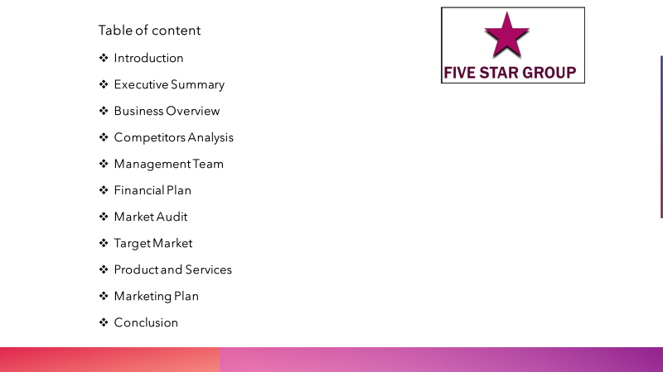

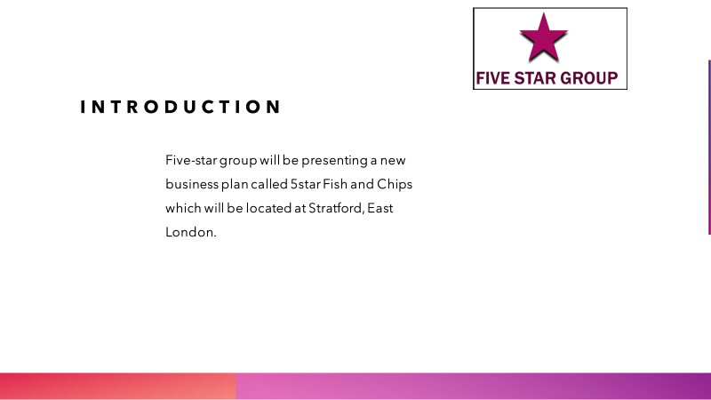

DAPAAH TWENEBOAH (1916217)

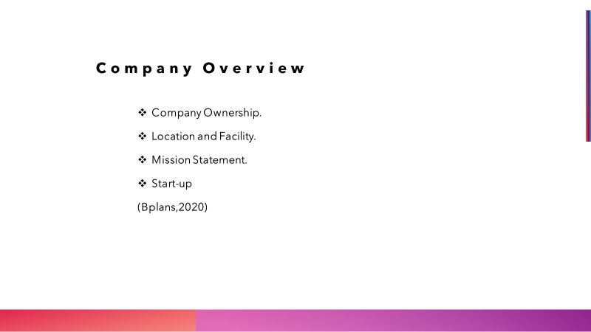

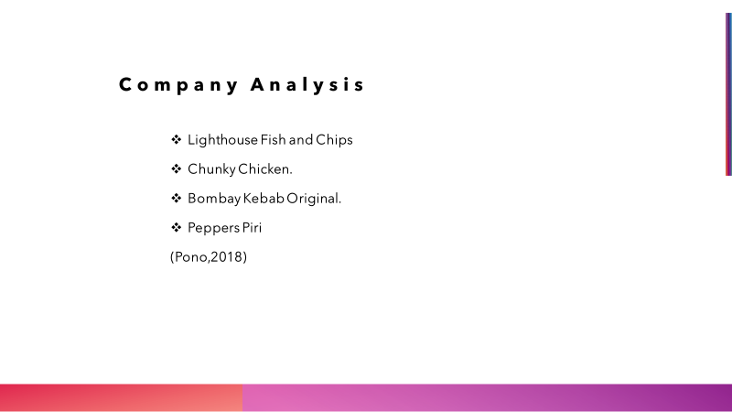

2.Company Overview

What is 5star fish and chips
5star Fish and chip limited is a new fast-food shop which is going to be opened at Stratford near the main bus/train station and close to university of east London on the 01/10 2020. The fries and fish are going to come from fresh potatoes from our suppliers. We will also be serving other fast food like hamburgers, kebabs, chicken, and chips, we will also offer customers the choice of salat which the customers can have together with the kebabs. As the fast food is close to the university, bus, train station and offices we have a good chance of success because from experience student, office workers always patronise fast food, after doing a survey at the area we saw that opening a fast food in the area will attract more customers because there was only a few fast food shops around and the food they were offering was not great and their customer service was bad, so we came into agreement that, with the service and food we are going to offer will give us advantage over our competitor, and also according to our survey the demand for fast food in the area is greater than what those few shop could provide and with the service and good quality food we are going to provide will make our shop stand out.
Company ownership
5star fish and chip company is going to be joint venture with five of us, and it will be registered as a limited company, the company owners are Dapaah Tweneboah, Shemeka Williams, Raquel Lewis, Sebastian Mudzumiri and Hakeem Uthman. Each one of us will be investing £4000 into the company making £20000 and 5star will be looking for outside investors to invest the remaining £28000 into the business. Mr Sebastian Mudzamiri is the company manager, He has over 7 years’ experience in the fast food industry and currently holds MBA degree from university of Leicester, he is the most competent person to lead the company, Dapaah Tweneboah has worked as assistant manager with WIMPY fast food for almost 10 years and with such experience he will be contributing into 5star fish and chips, Raquel Lewis has worked as waitress for 4 years, Shameka Williams has worked as kitchen assistant for 3 years, and Hakeem Uthman has also worked as kitchen staff for 6 years. The company will now employ 3 full time staff and 2 part time staff, and those staffs are going to be the 5 owners. What motivated us to come out with this business idea is to serve the community with good food, to supplement our income and also hope to open more fast food in different part of London and as a result jobs will be provided to people, one of our aim is to establish fast food chain the whole of united kingdom like McDonald’s, Burger king, and other fast food giants.
Our competitors serve only chicken and chips and it does not give the customers option to have other food, that is why 5star is adding fish, kebabs, salat to our menu to attract more customers, the more option the customers have the more they patronise your service. Our competitors do 90% take away and as a result they don’t provide a good environment for customers to eat inside the shop so when we did our survey we noticed that a lot of their customers hang around outside to eat their food, that is the reason why 5star has acquired a big space so that customers can have the options of eating their food in a clean and a spacious environment. We will also put table and chairs outside so that customers who want an open space can sit outside and enjoy their food, We are also dealing with suppliers who can provide us with fresh discounted product so that we can offer our customers with cheaper price than our competitors without compromising the quality of our food.
(Bplans, 2020)
Location and Facility
The company has rented a premise at a very good and busiest place at Stratford for a period of 5 years from the council and can be renewed at the end of the contract. 5star will be located at 1A1 DENNY ROAD, STRATFORD EAST LONDON, EN20 1ED. The cost of the place is £1,300.00 every month and is close to Stratford Westfield Mall. Currently 5star fish and chips does not have a rented office so the company manager MR Sebastian will be doing paper works from his home, as a new company we are trying not to put too much burden on the company financially that is why we have decided to run the office from home. Our long-term ambition is to expand the place and also make it like a home so that our customers will feel at home whenever they come to eat, and we are looking forward to add African local food as more African lives in the area. Our competitors do not serve African food and 5star introducing African food will put us ahead our competitor when it comes to patronage. We will be distributing flyers on the street and also in the local homes to make people aware of 5star presence and our opening date as well, we intend to give the first 20 people free meals on the day of opening. (Bplans, 2020)

Mission Statement
5Star Fish and Chips goals are to serve our customers with quality food and affordable price, we also aimed to give our customers the choice of variety of food. we will also be focused on how we can expand the business in the future so that we can employ people and contribute to the community.
Start-up
5star fish and chip will use start-up capital for Legal expenses, Kitchen Inventory and equipment, Insurance, Packing and other materials, Promotion, Advertisement, and business sign, below are the breakups.
Rent: The property will be leased from the council for £1300 a month and is for a period of 5 years and the possibility of renewing after the contract time for another 4 years.
Kitchen equipment are the tool and accessories 5star will need to make the shop possible for operational and those include:
Food preparation- apron, gloves, blender, storage containers, cleaning suppliers, pots and pans, glassware, paper wraps.
Fish and Chips tools: commercial fryer frying, chips cons, plain white chips wrap paper, Tubular handled chip, heavy chip fish fat fryer, Deep fryer basket, Free standing electric fryer twin tank 20 litre, chip scuttle.
Kebab tool: Kebab grill 4 burner machines, kebab sticks grill stainless steel, kebab knife, electric kebab slicer.
Burger tools: hamburger machine, burger wraps, all these equipment’s will be purchased new and they will be energy-efficient from a reputable supplier. Other expenses will include ingredient for fish and chip, kebab, burgers, toppings, cheese, burger, and kebab bread.
5star fish and chip will be paying £1600 insurance premium for business risk coverage for the next six month and we have decided to pay it upfront to the insurance company because it is far cheaper than paying it monthly. (O'Rourke, 2020)

3.Competitors Analysis
Competitors are businesses that provide the same services as we do, four competitors who are in the same area as we do are Lighthouse fish bar, Chunky Chicken, Peppers Piri and Bombay Kebab original.
Lighthouse fish and chips
Lighthouse fish bar are owned by two brothers, and they have been in business for three years, they offer fish and chips as their main product and their premises is a little bit smaller than ours, lighthouse fish and chips is our competitor because they offer the same food we are going to offer that is fish and chip and we are going to target the same customers they sell their product to, with the research 5star has done shows that lighthouse tend to target the local community by distributing flyers into their homes and also offering them promotions. The advantage 5star will have over lighthouse is that, they only offer take away services for their customers, but we are going to offer customers the option of eating and enjoying their food at our spacious premises and also we will give customers the option of allowing them to order their food before they get there to avoid wasting time, and it is our long term vision to introduce online ordering. All these services will be to our advantage as lighthouse does not offer such services. We will also be advertising in the local newspaper and distribute flyers into the local houses. Their strength is where they are located, they are closer to the Westfield mall than us, but with the service we are going to provide will put us ahead of them. Their weakness is also the size of their premises, it will not be possible for them to offer customers the option of eating there unless they relocate to a bigger place, and that will be to our advantage.
Chunky Chicken
Chunky chicken is a chicken and chips shop which is located further right to our shop, it is owned by two friends, it has been in operation for two years six months. They offer both take away and eating, but their space can only take two tables and 4 chairs which is not enough for customers who want to eat there. 5star can take more than 10 tables and 40 chairs and that will allow more customers to eat at our premises. Chunky chicken attracts more school children because of their proximity to one of the local school, they offer a price as low as £1.00 and that makes it possible for the school children to patronise their service but it does not come with a drink. 5star will offer a price of £1.20 but it will come with a drink and I think that will give us advantage over chunky chicken. They tend to target the youth.
Bombay Kebab original
Bombay kebab original is owned by five people and it was established seven years ago, they are doing very well, and they offer everything we are going to offer and even more. They will be a hard competitor to beat, they advertised on social media page, website, blog. They tend to target middle income customers, they are located at Stratford centre which is a little bit far from us, the opportunity 5star has is that we are targeting middle and low income customers and they are targeting only middle income customers, because we are targeting low income customers our prices for the food will be more affordable than Bombay Kebab original and that will give us advantage of attracting more customers.
Peppers Piri
Peppers Piri is a chicken and chips shop which is owned by one person who has employed two other persons to work with him. It was opened one and half years ago. They are located five blocks away from us. Their way of advertisement is through flyers distribution at the train and bus station. They are also targeting low income customers, the advantage we may have over them is our sitting capacity where our customers can relax and eat their food as they do not have this service available to them. (Pono, 2018)
Conclusion
In conclusion 5star understand that the competition will not be easy but we are determine to make it work, especially with the work experience the owner have got, we aim to expand the business to other part of London. We will also continue to do survey to our customers to find out what their interest are, and how we can meet their expectation. Any investment made to 5star will yield good equity. We hope to make 5star a big fast-food chain like Burger king, Subway, and other big fast-food chains.

References
Bplans, (2020). bplans. [Online]
Available at: http://bplans.com
[Accessed: 09 August 2020].
O'Rourke, A.(2020). bplans. [Online]
Available at: htts://bplans.com
[Accessed: 10 August 2020].
Pono, M. (2018). Competitive Analysis. [Online]
Available at: http://mykpono.com
[Accessed: 10 August 2020].

Shemeka Williams Id # 1913883

Management Team

4.Management Summary
We at 5star fish and chip have small strong team with experience in the fast food chain , we all are founders we don't have any help from outside for as a small business we aim to work together to try and keep additional overhead low until we establish better. This mean that extra work/support in needed from the team and doing this it will help us to try and pay back any borrow on a shorter term, as we aim to go forward with plans and we hope this business would succeed so we can open more 5star fish and chip shops in the future, we will be serving freshly, some healthy selection made from scratch on premises, we will be buying suppliers from our local and regional suppliers and will help to keep the cost down.
The Management Team
Our management team aim to drive force to our company giving leadership, guidance, energy and fun to the team, 5star fish and chip is created by five members and it's a small organization as we plan to have a small team to start off with until business develops, each members all have skills that can contribute in different ways to be better, we also motivate, develop and communicate effectively within the team, as managers we give feedback often so that we on the same part to delivered good work.
Organizational Structure of the Team
There are five member in the team starting with our executive manager follow by others managers, Sebastian Mudzamiri as executive manger, all other the other four are managers Dapaah Tweneboah, Raquel Lewis, Hakeem Uthman and myself Shemeka Williams. Sebastian who have seven years experience in fast food industry and currently holds MBA degree, Dapaah has worked as assistant manager at WIMPY fast food for almost ten years, Raquel has worked as waitress for four years, Shemeka worked as kitchen assistant for three years and Hakeem worked as kitchen staff for six years. Each individual have a main role to play as managers and also their daily jobs, roles to do within the work starting with Sebastian he's responsible for finance & recruitment, HR and daily tasks are preparing food and take order for takeout, Raquel is responsible for marketing and sales and daily tasks are stocking items, selling on the tills, Dapaah is responsible general management and daily tasks are cleaning hot equipment, frying and preparing food, Hakeem is responsible for product development and daily tasks are stocking, frying and preparing food and as myself Shemeka will be doing administration daily tasks are cleaning, washing up and prepping items for it to be ready for cooking, and every Sunday morning we all do a spring cleaning which on that day we open a bit later, there will be three full time and two part shift pattern , as to profit sharing arrangement we all going to be getting equal amount as equal owners, we all have a passion for food and have enjoy satisfying customers.
Layout of the Management team
Sebastian Mudzamiri
Executive Manager
Finance, Recruitment and HR

Raquel Lewis Hakeem Uthman
Manager
Marketing and Sales
Manager
Product Development

Manager
General Management

Manger
Administration

Dapaah Tweneboah Shemeka Williams

Our Mission, Values and Vision as Management
Our vision within our management team for the business is for it to become one of the fastest fish and chip restaurant in East London providing the best customer service with high quality product. Mission within management team is to give customer the quality fast food from local framer and sharing our authentic tradition to them, and to do right as manger by putting customer first and to create a good environment we would like tourists to plan stop in their visit. Values within our team is that we are passionate about our work, and to visualize been bigger.
Human Resources
Our responsibilities is to recruit, hiring, training, performance management, coaching, team building, health and safety communication and salary and benefits, so as we grow as a management team we are looking forward to expand so we can recruit more staff especially younger staff and from different culture. We promise to lead the company compliance by the government legal guidelines.
Objectives and Targets as Management
As manager one of our biggest struggles we going to face when dealing with our day to day in a restaurant task is trying to achieve goals, getting past the struggle each day make it seems more harder to overshadow on long term plans, we may sometime feels we not in control of how things are going, one of things we can do by try and keep our first time customers as a regular. Trying to keep things afloat going to feel hard, as managers there are many goals to be set but most important goal is financial, making share the team is performing be comparing work performance, goals have to be set for a business to reach milestone it makes you want to achieve more so you can move in the right direction of success, there are types of goal should be set for a business to grow and show you where more work needed on, you can use goals help other department see it they are reaching the business management objectives.
Some example of good goals are food quality, marketing, employee development, finances and customer service, as managers most goals can be achieved by (stop putting out fires) fixing problem straight away and to put off to a later time, delegate by leading the right way and taking accountability as managers when thing s goes wrong, schedule be on time when planning so you can meet the work plans, and giving and getting feedback, the more feedback you give it will open the door for other in the team to relate back to you which helps to meet goals.
Conclusion
As a small management team knowing with the strong background of experience we have the team would be able to delivered a good standard of service.

Financial Plan

5.Financial Plan Summary
5star fish and chip is now privately own by Sebastian, Dapaah, Hakeem, Raquel and Shemeka, the company is planning to do a one year business plan before doing a longer team plan, we as share holders are looking for an investment from investor towards the business with a 10% interest rate to be pay , the investors would received investment pay back on a monthly base by the agreement amount, as share holders we wouldn't be getting any share until after the first year but would be receiving a monthly wages as staffs, all the start up cost, capital, investment cost (share holders and investor) profit and gross margin are explain below, we are looking to start off with £48,000 and would like to make back a profit of £18,000 for the first year after all expense are pay out.
Start up Funding
The start up funds we worked out to be £41,622.68, any figure listed below was researched on before used.
Initial start up cost
Emergency funds £8,000
Property lease £14,400
Equipment £8,441
Food (three months) £2,932.88
Stationary (three months) £1,700
Furniture £730
Admin fee £2,370
Renovation £3,100
Total £41,673.68

Emergency funds is one set fund, property lease is work out for one year, equipment are for things such as glass door fridge, kebab grill, chill food service counter etc. The food cost is base on three month supplies, stationary also by three month supplies and also petty cash for small daily items, furniture price cover all table and chair, admin fee is for delivery and food permit license and renovation is to cover any repairing on the building.
Capital money that would be pay out monthly
Capital (monthly)
Bills £551
Salary £9,760.90
Food £977.56
Stationary £508
Total £11,797.46

All the capital are base on a monthly figure, the bill are include are gas, electric, water, council tax, TV licence, building insurance and internet broadband, the salary figure wouldn't be pay until the third month in but still be in the capital and base on three full and two part time on shift rotation pattern, food are calculated for month supplies, and stationary are monthly household items.

Investment cost are money (shares) that are put in by business partner and the investors
Share holder (5x£4,000) £20,000
Investors loan £28,000
Total start up cost £48,000
Interest rate at 10% (£2,800)

There are five share holders going to be putting £4,000 each and would be borrowing £28,000 from investors at a 10% interest rate.
As for the total start up cost £41,673.68 we still going to need money left over as emergency are back up funds.
Our personal finances would be available when need by investor to be view, such as bank statement, credit sore report, tax returns and financial information.
Monthly profit from October 2020-September 2021

The total for the year £160,000
The monthly expense for bill going out £11,802.96 (£11,802.96 x 12 =£141,635.52)
Take away the monthly expense from the £160,000 is £18,364 in profit
This is the monthly profit bar showing the figure for the year as you can see we aiming to make £160,000 but after the monthly expense multiply by twelve £141,635.52 then deducted from the yearly total which is £18,364.
So we are looking to make £18,000 to £21,000 are even more, to get how monthly figure we did a survey around the area then put our information together from what we got.

Gross Margin cost for the year by month from (Oct 2020 - Sep 2021)
Gross Margin

The gross margin chart explain the monthly income, profit and expense calculate within the year, as you can see there is a month in which we went below in profit and was able to make back up on the following month, when all the income comes in we deducted the monthly expense from it to give us our profit, all the figure were base on estimate on expense and survey done in the local area, base on the research a new fish and chip restaurant can make between £13,000 to £16,000 per year in profit but base on our business location we looking to make £18,000 to £21,000 and research show that profit can rise to 10% -13% each year.
All the expense for the month is just a fix amount that figure can go up are down by mostly up just in case there is any other cost to pay-out for that month e.g. like broken pipe, appliance repair and bills going up etc.
Conclusion
We as partner believe that by experiences and research and the investment gaining we can succeed with plans and could look to open more restaurant in the future.

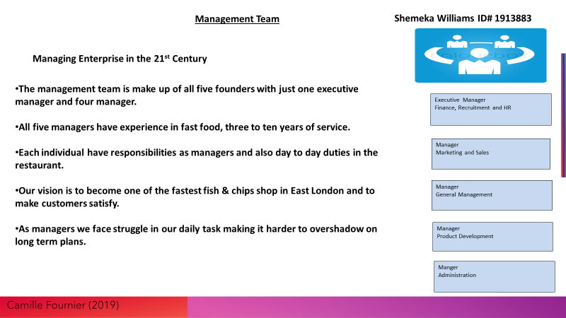



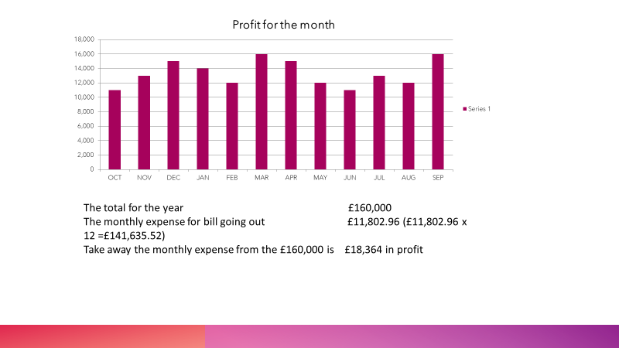

Management team reference

Jeff Haden (2015) Management Team at http://www.inc.com
Julie Zhou (2019)The Making of Manager. Reading
Financial plan
Todd E. Frank (2013) Financial Planning and Advisors. Available at https://Frankfinancialadvisors.com
Kimberlee Leonard (2019) How to Conclude a Business Plan. Available at https://smllbusiness.chron.com

RACQUEL LEWIS
Student ID 1914918
6.Market Audit
According to MBA skool.com, (2020). Market audit highlights the path a company should follow and the likelihood of the company achieving its targets and goals. This means that a market audit is a tool that can be used to identify the resources that are available and devise plans or goals or opportunities to achieve these goals. It also helps to strategize and find solutions to or resolve ongoing and future issues within a company. The market audit that was conducted on 5 Star Fish and Chips Ltd revealed the following information.

The company is a partnership comprising of five individuals who have a wealth of experience as well as qualification in the restaurant industry. Sebastian, the manager, holds an MBA degree and has seven years’ experience in the fast food industry. Dapaah has worked as the assistant manager at wimpy fast foods for almost ten years. Racquel has four years’ experience waitressing. Shemeka, has worked as a kitchen assistant for three years and finally, Hakeem has worked as a kitchen staff for six years. This vast amount of experience will help to set 5 Star Fish and chips Ltd apart from our competitors and help us to effectively compete within the industry.

The short-term goals of 5 Star Fish and Chips Ltd are to reduce our overhead costs significantly in order to at least break even for the first year of operations. In addition to this, we also aim to effectively compete with our competitors by providing top quality products and service to our customers at affordable prices. According to Thompson, Tracy (2010, pg.136). “Every customer contact is either building or destroying future business”. Therefore, we endeavour to maintain a clear and open communication with our customers by responding to issues in a timely manner and listening to and addressing feedback.

Our long-term goals include expanding the business by opening more branches in and around London. In order to achieve this, we aim to offer a 10% equity share in or business, in return for a £28,000 investment in our business. Additionally, we also aim to promote and advertise our business through social media platforms such as Instagram, Facebook and the 5 Star Fish and Chips web page. We also aim to increase our advertising by using radio adverts, printed flyers and advertising through the local newspapers.

Our fish and chip shop use vegetable oil to cook our food and other meals. At the end of the day, we filter the oil used with modern filtration machine to get the oil used as clean as possible. By doing this, we can cut costs and use the oil a minimum of two times before discarding properly. We have decided not to use the oil more than twice because we find that if used too many times, the chips will have distinct taste and customer may complain that the chips are not freshly made.

At Five Star Fish and Chips, we ensure that all our menu items are freshly cooked on site daily. We ground our own beef and chicken to make the burger patty. By doing this, it gives our customers sense of home cooking and satisfaction in the taste as these items are not mass produced. We also grind our own vegetables to come up with a unique patty to offer to our vegetarian customers.

The temperature for cooking our breaded fish is 145 degrees Fahrenheit. This is the optimal cooking temperature to ensure that the food is properly cooked.

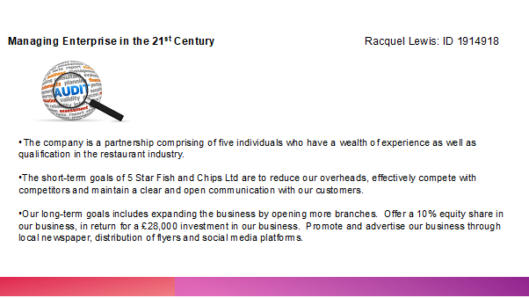

Overall, 5 Star Fish and Chips Ltd offers fresh, top quality food for all our customers. We especially cater for individuals who are busy and who may be time restricted to prepare or cook a meal. Our wide range of selections guarantees an option for even the pickiest of eaters. Our menu choices also take into consideration individuals who may be vegetarians or vegans. Our strengths include having experienced staff from a diverse background as well providing fresh fish that we purchase from Billingsgate Market every morning. We also offer 10% discount for students. For university students, they must present a valid ID in order to obtain this discount. We also offer 10% discount for old age pensioners (OAPs)and other products to our customers. We have also identified that Stratford is currently going through a massive development, therefore the potential for new customers is vast because there will be families with young children as well as working people.

On Friday’s business will be busier because fish and chips is popular as fast food. We have identified that business can be a bit slow during the winter months due the fact that it is very cold and the popular tourist. Another weakness that has been identified is that during the winter weeks, our sales might not be as high. This is because we have found out that our potential customers are mostly indoors. To combat the slow level of sales, we have decided to offer special discounts to get more customers and increase sales. We have also decided to lower the costs of our meals during the winter months in order to gain more customer, which will allow us to stay ahead of our competitors.

The website also talks about the business in general, so that people know we prepare all of our fish onsite, our peas are prepared overnight and the potatoes are chipped daily, so already people are expecting a premium product. We also have a link on their website homepage to our Facebook site. In order to engage our customers, we ensure that our website is updated frequently with colourful photos and pictures are published whenever we add a new menu item for our customers to see. By doing this, it will attract new customers.

During slower months, we have decided to get customer business cards and have monthly prize draws. We believe that this would work well because customers would normally stay an average of 10-15 minutes in the chop whilst waiting on their food. This will enable us to obtain feedback and some details from the customers so that we can sent them marketing information when we are approaching slower months.

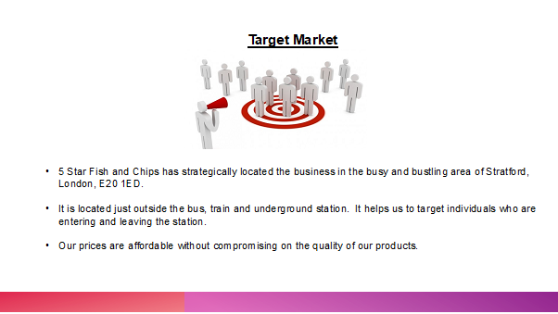

7.Target Market

In order to achieve good customer value and returns, the correct market segment has to be targeted (Slater, 2007). Therefore, it is extremely important that we know the individuals who will most likely purchase our food and what area will be best for the business to be located in. It is also important to know how to continuously attract custom from our customers, as this is paramount for the business sustainability. As a result, we strategically planned and agreed to locate the business in the busy and bustling area of Stratford London. The success of the 2012 Olympic bid, has led to the regeneration of the area (BBC.co.uk, 2020). In addition to this, the Stratford area has also seen a boom in vibrancy and popularity in the area. The business is located just outside that train and underground stations. This location helps us to target individuals who are both entering as well as leaving the station. In addition to this, the very popular Westfield Shopping mall is only just a short walk away from the business. We have also located the Queen Elizabeth Olympic Park as an ideal location to attract customers. This is because the park often keeps events such concerts, tours for tourists and football matches.

There are several other popular attractions in and around the area which we are confident that we can target to get more custom. In addition, we have identified the University of East London and Birkbeck University which is located about a 5-minute walk away from the location of our restaurant. Stratford is also home to the Aquatics Centre which enables visitors to nurture their inner child, which is ideal for us as a business because after swimming, they will be very hungry for traditional food.

We are living in a technological age where most households have access to the internet as well as all mobiles phones, individuals are able to access the internet on their phones. To reach a wider target market, we have decided to set up a website that shows off our shop, menu and opening hours. People are so use to using their mobile phones in order to access information on the internet that is why we believe that placing our business on the internet, potential customers will be able to locate our fish and chip shop and view our menu as well as place orders.

We believe that by targeting local customers, we can afford to spend a little more time and money to attract them to our fish and chip shop because while doing research, we have found that their average annual spend is usually higher.
People often are loyal to their local fish and chip shop, which means that we will need to build awareness for those who are new to the area. As a way of catering to families, we also offer a menu option for children which also includes battered sausage, chicken nuggets. In addition, we have small portion for children who would want fish and chip meal.

For the busy individual, we offer a delivery service where these customers can place their orders and have it delivered to their home at no extra charge. In today’s society many people prefer to purchase by card and as such, we take numerous methods of payment i.e. card and cash.

Thompson, Tracy, (2010, pg.127) states that “successful marketing, places the customer at the centre of all planning”. The partners have decided to provide our fish and chips to a wide range of individuals and not just people who love fish and chips or who may be vegetarians. This decision is evident in our wide selection of menu choices. Additionally, we have set our prices at an affordable rate. This has helped us to not only attract customers from other pricy restaurants in the area but also to effectively compete with similar restaurants in and around the area. The four P’s of marketing mix, product, price, place, and promotion has guided most of our marketing decisions. We offer our customers a convenient and top-quality service and meal. We price the meals we offer based on its quality and on the prices, competitors charge for similar products. We have been able to successfully do this without compromising the quality of the food that we sell. Finally, Our Company is in the very vibrant, busy and diverse area that helps us to attract a lot of sales, especially in the peak months of summer. During this time, there are numerous activities that takes place such as yearly fun fairs, numerous other attractions such as sliding down the ArcelorMittal Orbit.

List of References

BBC.co.uk, bite size guide, 2020. Urban change in the UK. Available at: https://www.bbc.co.uk/bitesize/guides/z9y47hv/revision/3. Accessed 13th August 2020.
Mbs skool.com. Available at :https://www.mbaskool.com/business-concepts/marketing-and-strategy-terms/3944-marketing-audit.html#:~:text=A%20market%20audit%20is%20a%20process%20which%20needs,it%20able%20to%20achieve%20its%20target%20and%20goals. [Accessed] 09/08/2020.
Slater, S.F., Hult, G.T.M. and Olson, E.M., 2007. On the importance of matching strategic behavior and target market selection to business strategy in high-tech markets. Journal of the Academy of Marketing Science, 35(1), pp.5-17.
Thompson, M., Tracy, B. and Hesselbein, F. (2010) Now, Build a Great Business!: 7 Ways to Maximize Your Profits in Any Market. Available
at: https://app.kortext.com/read/16320.

Student: Hakeem Uthman
Student no: 1913888
BMSW 4006
Managing Enterprise in the 21st Century
Tutor Dr Anupam Mazumdar

8.Business plan on Our Product and Services
A business plan helps to boost clarify one’s business idea, spot anything that can lead to potential problems, set out your goals, and measure your progress. According to Startup (2020) stress that ‘Your business plan outlines what your business does and what you are trying to achieve’. In this plan, I will be talking about the product and services of our proposed company 5star fish and chips eat-in and takeaway.

Our Product and Services
A product is an item, article, or substance that is manufactured or refined for sale that is put on display for acquisitions, consumption, or attention. While service can be described as an output of one or more persons. A product can be described as tangible while services can be described as intangible but in most cases, the difference between the two is always their tangibility but that is not always the case because in most cases services are intangible while products are not always tangible. According to PMA (2019) highlight that ‘product marketing can be summed up as the driving force behind getting products to market’

Products and services are two closely aligned concepts, and, as a matter of fact, most products have an element of service in them. For example, a car buyer now buys a full bundle of service benefits, in addition to the tangible components of the car1. However, there is a big difference between them, and it is important to establish some working definitions. One way to think of them is from the clients’ point of view, hence the product price and the service are the quality of price which are characterized by a balanced to a consequent game Morris A (1997).
When a client asks, "what can you make for me?" they are asking about products; when a client asks, "what can you do for me?" they are asking about services. While a product is something that can be measured and counted, a service is less concrete and is the result of the application of skills and expertise towards an identified need. A product is something you can point at, whereas a service, as The Economist defines it, is any activity "you can't drop on your foot"2 although this definition doesn't hold up when the products are digital in form – insubstantial objects that have no form or material definition aside from the physical media on which they exist. Nonetheless, even in file-based workflows, there is a distinction between a product being produced and a service provided to fill a need. For the purposes of the Digitization Services Branch Products and Services Project, these are the definitions of each component. McGraw Hill (2007)

At 5star fish and chips, we plan to offer excellent and best product and service which is why we have endeavored to do proper research about what product and services we will be rendering that will make us stand out among others we are going to be unique in our product and services at 5star fish and chips. Our product is going to be unique and better than all our competitors because we are going to be producing the best fish and chips around the area we are located in Stratford we have conducted a proper survey of this area and we have found out that fast food is in high demand in the area because of the population of people that live and work in this localities. Around the location we have chosen we have about three schools and some higher institutions as well as cooperate offices which make the population of targeted customers for our product to be very high. One of the qualities that will make us stand out and be the best among the rest is our experience and qualified staff that has years of experience in the food industry.

We aim and plan to deliver the best product and services to our intended customers and therefore we have conducted an extensive survey of the area we plan to locate our shop. We have found out what will be in high demand in the area and what is available in the area and this is why we have chosen fish and chips although we will also be including chicken and some other things such as beef, sausages, and different kinds of drinks to mention a few.
We chose our main menu to be fish and chips because we found out that there is no fish and chips shop around the area we are going to be located. This will give us an edge over our competitors in the area because we will be serving what they do not serve, and we hope this will give the consumers in the area an option of what they can get.

The 5star fish and chips will be offered
- Different varieties of fish with chips
- Chicken with chips
- Different varieties of burgers
- Different varieties of rolls
- Salads
- Coffee
- Tea and juice
- Milkshakes and Assorted drinks

At 5star fish and chips, we will be sourcing our fish from a reputable fish supplier in London and the name of our supplier is Billingsgate they are based in a canary wharf in London and they are we’ll know as a leading supplier of fish in the city of London
At 5star fish and chips, we aim to make our product unique and different from what is obtained in the area and this will give us an edge over our competitors in terms of sales and generating more income which we can be able to use in expanding the business to the level we envisage in the feature because we have a long term plan and forecast to expand the business to other parts of the city and if possible the whole Country and beyond.
At 5star chicken and chips we plan to keep our prices low to attract as much as possible customers and to boost our sales we will be comparing our prices with other product providers to be able to keep our prices low but keeping our prices low does not mean we will not be mindful of our set goal of making profits. We aim to make as many profits as we can, but we will be putting our intended customers into consideration while we do this, because the aim and objectives of any organization or company are to make profits. Our products will play a key role in our development because we will be producing the best possible fast foods around the area in other to gain enough customers and to lure our competitor's customers to our shop, to be able to do this we have put in place some activities with which we intend to use as our public relations services. We will be using some media outlets and some good advertising strategies to make people know and be aware of our presence and product in the area. Some of these are printing and distribution of leaflets, flyers, and posters. We will also be doing a promo from time to time.
At 5star fish and chips, we have developed a range of recipes which we will be using to produce our foods we have done this by doing a lot of research on food production and preparations, our recipes will be kept highly secret so as not to let our competitors know what we are using and doing that makes us stand out as the best. Our recipes will include varieties of different ethnicity and country because our intended customers are made up of different ethnics groups, we are highly confident that as soon as we get on board and start our business we will be taking most of the clients of our competitors because as soon as they see and taste our product there will be no going back and the sky will be out limit. Our services will be one of the best in town because it will be delivered by a team of individuals who are highly qualified and experienced in their respective fields.

We are five (5) in number that decided to come up with the idea of 5star fish and chips and each one of us will be playing a vital role in the development of the company we will also be coming up with some financial commitments which will be our commitment to the company.
We have Mr. Sebastian Mudzamiri who will be our chief operating officer and he has a degree in business administration from Leicester university and about seven years’ experience in the food industry specializing in the fast-food industry, he is a reputable and respected gentleman and he has held several management positions in the past. We also have Mr. Dappah who has worked in the food industry for about ten years at wimpy fast food at wimpy. Myself Hakeem I have worked in the kitchen as a chef in a hotel for six years, Miss Raquel who has worked and a waitress for four years, Miss Shemeka who has worked as a kitchen assistant for three years all of us are well experienced in the food and hospitality industry and we all will be working in the company from the inception and with time we will be employing more able hands to join his in the business to be able to move the business to greater heights.

More about Our Services
At 5star fish and chips, our services will be people-oriented, friendly, and focus on giving the best to our customers because we believe in given our best to achieve the desired results.
Our services will include eating in takeaway and home delivery to our customers because we want to be leading in competition with our competitors we will be aiming to provide a five-star service as it says in our company name to our clients. We will strive had to develop good public relations with our customers. ‘Customer satisfaction describes the interaction between corporate behavior and customer behavior’ Toa (2014). At 5star fish and chips, we aim to develop a good customer satisfaction goal which will make our customers always come back and be willing to introduce and recommend our services to friends and family. We aim to do all this by conducting a survey and doing promotional services and a good advertisement for our goods and services. At 5star fish and chips, we will be using modern technology such as the internet and telecommunications to deliver our services to our customers, we are going to be having online ordering and delivery as well as telephone order and delivery, we will also be using other delivery services that are provided by other individuals and company such as just eat, Deliveroo, we will include all this in our services to be able to compete and try to be at least a step ahead of our competitors. We are going to make sure our customers get the best services we can provide in Other to satisfy their needs. We will have customer support and feedback app that will be monitored by one of our team members on an everyday basis to know and keep a tab on what our customers feel and think about the services we are providing, this will allow us to know from time to time which area we need to improve or which area we are lacking and what our customers will like us to improve on. We will also be printing and distributing pamphlets and flyers to our customers and people around our area of operations this is to enable us to gain more customers and be able to compete well with our competitors
The core of our services will be done professionally and properly by our experienced team and we have already identified who our clients will be, therefore we have chosen where to locate our business Our business location will be Stratford and its close to the bus and train station. It is an area bustling with activity due to the high volume of people going in and out of the area, it is the home of the 2012 London Olympic and it also has a lot of schools and higher institutions We hope this will really boost our business in other to satisfy our customers. According to Humble J (1989) highlight that ‘satisfied customers are a good thing’.

In conclusion 5star fish and chips will be sourcing for the best raw material to produce the best products in other to satisfy our customers. Customer satisfaction has been one of the top tools for a successful business. Kabu K & Soniya M (2017) pg5 also we will aim to deliver the best techniques that can be used by shopping websites to entice our customers in purchasing our products. Adrian A (2017) argues that a ‘proposes system for recommending products and services provided by different online businesses to potential customers is essential. Lastly, marketing strategies are important to draw more customers and drive away any unnecessary confusion. According to Fifield P (1992), states ‘marketing strategy strips away the confusion and jargon that surround what ought to be one of the most straightforward areas of the modern businesses.’

References
Adrian A., Cristian Nicolae B., Mitică C., (2017) ‘Recommending Products and Services Belonging to Online Businesses Using Intelligent Agents’., 9(4), Pages i-x, 263-352
Fifield, P. (1992). Marketing Strategy: How to Prepare it – How to Implement it. Butterworth-Heinemann.
Berry, L. and Parasuraman, A. (1991). Marketing Services: Competing through quality. The Free Press.
Kabu K., Soniya M. (2017) Customer Satisfaction and Customer Loyalty Centria University of Applied Sciences
Govt Hill(2015) business plan (online), Available at https://webcache.googleusercontent.com/search?q=cache:cai218X88cgJ:https://www.gov.uk/write-business-plan+&cd=2&hl=en&ct=clnk&gl=uk Accessed 15thAug2020
Humble, J. (1989). ‘Satisfying the customer’, Harvard Business Review, Jul/Aug
Morris A. Cohen, Seungjin W., (1997) ‘Competing in Product and Service’: A Product Life-Cycle Model, 43(4), Pages 405-570.
Palmer, A. (2005). Principles of Services Marketing. McGraw-Hill
Palmer, Adrian. 2007 principles of services marketing McGraw
PMA (2019) what is product marketing (online), Available at https://productmarketingalliance.com/what-is-product-marketing/ Accessed 18thAug2020
Startup(2020) business plan (online), Available at https://www.startupdonut.co.uk/business-planning/write-a-business-plan/essential-guide-to-writing-a-business-plan Accessed20thAug2020
Tao, F. (2014). Customer Relationship m

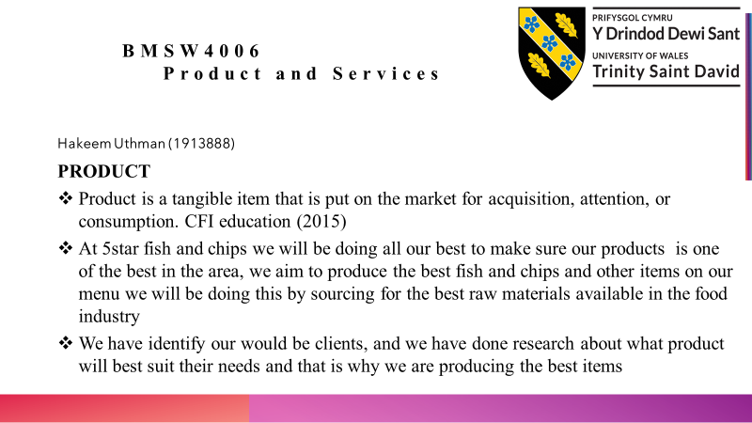

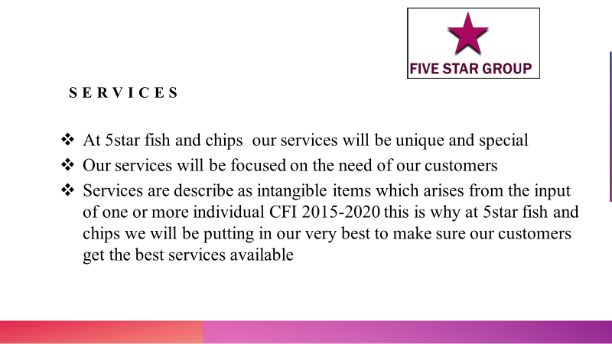

Name of Student: Sebastian Mudzamiri
Student Number: 1913885
Module Name: Managing Enterprise in the 21st Century
Module Code: BMSW4006

Marketing Plan for Five Star Fish and Chips Limited
Marketing is defined by the UK Chartered Institute of Marketing as the ‘management process involved in identifying, anticipating and satisfying consumer requirements profitably’. ‘Marketing is about supplying the right products, to the right customers, at the right price in the right place, at the right time’ (Anon). The basic function of marketing is to attract and retain customers at a profit’ Peter Drucker, The practice of Management (1983).
Five Star Fish and Chips Limited will be based in Stratford, East London. Since the 2012 London Olympics and the Paralympics Games that followed, Stratford has become a hub for shoppers according to visitlondon.com.
Stratford and Newtown is a ward in Newham of London, England. According to the Office of National Statistics (ONS), in the 2011 census, Stratford and Newtown had a population of 17 768 and is made up of 48% female and 52% male. The average age of people living in this area is 31while the median age is 29. 25% of people are married, 10,3% cohabit with a member of the opposite sex, 46,9% are single and have never married or been married in a registered same sex partnership. 8,2% are separated or divorced. There are780 widowed people living in this area.
The ONS goes on to give the religious make up of Stratford and Newtown as 45,65 Christian, 25,5% Muslim, 17,3% not affiliated to any religion, 5.5% Hindu, 1,2% Buddhist, 0,2% Jewish and 0,1% Agnostic.
The top occupations listed in this area are given as, 21% Professional, Elementary 16,2%, Associate professional 15.1%, Elementary administration and services 10,2% among others.
Our marketing objectives and strategies at Five Star Fish and Chips are:
- Achieving growth in sales value of at least 10% per year.
- Gaining a market share above 5% in the first year of operating.
- Building customer affinity relationships on an on-going basis to grow the business.
- Achieving profitability within three months of commencing operations.
- Aiming for a superior quality of service as our Unique Selling Proposition.
- Advertising the existence of the business initially through flyers, local radio and newspaper.
The above-mentioned statistics have shown that target area of our business is composed of a relatively young population 46,9% aged 31. For this reason, we shall Taylor-make our marketing strategy towards this segment of the market. This group of people are usually in a hurry and would find cooking at home bothersome, if not time consuming. They prefer a take-away meal in order to keep up with their busy schedules. For one to qualify for our loyalty discounts, they have to buy from us five times from us in a month and they have to do so every month in order to maintain their discounts.
The other marketing segment we shall target are the married couples who make up 25% of the population. This group of customers can be quite big if we factor in the fact that they have children. Besides loyalty discounts if they buy from us three times in a month, we shall offer to plan the birthdays, wedding anniversaries or any family celebrations they might have. We can do outside catering for them at reasonable prices and ensuring that we get value for money.
The third market segment will be the travelling train and bus passengers to or from the transport hub nearby. We shall take advantage of our strategic location to market our company to this segment by offering them inducements to keep coming and buying from us. We expect that 90% of our income will come these three market segments.
Our Unique Selling Proposition will be the superior quality of service to each walk-in customer. This we will achieve by training our staff and colleagues in customer centric courses. We shall strive to continuously improve the way we deliver our services in order to meet and exceed customer expectations. ‘The aim of marketing is to know and understand the customer so well the product or service fits him and sells itself’ Peter Drucker.
Marketing Plan
Our marketing plan shall be underpinned by the above objectives and strategies. As mentioned above, we shall be offering loyalty discounts as a basic rule to the three identified market segments. With time, we shall build upon this framework based on the interactions that we have with the three groups of customers.
We have a start-up modest budget of $1 215.00 for our marketing efforts. We shall distribute flyers at the train and bus station advertising the existence of our company in the area once a week for a month commencing from the start of our opening of the shop. We shall distribute the flyers to businesses in the area and through private household letter boxes within the vicinity of our shop. Because it is said that ‘visibility creates credibility’, we shall make our company visible through vigorous marketing efforts. We shall also have a large banner in front of our shop promoting our products and services. The punchline for our advertisements will be something like ‘Five Star Fish and Chips where you can eat in or take away quality food’.
Our products range from fish and chips, kebabs, grilled chicken wings, chicken donner wraps, kids meals, sausages, rice, salads, coleslaws and a varied range of chips, kebabs in large, medium, small or mixed donna kebabs. There will also be cod fillet, fish cakes, rock fish, chicken nuggets and chips for kids, saveloy, quarter or half pounder burger, chicken burgers, gravy sauces and many more.
Our marketing budget will be as displayed in the diagram below.

Medium 1st Q 2nd Q 3rd Q 4th Q Total
Radio station £210.00 £210.00 £210.00 £135 £765.00
Newspaper £ 75.00 £ 75.00 £ 75.00 £0.00 £225.00
Flyers £ 75.00 £ 0.00 £ 0.00 £75.00 £150.00
Banner £ 75.00 £ 0.00 £ 0.00 £0.00 £ 75.00
Total £435.00 £285.00 £285.00 £210.00 £1215.00

In order to monitor the effectiveness of our marketing strategies, we would conduct a random and simple survey to find out from our customers about how they heard about us and what their experiences have been so far with our products and service. We shall then collate the responses from this exercise and review our marketing strategies accordingly. According to Brian Tracy, Chairman and CEO of Brian Tracy International, Speaker and Author, there is a ‘Seven P Formula’ businesses ‘should use and to continually evaluate and re-evaluate your business activities’ These Seven Ps are what is called the ‘marketing mix’. Some definitions of marketing refer the seven Ps as the major tools that underpin marketing as a discipline.
The seven are given as, product, price, promotion, place, packaging, positioning, and people. These will be dealt with in turn below.
Product
The product is the good or service itself. According to Brian Tracy, when doing an evaluation of your products, treat yourself as an outsider looking inwards and critically look at the products on offer and ask yourself whether you are offering the product at the right place. ‘Is your current product or service, or mix of products and services, appropriate and suitable for the market and the customers of today?’ We would ask ourselves as Five Star Fish and Chips if the products and services we are offering are superior to what the rest of the market is offering. If they are not, then there is need for introspection. According to Anderton, A. (2003) ‘It is about research and development, quality and how technical specifications help satisfy the needs of customers’.
Price
Price is not just affected by costs of production but what the customers are willing pay as well as the volume the business is anticipating selling. In a market dominated by many players, pricing of goods can be quite difficult. Raising of prices may alienate a significant chunk of customers but sometimes those customers that remain can generate a profit for the business. When it comes to pricing a product, sometimes it requires the dexterity of a cyclist on tight rope. It is a balancing act between what the consumers are willing to pay, the costs of production for the business and the dictates of the market. At other times, the prices have to be reduced in order to push volumes and still make a reasonable profit for the business. At the end of the day, it is about being competitive as a survival tactic.
Promotion
Promotion is about the way the business communicates with its customers through the various advertising media. This aspect of the marketing mix is about promoting the value of the products to the customers. It is about the satisfaction the customers derive from the use of a company’s products and what offers and freebies they can get as value for money.
Place
Place is the actual location of a business. Brian Tracy advises that businesses should ‘develop the habit of reviewing and reflecting upon the exact location where the customer meets the salesperson. Sometimes a change in place can lead to a rapid increase in sales. In our case, we think that we stand to benefit from a strategic location, and we shall remain cognisant of this fact as we move forward. Because of the development of the internet and the growth of fast-food delivery companies, we may consider accepting orders that come through the internet and use delivery companies for example Deliveroo, to deliver to our customers.
Packaging
The fifth element in the marketing mix is packaging. We shall continue to examine the way of products are packaged with a view to improving them in appearance. It is said that we should look at our products through the eyes of a customer. It is said appearance is everything. Packing is not only about the products that we offer for sale, but it is as much about the image of the company as it is with the employees. Packaging is all about branding of the products, the way the staff are groomed, the decor of premises, the stationery the company uses and every aspect of the business.
Positioning
Positioning is about how the customers position your company in their hearts. It is about how the business is perceived in the marketplace. Again, according to Brian Tracy, ‘Attribution theory says that most customers think of you in terms of a single attribute, either positive or negative’. It is said sometimes it is ‘service’. At other times it ‘excellence’ or it’s ‘quality engineering’ as with Mercedes Benz or in the case of BMW ‘it’s the ultimate driving machine’. We shall be in the habit of brainstorming on how we could improve our market positioning both in the hearts and minds of our customers and in the way the market perceives our company. We shall always try to have marketing strategy meetings with every employee so that we are on the same page when it comes to marketing our company and every idea will be considered.

People
We at Five Star Fish and Chips consider our employees to be an essential part of the company. According to the Total Quality Management (TQM) concept, we have two types of customers, the internal and the external. The internal customers are the ones that drive the company forward and it is them that normally interface with our external customers. This is a critical role which cannot be ignored or overlooked. Brian Tracy said that ‘Your ability to select, recruit, hire and retain the proper people, with the skills and abilities to do the job you need to have done, is more important than everything else put together’. We are going to draw up an organogram which show the role of each specific person in the company so that at anytime, we can be sure every aspect of our operations is fully covered. We shall have a system of grading jobs accompanied by performance appraisals so that we have the right people in the right places. Performance will be rewarded accordingly.
Measuring Performance
We shall measure the performance of our marketing strategies by the use Key Result Areas, Key Performance Indicators for example growth in sales values and social media likes for our walk-in customers (footfall). As the business grows we shall engage the services of a specialist marketer to take us forward.
Conclusion
This is the marketing plan for Five Star Fish and Chips Limited. It is not cast in stone but it is subject to change depending on the trading conditions and market forces. In all our deliberations about marketing, we shall be guided by the marketing mix.

References
Anderton, A G. AS Level Business Studies for AQA. Ormskirk England, Causeway Press, 2003.
Surridge, Malcolm, and Andrew Gillespie. AS Business Studies. London, Hodder & Stoughton Educational, 2004.
Tracy, Brian. "Seven P Formula." Entrepreneur. Com, Brian Tracy, 2007,
www.entrepreneur.com. Accessed 2020 Aug. 12AD



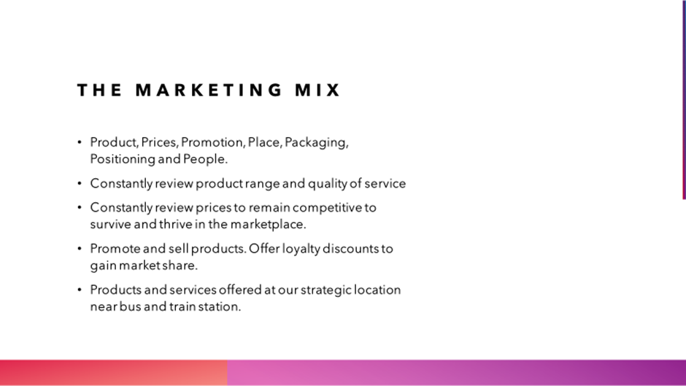

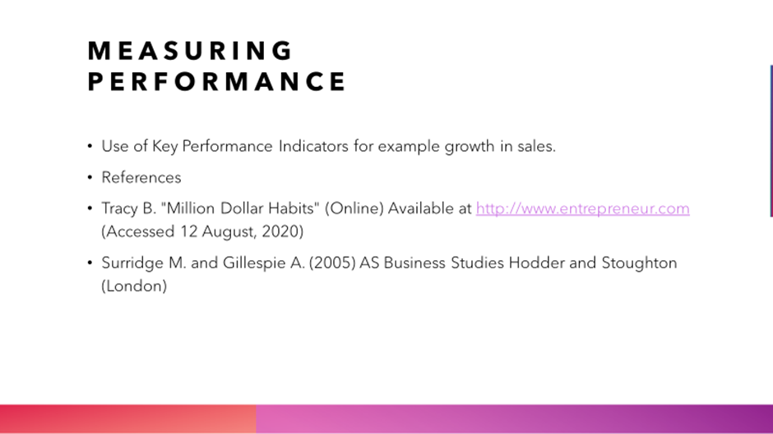

CONCLUSION:
In conclusion 5star understand that the competition will not be easy but we are determine to make it work, especially with the work experience the owner have got, we aim to expand the business to other part of London. We will also continue to do survey to our customers to find out what their interest are, and how we can meet their expectation. Any investment made to 5star will yield good equity. We hope to make 5star a big fast-food chain like Burger king, Subway, and other big fast-food chains.

‌

