EPortfolio
Task 1: Summary:
Mindfulness in psychology – a breath of fresh air?
Mindfulness is a traditional Buddhist meditation practice which focuses on placing one’s attention in the present moment to focus on the here and now rather than ruminating on prospects of the future or issues of the past. The Dali Lama states that this philosophy can prevent people from having a warped perception of reality that often leads to negative thoughts about an “ungraspable” future, rather, mindfulness encourages us to review and participate in the present moment to improve our quality of life as we go along. In recent years, mindfulness has been adopted by western culture and adapted into clinical mindfulness-based interventions (MBIs). Mindfulness-based cognitive therapy is being encouraged by organisations such as NICE and APA as it has proven to help with a variety of mental health conditions such as depression, anxiety, substance abuse and ADHD as well as helping cope with somatic illnesses like cancer. Mindfulness can also assist with academic performance, anger management and impulsivity just to list a few of its benefits, however, questions are now being raised as to if it is ethically appropriate to refer to this as true ‘mindfulness’. Traditionally, Buddhists dedicate years to mastering mindfulness in tandem with essential philosophical principles and teachings, compared to the western adaptation which often condenses this into an 8-week group program with related studies lacking credible validity due to performance bias, in addition, westerners have begun to view mindfulness as a fix-all tool and are neglecting Buddhist principles essential to correct mindfulness meditation which has led to occasional negative outcomes and an overreliance on meditation. These issues, however, are usually typical when reviewing ‘new’ psychological models. Western mindfulness has indeed proven effective across the board and is easily adaptable to different situations with many Buddhists accepting of and encouraging the adoption of their practice. (Shonin et al., 2015)

Task 2: Essential Skills Presentation
Presentation Video Link
https://drive.google.com/file/d/1a3xHlqBpBlTNMLbNAFc2PGOA6agwXtw4/view?usp=share_link
Presentation Slides Link
https://docs.google.com/presentation/d/17nfg_-YVnWsA6Xkhknfq_1Xrdqz1CDUU/edit?usp=share_link&ouid=113773565793039373191&rtpof=true&sd=true

Task 3: Academic Poster
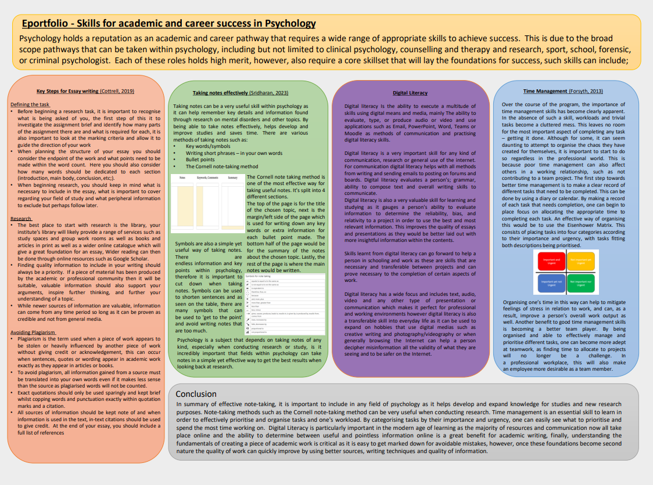
Drive Link: https://drive.google.com/file/d/10aE-R_p0gB7_HnSn1wPWkrJIYEkUZNzY/view?usp=share_link
Evidence of team communication




Individual Evaluation for Academic Poster
My contribution towards the poster involved a section titled Key Steps for Essay Writing, in which I covered a few key aspects of writing a successful academic paper as well as writing a short introduction about why core skills are necessary for success in academic psychology and resulting careers. In addition to my section, I also put suggested that our poster should be landscape to fully maximise the space available to fit in our own unique sections. I then took to Google for inspiration for the format and presentation of the poster and discussed what design worked best for the team through our WhatsApp group and library session. By making a template for our poster, my team could then slot their own research into their own dedicated column of the poster while allowing us the freedom to choose our own colour schemes and images to go with our research.

References
Article Reference
- Shonin, E., Van Gordon, W., & Griffiths, M. D. (2015). Mindfulness in psychology – a breath of fresh air? Mindfulness, 28(1), 28–31.
Presentation References
- Culley, S., & Bond, T. (2011). Foundation Skills. In Integrative counselling skills in action (pp. 42–52). essay, SAGE.
- Ethical framework for the counselling professions formally adopted 1 July 2018 (2018) BACP Ethical Framework for the Counselling Professions. Available at: https://www.bacp.co.uk/events-and-resources/ethics-and-standards/ethical-framework-for-the-counselling-professions/ (Accessed: January 8, 2023).
- Kitchener, K. S. (1984). Intuition, critical evaluation and ethical principles: The Foundation for Ethical Decisions in Counseling Psychology. The Counseling Psychologist, 12(3), 43–55. https://doi.org/10.1177/0011000084123005
- Lindon, J., & Lindon, L. (2008). 2. Effective Communication. In Mastering counselling skills (pp. 26–52). essay, Palgrave Macmillan.
- McLeod, J., & McLeod, J. (2011). 7. Ethical principles for embedded counselling. In Counselling skills: A practical guide for counsellors and helping professionals (2nd ed., pp. 103–124). essay, McGraw-Hill Education.
- Seehausen, M., Kazzer, P., Bajbouj, M., & Prehn, K. (2012). Effects of empathic paraphrasing – extrinsic emotion regulation in social conflict. Frontiers in Psychology, 3. https://doi.org/10.3389/fpsyg.2012.00482
Poster References
- Cottrell, S. (2019). B. Academic, People and Task Management Skills. In The Study Skills Handbook (5th ed., pp. 169–389). essay, Macmillan International Higher Education Red Globe Press. ​
- Forsyth, P. (2013). Successful time management (3rd Ed). 35-57.​ Murray, S. A., Davis, J., Shuler, H. D., Spencer, E. C., Hinton, A. (2022). Time management for STEMM students during the continuing pandemic. Trends in biochemical sciences, 47 (4), 279-283.​
- Sridharan, M. (2023, January 1). Cornell method - a method to take great notes. Think Insights. Retrieved January 10, 2023, from https://thinkinsights.net/consulting/cornell-method-great-notes/
- UNSU Current Students. (No Date). Techniques and Tips for Listening and Note Taking. https://www.student.unsw.edu.au/notetaking-tips ​
- Winter, L. A. (2020). Introducing therapeutic skills and clinical practice: the "basics" of therapeutic practice? In Sage Handbook of Counselling and Psychotherapy (4th ed., pp. 64–69). essay, SAGE PUBLICATIONS. ​

